

FINAL PROJECT REPORT
COMP3900 GROUP PROJECT

NOTIZBLOCK

Submitted By:

Tara Brown- 620012054
Jheanell Rainford- McPherson- 620012352
Andrew Stoddart- 062002171
Vaun-Pierre Wynter- 620003143

Supervisor
Dr. Gunjan Mansingh

ABSTRACT

Finding an effective medium to advertise and sell textbooks and off- campus housing can provide many aids and advantages for both vendors and consumers. Compared to the cluttered notice boards that go unnoticed around the UWI Mona Campus, a website would prove to be less expensive to vendors by avoiding printing costs, and more convenient to both vendors and consumers due to the popularity and accessibility of the internet.

The purpose of this report is to discuss the implementation of an online platform that we designed for the University of The West Indies Mona Campus, in order to facilitate the advertisement and sale of non- contemporary commodities such as used textbooks and off-campus housing. The website was created with special attention given to a bidding process as well as making informed product recommendations. The name of our website is NotizBlock – notizblock.com. The final product is a fun and easy to use website where students can easily attain the books necessary for school, at prices necessary for their pockets as well as much sought after housing in and around the Mona area.

TABLE OF CONTENT

Chapter 1: Introduction …………………………………………………………. 4-6
Problem Definition …………………………………………………………. 4
Approach to Solution …………………………………………………………. 5
Aims and Objectives …………………………………………………………. 5
Benefits of our Project ………………………………………………………… 6

Chapter 2: Background & Related Work ……………………………………………… 7
Ebay …………………………………………………………. 7a
Campus Clutter …………………………………………………………. 7b

Chapter 3: Method …………………………………………………………………. 8 -19
System Design …………………………………………………………………. 8
System Architecture …………………………………………………………… 10
System Implementation ……………………………………………………….. 15
Challenges …………………………………………………………………. 18
Project Expansion ……………………………………………………………... 18
Testing …………………………………………………………………. 18
Trade offs ………………………………………………………………….

Chapter 4: Results ………………………………………………………………….
User Login Screen ……………………………………………………………..
Admin Login Screen …………………………………………………………..

Chapter 5: Conclusion & System Evolution …………………………………………
Chapter 6: Acknowledgment …………………………………………………………
Chapter 7: References ………………………………………………………...

Chapter 1: Introduction

Problem Definition

In pursuit of a market whose expansion could be aided by the increasingly popular application of technology, it was quickly noted that despite the fact that the prices on academic books are 35% higher than they were five years ago, the retail market for used academic books remain very small. Every course at the University of the West Indies, Mona Campus (UWI), has a list of prescribed textbooks. Students sometimes prefer to purchase these textbooks, as an alternative to the library for varied reasons. Once these students have completed their course, they find themselves burdened with expensive textbooks they no longer need. In an attempt to regain a portion of the original cost of books, students often attempt to sell their textbooks by placing advertisements in the form of fliers, on the designated notice boards along with any other tree, wall or stall that proves convenient. There is also the group of students who don’t have the means to purchase these books for themselves, have no access/links to used textbooks, and therefore, they are reliant on the library for course reading material. Our solution was to design an alternative to the physical notice boards that would bring these two groups of students together so they could benefit from each other’s resources without a plethora of different fliers targeting events and other items popular among students.

In designing an online auctioning and shopping website, one must consider the types of online shopping sites and the different bidding methods that may be incorporated to create a user friendly environment. For NotizBlock, we have chosen to implement an Inquiry Based Website where it is important that clients are able to upload their product information unto the website with product code, product description, product images, etc. as well as categorize their products. With regards to the bidding process, it was important to us that we made the process extremely easy and familiar; therefore, we have chosen to construct the bidding process under what is known as the English Auction. The method includes an ascending bid auction in which bids are open for all to see and the winner is the highest bidder (i.e. the bidder offering the highest price).

Another point worth noting is the use of recommendation systems within online shopping websites. Recommender systems are used in many applications to suggest products, services and information items to potential consumers based on product attributes, consumer attributes and previous interactions between consumers and products. However, recommender systems depend heavily on high- quality consumer and product attributes that are often difficult to obtain.

Typical online auctioning and shopping sites involves charging the vendor a small fee for registering as a seller, registering a particular item for auction, and setting of a minimum bid that must be met in order for anyone to win the item- in essence, for hosting the auction. There is also the notion of setting a specific duration within which time the buyers will enter and bid for the item in question. We have also considered those vendors who simply wish to sell their items, no negotiations desired, and for this, the option of making a direct sale is also necessary. Like those who wish to auction their products, these users must register themselves and their items; however, this process only includes one decided asking price.

Approach to Solution

Due to the growing popularity of the internet and its services, it’s no wonder that the world of consumerism has taken on an entirely new dimension; and the auction concept has not gone unaffected. The scope and reach of these auctions have been propelled by the internet, to a level beyond what the initial purveyors had anticipated. Subsequently, we decided on implementing and online based auctioning and shopping platform. Inevitably there are reservations about participating in online shopping and online auctions. Concerns such as the sale of stolen goods to unassuming buyers and fraudulent activity have arisen and increased considerable. In designing this website, we had to take into consideration aspects such as user authentication and non-reputability, two security issues that could make or break the auction process.

Aims and Objectives

The aim of this project was to design an online environment for auctioning and shopping that will help increase the availability of reasonably priced academic books at the University of the West Indies Mona Campus. The objectives set out are as followed:

- Develop an interactive, attractive and user friendly interface
- Create a database to accommodate client and item information
- Authenticate users before they are able to participate in any transactions
- Restrict users from viewing or altering the personal information controlled by another user
- Construct an ascending auction/English auction environment
- Compile user information and activity so as to enable the recommendation of products

Benefits of our Project

NotizBlock can be considered a convenient addition to the suite of online services provided under The UWI Mona. The financial cost for implementing and maintaining the site is next to nothing with the exception the storage space required for the associated database. NotizBlock will be useful to the student population due to advantages such as:

- It eliminates the cost of printing resources and services
- It offers a convenient alternative to sifting through fliers on different notice boards at different locations.
- The application is user friendly
- It automates and speeds up the transaction process.
- The transactions are better informed and results are almost instantaneous.

Chapter 2: Background & Related Work

Majority of The UWI Mona’s student population are no strangers to the concept of online shopping and online auctions, it is one that has been extensively explored and as such, has become quite popular.


Ebay.com is an online auction service founded by Pierre Omidyar and Jeff Skoll. It stores no revenue, but instead, derives its revenue from the movement of information. In terms of architecture, Ebay focuses on scalability which led them to methods such as partitioning everything (i.e. from their databases to their search engines), asynchronous processing- in the form of event streaming and batch processing, and modularity. This allows them to manage the millions of users and billions of photos and SQL executions in a dynamic environment.



Campusclutter.com is a recent development; the product of a marketing venture of students of The UWI Mona. Campusclutter.com is an online bulletin board which seeks to motivate students to a pursue a more organized fashion of selling, purchasing or renting products or services on campus, as well as provide a main source of publicity for events and activities taking place on the premises. Similar to the concept of NotizBlock- the minds behind Campusclutter.com seek to provide students with a safe environment to promote products and services away from clustered and untidy notice boards thus enhancing the trading process. Like Ebay, it stores no revenue but provides a service via the movement of information.

Campusclutter.com executes a collaborative- filtering based recommender system based solely on consumer – product interaction data, resulting in system that recommends the most popular item among all consumers

Other Online Auction and Shopping Websites

There are other popular online-based platforms for auctioning and shopping. Amazon.com, known for its wide range of categories and sub-categories, is one such website. They use a collaborative-filtering approach to recommend their products based on the consumer-based algorithm running in the background.
Chapter 3: Methods

System Design

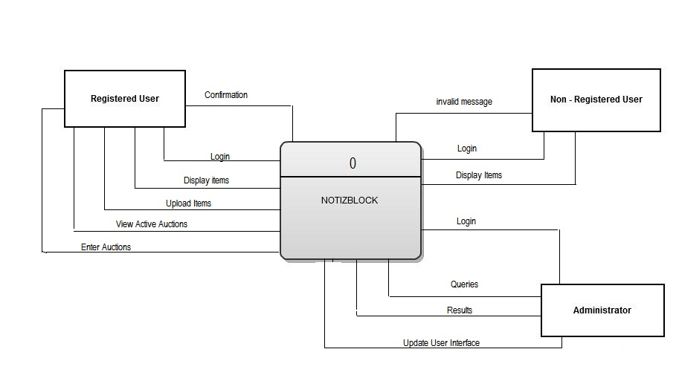
Figure1. NotizBlock: two-tier architecture

NotizBlock was written in PHP, a server-side scripting language, using an incremental approach during the development life cycle. The code was written in a modular fashion so as to accommodate the scalability that we wanted. The database was constructed using MYSQL along with phpmyadmin. The web pages were developed using pure HTML and tools such as Adobe Photoshop.

The system was designed to allow users to access the website using any web browsing application. While users are able to view the site without being registered users, in order for students to login, they must be registered users of the application. Users are required to login using the username and password they provided upon registration.

Unsuccessful Login

In the event that a user’s login attempt is unsuccessful, a message will be displayed to the user stating that either their username, password, or combination of both is wrong or for those who are not actually registered, the message will suggest that they do so before trying to login again. Upon receiving the error, the user may try entering the correct information or proceed to the registration page. The problem could also be caused by a database entry being incorrectly stored. If this is the case, the user may have to contact administrators via email to rectify the problem.

Successful Login

If a user has successfully entered their username and password, a session will be started and the user will be given access to their profile and features of the website not available to non-registered users (i.e. the ability to upload items, enter auctions, purchase products, etc.).

Administrative Login

Administrators of the website will also be assigned login credentials for the purpose of making improvements and updates to the code and performing administrative duties within the database. These duties include:
- Performing statistical queries
- Manual addition of new fields and features
- Adjusting the database to accommodate new categories

System Architecture

NotizBlock was designed using a client – server model as shown in Figure 2 below. The representation used is known as the Two- Tier client server architecture. In this approach, all aspects of the application processing and database management are carried out on the server while the client side is just responsible for presentation and data access. The user is responsible for running the application. The advantage of our chosen architecture is that there is no special software or hardware needed to access and use the application. This reduces the expense in the implementation process and enables the system to be easily accessible without much effort from its users. Basic requirements for the user’s computer include access to the internet as well input and visual output peripherals (mouse, keyboard, and monitor). However, a disadvantage is that a heavy processing load is placed on the server and the network.
If we were to make recommendations, we would suggest a computer with high processing ability as well as reasonable amount of random access memory (RAM). Also, without a high bandwidth network connection, users may experience some delays as they access the application. These delays will increase as the amount of simultaneous users increase.

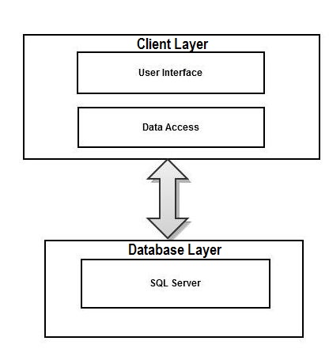
Figure2. NotizBlock: two-tier architecture

Use Cases

The system is designed with three types of users in mind as shown in the figure 3 below:

- Administrator:
This term defines a user who has administrative login privileges to the database
structure.

- Registered User
This term is used to define any user who is registered with the website and is therefore able to successfully login at the login interface. This term further defines
those users who are able to upload items, and enter into transactions with other registered users.

- Non- Registered User
This term is used to define any user who is not registered with the website and will therefore be unable to successfully login, withholding the ability to upload any items or participate in any transaction hosted by the website

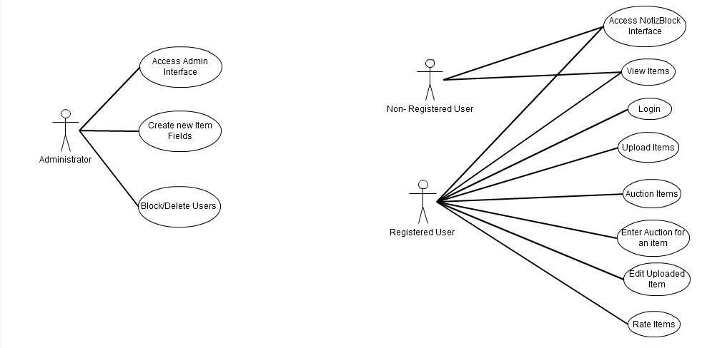
Figure3. NotizBlock Use Case Diagram

Database Structure

At the core of our website, is a database constructed via the relationships between several entities as show in figure 4 below:

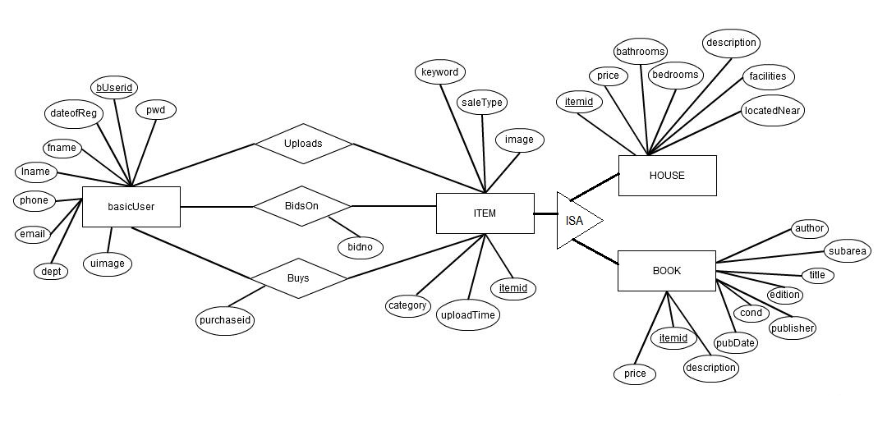
Figure4. NotizBlock E-R Diagram

Tables Derived from Strong Entities

- basicUser: The user table is used to store the detailed information on all registered users of the website.

Columns:
- bUserid - defines the unique ID assigned to each registered user
- pwd - defines the password that will validate the authenticity of a user
- fname - defines the first name provided by a user
- lname - defines the last name provided by a user
- phone- defines the phone number provided by the user
- email- defines the email address provided and validated by a user
- dept- defines the department of The UWI the user belongs
- uimage- defines the user’s image if they decide to provide one

- Item: The item table is used to store general information on all items uploaded by registered users.

Columns:
- itemid - defines the unique id assigned to each item upon being uploaded
- uploadTime- defines the time at which the item is uploaded to NotizBlock
- category - defines the category under which the item has been uploaded
- saleType- defines how the user wishes to sell their item (direct sale/ auction)
- image- defines the image or set of images uploaded to display the item
- keyword- defines any keywords the user provides to make item searchable

Tables derived from relationships between strong entities:

- Uploads: The upload table is used to keep track of all uploads made to the site by a particular user.

Columns:
- Itemid - defines the unique id assigned to each item upon being uploaded
- bUserid- defines the unique ID assigned to each registered user
- saleType - defines how the user wishes to sell their item(direct sale/auction)
- uploadDate- defines the date on which a particular item was uploaded
- uploadTime - defines the time at which a particular item was uploaded

- BidsOn: The bidson table is used to keep track of all the information collected whenever a user enters into an auction and bids on an item.

Columns:
- bidno - defines the number assigned to each user whenever they enter into
an auction.
- itemid - defines the unique id assigned to each item upon being uploaded
- bUserid- defines the unique ID assigned to each registered user
- bidDate- defines the date on which each individual bid for an item was made
- bidTime - defines the time at which each individual bid for an item was made
- bidAmount - defines the value of the offer made on an item during the bidding
process

- Buy: The buy table is used to store all information needed to indicate a completed transaction.

Columns:
- purchaseid- defines
- itemid- defines the unique id assigned to each item upon being uploaded
- bUserid- defines the unique ID assigned to each registered user
- itemPrice- defines the price of the item being purchased
- buyDate- defines the date on which the item was purchased
- buyTime- defines the time at which the item was purchased

Tables derived from weak entities:

- House: The house table is used to store specific information about each living space that is uploaded for the purpose of being sold

Columns:
- itemid - defines the unique id assigned to each item upon being uploaded
- bedrooms- defines the number of bedrooms that come with the living space
- bathrooms - defines the number of bathrooms that come with the living space
- description - defines any insights or comments the vendor has on the space.
- facilities - defines whether the living space is shared or single.
- locatedNear - defines where the living space is located in proximity to some
predefined location.
- price - defines the owner’s asking price for the book. It further represents
the minimum price of the book in the event that it is being auctioned

- Book: The book table is used to store information specific to each book uploaded for the purpose of being sold.

Columns:
- itemid - defines the unique id assigned to each item upon being uploaded
- title - defines the title of the book being uploaded to the site
- author- defines the names author(s) of the book being uploaded to the site
- publisher- defines the name of the book’s publisher
- pubDate- defines the date on which the book was published
- edition - defines which edition of the book is being made available
- cond - defines the condition the book being uploaded is in
- description- defines any insights or comments the owner has on the book
- sub area- defines the subject area the book is written for
- price- defines the owner’s asking price for the book. It further represents
the minimum price of the book in the event that it is being auctioned

- There customer review table is used to store the information used to build the similarity matrix to aid in the computation behind the recommender system. It takes in attribute such as user ratings and comments.

- There is also an itemsviewed table which records the id of the item that has been viewed, the id of the user who viewed it as well as the date the item was viewed.

System Implementation

The Upload Process

The graphical user interface (GUI) was designed using HTML and CSS. The purpose of the interface is to serve as the application’s presentation layer, providing a simple way for users to interact with the application server. Once a user logs in, their username and password will be validated by running a query on the basicUser table in the database. If a successful match is found, the user will be validated, a session will commence, and they will be able to view their profile, the items they have available and the different auctions that they have access to. While a user is logged in, they have the option of adding to their items list (i.e. the list of items whether it be books or living spaces that they have made available to other users). The item data is collected via a HTML form that corresponds with PHP linking the form to the database. Upon entering the required information and pressing the submit button, that information is transmitted to the database where it will be processed and stored in the appropriate tables.

At the database, a check will be done to ensure that all necessary information associated with the item has been entered before assigning an itemid, storing and validating its availability. Once the information is complete, the item information is stored, a message is sent to the user stating that the information has been validated, and the item is made available to other users. The above is represented in Figure (x) below.

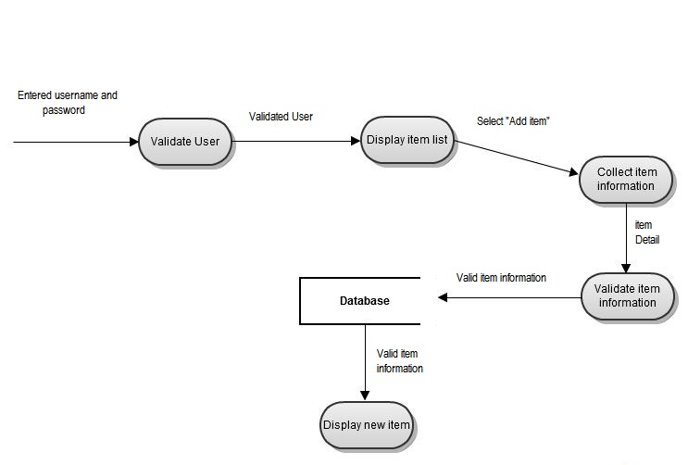
Figure 5. NotizBlock Upload process data_flow Diagram

The Bidding Process

With regards to arranging a transaction, users have two options – they can either search for the desired item up for a direct sale or they can search for the item, but look for one that is available for auction. If the user wishes to participate in a direct sale, they are only required to find the item and select the “Buy Now” button as the direct sale consists of one final price. The process of participating in a direct sale is represented in Figure(x) below.

However, if users wish to participate in an auction, they simply find an item they are interested in, and if the bid option and the auction are active - press the bid button below the item’s image and enter a competitive offer. When an offer is made, the price is compared to all the other offers being made on the item. This comparison will determine where in the ranks the user’s offer will fall. If it’s the highest, the offer will be placed in the number one spot and be most favorable for winning; if not, it will be placed accordingly among the other offers. There will be cases where offers are made simultaneously; however, if one offer is higher than the other, then, the application will inevitably give the higher bid a higher rank. However, in the rare case of two offers of the same value being submitted simultaneously, the timestamp given to each offer upon submission will be used to make the comparison and place the bids accordingly.

At the database, as each offer is made, the id of the user, the amount offered and the timestamp is stored in the bids table. This enables the compilation of a bidding history for every user who participates in an auction hosted by the sight. The bidding history mentioned is just one set of information that will contribute to the product recommendations that the application will make to its users. The above is depicted in Figure(x) below.

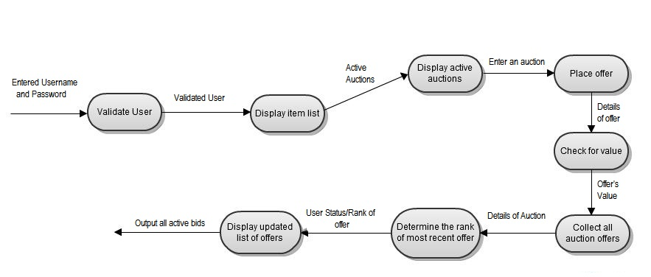
Figure 6. NotizBlock Bidding process data_flow Diagram

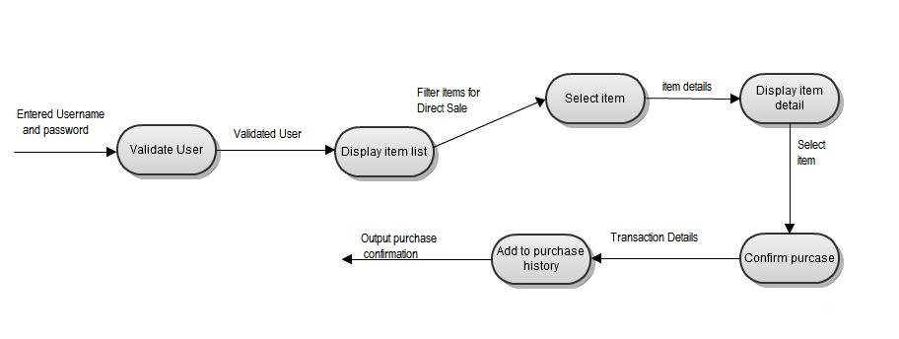
Figure 7. NotizBlock direct_sale process data_flow Diagram

Making recommendations to users about the type of items they may be interested in is really the job of the application. In order to do this, the application will be keeping track of the items that users have rated positively ,the items they bid for as well as any item they have previously purchased when they are logged in. Recommendations will be based on the overlapping of a sample group of customers whose history of bidding and buying overlap with that of the user who is logged in. The items from that group of customers will be aggregated, and the items they have in common with the current user will be eliminated, leaving a group of items the user has not purchased, but may be interested in.

Challenges

A major challenge presented was to handle the simultaneous submission of offers from different users during an auction. This problem was solved by recording a timestamp on each offer so that the application could channel them in order based on their times, if doing it buy their value was infeasible. In addition to this, all offers are made visible in hopes that users will pay attention to the values that are being offered before making their own, and therefore create some sort of delay between the offers made.

Another challenge was the execution of a recommendation algorithm that could operate using the data the site collects as well as creating an algorithm that was feasible for both books and housing. The web application collects data such as the ratings given to particular items by users. This problem was solved by looking for those customers whose purchase history and item ratings overlap with those of the user who is logged in. The comparisons were then made using similarity matrices which were computed by assigning scores based on how similar items are. The only problem with this approach lies in the new users of the site. New users will not have much of a history with the exception of a few ratings; therefore, it may be difficult to make useful recommendations to them.

The protection of the database from the administrator’s privileges was another problem encountered when building the site. This was not solved, as administrative users have access to the database and are able to modify the information there without constraint.

Project Expansion

We had decided to limit our project to the Computer Science and Physics departments. However, we believe that it has the potential to be expanded to incorporate the entire UWI Mona campus as well as other commodities that students may be inclined to sell online. In order to accomplish this, further consideration will have to be given to management of the bidding process as the problem will increase in proportion to the amount of active bidders in one auction. Also, our code may have to be altered in such a way that would allow administrative users to alter item features without having to edit the underlying database.

Testing

Component Testing:

The Database: Component testing was conducted on the database to verify that all records were being saved as expected and that queries were being executed successfully. Phpmyadmin was used to run sample queries and select functions on the database, and it was found that the queries were being retrieved successfully.

User Login: The login application was tested via the user interface to ensure it was enforcing the necessary authentication requirements.

Username | Password | Expected Results | Actual Results | Application Successful
Incorrect | Incorrect | Invalid Message | Invalid Message | Yes
Incorrect | Correct | Invalid Message | Invalid Message | Yes
Correct | Incorrect | Invalid Message | Invalid Message | Yes
Correct | Correct | NotizBlock /home | Home page | Yes

Bidding:

Direct Sale: Component Testing was carried out on the direct sale process, and all transactions were deemed successful.

Recommendation Application:

System Testing:

The web application was tested on various operating system and web browsers. The table below displays the result set for each test:

Operating System | Web Browser | Application Successful
Windows 7 | Google Chrome | Yes
Windows 7 | Mozilla Firefox | Yes
Windows 7 | Internet Explorer | Yes
Windows XP | Google Chrome | Yes
Window XP | Mozilla Firefox | Yes
Windows XP | Internet Explorer | Yes
Ubuntu, Linux 12.04 | Google Chrome | Yes
Ubuntu, Linux 12.04 | Mozilla Firefox | Yes

Chapter 4: Results

The main focus of this project was to successfully implement the item-based algorithm necessary to the recommender system as well as the development of a bidding system to operate the auction processes. Given the importance of user interface design to the web design process, we have also developed a fully functional and interactive interface that is suitable for users of all levels of computing competency. The results below represent various aspects of our design and implementation:

User Registration Page:

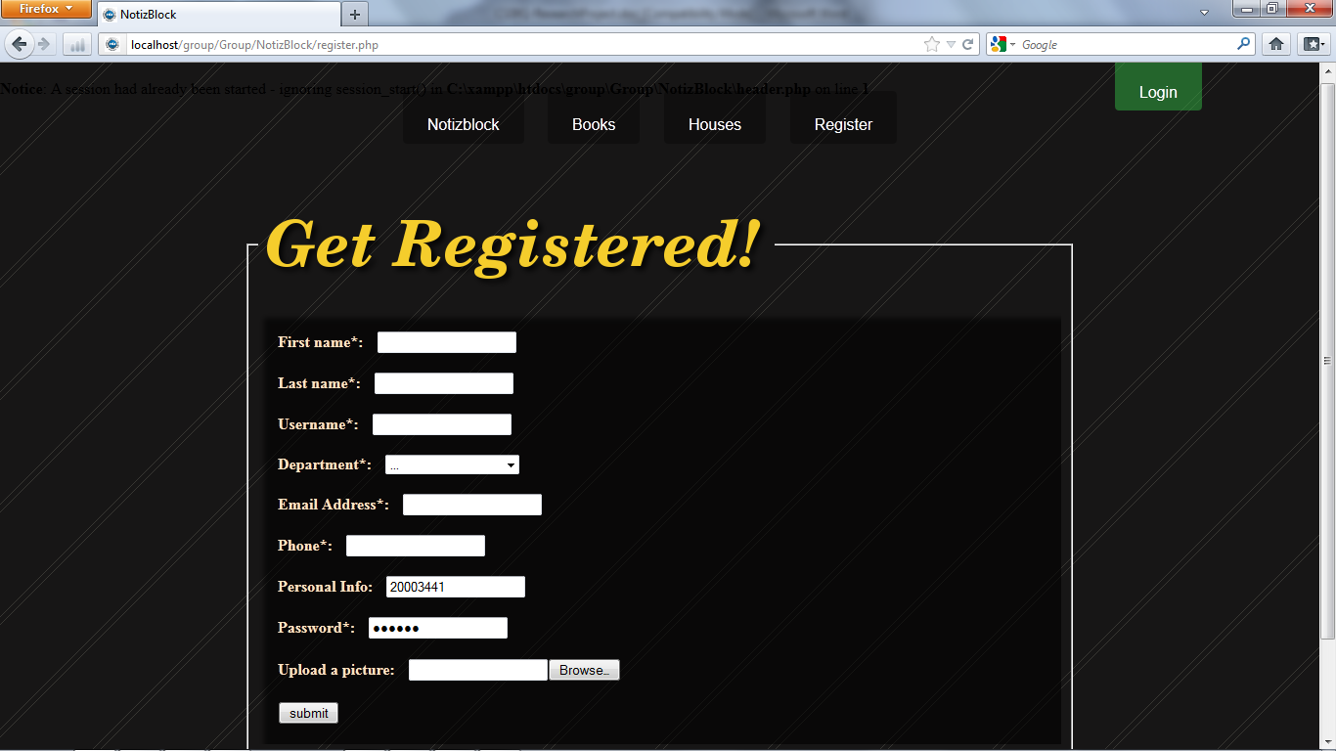
Figure 8 – User Registration Page

Screen Displaying User Login:

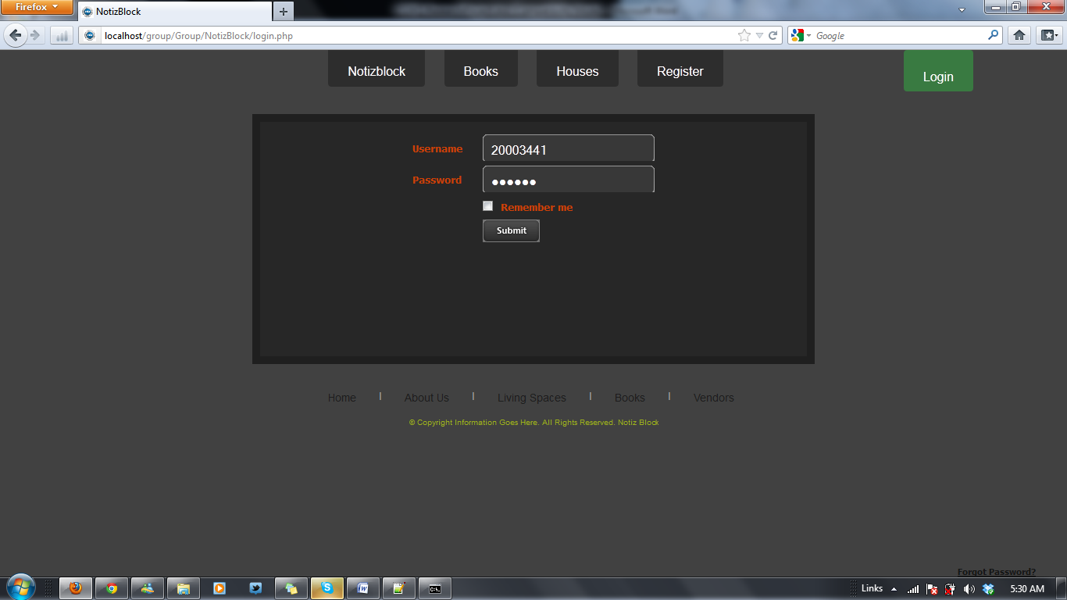

Screen Displaying home page
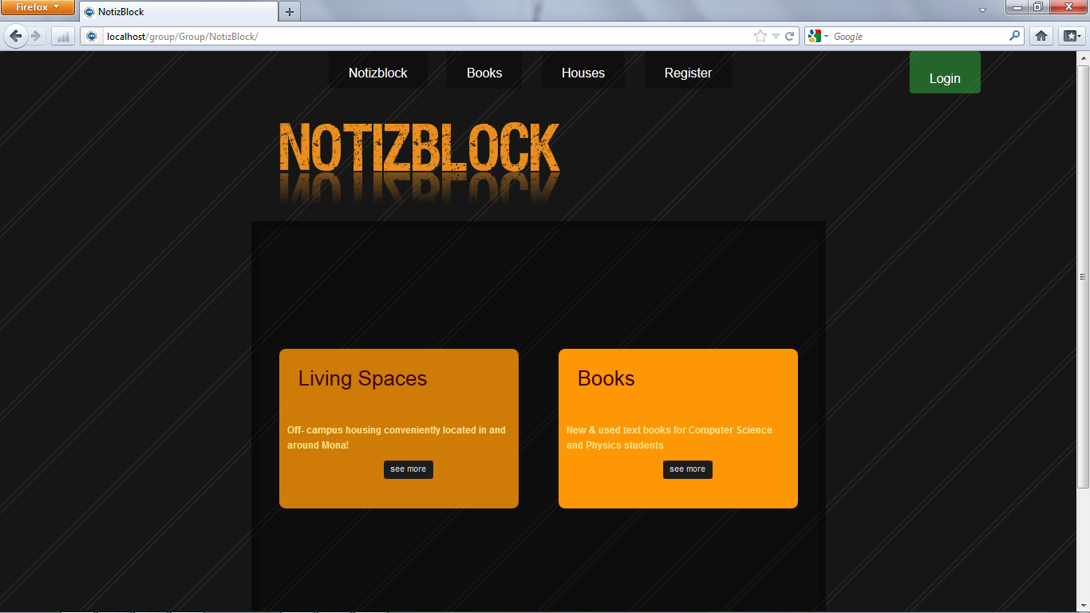
Figure 9. index.php – Home Page

Screen Displaying the Add Book Page:
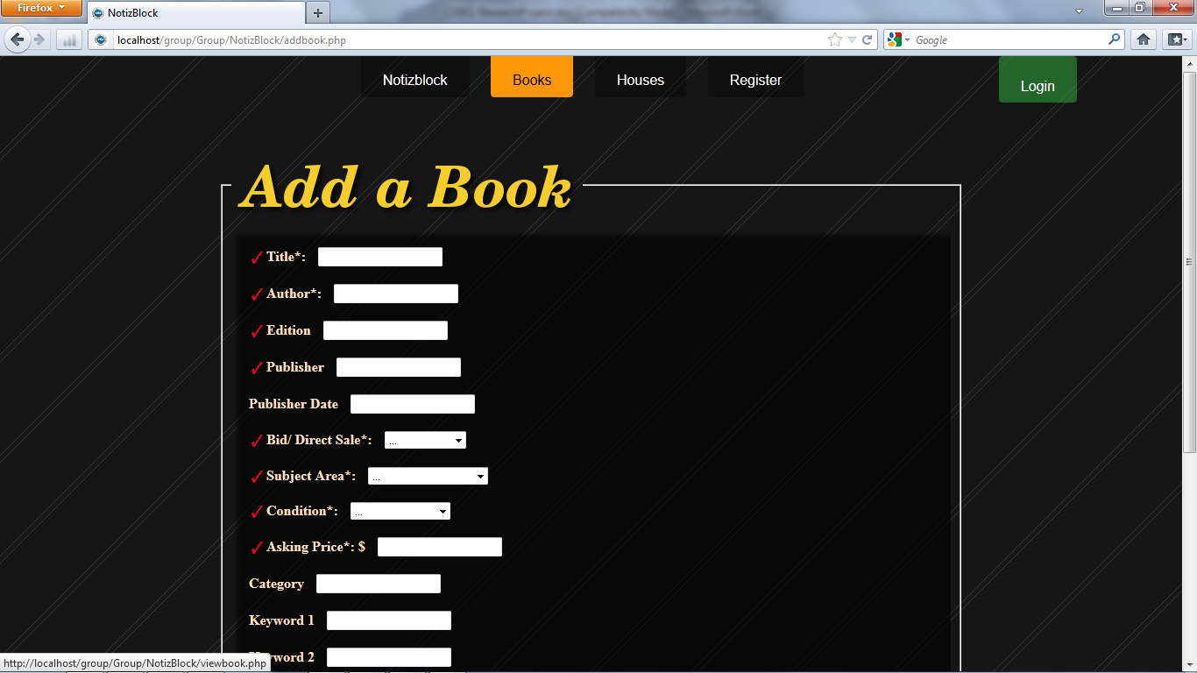
Figure 10. Add_ book page

Screen Displaying the View page of a specific book:
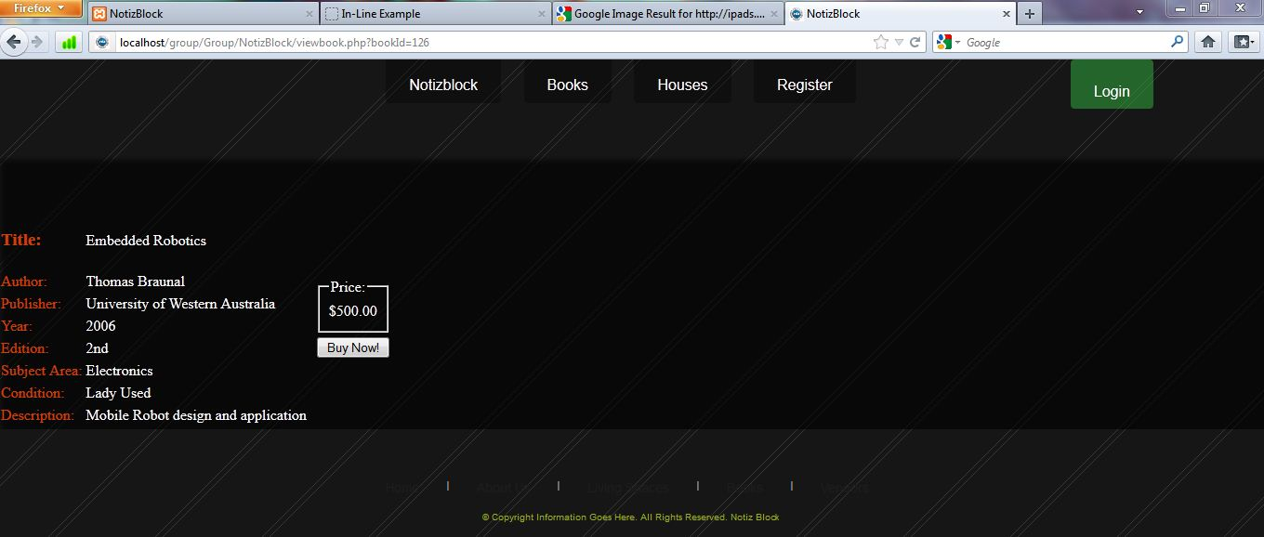
Figure 11. View_ book page(detailed view)

Chapter 5: Conclusion & System Evolution
The following aims and objective as previously set out were accomplished:

- We developed a fun, interactive and user friendly interface
- We created a database to store client and item information
- The application is able to authenticate users before they take part in transactions
- The application is user friendly
- We successfully implemented a bidding system to support the auction activities

NotizBlock can be considered a convenient addition to the suite of online services provided under The UWI Mona. The financial cost for implementing and maintaining the site is next to nothing with the exception the storage space required for the associated database.

Several lessons were learned during the development cycle of this project. One such lesson was the importance of communication among team members in order to enable the smooth flow of module development, testing and producing deliverables. The importance of the participation in research and planning by all group members was also noted. This project has extended our knowledge on topics such as the mechanics behind executing a capable online shopping sight which included the logic behind recommender systems and the different approaches that could be used in both the recommendation and bidding processes. Overall, this project has been an eye- opening experience in both the computational and social contexts.

Future work can be conducted in order to improve the security necessary to the information within the database as well as to improve the execution of the recommender system to produce consistent high quality results.

Chapter 6: Acknowledgements

This project was developed within the Department of Computer Science at The UWI Mona. It is a reflection of much of the knowledge we have gained from our lecturers and peers. Therefore we would like to express our gratitude toward the Computer Science department lecturers and course coordinators as well as our fellow students.

Chapter 7: References

- Linden 2003 Greg Linden, Brent Smith, Jeremy York. Amazon.com
Recommendations Item – to – item Collaborative Filtering, (2003).

- Hang 2010 Bo Hang. Design and Implementation of Online Bidding and
Tendering systems, (2010).

- CIC 2004 Construction Industry Council. Online – Bidding A CIC Brief
Note, (2010).

- Huang 2007 Zan Huang, Daniel Zeng, Hsinchun Chen. A Comparative Study
Of Recommendation Algorithms in E- Commerce Applications

