Noingay01thang10nam202

QUYETDINH Quy dinh ve viec thurc hien chinh sach ho trg nguroi lao dong va nguroisirdunglao dong bianh hurongboi dai dich COVID-19 tirQuybaohiemthatnghiep

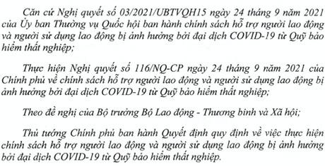

# Churong

Dieu 1.Doi turgng duroc ho tro

l.Nguroilao dong dang tham gia baohiem that nghiep tai thoidien ngay 30 thang 9 nam 2021 (co ten trong danh sach tham gia bao hiem thai nghiep cua co quan bao hiem xa hoi), khong bao gom cac trurong hop sau: a) Nguoi lao dong dang lam viec tai co quan nha nuoc, to chtrc chinh tri to churc chinh tri - xa hoi, don vi vu trang nhan dan

Nguroi lao dongdang tham gia baohiem that nghieptai tho 30 thang 9 nam2021 (co ten trong danh sach tham gia baohie p cuaco quan bao hiem xa hoi),khongbao gom cac trurong hop sau

Nguroilaodongdanglamviectaicoquannhanuroc,tochurcch c chinh tri - xa hoi, don vi vu trang nhan dan