ISO‑Style Process Sheet
LEA‑Hyper‑Alloy – Manufacturing Process Specification

1 Scope
This process sheet specifies the manufacturing steps, temperature and time windows, and quality requirements for the production of a conductive aluminum‑copper‑magnesium alloy (LEA alloy).
The process applies to continuously cast, direct‑chill cast, extruded, and rolled semi‑finished products.

2 Normative References
The following referenced documents are indispensable for the application of this process sheet:
• EN 573 – Aluminium and aluminium alloys – Chemical composition
• EN 485 – Aluminium and aluminium alloy sheet, strip and plate – Mechanical properties
• ISO 6892‑1 – Metallic materials – Tensile testing
• ISO 6506‑1 – Metallic materials – Brinell hardness test
• ISO 1463 – Metallic coatings – Micrographic determination of thickness

3 Terms and Definitions

LEA alloy:
An aluminum‑based alloy containing 1.5–3.5 wt% Cu and 1.0–2.0 wt% Mg, designed for enhanced electrical conductivity combined with moderate to high mechanical strength.

4 Chemical Composition
The alloy shall comply with the following mass fraction limits:
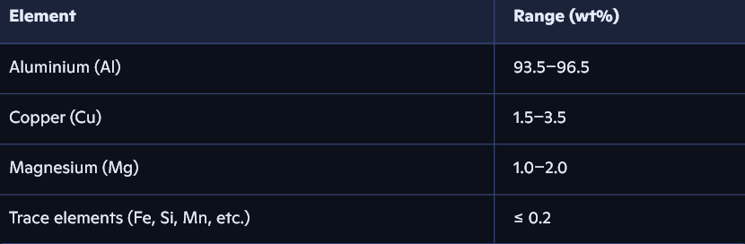

5 Process Flow

5.1 Overview (formal arrow diagram)

Raw Material Preparation
↓
Melting (650–700 °C, 30–120 min)
↓
Casting (680–700 °C)
↓
Homogenization (optional: 480–520 °C, 4–12 h)
↓
Hot Forming (400–450 °C)
↓
Solution Heat Treatment (500–520 °C, 30–90 min)
↓
Quenching (water or air)
↓
Artificial Aging / Overaging (150–200 °C, 4–12 h)
↓
Final Machining
↓
Quality Inspection

5.2 Detailed Process Requirements

5.2.1 Melting
• Temperature: 650–700 °C
• Holding time: 30–120 min
• Atmosphere: air or optional inert gas (argon)
• Objective: complete dissolution of alloying elements

5.2.2 Casting
• Casting temperature: 680–700 °C
• Methods: continuous casting or direct‑chill casting
• Cooling: controlled, air‑ or mold‑cooled

5.2.3 Homogenization (optional but recommended)
• Temperature: 480–520 °C
• Duration: 4–12 h
• Purpose: reduction of segregation and microstructural homogenization

5.2.4 Hot Forming
• Entry temperature: 380–450 °C
• Process temperature: 400–450 °C
• Methods: extrusion or hot rolling

5.2.5 Solution Heat Treatment
• Temperature: 500–520 °C
• Duration: 30–90 min
• Purpose: formation of a supersaturated solid solution
5.2.6 Quenching
• Medium: water (10–40 °C) or air
• Purpose: retention of supersaturation

5.2.7 Artificial Aging / Overaging
• Temperature: 150–200 °C
• Duration: 4–12 h
• Purpose: adjustment of conductivity/strength balance
• Recommended settings:
• LEA‑90: higher T, longer t → maximum conductivity
• LEA‑100: intermediate T/t → balanced properties
• LEA‑120: lower T, shorter t → higher strength

6 Quality Requirements

6.1 Mechanical Properties
• Tensile strength (Rm): 180–320 MPa (depending on grade)
• Elongation (A): ≥ 8 %
• Hardness: 60–90 HB

6.2 Electrical Properties
• Electrical conductivity: 45–55 % IACS (depending on grade)

6.3 Microstructural Requirements
• Uniform grain structure
• Low porosity
• No coarse intermetallic precipitates
• Controlled precipitation morphology

7 Inspection and Testing
• Tensile test: ISO 6892‑1
• Hardness test: ISO 6506‑1
• Electrical conductivity: eddy‑current method
• Metallography: optical or SEM examination
• Dimensional inspection: per product specification

8 Marking and Traceability
Each batch shall be marked with:
• Alloy grade (LEA‑90 / LEA‑100 / LEA‑120)
• Melt number
• Production date
• Heat treatment condition
• Verified test results (Rm, A, HB, IACS)

