**PROJECT ASSIGNMENT**

**In this assignment you have to implement a clustering technique. Format of the dataset is as follows.**

**Steps**

First we read the data and convert it in the form of matrix

We have to transform the dataset in given format then the number of columns

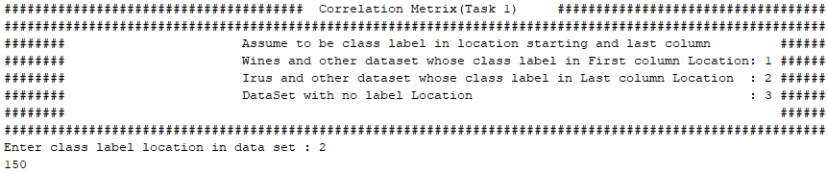Enter the option to see the result first we press 2 to check the dataset of iris.

First we have calculate the Correlation Matrix and create a correlation matrix from the data matrix using Pearson’s correlation coefficient.

The correlation matrix will be a NXN matrix (where N is number of records in your Input dataset) containing Pearson’s correlation coefficient between each of the row in data matrix. We can find using formula of Pearson’s correlation.

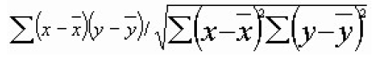

=mean

=sum

After calculating the correlation matrix convert it into discretize matrix now discretize matrix. Result is showing in fig 1.1



**Output**

Figure 1.1

Then we have to convert it this same bitmap image into the color coded matrix to see the green output image .by following steps.

* For each column in matrix, find max. Value.
* Divide each value in column by max. Value and multiply it with 255.
* Resulting values will be in range 0 to 255.
* Use this value for applying green shade to pixel.
* Sample image follow

**OUTPUT**

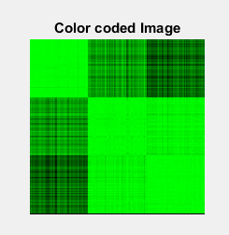

Figure 2

**Task 2 Iris Dataset Results:**

Resulted matrix before we have not permute it. Resulted image from matrix is shown in figure 3.

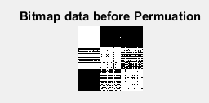

Figure 3

After create correlation matrix now we have to permute the created correlation matrix rearranging the rows of matrix individually. Result after permutation

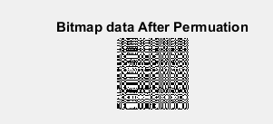

Figure 4

Now we have to recover the original image Recover the image clusters by using Signature technique. The method to generate the signature is as under

o first we Sum all the values in a row

o then Calculate mean of the row

o after it Multiply the Sum of the row with its Mean

o The above three step produces a signature for a row and the output comes after applying signature shown in figure 5. This is the signature colored image of permuted one.

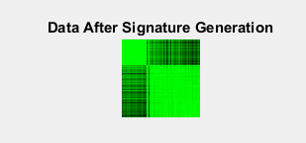

Figure 5

**Task 3 Results Of Iris Dataset**

In this task we first create a weighted graph for this we create permuted matrix calculate a correlation matrix and set the threshold every time need to enter threshold value the values which are greater the range of threshold will be assigned i.e. we are taking threshold **“ 0.99997 ”** and we are getting **134** clusters and when we enter threshold equal to “0.887” We get clusters. Results show that as we increase the value of threshold or limit we more numbers of cluster as we are decreasing the limit we get less number of clusters shown in figure 6 and figure 7.



**Results Of Dataset Wine**

**Task 1 output**

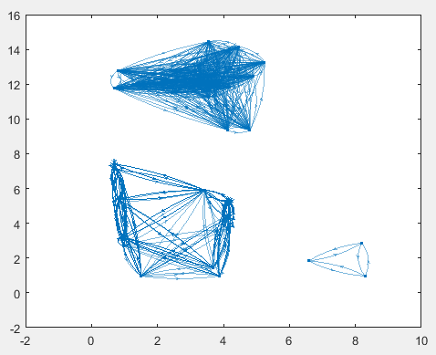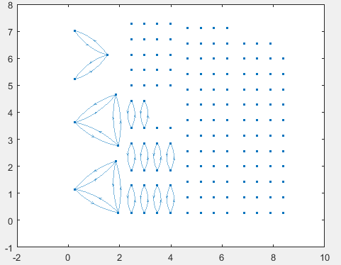

Figure 6 figure 7

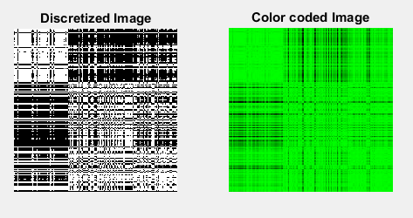

Figure 8

**Task 2 output**

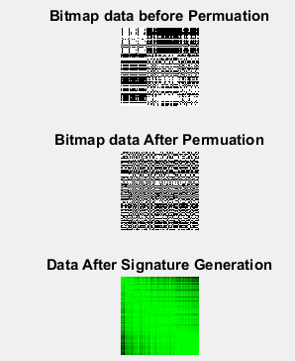

Figure 9

**Task 3 output**

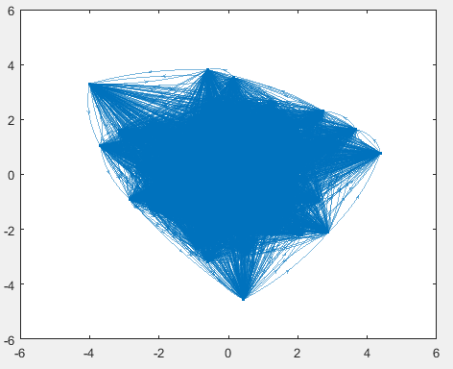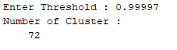

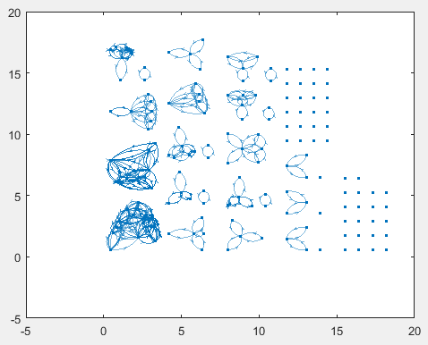

Figure 10

Figure 11