Article
Climate-Gated Nitrogen Export: An Equal-Effort Analysis of Nitrogen-Surplus Reduction Timing in Iowa
Samuel Mayokun Soetan ¹ and Amy Kaleita ^{1,}*
Academic Editor: Firstname Lastname
Received: date
Revised: date
Accepted: date
Published: date
Citation: To be added by editorial staff during production.
Copyright: © 2025 by the authors. Submitted for possible open access publication under the terms and conditions of the Creative Commons Attribution (CC BY) license (https://creativecommons.org/licenses/by/4.0/).
¹ Department of Agricultural and Biosystems Engineering, Iowa State University, Ames, IA 50011, USA; samuelms@iastate.edu (S.M.S.); kaleita@iastate.edu (A.K.)
* Correspondence: samuelms@iastate.edu
Abstract: Nitrogen export from the U.S. Corn Belt varies strongly with hydroclimatic conditions, so equal nitrogen-input reductions need not produce equal changes in riverine load across years. Using observation-derived annual loads for 98 Iowa counties (2001–2019; 1,750 county-years), we combined leakage-resistant Random Forest validation with two-way fixed-effects regression to evaluate whether precipitation conditions the association between agricultural nitrogen surplus (NS) and estimated nitrogen export. Temporal hold-out validation yielded NSE = 0.41 and KGE = 0.65; grouped county cross-validation yielded mean NSE = 0.59 and KGE = 0.69. Precipitation anomaly, tile-drained area, and antecedent load carried the greatest predictive importance, whereas the standalone NS term contributed little. The fixed-effects NS × precipitation interaction was positive (β = 1.85 × 10⁻⁴, p = 1.02 × 10⁻⁹), with the estimated marginal NS–load association crossing zero near 844 mm of annual precipitation. In a conservative equal-effort counterfactual that restricted reductions to positive surplus and set negative modeled response slopes to zero, reallocating a fixed 15% cumulative surplus reduction toward wet years produced 980 Mg N yr⁻¹ more modeled load removal than a uniform calendar schedule (coefficient-refitting bootstrap 95% CI: 406–1,602). Retaining the model-implied negative dry-year slopes increased the estimated dividend to 1,401 Mg N yr⁻¹. These results support a climate-gated association and motivate prospective evaluation of weather-responsive nutrient strategies; they do not constitute a forecast of realized policy outcomes.
Keywords: nitrogen surplus; tile drainage; water quality; climate adaptation; fixed-effects regression; Corn Belt; nutrient management
1. Introduction
Nitrogen (N) export from intensively managed agricultural landscapes in the U.S. Corn Belt remains a primary driver of local water-quality impairment and the seasonal hypoxic zone in the Northern Gulf of Mexico. Iowa, despite comprising approximately 4.5% of the Mississippi–Atchafalaya River Basin (MARB) area, contributes a disproportionate share of riverine nitrate export, with long-term assessments indicating average contributions of roughly 30% to the MARB and higher shares to the Upper Mississippi and Missouri River Basins [1–3]. Despite sustained investment in nutrient-reduction programs such as the Iowa Nutrient Reduction Strategy (INRS), riverine nitrate loads in Iowa and many Upper Mississippi River Basin watersheds have shown limited long-term decline and, in some cases, increases over recent decades, with high loads persisting in wet years [2]. This persistence highlights a fundamental challenge: reductions in nitrogen inputs do not consistently translate into proportional reductions in nitrogen export.
A large body of work has identified the dominant controls on nitrogen loss from agricultural systems. At watershed and basin scales, hydrologic variability, particularly precipitation and discharge, has repeatedly been shown to exert the strongest influence on interannual nitrate loads, often overwhelming changes in land management during wet years. In parallel, agronomic and nutrient-budget studies emphasize nitrogen surplus (NS), the balance between nitrogen inputs and crop removal, as the primary management lever for reducing losses. Recent national efforts have produced spatially explicit, multi-decadal inventories of N surplus across the contiguous United States, including the National Nutrient Inventory [4] and the county-scale TREND-Nitrogen data set [5], which document large regional variation in surplus trajectories and their coupling to riverine export. Reflecting the management perspective, nutrient-reduction strategies are commonly framed around static annual targets such as uniform percentage reductions in fertilizer application or fixed adoption rates of conservation practices applied consistently across years [6].
A small but growing literature has begun to question this static framing. Most directly, Liu et al. [7] used global crop modeling and machine learning to show that nitrogen losses to water rise during extremely wet years and proposed the Climate-Extreme Adaptive Nitrogen Strategy (CLEANS), which scales nitrogen inputs down adaptively in anticipation of wet conditions. That work establishes the principle at a global, simulation-based scale. What remains less well tested is whether the same pattern appears in observation-derived regional load estimates and whether a timing comparison can be made while holding cumulative reduction effort constant. The present study provides such an observational analysis for an intensively tile-drained region of the U.S. Corn Belt.
This climate-gating of export has a well-established hydrochemical analogue that the present study carries to an actionable scale. Concentration–discharge (C–Q) studies across the Upper Mississippi River Basin and the broader Corn Belt show that riverine nitrate shifts from chemodynamic behavior at low flow to more chemostatic behavior at high flow, and that subsurface tile drainage is a dominant control on where that flow threshold falls and on the degree of chemostasis [8,9]. Field- and plot-scale studies similarly find that the conversion of nitrogen balance into leaching loss is modulated by precipitation and weather sequence rather than fixed [10,11], and that consecutive wet and dry extremes drive non-additive deterioration of water quality [12]. What this body of work has not done is translate the transport threshold into a management quantity: whether the marginal effectiveness of a nitrogen-surplus reduction is itself precipitation dependent at the county scale at which reduction targets are set, and whether reallocating a fixed reduction effort toward wet conditions yields a quantifiable load-removal dividend. The present study makes that translation.
This question is especially pertinent within integrated food–energy–water frameworks. The Iowa Food–Energy–Water (IFEW) system model represents statewide nitrogen export as a function of agricultural nitrogen surplus, with the surplus itself driven by fertilizer rate, corn yield, and manure inputs [13,14]. In these formulations, the link from surplus to riverine load is represented through fixed transfer relationships, and weather enters primarily as a separate driver of surplus. Yet conversion of land-surface surplus into stream load is hydrologically mediated. By estimating the surplus–load association from observation-derived county loads and allowing it to vary with precipitation, this study evaluates whether the food-to-water coupling is constant or state dependent.
However, treating climate and management as independent, additive drivers of nitrogen export oversimplifies the underlying transport mechanisms. While wet conditions are known to enhance nitrate mobilization and delivery, relatively few studies have quantified how hydrologic variability modifies the marginal effectiveness of nitrogen-surplus reductions themselves at the county scale. Two questions therefore remain unresolved. First, does a unit reduction in nitrogen surplus yield comparable water-quality benefits in dry versus wet years? Second, is the efficiency of nitrogen reduction fundamentally climate dependent rather than fixed?
These questions are especially relevant at the county scale. Although hydrologic processes do not conform to administrative boundaries, counties represent the operational scale at which nutrient-reduction targets, reporting, and incentive programs are designed and implemented in Iowa and many other Midwestern states. County-level analyses therefore occupy a critical middle ground: coarse enough to support policy design, tracking, and program evaluation, yet fine enough to capture spatial variation in cropping systems, subsurface drainage, and hydroclimatic exposure.
In tile-drained landscapes such as Iowa, subsurface drainage further complicates the relationship between nitrogen surplus and export. Artificial drainage networks increase hydrologic connectivity between agricultural fields and streams, accelerating nitrate transport through subsurface flow, shallow groundwater discharge, and macropore pathways during wet periods, and reducing opportunities for in-field retention [15,16]. As a result, the same nitrogen surplus may produce markedly different export outcomes depending on precipitation and drainage intensity. Quantifying this interaction is essential for understanding not only how much nitrogen is lost, but also when reductions in surplus are most effective, especially as Midwest precipitation extremes have increased and heavier storms are projected under climate change [17,18].
If the surplus–load relationship varies with hydrologic state, calendar-based management frameworks that apply similar effort across years may allocate reductions across periods with unequal transport potential. Dry-year estimates are particularly uncertain because weak connectivity can decouple annual surplus from contemporaneous stream export, whereas wet years strengthen field-to-stream transport. This possibility motivates an equal-effort comparison of uniform and wet-targeted schedules, interpreted as a model-based diagnostic rather than a realized policy forecast.
In this study, machine-learning prediction was integrated with fixed-effects panel modeling across Iowa counties from 2001 to 2019. First, we evaluated out-of-sample predictability and the relative contribution of hydrologic, structural, antecedent, and management variables. Second, we estimated whether precipitation conditions the within-county association between nitrogen surplus and estimated load. Third, we compared two model-based schedules that applied the same cumulative mass of positive-surplus reduction: a uniform calendar schedule and a wet-year schedule. The counterfactual quantifies implications under the estimated relationship; it does not identify the effect of an implemented intervention.
2. Materials and Methods
2.1 Study Area and Data Compilation
This study focuses on Iowa, a core region of the U.S. Corn Belt characterized by intensive corn–soybean production, high nitrogen inputs, and widespread subsurface tile drainage. We constructed a county-level panel spanning 2001–2019, covering up to 99 counties per year. Raw load estimates were constructed for 2000–2019 also, to align with nitrogen surplus, precipitation, tile drainage, and lagged variables (2000 is required only to form the first-order lag for 2001). The corrected panel contains complete county coverage for each year, with 98 Iowa counties represented annually (Taylor County excluded for lack of same-watershed observations). After construction of lagged variables and complete-case filtering for the analytical model, the fixed-effects regression used 1,750 county–year observations. Driscoll–Kraay standard errors were used to account for serial correlation and cross-sectional dependence in the county-year panel.
2.2 Nitrogen Load Estimation
Annual riverine nitrogen load served as the dependent variable. Loads were derived from publicly available U.S. Geological Survey (USGS) National Water Information System (NWIS) and Water Quality Portal records. Monthly streamflow and nitrate concentration observations were retrieved from USGS monitoring stations and spatially associated with their corresponding HUC8 watershed polygons. Where multiple stations occurred within a watershed, observations were aggregated to watershed-level monthly estimates of discharge and concentration.
County nitrogen loads were estimated at the county–HUC-8 intersection level. Monthly runoff depth was paired with nitrate-N concentration observed in the same watershed and month; concentration records from Iowa DNR and USGS were pooled using a site-month then watershed-month mean to avoid overweighting frequently sampled sites. Piece load was computed as runoff depth × concentration × intersection area, using the conversion 1 mm × 1 mg L⁻¹ × 1 ha = 0.01 kg N. Pieces were summed to counties and annualized over complete 12-month county-years, then normalized by the monitored intersection area to give kg N ha⁻¹ yr⁻¹. Annual aggregation was used because discrete-sample uncertainty is less influential at annual than subannual resolution. A full-county-area denominator was evaluated as a sensitivity analysis. The resulting analysis frame contains 1,750 county-years for 98 counties.
2.3 Nitrogen Surplus
Nitrogen surplus (NS) was estimated using an annual county-scale mass balance, defined as total nitrogen inputs minus nitrogen removed in harvested grain: NS = N_{inputs} − N_{removal}. Inputs included commercial fertilizer, manure nitrogen, and biological nitrogen fixation; removals were based on nitrogen in harvested grain. Surplus is expressed in kg N ha⁻¹ yr⁻¹.
This mass-balance surplus represents the nitrogen remaining after harvest export and therefore the pool potentially available for loss. It is important to note what the metric does not capture: it does not subtract nitrogen removed through denitrification or other gaseous pathways, microbial immobilization, uptake by non-harvested biomass, or nitrogen stored in or transported through soil horizons and shallow groundwater. The metric thus implies no hydrological removal and should be interpreted as a potential-loss budget rather than a realized-loss estimate. Our county budget is conceptually consistent with national surplus products [4,5] but differs in spatial unit (county versus HUC8 subbasin) and in the specific input and removal terms compiled; like those products, it does not net out post-surplus biogeochemical processing.
Because the surplus is a mass balance, it takes negative values in county-years where harvested nitrogen removal exceeds inputs; such non-positive surplus occurred in 40.3% of analytical county-years and indicate net drawdown of soil nitrogen, consistent with the nitrogen-balance framework of McLellan et al. [21] and with documented variation in nitrogen-use efficiency across Corn Belt yield-stability classes [20]. We retain these observations because they carry genuine hydrologic and agronomic information, but their presence shapes how the management counterfactual is defined (Section 2.7).
2.4 Precipitation
Annual precipitation (mm yr⁻¹) was obtained from the Iowa Environmental Mesonet (IEM) IACLIMATE dataset, which aggregates Cooperative Observer Program station observations. Station measurements were spatially aggregated to the county level for consistency with the other variables, and annual totals were used to characterize interannual hydroclimatic variability relevant to nitrogen transport.
2.5 Subsurface Tile Drainage
Tile-drainage intensity was represented using county-level tile-drained cropland acreage from the USDA Census of Agriculture, accessed via USDA QuickStats. Because spatially explicit, time-varying maps of installed tile networks are not available statewide, the census-reported acreage provides the most consistent county-scale indicator of drainage prevalence and is treated here as a proxy for artificial hydrologic connectivity rather than a direct measure of network density. Because the Census of Agriculture reports tile-drained acreage only in periodic census years, values were carried forward and backward to populate intercensal years, consistent with treating drainage extent as effectively time-invariant over the study period. Its direct effect is therefore absorbed by county fixed effects in the econometric analysis; its influence nonetheless emerges through spatial patterns and predictive importance in the machine-learning results. Because tile-drained acreage and row-crop land share are spatially correlated in Iowa, we additionally compiled county-year corn-plus-soybean planted acreage from USDA QuickStats, expressed it as a fraction of county area, and used it to test whether the structural control on export is specifically attributable to drainage rather than to row-crop intensity (Section 3.10).
2.6 Analytical Framework
The framework combines two complementary analyses. The Random Forest evaluates out-of-sample predictability and predictor importance. The two-way fixed-effects model then estimates the conditional surplus–precipitation association after absorbing time-invariant county differences and statewide year shocks. Agreement between the analyses is interpreted as convergent descriptive evidence, not as proof of a causal mechanism.
2.6.1 Random Forest Modeling
Random Forest (RF) regression assessed the predictability of annual county nitrogen load. Predictors were lag-1 load, annual precipitation, county-standardized precipitation, tile-drained area, lag-1 precipitation, nitrogen surplus, and lag-1 surplus. The surplus×precipitation interaction was deliberately excluded so that the permutation analysis represented the standalone predictive contribution of surplus. The model used 400 trees and a minimum leaf size of three. County-standardized precipitation was calculated using training-period county means and standard deviations within every validation split, preventing future observations from informing earlier years. Skill was evaluated by a temporal hold-out (training through 2015; testing 2016–2019) and grouped five-fold cross-validation holding out entire counties. NSE, KGE, and RMSE were reported.
Predictor importance was quantified on the temporal test set by permuting each predictor while holding the others fixed and averaging the resulting loss of predictive skill over 30 repetitions. Permutation importance was used in place of impurity importance because correlated environmental predictors can bias tree-split counts. The result is predictive attribution and should not be read as a causal decomposition.
2.6.2 Fixed-Effects Regression and Identification
To test the hypothesized surplus–climate interaction we estimated a two-way fixed-effects panel regression:
Load_{it} = β₁NS_{it} + β₂P_{it} + β₃(NS_{it}×P_{it}) + α_{i} + γ_{t} + ε_{it} (1)
where Load_{it} is nitrogen load for county i in year t, NS is nitrogen surplus, P is annual precipitation, α_{i} are county fixed effects, and γ_{t} are year fixed effects. Driscoll–Kraay standard errors (bandwidth = 3) account for serial correlation and cross-sectional dependence common in county-year environmental panels.
The interaction coefficient β3 is identified from within-county, within-year variation: county fixed effects absorb all time-invariant county confounders (soils, geology, baseline drainage extent, long-run cropping mix), and year fixed effects absorb all statewide annual shocks (commodity prices, statewide weather anomalies, policy changes). The maintained identifying assumption is that no time-varying, county-specific confounder is correlated with both the surplus–precipitation product and nitrogen load after these effects are removed. Under this assumption, a positive β3 is consistent with precipitation amplifying the transport of surplus nitrogen to streams. We interpret the estimates as conditional associations consistent with the proposed transport mechanism rather than as effects from a randomized intervention, and accordingly use associational language in the Results.
2.6.3 Dynamic Specification and Legacy Effects
Here legacy refers to persistence of annual export conditions across years. The reported specification includes lag-1 load; a sensitivity specification adds lag-2 and lag-3 load. Because dynamic fixed-effects models can exhibit Nickell bias, inference focuses on the contemporaneous surplus×precipitation interaction, which remained stable between the one-lag (β = 1.85 × 10⁻⁴) and three-lag (β = 1.87 × 10⁻⁴) specifications.
2.7 Equal-Effort Timing Counterfactual
To evaluate implications of the estimated interaction, we compared two schedules under equal cumulative reduction effort for each county. Both schedules acted only on positive surplus; county-years with non-positive surplus were left unchanged. The calendar schedule applied a 15% reduction to positive surplus in every year. The wet-targeted schedule reallocated the same cumulative mass to the wettest tercile of years, subject to a 60% single-year cap. Annual modeled load change was calculated from the fixed-effects marginal association evaluated at each year’s precipitation.
The primary counterfactual imposed a conservative nonnegative-response constraint: negative fitted surplus–load slopes in dry county-years were set to zero rather than interpreted as load increases caused by surplus reduction. A second, explicitly labeled sensitivity retained the model-implied negative slopes. This comparison separates the timing result from an assumption that is weakly supported in the dry tail of the precipitation distribution.
2.8 Robustness and Validation
Uncertainty and robustness were assessed in four ways. First, a clustered bootstrap resampled counties and refitted the fixed-effects model in every replicate, propagating coefficient uncertainty into the timing interval. Second, 20% of wet-year classifications were randomly misclassified. Third, the timing calculation was repeated over the later portion of the panel. Fourth, an equal-effort placebo selected random rather than wet years within each county. A sensitivity grid varied the wet-year fraction from 25% to 40% and the single-year cap from 30% to 60%.
3. Results
3.1 Data Overview and Predictability of County-Level Nitrogen Loads
Across 1,750 county-years, estimated load averaged 21.2 kg N ha⁻¹ yr⁻¹ (range 0.29–96.0), nitrogen surplus averaged 12.8 kg N ha⁻¹ (range −54.6 to 195.5), and annual precipitation averaged 933 mm (range 483–1,863). The panel includes 98 counties from 2001 through 2019.
The leakage-resistant temporal hold-out produced NSE = 0.405, KGE = 0.651, and RMSE = 9.91 kg N ha⁻¹ yr⁻¹. Grouped five-fold cross-validation holding out complete counties produced mean NSE = 0.589 ± 0.054, KGE = 0.688 ± 0.061, and RMSE = 8.27 ± 0.97 kg N ha⁻¹ yr⁻¹. These results indicate useful but incomplete out-of-sample predictability and are more conservative than metrics obtained when precipitation standardization used information from the full study period.
3.2 Drivers of County-Level Nitrogen Export
Permutation importance ranked county-standardized precipitation highest (0.270 ± 0.033), followed by tile-drained area (0.219 ± 0.034) and antecedent load (0.133 ± 0.018). Lag-1 precipitation contributed 0.018 ± 0.006. Absolute annual precipitation and contemporaneous nitrogen surplus were near zero within this correlated predictor set, and lag-1 surplus was slightly negative.
This ordering indicates that interannual precipitation anomaly, structural drainage, and antecedent export contain most of the out-of-sample information available to the RF. The small standalone importance of surplus does not imply that surplus is irrelevant; it is consistent with surplus having a conditional rather than additive association with load. Because importance is affected by correlated predictors, the rankings are interpreted descriptively.
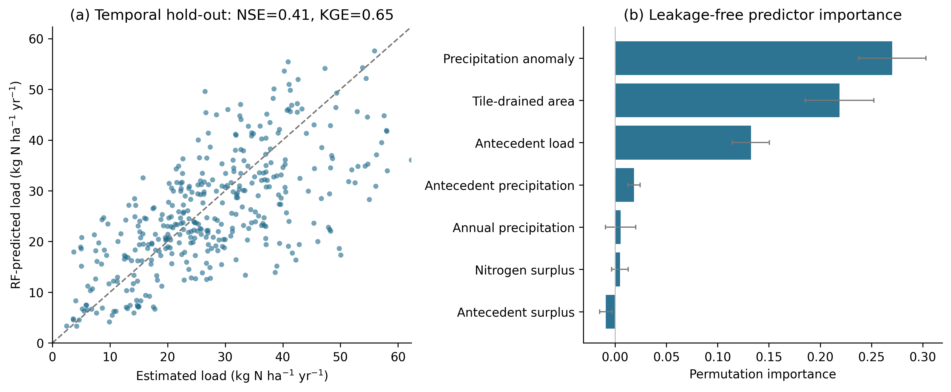
Figure 1. Random Forest analysis of estimated county nitrogen load. (a) Estimated versus RF-predicted load in the temporal hold-out (training 2001–2015; testing 2016–2019; NSE = 0.41, KGE = 0.65); the dashed line is the 1:1 reference. (b) Leakage-free permutation importance (mean ± SD over 30 repetitions).
3.3 Fixed-Effects Evidence for Climate-Gated Nitrogen Export
The two-way fixed-effects regression is reported in Table 1. The surplus×precipitation interaction was positive (β = 1.853 × 10⁻⁴, SE = 3.02 × 10⁻⁵, p = 1.02 × 10⁻⁹). The lag-1 load coefficient was 0.157 (p < 0.001), and the within-R² was 0.433. The negative NS main coefficient represents the fitted association at zero precipitation and is not interpreted in isolation.
The fitted marginal association, ∂Load/∂NS, increased across the observed precipitation range and crossed zero at 844 mm yr⁻¹ (Figure 2). The coefficient-refitting bootstrap placed the zero-crossing 95% interval at 697–971 mm and the interaction coefficient interval at 1.07 × 10⁻⁴ to 2.64 × 10⁻⁴. The dry-tail negative slopes are model estimates with wide uncertainty; they are therefore set to zero in the primary counterfactual and retained only in a sensitivity case.
Table 1. Two-way fixed-effects regression results for county-level nitrogen load (kg N ha⁻¹ yr⁻¹). Driscoll–Kraay standard errors; county and year fixed effects included.
Variable | Coefficient | Std. error | p-value
Nitrogen surplus (NS) | −0.156 | 0.0335 | 3.31×10⁻⁶
Precipitation (mm) | 0.0201 | 0.00557 | 3.19×10⁻⁴
NS × Precipitation | 1.853×10⁻⁴ | 3.02×10⁻⁵ | 1.02×10⁻⁹
Lagged load (t−1) | 0.157 | 0.0461 | 7.01×10⁻⁴
County fixed effects | Yes
Year fixed effects | Yes
Observations | 1,750
Within R² | 0.433
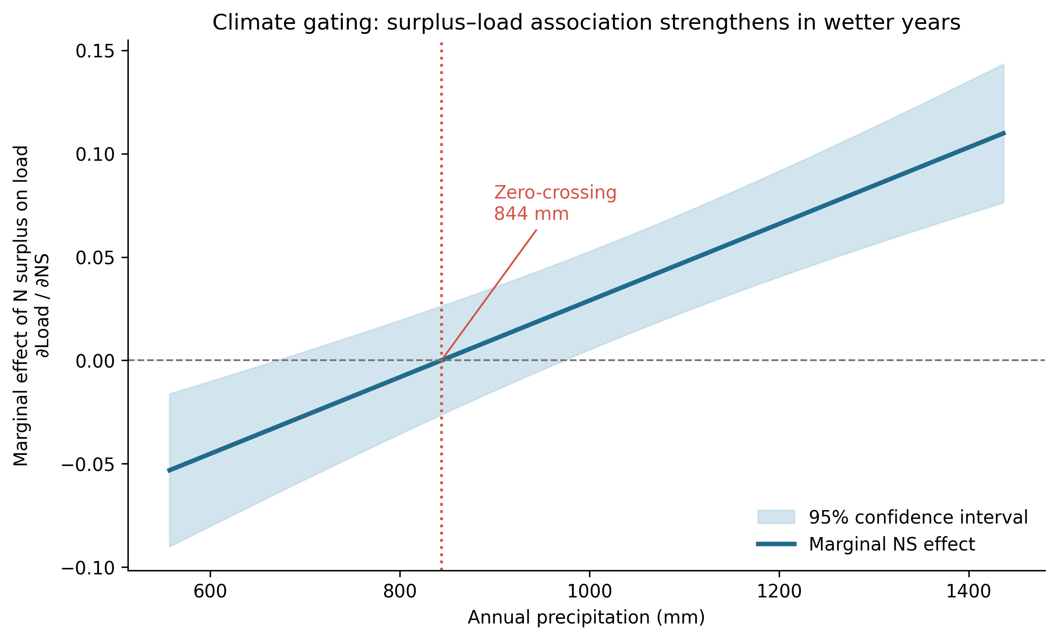
Figure 2. Marginal association between nitrogen surplus and estimated county load as a function of annual precipitation. The line is ∂Load/∂NS = βNS + βNS×P·P from the two-way fixed-effects model; shading is the Driscoll–Kraay 95% confidence interval. The fitted association crosses zero at approximately 844 mm yr⁻¹.
3.4 Short-Term Persistence and Legacy Effects
The lag-1 load coefficient in Table 1 was 0.157 (p = 0.0007). In the three-lag specification, lag-1 remained positive (0.148, p = 0.0015), whereas lag-2 (−0.014, p = 0.82) and lag-3 (−0.032, p = 0.52) were small; their joint exclusion was not rejected (χ² = 0.55, p = 0.76). The surplus×precipitation interaction remained positive (β = 1.873 × 10⁻⁴, p = 7.24 × 10⁻¹²). The annual series therefore shows short statistical persistence, although this does not exclude longer subsurface legacy storage.
3.5 Equal-Effort Timing Counterfactual
Under the primary nonnegative-response scenario, the uniform calendar schedule produced 775 Mg N yr⁻¹ of modeled removal and the wet-year schedule produced 1,756 Mg N yr⁻¹. The equal-effort timing dividend was therefore 980 Mg N yr⁻¹ (Figure 3), with a coefficient-refitting clustered-bootstrap 95% CI of 406–1,602 Mg N yr⁻¹. When the fitted negative response slopes in dry years were retained, the corresponding calendar and wet-year totals were 347 and 1,748 Mg N yr⁻¹, giving a larger sensitivity-case dividend of 1,401 Mg N yr⁻¹. The constrained result is emphasized because it does not treat a modeled dry-year surplus reduction as increasing load.
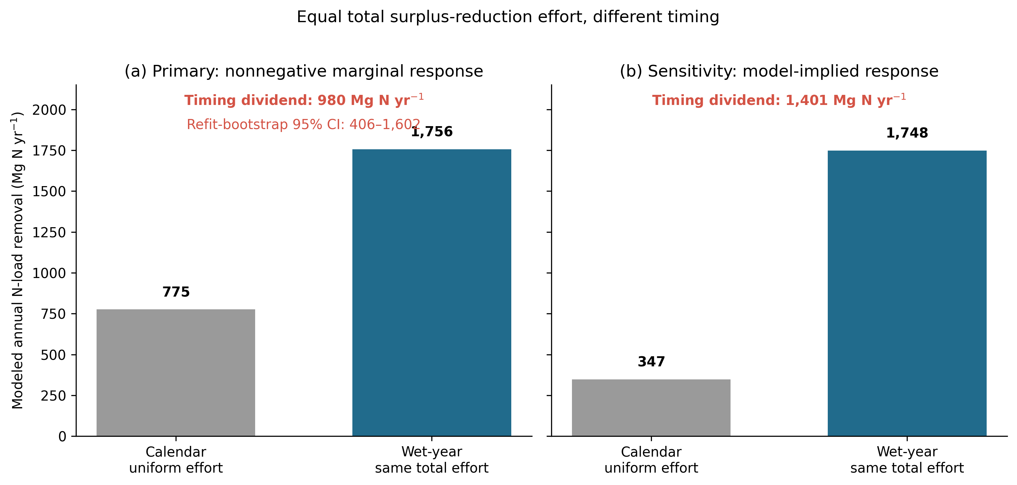
Figure 3. Equal-effort timing comparison. Both schedules reduce the same cumulative mass of positive nitrogen surplus. (a) Primary scenario with negative fitted marginal responses constrained to zero; the timing dividend is 980 Mg N yr⁻¹ (coefficient-refitting bootstrap 95% CI: 406–1,602). (b) Sensitivity retaining the model-implied negative dry-year slopes; the dividend is 1,401 Mg N yr⁻¹.
3.6 Spatial Distribution of Timing Benefits
The modeled timing dividend was spatially uneven. Under the primary constraint, 87 of 98 counties had a positive county-average dividend. The largest values occurred in Washington, Sioux, Hamilton, Hardin, and Carroll counties. This distribution indicates that the statewide result is broad but heterogeneous and is not confined to a single geographic cluster.
3.7 Robustness and Validation
The primary timing dividend was 980 Mg N yr⁻¹. Its bootstrap median was 994 Mg N yr⁻¹ and the coefficient-refitting 95% interval was 406–1,602. Deliberately misclassifying 20% of wet years reduced the dividend to 557 Mg N yr⁻¹, while the later-period calculation yielded 1,026 Mg N yr⁻¹. Random-year allocation produced a mean dividend of −14 Mg N yr⁻¹ and a 95th percentile of 75 Mg N yr⁻¹, approximately zero relative to the wet-targeted result. The timing pattern therefore survived the prespecified perturbations, although all values remain conditional on the fitted relationship.
3.8 Influence of High-Leverage Counties
Leave-one-county-out refits were completed for all 98 counties. The interaction remained positive in every refit (β range 1.64 × 10⁻⁴ to 2.10 × 10⁻⁴), the zero-crossing ranged from 821 to 880 mm, and the constrained timing dividend ranged from 779 to 1,081 Mg N yr⁻¹. The largest single-county change from the base dividend was 201 Mg N yr⁻¹. Removing the ten counties with the highest composite mean-load and positive-surplus ranks yielded β = 1.65 × 10⁻⁴, a zero-crossing of 815 mm, and a dividend of 725 Mg N yr⁻¹. No single county generated the central result.
3.9 Model Specification and Collinearity Diagnostics
Centering surplus and precipitation before forming their product left the interaction coefficient unchanged. Adding quadratic surplus and precipitation terms also retained a positive interaction (β = 1.80 × 10⁻⁴, p = 4.71 × 10⁻⁷); neither quadratic term was significant (p = 0.50 and p = 0.46). The central association is therefore not explained by the uncentered product or simple quadratic curvature.
3.10 Tile Drainage Versus Row-Crop Intensity
Tile fraction and row-crop fraction were correlated (r = 0.75). In an RF sensitivity including row-crop fraction, precipitation anomaly (0.236), tile-drained area (0.197), antecedent load (0.132), and row-crop fraction (0.053) were the leading importance values. In an augmented fixed-effects model, the row-crop×precipitation term was positive (β = 0.0171, p = 3.22 × 10⁻⁶), while the surplus×precipitation interaction remained positive but attenuated (β = 9.57 × 10⁻⁵, p = 0.012). Thus, row-crop intensity explains part of the precipitation-dependent pattern but does not eliminate it.
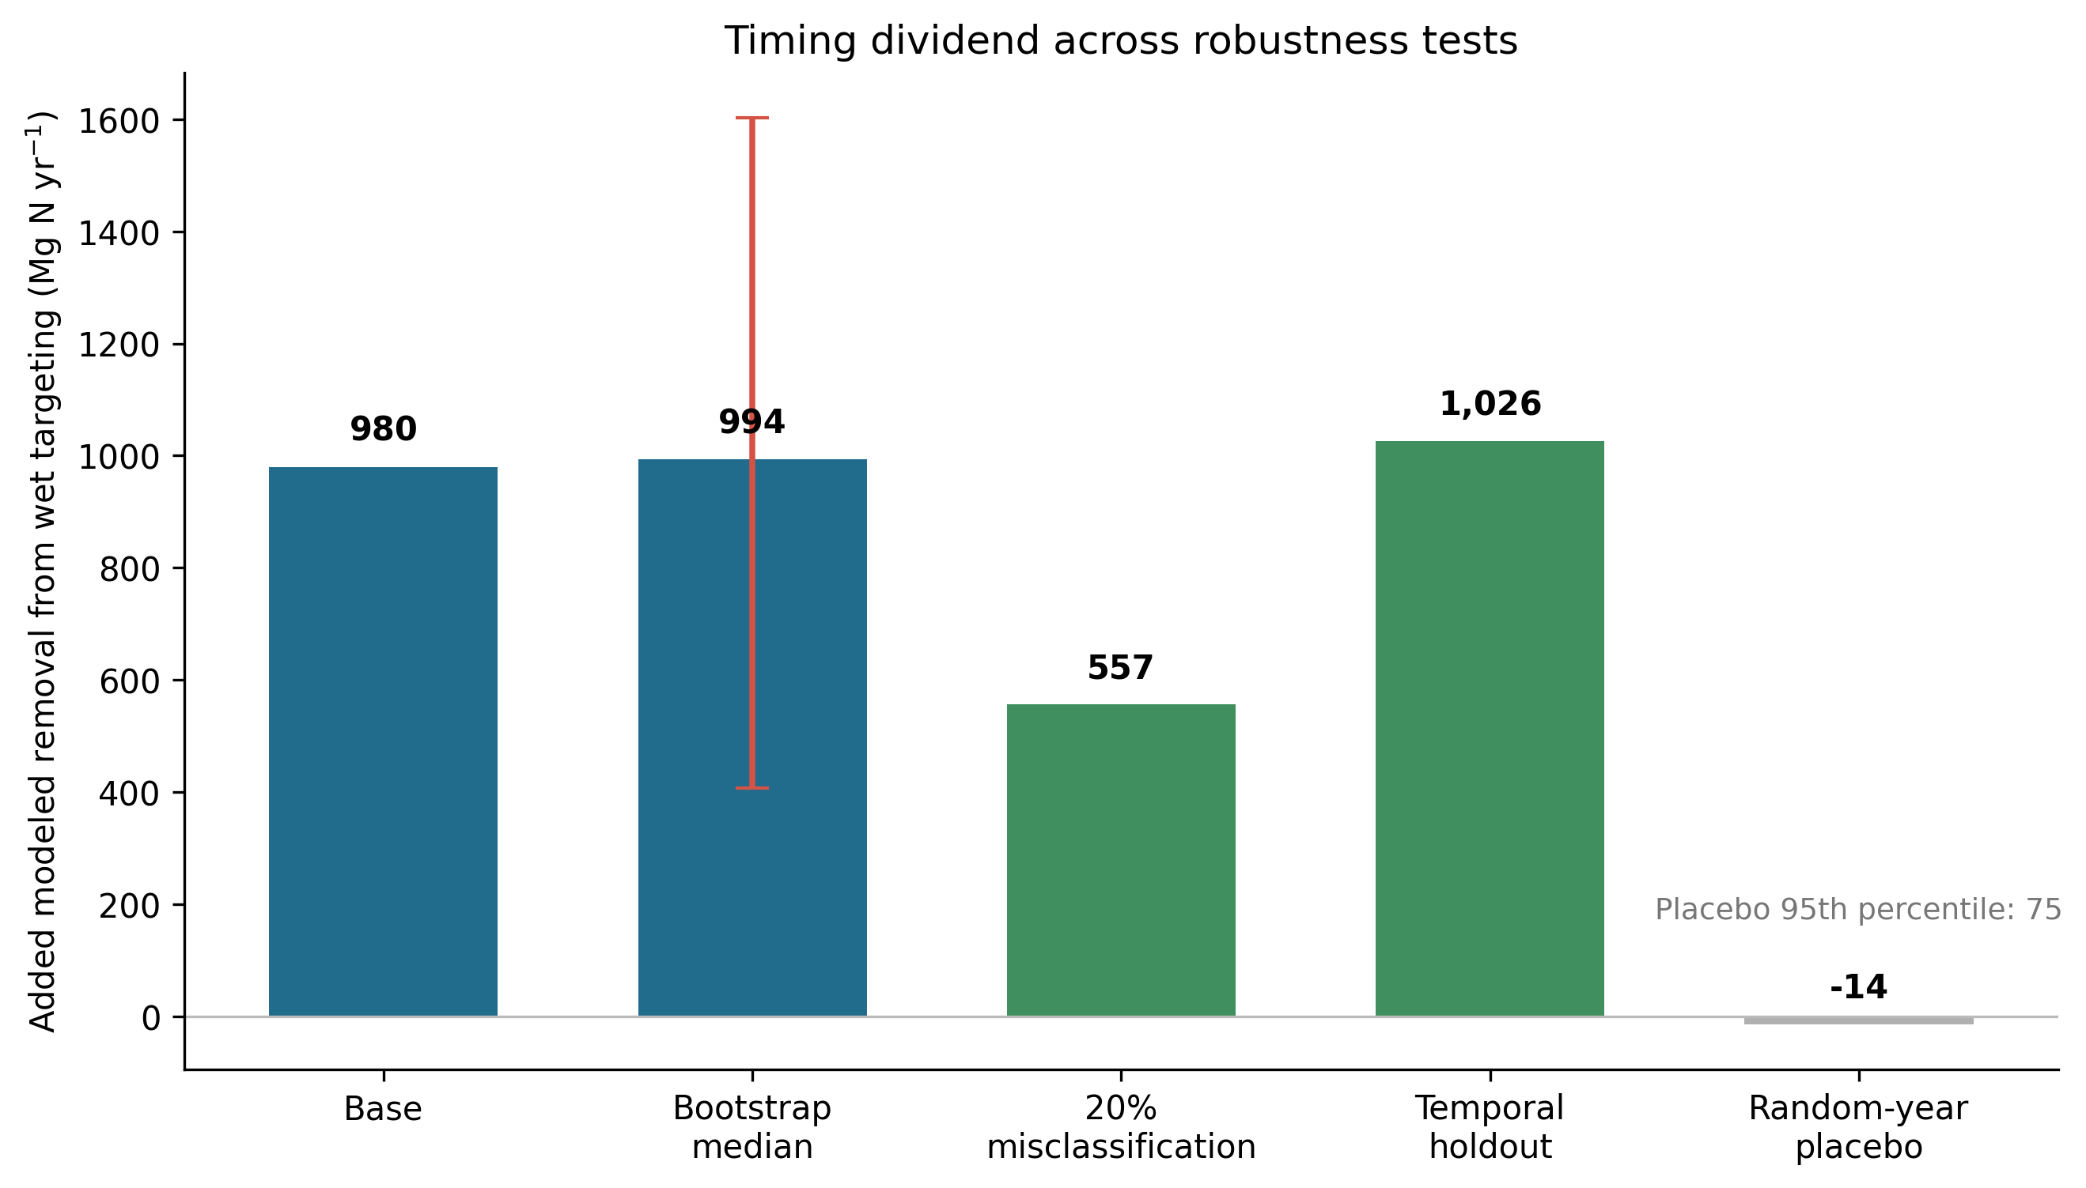
Figure 4. Robustness of the timing dividend. Added annual removal from wet-targeting under the base estimate, the clustered-bootstrap mean (with 95% interval), a 20% wet-year misclassification scenario, temporal hold-out validation, and a placebo that reallocates the same effort to randomly chosen years. The dividend remains substantial across the genuine tests and collapses to approximately zero under the placebo, confirming the benefit derives from hydrologic alignment.
3.11 Load Coverage and the Discharge-Multiplier Confound
All 1,750 analytical county-years contained 12 paired months. Spatial monitoring coverage nevertheless varied within county-years: median mean monitored-area coverage was 99.3%. Restricting the panel to county-years with mean coverage of at least 25%, 50%, or 75% retained positive interactions ranging from 1.68 × 10⁻⁴ to 1.98 × 10⁻⁴ (all p ≤ 1.43 × 10⁻⁹), with zero-crossings from 829 to 850 mm. Using the full county area rather than monitored area as the load denominator also retained the interaction (β = 1.80 × 10⁻⁴, p = 2.53 × 10⁻¹²; zero-crossing 822 mm).
Because annual load contains runoff, the surplus×precipitation interaction could partly reflect a mechanical discharge multiplier. We therefore re-estimated the model using annual flow-weighted mean nitrate-N concentration as the dependent variable. The interaction remained positive (β = 1.84 × 10⁻⁵, p = 1.42 × 10⁻⁵; within-R² = 0.062). This confirmatory result is consistent with wet-year concentration enrichment, while its modest explanatory power cautions against attributing the load interaction entirely to concentration.
4. Discussion
4.1 What Governs County Nitrogen Export
The predictive analysis showed useful but incomplete out-of-sample skill (temporal NSE = 0.41, KGE = 0.65; grouped-county mean NSE = 0.59, KGE = 0.69). Precipitation anomaly carried the highest permutation importance, tile-drained area was the strongest structural predictor, and antecedent load ranked third. Nitrogen surplus had little standalone importance within the correlated RF predictor set. The fixed-effects result complements this pattern by showing that the within-county surplus–load association varies with precipitation.
4.2 Climate-Gated Nitrogen Export at the County Scale
This study provides empirical evidence that nitrogen export from Iowa’s agricultural landscapes is climate gated: the marginal effectiveness of nitrogen-surplus reductions depends strongly on hydroclimatic conditions. Prior work has established that precipitation and discharge dominate interannual variability in nitrate loads and can overwhelm management changes in wet years [2,3]. The present analysis extends this understanding by showing that precipitation also modifies the marginal effect of nitrogen surplus itself, amplifying the conversion of surplus to riverine load during wet years. The significant surplus×precipitation interaction indicates that management and climate are not additive but interact in shaping export.
Mechanistically, this county-scale interaction is the management-relevant expression of the concentration–discharge behavior documented for Corn Belt nitrate. As flow rises, increasing hydrologic connectivity recruits nitrate from a larger fraction of the drained landscape, so a given surplus is converted to load more completely in wet years, and tile drainage sets the flow threshold at which this transition occurs [9]. The contribution here is to recast that transport signature as a policy lever: the marginal effectiveness of surplus reduction inherits the same precipitation dependence and can therefore be timed, rather than treated as the fixed transfer coefficient assumed in static budgets.
This finding helps reconcile a persistent difficulty in evaluating nutrient management. Conservation programs may appear ineffective when assessed over short windows or in dry periods, even when inputs decline, because transport pathways are weak; the same surplus reduction yields disproportionately larger load reductions in wet years when drainage and runoff connectivity are maximized. National surplus inventories document substantial regional variation in surplus and its coupling to export [4,5]; our results suggest that hydroclimatic context is a comparably important axis of variation that should be incorporated when interpreting surplus–load relationships.
4.3 Short System Memory and Adaptive Management
The dynamic specifications reveal short annual memory, with significant persistence limited to the previous year. This may appear to be in tension with the well-documented decadal legacy of nitrogen in groundwater-dominated systems [5], in which surplus accumulated over decades sustains elevated export long after inputs decline. The two findings are reconcilable: legacy stores set the slowly evolving baseline of available nitrogen, while the annual load delivered from that baseline is strongly modulated by each year’s hydrology. In a heavily tile-drained landscape, subsurface flow rapidly connects fields to streams, so the year-to-year signal at the county outlet is dominated by contemporaneous transport rather than by multi-year carryover in the load series itself. This distinguishes tile-drained Midwestern systems from those with long groundwater residence times, and implies that adaptive decisions can produce measurable water-quality benefits within the same or following year rather than over decades.
4.4 Role of Subsurface Drainage in Amplifying Transport
Although tile drainage is largely time invariant and absorbed by county fixed effects, it remained the strongest structural RF predictor. Its importance was smaller than that of precipitation anomaly in the corrected leakage-free analysis but substantially larger than row-crop fraction in the augmented RF. These results are consistent with drainage-enabled connectivity, while the observational design does not isolate a causal tile-drainage effect.
4.5 Timing as an Efficiency Lever
The conservative equal-effort counterfactual produced a modeled timing dividend of 980 Mg N yr⁻¹ (95% CI: 406–1,602), whereas the unconstrained model-implied sensitivity produced 1,401 Mg N yr⁻¹. The difference between these values shows that conclusions about magnitude are sensitive to treatment of negative fitted slopes in dry years. The more defensible qualitative conclusion is that modeled removal was greater when equal cumulative effort was concentrated in wet years; prospective trials and decision-focused simulations are needed before translating this diagnostic into program rules.
4.6 Operational Feasibility and Policy Relevance
Forecast error is a practical concern for any weather-responsive strategy. In the sensitivity analysis, 20% wet-year misclassification reduced but did not eliminate the modeled dividend (557 Mg N yr⁻¹). This does not demonstrate operational feasibility: seasonal forecast skill, within-season application windows, yield risk, producer behavior, and abatement costs were not modeled. Those elements should be evaluated before implementation.
4.7 Closing the Food–Water Coupling in the IFEW System
These results have a direct bearing on integrated nitrogen modeling for Iowa. The IFEW system model and its county-level extensions characterize how fertilizer, yield, and livestock manure determine nitrogen surplus, and they identify surplus as the central lever connecting the food system to downstream water quality [13,14]. What those models represent through fixed transfer relationships, this study estimates directly: the marginal conversion of county surplus into riverine load. The key finding is that this conversion is not a constant but a precipitation-gated quantity, near zero or negative in dry years and strongly positive in wet years. Embedding a climate-gated transfer term in the IFEW chain would make its export predictions responsive to interannual hydrology rather than to surplus alone, and would reconcile the model with the observation that statewide loads are dominated by wet years. More broadly, it reframes the food–water link in the nexus as conditional: the same agricultural surplus carries very different downstream consequences depending on the hydrologic state in which it is left on the landscape, so the leverage of food-system interventions on water quality is itself weather-dependent.
4.8 Limitations and Future Directions

Several limitations bound the interpretation. Loads are annual runoff×concentration estimates derived from discrete observations, not gauged county fluxes. Annual aggregation masks event and seasonal dynamics, and county surplus averages do not represent within-county heterogeneity, denitrification, immobilization, or storage. The fixed-effects model estimates conditional associations under an untestable no-time-varying-county-confounding assumption. The timing counterfactual applies the estimated marginal relationship outside an implemented intervention and omits forecast skill, practice choice, costs, crop response, nitrous-oxide emissions, and behavioral adaptation. Future work should evaluate the strategy prospectively, resolve subannual timing, compare alternative load estimators, and study possible yield or emissions co-benefits separately.
Two methodological caveats bear directly on the central interaction and motivate confirmatory analyses. First, because annual load is the product of runoff and nitrate concentration, and precipitation drives runoff, the estimated surplus×precipitation interaction could in principle reflect a mechanical discharge multiplier rather than enhanced concentration enrichment in wet years. Re-estimating the interaction with flow-weighted mean nitrate concentration as the dependent variable removes the discharge multiplier and isolates the concentration response; concentration–discharge evidence that Corn Belt nitrate is sustained at high flow rather than diluted [9] indicates the enrichment mechanism is operative; a direct test on these county data confirms it, the surplus×precipitation interaction remaining positive and significant with flow-weighted concentration as the dependent variable (Section 3.11). Second, county loads here use a transparent runoff×concentration×area aggregation rather than a rating-curve or weighted-regression estimator; the panel design differences out time-invariant estimator bias through county and year fixed effects, and cross-validating the headline interaction against a Beale ratio or weighted-regression load estimate would further strengthen the load basis.
4.9 Synthesis
Taken together, the results show a robust positive surplus×precipitation association across the rebuilt load panel and multiple sensitivity analyses. Equal cumulative surplus-reduction effort produced greater modeled removal when concentrated in wet years, but the estimated magnitude depended on how negative dry-year slopes were treated. The evidence supports climate gating as a testable management hypothesis rather than a confirmed intervention effect.
5. Conclusions
Using a combined machine-learning and fixed-effects framework for 98 Iowa counties from 2001 to 2019, we found that the association between nitrogen surplus and estimated riverine load strengthened with annual precipitation and crossed zero near 844 mm. The interaction was positive in the primary model (β = 1.85 × 10⁻⁴, p = 1.02 × 10⁻⁹), under alternative load denominators and coverage screens, after row-crop adjustment, and in the flow-weighted-concentration test. Under a conservative nonnegative-response constraint, reallocating equal cumulative positive-surplus reduction toward wet years produced 980 Mg N yr⁻¹ more modeled removal than a uniform schedule (95% CI: 406–1,602); the unconstrained sensitivity produced 1,401 Mg N yr⁻¹. These findings justify prospective evaluation of hydroclimatic timing but do not by themselves predict realized policy outcomes.
Supplementary Materials: The repository cited in the Data Availability Statement contains the corrected analysis code, analytical panel, sensitivity outputs, and figure-generation workflow.
Author Contributions: S.M.S.: Conceptualization, Data curation, Formal analysis, Methodology, Visualization, Writing – original draft, Writing – review and editing. A.K.: Conceptualization, Funding acquisition, Project administration, Supervision, Writing – review and editing. All authors have read and agreed to the published version of the manuscript.
Funding: This research received no external funding.
Institutional Review Board Statement: Not applicable.
Informed Consent Statement: Not applicable.
Data Availability Statement: Public source observations were obtained from the USGS National Water Information System and Water Quality Portal, Iowa Environmental Mesonet, USDA NASS QuickStats, and the IFEWS nitrogen-balance product. The corrected analytical panel, analysis code, and reproducibility outputs will be archived in the next version of the Zenodo record associated with https://doi.org/10.5281/zenodo.20721859 and maintained at https://github.com/researchsam/climate-gated-nitrogen. The final version-specific DOI will replace this concept DOI before submission.
Acknowledgments: The authors thank the U.S. Geological Survey, the Iowa Environmental Mesonet, and the USDA National Agricultural Statistics Service for maintaining the publicly available datasets on which this analysis relies.
Conflicts of Interest: The authors declare no conflicts of interest.
References
- Goolsby, D.A.; Battaglin, W.A.; Aulenbach, B.T.; Hooper, R.P. Nitrogen input sources and watershed nitrogen export in the Upper Mississippi River Basin. J. Am. Water Resour. Assoc. 1999.
- Jones, C.S.; Schilling, K.E.; Seeman, M. Iowa stream nitrate and the Gulf of Mexico. PLoS ONE 2018, 13, e0195930. https://doi.org/10.1371/journal.pone.0195930.
- Tian, H.; Xu, R.; Pan, S.; et al. Long-term trajectory of nitrogen loading and delivery from the Mississippi River Basin to the Gulf of Mexico. Glob. Biogeochem. Cycles 2020, 34, e2019GB006475. https://doi.org/10.1029/2019GB006475.
- Sabo, R.D.; Clark, C.M.; Bash, J.; et al. Decadal shift in nitrogen inputs and fluxes across the contiguous United States: 2002-2012. J. Geophys. Res. Biogeosci. 2019, 124, 3104-3124. https://doi.org/10.1029/2019JG005110.
- Byrnes, D.K.; Van Meter, K.J.; Basu, N.B. Long-term shifts in U.S. nitrogen sources and sinks revealed by the new TREND-nitrogen data set (1930-2017). Glob. Biogeochem. Cycles 2020, 34, e2020GB006626. https://doi.org/10.1029/2020GB006626.
- Iowa Nutrient Reduction Strategy; Iowa Department of Agriculture and Land Stewardship, Iowa Department of Natural Resources, and Iowa State University: Ames, IA, USA, 2017. Available online: https://www.nutrientstrategy.iastate.edu/ (accessed on 16 June 2026).
- Liu, W.; Li, M.; Huang, Y.; Makowski, D.; Su, Y.; Bai, Y.; Schauberger, B.; Du, T.; Abbaspour, K.C.; Yang, K.; et al. Mitigating nitrogen losses with almost no crop yield penalty during extremely wet years. Sci. Adv. 2024, 10, eadi9325. https://doi.org/10.1126/sciadv.adi9325.
- Basu, N.B.; Destouni, G.; Jawitz, J.W.; Thompson, S.E.; Loukinova, N.V.; Darracq, A.; Zanardo, S.; Yaeger, M.; Sivapalan, M.; Rinaldo, A.; et al. Nutrient loads exported from managed catchments reveal emergent biogeochemical stationarity. Geophys. Res. Lett. 2010, 37, L23404. https://doi.org/10.1029/2010GL045168.
- Marinos, R.E.; Van Meter, K.J.; Basu, N.B. Is the river a chemostat? Scale versus land use controls on nitrate concentration-discharge dynamics in the Upper Mississippi River Basin. Geophys. Res. Lett. 2020, 47, e2020GL087051. https://doi.org/10.1029/2020GL087051.
- Iqbal, J.; Necpalova, M.; Archontoulis, S.V.; Anex, R.P.; Bourguignon, M.; Herzmann, D.; Mitchell, D.C.; Sawyer, J.E.; Zhu, Q.; Castellano, M.J. Extreme weather-year sequences have nonadditive effects on environmental nitrogen losses. Glob. Change Biol. 2018, 24, e303-e317. https://doi.org/10.1111/gcb.13866.
- Tamagno, S.; Eagle, A.J.; McLellan, E.L.; Pittelkow, C.M.; et al. Quantifying N leaching losses as a function of N balance: a path to sustainable food supply chains. Agric. Ecosyst. Environ. 2022, 324, 107714. https://doi.org/10.1016/j.agee.2021.107714.
- Loecke, T.D.; Burgin, A.J.; Riveros-Iregui, D.A.; Ward, A.S.; Thomas, S.A.; Davis, C.A.; St. Clair, M.A. Weather whiplash in agricultural regions drives deterioration of water quality. Biogeochemistry 2017, 133, 7-15. https://doi.org/10.1007/s10533-017-0315-z.
- Raul, V.; Kaleita, A.; Bhattacharya, S. Modeling the contribution of agriculture toward soil nitrogen surplus in Iowa. In Advances in Information and Communication; Springer: Cham, Switzerland, 2022; pp. 282-295.
- Tuthill, J.B.; Kaleita, A. Mapping the nexus: a county-level analysis and visualization of Iowa's Food-Energy-Water systems. Sustainability 2024, 16, 5591. https://doi.org/10.3390/su16135591.
- Tomer, M.D.; Moorman, T.B.; Rossi, C.G. Assessment of the Iowa River's South Fork watershed: subsurface drainage and water quality. J. Soil Water Conserv. 2003, 58, 346-354.
- Malone, R.W.; Meek, D.W.; Hatfield, J.L.; et al. Cover crops and tile drainage: impacts on nitrate leaching and water quality. J. Soil Water Conserv. 2014, 69, 541-552. https://doi.org/10.2489/jswc.69.6.541.
- Lu, C.; Tian, H.; Zhang, J.; et al. Increasing trend in extreme precipitation over the U.S. Midwest. J. Geophys. Res. Atmos. 2020, 125, e2019JD032199. https://doi.org/10.1029/2019JD032199.
- Fifth National Climate Assessment. Chapter 9: Midwest; U.S. Global Change Research Program: Washington, DC, USA, 2023. https://nca2023.globalchange.gov/chapter/9/.
- Danalatos, G.J.N.; Wolter, C.; Archontoulis, S.V.; Castellano, M.J. Nitrate losses across 29 Iowa watersheds: measuring long-term trends in the context of interannual variability. J. Environ. Qual. 2022, 51, 708-718. https://doi.org/10.1002/jeq2.20349.
- Basso, B.; Shuai, G.; Zhang, J.; Robertson, G.P. Yield stability analysis reveals sources of large-scale nitrogen loss from the US Midwest. Sci. Rep. 2019, 9, 5774. https://doi.org/10.1038/s41598-019-42271-1.
- McLellan, E.L.; Cassman, K.G.; Eagle, A.J.; Woodbury, P.B.; Sela, S.; Tonitto, C.; Marjerison, R.D.; van Es, H.M. The nitrogen balancing act: tracking the environmental performance of food production. BioScience 2018, 68, 194-203. https://doi.org/10.1093/biosci/bix164.
- Sela, S.; van Es, H.M.; Moebius-Clune, B.N.; Marjerison, R.; Moebius-Clune, D.; Schindelbeck, R.; Severson, K.; Young, E. Adapt-N outperforms grower-selected nitrogen rates in northeast and midwestern United States strip trials. Agron. J. 2016, 108, 1726-1734. https://doi.org/10.2134/agronj2015.0606.
Disclaimer/Publisher’s Note: The statements, opinions and data contained in all publications are solely those of the individual author(s) and contributor(s) and not of MDPI and/or the editor(s). MDPI and/or the editor(s) disclaim responsibility for any injury to people or property resulting from any ideas, methods, instructions or products referred to in the content.

