Project Summary/Abstract

This section must be no longer than 30 lines of text,

**Abstract**

Genome instability drives the progression of benign neoplasias to life-threatening disease, but the causes of genome instability are not fully understood. Since genome instability can promote development of metastasis angiogenesis, and chemotherapy resistance, it is urgent to understand the causes of genome instability in cancer and to predict future genome instability. Re-replication, the abnormal firing of DNA replication origins more than once per cell division cycle, causes genome instability in cultured human cells. **We hypothesize that DNA re-replication is a source of genome instability in human tumors, and that differences in re-replication drive different courses of cancer progression.** Though re-replication cannot be directly measured in tumor biopsies, we propose that the cellular response to re-replication is reflected in distinct patterns of gene expression. We will therefore test an innovative strategy to detect re-replication in human tumors by gene expression profiling. We will induce re-replication in cultured normal mammary or bronchial epithelial cells, evaluate mRNA abundance by microarray analysis, and define a re-replication gene expression signature. We will then compare this signature to databases of mRNA abundance in breast tumors and to established oncogene mRNA signatures. This comparison will determine which oncogene pathways, cancer subtypes, and clinical parameters correlate with re-replication. Although all cancers have mutations, tumors from individual patients show different degrees and types of chromosomal abnormalities.Therefore, we will classify individual tumors for high or low genome instability using new cancer genome databases to determine if re-replication correlates with high genome instability or specific spectra of genetic alterations.

**Lay summary (250 words)**

Cancer is a heterogeneous collection of distinct diseases and disease subtypes. One of the most challenging issues for treatment is predicting how an individual patient’s cancer will progress. Cancer cells give rise to new mutations faster than normal cells do, and are thus said to exhibit “genome instability.” Genome instability is a major driver of cancer metastasis, resistance to chemotherapy, and relapse. We do not yet fully understand the reasons for genome instability in cancers, nor do we have satisfactory methods to compare genome instability between tumors.

Based on our work and the work of others, we hypothesize that a particular form of DNA replication mistake, known as “re-replication,” is a source of genome instability in human tumors, and that differences in re-replication drive different courses of disease progression. We propose an innovative approach to evaluate re-replication in human cancers that combines laboratory tests of cultured mammary epithelial cells with statistical analysis of human breast tumor databases. Our goal is to derive a signature of re-replication that can then be evaluated in any new tumor. Success will generate an entirely novel means to classify tumors. Moreover, we will identify sources of endogenous DNA damage and regulatory mechanisms driving genome instability *in vivo*, uncover potential activities for new targeted therapies, and create an enormously valuable tool for predicting disease progression. Our long-term goals for this project include determining precisely how re-replication contributes to the spectrum of genetic abnormalities in breast cancer cells and extending the analysis to ovarian and cervical cancers.

Project Narrative Using no more than two or three sentences, describe the relevance of this research to **public** health. In this section, be succinct and use plain language that can be understood by a general, lay audience.

**Re-replication as a diagnostic and predictive tool to analyze genome instability in cancer**

**Specific Aims.** The development of aggressive, resistant, or relapsing disease from a benign initiating tumor reflects the inherent genome instability of transformed cells. Genome instability manifests as chromosome translocations, gene amplifications, insertions, deletions, point mutations, and changes in ploidy. Identifying the extent and nature of a tumor’s genome instability at the time of diagnosis represents a potentially powerful biomarker to predict the likelihood that the tumor will acquire the potential for angiogenesis and metastasis or develop drug resistance and relapse. We have shown that, unlike normal cells, transformed cells constitutively re-utilize DNA replication origins within a single cell division cycle, an abnormal phenomenon known as ‘*re-replication*.’1,2 Uncontrolledre-replication is a potential source of endogenous double-strand DNA breaks that could drive many types of chromosome alterations. Not all cancer cell lines have the same propensity to undergo re-replication however, suggesting that similar differences may exist among tumors *in vivo*.3-5 We hypothesize that different re-replication frequencies among tumors promote different mutation rates and mutation spectra that are relevant to cancer patient outcomes.

A challenge now facing the field is to determine how frequently re-replication occurs in human tumor cells *in vivo* and if re-replication is a useful biomarker that predicts clinically-relevant aspects of genome instability. We intend to address this challenge by testing a novel strategy to interrogate and quantify re-replication in human tumors. Although direct measurement of re-replication in biopsies is not technically feasible, information about both gene expression and genetic changes in tumors is now readily available. We suggest that re-replication induces a cellular response that is reflected in a distinct pattern of gene expression. We propose to identify these changes and then develop a gene expression signature of re-replication. We will then use this signature to interrogate databases of mRNA abundance and genetic alterations in tumors to answer the following:

* Is re-replication a common feature of a particular cancer stage or subtype?
* Is there a correlation between the re-replication gene expression signature in tumors and the type or number of genetic changes (i.e. genome instability) in those same tumors?
* What is the relationship of the re-replication signature to established gene expression signatures of individual activated oncogene pathways?
* Does re-replication predict clinical parameters such as metastasis, relapse, drug sensitivity, and survival?

**Aim 1. Determine gene expression changes induced by re-replication.** We have induced *bona fide* re-replication in normal mammary epithelial cells and primary bronchial epithelial cells by precisely manipulating key DNA replication proteins. RNA from these cells and parallel control cells will be hybridized to microarrays to derive a gene expression signature that is common to re-replication in at least two cell types. Emerging evidence suggests that activated oncogene pathways not only stimulate cell proliferation, but may also directly induce re-replication.6,7 We will compare the re-replication signature to established gene expression profiles to determine which oncogene pathways are most likely to promote re-replication.

**Aim 2. Determine the relationship between re-replication and parameters of genome instability and clinical outcome in cancer patients.** We will take advantage of extensive databases of mRNA and DNA from human breast and lung tumors to probe the contribution of re-replication to tumor progression *in vivo*. In particular we will search for the re-replication signature in the mRNA databases and determine if it predicts the number and/or types of genetic alterations in tumors. We anticipate that high levels of re-replication will prove to be a biomarker for the highly aggressive disease subtypes, higher numbers of genetic alterations, and a higher likelihood of drug resistance and relapse.

Our goal is to both identify useful correlations between re-replication and clinical outcomes and to evaluate the predictive power of re-replication for future incorporation into clinical assays. We expect that the gene expression signature can be distilled to a small number of genes whose expression reflects authentic re-replication *in vivo*. The addition of re-replication parameters to current profiling strategies (e.g. MammaPrint and Oncotype DX) will add an entirely new dimension to individualized tumor profiling that is linked to a mechanism of genome instability. Biopsies of future cancer patients can then be screened for these key markers of re-replication and tied to predictions of disease progression that will inform clinical decision making. Ultimately this work will 1) provide an improved means to precisely define tumor subtypes at highest risk for rapid development of aggressive, resistant, or relapsing disease, and 2) uncover cellular pathways unique to re-replicating cells that are both biomarkers and targets for novel therapies.

**Research Strategy**

**A. Significance.** Cancer is a heterogeneous collection of distinct disease subtypes. One of the most challenging aspects for treatment is the need to predict how a particular cancer will progress. Since cancers have inherently unstable genomes, the “target” is constantly changing such that an early benign tumor could soon give rise to highly aggressive cells. Some cancers rapidly develop resistance to chemotherapies through amplification of drug resistance genes or mutations in the drug-targeted pathways, and genome instability drives these changes. At least one cause of genome instability is DNA repair defects such as those associated with inherited cancer predispositions. The endogenous source of the damage that is not efficiently repaired has not yet been fully elucidated, but understanding such drivers of genome instability is crucial to developing effective diagnostic and therapeutic tools. Thus far however, specific knowledge about the mechanisms of genome instability has not been fully incorporated into clinical tumor profiling strategies. *The tools we develop here may be able to predict future genome instability in tumors that have not yet shown extensive chromosomal changes providing critical information for prognosis and early intervention.* This project takes advantage of the newest databases of both mRNA and DNA in human tumors to specifically test the idea that uncontrolled DNA replication is a major source of genome instability *in vivo*.

*Replication licensing control.* DNA replication origins proceed through a rhythm of licensing and firing to ensure precise “once, and only once” genome duplication8,9 (Fig. 1A).

**Fig.1 A)** Levels of the Cdt1 licensing protein are high in G1 but low in S phase; the Cdt1 inhibitor, geminin, is low in G1 but high in S phase/ G2. These fluctuations promote precise DNA replication. **B)** Excess Cdt1 causes re-licensing and re-replication, a form of DNA damage that promotes genome instability. **C)** Normal replication of a single DNA fiber (left) compared to re-replicated DNA from cervical carcinoma cells (right). Re-replication during both sequential pulses of different dNTP analogs leads to double labeling of a single locus. (Dorn *et al.* 2009.)

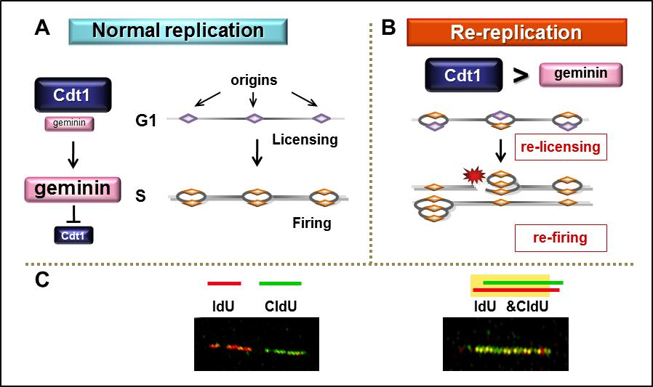

**Bibliography & References Cited**

1 Dorn, E. S., Chastain, P. D., 2nd, Hall, J. R. & Cook, J. G. Analysis of re-replication from deregulated origin licensing by DNA fiber spreading. *Nucleic Acids Res* **37**, 60-69 (2009).

2 Vaziri, C. *et al.* A p53-dependent checkpoint pathway prevents rereplication. *Mol Cell* **11**, 997-1008 (2003).

3 Aggarwal, P. *et al.* Nuclear cyclin D1/CDK4 kinase regulates CUL4 expression and triggers neoplastic growth via activation of the PRMT5 methyltransferase. *Cancer Cell* **18**, 329-340 (2010).

4 Liu, E. *et al.* The ATR-mediated S phase checkpoint prevents rereplication in mammalian cells when licensing control is disrupted. *The Journal of Cell Biology* **179**, 643-657 (2007).

5 Lee, A. Y., Liu, E. & Wu, X. The Mre11/Rad50/Nbs1 complex plays an important role in the prevention of DNA rereplication in mammalian cells. *The Journal of Biological Chemistry* **282**, 32243-32255 (2007).

6 Di Micco, R. *et al.* Oncogene-induced senescence is a DNA damage response triggered by DNA hyper-replication. *Nature* **444**, 638-642 (2006).

7 Halazonetis, T. D., Gorgoulis, V. G. & Bartek, J. An oncogene-induced DNA damage model for cancer development. *Science* **319**, 1352-1355 (2008).

8 Diffley, J. F. Regulation of early events in chromosome replication. *Curr Biol* **14**, R778-786 (2004).

9 Sclafani, R. A. & Holzen, T. M. Cell cycle regulation of DNA replication. *Annu Rev Genet* **41**, 237-280, doi:10.1146/annurev.genet.41.110306.130308 (2007).

10