The global M&A and The development of IC industry ecosystem in China: What can we learn from The case of Tsinghua Unigroup?

Abstract: The IC industry is the foundation of the information industry. Its level of development is an important manifestation of the economic and technological strength of a country. At present, the IC industry is mainly monopolized by developed countries. Although China is the world's largest semiconductor consumer country, its international market share and domestic chip self-sufficiency rate are seriously insufficient, and there is a big gap compared to Europe, the United States, Japan, and South Korea. This article uses Tsinghua Unigroup as a case study object, through the observation and analysis of its international mergers and acquisitions process, trying to clarify the steps and measures for the development of the IC industry ecosystem in the process of catching up with foreign advanced enterprises, and hopes to enrich the technology of the post-investment countries and catch up with enterprises. The relevant theory of industrial ecosystem, and provide useful reference for the development of IC industry in the post-developed countries.

Keywords: IC industry, innovation ecosystem, catch-up

1. Introduction

IC is an abbreviation of integrated circuit. The IC industry is the foundation of the information industry, and its level of development is an important manifestation of the economic and technological strength of a country. With the arrival of the global informatization, networking, and knowledgeization wave, the status of the IC industry has become increasingly important. It has become a basic pillar industry that concerns economic construction, people's lives, and information security. However, at present, the IC industry is mainly monopolized by developed countries. For developing countries, how to narrow the gap with developed countries is a huge challenge.

Most domestic IC companies in China are small, weak, and have poor competitiveness. The links and cooperation between upstream and downstream companies and related companies are weak. The IC industry has not successfully established a dynamic industrial ecosystem. In 2000, the Chinese government began to pay attention to the shortcomings of the IC industry. The State Council of the People's Republic of China issued “Several Policies to Encourage the Development of the Software Industry and the Integrated Circuit Industry”, and the Chinese IC industry has really entered the initial stage; in 2014, the Outline of the National Integrated Circuit Industry Development Promotion The release of China's IC industry has taken the development and policy attention to a new height.

Tsinghua Unigroup is a high-tech enterprise under Tsinghua University. In recent years, it has rapidly become an influential IC company in the world through a large number of mergers and acquisitions of IC companies at home and abroad, and has initially established an ecological system for IC industry and promoted China. Native semiconductor technology and strength. This study uses the case of Tsinghua Unigroup as the research object and mainly considers the following issues:

(1) How does Tsinghua Unigroup help build the IC industry ecosystem through a series of mergers and acquisitions?

(2) What are the important roles and influences of Tsinghua Unigroup M&A on China's IC industry ecosystem?

(3) In terms of catching up on industrial technology in the late-developing countries, what is the significance of Tsinghua Unigroup's case?

2. Theoretical and literature review

At present, mergers and acquisitions of enterprises in developed countries, including Tsinghua Unigroup, are developing rapidly. Some enterprises have not only crossed the gap of technological innovation through mergers and acquisitions, but have also achieved further technological catch-up, and they have built their own industrial ecosystem and formed a real In the sense of international competitiveness. Although existing literature has studied related issues such as technology catch-up, it still lacks sufficient theoretical explanation power for this new phenomenon. This study hopes to develop related theories by sorting out relevant documents in the past.

2.1 The theory of technological catch-up of late-developing national enterprises

Current theories of technology catch-up in late-development enterprises are mainly based on Hobday's (1995) oem-odm-obm reverse product life cycle curve model[1]And Kim (1980,1997) proposed the introduction - digestion - improvement three-stage model[2][3]As a representative. Subcontracting and OEM mechanism play the role of a training school in the process of technology catch-up of later development enterprises (Perez&Soete, 1988). Hobday, 1995).[3][1]. It enables late-development enterprises to overcome barriers to entry and absorb design and manufacturing technologies. The needs of customers promote the pace of learning, so that the late-development enterprises focus on technology digestion, adaptation and innovation. Unlike those leading the way in r&d and design, latecomers gradually improve the manufacturing process through incremental product innovation. With continuous catch-up efforts, a number of late-development enterprises began to have product design capability, which promoted the evolution of OEM system to ODM (Hobday, 1995; Cho&Lee, 2003).[1][5].

However, due to the weak research and development capacity and the low visibility of enterprises, late-development enterprises continue to rely on hybrid catch-up, growth based on imitation and incremental innovation (Hobday, 1995).Mathews, 2002;Dutrenit, 2004).[1][6][7]. In order to overcome the problems in the OEM-ODM system, some enterprises begin to strengthen R&D investment and adopt OBM to improve the brand image.As these late adopters approached the technological frontier, they began to establish strategic partnerships with the world's leading companies to acquire more advanced technologies (Hobday, 1995,2005;Mathews&Cho, 1999).[1][8][9].

Kim (1980,1997) believed that the innovation process of late-developing countries was fundamentally different from that of developed countries[2][3]. He proposed a three-stage model to describe the process of developing countries from technology introduction to digestion and absorption, and ultimately improvement and improvement (Kim, 1980).[2].Based on the model of Kim (1980), Lee et al. (1988) further proposed that in the early stage of technological catch-up, the speed of product innovation was high and the speed of technological innovation was low. In the transition phase, the market buyer dominates the design while the supplier focuses on the specific technology. In the third stage, the product design is becoming mature, and the competition mainly focuses on the improvement of the process[10]. Kim& lee (1987), Kim (1997) and others have also clearly identified catch-up patterns for different technical characteristics.They found that product innovation was most important for catch-up in small batches, such as large shipbuilders and machine makers. In mass production (such as electronics and car production), hybrid technological innovation and product development capabilities are important[11][3]. Later, Lee&Lim (2001) extended these models, and proposed the possibility of technology catch-up phase jump of late-development enterprises.In their opinion, late-development enterprises do not simply follow the technological development path of developed countries. They may cross certain stages and even create their own unique path[12].

At present, the research on IC industry technology catch-up is mainly based on the above two models. Like Brian chan, Chen Xiangtang and Yang Guohang (2005), according to south Korean semiconductor industry is undergoing a process of technology introduction, digestion to innovation, and the Taiwan semiconductor industry is undergoing a from OEM, ODM, OBM gradually realize technological catch-up growth path[13]. But these theories focus on the technical ability of backwardness enterprise progressive accumulation process, and through overseas acquisitions and other ways to backwardness enterprise technological catch-up and not give enough attention (Chang et al., 2006)[14]. In their model, enterprise in developing countries and developed countries completely in the unequal status of enterprise, only by technology transfer, joint venture and OEM close to the technology of the multinational enterprise, and climbed the ladder of OEM, ODM, OBM slowly climb.

2.2 Industrial ecosystem theory

Industry ecological system (IE) is the new paradigm of innovation ecosystem development, in particular, refers to each other between industrial agglomeration and influence each other so as to constitute a network system, in this network, to share information between different participants and circulation of resources, promote the sustainable development of industrial ecological system.

The existing research is related to the connotation, main body, structure and characteristics of industrial ecosystem. For example, Moore (1996) believed that the industrial ecosystem was centered on enterprises, especially enterprises with core capabilities[15]. Korhonen (2001) pointed out that the industrial ecosystem has the characteristics of circularity, diversity, gradualism and regionalism[16]. Iansiti&levien (2004) believed that the measures taken by enterprises would affect the health status of the ecosystem to varying degrees, which in turn would affect the performance and behaviors of enterprises[17]. Hearn&Pace (2006) focuses on the frontier development and technological innovation of the creative industry, so as to show how enterprises create value continuously through the ecosystem[18]. Iansiti&Richards (2006) says that platform providers play a key role in the ecosystem[19]. Adner (2006,2010) further believes that enterprise innovation is often not completed independently by a single enterprise, but through complementary cooperation with a series of partners to establish an ecosystem strategy[20][21].

There are more researches on innovation ecosystem in China.Liu Ling (1996) put forward the enterprise ecology theory, enterprise ecology is defined as the study of the relationship between enterprise and its environment ", put forward the "business ecosystem", "enterprise ecological network", "business ecosystem" and "enterprise ecological countermeasures" concept, and further discusses the ecology point of view the relationship between the enterprise management and ecology[22]. Li xiangju & zhan yongfei (2008) believed that the essence of innovation ecosystem was to integrate knowledge to make innovation subjects complete, and proposed the concept of innovation ecosystem management matrix[23]. Yu-hui lv (2011), the enterprise technical innovation to form a dynamic ecological system, the system by the implementation and impact of technology innovation activities of the organization, system and environment factors of the total, has some similarities with the natural ecosystem[24].On this basis, wu chunlai et al. (2013) believed that the industrial technology innovation ecosystem was interwoven by different industrial chains and formed an open, multi-dimensional and complex network structure[25].

The perspective of industrial ecosystem influences the development of industrial organization theory and enterprise strategic management.From this research perspective, the researchers mainly focus on the coordination and evolution process between the internal network entities in the industry, which is characterized by cooperation and competition[34][35].Jacobides et al. (2006,2007) put the research situation at different levels of bilateral relations, industrial background and even the entire industrial ecosystem to reflect the interaction process between enterprises[36][37].At present, more and more researchers believe that the competition between enterprises has become the competition among ecosystems[21][27][28][29].Wu jinxi (2014) introduced the importance of innovation ecosystem from the case of nokia's decline and discussed its essence, connotation, characteristics and policy implications in depth[26].The advantage of an enterprise depends on its position in the ecosystem and the ability of the whole ecosystem[30][31[32][33].But the study of industrial ecological system has not yet mature, due to different industry ecological system of the difference is very big, such as mature industry ecosystem and emerging industries, industry ecology system of developing countries and developed countries, the future will also need to do more to explore in the field of many important aspects and[38][39][40].

2.3 literature review

Through the literature review found that with the development of international mergers and acquisitions, before is described by the theory of technological catch-up model and framework has been challenged, many scholars start from the Angle of enterprise internationalization gives explanation, is one of the representative theory Mathews (2006) the name 'LLL (Linkage - Leverage - Learning) model[41]And the Springboard Perspective of Luo and Tung (2007)[42]. Mathews believe that Dragon Multinationals (Dragon Multinationals) have many common innovation characteristics, such as rapid internationalization, through organizational change, not technology to change speed up this process, establish the advantage position in the international market through strategic change, etc. Mathews summed up the challenge of multinational enterprises is through the "connection - leveraged use - learning" repeated application of the process, to overcome the disadvantage of the early, and establish a strong competitive position in the global market. Luo and Tung (2007) tried to describe the internationalization behavior of emerging market enterprises from the perspective of springboard. They think, backwardness enterprise international expansion as a springboard, a series of aggressive and adventure action on the global stage positive key asset purchase or purchase mature multinationals, to make up for the lack of competitiveness, to overcome the disadvantages of backwardness. In a sense, this effort is systematic and requires a grand plan, the intentional design of the gangway steps, with Recursive and Revolving characteristics.

Although the rise of the theory on late-development country enterprise gives insightful explanation, but mostly focus on technological catch-up stage, ignored the enterprise in the process, the construction of industrial ecological system, especially the emerging multinationals pursued theory, because there is no attention to the enterprise in the industry the position and merger and acquisition of the intention and function of ecosystem, so difficult to explain the process of technological catch-up late-development country enterprises.For industrial ecological system theory, the present study pay more attention to the existing industrial ecology as well as the interactions between different subjects, ignore the time sequence on the establishment, development and improvement of industrial ecological system.Late-development country of this research is trying to enterprises on the basis of the theory of technological catch-up, in view of the Tsinghua Unigroup international M&A cases, focused on how companies in developing countries through the layout of industrial ecological system in the hope to achieve a leap-forward development, so as to put forward the theoretical framework and discovery.

3.Current situation of China's IC industry

3.1 Basic information

The past few decades, Europe and the United States, Japan and South Korea dominates the global IC industry pattern, from the point of global IC industry output value share in 2015, Europe and the United States, Japan and South Korea respectively 9%, 50%, 11%, 50%, accounted for only 4% of mainland China.China is now the world's largest consumer of semiconductors, accounting for one-third of the world's demand for chips, but imports account for more than 90 per cent of chip consumption.According to statistics, China's semiconductor association, since 2013, China's imports of integrated circuits more than $200 billion for four consecutive years, China's imports of integrated circuits for $2016 in 227 billion, exports of just $61 billion.In 2016, sales exceeded 430 billion us dollars, an increase of about 20% over the same period last year.It is estimated that the domestic IC industry will grow by about 25% in 2018 under the pattern of simultaneous and coordinated development of the three industries of design, manufacturing and sealing and testing in China.Generally speaking, China's IC industry is developing rapidly at present, but the international market share and domestic chip self-sufficiency rate are seriously insufficient, which is quite different from Europe, America, Japan and South Korea.

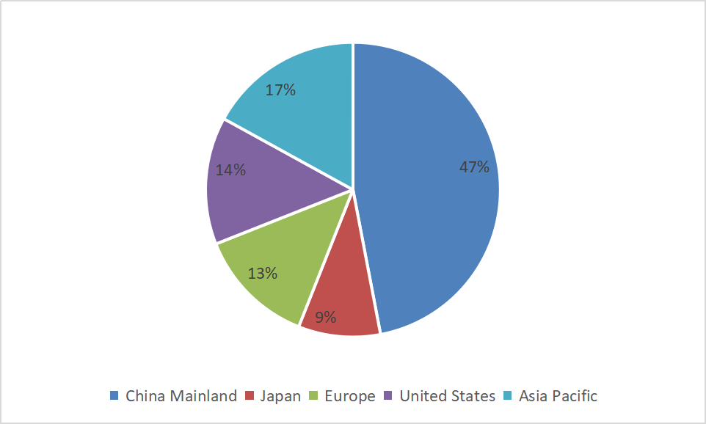

Source: compiled according to Internet information

**FIG. 1 global share of China's IC industry market (2020 forecast)**

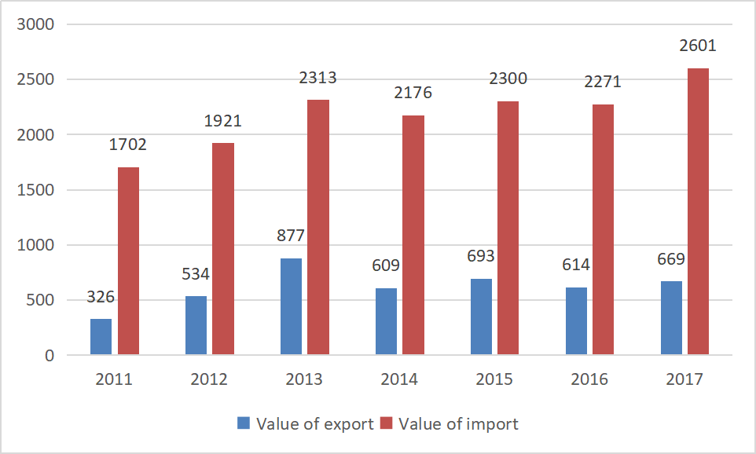

Source: China semiconductor industry association

**Figure 2 import and export volume of China's IC industry (unit: us $100 million)**

3.2 IC industrial ecosystem

As is known to all, the IC industry can be subdivided into the upstream chip design industry, the mid-stream chip manufacturing industry and the downstream chip packaging and testing industry, which constitute the core of the value chain of the IC industry.Among them, the chip design industry with technology-intensive attributes, chip manufacturing is capital intensive and technology intensive for all have certain requirements, and encapsulation testing industry tend to be more labor intensive and capital intensive.

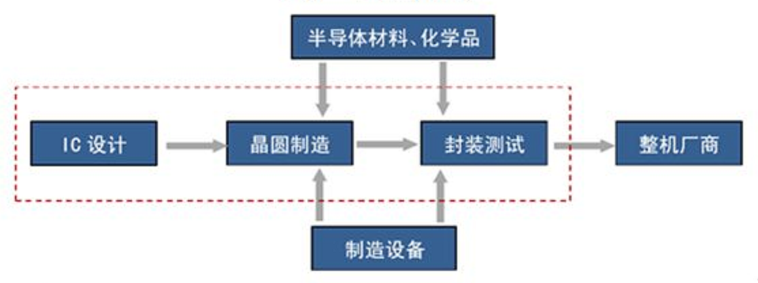

Source: author compilation

**FIG. 3 IC industry chain**

High degree of IC industry in international division of labor, such as qualcomm (ARM), broadcom, AMD and Intel, samsung and so on Europe and the United States, South Korea enterprise using the technology monopoly, a lucrative business focused on the chip design process;Domestic enterprises mainly focus on the wafer manufacturing (mainly OEM manufacturing), packaging testing and other relatively low profit links, the competition is fierce.

3.2.1 Chip design industry

Chip design is the core part of IC industry.The research and development cost of this link is high, with high technical barriers. Since it does not need to invest in the production line, it does not have high capital requirements, but requires a large number of talents. The key factors of market competition are product creativity, performance, quality and service. Qualcomm, broadcom and mediatek of Taiwan have led the pack. The domestic chip design industry has developed rapidly in recent years, among which huawei hasi and Tsinghua Unigroup zhanxun have ranked among the top 10 in the world.However, domestic enterprises generally lack independent intellectual property rights, and there are still bottlenecks in high-end chip design.

Qualcomm, broadcom and AMD of the United States have maintained a high market share in the global rankings of chip design manufacturers in recent years.In international Fabless mode (no wafer), under the drive of domestic chip design companies amount has reached more than 600, but the overall size is small, sales only accounts for two-thirds of Taiwan and the United States and 1/5 respectively.China's chip design industry is still in its infancy, with less than 10 per cent of the local supply, and some high-value chips are almost entirely imported.Because local Chinese companies are faced with problems such as weak research and development foundation and lack of talents, the early investment and risk of chip design enterprises are higher than other industries.In recent years, international mergers and acquisitions have gradually become the main choice for the development of chip design industry of latecomers in China. For example, the acquisition of Tsinghua Unigroup and rudyke is a typical example.

3.2.2 Chip manufacturing

The chip manufacturing (mainly wafer manufacturing) processes include lithography, etching, oxidation, deposition, diffusion, and flatting. Because of the extremely complex wafer processing technology, line width smaller and smaller, require specialized laser deep ultraviolet (EUV) light corrosion, such equipment and tools investment highest price to billions of dollars, therefore has higher capital barriers, such as TSMC in recent years the scale of capital spending up to $10 billion a year.At the same time, chip manufacturing process requires a long learning curve, and with the improvement of processing precision, the r&d cost is also increasing day by day, so this industry also has high technical barriers. At present, wafer foundry has formed an oligopoly competition pattern, because wafer manufacturing has high requirements on the technology and capital of enterprises, and the industry threshold is high.

In 2016, the world number one wafer foundry enterprise, TSMC sales reached $29.488 billion, up 10.97% from a year earlier, after two years of a monopoly on the global market share of nearly 60%, is ranked the second of Romania's five times, is the fourth Chinese smic wafer foundry enterprises ten times.In 2016, the total operating revenue of the top ten wafer OEM enterprises in the world was usd 47.754 billion, an increase of 11.49% over 2015, accounting for 94.68% of the annual total wafer OEM sales, and an obvious oligopoly pattern.Chinese chip manufacturing industry in the compound growth rate of 15% in the past 10 years, domestic enterprises is rapid growth in terms of production scale, but in terms of technical strength and there is still a significant gap between advanced enterprises around the world.At the same time, overseas including Taiwan area have restricted its chip manufacturers will invest in mainland China, advanced chip manufacturing technology makes the mainland chip manufacturing technology, talent shortage, the industry foundation is weak, only in China mainland smic, huahong hongli 2 chip manufacturing enterprises one of the top 10 in the whole industry.

3.2.3 Chip sealing and testing industry

Chip packaging test link is the process after the semiconductor industry chain, is the pin, the circuit on the silicon wafer with wires connect to external junction, in order to connect to other devices, specific encapsulation shell is refers to the installation of semiconductor integrated circuit. The technical threshold of this link is relatively low and it is labor-intensive. Encapsulation testing enterprise mainly OEM mode, scale effect is obvious, the service customer mainly for industrial chain upstream chip design and manufacturing enterprises, the high quality customer resources, therefore, the expansion of market share is vital for encapsulation testing promotion enterprise's operating performance.

Countries and regions engaged in semiconductor packaging testing worldwide are mainly Taiwan, Malaysia, mainland China, the Philippines, South Korea and Singapore. Thanks to the comparative advantage of labor cost, China's packaging and testing industry develops fastest in the IC industry chain and has the highest industry maturity.The domestic sealing and testing enterprises have gradually developed to high-end sealing and testing services, and their technical strength and scale have been further improved through extensive mergers and acquisitions. At present, the mainstream of chip packaging technology in the world is in the era of surface packaging. 3D lamination, 3DTSV and other 3D packaging technologies are still under development.International integrated circuit packaging technology takes BGA and CSP as the mainstream technology route, while local packaging testing manufacturers in China mainly use DIP, SOP and QFP.With the development of the domestic part of the packaging enterprises, domestic enterprises have advanced packaging technology (copper technology, wafer level packaging, 3 d stack size), and has already begun batch orders, domestic technology level and international mainstream level gradually.Domestic enterprises also by actively seeking overseas mergers and acquisitions to further enhance competitiveness in global markets, such as domestic leading testing long telegram in Singapore established science and technology enterprise star after chippac, world's top 15 major semiconductor companies have become a long telegram the customer of science and technology, industry rankings from 6 to 4 in the world, global market share has increased from 3.9% to 3.9%.

**Table 1 ranking of global IC enterprises**

|  |  |  |  |  |  |  |  |  |  |  |
| --- | --- | --- | --- | --- | --- | --- | --- | --- | --- | --- |
| **Chip design company** | | | **Chip manufacturer** | | | | | **Chip sealing and testing enterprises** | | |
| Enterprise | Headquarters | Sales (millions of dollars) | | Enterprise | Headquarters | Sales (millions of dollars) | Enterprise | | Headquarters | Sales (millions of dollars) |
| Qualcomm | The United States | 15436 | | TSMC | Taiwan, China | 29488 | ASE | | Taiwan, China | 4896 |
| Broadcom | Singapore | 15322 | | GlobalFoundries | The United States | 5545 | Amkor Technology | | The United States | 3894 |
| MediaTek | Taiwan, China | 8610 | | UMC | Taiwan, China | 4582 | JCET | | China | 2874 |
| Apple | The United States | 6493 | | SMIC | China | 2921 | SPIL | | Taiwan, China | 2626 |
| Nvdia | The United States | 6340 | | Powerchip | Taiwan, China | 1275 | Powertech | | Taiwan, China | 1499 |
| AMD | The United States | 4272 | | TowerJazz | Israel | 1249 | Huatian | | China | 823 |
| Hisilicon | The Chinese mainland | 3978 | | VIS | Taiwan, China | 800 | Tongfu | | China | 689 |
| Marvell | The United States | 2318 | | Huahong Grace | China | 712 | KYEC | | Taiwan, China | 623 |
| Xilinx | The United States | 2311 | | Dongbu HiTek | South Korea | 672 | UTAC | | Singapore | 689 |
| Spreadtrum | The Chinese mainland | 1912 | | X-ray Fab | Germany | 510 | ChipMos | | Taiwan, China | 568 |

Source: compiled according to Internet information

**Table 2 ranking of IC enterprises in mainland China in 2017**

|  |  |  |
| --- | --- | --- |
| **Chip design company** | **Chip manufacturer** | **Chip sealing and testing enterprises** |
| Shenzhen hasi semiconductor co. LTD | Samsung (China) semiconductor co. LTD | Jiangsu xinchao technology group co. LTD |
| **Tsinghua ultraviolet ray exhibition sharp** | Smic international integrated circuit manufacturing co. LTD | Nantong huada microelectronics group co. LTD |
| Shenzhen zhongxing microelectronics technology co. LTD | SK hynix semiconductor (China) co. LTD | Tianshui huatian electronics group |
| Huada semiconductor co. LTD | Intel semiconductor (dalian) co. LTD | Weixun united semiconductor (Beijing) co. LTD |
| Beijing zhixin microelectronics technology co. LTD | Shanghai hua hong (group) co. LTD | Nzep semiconductor |
| Shenzhen huiding technology co. LTD | China resources microelectronics co. LTD | Intel products (chengdu) co. LTD |
| Hangzhou shilan microelectronics co. LTD | TSMC (China) co. LTD | Andepend packaging test (Shanghai) co. LTD |
| Duntai technology (shenzhen) co. LTD | Xi 'an institute of microelectronics technology | Haitai semiconductor (wuxi) co. LTD |
| Gekko microelectronics (Shanghai) co. LTD | **Wuhan xinxin integrated circuit manufacturing co. LTD** | Shanghai kaihong technology co. LTD |
| Beijing zhongxing microelectronics co. LTD | Hejian technology (suzhou) co. LTD | Shengdian semiconductor (Shanghai) co. LTD |

Source: compiled according to Internet information

4. Research method

This study mainly adopts case study method.Relative to other research methods, case method can carry on the thick description to the case and the understanding of the system, the dynamic process of interaction with the master's context, can obtain a more comprehensive and overall point of view.First of all, it is more appropriate to study the "how" problem by induction[43]. The key problem of this study is how the acquisition behavior of Tsinghua Unigroup affects its IC industry ecosystem and even realizes technological catch-up.Secondly, analytic generalization from case to theory[44]It is more suitable to explore and explain this phenomenon.As the relationship between international M&A and IC industry ecosystem is complex, and relevant factors and processes are not completely clear, quantitative methods may be difficult to solve the above research problems.Thirdly, case study method is very suitable for problems of theoretical and practical significance, especially for overall and long-term organizational strategy[44].

In this study, Tsinghua Unigroup, a representative enterprise in China's IC industry, was selected as the case study object. Tsinghua Unigroup as a leader in China's IC industry, in recent years, a series of international M&A behavior can be on behalf of the Chinese IC industry practice and development, as well as observation analysis provides rich material for us.In addition, the Tsinghua Unigroup from a general growth as the core enterprise in China's IC industry, there are many successful experience is worth summarizing, especially in the ecological system of IC industry, guide the late-development country enterprise implementation technology after has important theoretical and realistic significance.

According to the relevant literature review and preliminary data collection and basic logic of this study are as follows: first of all, based on the investigation to the existing situation and problems of China's IC industry, from the chip design, manufacture, testing three aspects discusses violet light path to development of the IC industry ecological system; Secondly, it focuses on analyzing the contribution of the international M&A of Tsinghua Unigroup to China's IC industry and its role. Third, the paper discusses and summarizes the enlightenment of the case of Tsinghua Unigroup on the technological catch-up of enterprises in the later developing countries, and enriches the theory of innovation ecosystem and the theory of technological learning and catch-up.

5. Cases of Tsinghua Unigroup

5.1 Basic information

The former company was established by Tsinghua university in 1988, and formed in 1993. Tsinghua Unigroup combined with the global trend of the development of information industry and the characteristics of their own advantages business gradually established in the IC industry as the leading factor, to the memory chips and memory manufacturing, mobile Internet, cloud computing and cloud services such as information industry industry direction of the development of the core areas of focus.In 2017, its operating revenue reached 39.071 billion yuan, up 41% year on year.

Europe and the United States and to build ecological system of IC industry and narrow the gap between, Tsinghua Unigroup from the 2013 acquisition of Spreadtrum into the field of integrated circuits, with "international M&A + independent innovation" as the two-wheel drive, is becoming the core strength of domestic IC industry, at present, the Tsinghua Unigroup is China's largest comprehensive semiconductor companies, the world's third largest mobile phone chip design companies;Ranked first in China and second in the world in enterprise IT service subdivision;And with Intel, HP, western data and other global IT giants form strategic cooperation.

5.2 The course of Tsinghua Unigroup's international M&A and the construction of its IC industrial ecosystem

By sorting out the M&A cases of Tsinghua Unigroup, we can get a general understanding of the growth path of establishing domestic IC industrial ecosystem of Tsinghua Unigroup. First, Tsinghua Unigroup group through a series of international M&A is trying to make up for the domestic IC industry in chip design and manufacturing, especially in promoting the international competitiveness of memory chips, shorten the cycle of industrial upgrading;Secondly, we should integrate domestic and foreign resources, invest in building a research and development and manufacturing base for memory chips, and open up and build a complete industrial chain from design, manufacturing to sealing and testing. In the future, Tsinghua Unigroup will increase investment in product research and development, localization of technology and clustering of manufacturing, and focus on building an ecological system of storage chip industry.

**Table 3. The acquisition process of Tsinghua Unigroup international**

|  |  |  |  |  |  |
| --- | --- | --- | --- | --- | --- |
| **Time** | **Acquisition/investment target** | **Investment in the form of** | **Investment amount** | **Purpose** | **Note** |
| In December 2013. | Spreadtrum | acquisition | - $1.78 billion | Chip design |  |
| In July 2014, | Rudyke microelectronics co. (RDA) | acquisition | - $910 million | Chip design |  |
| In September 2014, | Intel | investment | Plus 9 billion yuan | Chip design |  |
| In February, 2015, | National integrated circuit industry investment fund and national development bank | investment | Plus 30 billion yuan |  |  |
| In May 2015, | H3C, a wholly-owned subsidiary of HP | Acquisition and participation in 51% | - $3 billion | Memory chip design |  |
| In July 2015, | Acadine Technologies of Hong Kong | acquisition | - $100 million | Mobile operating system (OS) software development |  |
| In July 2015, | Micron Technologies | acquisition | - $23 billion | Memory chip manufacturing | Unrealized. |
| In September 2015, | Western Digital | 15% stake | - $3.8 billion | Memory chip manufacturing |  |
| In October 2015, | Taiwan licheng technology | 25% stake | - $600 million | Chip sealing industry |  |
| In November 2015, | mediatek | merge |  | Chip design | Unrealized. |
| In December 2015. | Taiwan silicon precision | 24.9% stake | T $56.8 billion | Chip sealing industry |  |
| In December 2015. | Nanmao technology, Taiwan | 25% stake | -t $11.97 billion | Chip sealing industry |  |
| In July 2016, | Wuhan new core | More than 50% | - $24 billion | Chip manufacturing (manufacturing base) |  |

Source: compiled according to Internet information

5.2.1 Chip design industry

In 2013, Tsinghua Unigroup started to enter the chip design industry when it bought Spreadtrum communications, a us-listed company, for nearly $1.8 billion.In 2014, it bought rudyke for $910 million, bringing together two of the top three chip design companies in mainland China.In September of the same year, Intel invested 9 billion yuan in Tsinghua Unigroup's zhanxun and RDAko, and the two sides will jointly develop mobile phone solutions based on Intel architecture and communication technology.Through the acquisition of Spreadtrum and RDA, Tsinghua Unigroup received 10 billion yuan of investment from the integrated circuit fund and 20 billion yuan of loans from the national development bank.

Tsinghua Unigroup, as it were, on the layout and positioning of IC industry started with mobile communication chip design, in combination with smartphones, future development in this respect, the Tsinghua Unigroup series of decided to influence, not only in the design process of mobile communication chip assuring the heel, and through RDA and Spreadtrum effective coordination on the technology and products, improve the Chinese enterprises in the global market position in the field of mobile communication chip, has the milestone significance for China's IC industry.But in the high-end chip design has not reached the international first-class level.

5.2.2 Chip manufacturing

After the acquisition of Spreadtrum, RDA, Tsinghua Unigroup began to lay out chip manufacturing. With the development and popularization of the Internet, cloud computing and big data, the storage chip as an important infrastructure has become increasingly prominent.Memory chip can represent IC industry scale economy benefit and advanced manufacturing technology most.According to statistics, memory chips account for more than 25% of the overall chip market and will reach about 45% in the future. As a result, the company's manufacturing footprint is focused on memory chips. China's memory chips start late, slow development, lack of core technology, China's semiconductor industry is a shortcoming. Now several companies such as samsung and hynix, Intel monopoly over more than 90% of the global storage market, under the oligopoly structure, the blockade of technology, talent, the limitation of business policy, especially for the Chinese mainland IC enterprises rise apparently, become China's development of memory chips hurdles on the road.

Memory chips are a "technology + manufacturing" heavyweight field.Until now, China had been at the mercy of both the market and information security because it had no real capacity to produce memory chips. In 2015, Tsinghua Unigroup became the controlling shareholder of hewlett-packard co. 's xinhua iii company when it bought a 51 percent stake in the company for at least $2.5 billion.In October of the same year, Tsinghua Unigroup invested $3.8 billion to acquire a 15 percent stake in western digital, becoming the largest shareholder in western digital and owning a board seat.After an attempt to acquire micron was blocked by the us government, Tsinghua Unigroup used western data to circumvent the us government's control and buy flash for $19bn.In mechanical hard drives from western digital field strength can compete Seagate, but relatively weak in the field of the emerging SSD solid-state drives, sandisk flash memory is the world's third largest producer, 27 years in the areas of solid-state hard drives, memory card, U disk is of rich experience, just make up for the western digital board.By acquiring a 15 per cent stake in western digital, Tsinghua Unigroup has begun to break into the storage chip market with a further bid from western digital to acquire flash.

The acquisition of xinhua 3, xisu and svendi is aimed at breaking the foreign technology monopoly, with the power to produce memory. However in the acquisition of micron measures such as one after another after failure, Tsinghua Unigroup began with domestic enterprises and local governments to integrate resources, form a resultant force, in the form of construction of manufacturing base, perfect the memory chip manufacturing.In July 2016, Tsinghua Unigroup acquired a majority stake in wuhan xinxin and registered and established a new changjiang storage company, which turned wuhan xinxin into its wholly-owned subsidiary. Tsinghua Unigroup, meanwhile, cooperating with local government, successively in wuhan, nanjing, chengdu and other places built a total investment of nearly $100 billion of memory chips and memory manufacturing factory, open from the mergers and acquisitions to independent construction of manufacturing base.

5.2.3 Chip sealing and testing industry

Because Taiwan's chip sealing and testing industry has always been the strong point of its IC industry, Tsinghua Unigroup mainly faces Taiwan enterprises in the layout of chip sealing and testing.In October 2015, Tsinghua Unigroup invested about us $600 million in licheng technology and acquired about 25% of licheng technology, becoming its largest legal shareholder.Licheng technology is a senior sealing and testing enterprise in Taiwan, especially the leading position of memory chip sealing and testing in Taiwan. It is also the largest storage sealing and testing factory in the world. From then on, the whole industry ecology of memory chip from design to package test was constructed. At the end of the same year, Tsinghua Unigroup became the first and second largest shareholder of Taiwan siliconware precision and nanmao technology with a total price of 13.5 billion yuan.As the world's third largest sealing plant, silicon products in Taiwan market only in Japan. NMC is similar to silicon, and ranks second in the world in the production capacity of LCDS driven IC packaging tests.

**Table 4 industry system of ultraviolet ray IC**

|  |  |  |  |
| --- | --- | --- | --- |
|  | **Chip design** | **Chip manufacturing** | **Chip sealing industry** |
| Original (self-established) | Ultraviolet core microelectronics |  |  |
| Now (through acquisitions, investments, etc.) | Ultraviolet ray (Spreadtrum + rudicko) | Micron technology | Force into science and technology |
| Intel | Western digital | Silicon product precision |
| Xinhua three | Wuhan new core | South mau science and technology |
| In the future | mediatek | Nanjing semiconductor industry base |  |
|  | Chengdu IC international city |  |
|  | Suzhou super SSD factory |  |

Source: based on Tsinghua Unigroup case study

6. Case analysis of Tsinghua Unigroup international M&A

6.1 Process analysis

6.1.1 Company strategy first

Company strategy is the first, the sense of mission of entrepreneurs and the foundation of Tsinghua Unigroup IT industry are the preconditions for its development of IC industry.Strategic positioning of the company is the core issue of enterprise management. As early as 2012, Tsinghua Unigroup has set the goal and development strategy of "building a world-class high-tech enterprise". A year later, by means of international cooperation, Tsinghua Unigroup quickly completed the acquisition of zhanxun and rudyke.In addition, entrepreneurship has an irreplaceable influence on the strategic positioning of the company. As an important and special intangible production factor, it is one of the sources of enterprise's core competitiveness. Tsinghua Unigroup's international acquisition cannot be separated from chairman zhao weiguo's efforts. Wei-guo zhao since 2009 as Tsinghua Unigroup chairman, has spent nearly $6 billion acquisition of Spreadtrum, three RDA branch, China communications company with global influence, such as led Tsinghua Unigroup made remarkable achievements. Tsinghua Unigroup to effectively integrate talent, technology, capital for way, relying on the unique advantages of national strategic support and tsinghua university, form a Tsinghua Unigroup IC industrial chain, foster global giants in the field of integrated circuit and mobile Internet enterprises.The future strategic layout of Tsinghua Unigroup is to build a world-class enterprise group in China's high-tech field.

6.1.2 The state supports the second

Of course, behind the acquisition of Tsinghua Unigroup international also cannot leave the strong support of national strategy and policy.At the beginning, Tsinghua Unigroup's independent international M&A has produced good results, which has attracted the attention of the country. In 2014, when the outline of national integrated circuit industry development and promotion was released, the national investment fund for integrated circuit industry was established. In February 2015, the national integrated circuit industry investment fund invested 10 billion yuan in the chip business of Tsinghua Unigroup, the first large-scale investment since the establishment of the fund.At a time when violet light group's chip business mainly Spreadtrum communications and RDA microelectronics two companies, visible violet light of certain achievements have been made in the independent M&A, and then soon got the support of the government.

The Chinese government for the development of IC industry provides a favorable policy environment, Tsinghua Unigroup is also actively respond to a nation "five-year strategic emerging industry development planning" and "independent innovation, safety control" of the development strategy of the integrated circuit.The powerful national IC industry investment and financing platform provides Tsinghua Unigroup with an important source of funds for the international M&A of hundreds of millions of millions of dollars.When the industry is in the stage of technology reserve and accumulation, in addition to relying on large enterprises, a large number of key technology research and development activities guided by national will or government planning will take on heavy responsibilities.Such as Tsinghua Unigroup at the end of 2016 in wuhan east lake high-tech zone construction of national memory base project is under the national and local government leading, by the national IC industry investment fund and local funds, hubei province, hubei province jointly invest in the construction.

6.2 Result analysis

The sound development of IC industry requires proper industrial environment and perfect ecological system.One of the key problems in China's semiconductor industry is that there are short boards in the industrial chain. A large number of supporting products, including materials, are imported, and local enterprises cannot provide effective support. Through a series of international mergers and acquisitions, Tsinghua Unigroup has initially constructed an IC industrial ecosystem and effectively enhanced the international competitiveness of China's IC industry.

6.2.1 Strengthen the overall strength of domestic IC industry

First of all, the most obvious is that China's IC industry comprehensive capacity has been improved.Chip design, for example, 2013 Tsinghua Unigroup buy multinationals Spreadtrum (main) baseband chips and RDA rf chip (main) to realize the power-and-power union, just a few short years become second only to qualcomm, mediatek, the world's third-largest mobile phone baseband chip suppliers, one of the world, and with the distance of the IC industry, such as the United States, South Korea power is gradually shrinking.

In the manufacturing of memory chips, it is obvious that Tsinghua Unigroup invested in wuhan, hubei province to build a world-class semiconductor base in order to break through the defects of Chinese IC industry in manufacturing.The investment has also had a significant impact. The establishment of wuhan xinxin corporation and the construction of 12-inch chip project have successfully led to the concentration of upstream and downstream semiconductor industries.At present, the existing more than 20 IC design companies, more than 10 world semiconductor equipment suppliers, more than 10 raw materials production enterprises, involving more than 10 chemicals supplier in optical valley, good industry ecological system is gradually formed.

6.2.2 Improved the independent innovation ability of enterprise semiconductor

International merger and acquisition to a certain extent, help enterprises to quickly obtain the advanced technology of developed countries, but for the independent innovation ability of ascension requires the enterprise after M&A for digestion, absorption and integration optimization technology.In 2016, Tsinghua Unigroup integrated the acquired zhanxun and rudyke into zhongrui, committed to the integration of mobile chip technology and the improvement of independent research and development capacity.Based on the powerful advantages of low-end chips (2G/3G), zhongrui has been catching up with 4G, which is basically the same speed as qualcomm and mediatek.According to statistics, the company has more than 5,000 employees, more than 90 percent of whom are r&d personnel, and has 16 technology r&d centers around the world. Tsinghua Unigroup after a series of international mergers and acquisitions on chip manufacturing, industry layout is entering a new era of "inside and outside and repair", namely, to realize acquisition technology localization, production base of clustering, IC industry technical phase of the capability of independent innovation.

Generally speaking, the development of China's IC industry is indispensable to the construction of industrial ecological system, the construction of industrial ecological system, the key is to rely on enterprise especially like Tsinghua Unigroup backbone enterprise progress and success.The past Chinese enterprises small in scale, strength is weak, and it alone, Tsinghua Unigroup through the IC industry chain through M&A, and after the merger, conducted a series of integrated work, promote the benign development of the ecological system of IC industry.

7. Conclusion

Through the case of the merger of Tsinghua Unigroup, we found that the rise of IC industry mergers and acquisitions is the general trend of economic restructuring. Tsinghua Unigroup, as the forerunner of the IC industry in mainland China, has also started a new wave of mergers and acquisitions in the domestic IC industry. The growing IC industry in China will have a profound impact on the global IC industry. Analyze the process and experience behind Tsinghua Unigroup’s capital operation, focusing on exploring how to acquire domestic and foreign enterprises in succession and achieve the growth of their own strength so that the Chinese IC industry's ecological system will be stronger and healthier, and at the same time, it will also provide provide beneficial reference for late-development country the development of IC industry.

In terms of theory, based on the summarization of previous OEM-ODM-OBM and introduction-digestion-improvement model, it is believed that the current rise of international mergers and acquisitions plays an important role in the catch-up of enterprises in the developing countries, but this catch-up It is not a process of accumulating progressive technological capabilities that resembles a step-like climb, but rather has some leapfrogging characteristics. In addition, the development of industrial ecosystem in the process of catch-up of the enterprises in the post-developed countries is also the focus of this study. The case of Tsinghua Unigroup shows that the process of catching up on enterprises in emerging countries is inseparable from the construction of their industrial ecosystem. The steps and initiatives of international mergers and acquisitions can, to a certain extent, reflect the macro industrial ecosystem and the objectives to be achieved.

In practice, for late-developing countries, because they have lost the opportunity of technology from invention to application from the very beginning, if they break through the monopoly of developed countries through independent research and development, they will need a lot of time and cost. Therefore, with reference to Tsinghua Unigroup's experience, we acquire technology and related companies through international mergers and acquisitions, and then realize the transfer of technology localization. If you only accumulate and upgrade your industry through local technology, you will not only be unable to afford it, but you will miss out on the next opportunity. This will make the gap with the developed countries widen. Therefore, it will be much easier to use international mergers and acquisitions to allow them to become stronger, have an equal right to speak, and then engage in independent innovation on the basis of equity cooperation with international giants. The integration of technologies after international mergers and acquisitions also needs to attract the attention of the companies in the post-commercial countries. If we can't use the technology acquired from mergers and acquisitions for me, then the difficulty in the process of catching up with technology will increase greatly.

Due to the influence and restrictions of international politics, there have been many cases of failure in mergers and acquisitions of Tsinghua Unigroup. However, in building the domestic IC industry ecosystem, Tsinghua Unigroup has made important contributions and provided lessons to be learned. The development of the IC industry in post-developed countries should go hand in hand. In addition to opening IC design, manufacturing, and packaging and testing to develop the IC industry ecosystem, it is necessary to follow-up the supporting equipment and materials, as well as the gradual improvement of personnel training and the industrial environment. In the construction of the domestic IC industry ecosystem, especially in the context of national policies tending to fully support the “domesticization” of semiconductor chips, the government can lead the joint IC Industry Association and leading companies to create an open innovation platform and actively attract each The addition of party resources includes scientific research institutions, IC industry materials, equipment suppliers, system service providers, multinational companies, mobile phone, automotive electronics and other end consumer manufacturers, venture capital institutions and so on. Encourage joint innovation on the basis of open management, realize the sharing of knowledge and technology, and create an IC industry innovation ecosystem.