**The jury is in the detail**

Yuan-Ye Zhang

**Abstract**

Sánchez-Tójar et al. (2020, Ecol Lett) question the methodology, transparency and the conclusion of our study (Yin et al. 2019, Ecol Lett, 22, 1976). I feel that these arguments ignore critical assumptions and misunderstand our peer-review process. General does not mean always; the jury is when and where a transgenerational effect is beneficial, which enlightens future research.

**Keywords:** transgenerational effect, phylogenetic meta-analysis

# INTRODUCTION

Sánchez-Tójar et al. (2020) identify limitations in the methodology of our meta-analysis and suggest the conclusion is not robust. They also indicate that these limitations should have been avoided if the peer review stage is transparent. I will address each of these concerns using the following three sub-headings.

**How robust are the patterns?**

A major criticism from Sánchez-Tójar et al. is not fully accounting for the non-independence. As the patterns are robust against accounting for the crossed random effect and shared control, possibly because the crossed random effect is associated with a small proportion of data (10 out of 139 studies) and the shared control has been accounted by the study as a random effect, the following discussions will focus on phylogenetic non-independence. Together, I highly appreciate all these efforts and the code-sharing, and agree that our study has limitations. I would like to address, as we’ve already addressed in Yin et al., that not including phylogenetic structure is not because we think it is not important or non-exiting, but because the such a non-independence due to the shared common ancestor is probably very weak and difficult to estimate with our data. Our data including both plants and animals which share a very ancient common ancestor, and over such a long evolutionary time, too many events like independent selection can substantially weaken the constraint by the common ancestor. Furthermore, our data including different traits of different species, such as the root length of species A and specific leaf area for species B, which are likely to have a common origin different from that of species A and B, making it difficult to estimate the relevant evolutionary history with species phylogenetic trees. Using a wrong estimation could be even worse than not using it.

Even it is possible to estimate shared evolutionary history properly, though it proves challenging as a result of genomics (Pennisi 2016; Kern & Hahn 2018), Sánchez-Tójar et al.’s approach still suffers problems (Fig. 1). First, they employ the Brownian Motion model (Felsenstein 1985) to estimate the variance-covariance matrix (Fig. 1), which assumes evolutionary change to be gradual with time and no selection that changes the rate of evolution. While such a simplified neutral assumption may hold for short evolutionary history or small phylogenies, it is hardly applicable to our data with large lineages including plants and animals. Secondly, the Brownian Motion model requires using the coalescent time to estimate branch lengths, but they use the number of leaves of the subtree (Grafen 1989) instead. Such estimation is highly biased by the sample size along each branch, i.e. gymnosperm-angiosperm divergent time is underestimated owning to the small sample size of gymnosperm clade (one species, Supplementary information 3.1 in Sánchez-Tójar et al.). Ignoring these assumptions and blindly applying the phylogenetic approach can dramatically reduce the statistic power and lead to over-conservative results. With our data, this approach appears to reduce the independent sample size to three referring to three major clades (plants, invertebrates and vertebrates), as the variance-covariance coefficients are quite high (>0.6) within each clade (Fig. 2). Although using alternative evolutionary models can generate significant results (Fig. S1), I don’t consider these approaches plausible as critical assumptions have been violated before adopting them.

As Sánchez-Tójar et al.’s approach appears to be broadly applied owing to its accessibility (Lajeunesse 2009, 2011; Chamberlain *et al.* 2012; Paradis & Schliep 2019), I hope these discussions can warn its usage and promote development of phylogenetic meta-analysis methods through the crosstalk between evolutionary ecologist and meta-analysis scientists.

**Where is the jury?**

Although the above discussion suggests the patterns are robust, I disagree with Sánchez-Tójar et al. that the “jury” of our study are the significant patterns showing the “generality”, and I also disagree that the previous meta-analysis “challenge their generality”. Radersma *et al.* (2018) included 6 studies and 46 effect sizes and Uller *et al.* (2013) included 58 studies and 655 effect sizes, both revealing an overall positive effect albeit non-significant, and the pattern of generality is thus anticipated. We may even find nothing more than what has been anticipated, but we work out a most detailed picture through dissecting the heterogeneity underlying transgenerational effects. The resulted picture tells when and which taxa such effect is beneficial, which contributes to weighing the evidence for theories. This picture also suggests, instead of being always beneficial, such effect in some environments for some taxa is even disadvantageous, which also explains the high heterogeneity estimated quantitatively by Sánchez-Tójar et al.

Sánchez-Tójar et al. also suggest to focus on the effect on F2 and F3 and to exclude the effect of parental condition-transfer (Engqvist & Reinhold 2016). While I also find these concerns are important for experimental studies, I wonder whether it is possible to collect enough evidence for a meta-analysis, given the difficulty of conducting multi-generation experiments and separating between parental “cues” and “conditions” (Engqvist & Reinhold 2016). Furthermore, whether the condition-transfer (= context-dependent silver-spoon) should be considered adaptive is still controversial (Bonduriansky & Crean 2018; Engqvist & Reinhold 2018). Our effects of drawing a picture that is compatible with these concerns seems to be a sensible first step, which can also insight the future accumulating of evidence.

**How transparent is our study?**

Sánchez-Tójar et al. identify limited coverage, data errors, and evidence for publication bias in our study, and suggest having these limitations is because the peer-review stage lacks transparency. While I accept the criticisms for the coverage and errors, I do not accept those for the publication bias and, in particular, for the peer-review stage. A similar significant result of Egg’s test is reported in Yin et al., but our conclusion is also established on all alternative assessments’ showing no evidence for bias. Both our raw data and code were submitted for revision, and thanks to the professional and generous reviewers, most concerns raised by Sánchez-Tójar et al. have been considered carefully. For instance, reviewers suggested to (i) repeat the literature search stepwise, (ii) evaluate the influence of missing words, (iii) mine the readily collected data for the diet effect, and (iv) compare full-factorial with non-full-factorial subsets of data (Please refer to the supplementary files for details). Although they identify these limitations and suggest to refer the study instead as “a MORE comprehensive study”, they are more enthusiastic about the detailed picture we provide, the real “jury”, and the opportunity to bridge patterns with theories. Furthermore, their efforts also result in error-free for some moderators, i.e., taxonomic, and adopting sensitivity analysis to evaluate the uncertainty in characterizing moderators (Supplementary information 2.5 and 2.7 in Sánchez-Tójar et al.). In fact, Sánchez-Tójar et al. also benefit from the transparency and detailed documentation of our data, which allows checking each moderator without referring to original publications. Therefore, instead of being criticized, our study provides a good example of how a study benefits from transparent review and competent reviewers.

I hope these discussions can promote open science practice, methodological development and the maturation of meta-analysis studies, which serve to bridge empirical evidence with theories and enlighten further research.

# ACKNOWLEDGEMENTS

# REFERENCES

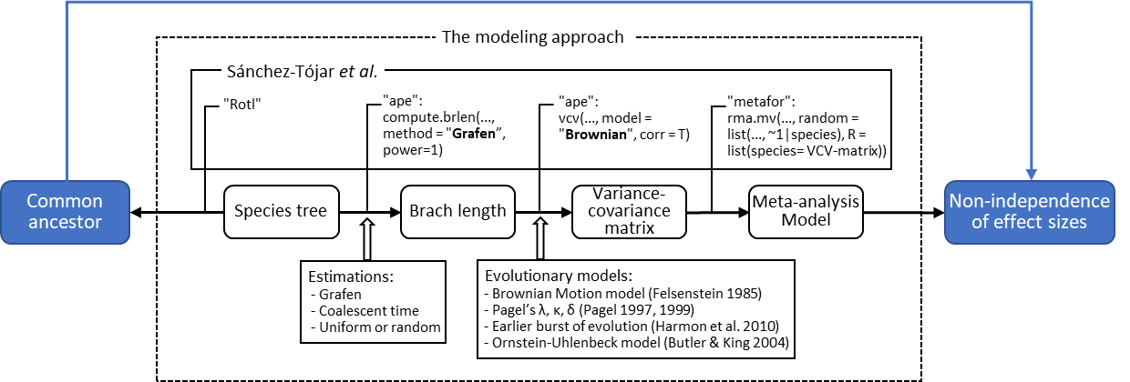

**Figure 1** Phylogenetic meta-analysis. The blue error shows the basic principle of phylogenetic meta-analysis that the effect sizes are not-independence owning to their shared evolutionary history/common origin/common ancestor. The dashed box indicates how this non-independence is generally modeled in a meta-analysis practice. The solid box describes how it is specifically modeled in Sánchez-Tójar *et al.* (2020). The opening arrows provide alternative modeling approaches for phylogenetic non-independence.

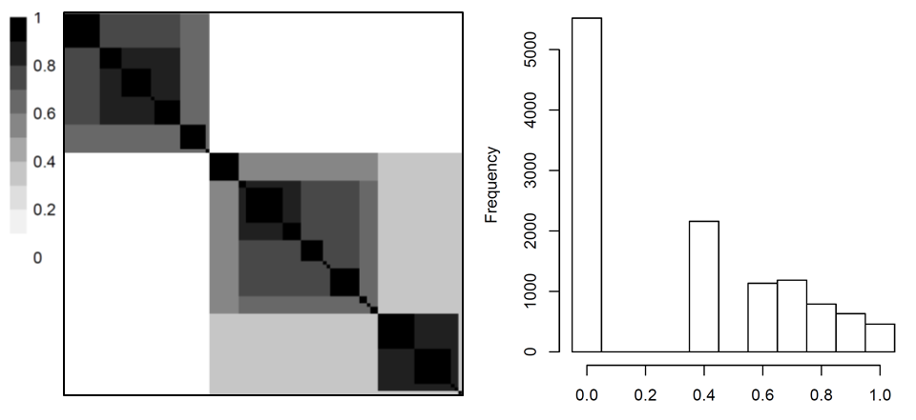

**Figure 2** The heatmap (a) and the histogram (b) of the variance-covariance matrix calculated following Sánchez-Tójar *et al.* (2012) as illustrated in Fig.1. The detailed heatmap with species names is shown in Fig. S2

**A list of supplementary materials**

Data and code

Review and reply of Yin et al. v1 & v2

Fig S1

Fig S2

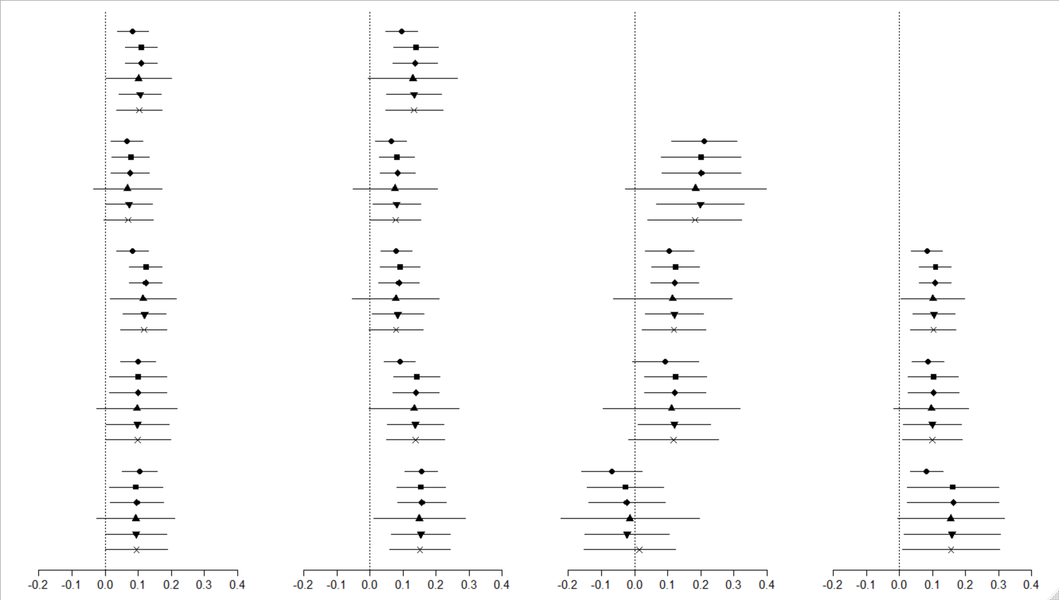

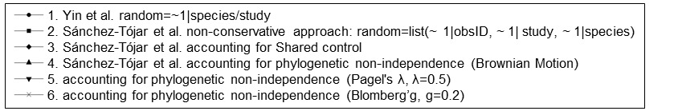

**Figure S1** Patterns analyzed with different models. Model 1 uses Yin et al.’s submitted raw data, models 2-6 use Sánchez-Tójar *et al.* proofed data.Figure S2

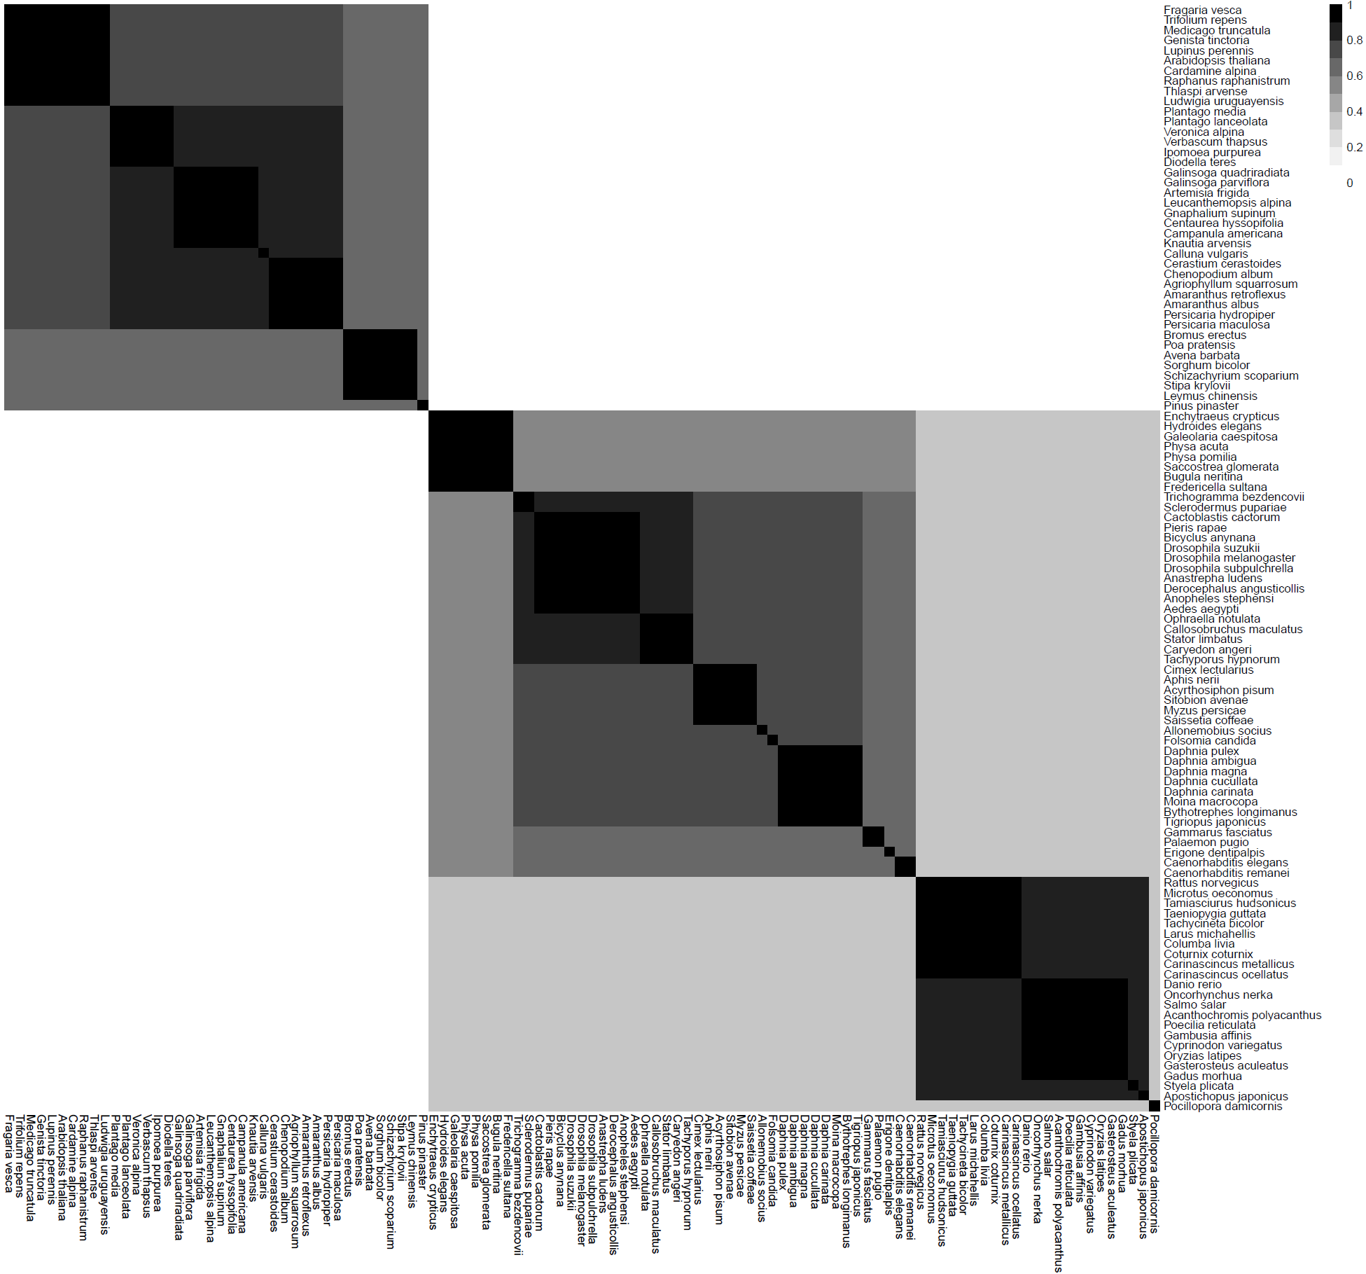

**Figure S2** variance-covariance matrix with species names following Sánchez-Tójar *et al.* supplementary information 3.1