# How to create Instrumentator.jar from microbat_instrumentator project.

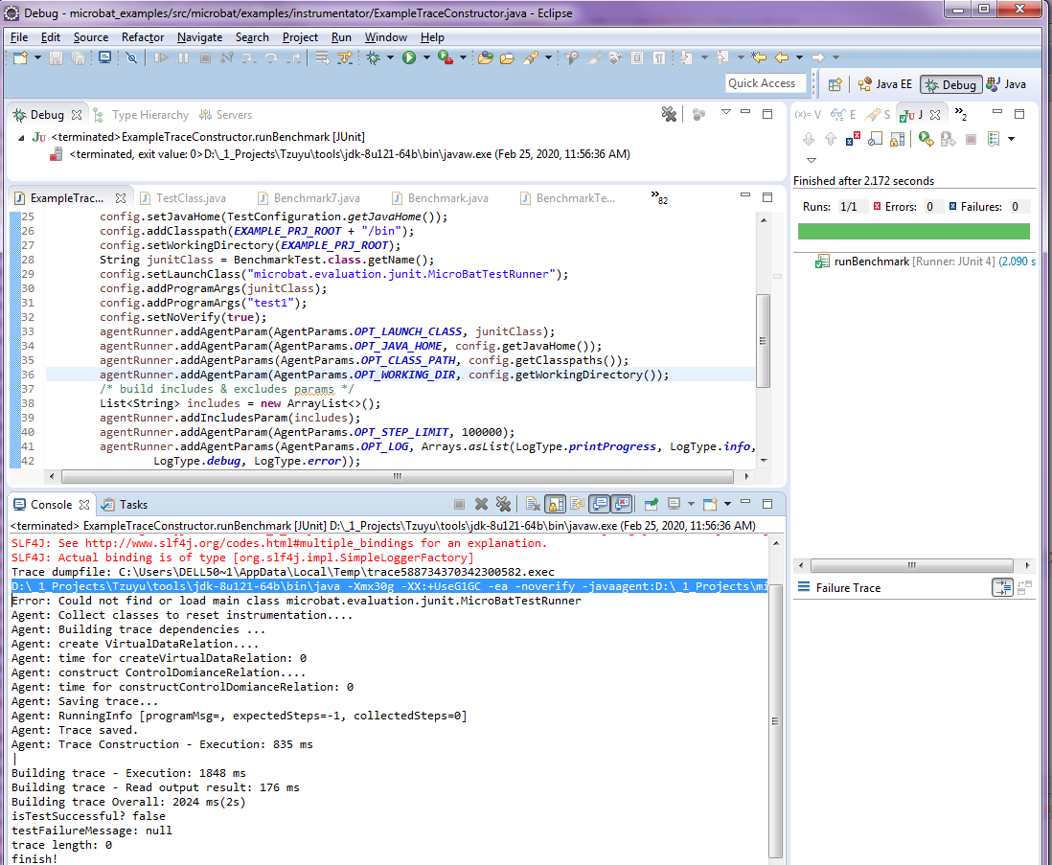

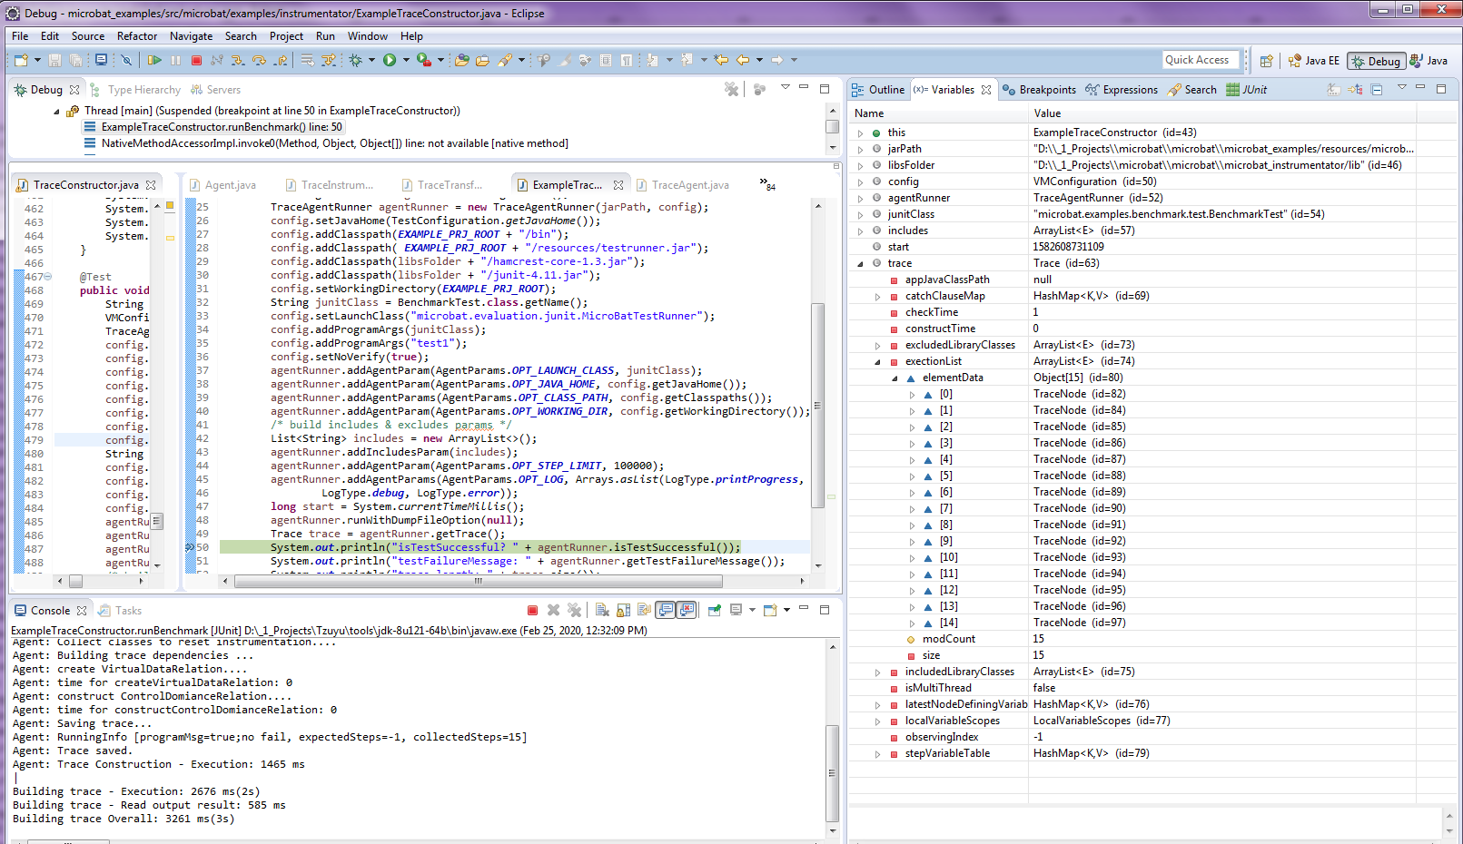

D:\_1_Projects\Tzuyu\tools\jdk-8u121-64b\bin\java -agentlib:jdwp=transport=dt_socket,server=y,suspend=y,address=9595 -Xmx30g -XX:+UseG1GC -ea -noverify -javaagent:D:\_1_Projects\microbat\microbat\microbat_examples/resources/microbat_instrumentator.jar=java_home=D:\_1_Projects\Tzuyu\tools\jdk-8u121-64b,stepLimit=100000,log=printProgress;info;debug;error,working_dir=D:\_1_Projects\microbat\microbat\microbat_examples,launch_class=microbat.examples.benchmark.test.BenchmarkTest,class_path=D:\_1_Projects\microbat\microbat\microbat_examples/bin,dump_file_path=C:\Users\DELL50~1\AppData\Local\Temp\trace588734370342300582.exec -cp D:\_1_Projects\microbat\microbat\microbat_examples/bin microbat.evaluation.junit.MicroBatTestRunner microbat.examples.benchmark.test.BenchmarkTest test1

