RES-Timekeeper Help Document

Introduction
RES-Timekeeper is an application that will help you track your working time and enter your weekly summaries into Agresso.

Getting Started
The installer for RES-Timekeeper will have added a shortcut to your Start Programs folder so the application will run automatically every time you log in. RES-Timekeeper appears as a small clock icon in the application notification area which is usually located in the bottom right hand corner of your screen. Right click on this icon to get a menu. To start with choose the “Edit Workorders…” option from this menu.
A window will appear into which you should enter the projects you commonly work on. You add a project by clicking on the empty line near the bottom of the form. Enter the project’s Agresso code in the Code column and the description of the project from Agresso in the Title column. Just add a few projects for the moment; you can always add more later.
Every 15 minutes a small window will pop-up in the bottom right hand corner of your screen. Use the small button to select the project that you have been working on. You can record a short note in the area on the right. Click on the checkbox to store the line.
If you realise that you have made a mistake you can use the “Edit Times…” menu option to change items that have been committed.
You can use the “Display Summary” menu option to see a week-by-week summary of the projects that you have been working on. This summary can be transferred automatically into Agresso.

Popup Menu
RES-Timekeeper doesn’t have a window but it has an icon that looks like a clock. This icon appears in the system notification area which is usually located in the bottom right hand corner of your taskbar. If you right click on the icon this menu will appear:
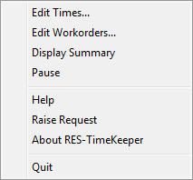
Edit Times: See here for more information.
Edit Workorders: See here for more information.
Display Summary: See here for more information.
Pause: Stops the pop-up window appearing.
Help: Displays this file.
Raise Request: Allows you to submit a bug report or new feature request.
Quit: Exits the RES-Timekeeper application

Popup Window
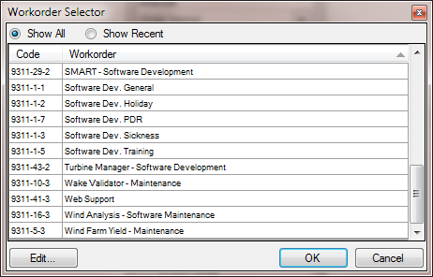
Every 15 minutes a window like this will pop-up allowing you to record what project or work-order you have been working on. The work-order will default to be the same as the previous period. You can enter a short description in the “Notes” section if you want to.
If you have been working on something different use the button to change the project. When you click on the button the project selector pictured on the left will appear. Double click on the project you require to select it. The option restricts the list to the last 10 projects that you have booked time to.
If your current project isn’t listed you should click the button to bring up the project editor which is documented here.
If you happen to have been too busy to acknowledge the pop-up new lines are added to the pop-up window every 15 minutes. Note that if you change the project on any line that project is applied to all subsequent times. Make sure that you confirm times from the earliest first to the most recent last.
Use the LUNCH project to record those times when you weren’t working but your PC was on.

Edit Workorders
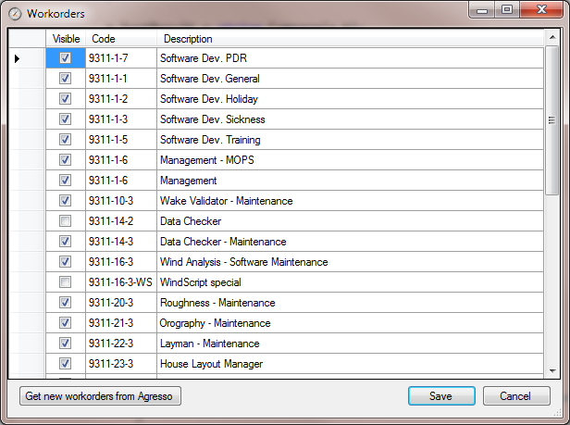
Use this form to add new and edit existing projects or workorders on your personal list.
To add a project click in the “Code” cell on the empty bottom line and enter a description in the “Title” cell. Make sure you use the same code and deception as the working order in Agresso. If they don’t match then the automatic entry of timesheets into Agresso will fail.
If you have finished working on a project and are unlikely to ever work on it again you can untick the checkbox on the left of the project’s line. This will hide that project from the list in the pop-up window.
If you have a lot of new projects to add you can try importing them from Agresso. Make sure the Agresso time entry page is open in Internet Explorer and click the button. This import method is experimental and not guaranteed to work.

Edit Items
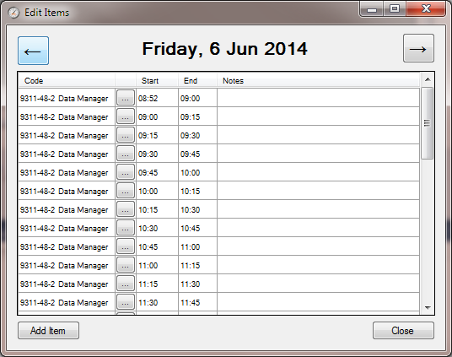
You can use the Edit Items form to alter any items that you have may committed by mistake. You can change the project by clicking on the button. You can add and edit the description for a time period by clicking in the “Notes” section. The start and end times can be edited by double clicking on them.
You can go back and forwards between days by clicking on the arrow buttons.
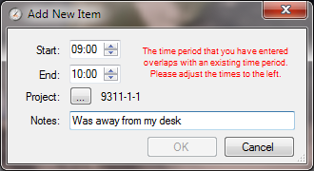
If you need to add some project work that wasn’t recorded because, for example, you were on a site visit that day you can use the button. This form will appear:

Enter the start and end times. Note that you can’t enter a time period that overlaps with any exiting times in the database. Choose a project and enter a description before clicking on OK.

Display Summary
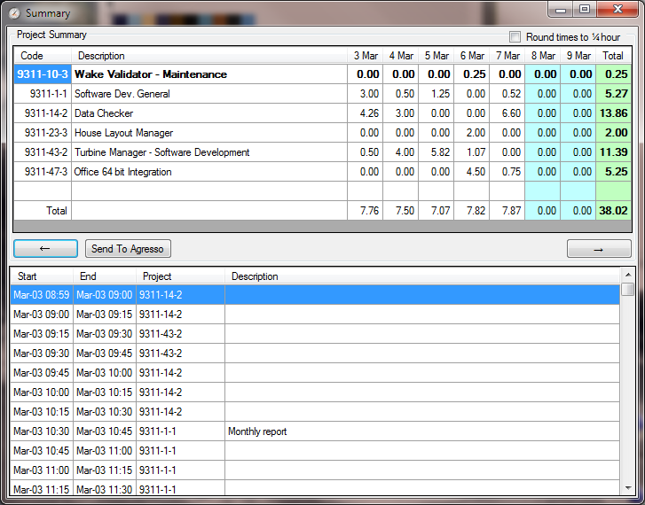
The summary form displays all the work that you have done during a week. You can move backwards and forwards through the weeks with the arrow buttons.
The upper grid shows the hours that you have worked on each active project in the week. The lower grid shows the time periods and notes recorded throughout the week.
When you are happy with the recorded times you can click the button which opens another form. Make sure that your Agresso webpage is looking at the time sheet entry page for the correct week and click the button. As each line is filled in the comment line will be ticked if the hours were successfully added to Agresso. If there was an error the commetn will be a cross and a reason for the error. Correct the problem by adjusting the project codes or description and try again.
Note that RES-Timekeeper does not automatically submit the completed timesheet. It is up to you to check the data entered into Agresso and submit the data yourself.

Release Notes

Version 1.2.0
First public release

Version 1.2.2
This version added two new features
Session logging: We can track who is using Timekeeper in case we need to notify you of any issues.
Update notification: You will be notified whenever a new version of Timekeeper is released and asked to update your installed copy.

Version 1.2.3
This version added several new features. Hello to the 47 people who use Timekeeper in the last week!
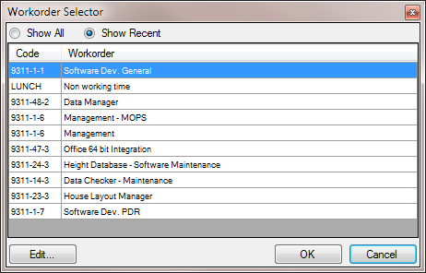
Easier selection of workorders: The Workorder Selector can now display the last 10 work orders that you have booked time to. This makes selecting codes easier if you have a lot of actives things that you are booking time to.
Prevention of multiple copies: There have been a few cases of users managing to run multiple simultaneous copies of Timekeeper when has caused problems with the database. Timekeeper now ensures that only one copy runs at a time.
Warning of overlapping times: If you did have two copies of timekeeper running it was possible to double book the same time. If this has occurred a warning now appears in the Summary window.
Rounding in Summary window: The rounding of the summation of project hours was incorrect. This didn’t affect the times entered into Agresso (which does its own summation) but the discontinuity was confusing.
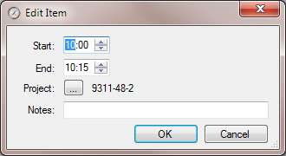
Editing of start and end times: You can now modify the start and/or end times of a work period via the Edit Times form. Double click on a time

