**ASSIGNMENT**

ANIMATION

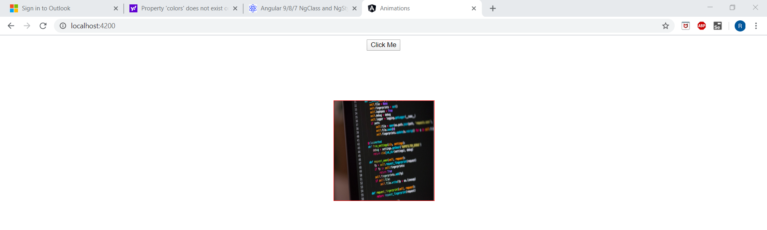

Figure 1Animation - moving the element when button is clicked

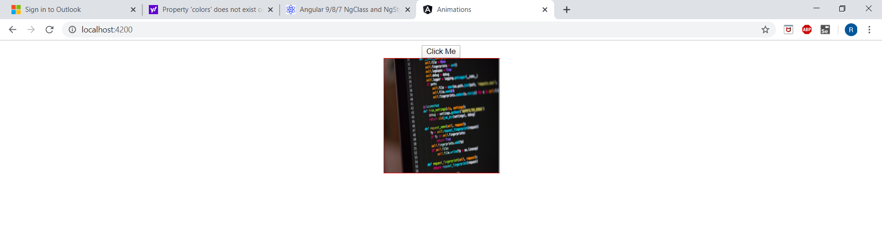

Figure 2 On click the element moves to the specified position

PARENT-CHILD

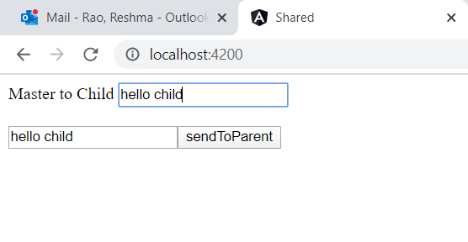

Figure 3Parent sends a message to the child

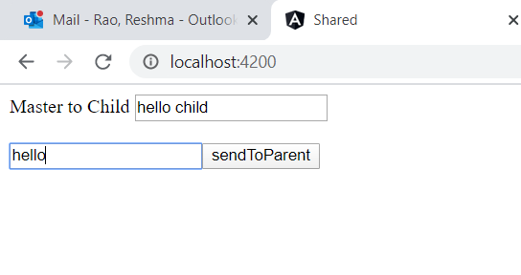

Figure 4 Child modifies the message and sends to master

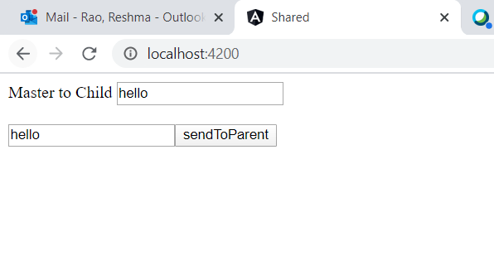

Figure 5 On button click master receives the message

DATA BINDING, EVENT BINDING

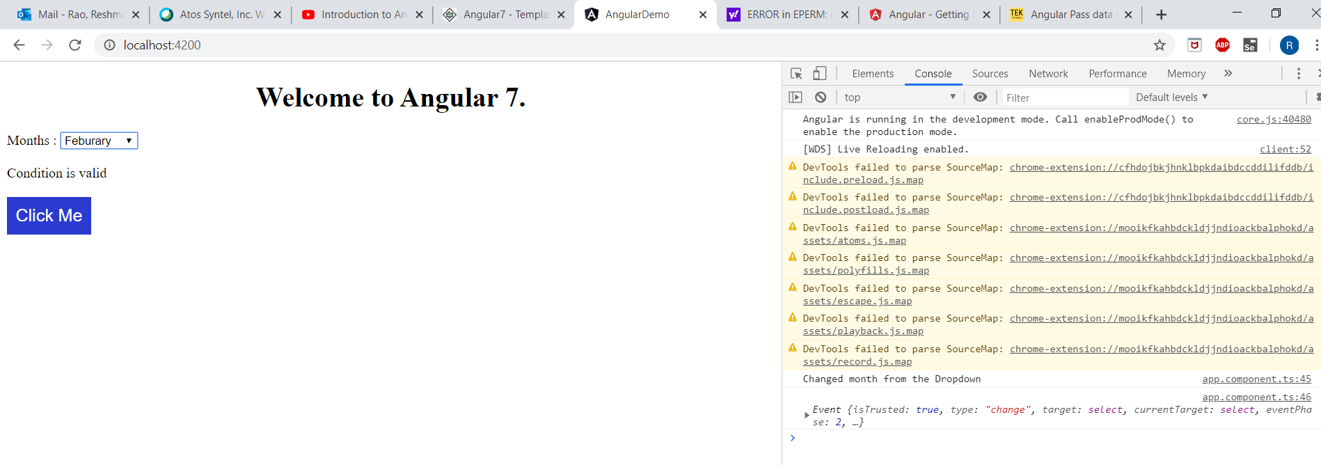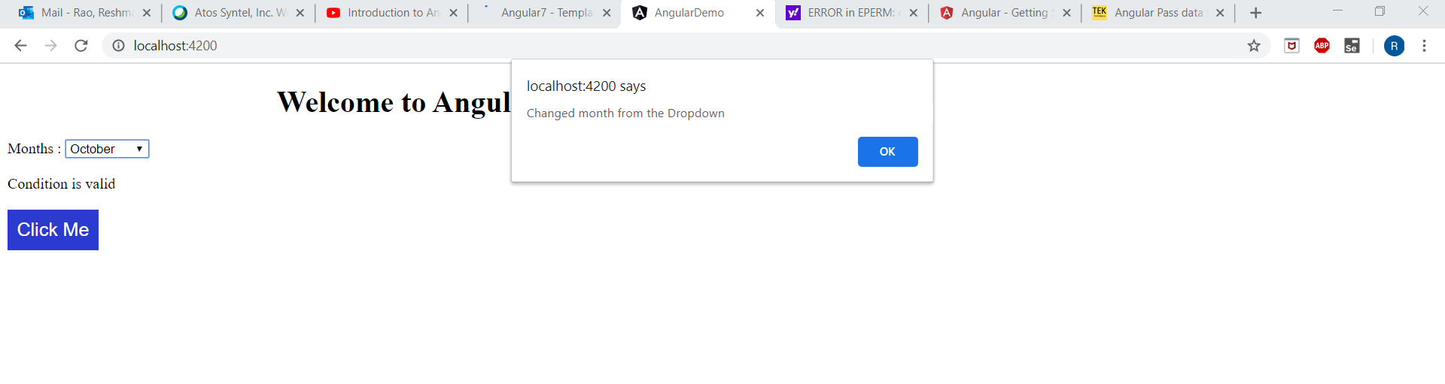

REACTIVE FORM

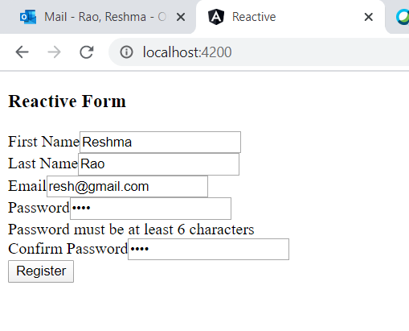

TEMPLATES

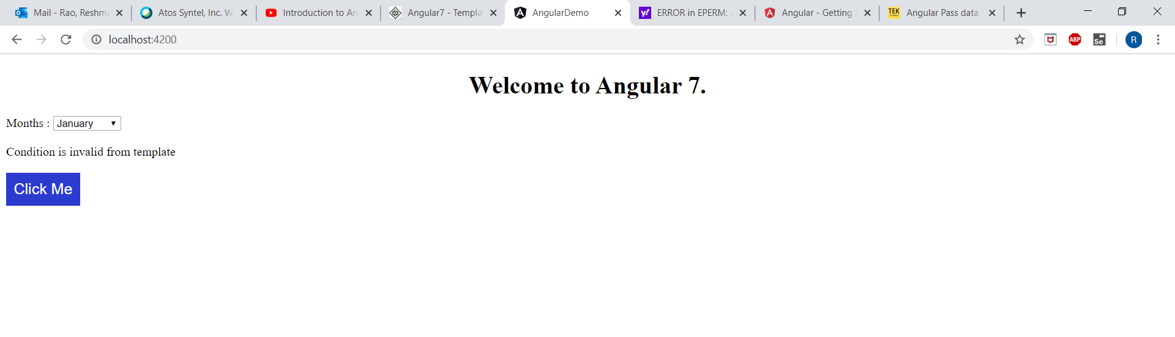

DIRECTIVES

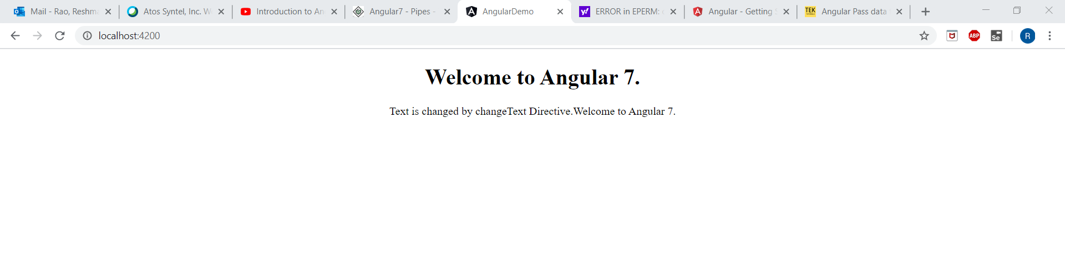

SORT

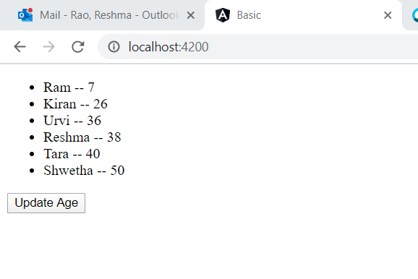

Figure Before updating age

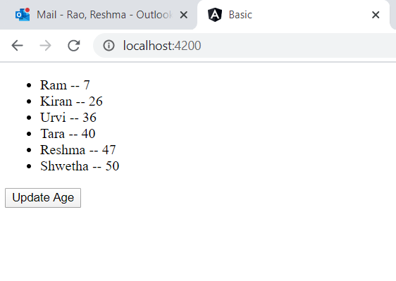

Figure On clicking, Randomizing age and sorting