Resham Furqan and
and 22765585
Healthcare Provider

Developing a computer systems environment
Assignment 2025

Table of Contents

Introduction ............................................. 3
Description of IT Requirements .............. 3
System Architecture ................................ 7
Network Topology ...................................11
Bash Scripting, Testing, and Validation.................................................13
User Manual ........................................... 35
References ............................................. 44
Appendix ................................................ 48

Introduction
A reliable IT system is essential for any healthcare provider company nowadays to maintain efficient operations, smooth patient care, and secure data management. This report outlines the key IT requirements for our healthcare system, including data backup and disaster recovery, secure EHRs, user access control, appointment scheduling, and communication tools. Moreover, this document details the necessary software, hardware, and network components to support a scalable and secure IT environment for our company. By implementing these technologies, our healthcare system will improve operational efficiency and patient experience.

Environment Set-Up for a Healthcare Provider
Description of Company’s Operational IT Requirements:
1. Secure Storage and Management of Patient Data
Electronic Health Records (EHR):
EHR software is a digital system that allows secure and real-time access to patient information, such as medical histories, diagnoses, medications, treatment plans, lab test results, etc. Implementing an EHR system for a healthcare company will enhance efficiency and improve patient care. Some types of EHR include Cloud-based, Open-Source, and On-Premises [1]
Depending on our needs for our healthcare company, we think a Cloud-Based EHR is recommended due to its lower cost, scalability, and security. Praxis EMR is an AI-powered EHR that offers both cloud-based and on-premises deployment options at a cost of $259/month. [7]
Data Security:
In any Healthcare system, data is very crucial. The sensitive nature of patient information requires proper confidentiality. With the rise of cloud computing, AI, and digital health records, new vulnerabilities are emerging such as cyberattacks, insider threats, third-party risk, and human errors – accounting for 88% of breaches. A healthcare company should have strict access controls, encryption and secure storage, threat detection, and regular security training. [2]
Some companies that help to maintain cybersecurity for healthcare centers include Menlo Security, Claroty, Imprivata, CyberArk, etc. Most of them have custom prices according to your needs. [8]

2. Efficient Appointment and Scheduling Systems
Efficient appointment scheduling is crucial in healthcare for patients to easily reach out the healthcare providers without any difficulty. This can help reduce the inefficiencies sometimes caused by phone calls and paper logs. These systems enable patients to book appointments and receive reminders about them to ensure they are not late or missing out. [3]
For our Healthcare system, such a system can be very beneficial and offer real-time booking, reminders, and availability checks. Dexcare and Goodcall are examples of AI-powered patient scheduling systems that help to connect patients with the right departements faster. [9]
Incorporating this feature into our Healthcare system will lead to better time management, resource allocation, and communication. It will improve patient experience and ensure smooth functioning across all departments.

3. Backup and Disaster Recovery
Protecting the data is one of the crucial elements of a healthcare system. With so much reliance on digital platforms, data can become more vulnerable to cyberattacks, natural disasters, and even human errors [4], to make sure when such events occur little to no data is lost, we can do the following:
- 3-2-1-1-0: This is a backup rule which is very effective. Maintain 3 copies of data on 2 different media, one of which should be offsite. [4]
- Disaster Recovery Planning: healthcare systems need comprehensive plans that minimize downtime and ensure rapid data recovery. [4]
- Regular Testing: conduct disaster recovery drills to test and refine response strategies. [4]
- Local backup plans: backing up the data to a hard disk or any other local device can offer fast recovery and data control as you know the exact location of where data is, but it also has disadvantages such as scalability issues and increased disaster risk as original data and backed up data are at the same place and can be damaged together. Although it can be useful, offsite data recovery plans are preferable. [25]
Healthcare Triangle provides cloud disaster recovery with a cost-effective model (pay-as-you-go) that can help a healthcare system with efficient backup. [10]

4. User Management and Access Control
In our healthcare system, we need to ensure that only authorized people have access to the data, this is essential for safeguarding Protected Health Information and ensuring operational security. [5]
Types of Digital Access Controls:
- Role-Based Access Control: effective RBAC ensures users only access information necessary for their roles, reducing potential security risks and accidental breaches.
- Multi-Factor Authentication: adds layers of security, requiring multiple forms of identification.
- Network Access Control: manages device connections to prevent unauthorized access to healthcare networks. [5]
bluebriX offers a comprehensive access control system with customizable features, including RBAC and Audit Trails. Some key functions are as follows:
- Access Control List: provides granular control over user permissions.
- Break-the-Glass Privacy: enables emergency access to critical data.
- Patient-Controlled Access: gives patients control over who can access their health records. [5]

5. Communication and Collaboration Tools:
Our Healthcare system should also have up-to-date communication and collaboration tools, such as cloud-based phone systems, VoIP technology, and collaborative tools. These can help to streamline workflows, improve communication, and address critical challenges that impact healthcare delivery [6].
- Cloud-based Phone Systems: these allow flexible and scalable communications across departments, improving response times and reducing hardware costs. [6]
- Collaboration Tools: Secure messaging and video calls improve real-time communication, while collaborative document sharing enables timely updates and better decision-making. [6]

System Architecture
- Hardware Specifications
Local Servers
Office Size | Minimum Specifications |  | Recommended Specifications
Office Size | CPU | RAM | CPU | RAM
For 1-10 computers | Dual-Core Xeon 1.6GHz+ | 8GB or higher | Quad-Core Xeon 1.6GHz+ | 12GB or higher
For 11-25 computers | Quad-Core Xeon 1.6GHz+ | 8GB or higher | Two Quad-Core Xeons 1.6GHz+ | 16GB or higher
For 26-50 Computers | Quad-Coe Xeon 1.6GHz+ | 12GB or higher | Two Quad Core Xeons 2.26GHz+ | 32GB or higher
[12]
In a hospital, managing patient data and handling appointments should be managed efficiently. For this reason, a server’s CPU like dual-core and quad-core are efficient as they consume less power, handle complex tasks and run multiple programs simultaneously. [20]
RAM allows the server to handle multiple processes simultaneously and higher RAM is crucial for hospitals as the number of connected devices increases, which ensures stability and faster data access for users, [21]

Terminal Servers
Office Size | Minimum Specifications |  | Recommended Specifications
Office Size | CPU | RAM | CPU | RAM
For 1-10 Remote Users | Quad-Core Xeon 1.6GHz | 8GB or higher | Two Quad-Core Xeons 1.6GHz+ | 12GB or higher
For 11-25 Remote Users | Quad-Core Xeon 1.6GHz+ | 12GB or higher | Two Quad-Core Xeons 1.6GHz+ | 16GB or higher
For 26-50 Remote Users | Quad-Core Xeon 1.6GHz | 16GB or higher | Two Quad-Core Xeons 2.26GHz+ | 32GB or higher
[12]
In hospitals, terminal servers manage remote user connections such as doctors, nurses, and administrative staff that access patient records and medical software. Robust CPUs, with high core counts, ensure smooth performance and real-time processing of medical data without delays. [20]
Terminal servers require additional memory because they manage the operating system and the applications for remote users. More users require higher memory usage due to session management and application demands. [20]
Workstations
 | Minimum | Recommended
CPU | Intel i5 or equivalent | Intel i7 or equivalent
RAM | 4GB or higher | 8GB or higher
Wireless | 802.11G+ | 802.11N+
[12]

Role-Based Workstation Requirements
Role | Recommended Specifications | Benefit
Doctors | Intel Core i7 or equivalent and 16GB+ RAM | Enhanced patient interaction and easier access to test results and patient data
Nurses | Intel Core i5 or equivalent and 8GB+ RAM | Efficient medication administration and real-time data access
Administrators | Intel Core i5 or equivalent and 8GB+ RAM | Better management of emails and video conferencing
Lab technicians | Intel Core i7 or equivalent and 16GB+ RAM | Faster analysis of larger datasets and accurate lab results.
[22] [23] [24]

2. Required Software Packages and Dependencies
Core Packages:
Server Operating System: Windows Server 2012 – 2022. [12]
Workstations Operating System: Win 8 Pro, Win 10 Pro, Win 11 Pro. [12]
Antivirus software: Microsoft Defender ATP. [13]
Encryption: BitLocker (Windows) / FileVault 2 (macOS). [13]
Key features of Hospital Software Modules:
EMR: Integrated patient records and appointment scheduling. [14]
Clinical Decision Support: Evidence-Based guidelines for diagnostics. [14]
Telemedicine: HD video consultations and remote monitoring. [14]
Practice Management Software: Appointment scheduling, billing management, and administrative task automation. [14]
Radiology Information System: Patient appointment scheduling, imaging process, and billing. [14]
Network Components
Bandwidth
Facility | Minimum Bandwidth | Use Cases
Hospital (100+ Beds) | 100 Mbps | Real-time imaging, HD telemedicine, and EHR
Clinic | 25 Mbps | Concurrent HER access and remote monitoring
Remote Users | 300 Kbps | Terminal server access
[15]
Network design requirements for the hospital:
- Multiple routers
- Structured cabling
- Optical fibers throughout the building
This is to prevent unauthorized access. These network components should be securely enclosed and only be accessed by authorized hospital network professionals. [17]
Performance Standards:
- Near real-time data replication (1 minute delay) between primary or secondary sites. [18]
- Carrier-class uptime to support life-critical applications. [18]
Security Implementation
- AI-driven threat detection with 24/7 anomaly monitoring.
- Multi-factor authentication for all clinical data access.
- Zero-trust segmentation for medical IoT devices. [19]
Network Topology to Illustrate the Design
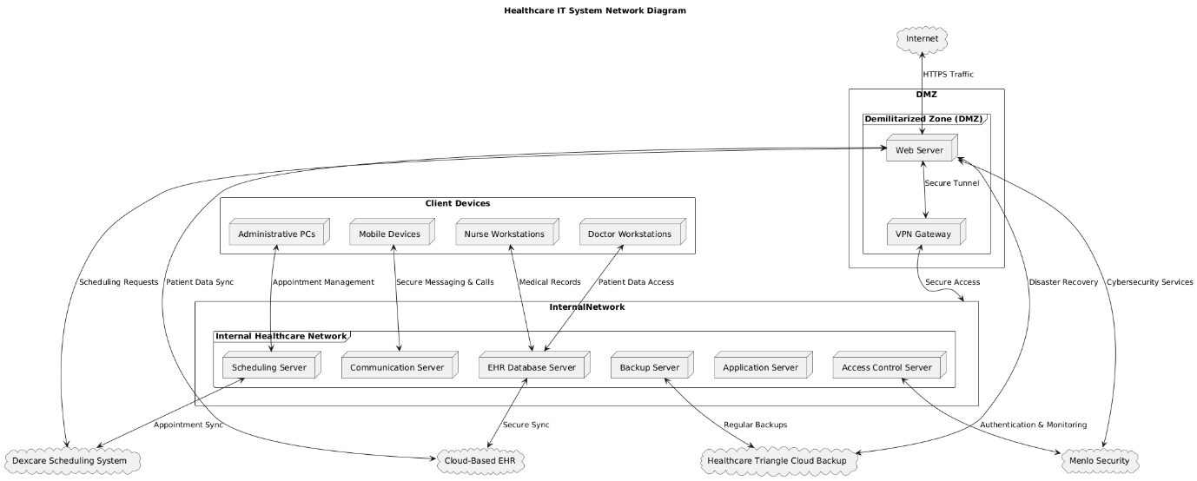[11]
This network diagram represents the system architecture of the IT System for our Healthcare provider. It illustrates the interaction between external cloud-based services, internal healthcare providers, clients' devices, and the Demilitarized Zone (used as a buffer between internal and external systems to avoid unauthorized access to sensitive data). It hosts the web server and VPN gateway to manage external connections safely. The web server interacts with cloud-based EHR systems, Healthcare Triangle cloud backup, and the Dexcare scheduling system to offer disaster recovery, patient data management, and scheduling. Menlo Security guarantees threat detection, safe access management, and encryption. Core operations are managed by some servers within the internal network, such as an EHR database server for patient data storage, a scheduling server for appointment scheduling, an application server for healthcare applications, an access control server for user permissions and authentication, and a backup server for disaster recovery. This design ensures security and maintains data integrity and accessibility across all the components.

Client Device Network:
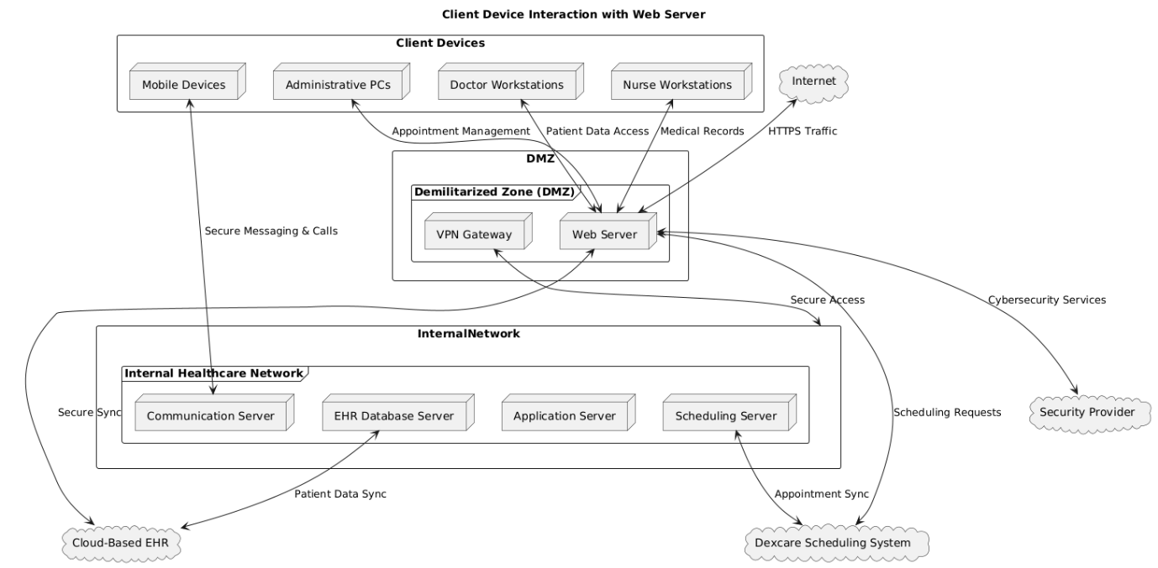
[11]
This client device network diagram explains how various users (doctors, admin staff, nurses, and mobile device users) connect to the system mentioned above. To access patient data and medical records, the workstations of nurses and doctors connect to the EHR database via the web server. To manage appointments, the admin PCs communicate with the scheduling server, and that server is connected to mobile devices, which allows healthcare providers to collaborate and send secure messages. With the use of HTTPS protocols, the web server located in the DMZ guarantees safe communication between external services and client devices. Moreover, authorized people can access the network securely from a distance with the help of a VPN gateway. This system promises effective data flow, smooth patient administration, strict security enforcement, and strong disaster recovery procedures.

Bash Scripting
1) Automated Encrypted Backups
Name of Script:
healthcare_backup.sh
Purpose:
This bash script performs automated backups for our Healthcare system. It will create timestamped backup archives of specified directories, log all operations and errors, and send email notifications on completion or failure. It implements rotation of backups, which means removing old backups to save space. It can also be scheduled through cron for regular execution.
Testing Methodology:
- Unit Testing
Each function was tested individually to ensure it performed its specific task as intended.
Function | Tested
log_message() | Verified log entries were correctly written and formatted.
check_disk_space() | Tested with various disk space scenarios.
verify_backup() | Tested with valid and corrupted archives.
load_config() | Tested with invalid and valid configuration files.
perform_backup() | Tested backup creation with different source configurations.
rotate_backups() | Verified proper removal of old backups.

- Edge Case Testing:
The script was tested with multiple edge cases including empty source directories, limited disk space scenarios, non-existent source directories, and invalid configuration parameters.

- Integration Testing:
The script was tested entirely to ensure that all the components work as intended, such as the email notification system, end-to-end backup process with actual data, and proper error handling when encountering issues.

Test Cases and Expected Outcomes:
Test Case | Description | Expected Outcome | Pass / Fail
Normal Backup | Normal backup operation with valid config | Successfully backed up, log entries created, and a notification sent | PASS
Low Disk Space | Insufficient disk space | Error message, notification for failure, exit code 7 | PASS
Email Failure | Email notification system failure | Warning in the log, the script continued | PASS
Backup Rotation | Backup rotation with 10 existing backups | Oldest 3 backups removed, 7 newest saved | PASS
Missing Config | Missing configuration file | Error message, notification for failure, exit code 2 | PASS
Non-existent Source | The source directory does not exist | Warning in the log, continued with other sources | PASS
Corrupt Archive | Failed backup verification | Error message, notification for failure, exit code 10 | PASS
Multiple Sources | Multiple sources directories | All directories backed up in a single archive | PASS

Test case: Normal backup
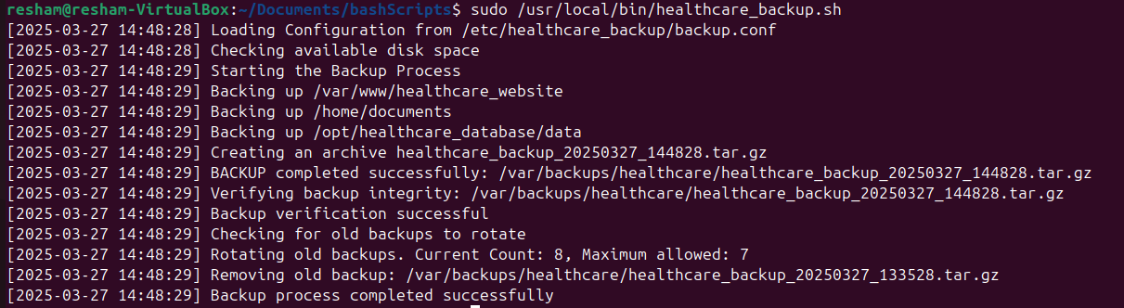
Test case: Backup Rotation
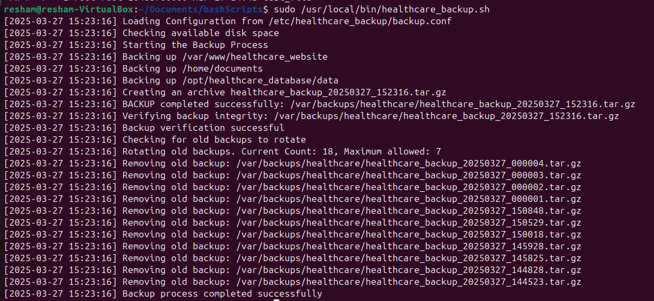

Test case: Non-existent source
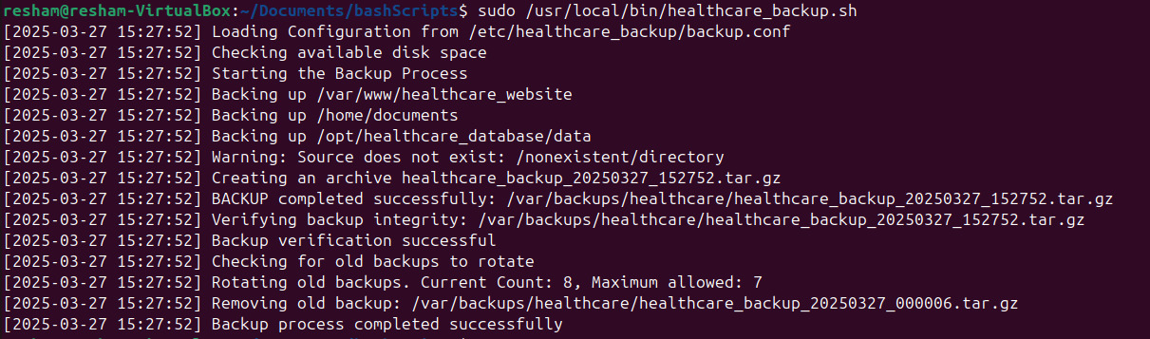

Issues found during Testing and their Solutions:
Issues | Solutions
Initial implementation failed when a source path contained spaces | The script was modified to properly handle paths with spaces
Email notifications were not working as intended in all environments | Error handling was added for mail command and email notifications were made optional
The script continued even when it could not create log directories | Error handling was added to exit if the log directory cannot be created
Backup verification sometimes failed due to incorrect tar parameters | tar parameters were standardized to ensure consistent archive creation and verification
Large directories caused temporary disk space shortages during backup | Disk space checking function was added to calculate the required space before starting

- System Performance and Resource Monitoring
Name of Script:
system_monitor.sh
Purpose:
This bash script monitors system performance and resource usage including CPU, memory, and disk usage. It logs the metrics, sends email notifications where thresholds are exceeded, and can run continuously in the background.
Testing Methodology:
- Unit testing
Each function was tested individually to ensure it performed its specific task correctly.
Function | Tested
Log_message() | Verified log entries were correctly written and formatted
Send_notification() | Tested with valid email addresses
Handle_error() | Verified error messages were correctly logged
Check_cpu() | Tested with various CPU load scenarios
Check_memory() | Tested with different memory usage levels
Check_disk() | Verified disk usage detection and alerting
Load_config() | Tested with valid and invalid configuration files
Monitor_system() | Verified correct execution for all check functions

- Edge Case Testing
The script was tested with multiple edge cases including 1000% CPU usage, near-full memory, and critically low disk space.
- Integration Testing
The script was tested to ensure that all components work together including the monitoring loop, email notification system, and proper error handling.

Test Cases and Expected Outcomes:
Test Case | Description | Expected Outcomes | Pass/Fail
Normal Operation | The system under normal load | Regular log entries, no alerts | PASS
High CPU usage | CPU usage exceeding the threshold | Log entry and email alert for high CPU usage | PASS
High memory usage | Memory usage exceeding the threshold | Log entry and email alert for high memory usage | PASS
High disk usage | Disk usage exceeding the threshold | Log entry and email alert for high disk usage | PASS
Missing Config | Configuration file not found | Error message, notification for failure | PASS
Invalid Thresholds | Negative or >100% thresholds in config | Script uses default values, warning in the log | PASS
Email Failure | Email notification system failure | Warning in log and script continues monitoring | PASS

Test Case: Normal Operation
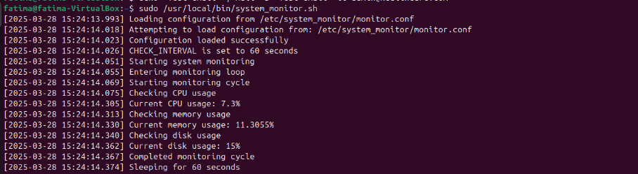
Test case: High CPU usage
CPU threshold was set to 10 for faster results.
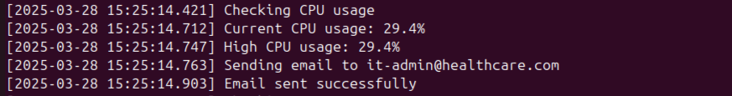
Test Case: High Memory usage
The memory threshold was set to 10 for faster results.

Issues found during Testing and their Solutions:
Issues | Solutions
Initial implementations caused high CPU usage. | Improved resource usage checks and increased interval
The script was not executed consistently at specified intervals | Implemented precise timing for the interval in the monitor_system function
Email notifications were not working | Added error handling for mail command

- Automated Patient Data Encryption
Name of Script:
patient_data.sh
Purpose:
This script ensures a secure method for encrypting sensitive patient data while generating unique encryption keys, logging all encryption activities, encrypting patient files with GPG encryption, and ensuring patient data privacy with compliance with healthcare data protection regulations.

Testing Methodology:
- Static Code Analysis:
Static Code Analysis was used to validate the security of this script. To identify any potential vulnerability in the script, bad coding practices, and errors in the script, shellcheck was used to perform a comprehensive scan. This was done to ensure the scripts were secure to maintain patient data encryption.
- Functional Testing:
Test Case | Input | Expected Outcome | Validation Method
Key Generation | Patient ID | A unique ID for the patient should be generated for data encryption and successful log entry | Verified key existence in $ENCRYPTION_KEY_DIR and checked the log file for the success of the generation message
File Encryption | Patient ID and sample patient data file | The original file should be encrypted and created in $ENCRYPTED_DATA_DIR and the original file should be securely deleted using shred | Confirmed the encrypted file exists, verified the original file is removed, and checked the encryption integrity

- Security Testing:
This involved validating critical security mechanisms. GPG key generation parameters were verified to ensure cryptographic protection, with a one-year key expiration mechanism to reduce long-term security risks. The effectiveness of the shred utility was confirmed for secure file detection, which ensured that sensitive patient information could not be recovered after encryption, maintaining high standards of data confidentiality.

Test Cases and Expected Outcomes:
Test Case | Description | Input | Expected Outcomes | PASS/FAIL
Basic Key Generation | Verify successful encryption key generation for a patient | Valid Patient ID | A unique GPG key should be generated and stored in a specified encryption key directory with a successful log entry and the key should match the 4096-bit RSA specification | PASS
File Encryption Process | Encrypt a patient data file | Patient ID and sample patient data file | An encrypted file should be created in the encrypted data directory, the original file should be securely deleted, an encryption log should be generated, and the encrypted file should not be readable without key | PASS
Invalid Patient ID | Attempt key generation with invalid or empty patient ID | Empty or Null patient ID | The script should generate an error log, no key generation should occur, the script should exit with a non-zero status, and the detailed error message should be in the log file | PASS
Non-Existent Input File | Attempt to encrypt a non-existent file | Path to file that does not exist | The script should generate an error log, with no encryption attempted, a detailed error message, and the script should exit with a non-zero status | PASS
Multiple Concurrent Encryption | Simulate multiple patient data encryption requests | Multiple patient IDs and files | Each file should be encrypted separately, unique keys should be there for each patient, no key or conflict, and accurate logging of each encryption | PASS
Key Expiration Mechanism | Verify key expiration after one year | Generated encryption key | The key should be valid for exactly one year, the automatic key invalidation should occur after expiration, and warning logs near the expiration date | PASS
Log File Management | Verify logging functionality | Multiple script executions | Comprehensive log entries should be there, log files should grow with each execution, timestamps should be accurate, and clear distinction between info and error logs | PASS

Test Case: Basic Key Generation:
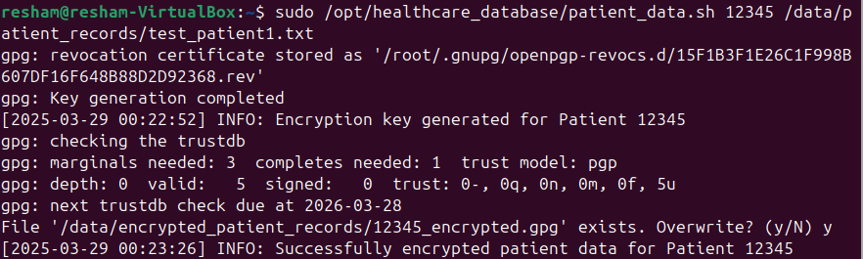

Test Case: Invalid Patient ID:
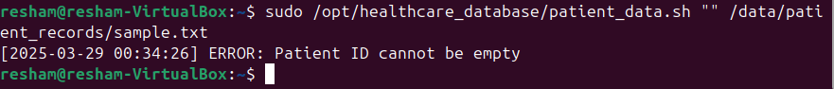

Test Case: Non-Existent Input File:

Issues found during Testing and their Solutions:
Issues | Solutions
Unauthorized users could potentially run the script | Added root privilege check in the main function
Insufficient logging for security events | Comprehensive logging with timestamp and message type
No mechanism for key rotation or revocation | Added a one-year expiration to generate keys
Generic error handling | Added global error trap with line number reporting

- Automated Health Insurance Claim Processing:
Name of Script:
health_insurance_claim.sh
Purpose:
This script is designed to automate the processing of health insurance claims for our healthcare company. It validates the incoming claim files, logs all activities, processes the claims with error handling, and organizes the claims into processed and error directories.

Testing Methodology:
- Unit Testing:
In unit testing individual functions from the script were tested to verify that each function can handle multiple inputs without crashing, it also validated claim files and processed claims correctly.

- Integration Testing:
Integration testing examined the entire claim processing workflow. Tested the script’s ability to handle multiple claims, verified correct file routing, and ensured comprehensive logging
- Error Handling Testing:
Error handling testing was done with different scenarios such as invalid claims, insufficient file permissions, resource constraints, and unexpected system conditions to ensure proper error messages are displayed and the script does not crash.

Test Cases and Expected Outcomes:
Test Case | Description | Input | Expected Outcome | PASS/ FAIL
Valid Claim File Processing | Validates successful processing of a correctly formatted claim file, ensuring efficient handling of standard claim submissions | Properly formatted claim file with valid data | The file should be moved to the processed directory, a successful log entry should be created, and no errors should be generated | PASS
Invalid File Format | Tests error handling for malformed claim files, verifying the system’s ability to detect and reject incorrectly structured claims | Claim file with insufficient columns | The file should be moved to the error directory, an error log should be generated, and processing should be stopped for that specific file | PASS
Empty Claims Directory | Evaluate script behavior when no claims are present, ensuring graceful handling of empty processing scenarios | No claim files in the claims directory | Informational log messages should be there, no processing should be attempted, and script should continue executing | PASS
File Permission Issues | Check system robustness against file access restrictions, ensuring proper error detection and logging of permission-related problems | Claim files with restricted permissions | Appropriate error handling should be there to identify problematic files and log the error | PASS
Zero or Negative Claim | Examines validation of claim amounts, confirming rejection of financially impossible or invalid claim submissions | Claim file with invalid claim amount | File should be moved to error directory, error log should be generated, and processing should be halted for that specific file | PASS
Large Volume of Claims | Stress tests the script’s performance with multiple claims, validating batch processing and claim segregation capabilities | Multiple claim files in the claims directory | All valid claims should be processed, and invalid claims should be segregated, there should be comprehensive logging of all activities | PASS

Test Case: Valid Claim File Processing:
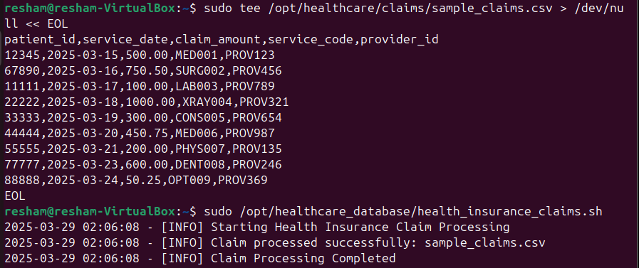
Test Case: Invalid File Format
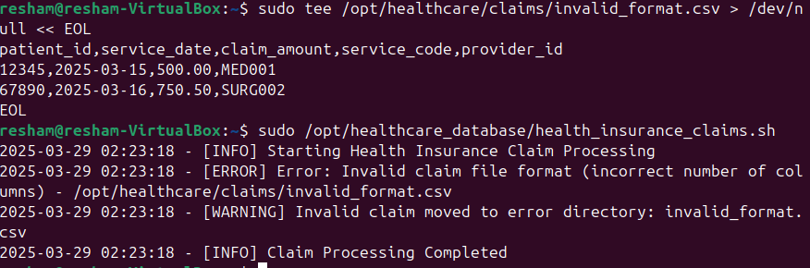
Test Case: Empty Claims Directory:
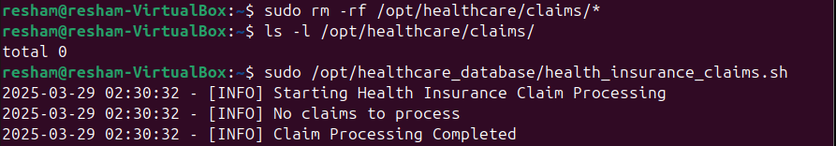
Issues found during Testing and their Solutions:
Issues | Solutions
Script unable to read/write claim files | Implemented robust file permission checks with comprehensive error logging and graceful error handling mechanisms
Extremely large claim files causing performance bottlenecks | Applied file size limits, implemented streaming processing, and added dynamic memory management for efficient large file processing
Multiple script instances running simultaneously | Created a PID-based locking system to prevent simultaneous script executions and ensured process integrity
Temporary network or storage unavailability | Developed a robust retry strategy with exponential backoff and comprehensive error tracking and logging

- User Management Script
Name of script:
hospital_user_management.sh
Purpose: This script automates user management tasks for the hospital’s IT system, including adding and removing users, setting permissions, and managing access to various hospital resources. It ensures secure and efficient management of user accounts, which is crucial for maintaining patient data privacy.
Testing Methodology:
- Unit testing: The functions were tested to verify their ability to handle various inputs, correctly add and remove users, and set appropriate permissions without errors.
- Integration testing: The entire user management workflow was tested, testing the script’s ability to handle multiple operations and interact with system user databases across different hospital departments.
- Error handling: Verified script handling with invalid inputs like if the user attempts to remove a non-existing user and creates error conditions to validate the script’s error handling mechanisms and logging capabilities.

Test cases and Expected outcomes:
Test case | Description | Input | Expected Outcome | PASS/FAIL
Adding new user | Validates successful creation of the new user account | New user details like username and role. | User account created and appropriate permissions added | PASS
Removing existing user | Tests proper removal of the user account | Existing username | The user account removed, and access revoked | PASS
Modifying user permissions | Checks the ability to update user access levels | Username and new permission set | User permissions updated, changes logged | PASS
Removing a non-existing username | Tests error handling for invalid user inputs for non-existing usernames | Non-existing username | Error message generated saying the username does not exist. | PASS

Test case: Adding new user


Test case: Removing a user
Test case: Removing a user that does not exist
Issues found during testing and their solutions:
Issue | Solution
LDAP server was not running and accessible. | Adjusted the script to work without LDAP and modified it using local user database.

6) System Uptime Checker
Name of script:
Uptime_checker.sh
Purpose: This script checks system’s uptime logs the information, and sends email notifications when the system has been up for a specified duration. It runs continuously in the background as a system service after every hour.

Testing Methodology:
- Unit testing: each function was tested separately to ensure it performs its specific task correctly.
Function tested | Testing approach
Log_message() | Verified log entries were correctly written and formatted
Send_noficiation() | Tested with valid email addresses
Check_uptime() | Tested with different uptime scenarios
Load_config() | Tested with valid and invalid configuration files

2. Edge case testing: The script was tested with multiple edge cases including very short and long uptime durations.
Test cases and Expected outcomes:
Test case | Description | Expected outcomes | Pass/Fail
Normal operation | System uptime below threshold | Regular log entries and no alerts | PASS
Uptime exceeded | System uptime exceeding the threshold | Log entry and email alert for high uptime | PASS
Missing configuration file | Configuration file not found | Error message, notification for failure | PASS
Invalid threshold | Negative threshold in configuration file | Script uses default value, warning in the log | PASS
Multiple log files | Process directory with 5+ log files | All files analyzed correctly in sequence | PASS
Email failure | Email notification system failure | Warning in log and script continues monitoring | PASS

Test case: Normal operation
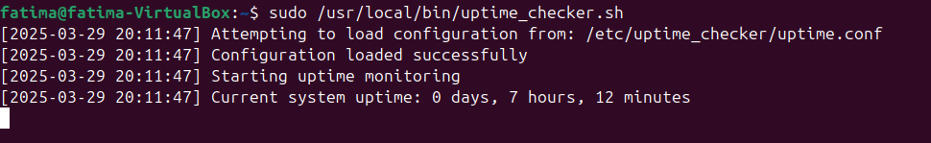
Test case: Uptime threshold exceeded
To test this, the script was temporarily modified to simulate a longer uptime and set the uptime threshold in the config file lower than the simulated uptime.
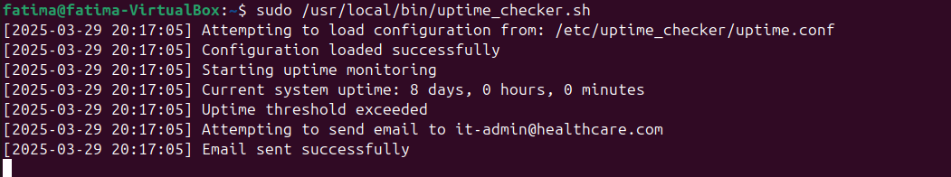
Test case: Missing configuration file
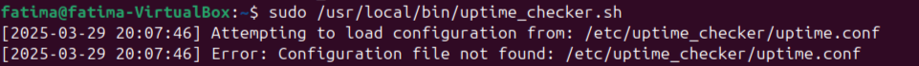

Issues found when testing and their solutions:
Issues | Solutions
Incorrect uptime calculation | Fixed the uptime calculation logic in the check_uptime function
Script not executing at precise intervals | Implemented precise timing in the main loop

User Manual
All the scripts can be run in either Ubuntu or RHEL-based redhat environment, but Ubuntu is preferable.
- healthcare_backup.sh:
Required Directories:
Directory Path | Purpose
/var/www/healthcare_website | To store website-related files for backup
/home/documents | Contains important healthcare documents
/opt/healthcare_database/data | To store database files for backup
/var/backups/healthcare | Destination for storing backup files

Create Directories:
- sudo mkdir -p /var/www/healthcare_website
- sudo mkdir -p /home/documents
- sudo mkdir -p /opt/healthcare_database/data
- sudo mkrdir -p /var/backups/healthcare
Update system packages to install required utilities:
- sudo apt update
- sudo apt install tar gzip
- sudo apt install mailutils
Create MySQL user and set permissions:
- sudo group add mysql
- sudo useradd -r -g mysql -s /bin/false mysql
- sudo chown -R mysql:mysql /opt/healthcare_database/data
Install the backup script and create a config file:
Save the script at: /usr/local/bin/healthcare_backup.sh
The contents of the config file are provided in the appendix. To create the config file: sudo mkdir -p /etc/healthcare_backup
Open in a text editor such as vim to edit.
Set appropriate permissions:
- sudo chmod 750 /usr/local/bin/healthcare_backup.sh
- sudo chmod 640 /etc/healthcare_backup.conf
- sudo chmod 750 /var/backups/healthcare
Configure cron job:
sudo crontab -e and set it to: 0 2 * * * /usr/local/bin/healthcare_backup.sh
Run the script:
sudo /usr/local/bin/healthcare_backup.sh

- system_monior.sh
Install required utilities
Sudo apt update
Sudo apt install bc mailutils

Create necessary directories
Run the following command:
Sudo mkdir -p /etc/system_monitor /var/log

Save the monitoring script
Run the following command: sudo vim /usr/local/bin/system_monitor.sh and copy paste the provided script the appendix to this file

Create the configuration file
Run the command: Sudo vim /etc/system_monitor/monitor.conf
Copy paste the config file provided in the appendix to this file

Set correct permissions
Run these commands:
sudo chmod 750 /usr/local/bin/system_monitor.sh
sudo chmod 640 /etc/system_monitor/monitor.conf

Test the script
Run the command: sudo /usr/local/bin/system_monitor.sh

Set up as a Systemd service
Create the service file by running the following command:
Sudo vim /etc/system/system/system-monitor.service and add the content which is provided in the appendix.

Enable and start the service
Run these commands:
Sudo systemctl enable system-monitor.service
Sudo systemctl start system-monitor.service

Check service status
To very if service is running run the command:
Sudo systemctl status system-monitor.service

View the logs
Sudo tail -f /var/log/system_monitor.log

- patient_data.sh
Requirements:
Install GPG (GNU Privacy Guard) using: sudo apt-get install gpg
Sudo privilieges
500 MB Minimum disk space for encryption keys and logs

Copy the Script:
(use the code from appendix)
sudo mkdir -p /opt/healthcare_database/patient_data.sh

Create the Input File:
Sudo touch /var/opt/healthcare_database/patient_data.txt

Set appropriate permissions:
sudo chmod +x /opt/healthcare_database/patients_data.sh
Required Directories:
Directory | Purpose
/etc/healthcare/encryption_keys/ | To store patient encryption keys
/data/patient_records/ | Source patient data files
/data/encrypted_pateint_records/ | Encrypted patient files
/var/log/patient_data_encryption.log | Logging files

Run the script:
sudo /opt/healthcare_database/patient_data.sh 12345 /var/opt/healthcare_database/patient_data.txt
Press Y and promted for overwite.

- health_insurance_claim.sh
Required Directories:
Directory | Purpose
/opt/healthcare/claims | For incoming claim files
/opt/healthcare/processed_claims | For processed claims to be moved to
/opt/healthcare/error_claims | For invalid claims to be moved to
Create these directories using sudo mkdir -p

Set Permissions:
The script should have read and write permissions for the above-mentioned directories, and the log file (/var/log/healthcare_insurance_claims.log) must be writable. You can use the following commands:
sudo -R 775 /opt/healthcare/claims /opt/healthcare/processed_claims /opt/healthcare/error_claims
verify by using the following command:
ls -ld /opt/healthcare/claims /opt/healthcare/processed_claims /opt/healthcare/error_claims

Create the log file and set the permissions:
sudo touch /var/log/health_insurance_claims.log
sudo chmod 666 /var/log/health_insurance_claims.log

Copy the Script:
Copy the script from the appendix to sudo vim /opt/healthcare_database/health_insurance_claims.sh. Additionally, create a CSV file:
sudo tee /opt/healthcare/claims/sample_claims.csv > /dev/null << EOL
patient_id,service_date,claim_amount,service_code,provider_id
12345,2025-03-15,500.00,MED001,PROV123
67890,2025-03-16,750.50,SURG002,PROV456
11111,2025-03-17,100.00,LAB003,PROV789
22222,2025-03-18,1000.00,XRAY004,PROV321
33333,2025-03-19,300.00,CONS005,PROV654
44444,2025-03-20,200.00,MED006,PROV987
55555,2025-03-21,200.00,PHYS007,PROV135
77777,2025-03-23,600.00,DENT008,PROV246
88888,2025-03-24,0.00,OPT009,PROV369
EOL

Make the Script Executable:
sudo chmod +x /opt/healthcare_database/health_insurance_claims.sh

Run the Script:
sudo /opt/healthcare_database/health_insurance_claims.sh

- hospital_user_management.sh
Ensure jq is installed:
sudo apt-get install jq
Save the script:
sudo vim /usr/local/bin/hospital_user_management.sh
Copy paste the script provided in the appendix to this file.
Make the script executable
sudo chmod +x /usr/local/bin/hospital_user_management.sh
Create the following files and directories:
Run the following commands:
sudo mkdir -p /etc/hospital
sudo touch /etc/hospital/users.db
sudo touch /etc/hospital/permissions.json
sudo mkdir -p /var/log
sudo touch /var/log/hospital_user_management.log
Create the permissions file:
sudo vim /etc/hospital/permissions.json
Add role-based permissions, for e.g. :
{
“doctor”: [“view_patient_records”, “prescrible_medication”],
“nurse”: [“view_patient_records”, ‘update_vitals”],
“admin”: [“manage_users”, “view_patient_records”, “update_vitals”]
}
Adding a user
sudo /usr/local/bin/hospital_user_management.sh add (username) (role) (department)
For example:
sudo /usr/local/bin/hospital_user_management.sh add testuser doctor cardiology
To verify if user was added:
Run the command: cat /etc/hospital/users.db
Removing the user
sudo /usr/local/bin/hospital_user_management.sh remove (username)
Bulk importing users:
Create a csv file
vim users.csv
With format: username,role,department with no space
For example include:
Testuser1, doctor, cardiology
Run the import command:
sudo /usr/local/bin/hospital_user_management.sh import /home/Fatima/users.csv
Replace Fatima with your path name
Check the log file for error messages:
sudo tail -f /var/log/hospital_user_management.log
Verify file permissions:
ls -l /etc/hospital/users.db /etc/hospital/permissions.json
To ensure they are readable and writable by the script.
Keep the permissions file updated as roles change:
sudo vim /etc/hospital/permissions.json

6. uptime_checker.sh
Install required utilities
sudo apt update
sudo apt install mailutils
Create the necessary directories
sudo mkdir -p /etc/uptime_checker /var/log
Save the script
Run the command: sudo vim /usr/local/bin/uptime_checker.sh
Copy and paste the provided script in the appendix to this file
Create the configuration file
sudo vim /etc/uptime_checker/uptime.conf
Copy and paste the config file provided in the appendix to this file.
Set correct permissions
Run command
sudo chmod 750 /usr/local/bin/uptime_checker.sh
sudo chmod 640 /etc/uptime_checker/uptime.conf
Test the script
Run command:
sudo /usr/local/bin/uptime_checker.sh
REFERENCES
[1]
Bigscal Technologies, “How EHR Software Affects Efficiency in Healthcare? - Bigscal Technologies - Medium,” Medium, Jun. 05, 2024. https://medium.com/@Bigscal-Technologies/how-ehr-software-affects-efficiency-in-healthcare-c34c6cba7c26 (accessed Mar. 09, 2025).
[2]
“A Comprehensive Guide to Healthcare Data Security | Metomic,” Metomic.io, 2022. https://www.metomic.io/resource-centre/a-comprehensive-guide-to-healthcare-data-security
[3]
Smart Medical History, “Why Appointment Scheduling Systems Are Essential for Healthcare Success,” Smart Medical History, Dec. 18, 2024. https://smartmedhx.ai/trends/appointment-scheduling-system/
[4]
Dataprise, “The Importance of Data Backup and Disaster Recovery in Healthcare,” Dataprise, Jan. 10, 2024. https://www.dataprise.com/resources/blog/data-backup-importance-in-healthcare/
[5]
blueBriX, “The Importance of Access Control in Healthcare - blueBriX,” blueBriX, Nov. 22, 2024. https://bluebrix.health/blogs/the-importance-of-access-control-in-healthcare
[6]
V. Finaldi, “Enhancing Efficiency & Collaboration in the Digital Age of Healthcare,” Telecloud.net, Jul. 06, 2023. https://telecloud.net/blog/enhancing-efficiency-collaboration-in-the-digital-age-of-healthcare
[7]
Praxis, “Top EHR Software Vendors of 2020 Comparison | Electronic Medical Records Software | EMR Software | Praxis EMR/EHR Software,” www.praxisemr.com, 2024. https://www.praxisemr.com/top-ehr-vendors.html
[8]
M. Law, “Top 10 cybersecurity companies in healthcare,” cybermagazine.com, Sep. 13, 2023. https://cybermagazine.com/top10/top-10-cybersecurity-companies-in-healthcare
[9]
“Top 10 Healthcare Appointment and Scheduling Systems,” Goodcall.com, 2025. https://www.goodcall.com/post/healthcare-appointment-scheduling-software (accessed Mar. 16, 2025).
[10]
“Disaster Recovery and Backup for Healthcare | Healthcare Triangle,” Healthcaretriangle.com, Oct. 20, 2023. https://www.healthcaretriangle.com/backup-and-disaster-recovery/ (accessed Mar. 16, 2025).
[11]
“nwdiag,” PlantUML.com, 2025. https://plantuml.com/nwdiag (accessed Mar. 16, 2025).
[12]
“1st Providers Choice,” 1st Providers Choice, Apr. 02, 2024. https://1stproviderschoice.com/company/system-requirements.php (accessed Mar. 17, 2025).
[13]
M. M. School, “Minimum Hardware and Software Requirements,” Medical School Information Technology. https://med.uth.edu/msit/policies/minimum-hardware-and-software-requirements/

[14]
“Computer Software Used In Hospitals: Types & Benefits,” LazyMonkey - QR Based Feedback System - Blogs, Jun. 14, 2024. https://lazymonkey.in/blog/computer-software-used-in-hospitals/ (accessed Mar. 17, 2025).
[15]
“What is the recommended bandwidth for different types of health care providers? | HealthIT.gov,” www.healthit.gov, Sep. 10, 2019. https://www.healthit.gov/faq/what-recommended-bandwidth-different-types-health-care-providers
[16]
mydsn, “Hardware and Software Requirements for a Hospital Management System in Kenya,” TechSphere, Aug. 20, 2024. https://techsphereltd.com/hardware-and-software-requirements-for-a-hospital-management-system-in-kenya/ (accessed Mar. 17, 2025).
[17]
A. Lundin, “Best Practices in Networking a Hospital Building,” 24x7, Jan. 04, 2023. https://24x7mag.com/medical-equipment/software/it-integration/best-practices-in-networking-a-hospital-building/
[18]
“FIVE REQUIREMENTS OF A HEALTHCARE NETWORK.” Available: https://www.juniper.net/content/dam/www/assets/white-papers/us/en/2021/five-requirements-of-a-healthcare-network.pdf
[19]
Om V, “In the digital age, healthcare institutions face relentless pressure to safeguard patient data and maintain the uninterrupted flow of essential services. Hospitals, due to their treasure trove of valuable data and critical functions, have emerged as prime targets for cyberattacks.,” Linkedin.com, Oct. 03, 2023. https://www.linkedin.com/pulse/strengthening-hospital-networks-guide-security-healthtech-om-v (accessed Mar. 17, 2025).
[20]
B. Marijan, “Dual-Core vs. Quad-Core CPU: What’s the Difference?,” Knowledge Base by phoenixNAP, Apr. 19, 2023. https://phoenixnap.com/kb/dual-core-vs-quad-core
[21]
“Server vs Home Computer Specs (CPU, RAM, Storage) | ZebraHost Blog,” Zebrahost.com, 2023. https://blog.zebrahost.com/server-vs-home-computer-specs-cpu-ram-storage/ (accessed Mar. 24, 2025).
[22]
“Benefits of Workstations on Wheels in Healthcare - Scott Clark Medical,” Jan. 13, 2020. https://www.scott-clark.com/blog/benefits-workstations-wheels-healthcare-2/
[23]
wphungerford, “Workstations on Wheels (WOWs) and Their Benefits to Nurses | Convergint IMS | Carts, Workstations, L&D Furniture,” Convergint IMS | Carts, Workstations, L&D Furniture, Jan. 10, 2024. https://innovative-medical.com/blog/workstations-on-wheels-wows-benefits-to-nurses/
[24]
A. Arellano, “Year-Long Study Reinforces Benefits of Standing Desks,” Steelcase, Jul. 25, 2018. https://www.steelcase.com/eu-en/research/articles/topics/wellbeing/year-long-study-reinforces-benefits-standing-desks/ (accessed Mar. 24, 2025).
[25]
“What is Cloud Backup? Difference from Local Backup,” Acronis. https://www.acronis.com/en-gb/blog/posts/cloud-vs-local-backup/

Appendix
Bash Script 1: Automated backups of critical data
(healthcare_backup.sh)
#!/bin/bash
#############################################################################
# Healthcare System Data Backup Script
#
# Purpose: Automates the backup of critical company data
# Author: Resham Furqan and
# Date: 24/03/2025
#
# Usage: ./backup.sh [config_file]
#############################################################################

# default configuration file location
CONFIG_FILE="/etc/healthcare_backup/backup.conf"

# setting the default values
BACKUP_SRC=()
BACKUP_DEST="/var/backups/healthcare"
LOG_FILE="/var/log/healthcare_backup.log"
NOTIFY_EMAIL=""
MAX_BACKUPS=7
DATE_FORMAT=$(date +"%Y%m%d_%H%M%S")
BACKUP_NAME="healthcare_backup_${DATE_FORMAT}.tar.gz"

# ensuring log directory exists
mkdir -p "$(dirname "$LOG_FILE")"

# function used to log messages
log_message()
{
local message="$1"
local timestamp=$(date +"%Y-%m-%d %H:%M:%S")
echo "[$timestamp] $message" >> "$LOG_FILE"
echo "[$timestamp] $message"
}

# function used to send the email notifications
send_notification()
{
local subject="$1"
local message="$2"
if [[ -n "$NOTIFY_EMAIL" ]]; then
echo "$message" | mail -s "$subject" "$NOTIFY_EMAIL" || log_message "Error: failed to send the email notification"
fi
}

# function used to handle the errors
handle_error()
{
local error_message="$1"
local exit_code="$2"

log_message "Error: $error_message"
send_notification "Backup failed: Company data" "Backup process failed with error: $error_message"

exit "${exit_code:-1}"
}

# function used to load configuration
load_config()
{
local config="$1"
if [[ ! -f "$config" ]]; then
handle_error "Configuration File could not be found: $config" 2
fi

# source the configuration file
source "$config" || handle_error "Failed to load the Configuration File" 3

# validating the required settings
if [[ ${#BACKUP_SRC[@]} -eq 0 ]]; then
handle_error "No backup sourceswere defined in config" 4
fi

if [[ ! -d "$BACKUP_DEST" ]]; then
mkdir -p "$BACKUP_DEST" || handle_error "Failed to create backup destination directory" 5
fi

# creating a log directory if it does not exist
local log_dir=$(dirname "$LOG_FILE")
if [[ ! -d "$log_dir" ]]; then
mkdir -p "$log_dir" || handle_error "Failed to create log directory" 6
fi
}

# function used to check if there is space available on disk
check_disk_space()
{
local required_space=0

# calculating the total size of backup sources
for src in "${BACKUP_SRC[@]}"; do
if [[ -e "$src" ]]; then
local size=$(du -sk "$src" | cut -f1)
required_space=$((required_space + size))
fi
done

# adding 20% buffer
required_space=$((required_space * 12 / 10))

# getting the available space in backup destination
local available_space=$(df -k "$BACKUP_DEST" | tail -1 | awk '{print $4}')
if [[ $available_space -lt $required_space ]]; then
handle_error "Insufficient disk space. Required: ${required_space}KB, Available: ${available_space}KB" 7
fi
}

# function used to perform backup
perform_backup()
{
log_message "Starting the Backup Process"
# creating temporary directory for staging
local status=0
temp_dir=$(mktemp -d)
for src in "${BACKUP_SRC[@]}"; do
if [[ -e "$src" ]]; then
local dirname=$(basename "$src")
log_message "Backing up $src"
cp -a "$src" "$temp_dir/" || status=$?
if [[ $status -ne 0 ]]; then
rm -f "$temp_dir"
handle_error "Failed to copy $src to the staging area" 8
fi
else
log_message "Warning: Source does not exist: $src"
fi
done

# creating the tar archive
log_message "Creating an archive $BACKUP_NAME"
tar -czf "$BACKUP_DEST/$BACKUP_NAME" -C "$temp_dir" . ||
{
local err=$?
rm -rf "$temp_dir"
handle_error "Failed to create the backup archive" $err
}

# cleaning the temp dir
rm -rf "$temp_dir"

# setting permissions
chmod 640 "$BACKUP_DEST/$BACKUP_NAME" || {
log_message "Error: could not set permissions on $BACKUP_DEST/$BACKUP_NAME"
sudo chown root:root "$BACKUP_DEST/$BACKUP_NAME"
sudo chmod 640 "$BACKUP_DEST/$BACKUP_NAME"
}
log_message "BACKUP completed successfully: $BACKUP_DEST/$BACKUP_NAME"
}

# function used to rotate old backups
rotate_backups()
{
log_message "Checking for old backups to rotate"
local backup_count=$(ls -1 "$BACKUP_DEST"/healthcare_backup_*.tar.gz 2>/dev/null | wc -l)

if [[ $backup_count -gt $MAX_BACKUPS ]]; then
log_message "Rotating old backups. Current Count: $backup_count, Maximum allowed: $MAX_BACKUPS"
ls -1t "$BACKUP_DEST"/healthcare_backup_*.tar.gz | tail -n +$((MAX_BACKUPS+1)) | while read backup; do
log_message "Removing old backup: $backup"
rm "$backup" || log_message "Warning: Failed to remove old backup: $backup"
done
else
log_message "No backup rotation needed. Current Count: $backup_count, Maximum allowed: $MAX_BACKUPS"
fi
}

# function used to verify backup integrity
verify_backup()
{
local backup_file="$BACKUP_DEST/$BACKUP_NAME"
log_message "Verifying backup integrity: $backup_file"

# checking if the file exists
if [[ ! -f "$backup_file" ]]; then
handle_error "Backup file does not exist: $backup_file" 9
fi
# verifying the tar file is not corrupted
tar -tzf "$backup_file" >/dev/null 2>&1
if [[ $? -ne 0 ]]; then
handle_error "Backup verification failed. Archive may be corrupted" 10
fi
log_message "Backup verification successful"
}

# main execution flow
main()
{
# using the provided config file or default
local config="${1:-$CONFIG_FILE}"

# initializing error handling for unexpected exits
trap 'handle_error "Script Terminated Unexpectedly" $? || exit 1' ERR

# loading and validating configuration
log_message "Loading Configuration from $config"
load_config "$config"

# checking for disk space
log_message "Checking available disk space"
check_disk_space

# performing the backup
perform_backup

# verifying the backup integrity
verify_backup

# rotating the old backups
rotate_backups

# sending success notification
send_notification "Backup Successful: Healthcare Data" "Backup completed successfully: $BACKUP_DEST/$BACKUP_NAME"
log_message "Backup process completed successfully"
}
# executing the main function
main "$@"

Configuration file for Bash script 1 (healthcare_backup.sh)
#!/bin/bash

# directories to be backed up (array)
BACKUP_SRC=(
"/var/www/healthcare_website"
"/home/documents"
"/opt/healthcare_database/data"
)

# backup destination directory
BACKUP_DEST="/var/backups/healthcare"

# log file location
LOG_FILE="/var/log/healthcare_backup.log"

# number of backups to retain before rotation
MAX_BACKUPS=7

# email address for notifications
NOTIFY_EMAIL="it-admin@healthcare.com"

Bash Script 2: System Performance and Resource Monitoring
(system_monitor.sh)
#!/bin/bash
#############################################################################
# System Performance and Resource Monitoring Script
#
# Purpose: Monitors and logs system performance metrics
# Author: Resham Furqan and
# Date: 28/03/2025
#
# Usage: ./system_monitor.sh [config_file]
#############################################################################

# configuration file location
CONFIG_FILE="/etc/system_monitor/monitor.conf"

LOG_FILE="/var/log/system_monitor.log"
NOTIFY_EMAIL=""
CPU_THRESHOLD=80
MEM_THRESHOLD=80
DISK_THRESHOLD=80
CHECK_INTERVAL=60 # script will run for 1 minute

# function for log messages
log_message() {
local message="$1"
local timestamp=$(date +"%Y-%m-%d %H:%M:%S.%3N")
echo "[$timestamp] $message" >> "$LOG_FILE"
echo "[$timestamp] $message"
}

# function to send email notifications
send_notification() {
local subject="$1"
local message="$2"
if [[ -n "$NOTIFY_EMAIL" ]]; then
log_message "Sending email to $NOTIFY_EMAIL"
echo "$message" | mail -s "$subject" "$NOTIFY_EMAIL" && \
log_message "Email sent successfully" || \
log_message "Email failed to send"
else
log_message "No email configured for notifications"
fi
}

# function to handle errors
handle_error() {
local error_message="$1"
local exit_code="$2"
log_message "Error: $error_message"
send_notification "System Monitor Error" "Monitoring process encountered an error: $error_message"
exit "${exit_code:-1}"
}

# function to load configuration
load_config() {
local config="$1"
log_message "Attempting to load configuration from: $config"
if [[ ! -f "$config" ]]; then
handle_error "Configuration file not found: $config" 2
fi
source "$config" || handle_error "Failed to load configuration file" 3
log_message "Configuration loaded successfully"
log_message "CHECK_INTERVAL is set to $CHECK_INTERVAL seconds"

# to ensure log directory exists
mkdir -p "$(dirname "$LOG_FILE")" || handle_error "Failed to create log directory" 4
}

# function to check CPU usage
check_cpu() {
log_message "Checking CPU usage"
local cpu_usage=$(top -bn1 | grep "Cpu(s)" | sed "s/.*, *\([0-9.]*\)%* id.*/\1/" | awk '{print 100 - $1}')
log_message "Current CPU usage: ${cpu_usage}%"
if (( $(echo "$cpu_usage > $CPU_THRESHOLD" | bc -l) )); then
log_message "High CPU usage: ${cpu_usage}%"
send_notification "High CPU Usage Alert" "CPU usage is at ${cpu_usage}%, exceeding threshold of ${CPU_THRESHOLD}%"
fi
}

# function to check memory usage
check_memory() {
log_message "Checking memory usage"
local mem_usage=$(free | grep Mem | awk '{print $3/$2 * 100.0}')
log_message "Current memory usage: ${mem_usage}%"
if (( $(echo "$mem_usage > $MEM_THRESHOLD" | bc -l) )); then
log_message "High memory usage: ${mem_usage}%"
send_notification "High Memory Usage Alert" "Memory usage is at ${mem_usage}%, exceeding threshold of ${MEM_THRESHOLD}%"
fi
}

# function to check disk usage
check_disk() {
log_message "Checking disk usage"
local disk_usage=$(df -h / | awk 'NR==2 {print $5}' | sed 's/%//')
log_message "Current disk usage: ${disk_usage}%"
if (( disk_usage > DISK_THRESHOLD )); then
log_message "High disk usage: ${disk_usage}%"
send_notification "High Disk Usage Alert" "Disk usage is at ${disk_usage}%, exceeding threshold of ${DISK_THRESHOLD}%"
fi
}

# main monitoring function
monitor_system() {
log_message "Entering monitoring loop"
while true; do
start_time=$(date +%s)

log_message "Starting monitoring cycle"
check_cpu
check_memory
check_disk
log_message "Completed monitoring cycle"

end_time=$(date +%s)
elapsed=$((end_time - start_time))
sleep_time=$((CHECK_INTERVAL - elapsed))

if ((sleep_time > 0)); then
log_message "Sleeping for $sleep_time seconds"
sleep $sleep_time
else
log_message "Cycle took longer than interval, starting next cycle immediately"
fi
done
}

# for main execution
main() {
local config="${1:-$CONFIG_FILE}"

# to initialize error handling for unexpected exits
trap 'handle_error "Script terminated unexpectedly" $?' ERR

# to load and validate configuration
log_message "Loading configuration from $config"
load_config "$config"

log_message "Starting system monitoring"
monitor_system
}

# to execute the main function
main "$@"

Configuration file for Bash script 2 (system_monitor.sh)
#!/bin/bash

# log file location
LOG_FILE="/var/log/system_monitor.log"

# email address for notifications
NOTIFY_EMAIL="it-admin@healthcare.com"

# thresholds for alerts
CPU_THRESHOLD=80
MEM_THRESHOLD=80
DISK_THRESHOLD=80

# interval (in secs)
CHECK_INTERVAL=60
Service file for system_monitor.sh
[Unit]
Description=System Performance Monitor
After=network.target

[Service]
ExecStart=/usr/local/bin/system_monitor.sh
Restart=always
User=root

[Install]
WantedBy=multi-user.target

Bash Script 3: Patient Data Encryption (patient_data.sh)
#!/bin/bash

# Patient Data Encryption Script
# Purpose: Securely encrypt and manage sensitive patient healthcare data
# Author: Resham Furqan and
# Date: 27/03/2025
# Version: 1.0

# Global Variables
LOG_FILE="/var/log/patient_data_encryption.log"
ENCRYPTION_KEY_DIR="/etc/healthcare/encryption_keys"
PATIENT_DATA_DIR="/data/patient_records"
ENCRYPTED_DATA_DIR="/data/encrypted_patient_records"

#to ensure required directories exist
create_directories() {
mkdir -p "$ENCRYPTION_KEY_DIR" "$PATIENT_DATA_DIR" "$ENCRYPTED_DATA_DIR"
if [ $? -ne 0 ]; then
log_error "Failed to create required directories"
exit 1
fi
}

log_message() {
echo "[$(date +'%Y-%m-%d %H:%M:%S')] INFO: $1" | tee -a "$LOG_FILE"
}

log_error() {
echo "[$(date +'%Y-%m-%d %H:%M:%S')] ERROR: $1" | tee -a "$LOG_FILE" >&2
}

#to generate Encryption Key
generate_encryption_key() {
local patient_id="$1"

#enhanced check for invalid patient ID
if [ -z "$patient_id" ] || [[ "$patient_id" =~ ^[[:space:]]*$ ]]; then
log_error "Invalid or empty patient ID provided"
return 1
fi

local key_path="$ENCRYPTION_KEY_DIR/${patient_id}_key.gpg"

#to generate a strong encryption key
gpg --batch --generate-key <<EOF
%no-protection
Key-Type: RSA
Key-Length: 4096
Subkey-Type: RSA
Subkey-Length: 4096
Name-Real: Patient $patient_id
Name-Email: patient${patient_id}@healthsecure.local
Expire-Date: 1y
%commit
%echo Key generation completed
EOF

if [ $? -eq 0 ]; then
log_message "Encryption key generated for Patient $patient_id"
return 0
else
log_error "Failed to generate encryption key for Patient $patient_id"
return 1
fi
}

# to encrypt Patient Data
encrypt_patient_data() {
local patient_id="$1"
local input_file="$2"
local encrypted_file="$ENCRYPTED_DATA_DIR/${patient_id}_encrypted.gpg"

if [ ! -f "$input_file" ]; then
log_error "Input file $input_file does not exist"
return 1
fi

# to encrypt file using patient specific key
gpg --encrypt \
--recipient "Patient $patient_id" \
--output "$encrypted_file" \
"$input_file"

if [ $? -eq 0 ]; then
log_message "Successfully encrypted patient data for Patient $patient_id"
shred -u "$input_file"
return 0
else
log_error "Failed to encrypt patient data for Patient $patient_id"
return 1
fi
}

# main Execution
main() {
# to validate script is run with root privileges
if [[ $EUID -ne 0 ]]; then
log_error "This script must be run with root privileges"
exit 1
fi

create_directories

local patient_id="$1"
local patient_file="$2"

#to check if patient ID and file path are provided
if [ $# -ne 2 ]; then
log_error "Usage: $0 <patient_id> <input_file>"
exit 1
fi

# additional validation for patient ID
if [ -z "$1" ] || [[ "$1" =~ ^[[:space:]]*$ ]]; then
log_error "Patient ID cannot be empty"
exit 1
fi

validate_input_file()
{
local file="$1"
if [ ! -f "$file" ]; then
log_error "Input file $file does not exist"
exit 1
fi
}
validate_input_file "$patient_file"
generate_encryption_key "$patient_id"
encrypt_patient_data "$patient_id" "$patient_file"
}

# error trap
trap 'log_error "An unexpected error occurred on line $LINENO"' ERR

#to execute main function
main "$@"

Bash script 4: Automated health insurance claim processing (health_insurance_claim.sh)
#!/bin/bash
###############################################################
#
# Health Insurance Claim Automation Script
# Author: Resham Furqan and
# Date: 28/03/2025

# Script Purpose:
# Automate the processing of health insurance claims for a healthcare company
# Handles claim submission, validation, and basic processing workflow
#
################################################################
#global Variables
LOG_FILE="/var/log/health_insurance_claims.log"
CLAIMS_DIR="/opt/healthcare/claims"
PROCESSED_DIR="/opt/healthcare/processed_claims"
ERROR_DIR="/opt/healthcare/error_claims"

#to create necessary directories if they don't exist
mkdir -p "$CLAIMS_DIR" "$PROCESSED_DIR" "$ERROR_DIR"

#logging function
log_message() {
local message="$1"
local log_level="${2:-INFO}"
echo "$(date '+%Y-%m-%d %H:%M:%S') - [$log_level] $message" | tee -a "$LOG_FILE"
}

validate_claim_file() {
local claim_file="$1"

# to check if file exists
if [[ ! -f "$claim_file" ]]; then
log_message "Error: Claim file does not exist - $claim_file" "ERROR"
return 1
fi

# to check file size
if [[ $(wc -c < "$claim_file") -lt 50 ]]; then
log_message "Error: Claim file is too small - $claim_file" "ERROR"
return 1
fi

# to validate claim file format
if ! awk -F',' 'NR > 1 {if(NF != 5) exit 1}' "$claim_file"; then
log_message "Error: Invalid claim file format (incorrect number of columns) - $claim_file" "ERROR"
return 1
fi

# to validate claim amount format
if ! awk -F',' '{if(NR>1 && $3 !~ /^[0-9]+(\.[0-9]{1,2})?$/) exit 1}' "$claim_file"; then
log_message "Error: Invalid claim amount in file - $claim_file" "ERROR"
return 1
fi

return 0
}

process_claim() {
local claim_file="$1"
local filename=$(basename "$claim_file")

# to validate claim file
if ! validate_claim_file "$claim_file"; then
# to move invalid claim to error directory
mv "$claim_file" "$ERROR_DIR/$filename"
log_message "Invalid claim moved to error directory: $filename" "WARNING"
return 1
fi

# to simulate claim processing
# to extract relevant claim information
local patient_id=$(awk -F',' '{print $1}' "$claim_file")
local claim_amount=$(awk -F',' 'NR==2 {print $3}' "$claim_file")

# basic validation of claim amount
if ! [[ "$claim_amount" =~ ^[0-9]+(\.[0-9]{1,2})?$ ]] || (( $(echo "$claim_amount > 0" | bc -l) == 0 )); then
log_message "Error: Invalid claim amount for $filename" "ERROR"
mv "$claim_file" "$ERROR_DIR/$filename"
return 1
fi

mv "$claim_file" "$PROCESSED_DIR/$filename"
log_message "Claim processed successfully: $filename" "INFO"

return 0
}

process_claims() {
# to check if claims directory is empty
if [[ -z "$(ls -A "$CLAIMS_DIR")" ]]; then
log_message "No claims to process" "INFO"
return 0
fi

# to process each claim file
for claim_file in "$CLAIMS_DIR"/*; do
if [[ -f "$claim_file" ]]; then
process_claim "$claim_file"
fi
done
}

#error handling trap
error_handler() {
local error_code=$?
log_message "Unexpected error occurred. Error Code: $error_code" "CRITICAL"
exit 1
}
trap error_handler ERR

# for main Execution
main() {
log_message "Starting Health Insurance Claim Processing" "INFO"

# to process claims
process_claims

log_message "Claim Processing Completed" "INFO"
}

# to r un the script
main

Bash Script 5: User management
(hospital_user_management.sh)
#!/bin/bash
##########################################################
#
# Hospital User Management Script
# Purpose: Securely manage user accounts and permissions for hospital IT systems
# Author: Resham Furqan and
# Date: 28/03/2025
#
##########################################################

LOG_FILE="/var/log/hospital_user_management.log"
USER_DB="/etc/hospital/users.db"
PERMISSION_FILE="/etc/hospital/permissions.json"

# to ensure required directories and files exist
initialize_environment() {
mkdir -p "$(dirname "$LOG_FILE")" "$(dirname "$USER_DB")" "$(dirname "$PERMISSION_FILE")"
touch "$LOG_FILE" "$USER_DB" "$PERMISSION_FILE"
if [ $? -ne 0 ]; then
echo "Failed to initialize environment. Check permissions." >&2
exit 1
fi
}

# the logging functions
log_message() {
echo "[$(date +'%Y-%m-%d %H:%M:%S')] INFO: $1" | tee -a "$LOG_FILE"
}

log_error() {
echo "[$(date +'%Y-%m-%d %H:%M:%S')] ERROR: $1" | tee -a "$LOG_FILE" >&2
}

# user management functions
add_user {
local username="$1"
local role="$2"
local department="$3"

# input validation
if [[ -z "$username" || -z "$role" || -z "$department" ]]; then
log_error "Invalid input for user creation"
return 1
fi

# to check if user already exists
if grep -q "^$username:" "$USER_DB"; then
log_error "User $username already exists"
return 1
fi

# to add user to local database
echo "$username:$role:$department" >> "$USER_DB"

log_message "User $username added successfully"
set_permissions "$username" "$role"
return 0
}

remove_user() {
local username="$1"
# input validation
if [[ -z "$username" ]]; then
log_error "Username required for removal"
return 1
fi

#to check if user exists before removing
if ! grep -q "^$username:" "$USER_DB"; then
log_error "User $username does not exist in the system"
return 1
fi

# to remove user from local database
sed -i "/^$username:/d" "$USER_DB"
log_message "User $username removed successfully"
return 0
}

set_permissions() {
local username="$1"
local role="$2"

# to load permissions from JSON file
local permissions=$(jq -r ".$role" "$PERMISSION_FILE")

if [[ -z "$permissions" ]]; then
log_error "No permissions defined for role $role"
return 1
fi

# to apply permissions
echo "Setting permissions for $username: $permissions"
# to implement your permission-setting logic here

log_message "Permissions set for user $username"
}

bulk_import_users() {
local csv_file="$1"

if [[ ! -f "$csv_file" ]]; then
log_error "CSV file not found: $csv_file"
return 1
fi

while IFS=',' read -r username role department; do
add_user "$username" "$role" "$department"
done < "$csv_file"

log_message "Bulk user import completed"
}

# main execution
main() {
initialize_environment

case "$1" in
add)
add_user "$2" "$3" "$4"
;;
remove)
remove_user "$2"
;;
import)
bulk_import_users "$2"
;;
*)
echo "Usage: $0 {add <username> <role> <department>|remove <username>|import <csv_file>}"
exit 1
;;
esac
}

#error handling
set -e
trap 'log_error "An unexpected error occurred on line $LINENO"' ERR

#to execute main function
main "$@"

Bash script 6: System uptime checker
(uptime_checker.sh)
#!/bin/bash
#############################################################################
# System Uptime Monitoring Script
#
# Purpose: Monitors system uptime and sends notifications when exceeded
# Author: Resham Furqan and
# Date: 29/03/2025
#
# Usage: ./uptime_checker.sh (config file)
#############################################################################

# default configuration
CONFIG_FILE="/etc/uptime_checker/uptime.conf"
LOG_FILE="/var/log/uptime_checker.log"
NOTIFY_EMAIL=""
UPTIME_THRESHOLD=604800 # 7 days in seconds
CHECK_INTERVAL=3600 # 1 hour in seconds

# function to log messages
log_message() {
local message="$1"
local timestamp=$(date +"%Y-%m-%d %H:%M:%S")
echo "[$timestamp] $message" >> "$LOG_FILE"
echo "[$timestamp] $message"
}

send_notification() {
local subject="$1"
local message="$2"
if [[ -n "$NOTIFY_EMAIL" ]]; then
log_message "Attempting to send email to $NOTIFY_EMAIL"
if ! echo "$message" | mail -s "$subject" "$NOTIFY_EMAIL"; then
log_message "WARNING: Email failed to send"
else
log_message "Email sent successfully"
fi
else
log_message "No email configured for notifications"
fi
}

# function to load configuration
load_config() {
local config="$1"
log_message "Attempting to load configuration from: $config"
if [[ ! -f "$config" ]]; then
log_message "Error: Configuration file not found: $config"
exit 1
fi
source "$config"
log_message "Configuration loaded successfully"
}

#function to check uptime
check_uptime() {
local uptime_seconds=$(cat /proc/uptime | awk '{print $1}' | cut -d. -f1)
local uptime_days=$((uptime_seconds / 86400))
local uptime_hours=$(( (uptime_seconds % 86400) / 3600 ))
local uptime_minutes=$(( (uptime_seconds % 3600) / 60 ))

log_message "Current system uptime: $uptime_days days, $uptime_hours hours, $uptime_minutes minutes"

if [ "$uptime_seconds" -gt "$UPTIME_THRESHOLD" ]; then
log_message "Uptime threshold exceeded"
send_notification "System Uptime Alert" "System uptime has exceeded the threshold of $(($UPTIME_THRESHOLD / 86400)) days. Current uptime: $uptime_days days, $uptime_hours hours, $uptime_minutes minutes"
fi
}

#main function
main() {
local config="${1:-$CONFIG_FILE}"

load_config "$config"

log_message "Starting uptime monitoring"
while true; do
check_uptime
sleep "$CHECK_INTERVAL"
done
}

# to execute the main function
main "$@"

Configuration file for uptime_checker.sh
# configuration file for uptime_checker.sh
# location: /etc/uptime_checker/uptime.conf

# log file location
LOG_FILE="/var/log/uptime_checker.log"

# email address for notifications
NOTIFY_EMAIL="it-admin@healthcare.com"

# uptime threshold (in secs)
# default is 7 days
UPTIME_THRESHOLD=604800

#interval (in seconds)
# default is 1 hour (3600 secs)
CHECK_INTERVAL=3600

