
ADTs for autonomous vehicle management system
DSA final assignment


Resham Furqan
Due Date: 31 March, 2025

Table of Contents

Introduction ................................................................. 2
Class and Method Descriptions .................................. 2
UML Diagram ............................................................ 14
Challenges and Solutions ......................................... 15
Efficiency Analysis .................................................... 16
Test Cases ................................................................ 18
Potential Improvements ............................................ 22
Conclusion ................................................................ 22

Introduction
The purpose of this assignment was to design and implement an Autonomous Vehicle Management System that handles the management of road networks and vehicle tracking, using the key data structures and algorithms learned in this unit. This system allows the user to add locations, and roads, manage vehicles, and support various sorting algorithms to recommend the best vehicles based on their battery levels and distance from their destination. This report outlines the implementation strategy, the structure of classes and methods, test cases, challenges faced during the implementation process, and performance analysis.

Class and Method Descriptions
This section explains the classes, methods, and algorithms used in the development of this system. The design aims to simulate an autonomous vehicle management system, integrating a road network (graph structure) and a hash table for managing vehicles.
- Deque Class:
Purpose:
This class is a data structure that implements a double-ended queue, which allows elements to be added and removed from both ends efficiently. It is used in the Graph class for the is_path method to handle queue operations during the BFS traversal.
Data Structure:
The Deque class is implemented using a list, which supports constant time operations for appending and popping from the right end. However, inserting or removing from the left end is linear in time complexity, as it involves shifting all elements.
Key Methods:
Method | Purpose | Implementation
__init__ | To initialize an empty deque. | Initializes the deque using a list to hold the elements
append_right(value) | To add an element to the right end of the deque. | Uses the append method of the list to add the value to the end.
append_left(value) | To add an element to the left end of the deque. | Uses insert(0, value) to add the value at the front of the deque.
pop | To remove and return the rightmost element from the deque. | Uses pop to remove the last element from the list and return it. If the deque is empty, it raises an IndexError.
pop_left | To remove and return the leftmost element from the deque. | Uses pop(0) to remove and return the first element from the list. If the deque is empty, it raises an IndexError.
size | To return the number of elements currently in the deque. | Uses the len function to return the size of the deque.

- Graph Class:
Purpose:
This class manages the road network where vertices (locations) are connected by edges (roads). The main operations involve adding locations, connecting them with roads, displaying the network, and checking for a path between two locations.
Key Methods:
Method | Purpose | Implementation | Data Structure
add_vertex(vertex) | To add a location to the road network. | The location is added to the adjacency list with an empty list of connected roads (edges) if it’s not already there. | Uses a dictionary (adj_list) to store the locations and their corresponding edges.
add_edge(vertex1, vertex2, distance) | To connect two locations with a road (edge), specifying the distance. | If both vertices are present in the adjacency list, an edge is added in both directions (bidirectional roads). | Uses adjacency lists to represent roads between locations.
get_neighbours(vertex) | Retrieves the list of locations connected to the given vertex. | Accesses the adjacency list to return the neighbors of a specific location.
display_graph | Displays all the locations and their connected roads in the terminal. | Iterates through the adjacency list and prints each vertex (location) and its associated edges (roads).
is_path(source, destination) | Check if there is a path between two locations. | Uses BFS to explore the graph. If the destination is reached, it returns True. Otherwise, it returns False. | Uses a queue  To implement BFS and a set to track visited nodes.

Algorithm:
Breadth-first search (BFS) is used in the is_path method to explore the graph iteratively. This method ensures that the algorithm checks each location in the shortest path first, ensuring it finds a path if it exists.

- VehicleHashTable Class:
Purpose:
This class uses a hash table for storing vehicles by their unique vehicle IDs. This class supports insertion, deletion, search, and display operations for vehicles.
Key methods:
Method | Purpose | Implementation | Data Structure
__init__(size) | To initialize the hash table with a given size. | Creates a list (table) with None entries of the specified size. | List (array-based Hash Table).
hash_function(vehicle_ID) | To compute an index for a given vehicle_ID to determine its index in the table. | Uses a polynomial rolling hash function with base 31 and modulo self.size to prevent overflow. | Integer computation for indexing.
insert(vehicle) | To add a new vehicle object into the hash table. | Computes the index using hash_function  (vehicle.vehicle_ID. If the index is occupied, it uses linear probing until an empty slot is found, | List for storage, linear probing for collision resolution.
delete(vehicle) | To remove a vehicle entry from the hash table. | Computes the index using hash_function (vehicle_ID), it uses linear probing to find the exact entry in case of hash collisions, once found, it sets the entry to None. | List, linear probing for search
search(vehicle_ID) | To search for a vehicle in the hash table by vehicle_ID. | Computes the index using hash_function (vehicle_ID), if the vehicle is not found at that index, it uses linear probing to check subsequent indices until it finds the vehicle or an empty slot. | List, linear probing.
display_all | To display all sorted vehicles and their details. | To iterate through the hash table (self.table) and print details of non-None entries. | List (iterated with enumeration)

Algorithm:
Linear Probing:
This technique is used to handle collisions in the hash table. If an index is occupied, the algorithm checks the next available index until it finds an empty spot.
- Vehicle Class:
Purpose:
The Vehicle class models an autonomous vehicle with attributes like vehicle ID, current location, destination, distance to the destination, and battery level.
Key Methods:
Method | Purpose | Implementation
__init__( vehicle_ID, current_location, destination, distance_to_destination, battery_level) | To initialize a new vehicle object with the provided attributes. | Directly assigns the input values to corresponding instance variables.
set_location(location) | To set the vehicle’s current location. | Updates the current_location attribute.
set_destination(destination) | To set the vehicle’s destination. | Updates the destination attribute.
set_distance_to_destination(distance) | To set the vehicle’s distance to the destination. | Updates the distance_to_destination attribute.
set_battery_level(level) | Sets the vehicle’s battery level. | Updates the battery_level attribute.
Comparison Methods (__lt__, __gt__) | Implements comparison operators to enable sorting of vehicles based on their distance to destination or battery. | The __lt__ method compares vehicles by distance (for sorting) and __gt__ compares by battery level (for another sorting scenario).
__repr__ | Provides a string presentation of the vehicle. | Returns a string with the vehicle’s details in a human-readable format. Used the Unicode Box Draw characters for a unique display.

- maxHeap Class:
Purpose:
This class is designed to maintain a collection of vehicles efficiently and allows operations like insertion, removal of the largest element (root), and heapifying to maintain the heap property. It is mainly used for sorting vehicles based on their distance_to_destination in ascending order. This class is used as part of the vehicle recommendation system to prioritize vehicles closer to their destination.
Key Methods:
Method | Purpose | Implementation
__init__(self) | To initialize the heap as an empty list. | Set up the self.heap attribute to an empty list.
parent(self, index) | To return the index of the parent element of the heap element at a given index. | Uses the formula (index – 1) // 2 to calculate the parent index in a 0-based heap.
left_child(self, index) | To return the index of the left child of the heap element at the given index. | Uses the formula 2 * index + 1 to calculate the left child index.
right_child(self, index) | To return the index of the right child of the heap element at the given index. | Uses the formula 2 * index + 2 to calculate the right child index.
has_left_child(self, index) | To check whether the element at the given index has a left child. | Check if the left child index is within the bounds of the heap.
has_right_child(self, index) | To check whether the element at the given index has the right child. | Check if the right index is within the bounds of the heap.
swap(self, i, j) | To swap the elements at indices i and j in the heap. | Uses tuple unpacking to swap self.heap[i] and self.heap[j].
heapify_up(self, index) | To ensure that the heap property is maintained by moving the element at index upwards if necessary. | Compares the element with its parent and swaps if the parent is greater. Repeats until the heap property is restored.
heapify_down(self, index) | To ensure that the heap property is maintained by moving the element at index downwards if necessary. | Compares the element with its children and swaps it with the smallest child if needed. Recursively ensures the heap property is maintained.
insert(self, value) | To insert a new element into the heap. | Appends the value to the heap and then calls heapify_up to ensure the heap property is maintained.
pop(self) | To remove and return the largest element (root) from the heap. | Swaps the root with the last element, pops the last element, and then calls heapify_down to restore the heap property.
size(self) | To return the number of elements in the heap. | Returns the length of self.heap.
display(self) | To print all the elements in the heap. | Iterates through the heap and prints each element.

Data Structure:
Heap:
An array-based binary tree (represented as a list). Each element in the heap is compared to its children, and the heapifying operations maintain the tree structure.
Array List:
The underlying storage for the heap, where the heap elements are stored.
Algorithm:
Heapify Up:
After adding a new element, the heap is restructured by repeatedly comparing it to its parent and swapping, if necessary, until the heap property is restored.
Heapify Down:
After removing the root, the heap is restructured by comparing the root with its children and moving the largest child up to restore the heap property.

Insertion:
Insert a new element at the end of the heap and then use heapify_up to move it to its correct position.
Pop:
The largest element (root) is removed, and the last element is moved to the root, then heapify_down is used to restore the heap structure.

- Vehicle Recommendation based on Sorting Algorithms
Functions | Purpose | Implementation | Data Structure
heapsort(vehicles) | This function is used to sort a list of vehicles based on their distance_to_destinantion in ascending order. This is helpful when you want to prioritize vehicles that are closer to their destination or can be used for efficient route planning. | It is used here to implement sorting by inserting all vehicles into a max-heap, and then popping the largest element (closest vehicle) from the heap until all vehicles are sorted. The vehicles are sorted based on the distance_to_destination attribute, ensuring that the vehicles closest to their destination are prioritized. | maxHeap is used to sort vehicles in ascending order of distance_to_destination. This structure allows efficient sorting without requiring a full scan of the list.
find_vehicle_with_highest_battery(vehicles) | This function is designed to recommend the best vehicle based on battery level. | Iterates over the list of vehicles and returns the one with the highest battery level using the max with a custom key. | Works with a list of vehicle objects and the key in the max is a Lambda function used to define the sorting by battery level.
find_nearest_vehicle(vehicles) | This function is designed to recommend the best vehicle based on distance to the destination. | Finds the nearest vehicle to a given location by comparing the distance_to_destination attribute using min | Works with a list of vehicle objects and the key in the min is a Lambda function used to define the sorting by distance to the destination.

Quicksort Algorithm:
quicksort function:
Function | Purpose | Implementation | Data Structure
quicksort | It is another sorting algorithm that orders the  vehicles based on their battery level, sorting them in descending order. | This is a divide-and-conquer algorithm. The list is partitioned into two sub-lists:  - Vehicles having a higher battery level than the pivot  - Vehicles having a lower battery level than the pivot  The algorithm is recursively applied to these sub-lists. | List of vehicles used for sorting and the function uses recursion to sort the sub lists.

UML Diagram
Flow of Algorithm and Structure:
The following UML diagram illustrates the flow of an AVMS system in which vehicles are stored, managed, and navigated in a graph-based structure. The Graph class uses an adjacency list and employs a Deque for efficient pathfinding, determining if a path exists between source and destination vertices. Vehicles, represented by the vehicle class, are stored in a VehicleHashTable for quick lookup using their unique IDs. The maxHeap class prioritizes vehicles based on attributes like distance to destination or battery level, facilitating efficient vehicle management.
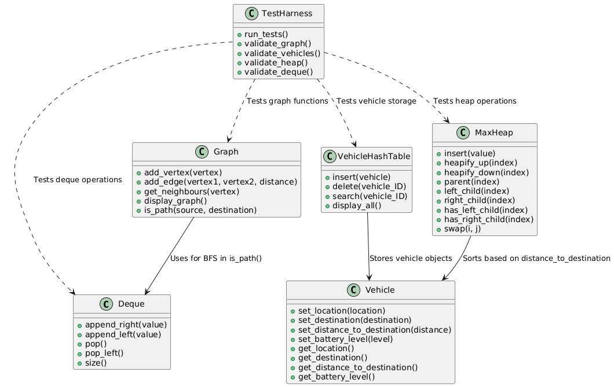

Challenges Faced During the Implementation and Their Solutions
- Heap Property maintenance:
Challenge:
One of the challenges I had to face during the implementation of this AVMS was maintaining the heap property while inserting elements and popping the root. The heapify_up and heapify_down methods required very careful implementation to ensure the vehicle with the smallest distance to the destination is always at the root, and the heap property is restored after each operation.
Solution:
To ensure the heap property works as expected, I thoroughly tested these methods with multiple insertions and deletions. The iterative process of heapifying both up and down ensured the elements were correctly placed in the heap.

- Handling Empty Lists or Missing Data:
Challenge:
There were cases where operations like pop and find_nearest_vehicle might be called on an empty list of vehicles, leading to potential errors.
Solution:
For the pop method now, if the heap is empty, it raises an IndexError, which prevents trying to remove an element from an empty heap. For the find_nearest_vehicle function, I added a check to ensure that the vehicle list is not empty before attempting to find the nearest vehicle. If the list is empty, the function returns None.

- Edge Case Handling for Empty or Single Vehicle Lists:
Challenge:
Edge cases such as when the list of vehicles is empty or contains only one vehicle need to be handled carefully to avoid errors during operations like sorting or finding the nearest vehicle.
Solution:
In the quicksort, I added a base case to return the list as-it-is when the length is 1 or 0, and for find_nearest_vehicle, I added a check to ensure that an empty list does not lead to errors.

Efficiency Analysis
Component | Operation | Time Complexity | Space Complexity
Deque | append_right | O(1) | O(n)
 | append_left | O(n) (list insert) | O(n)
 | pop | O(1) | O(n)
 | pop_left | O(n) (list removal) | O(n)
 | size | O(1) | O(1)
Graph | add_vetex | O(1) | O(V+E)
 | add_edge | O(1) | O(V+E)
 | get_neighbours | O(1) | O(1)
 | is_path  (BFS) | O(V+E) | O(V)
Vehicle Hash Table | hash_function | O(k)  (k is the length of ID) | O(1)
 | insert | O(1) | O(n)
 | delete | O(1) | O(n)
 | search | O(1) | O(n)
Vehicle Class | get_* methods | O(1) | O(1)
 | set_* methods | O(1) | O(1)
Max-Heap | insert | O(log n) | O(n)
 | pop | O(log n) | O(n)
Sorting Algorithms | heapsort | O(n log n) | O(n)
 | quicksort( )  (average) | O(n log n) | O(n)  (recursive)
 | quicksort  (worst) | O(n²) | O(n)  (recursive)
Vehicle Recommendations | find_vehicle_with_  highest_battery | O(n) | O(1)
 | find_nearest_  vehicle | O(n) | O(1)

Test Cases
Deque Class:
Function | Test | Input | Expected Output
append_right | Add an element to the right of the deque | deque.append_right(5) | The deque should contain: [5]
append_left | Add an element to the left of the deque | deque.append_left(3) | The deques should contain: [3, 5]
pop | Remove and return the rightmost element | deque.pop | Should return 5 and deque should contain: [3]
pop_left | Remove and return the leftmost element | deque.pop | Should return 3 and deque should now be empty [ ]
size | Get the size of the deque | deque.pop_left | Should return 0 as the deque is now empty

Graph Class:
Function | Test | Input | Expected Output
add_vertex | Add a location to the graph | graph.add_vertex(“Dubai”) | {“Dubai”: [ ]}
add_edge | Add a road between two locations | graph.add_edge(“Dubai”, “Ajman”, 2.9) | {“Dubai”: [(“Ajman”, 2.9)], “Ajman”: [(“Dubai”, 2.9)]}
get_neighbours | Get the neighbours of a location | graph.get_neighbours(“Dubai”) | [(“Ajman”, 2.9)]
is_path | Check if there is a road between the two locations | graph.is_path(“Dubai”, “Ajman”) | True

VehicleHashTable Class:
Functions | Test | Input | Expected Outcome
insert | Insert a vehicle in the hash table | vehicle_table.insert(vehicle) | The vehicle should be inserted at an appropriate index in the table
delete | Delete a vehicle from the hash table using its ID | vehicle_table.delete(“V60”) | If the vehicle of that ID exists, it should be removed from the table
search | Search a vehicle in the hash table using its ID | vehicle_table.search(“V60”) | If the vehicle of that ID exists, the functions return it

Vehicle Class:
Functions | Test | Input | Expected Outcome
set_location | Set the current location of the vehicle | vehicle.set_location(“Home”) | The vehicle’s location set to Home
set_battery_level | Set the battery level of the vehicle | vehicle.set_battery_level(60) | Vehicle’s battery level set to 60

maxHeap Class:
Functions | Test | Input | Outcome
insert | Insert a vehicle into the heap | heap.insert(vehicle) | The vehicle should be inserted in the heap while maintaining the max-heap property based on distance_to_destination
pop | Pop the vehicle with the largest distance to the destination | heap.po | Should return the vehicle with the largest distance_to_destination  While maintaining the max-heap property.

Sorting Functions:
Functions | Test | Input | Expected Outcome
heapsort | Sort vehicles by distance to destination | heapsort([vehicle1, vehicle2, vehicle3]) | Vehicles should be sorted in ascending order of distance to the destination
quicksort | Sort vehicles by battery level | quicksort([vehicle1, vehicle2, vehicle3]) | Vehicles should be sorted in descending order of battery level
find_vehicle_with_  highest_battery( ) | Find the vehicle with the highest battery level | find_vehicle_with_highest_  Battery([vehicle1, vehicle2]) | Should return the vehicle with the highest battery level
find_nearest_vehicle | Find the nearest vehicle based on the distance to the destination | find_nearest_vehicle(“Home”, [vehicle1, vehicle2]) | Should return the vehicle with the smallest distance to the destination

Potential Improvements
The current version of the AVMS fulfills the requirements of this assignment. However, this implementation could be improved in the future by adding more features such as traffic data that will note the difference in a vehicle’s battery level and the time taken to reach the destination. Currently, linear probing is used to handle the collisions in the hash table, trying to resolve collision with other techniques such as double hashing and quadratic probing should also be tested to find which suits the system better. The vehicle’s location is static in this version of AVMS, by adding more functionality in the code, the vehicle’s movement over time can be recorded, such as by using a timer to update the vehicle’s location, battery level, and distance remaining to reach the destination. These potential improvements can improve the scalability and maintainability of the code, allowing for a better real-world simulation of an AVMS.
Conclusion
In conclusion, this assignment was an effective way for me to try and implement the data structures and algorithms I have learned in this unit. The key outcomes of this assignment include applying BFS to find the roads between two locations, using linear probing to handle the collision in the hash table, and utilizing heapsort and quicksort for vehicle prioritization. Overall, the assignment was a reflection on what algorithms and data structures I learned throughout the semester, testing my understanding of them.

Reference:
PlantUML. (n.d.). Class diagram syntax and features. PlantUML.com. https://plantuml.com/class-diagram

