COMP1005 – Fundamentals of Programming
Project Report

Name: Resham Furqan
Student ID:

Contents
Overview ---------------------------------------------------------------------------------------- 2 - 3
User Guide -------------------------------------------------------------------------------------- 3
Traceability Matrix ----------------------------------------------------------------------------- 4 - 5
Discussion -------------------------------------------------------------------------------------- 6 - 9
UML Diagram ---------------------------------------------------------------------------------- 9
Showcase --------------------------------------------------------------------------------------- 10 - 19
Conclusion -------------------------------------------------------------------------------------- 19
Future Work ------------------------------------------------------------------------------------- 20
References -------------------------------------------------------------------------------------- 20

Overview
The report demonstrates a Python program that simulates the spread of a disease within a population on a grid. The purpose of this program is to simulate how a disease spreads across a grid over multiple timesteps. It also includes the probability of infection, death, recovery, immunity, and movement with added extensions of barriers and airports that determine the disease behavior.
The features that were implemented include:
Grid Initialization: representing a population where people are distributed randomly across various states (e.g. infected, uninfected).
Infection Process: infection is spread based on probability (prob_infect), which determines the chances of uninfected people being infected in every timestep, and they have a chance to die (prob_death), recover (prob_recover), or become immune after recovery (prob_immunity).
Movement of People (including Neighbourhood, Barriers, and Airports): after every timestep, people are moved around the grid and that movement is controlled by the type of neighbourhood the user selects from Moore or Von Neumann. The type of neighbourhood selected determines how the people will move (including or excluding diagonals). The movement is also influenced by barriers and airports. Barriers are randomly placed in the grid so that infected people are blocked from moving anywhere to avoid the further spread of the disease. Airports are added to the grid to allow people to move between airports, which affects the spread of disease.
Statistics: to track the number of uninfected, infected, dead, immune, or recovered people over time and these statistics are plotted on the graph after every timestep.
Command-line Arguments: allows the user to set the parameters such as the number of simulation steps, rows, columns, and probabilities.
Graphical Output: After every simulation, a scatter plot shows the infected, uninfected, dead, immune, and recovered people. The points' sizes show the population counts at every location, and a legend distinguishes between different groups.

User Guide:
This disease simulation program simulates the spread of disease in a grid-based environment, with features such as infection, recovery, death, airports, barriers, and visual representation of these.
To run this program, ensure you have a Python-supporting environment, and the libraries, numpy and matplotlib are installed. Spyder via the Anaconda is recommended. Download the zip file, extract all, go to Spyder, and open the Python file.
When you run the code, the user is asked to enter the dimensions for the grid, simulation steps, probabilities for disease spread, the number of barriers and airports, and the type of neighbourhood for movement in the grid. After that simulation runs for a specified number of times and at the end gives you the statistical analysis and the visual representation of disease spread over time, in the form of scatter plots and a line graph.

Traceability Matrix:
Feature No. | Feature | Code Reference | Test Reference | Completion Date
1 | Randomly distributing people in the grid | distribute(grid, num_r, num_c, numpeep) | Tested through the initial population distribution, using the displayGrid function | 15/11/24
2 | Generating Scatter plot for displaying data | make_scatter(grid, num_r, num_c) | Tested by plotting data using plotGrids function | 15/11/24
3 | Option for using either Moore or Von Neumann | get_neighbourhood_type | Tested by running the program and selecting Moore one time and Von Neumann the other | 16/11/24
4 | Handling dead, recovered, and immune people | infect(inf, notinf, rec, dead, immune, r, c, prob_infect, prob_recover, prob_death) | Tested by setting some infected, dead, recovered, and immune people at the beginning and then looking at the further timesteps how different probabilities affect the population in terms of being recovered, dead, or immune | 16/11/24
5 | Adding barriers and airports | add_barriers(grid, num_barriers) and add_airports(grid, airport_locations) | Tested by plotting a grid before and after calling the function to ensure barriers are placed as required | 17/11/24
6 | Statistics of disease spread over time | plot_stats | Tested by visual inspection of the plotted stats | 17/11/24
7 | Plot grids with the status of infected, uninfected, recovered, and dead | plot_grids | Tested by visual inspection of scatter plot showing grid status | 17/11/24
8 | Initializing the parameters for the simulation | INIT_POP, num_rows, num_steps, etc. | Tested by running the program and checking if inputs are correctly handled | 19/11/24

Discussion:
- Randomly Distributing People in the Grid:
Working:
This feature initializes the population by randomly placing people in the grid. The grid has a specified number of columns (num_c) and rows (num_r), and the specified number of people (numpeep) is placed at random positions in the grid. Every person is assigned a state (infected, uninfected, recovered, immune, or dead) at the start.
Implementation:
The ‘distribute’ function is used to generate random column and row indices and place people in those randomly selected positions. A grid represents the entire population, where each cell demonstrates a person. The function assigns a random state (infected, uninfected, etc) to each person. This function is important for initializing the simulation and creating a realistic environment for the spread of disease.
- Generating Scatter Plot for Displaying Data:
Working:
This feature is used to generate a scatter plot for visualizing the simulation data. It shows the state of the grid with the distribution of people at a given point in the simulation.
Implementation:
The ‘make_scatter’ function is used to process the grid and get the status of each person to plot this data on the scatter plot. The variables, num_c, and num_r specify the grid’s dimensions, and the scatter plot is updated during the simulation to reflect changes in population status. This function is important to visualize the results of simulation to track the spread of disease.
- Option for Using either Moore or Von Neumann Neighbourhood:
Working:
This feature gives the user the option to select the type of neighbourhood for the spread of disease from either Moore or Von Neumann. The Moore neighbourhood includes the diagonal movement and Von Neumann excludes it.
Implementation:
The ‘get_neighbourhood_type’ function is used to get the input from the user for which neighbourhood they want to use. The infection-spreading logic is adjusted on the base of this user input. If Moore is selected the disease spreads in all eight directions but if Von Neumann is selected then it only spreads in four directions excluding the diagonal movement. This feature is important as it provides the user with the flexibility to simulate different disease behaviors.
- Handling Dead, Recovered, and Immune People:
Working:
This feature handles the transition of people through different states (infection, death, recovery, and immunity). Based on certain probabilities, a person can die, recover, or get infected in the grid. After recovery, the person becomes immune to the disease and will not be infected again.
Implementation:
The ‘infect’ function is used to update the states of people. It uses probabilities to decide whether a person goes from uninfected to infected, or infected to recovered or dead. It takes the grid location (r, c) and for every person in that location, checks the possibility of infection, death, or recovery. Immune people are not considered for infection or recovery now.
- Adding Barriers and Airports:
Working:
This feature adds barriers and airports in the grid to affect the spread of disease. The barriers ensure that infection does not spread through certain areas by blocking the movements of the disease in the grid. Whereas the airports act as the entry point for the disease, it allows the spreading of disease to other places of the grid quicker.
Implementation:
The ‘add_barriers’ function places a specified number of barriers (num_barreirs) randomly in the grid and the ‘add_airports’ function places airports at predefined locations (airport_locations) in the grid. These elements are added to the grid, and the disease spread is adjusted, barriers are implemented to prevent the spread of disease in certain areas, and airports are implemented to rapidly spread the disease to and from airport cells.
- Statistics of Disease Spread Over Time:
Working:
This feature collects the statistics of the disease spread over time and visualizes it in the form of a plot. These statistics can help track the effectiveness of interventions and disease progress.
Implementation:
The ‘plot_stats’ function is used to collect the data about the current state of the population at every timestep and generate plots to visualize these statistics over time. It displays the graph of the number of people infected, recovered, or dead at every timestep.
- Plot Grids with the Status of Infected, Uninfected, Recovered, and Dead:
Working:
This feature is used to visualize the state of each person in the grid at a given time, showing their current state and providing a visual presentation of the simulation’s progress.
Implementation:
The ‘plot_grids’ function is used to iterate through the grid and provide a visual representation of the population's state using different colors to represent different states.
- Initializing the Parameters for the Simulation:
Working:
This feature initializes the various parameters that are required for running the simulation properly, such as population size (INIT_POP), number of simulation steps (num_steps), etc.
Implementation:
These initialization parameters are at the beginning of the simulation. The user can modify these parameters according to their liking. The grid size and the number of steps for simulation are arranged according to the user input, ensuring the simulation runs with the correct settings. This feature meets the requirement for setting up the grid before starting the simulation.
UML Diagram:

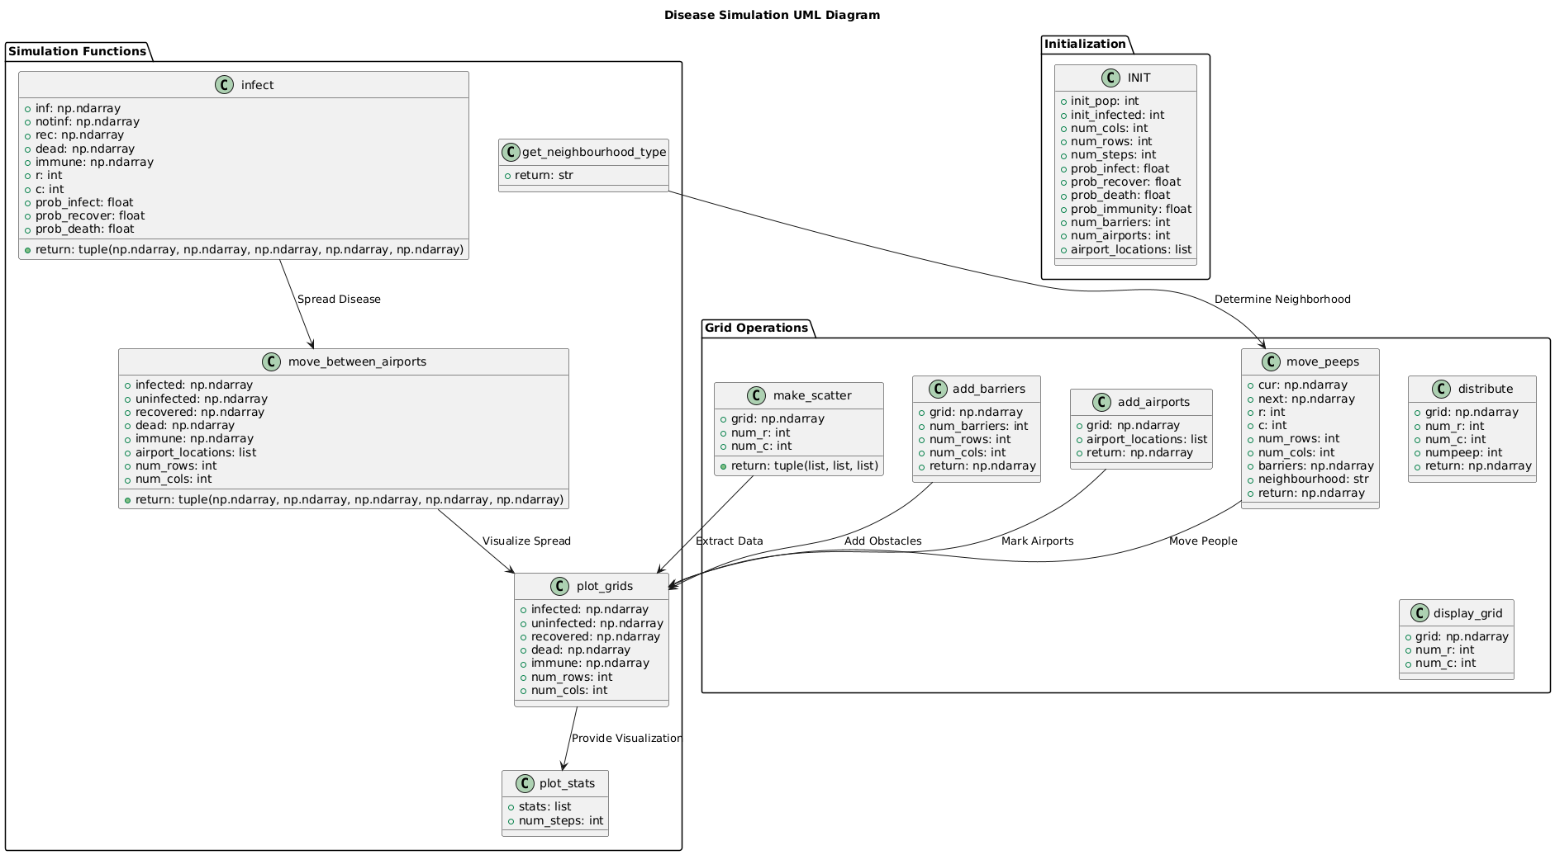
Showcase:

Introduction:
For the showcase, I will compare 3 different scenarios of the disease spread simulation. The scenarios are designed by getting different inputs from the user to see how the simulation of disease spread is affected when the number of barriers and the probabilities of infected, recovered, immune, and dead are different every time.

Discussion:
Scenario 1: High Rate of Infection, No Barriers
In this scenario, the probability of being infected is very high and there are no barriers to refrain the infected people from moving.
The output can be reproduced by just adding the following values at the beginning of the program execution:
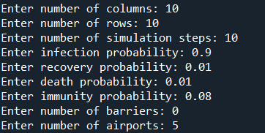
These are the key parameters that help reproduce the following output. The neighbourhood selected is Moore.
These were the initial states of people:
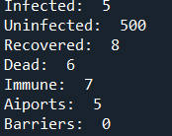
After the 10 Timesteps, this is the final statistics:
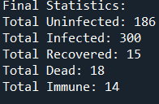
Here, we have 300 people infected, as there were no borders to stop the infected people from moving into the grid, the disease spread quickly, resulting in more people being infected or dead than recovering or being immune.
Output:
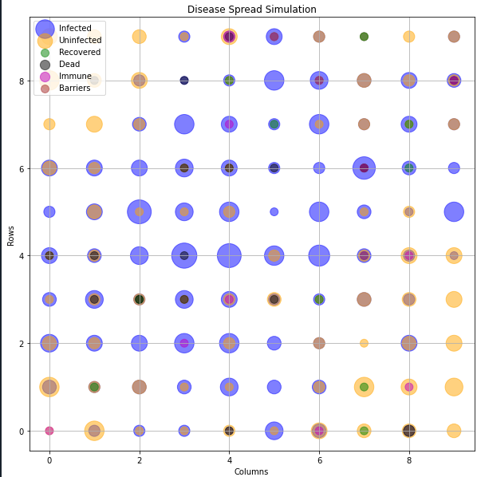
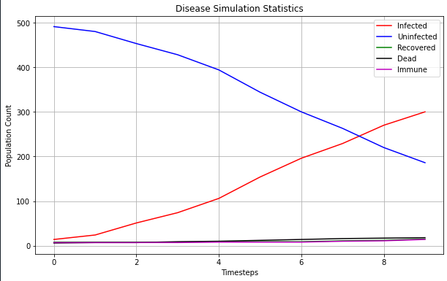

Scenario 2: Equal Rate of Infection and Recovery, with Barriers:
In this scenario, the probability of being infected and recovering is the same, and there are 10 barriers in the grid to stop the infected people from moving inside the grid to avoid spreading the disease.
The output can be reproduced by just adding the following values at the beginning of the program execution:
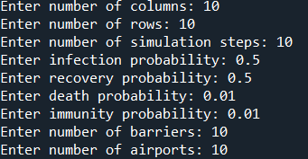
These are the key parameters that help reproduce the following output. The neighbourhood selected is von Neumann.
These were the initial states of people:
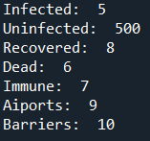
After the 10 Timesteps, this is the final statistics:
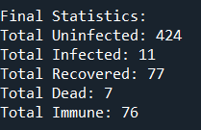
Here, we see the number of uninfected people has increased due to the 10 barriers in the grid. The movement of infected people refrained to avoid the spread of disease, and the results show that fewer people were infected or died and more people recovered and were immune when there are borders and the rate of infection is low.
Output:
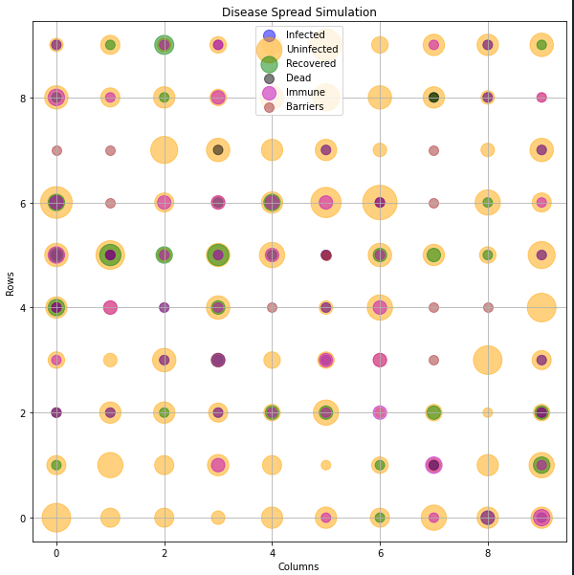
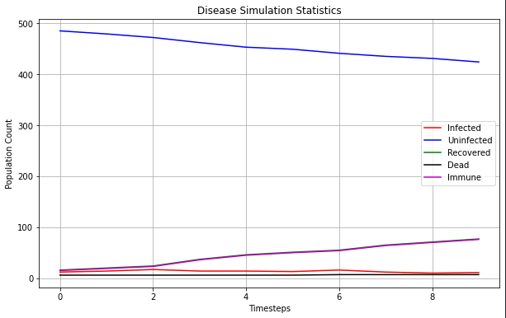

Scenario 3: Low Infection Rate, More Barriers:
In the scenario, the probability of getting infected is very low, and more barriers are introduced in the grid so that infected people would not leave the current region and infect others.
The output can be reproduced by adding the following values at the beginning of the program execution:
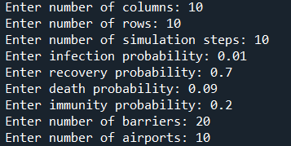
These are the key parameters that help reproduce the following output. The neighbourhood selected is Moore.
These are the initial states of people:
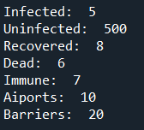
After the 10 timesteps, this was the final statistics:
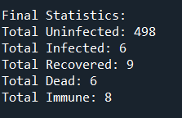
Here, we can see that when the chances of being infected are lower and there are multiple barriers in the grid, the disease does not spread that fast, and the probabilities of recovery and being immune are also higher than being infected. Therefore, by the end of the simulation, more people were recovered and immune than being infected.
Output:
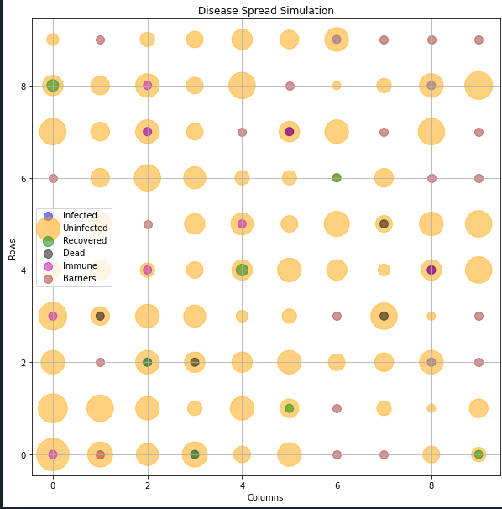
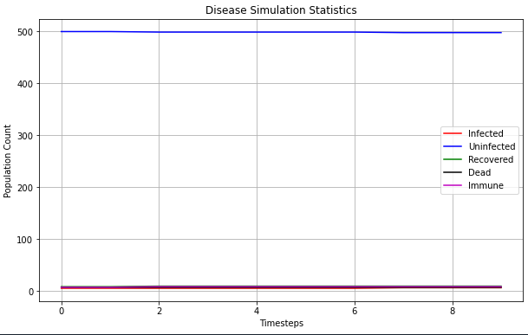

Conclusion:
In conclusion, this assignment provided an opportunity to work with a simulation of how a disease spreads, and how factors such as adding barriers and airports to stop the movement of infected people can help in reducing the risk of spread of disease. The grid-based simulations demonstrated how disease spread is influenced by different probabilities and movement constraints.
The code design conforms to the specifications described in the assignment brief, integrating comments for better readability and understanding of the code. The functions were implemented and tested, and different scenarios were simulated to see how the disease spreads under different circumstances, allowing flexibility in simulation configurations. Additionally, the visual representation of the final statistics offers a better understanding of how to control the disease spread.

Future Work:
Although object-oriented programming with classes can be beneficial, I did not use classes because I felt doing it in different functions was easier for me to manage my code. This is not the perfect assignment, it still has some issues, I tried my best to fix as many as I could. In the future, when I have more time, I can try doing this with classes. Moreover, vaccination strategies could also be implemented, like how I did barriers and airports to avoid spreading disease. This could provide a better framework to deal with disease spread.

References:
. (2024). COMP1005 – Fundamentals of Programming. Lecture 7: Object Relationships and Exception Handling [PowerPoint slides]. https://lms..edu.au/webapps/blackboard/content/listContent.jsp?course_id=_141770_1&content_id=_12656883_1
PlantUML. (n.d). https://plantuml.com/
van Rossum, G., Warsaw, B., & Coghlan, N. (2001, July 5). PEP 8 – Style Guide for Python Code. Peps.python.org. https://peps.python.org/pep-0008/

