3PM
1.Each week the planner receives requirements from 3PM planner:
coopacer name | coopacer contact details | products
VFI Wels | Kiss, Ilona <ilona.kiss@vfi-oilsforlife.com>, Weiss, Marlene <M.Weiss@vfi-oilsforlife.com> | 3578079, 1044556, 1044578, 1044587
SimeDarby | NL-RawMaterials <nl.rawmaterials@sdguthrie.com>; bart.jan.rust@sdguthrie.com | 91401567 ( GTS)
Cargil | Inbound Izegem <Inbound_Izegem@cargill.com> | 9222142
VDM Zeewolde | David Mladenovski <david.mladenovski@vandemoortele.com> | 3578079, 1044556, 1044578, 1044587
Brochenin | Service Commandes <commandes@brochenin.com>; Service Commercial <servicecommercial@brochenin.com> | 91101963
Frieslandcampina | Mourik, M.J. van (Maurits) <Maurits.VanMourik@frieslandcampina.com> | 1044499
Bunge Loders | BEU NEU SOURCING - MAILBOX <beu.neuss.sourcing@bunge.com> | 91401567( GTS)
RIAZOR | Rui Cardoso <rui.cardoso@torrejana.pt>, Luís Santana - Fábrica Torrejana, SA <luis.santana@torrejana.pt> | 9222142

2. transaction ME3M for contract searching, depending on loading location (country):
plant | loading place
3723 | NL
1024 | DE
2522 | BE
2001 | CZ

3. Fill details in delivery plan and wait until Procurement Operation Team creates sales order (contact Procuremet Operation Team: Robert.Gierczak@florafg.com, Tania.Printezi@ florafg.com
SO | PR
2311614 | 271145865

While sales order is created, planner can create Purchase order and link Purchase req as below:
When purchase requisition is successfully linked, the data below appears:
-Account assignment category:
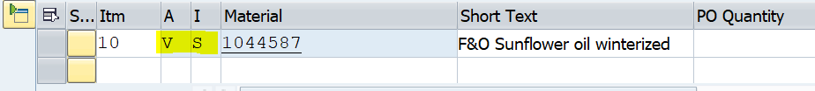
- 3PM name and address details
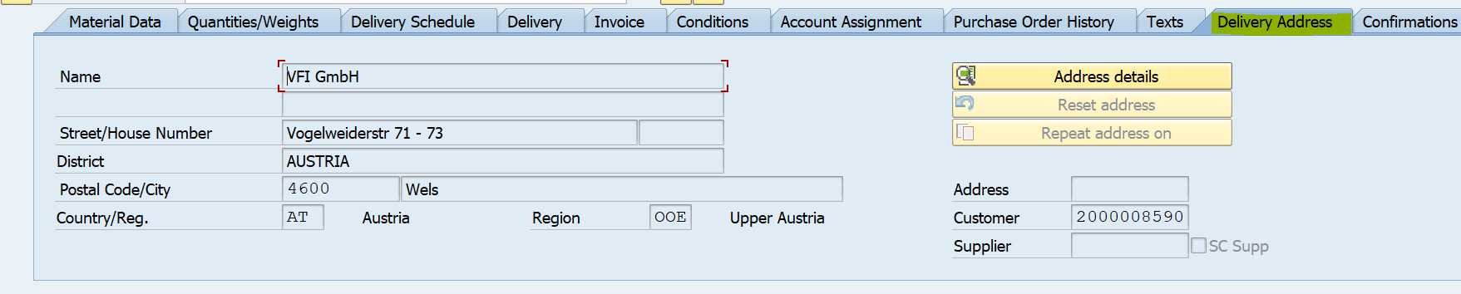
The next step is to send orders to suppliers (as per normal WoW) + send order confirmation to 3PMvia email

