GTS
Glycerol Tristearate_GTS semi-pr is component for eres130 and eres148 production,
ERES1148 50% cGTS69
ERES1130 20% cGTS69

Depending on eres130/148 requirements suppliers (Simedarby+ Bunge Loders ) orders GTS
KLK confirms each Tuesday volume available for next week loadings, planned will share plan with SD/ SD provides official orders to planner- further steps are per normal WoW
First scenario:
If SD can load less that offered by KLK planned needs to arrange delivery to external tanks Chane Zaandam – then order does not require sales order as oil needs to be kept on Flora stock. While orders for external tanks are created planner needs to send truck nomination to Chane (Unlaoding to tank)
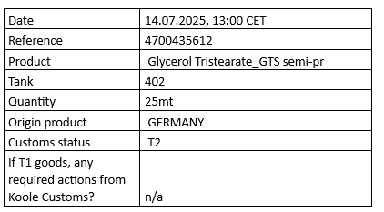
Each offloading to external tank requires Quality Approval, Once truck is loaded ex KLK carrier send documents which must be shared with katerina.meditskou@florafg.com and anna.gradkowska@florafg.com> and wait for return with approval
Second scenario:
IF requirements are higher than KLK weekly capacity, the planners arrange pick up from Chane tank- SD send their order number which indicates loading
customer no: | Delivery planned to SD | delivery wk
PO10978#20 | 6.02.2025 | 6

+ send nomination to Chane (unloading from tank)

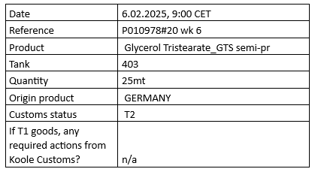

Tank rental/ storage/how to book costs
Planner receive invoice through VIM :
Go to Ariba:
Ariba Spend Management
There is one PO created 4800157352
- Click PO number:
- Click receive
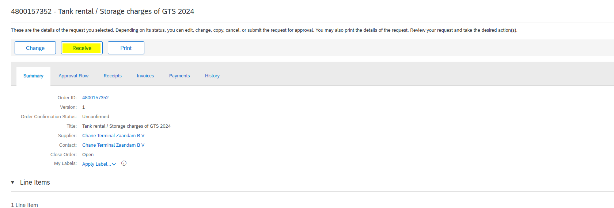
3.mark price excluding VAT+ invoice number

Chane Tank Management
Tanks are in use only for fill out or fill in, While tank is full planner needs to arrange analysis with Agrolab, Serviceteam 1 • AGROLAB Dr. Verwey B.V. serviceteam1@drverwey.nl Requested Analyses:
• Iodine value max 2.0
• Water max. 0.15%
• Acid value max 10
• Lovidbond red
• C16 + C18 fatty acids min 95
• BAP** <2.0 ppb

Ask Operations | BCI Rotterdam BV operations@bci-rotterdam.com to deliver sample form Chane to Agrolab
When CoA is provided needs to be shared with SimeDarby
GR CHANE- offloading from tank to SimeDarby
When volume is delivered to Chane planner book GR for Flora and move to KOOLE batch as below

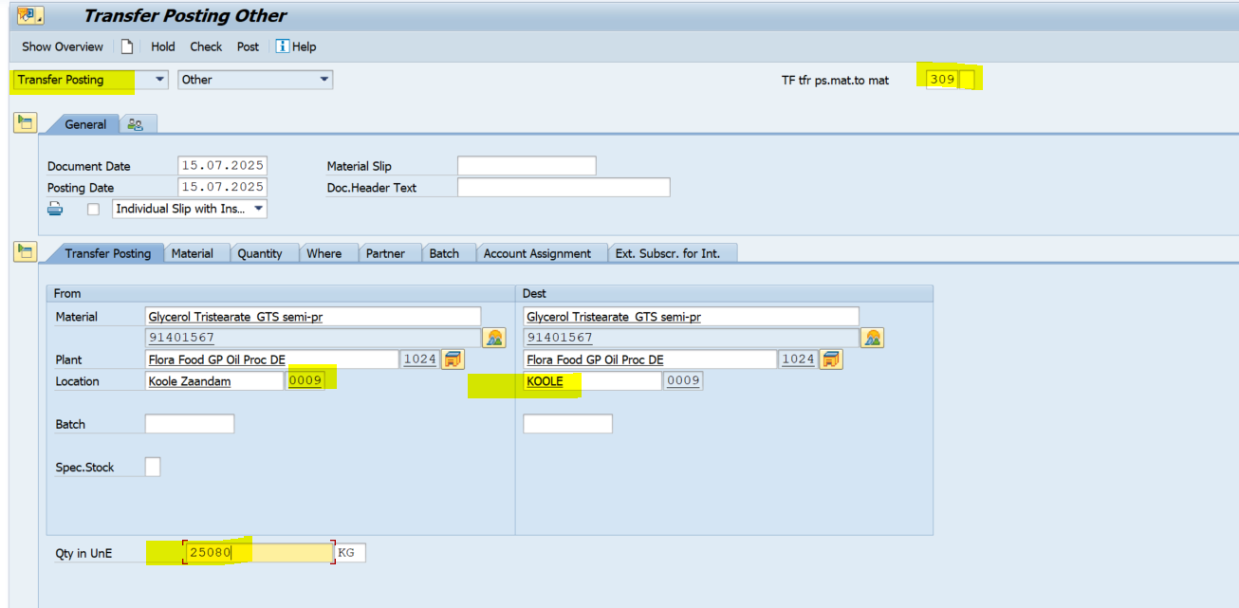

While volume is collected from Chane to SD planner mark Order number +date in deliver plan to make Procurement Operation Team create sales ex stock
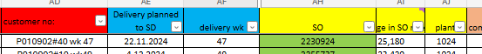
When SD confirm exact qty loaded through CMR /delivery note planned needs to create Good issue
Go to transaction vl01n
Shipping point :1023
Order – sales order number
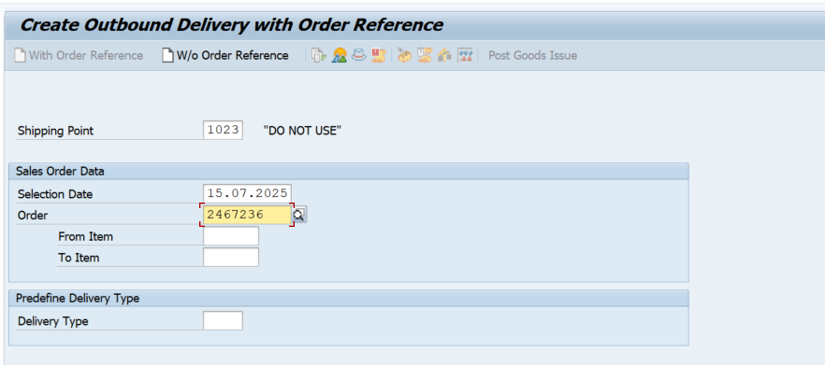
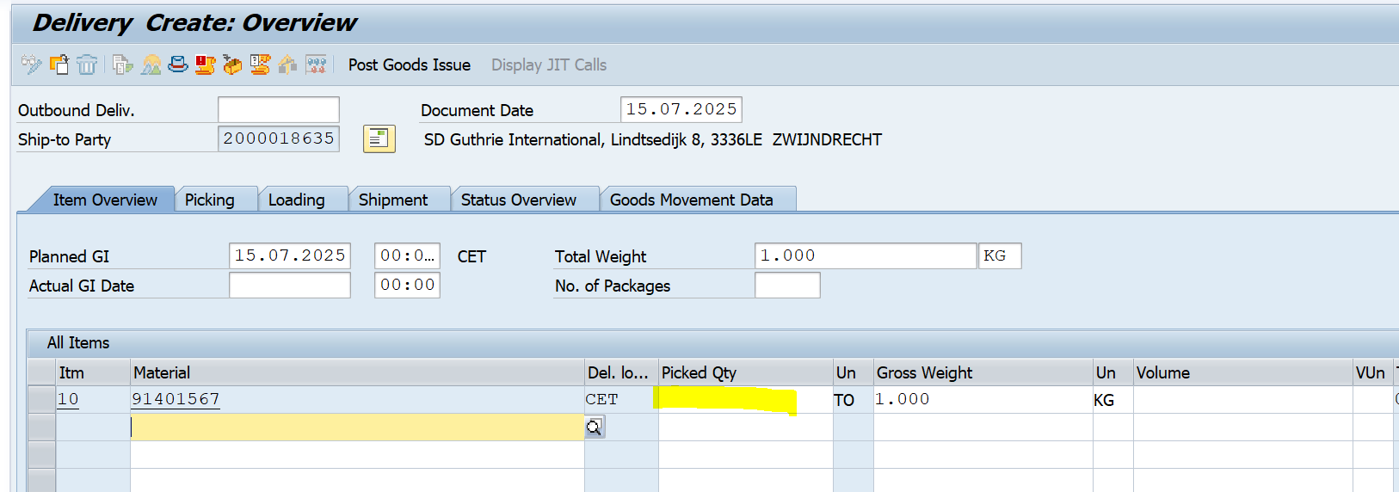
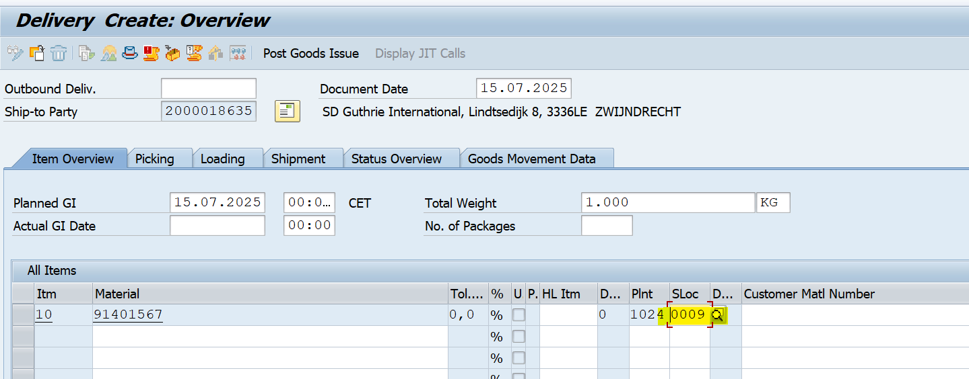
Click : post good issue

