**CONFERSECPRO: Secure Meetings & Projects**

VIDEO CONFERENCE CALL AND PROJECT MANAGEMENT SECURITY

TEAM MEMBERS: DEEVESH A/L S.PARAMESWARAN

(32DDT1F1054)

RESHIKESAN A/L BALASUBRAMANIAM

(32DDT21F1050)

MUHAMMAD NOOR HAFIZUDDIN BIN BIN MOHD RIDZUAN

(32DDT21F1058)

#### SUPERVISOR: CIKPUAN [NOR ZALINA BINTI SALLEH](https://pmtglms.cidos.edu.my/user/profile.php?id=348)

**CONTENT**

* INTRODUCTION …………………………………………………...PAGE 3
* PROBLEM STATEMENT……………………………………………………PAGE 4
* PROJECT OBJECTIVE ……………………………………………………PAGE 5
* PROJECT SCOPE ……………………………………………………PAGE 6
* LITERATURE REVIEW ……………………………………………………PAGE 7
* METHODOLOGY ……………………………………………………PAGE 8
* REFERENCES ……………………………………………………PAGE 9
* GANTT CHART ………………………………………………......PAGE 10
* COST PLANNING ……………………………………………………PAGE 11
* CONCLUSION ……………………………………………………PAGE 12
* APPENDIX ……………………………………………………PAGE 13

**INTRODUCTION**

In today's fast-paced world, effective communication and collaboration are paramount for success. Enter Pro, the all-in-one web designed to revolutionize your team's connectivity, making it easier and more efficient than ever before. SecureSync Pro seamlessly combines high-quality stereo conference calls with advanced project management tools and top-notch security features to empower your team like never before.

PROBLEM STATEMENT

In today's dynamic and interconnected work environment, traditional communication and collaboration tools fall short in providing a comprehensive solution that combines high-quality audio conferencing, efficient project management, seamless file sharing, and robust security. Teams often struggle with the following challenges:

Problem statement 1

* Singular Audio Quality and Latency
* Existing conferencing tools often suffer from poor audio quality and noticeable latency, hindering effective communication and collaboration.
* Project Management Complexity
* Teams find it challenging to manage projects, tasks, and timelines efficiently, resulting in missed deadlines and a lack of overall project visibility.
* Insecure File Sharing and Project management
* Large file sharing, a fundamental aspect of modern collaboration, poses security risks when using mainstream file-sharing services that may lack robust security measures.
* Project Management, data breaches,project disruptions,unauthorized access

PROJECT SCOPE

This project scope outlines the features and functionalities for an website that combines communication, collaboration, file sharing, and security. It aims to provide a comprehensive solution for professionals and organizations seeking a secure and efficient platform for remote work and project management.

1. User Scope:

1.1. Collaboration:

* Gantt Chart Features: The app should include project management features similar to Trello, enabling users to create, manage, and track tasks using Gantt charts.
* Task Assignments: Users should be able to assign tasks to team members, set deadlines, and track progress.
* File Sharing: Users should be able to share files of varying sizes seamlessly within the app.
* Document Collaboration: The app should support real-time collaboration on documents and files.
* Version Control: Version control features should be available for shared documents.1.2 Communications:

1.2 Communications

* Conferencing: Users should be able to initiate and participate in high-quality stereo audio and video conferences with minimal latency.
* Stereo Audio: The app will support stereo audio to enhance the clarity of communication.
* Low Latency: The app should provide low-latency communication to ensure a seamless conferencing experience.
* Screen Sharing: Users should be able to share their screens during conferences.
* Messaging: In addition to audio and video calls, the app should support text-based messaging.

1.3 Security

* Highly Secure: The app must employ robust security measures to protect user data, communications, and shared files.
* End-to-End Encryption: All communications and shared files should be end-to-end encrypted.
* User Authentication: Secure user authentication and authorization mechanisms should be in place.
* Access Control: Administrators should be able to manage user access and permissions.
* Data Privacy: The app should comply with data privacy regulations

2. System Scope

2.1 Communication Infrastructure:

* Audio and Video Quality: Implement audio and video codecs that ensure high-quality communication.
* Low Latency: Optimize the network and server infrastructure to minimize latency during audio and video calls.
* Server Scalability: The system should be able to scale to accommodate a growing user base.

2.2. Collaboration Features:

* Gantt Chart Module: Develop a robust Gantt chart module that allows users to create, edit, and manage projects and tasks.
* File Sharing: Implement a secure and efficient file-sharing mechanism with support for large files.
* Real-time Collaboration: Enable real-time collaboration on documents and files through features like live editing and comments.
* Version Control: Implement version control for files shared within the app.

2.3. Security Measures:

* End-to-End Encryption: Implement strong encryption algorithms for all data in transit and at rest.
* User Authentication: Develop secure authentication methods, including multi-factor authentication if needed.
* Access Control: Implement role-based access control to manage user permissions.
* Regular Security Audits: Conduct regular security audits and updates to address potential vulnerabilities.

LITERATURE REVIEW

Zoom Website

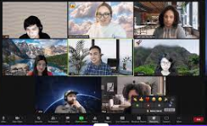

Google Meet

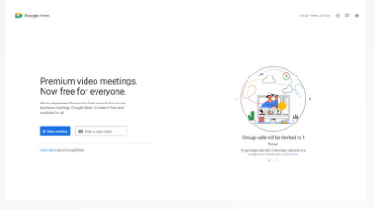

Trello Website

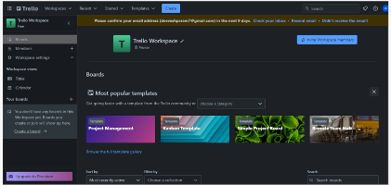

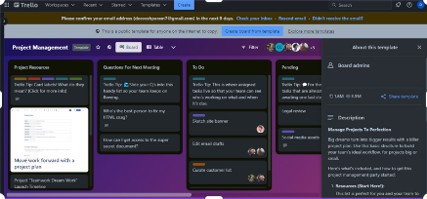

REFERENCES

https://gcloud.devoteam.com/blog/comparing-zoom-microsoft-teams-and-google-meet/

https://trello.com/b/EM98m2rJ/my-trello-board

<https://community.zoom.com/t5/Meetings/error-quot-unable-to-establish-secure-connection-to-zoom-quot/m-p/63673>

https://meet.google.com/?hs=197&authuser=0

GANTT CHART

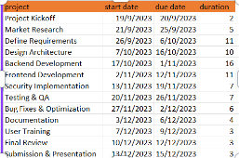

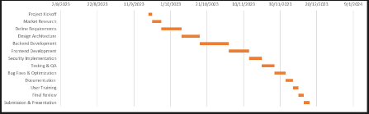

METHODOLOGY : Agile Development

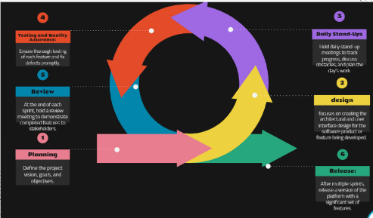

COST PLANNING

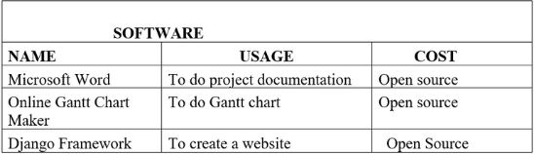

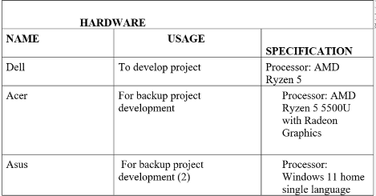

CONCLUSION

Finally, we can ensure that those who utilize our program do so in a private manner. For instance, if one of our clients uses our program to listen to music during a meeting with others, the music won't be audible to the other attendees.

Our clients may effectively safeguard their privacy from being overheard by others as a consequence.

APPENDIX