1.In database Employee.
> use EMP
switched to db EMP
> show collections
empDetails
> db.empDetails.find()
{ "_id" : ObjectId("611283a5ba6fd56e242ddb3a"), "Name" : "Mohan", "Age" : 30, "Email" : "mohan143@gmail.com", "Salary" : 5000 }
{ "_id" : ObjectId("611283edba6fd56e242ddb3b"), "Name" : "Raju", "Age" : 35, "Email" : "raju@gmail.com", "Salary" : 7000 }
{ "_id" : ObjectId("6112841cba6fd56e242ddb3c"), "Name" : "Bhuvan", "Age" : 25, "Email" : "bhuvan@gmail.com", "Salary" : 10000 }
{ "_id" : ObjectId("6112846aba6fd56e242ddb3d"), "Name" : "Ramchandran", "Age" : 27, "Email" : "ramchandran@gmail.com", "Salary" : 9000 }
{ "_id" : ObjectId("61128532ba6fd56e242ddb3e"), "Name" : "Raman", "Age" : 60, "Email" : "raman@gmail.com", "Salary" : 15000 }
> db.empDetails.updateMany({Name:"Mohan"},{$set:{Department:"Developer"}})
{ "acknowledged" : true, "matchedCount" : 1, "modifiedCount" : 1 }
> db.empDetails.updateMany({Name:"Raju"},{$set:{Department:"Designer"}})
{ "acknowledged" : true, "matchedCount" : 1, "modifiedCount" : 1 }
> db.empDetails.updateMany({Name:"Bhuvan"},{$set:{Department:"Programmer"}})
{ "acknowledged" : true, "matchedCount" : 1, "modifiedCount" : 1 }
> db.empDetails.updateMany({Name:"Ramchandran"},{$set:{Department:"HR"}})
{ "acknowledged" : true, "matchedCount" : 1, "modifiedCount" : 1 }
> db.empDetails.updateMany({Name:"Raman"},{$set:{Department:"Tester"}})
{ "acknowledged" : true, "matchedCount" : 1, "modifiedCount" : 1 }
> db.empDetails.aggregate([{$group:{_id:"$Department","Salary":{$avg:"$Salary"}}}] )
{ "_id" : "HR", "Salary" : 9000 }
{ "_id" : "Developer", "Salary" : 10000 }
{ "_id" : "Programmer", "Salary" : 10000 }
{ "_id" : "Designer", "Salary" : 7000 }
> db.empDetails.updateMany({Name:"Raman"},{$set:{Department:"Tester"}})
{ "acknowledged" : true, "matchedCount" : 1, "modifiedCount" : 1 }
> db.empDetails.aggregate([{$group:{_id:"$Department","Salary":{$avg:"$Salary"}}}] )
{ "_id" : "Developer", "Salary" : 5000 }
{ "_id" : "Designer", "Salary" : 7000 }
{ "_id" : "Tester", "Salary" : 15000 }
{ "_id" : "Programmer", "Salary" : 10000 }
{ "_id" : "HR", "Salary" : 9000 }

1. find the average salary of each dept.
> db.empDetails.aggregate([{$group:{_id:"$dept","Minimum Salary":{$avg:"$Salary"}}}] )
{ "_id" : null, "Minimum Salary" : 9200 }
2. find the minimum salary of each dept.
> db.empDetails.aggregate([{$group:{_id:"$dept","Minimum Salary":{$min:"$Salary"}}}] )
{ "_id" : null, "Minimum Salary" : 5000 }
3. find the maximum salary of each dept.
> db.empDetails.aggregate([{$group:{_id:"$dept","Maximum Salary":{$max:"$Salary"}}}] )
{ "_id" : null, "Maximum Salary" : 15000 }
4. find the no.of employees of each dept.
> db.empDetails.aggregate([{$group:{_id:"$dept","Number of Employees":{$sum:1}}}] )
{ "_id" : null, "Number of Employees" : 5 }
5. sort the collection empDetails in descending order of name
> db.empDetails.aggregate([{$group:{_id:"$dept","Number of Employees":{$sum:1}}}] )
{ "_id" : null, "Number of Employees" : 5 }
> db.empDetails.find().sort({"Name":-1})
{ "_id" : ObjectId("6112846aba6fd56e242ddb3d"), "Name" : "Ramchandran", "Age" : 27, "Email" : "ramchandran@gmail.com", "Salary" : 9000, "Department" : "HR" }
{ "_id" : ObjectId("61128532ba6fd56e242ddb3e"), "Name" : "Raman", "Age" : 60, "Email" : "raman@gmail.com", "Salary" : 15000, "Department" : "Tester" }
{ "_id" : ObjectId("611283edba6fd56e242ddb3b"), "Name" : "Raju", "Age" : 35, "Email" : "raju@gmail.com", "Salary" : 7000, "Department" : "Designer" }
{ "_id" : ObjectId("611283a5ba6fd56e242ddb3a"), "Name" : "Mohan", "Age" : 30, "Email" : "mohan143@gmail.com", "Salary" : 5000, "Department" : "Developer" }
{ "_id" : ObjectId("6112841cba6fd56e242ddb3c"), "Name" : "Bhuvan", "Age" : 25, "Email" : "bhuvan@gmail.com", "Salary" : 10000, "Department" : "Programmer" }

6. Create a text index for ‘name’ and search for names mohan and bhuvan
> db.empDetails.createIndex({Name:"text"})
{
"numIndexesBefore" : 1,
"numIndexesAfter" : 2,
"createdCollectionAutomatically" : false,
"ok" : 1
}
> db.empDetails.find()
{ "_id" : ObjectId("6141db0be3945e33a7255b56"), "Name" : "Mohan", "Age" : 30, "Email" : "mohan@gmail.com", "Salary" : 5000 }
{ "_id" : ObjectId("6141db14e3945e33a7255b57"), "Name" : "Raju", "Age" : 35, "Email" : "raju@gmail.com", "Salary" : 7000 }
{ "_id" : ObjectId("6141db20e3945e33a7255b58"), "Name" : "Bhuvan", "Age" : 25, "Email" : "bhuvan@gmail.com", "Salary" : 10000 }
> db.empDetails.find({$text:{$search:"Mohan Bhuvan"}})
{ "_id" : ObjectId("6141db20e3945e33a7255b58"), "Name" : "Bhuvan", "Age" : 25, "Email" : "bhuvan@gmail.com", "Salary" : 10000 }
{ "_id" : ObjectId("6141db0be3945e33a7255b56"), "Name" : "Mohan", "Age" : 30, "Email" : "mohan@gmail.com", "Salary" : 5000 }

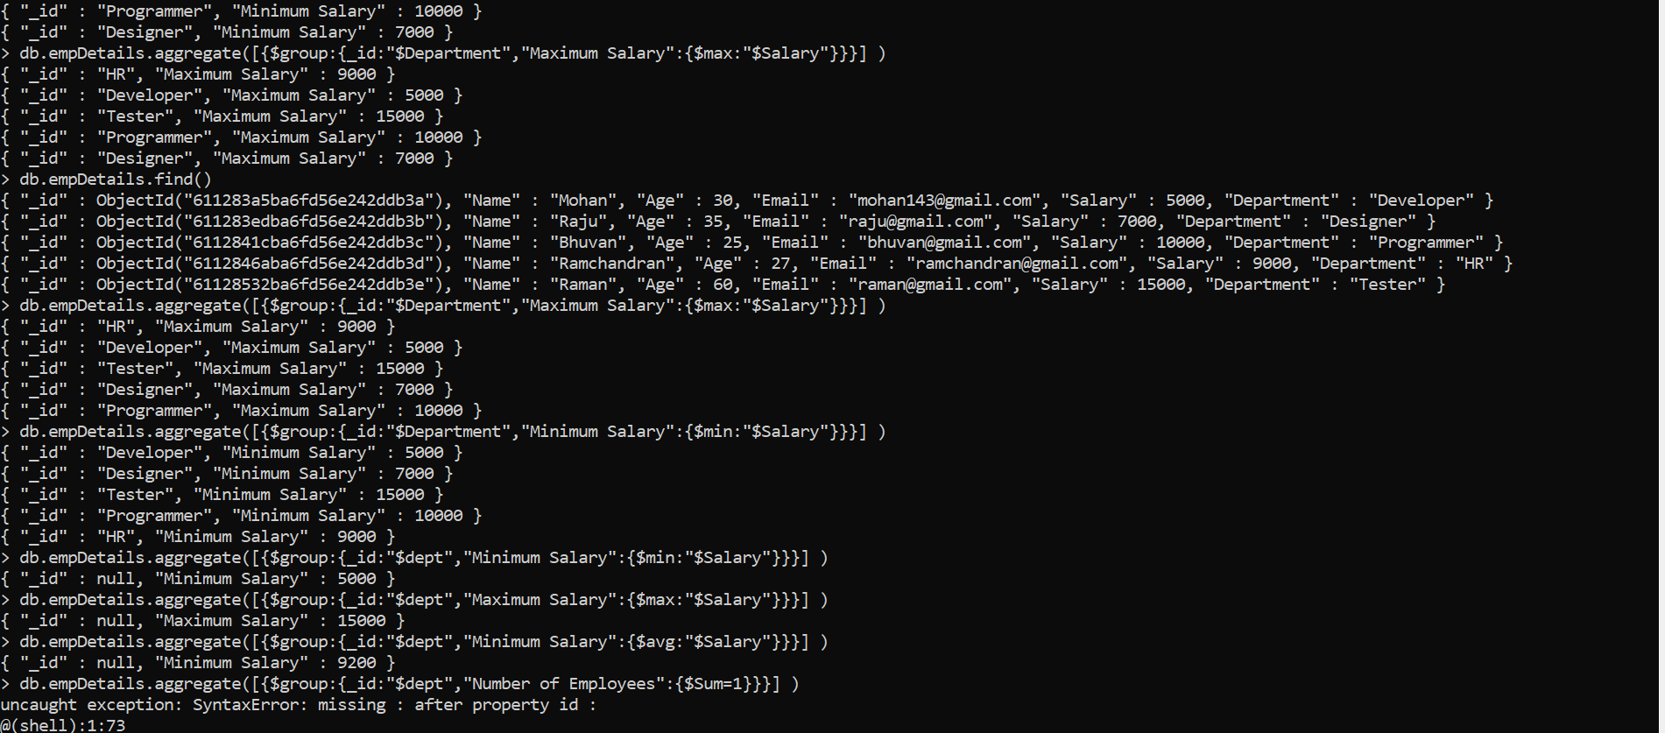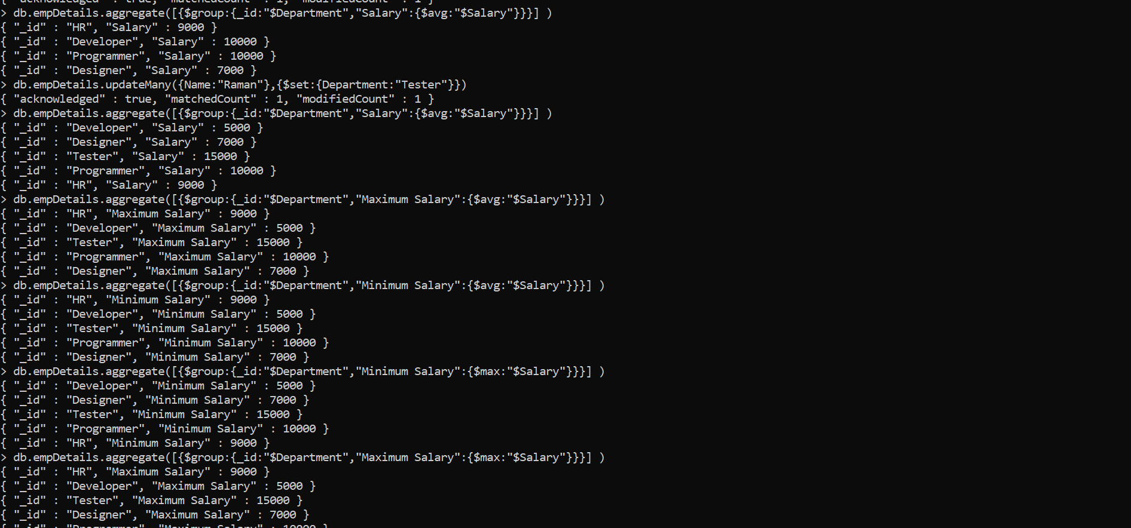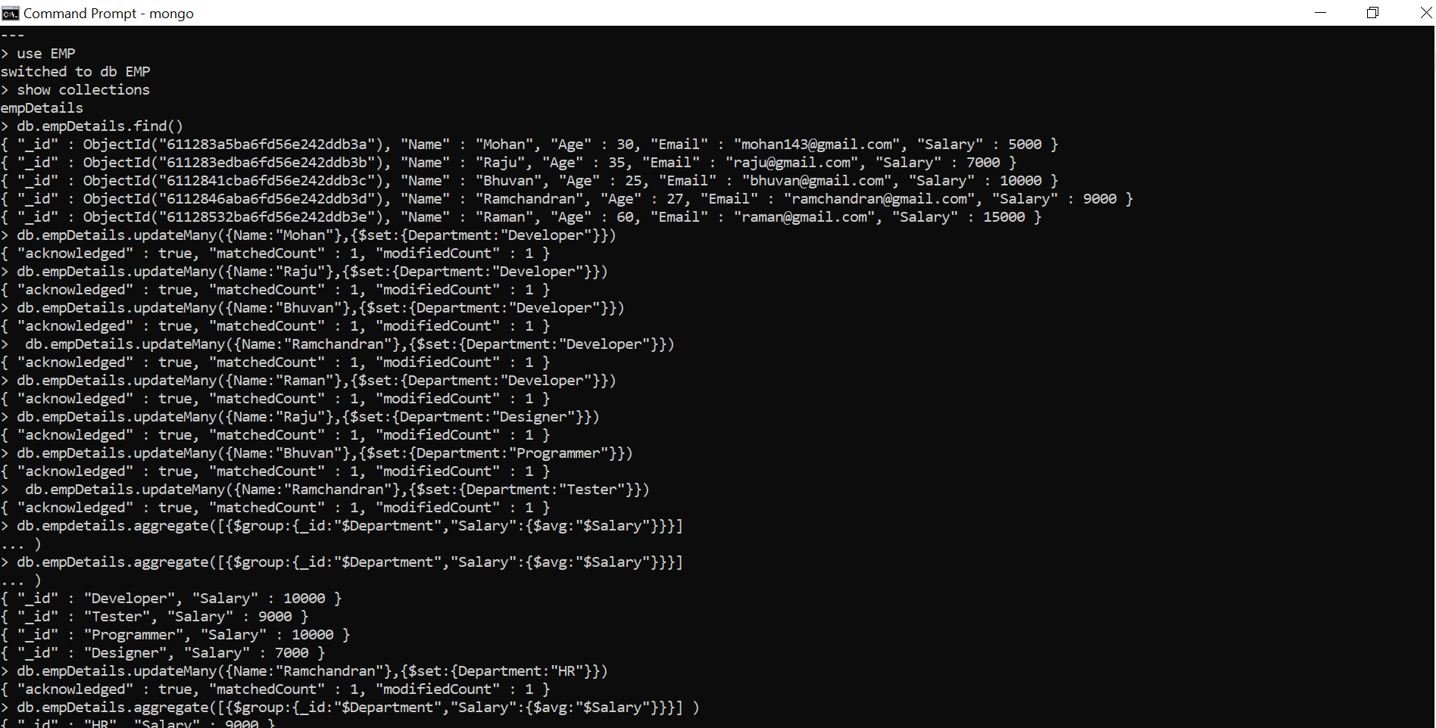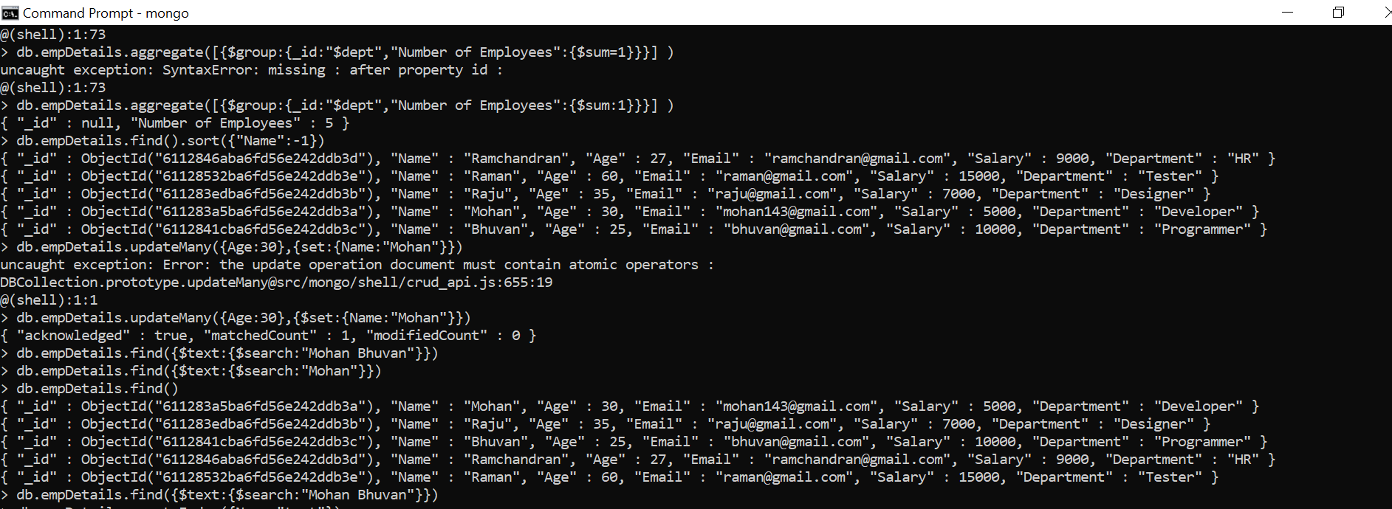
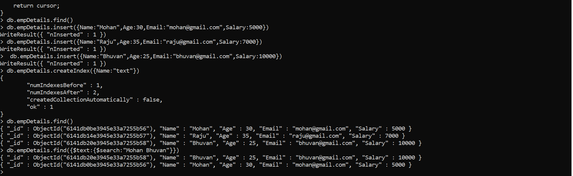
2.create a database Inventory and create an orders collection. Apply MapReduce operation for
finding the total purchase of each customer.
> use Inventory
switched to db Inventory
> db.createCollection("Orders")
{ "ok" : 1 }
> db.orders.insert({Custid:100,Name:"Reshma",Item:"Cake",Price:2000})
WriteResult({ "nInserted" : 1 })
> db.orders.insert({Custid:100,Name:"Remya",Item:"Biscuit",Price:500})
WriteResult({ "nInserted" : 1 })
> db.orders.updateMany({Name:"Remya"},{$set:{Custid:101}})
{ "acknowledged" : true, "matchedCount" : 1, "modifiedCount" : 1 }
> db.orders.find()
{ "_id" : ObjectId("61419345877df53c3879306d"), "Custid" : 100, "Name" : "Reshma", "Item" : "Cake", "Price" : 2000 }
{ "_id" : ObjectId("61419447877df53c3879306e"), "Custid" : 101, "Name" : "Remya", "Item" : "Biscuit", "Price" : 500 }
> db.orders.insert({Custid:102,Name:"Renjini",Item:"Rice",Price:200})
WriteResult({ "nInserted" : 1 })
> db.orders.insert({Custid:103,Name:"Reeba",Item:"Wheat",Price:200})
WriteResult({ "nInserted" : 1 })
> db.orders.insert({Custid:104,Name:"Reema",Item:"Wheat",Price:200})
WriteResult({ "nInserted" : 1 })
> db.orders.insert({Custid:105,Name:"Reeja",Item:"Mustard Oil",Price:100})
WriteResult({ "nInserted" : 1 })
> db.orders.insert({Custid:106,Name:"Rimi",Item:"Coconut Oil",Price:100})
WriteResult({ "nInserted" : 1 })
> db.orders.insert({Custid:107,Name:"Rimi",Item:"Sugar",Price:150})
WriteResult({ "nInserted" : 1 })
> db.orders.find()
{ "_id" : ObjectId("61419345877df53c3879306d"), "Custid" : 100, "Name" : "Reshma", "Item" : "Cake", "Price" : 2000 }
{ "_id" : ObjectId("61419447877df53c3879306e"), "Custid" : 101, "Name" : "Remya", "Item" : "Biscuit", "Price" : 500 }
{ "_id" : ObjectId("61419633877df53c3879306f"), "Custid" : 102, "Name" : "Renjini", "Item" : "Rice", "Price" : 200 }
{ "_id" : ObjectId("61419666877df53c38793070"), "Custid" : 103, "Name" : "Reeba", "Item" : "Wheat", "Price" : 200 }
{ "_id" : ObjectId("6141967d877df53c38793071"), "Custid" : 104, "Name" : "Reema", "Item" : "Wheat", "Price" : 200 }
{ "_id" : ObjectId("614196ab877df53c38793072"), "Custid" : 105, "Name" : "Reeja", "Item" : "Mustard Oil", "Price" : 100 }
{ "_id" : ObjectId("61419752877df53c38793073"), "Custid" : 106, "Name" : "Rimi", "Item" : "Coconut Oil", "Price" : 100 }
{ "_id" : ObjectId("6141978d877df53c38793074"), "Custid" : 107, "Name" : "Rimi", "Item" : "Sugar", "Price" : 150 }
> var mapFunction = function() {emit(this.Custid,this.Price);};
> var reduceFunction = function(keyCustid,valuesPrices){return Array.sum(valuesPrices);};
> db.orders.mapReduce(mapFunction,reduceFunction,{out:"map_example"})
{ "result" : "map_example", "ok" : 1 }
> db.map_example.find()
{ "_id" : 105, "value" : 100 }
{ "_id" : 106, "value" : 100 }
{ "_id" : 107, "value" : 150 }
{ "_id" : 101, "value" : 500 }
{ "_id" : 103, "value" : 200 }
{ "_id" : 104, "value" : 200 }
{ "_id" : 100, "value" : 2000 }
{ "_id" : 102, "value" : 200 }

