- Create a simple calculator webpage using JavaScript operators.
Requirements:

Create two input fields for numbers
Create buttons for: Add, Subtract, Multiply, Divide, Modulus, Power
Display the result below the buttons
Handle division by zero with an appropriate message
Use comparison operators to check if the result is positive, negative, or zero

I.Source Code
<!DOCTYPE html>
<html lang="en">
<head>
<meta charset="UTF-8">
<meta name="viewport" content="width=device-width, initial-scale=1.0">
<title>Simple Calculator</title>
<style>

body {
font-family: sans-serif;
background-color: #f4f4f4;
display: flex;
justify-content: center;
padding: 20px;
}
.calculator-container {
background: white;
padding: 20px;
border: 1px solid #ccc;
width: 300px;
}
input {
width: 100%;
padding: 8px;
margin-bottom: 10px;
box-sizing: border-box;
button {
padding: 8px;
margin: 2px;
cursor: pointer;
}
.output-area {
margin-top: 15px;
padding: 10px;
background-color: #eee;
font-weight: bold;
}
}
</style>
</head>
<body>

<div class="calculator-container">
<h3>Arithmetic Calculator</h3>

<input type="number" id="num1" placeholder="First Number">
<input type="number" id="num2" placeholder="Second Number">

<div>

<button onclick="calculate('+')">Add</button>
<button onclick="calculate('-')">Subtract</button>
<button onclick="calculate('*')">Multiply</button>
<button onclick="calculate('/')">Divide</button>
<button onclick="calculate('%')">Modulus</button>
<button onclick="calculate('**')">Power</button>
</div>

<div class="output-area">
<p id="result">Result: </p>
<p id="status">Status: </p>
</div>
</div>

<script>
function calculate(op) {

const n1 = parseFloat(document.getElementById('num1').value);
const n2 = parseFloat(document.getElementById('num2').value);
const resultDisplay = document.getElementById('result');
const statusDisplay = document.getElementById('status');

let calcResult;

if (isNaN(n1) || isNaN(n2)) {
resultDisplay.innerHTML = "Result: Invalid Input";
return;
}

if (op === '+') calcResult = n1 + n2;
else if (op === '-') calcResult = n1 - n2;
else if (op === '*') calcResult = n1 * n2;
else if (op === '/') {
if (n2 === 0) {
resultDisplay.innerHTML = "Result: Error";
statusDisplay.innerHTML = "Status: Cannot divide by zero!";
return;
}
calcResult = n1 / n2;
}
else if (op === '%') calcResult = n1 % n2;
else if (op === '**') calcResult = n1 ** n2;

resultDisplay.innerHTML = "Result: " + calcResult;

if (calcResult > 0) {
statusDisplay.innerHTML = "Status: Positive";
} else if (calcResult < 0) {
statusDisplay.innerHTML = "Status: Negative";
} else {
statusDisplay.innerHTML = "Status: Zero";
}
}
</script>

</body>
</html>
II.Output
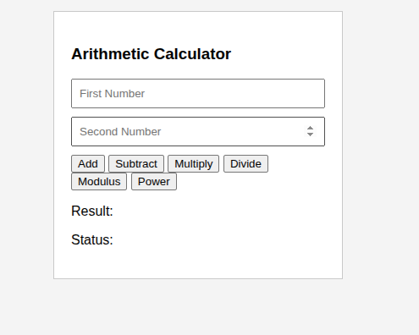

2. Create a student grade calculator using conditional statements.

Requirements:

Create an input field for entering marks (0-100)
Use if...else if...else to determine the grade:
90-100: A+ (Outstanding)
80-89: A (Excellent)
70-79: B+ (Very Good)
60-69: B (Good)
50-59: C (Average)
40-49: D (Below Average)
Below 40: F (Fail)
Display the grade and remarks
Validate input (should be between 0-100)
Also implement the same logic using a switch statement in a separate function

I.Source Code
<!DOCTYPE html>
<html>
<head>
<title>Grade Calculator</title>
</head>
<body>

<h3>Student Grade Calculator</h3>

Enter Marks:
<input type="text" id="marks">
<br><br>

<button onclick="gradeSwitch()">Using switch</button>

<p id="result"></p>
<script>
function gradeSwitch() {
var m = document.getElementById("marks").value;
m = Number(m);

if (m < 0 || m > 100) {
document.getElementById("result").innerHTML = "Enter marks between 0 and 100";
return;
}

var r = Math.floor(m/10);

switch(r) {
case 10:
case 9:
document.getElementById("result").innerHTML = "A+ (Outstanding)";
break;
case 8:
document.getElementById("result").innerHTML = "A (Excellent)";
break;
case 7:
document.getElementById("result").innerHTML = "B+ (Very Good)";
break;
case 6:
document.getElementById("result").innerHTML = "B (Good)";
break;
case 5:
document.getElementById("result").innerHTML = "C (Average)";
break;
case 4:
document.getElementById("result").innerHTML = "D (Below Average)";
break;
default:
document.getElementById("result").innerHTML = "F (Fail)";
}
}
</script>
</body>
</html>

II.Output

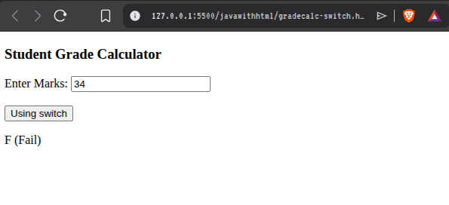

III.Source Code
<!DOCTYPE html>
<html>
<head>
<title>Grade Calculator</title>
</head>
<body>

<h3>Student Grade Calculator</h3>

Enter Marks:
<input type="text" id="marks">
<br><br>

<button onclick="gradeIf()">Check Grade</button>

<p id="result"></p>

<script>
function gradeIf() {
var m = document.getElementById("marks").value;
m = Number(m);

if (m >= 90 && m <= 100)
document.getElementById("result").innerHTML = "A+ (Outstanding)";
else if (m >= 80)
document.getElementById("result").innerHTML = "A (Excellent)";
else if (m >= 70)
document.getElementById("result").innerHTML = "B+ (Very Good)";
else if (m >= 60)
document.getElementById("result").innerHTML = "B (Good)";
else if (m >= 50)
document.getElementById("result").innerHTML = "C (Average)";
else if (m >= 40)
document.getElementById("result").innerHTML = "D (Below Average)";
else
document.getElementById("result").innerHTML = "F (Fail)";
}
</script>

</body>
</html>

IV.Output
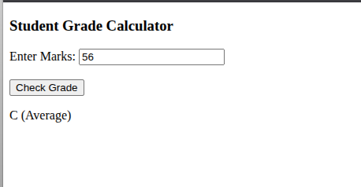

3. Create a web page using HTML, CSS, and JavaScript where a user enters a number and, using a loop, the program displays its multiplication table dynamically on the page.

I.Source Code

<!DOCTYPE html>
<html>
<head>
<title>Multiplication Table</title>
<style>
table, th, td {
border: 1px solid black;
border-collapse: collapse;
padding: 5px;
}
</style>
</head>
<body>

<h3>Multiplication Table</h3>

Enter a number:
<input type="text" id="num">
<button onclick="showTable()">Show Table</button>

<br><br>

<div id="output"></div>

<script>
function showTable() {
var n = document.getElementById("num").value;
n = Number(n);

var text = "<table>";

for (var i = 1; i <= 10; i++) {

text += "<tr>";
text += "<td>" + n + " x " + i + "</td>";
text += "<td>=</td>";
text += "<td>" + (n*i) + "</td>";
text += "</tr>";
}

text += "</table>";

document.getElementById("output").innerHTML = text;
}
</script>

</body>
</html>

II.Output
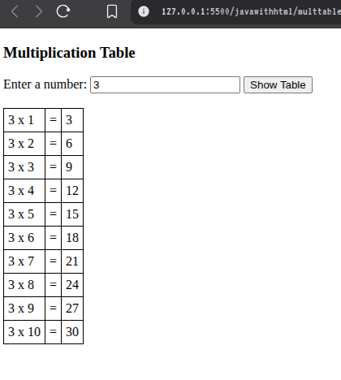

4. Create a page where a function validates whether the entered email is in the correct format.

I.Source Code

<!DOCTYPE html>
<html>
<head>
<title>Email Validation</title>
</head>
<body>

<h3>Email Validator</h3>

Enter Email:
<input type="text" id="email">
<button onclick="checkEmail()">Check</button>

<p id="result"></p>

<script>
function checkEmail() {
var e = document.getElementById("email").value;

if (e.includes("@") && e.includes(".") && e.indexOf("@") < e.lastIndexOf(".")) {
document.getElementById("result").innerHTML = "Valid Email";
} else {
document.getElementById("result").innerHTML = "Invalid Email";
}
}
</script>

</body>
</html>

II.Output
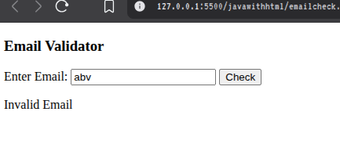

5. Create a page where a function clears all input fields when a reset button is clicked.

I.Source Code
<!DOCTYPE html>
<html>
<head>
<title>Clear Inputs</title>
</head>
<body>

<h3>Form</h3>

Name:
<input type="text" id="name"><br><br>

Email:
<input type="text" id="email"><br><br>

Age:
<input type="text" id="age"><br><br>

<button onclick="clearFields()">Reset</button>

<script>
function clearFields() {
document.getElementById("name").value = "";
document.getElementById("email").value = "";
document.getElementById("age").value = "";
}
</script>

</body>
</html>

II.Output
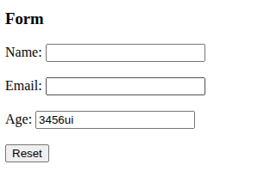

6. Create a web page where a button calls a function to display the current date and time.

I.Source Code
<!DOCTYPE html>
<html>
<head>
<title>Show Date and Time</title>
</head>
<body>

<h3>Current Date and Time</h3>

<button onclick="showDateTime()">Show Date & Time</button>

<p id="datetime"></p>

<script>
function showDateTime() {
var now = new Date();
document.getElementById("datetime").innerHTML = now.toString();
}
</script>

</body>
</html>

II.Output

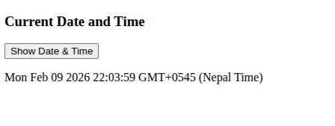

7. Write a function that reverses a given number or string.
I.Source COde
<!DOCTYPE html>
<html>
<head>
<title>Reverse Number/String</title>
</head>
<body>

<h3>Reverse Number or String</h3>

Enter value:
<input type="text" id="inputValue">
<button onclick="reverseValue()">Reverse</button>

<p id="result"></p>

<script>
function reverseValue() {
var val = document.getElementById("inputValue").value;

var str = val.toString();

var reversed = str.split("").reverse().join("");

document.getElementById("result").innerHTML = "Reversed: " + reversed;
}
</script>

</body>
</html>

II.Output
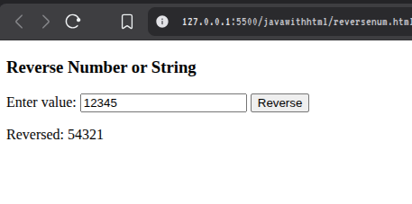
8. Write a function that counts the number of vowels in a string.
I.Source Code

<!DOCTYPE html>
<html>
<head>
<title>Count Vowels</title>
</head>
<body>

<h3>Vowel Counter</h3>

Enter text:
<input type="text" id="textInput">
<button onclick="countVowels()">Count Vowels</button>

<p id="result"></p>

<script>
function countVowels() {
var text = document.getElementById("textInput").value;
var count = 0;
var vowels = "aeiouAEIOU";

for (var i = 0; i < text.length; i++) {
if (vowels.indexOf(text[i]) !== -1) {
count++;
}
}

document.getElementById("result").innerHTML = "Number of vowels: " + count;
}
</script>

</body>
</html>

II.Output
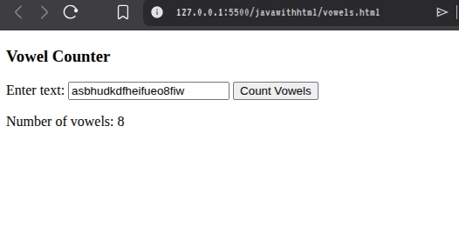

9. Write a function that converts Celsius temperature to Fahrenheit.
I.Source Code

<!DOCTYPE html>
<html>
<head>
<title>Celsius to Fahrenheit</title>
</head>
<body>

<h3>Celsius to Fahrenheit Converter</h3>

Enter Temperature (°C):
<input type="text" id="celsius">
<button onclick="convertToFahrenheit()">Convert</button>

<p id="result"></p>

<script>
function convertToFahrenheit() {
var c = document.getElementById("celsius").value;
c = Number(c);

var f = (c * 9/5) + 32;

document.getElementById("result").innerHTML = c + "°C = " + f + "°F";
}
</script>

</body>
</html>

II.Output
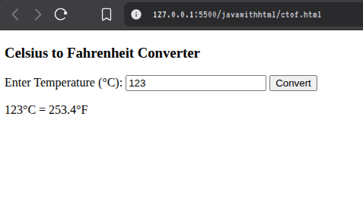

10. Write a JavaScript program to find the largest number in an array [23, 45, 12, 67, 34] using a loop.
I.Source Code

<!DOCTYPE html>
<html>
<head>
<title>Find Largest Number</title>
</head>
<body>

<h3>Largest Number in Array</h3>

<button onclick="findLargest()">Find Largest</button>

<p id="result"></p>

<script>
function findLargest() {
var arr = [23, 45, 12, 67, 34];
var largest = arr[0];

for (var i = 1; i < arr.length; i++) {
if (arr[i] > largest) {
largest = arr[i];
}
}

document.getElementById("result").innerHTML = "Largest number is: " + largest;
}
</script>

</body>
</html>

II.Output
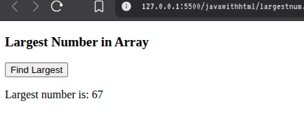

11. Write a JavaScript program to find all even numbers from an array [12, 7, 18, 23, 30, 45, 56] and store them in a new array. Display both the original array and the new array of even numbers.
I.Source Code
<!DOCTYPE html>
<html>
<head>
<title>Even Numbers in Array</title>
</head>
<body>

<h3>Find Even Numbers in Array</h3>

<button onclick="findEvenNumbers()">Show Even Numbers</button>

<p id="original"></p>
<p id="even"></p>

<script>
function findEvenNumbers() {
var arr = [12, 7, 18, 23, 30, 45, 56];
var evenArr = [];

for (var i = 0; i < arr.length; i++) {
if (arr[i] % 2 === 0) {
evenArr.push(arr[i]);
}
}

document.getElementById("original").innerHTML = "Original Array: [" + arr + "]";
document.getElementById("even").innerHTML = "Even Numbers: [" + evenArr + "]";
}
</script>

</body>
</html>

II.Output
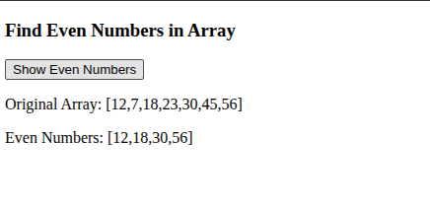

12. Write a JavaScript program to create a student object with the following properties: name, rollNumber, marks (array of 5 subjects)

Include methods to:

a. Calculate and return the total marks

b. Calculate and return the average marks

c. Display student information

d. Create an object and demonstrate calling all the methods.
I.Source Code

<!DOCTYPE html>
<html>
<head>
<title>Student Object</title>
</head>
<body>

<h3>Student Object Example</h3>

<button onclick="showStudent()">Show Student Info</button>

<p id="output"></p>

<script>

var student = {
name: "Reshma",
rollNumber: 101,
marks: [85, 78, 92, 66, 74],

totalMarks: function() {
var total = 0;
for (var i = 0; i < this.marks.length; i++) {
total += this.marks[i];
}
return total;
},

averageMarks: function() {
return this.totalMarks() / this.marks.length;
},

displayInfo: function() {
var info = "Name: " + this.name + "<br>";
info += "Roll Number: " + this.rollNumber + "<br>";
info += "Marks: " + this.marks.join(", ") + "<br>";
info += "Total Marks: " + this.totalMarks() + "<br>";
info += "Average Marks: " + this.averageMarks().toFixed(2);
return info;
}
};

function showStudent() {
document.getElementById("output").innerHTML = student.displayInfo();
}
</script>

</body>
</html>

II.Output
