1. Design following web page layout using CSS Flexbox, incorporating at least three different flex properties.
HTML code:
<!DOCTYPE html>
<html lang="en">
<head>
<meta charset="UTF-8">
<meta name="viewport" content="width=device-width, initial-scale=1.0">
<title>Flexbox Layout Example</title>
<link rel="stylesheet" href="question1.css">
</head>
<body>
<header>Header</header>

<section class="content-row">
<aside>Sidebar 1</aside>

<div class="article">Article</div>
<aside>Sidebar 2</aside>
</section>

<footer>Footer</footer>
</body>
</html>

CSS:

* {
margin: 0;
padding: 0;
box-sizing: border-box;
font-family: Arial, sans-serif;
}
body {
display: flex;
flex-direction: column;
align-items: center;
background: #f0f0f0;
min-height: 100vh;
gap: 5px;
padding: 20px 0;
}

header, footer {
width: 80%;
max-width: 1000px;
background: #ccc;
text-align: center;
padding: 20px;
border: 2px solid #999;
}

.content-row {
display: flex;
width: 80%;
max-width: 1000px;
gap: 5px;
justify-content: center;
}

aside {
flex: 1;
background: #ccc;
text-align: center;
padding: 40px 0;
border: 2px solid #999;
}

.article {
flex: 2;
background: #ccc;
text-align: center;
padding: 40px 0;
border: 2px solid #999;
}

Output:
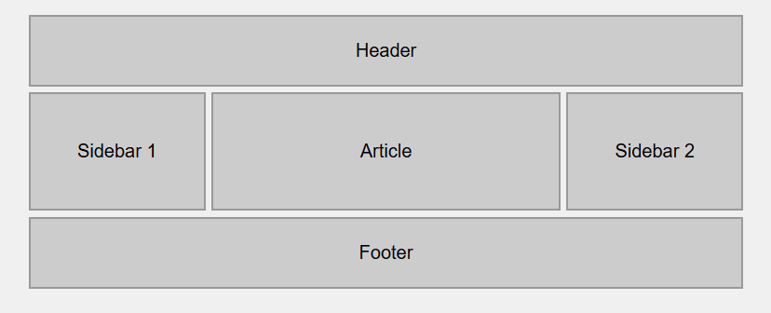

2. Design following web page layout using CSS Grid.
HTML code:
<!DOCTYPE html>
<html lang="en">
<head>
<meta charset="UTF-8">
<meta name="viewport" content="width=device-width, initial-scale=1.0">
<title>Three Column Layout</title>
<link rel="stylesheet" href="question2.css">
</head>
<body>

<header>HEADER</header>

<div class="main-container">
<aside class="sidebar">
<h3>Sidebar</h3>
<ul>
<li>Nav Item 1</li>
<li>Nav Item 2</li>
<li>Nav Item 3</li>
<li>Nav Item 4</li>
</ul>
</aside>

<div class="main-content">
<h2>Main Content Area</h2>
<p>
This is the main content area of the page. Grid template areas make it very easy to create
complex layouts with readable code. The layout is defined visually in the CSS, making it
easy to understand and modify.
</p>
</div>

<aside class="ads">
<h3>Ads</h3>
<p>Advertisement space</p>
</aside>
</div>

<footer>FOOTER - Copyright 2026</footer>

</body>
</html>

CSS:

* {
margin: 0;
padding: 0;
box-sizing: border-box;
font-family: Arial, sans-serif;
}

body {
display: flex;
flex-direction: column;
align-items: center;
gap: 5px;
background: #f0f0f0;
padding: 20px 0;
}

header {
width: 80%;
max-width: 1000px;
background: #2196f3; /* blue */
color: white;
text-align: center;
padding: 20px;
font-weight: bold;
}

footer {
width: 80%;
max-width: 1000px;
background: #607d8b;
color: white;
text-align: center;
padding: 15px;
}

.main-container {
display: flex;
width: 80%;
max-width: 1000px;
gap: 5px;
}

.sidebar {
flex: 1;
background: #4caf50;
color: white;
padding: 20px;
border-radius: 5px;
}

/* Main Content */
.main-content {
flex: 2;
background: white;
padding: 20px;
}

.ads {
flex: 1;
background: #ff9800;
color: white;
padding: 20px;
}

.sidebar ul {
list-style: none;
margin-top: 10px;
}

.sidebar li {
padding: 5px 0;
}

Output:
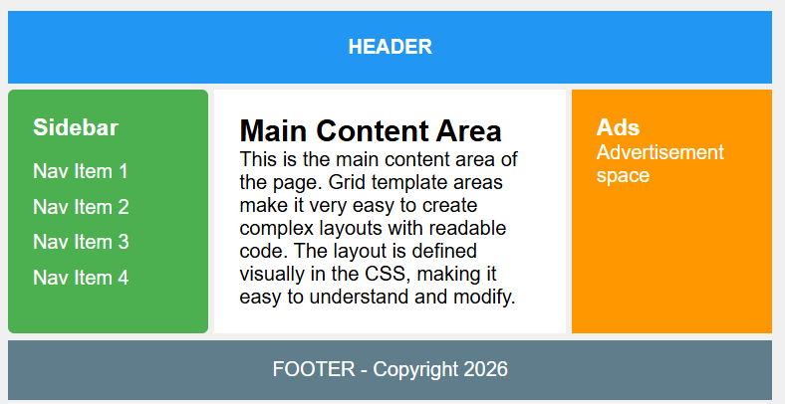

3. Implement a responsive navigation menu as follows using HTML and CSS, including a media query for mobile devices.
HTML code:
<!DOCTYPE html>
<html lang="en">
<head>
<meta charset="UTF-8">
<meta name="viewport" content="width=device-width, initial-scale=1.0">
<title>DesignX</title>
<link rel="stylesheet" href="question3.css">
</head>
<body>

<nav class="navbar">
<div class="logo">DesignX</div>

<!-- Hidden checkbox for toggle -->
<input type="checkbox" id="menu-toggle">
<label for="menu-toggle" class="hamburger">
<span></span>
<span></span>
<span></span>
</label>

<ul class="nav-links">
<li><a href="#">Home</a></li>
<li><a href="#">About</a></li>
<li><a href="#">Services</a></li>
<li><a href="#">Contact</a></li>
<li><a href="#">Feedback</a></li>
</ul>
</nav>

</body>
</html>

CSS:

* {
margin: 0;
padding: 0 ;
box-sizing: border-box;
font-family: Arial, sans-serif;
}

.navbar {
display: flex;
justify-content: space-between;
align-items: center;
background-color: #1e1e1e;
padding: 10px 20px;
color: #fff;
position: sticky;
top: 0;
z-index: 1000;
}

.logo {
font-size: 24px;
font-weight: bold;
}

.nav-links {
list-style: none;
display: flex;
gap: 20px;
}

.nav-links li a {
text-decoration: none;
color: #fff;
font-weight: 500;
transition: color 0.3s;
}

.nav-links li a:hover {
color: #00bcd4;
}

#menu-toggle {
display: none;
}

.hamburger {
display: none;
flex-direction: column;
cursor: pointer;
gap: 5px;
}

.hamburger span {
width: 25px;
height: 3px;
background-color: #fff;
border-radius: 3px;
}

/* Mobile view */
@media (max-width: 768px) {
.hamburger {
display: flex;
}

.nav-links {
position: absolute;
top: 60px;
right: 0;
width: 100%;
background-color: #1e1e1e;
flex-direction: column;
display: none;
}

.nav-links li {
text-align: center;
padding: 15px 0;
border-top: 1px solid #333;
}

#menu-toggle:checked + .hamburger + .nav-links {
display: flex;
}
}

Output:
For Desktop View:

For Mobile View:
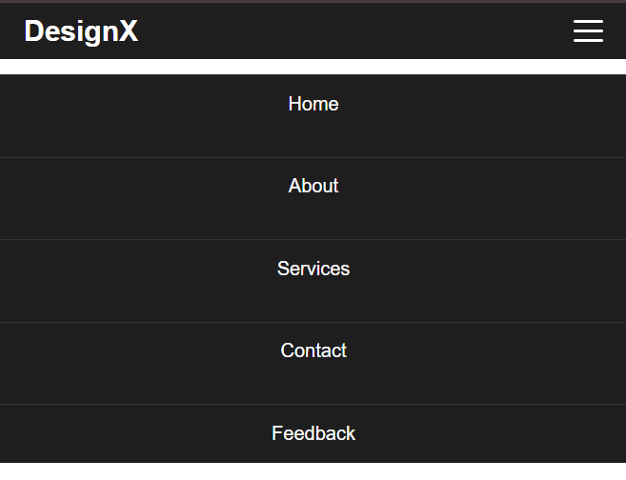

4. Create a card component that has the following effects: Scale up on hover, Shadow increases on hover, Smooth transition for all changes.
HTML code:
<!DOCTYPE html>
<html lang="en">
<head>
<meta charset="UTF-8">
<meta name="viewport" content="width=device-width, initial-scale=1.0">
<title>Document</title>
<link rel="stylesheet" href="question4.css">
</head>
<body>
<div class="card">
<img src="https://via.placeholder.com/300x180" alt="Sample Image">
<div class="card-content">
<h3>Card Title</h3>
<p>This is a sample card description. Add any content you like here.</p>
<a href="#" class="card-button">Learn More</a>
</div>
</div>
</body>
</html>

CSS:

.card {
width: 300px;
background-color: #fff;
border-radius: 12px;
overflow: hidden;
box-shadow: 0 4px 8px rgba(0,0,0,0.1);
transition: transform 0.3s ease, box-shadow 0.3s ease;
cursor: pointer;
}

.card img {
width: 100%;
height: auto;
display: block;
}

.card-content {
padding: 15px 20px;
}

.card-content h3 {
margin-bottom: 10px;
font-size: 20px;
color: #333;
}

.card-content p {
font-size: 14px;
color: #555;
margin-bottom: 15px;
}

.card-button {
text-decoration: none;
padding: 8px 15px;
background-color: #00bcd4;
color: #fff;
border-radius: 6px;
font-weight: bold;
transition: background-color 0.3s ease;
}

.card-button:hover {
background-color: #0097a7;
}

/* Hover effect for card */
.card:hover {
transform: scale(1.05);
box-shadow: 0 12px 20px rgba(0,0,0,0.25);
}

Output:
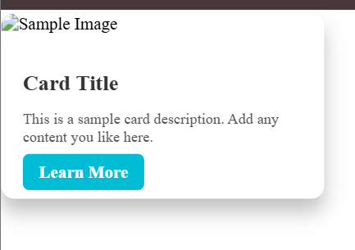

5. Create a basic spinner using CSS.
HTML code:
<!DOCTYPE html>
<html lang="en">
<head>
<meta charset="UTF-8">
<meta name="viewport" content="width=device-width, initial-scale=1.0">
<title>Document</title>
<link rel="stylesheet" href="question5.css">
</head>
<body>
<div class="spinner"></div>
</body>
</html>

CSS:
.spinner {
width: 50px;
height: 50px;
border: 5px solid #f3f3f3;
border-top: 5px solid #00bcd4;
border-radius: 50%;
animation: spin 1s linear infinite;
margin: 50px auto;
}

/* Spin animation */
@keyframes spin {
0% {
transform: rotate(0deg);
}
100% {
transform: rotate(360deg);
}
}

Output:


