
Applied Software Project Report

By

Reshma Satyanarayan Neelam

A Master’s Project Report submitted to Scaler Neovarsity - Woolf in partial fulfillment of the requirements for the degree of Master of Science in Computer Science

September, 2026

Scaler Mentee Email ID : roshninilam@gmail.com
Thesis Supervisor : Naman Bhalla
Date of Submission : 16/09/2026

Certification

I confirm that I have overseen / reviewed this applied project and, in my judgment, it adheres to the appropriate standards of academic presentation. I believe it satisfactorily meets the criteria, in terms of both quality and breadth, to serve as an applied project report for the attainment of Master of Science in Computer Science degree. This applied project report has been submitted to Woolf and is deemed sufficient to fulfill the prerequisites for the Master of Science in Computer Science degree.

Naman Bhalla
…………………
Project Guide / Supervisor

DECLARATION

I confirm that this project report, submitted to fulfill the requirements for the Master of Science in Computer Science degree, completed by me from 23 February 2026 to 17 September 2026, is the result of my own individual endeavor. The Project has been made on my own under the guidance of my supervisor with proper acknowledgement and without plagiarism. Any contributions from external sources or individuals, including the use of AI tools, are appropriately acknowledged through citation. By making this declaration, I acknowledge that any violation of this statement constitutes academic misconduct. I understand that such misconduct may lead to expulsion from the program and/or disqualification from receiving the degree.

Reshma Satyanarayan Neelam

<Signature of the Candidate> Date: 17 September 2026

ACKNOWLEDGMENT

I would like to thank my family for their patience during the many late nights this project demanded, and my instructors and mentors at Scaler Neovarsity for the guidance that shaped the way I now think about designing software. A particular thanks goes to my project module Instructors, Naman Bhalla and Anurag Khanna, whose feedback repeatedly pushed me to justify my design decisions rather than simply making them. I am also grateful to my peers, whose questions during review sessions exposed gaps I would otherwise have missed. Whatever I have learnt about building resilient, service-oriented systems is a direct result of this support.

Table of Contents

List of Tables 8
List of Figures 10
Applied Software Project 11
Abstract 11
Project Description 13
Requirement Gathering 17
2.1 Functional Requirements 17
2.2 Non-Functional Requirements 18
2.3 Users and Use Cases 18
2.4 Feature Set 20
2.5 Stakeholder Analysis 21
2.6 Development Milestones and Sprint Plan 22
2.7 Week-by-Week Milestone Review 23
2.8 Development Gate and Current Test Evidence 24
2.9 Scope Constraints and Deferred Work 25
Class Diagrams 26
3.2 User Management Service Class Design 28
3.3 Order Processor Service Class Design 29
3.4 Payment Processor Service Class Design 30
3.5 Notification Service and Service Discovery Design 31
3.6 Layered Design Across Services 32
Database Schema Design 33
4.1 Conventions 33
4.2 Schema Ownership 33
4.2.1 Complete Implemented Schema Summary 37
4.2.2 Entity Relationships and Enforcement 38
4.2.3 Indexing, Constraints and Migration Control 39
4.3 Order State and Transitions 40
Feature Development Process 41
5.1 The problem 41
5.2 The request flow 41
5.3 How the flow maps to MVC 42
5.4 The correctness mechanisms 42
5.5 Verification 43
5.6 Performance note 44
5.7 Cross-Service API Contract Summary 45
5.8 End-to-End Purchase and Event Flow 46
5.9 Test Strategy and Requirement Traceability 47
5.10 Current Functional Boundary 48
Deployment Flow 49
6.1 Deployment Security and Operational Boundaries 51
6.2 Current, Demonstration and Production-Shaped Deployment 52
Technologies Used 53
Conclusion 56
References 57
Supplementary Design and Implementation Appendices 59
Appendix A — Source Class Inventory 60
A.1 Product Catalog Source Inventory 61
A.2 User Management Source Inventory 62
A.3 Order Processor Source Inventory 63
A.4 Payment Processor Source Inventory 64
A.5 Notification Service Source Inventory 65
A.6 Service Discovery Source Inventory 66
Appendix B — Column-Level Data Dictionary 67
B.1 Product Catalog Schema — Core Catalogue 68
product 68
category 68
product_category 68
B.2 Product Catalog Schema — Inventory and Events 69
product_inventory 69
inventory_reservation 69
product_image 69
outbox_event 69
B.3 User Management Schema — Identity and Sessions 70
users 70
user_credential 70
user_session 70
B.4 User Management Schema — Addresses, Roles and Events 71
user_address 71
role 71
user_role 71
outbox_event 71
B.5 Order Processor Schema — Order Aggregate 72
orders 72
order_item 72
order_address 72
B.6 Order Processor Schema — History and Reliability 73
order_status_history 73
order_idempotency 73
inbox_event 73
outbox_event 73
B.7 Payment Processor Schema 74
payment 74
webhook_event 74
outbox_event 74
Appendix C — Implemented Endpoint Catalogue 75
C.1 Product Catalog and User Management Endpoints 76
C.2 Order and Payment Endpoints 77
Appendix D — Additional Verification Cases 78
D.1 Additional Test Evidence 79

List of Tables

Table No. | Title | Page No.
2.01 | Functional requirements by service
2.02 | Non-functional requirements
2.03 | Primary actors and their goals
2.04 | Feature set of the platform
4.01 | Product Catalog owned tables
4.02 | Order state machine transitions
7.01 | Technology baseline summary
2.05 | Stakeholder needs and implemented response
2.06 | Sprint overview and current status
2.07 | Planned milestones compared with repository status
2.08 | Module-level test execution summary
2.09 | Scope decisions used during implementation
3.01 | Layer implementation across the business services
4.03 | Implemented schema ownership summary
4.04 | Important entity relationships
4.05 | Database mechanisms and their purpose
5.01 | Main implemented API groups
5.02 | Purchase flow and safety mechanism at each step
5.03 | Requirement-to-test traceability
6.01 | Deployment security boundary
6.02 | Deployment stages and claims

List of Figures

Figure No. | Title | Page No.
1.01 | Project development process
1.02 | System context and service communication
2.01 | Use case diagram for the customer purchase journey
3.01 | Product Catalog class diagram (hexagonal ports and adapters)
4.01 | Entity relationship diagram across the four stateful service schemas
5.01 | Inventory reservation request flow
6.01 | AWS single-host deployment topology
3.02 | User Management core class relationships
3.03 | Order Processor core class relationships
3.04 | Payment Processor core class relationships
3.05 | Notification and discovery class relationships

Applied Software Project

Abstract

Online retail platforms have to do several complex things at the same time: show an accurate catalogue, never sell stock they do not have, secure financial transactions, and keep the customer informed, all while remaining available under load. This project is my attempt to build such a platform the way it is actually built in industry — as a set of independently deployable microservices rather than one large application.
The system is built as five Spring Boot business services (Product Catalog, User Management, Order Processor, Payment Processor, and Notification) plus a Eureka service-discovery registry, all living in a Maven monorepo and communicating through a mix of narrow synchronous HTTP calls and asynchronous Kafka events. MySQL is the system of record, with each stateful service owning its own logical database and no cross-service foreign keys. Payments are handled through Stripe in test mode, so the platform makes genuine API and webhook calls that represent real life transactions of actual currency.
The core engineering ideas I wanted to demonstrate are idempotency (so a retried request never charges or reserves twice), the transactional outbox pattern (so a service never loses an event after committing its data), and saga-style compensation (so a failed step can be safely reversed instead of relying on a distributed transaction). The Notification service consumes order and payment events, and the Eureka registry ties them together. The feature I describe in depth is the concurrency-safe inventory reservation mechanism in Product Catalog, which I verified cannot oversell even when two orders race for the last unit of stock.
The practical value of this work is that the same patterns used here — service ownership, event-driven decoupling, and idempotent processing — are the patterns that let real e-commerce, ticketing, and banking systems stay correct and available. This report explains the requirements, the design, feature in depth, and how the system is intended to be deployed on AWS.

Project Description

The objective of this project is to design and build a backend for an e-commerce platform that behaves correctly under the conditions that actually break naive shopping systems: concurrent orders for the same item, retried network requests, payment provider callbacks arriving out of order, and services being temporarily unavailable. Rather than build one monolith and hope it scales, I chose a microservices architecture so that each business capability could be owned, deployed, and reasoned about on its own.
The platform is broken into five business services:
- Product Catalog Service — manages products, categories, images, stock levels, and the reservation/release of inventory for orders.
- User Management Service — handles signup, login, JWT issuance, profiles, addresses, and roles.
- Order Processor Service — the source of truth for an order's amount, currency, ownership, and lifecycle state; it orchestrates the purchase saga.
- Payment Processor Service — talks to Stripe, records payment and refund attempts, and ingests verified webhooks.
- Notification Service — consumes order and payment events and delivers emails, without ever blocking a business transaction.
Around these sit a Service Discovery component — a single-node Netflix Eureka registry that lets the services find each other by name rather than by hard-coded host — and the infrastructure dependencies — MySQL, a single Kafka broker, and a reverse proxy — which are not themselves "microservices" but the plumbing the services rely on.
A guiding decision throughout was to keep the scope honest for a learning project. Instead of trying to build all five services superficially, I built one runnable vertical slice at a time and only moved forward when the current slice passed its tests. The four core services — Product Catalog, User Management, Order Processor, and Payment Processor — are fully implemented, tested, and registered with Eureka; the Notification service is implemented as a durable Kafka consumer; and the remaining work (Login via IDP, Ecommerce interactive UI) is future scope.
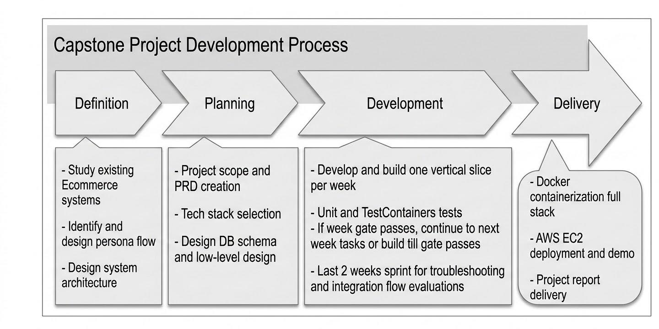
Figure 1.01: Project Development Process (Figure captions go below figures.)
The development of the E-Commerce Microservices Platform followed a structured and iterative approach to ensure systematic implementation, continuous testing, and reliable integration of the individual services. The development process was divided into multiple stages, beginning with requirements and low-level design and progressing through incremental feature development, testing, integration, and deployment.
1. Requirements and Low-Level Design
The initial stage focused on understanding the functional and non-functional requirements of the e-commerce platform and defining the overall technical design. The responsibilities of individual microservices, their interactions, and the major business workflows were identified. Low-level design was also performed to establish the structure of the services and their core components before implementation.
2. Database Schema Design
After defining the requirements and service structure, the database schemas were designed according to the data ownership and responsibilities of the individual services. This stage established the required entities, relationships, and persistence structure before feature implementation. The project uses MySQL as the persistent data store, with each stateful service maintaining ownership of its respective data.
3. Vertical Slice Development
The implementation was performed incrementally by developing one runnable vertical slice at a time. Rather than implementing all services simultaneously, each slice was developed as a complete piece of functionality and integrated with the components required for its execution. This approach helped maintain a manageable development scope and allowed individual features to be validated before moving to subsequent functionality.
4. Testing and Validation
Each completed vertical slice underwent multiple levels of testing, including unit testing, slice-level testing, and Testcontainers-based integration testing. These tests were used to verify business logic, service behaviour, and interaction with infrastructure components. Testing was treated as an integral part of the development process rather than being deferred until the final integration stage.
5. Development Gate
A development gate was applied after each implementation and testing cycle. If the required tests or acceptance conditions were not satisfied, development returned to the current vertical slice for troubleshooting, correction, and re-testing. If the gate was successfully passed, development proceeded to the next service or vertical slice. This iterative feedback mechanism helped identify and resolve issues at an early stage.
6. Full-Stack Integration
After the required service slices had been individually implemented and validated, the services and their supporting infrastructure were integrated into a complete application stack using Docker Compose. This provided a consistent environment for running the microservices together with their infrastructure dependencies, including the required databases and messaging components.
7. Deployment and Demonstration
The final stage involved preparing the complete containerized application for deployment and demonstration on an AWS EC2 instance. This stage verified the ability to run the integrated system in a cloud environment and provided the final setup for project demonstration. The overall process therefore progressed from requirements and design through incremental implementation and validation to full-stack integration and cloud deployment.
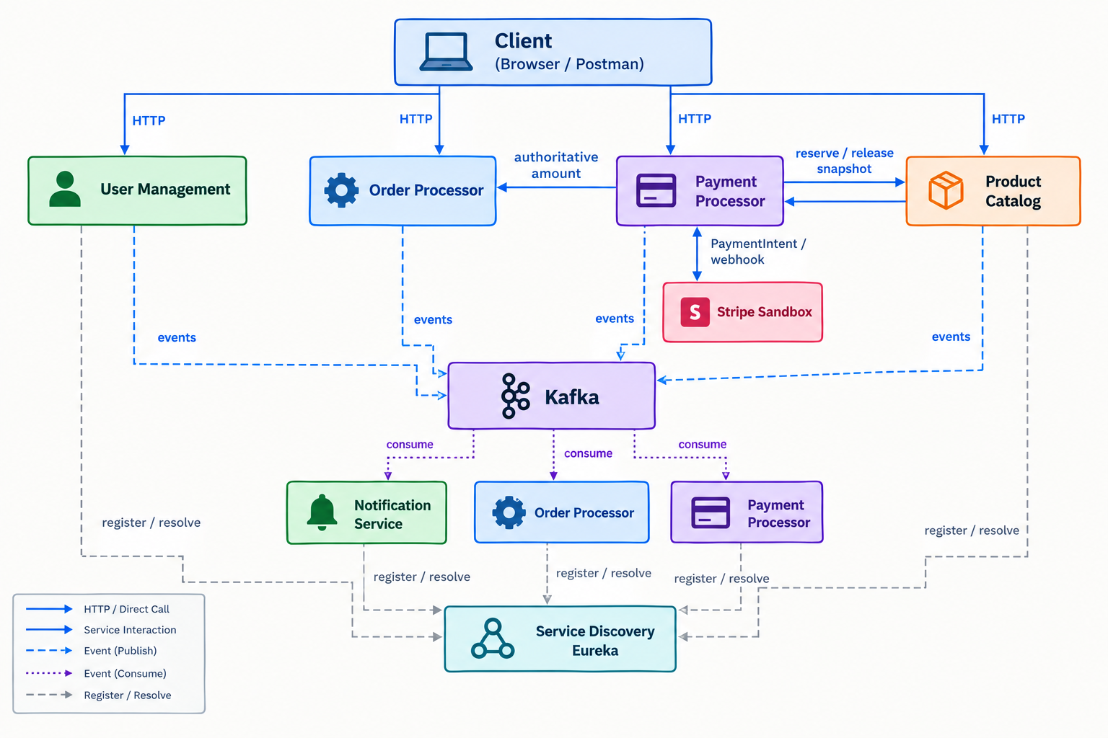Figure 1.02: Microservices Architecture and Service Interaction Flow
This project has widespread relevance, almost every online business — retail, food delivery, ticketing, travel — solves exactly these problems. The specific techniques I implement here (idempotency keys, transactional outbox, optimistic and pessimistic locking, and saga compensation) are the same building blocks those companies use to avoid double-charging customers and overselling stock.

Requirement Gathering

2.1 Functional Requirements
The functional requirements were derived per service, since each service owns a distinct slice of the business.
Table 2.01: Functional requirements by service.
Service | Key functional requirements
Product Catalog | Create/update/soft-delete products and categories; upload image metadata; search products with bounded pagination and safe sorting; adjust on-hand stock; reserve and release inventory idempotently per order; expire stale reservations.
User Management | Signup with hashed passwords; login returning a short-lived JWT and a rotating refresh token; refresh and logout; retrieve/update profile; manage shipping and billing addresses; assign CUSTOMER/ADMIN roles.
Order Processor | Create an order from product IDs and quantities with an idempotency key; snapshot SKU, name, price, currency, and addresses; compute subtotal and total; expose order detail, history, and status; cancel orders subject to state rules.
Payment Processor | Create exactly one Stripe PaymentIntent per order using authoritative amounts loaded from Order; verify and deduplicate Stripe webhooks; record payment attempts; issue refunds on cancellation.
Notification | Consume order/payment events, deduplicate them, render a template, and deliver email with retry — without blocking any business transaction.

2.2 Non-Functional Requirements
Table 2.02: Non-functional requirements.
Category | Requirement
Correctness | Stock must never be oversold; a retried request must never have a second business effect.
Reliability | An event must not be lost after its business data is committed (transactional outbox); a consumer crash must result in safe redelivery, not data loss.
Security | Passwords stored only as bcrypt hashes; JWT access tokens short-lived; only Stripe test keys accepted in demo profiles; no raw card data ever reaches the backend.
Isolation | Each service owns its own database; no cross-service foreign keys or joins.
Observability | Every service exposes liveness/readiness probes; every mutating request carries a correlation ID.
Portability | The whole stack runs from one docker compose up on a laptop and on a single EC2 instance.
Maintainability | Code follows SOLID and a ports-and-adapters layout so providers (e.g. payment gateway) can be swapped without touching business logic.

2.3 Users and Use Cases
The system has three principal actors.

Table 2.03: Primary actors and their goals.
Actor | Goal
Customer | Browse products, place an order, pay for it, track its status, and cancel or get refunded when needed.
Administrator | Manage the catalogue and stock, and transition orders through fulfilment states.
External systems | Stripe (payment confirmation via webhook) and the email provider (delivery).

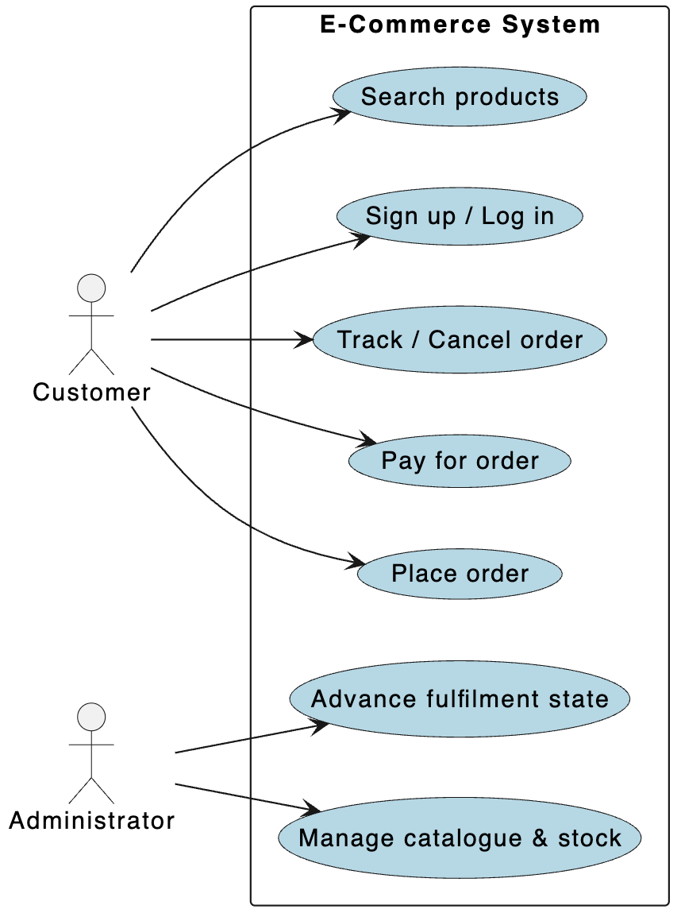
Figure 2.01: Use case diagram for the customer purchase journey.
A representative use case is Place Order: an authenticated customer submits product IDs and quantities with an idempotency key. The Order service fetches current product snapshots and asks Product Catalog to reserve stock. If reservation succeeds, the order is persisted as PENDING_PAYMENT and an OrderCreated event is written to the outbox in the same transaction. If the customer submits the same request again (a double-click or a network retry), the idempotency key ensures they get the original order back rather than a duplicate.

2.4 Feature Set

Feature | Owning service
Product & category CRUD with soft delete | Product Catalog
Product search with bounded pagination and allow-listed sorting | Product Catalog
Concurrency-safe, idempotent inventory reservation & release | Product Catalog
Reservation expiry worker | Product Catalog
Transactional outbox for product/inventory events | Product Catalog
Signup / login / JWT / roles | User Management
Idempotent order creation with snapshots | Order Processor
Stripe test-mode payments with verified webhooks | Payment Processor
Kafka-driven order confirmation | Order + Payment
Cancellation and refund saga | Order + Payment
Durable, non-blocking notifications | Notification
Service discovery / registry | Service Discovery (Eureka)
Table 2.04: Feature set of the platform.

2.5 Stakeholder Analysis
Table 2.05: Stakeholder requirements and solution approach
Stakeholder | Primary Requirements | Solution Approach
Customer | Secure account access, accurate products, safe ordering and payment status | JWT authentication, owner validation, inventory reservation, order snapshots and Stripe test-mode payment
Administrator | Controlled catalogue and stock maintenance | Role-aware product/category operations, stock adjustment endpoints and auditable status data
Application maintainer | Predictable builds, isolated services and diagnosable failures | Root Maven reactor, environment profiles, Actuator health, correlation IDs, outbox/inbox records and service-owned migrations
Payment provider | Correct amount, idempotent requests and verified callbacks | Payment reads the authoritative order amount, creates one logical payment and verifies Stripe webhook signatures
Notification provider | A clear message contract without blocking business work | Kafka consumer converts supported events to email/log messages after the order or payment transaction completes
Project guide / reviewer | Traceable claims and demonstrable implementation evidence | Requirements are mapped to source classes, Flyway tables and named automated tests

2.6 Development Milestones and Sprint Plan
Table 2.06: Sprint overview and implementation status.

Sprint | Weeks | Planned outcome | Implementation
Sprint 1: Foundation and Catalogue | 1–2 | Reproducible build, dependency stack and concurrency-safe catalogue | Parent POM, Maven wrapper, profiles, MySQL/Kafka Compose dependencies, full Product Catalog schema and reservation tests
Sprint 2: Identity and Orders | 3–4 | JWT identity plus idempotent order creation with snapshots | User Management and Order Processor modules, JWT/session/address flows, Product client, request hash, status history and ownership tests
Sprint 3: Payments and Messaging | 5–6 | Stripe test payment and Kafka-confirmed purchase | PaymentGateway/Stripe adapter, signed webhook processing, payment/order outboxes, Order inbox deduplication and event-flow integration tests
Sprint 4: Reversal, Notification and MVP | 7–9 | Cancellation/refund, durable notification and simple end-to-end demo | Reservation expiry and event-driven email/log sender exist; refund saga, durable notification jobs and user interface remain incomplete
Sprint 5: Packaging, Hosting and Operations | 10–12 | Complete Compose stack, EC2 demo, monitoring and recovery guidance | Health endpoints, profiles, correlation IDs and dependency Compose exist; service images, hosted deployment, central metrics and backup/restore proof remain future work

2.7 Week-by-Week Milestone Review

Table 2.07: Planned milestones and Deliverables.

Week | Milestone | Deliverable
1 | Reproducible foundation | Six-module Maven reactor, Java 21, Spring Boot 3.5.16, H2 test profiles, Actuator and dependency Compose
2 | Product Catalog | Seven active tables, CRUD/search, inventory reservation/release/expiry and concurrency coverage
3 | User Management | Signup/login/refresh/logout, profile/address APIs, BCrypt, JWT and CUSTOMER/ADMIN roles
4 | Order creation | Product snapshot client, stock reservation, monetary calculation, idempotency and status history
5 | Stripe payment | Stripe port/adapter, authoritative order lookup, PaymentIntent creation and verified webhook handling
6 | Kafka purchase flow | Order/payment outbox relays, topics, PaymentEventConsumer, inbox deduplication and state-machine tests
7 | Cancellation/refund | Order states and inventory expiry support recovery, complete refund orchestration
8 | Notification | Kafka consumer, message factory and email/log senders; database-backed retry queue
9 | Integrated demo | Bruno API collection; automated smoke flows
10 | Containerized application | MySQL/Kafka dependencies are containerized; complete Compose deployment for application services
11 | AWS deployment | Deployment design, hosted deployment artifacts or verification records
12 | Hardening and recovery | Correlation IDs and broad automated tests; central metrics, outage runbook and restore proof

2.8 Scope Constraints and Future Scope

Table 2.08: Scope decisions used during implementation.

Constraint | Decision | Reason
Academic project duration | Build one vertical slice at a time | A tested purchase path provides stronger evidence than many incomplete modules
Local infrastructure | One MySQL server, one Kafka broker and one Eureka node | Sufficient to demonstrate service boundaries and messaging without claiming high availability
Payment access | Stripe test mode only | Exercises genuine intent/webhook behaviour without moving money
Performance features | No Redis cache in the current implementation | Correctness, schema ownership and retry safety were prioritised; caching is future scope
Deployment | Single-host EC2/Compose target | A realistic learning target that avoids premature orchestration complexity
Deferred features | Cart, Product reviews, Product promotions, shipment integration, UI and distributed tracing | Not required to prove the implemented backend patterns

Class Diagrams

The low-level design follows a hexagonal (ports-and-adapters) structure. The important idea is that application and domain code depend only on interfaces (ports); Spring infrastructure classes implement those interfaces (adapters). This is what makes the PaymentGateway swappable and keeps the CreateOrderService free of any WebClient or JpaRepository reference.
3.1 Product Catalog Service Class Design
The diagram below shows the Product Catalog service, used here as the representative example; the same ports-and-adapters structure is repeated across the other implemented services. A controller handles only HTTP concerns and delegates to a service; the service coordinates the business action and talks to repositories and the outbox writer through ports.
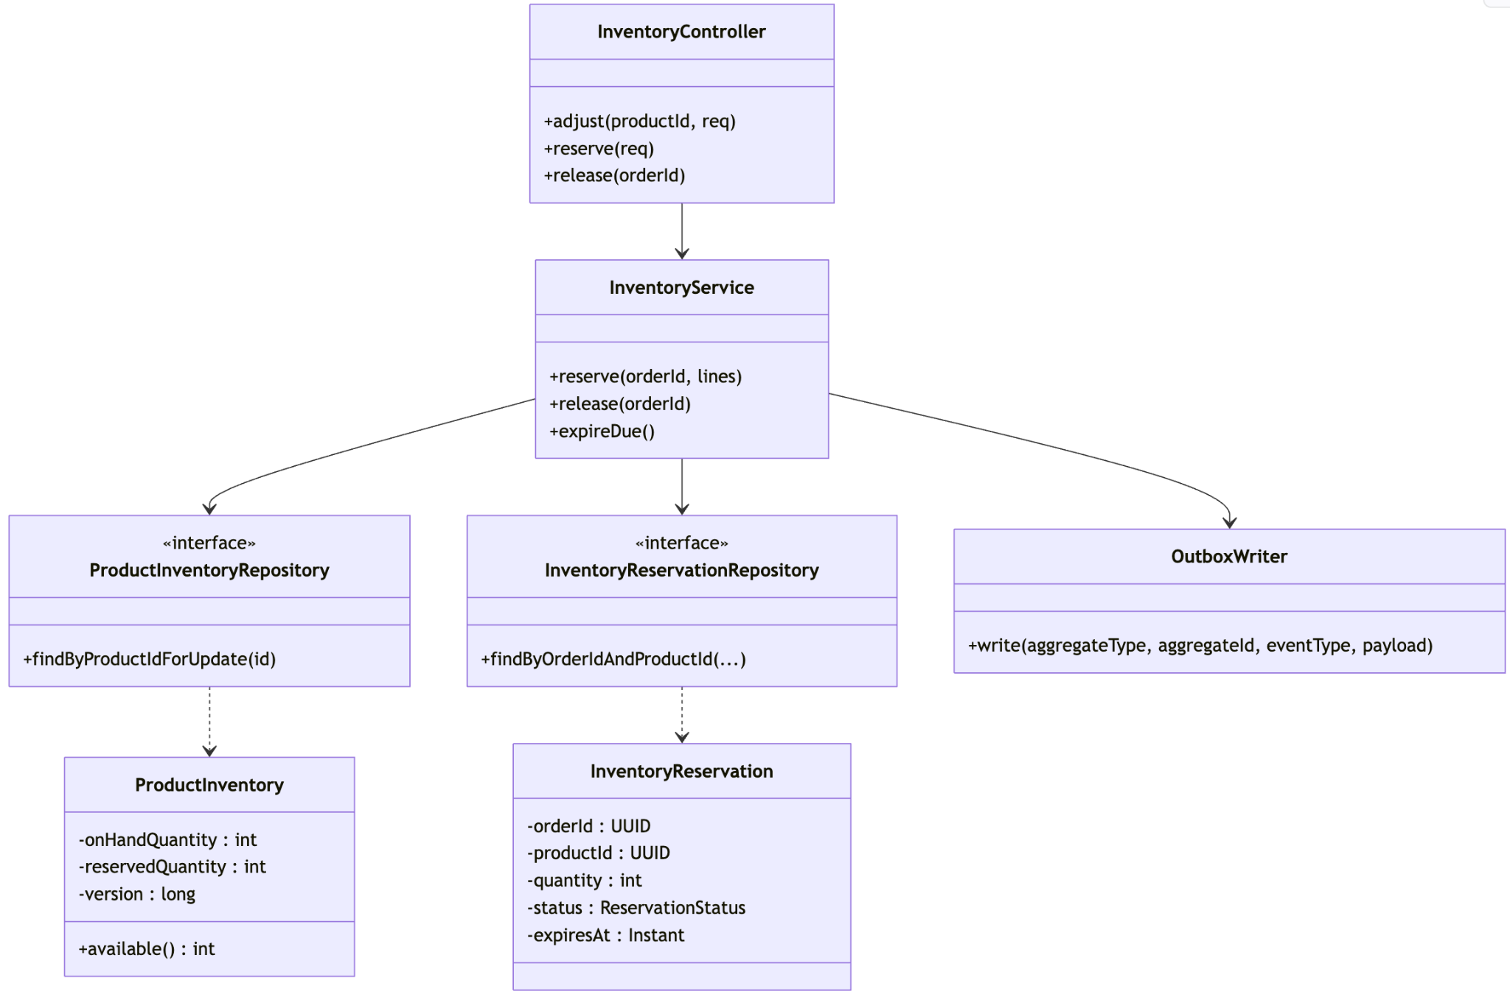
Figure 3.01: Product Catalog class diagram (hexagonal ports and adapters).
A few design rules are visible in this structure. The controller never contains business logic; overselling is prevented inside InventoryService using a pessimistic write lock combined with an optimistic @Version column. The reservation record carries the orderId so that reserving twice for the same order is a no-op rather than a second deduction, and the OutboxWriter persists the domain event in the same transaction as the inventory change so the event can never be lost.
The same skeleton repeats across the other services. For example Payment Processor has a PaymentController, a PaymentService, and a PaymentGateway port whose only real implementation is StripePaymentGateway; in tests the port is replaced with a Mockito stub so the whole payment flow can be exercised without calling Stripe on every build. Keeping the port narrow is what lets me test the payment logic in isolation while still driving the genuine Stripe SDK from the integration profile.

3.2 User Management Service Class Design

User Management separates profile information, credentials and refresh sessions. AuthController handles signup and token operations, UserController handles the authenticated profile and addresses, and InternalUserController exposes only the small projection required by another service. The separation prevents password data from becoming part of normal profile queries.

Controllers | Services | Security / persistence | Domain
AuthController  UserController  InternalUserController | AuthenticationService  UserProfileService  AddressService | JwtAuthenticationFilter  JwtTokenService  TokenService  5 repositories | User  UserCredential  UserSession  UserAddress  Role

Relationship | Responsibility
AuthController → AuthenticationService | Signup, login, refresh rotation and logout.
AuthenticationService → PasswordEncoder / TokenService | BCrypt credential checks and JWT creation without exposing implementation in the controller.
UserController → UserProfileService / AddressService | Owner-scoped profile and address operations.
JwtAuthenticationFilter → JwtTokenService | Validates bearer tokens and creates AuthenticatedUser.

Figure 3.02: User Management core class relationships.

3.3 Order Processor Service Class Design

Order Processor is the orchestration point for the purchase. OrderService resolves live Product Catalog data, reserves inventory and checks the request idempotency key. OrderPersistenceService saves the order aggregate and the outbox event in one transaction. PaymentEventHandler later applies payment facts after InboxEvent has protected the consumer from duplicate Kafka delivery.

Controllers | Application | Clients / persistence | Domain
OrderController  InternalOrderController  InternalOutboxController | OrderService  OrderPersistenceService  OrderStateMachine  PaymentEventHandler / Consumer | ProductClient  7 repositories  OutboxWriter  OutboxRelayPublisher | Order  OrderItem  OrderAddress  OrderStatusHistory  OrderIdempotency  InboxEvent  OutboxEvent

Relationship | Responsibility
OrderController → OrderService | Create, list and retrieve an order owned by the authenticated user.
OrderService → ProductClient | Fetch immutable product snapshots and reserve stock.
OrderService → OrderPersistenceService | Persist the aggregate, request hash and outbox event atomically.
PaymentEventConsumer → PaymentEventHandler | Separate Kafka acknowledgement from transactional state handling.
PaymentEventHandler → InboxEventRepository / OrderStateMachine | Deduplicate the event and validate the next order state.

Figure 3.03: Order Processor core class relationships.

3.4 Payment Processor Service Class Design

Payment Processor uses a port-and-adapter boundary around Stripe. PaymentService reads the owner, amount, currency and payable state from Order Processor; the client cannot choose the charge amount. StripePaymentGateway is the provider adapter, while PaymentWebhookService records the provider event ID before changing the local payment state and producing an outbox event.

Controllers | Application | Ports / persistence | Domain
PaymentController  StripeWebhookController  InternalOutboxController | PaymentService  PaymentWebhookService  PaymentStateMachine  OutboxRelayPublisher | PaymentGateway  StripePaymentGateway  OrderPaymentDetailsClient  3 repositories | Payment  WebhookEvent  OutboxEvent  CreatePaymentCommand  CreatePaymentResult

Relationship | Responsibility
PaymentController → PaymentService | Create one logical payment and return an owned payment.
PaymentService → OrderPaymentDetailsClient | Obtain the authoritative amount and validate the order state.
PaymentService → PaymentGateway | Create the external intent without coupling the use case to the Stripe SDK.
StripeWebhookController → PaymentWebhookService | Apply only signature-verified provider facts.
PaymentWebhookService → WebhookEventRepository | Use provider_event_id as the webhook deduplication key.
Figure 3.04: Payment Processor core class relationships.

3.5 Notification Service and Service Discovery Design

Notification Service is deliberately smaller than the stateful services. It receives an EventEnvelope, maps supported order/payment events to NotificationMessage and sends through the configured NotificationSender implementation. The current module has no database-backed retry queue, so that is reported as a limitation rather than shown as implemented. Service Discovery contains the Eureka server entry point and keeps only a live registry, not business data.
Kafka input | Message mapping | Output port | Discovery
NotificationEventConsumer  EventEnvelope | NotificationMessageFactory  NotificationMessage | NotificationSender  EmailNotificationSender  LogNotificationSender | ServiceDiscoveryApplication  Eureka registry
Figure 3.05: Notification and discovery class relationships.

3.6 Layered Design Across Services

The names vary by domain, but the dependency direction remains the same. A web or messaging adapter delegates to an application service; the service uses repository, HTTP-client or provider ports; and the domain model remains owned by one module. DTO classes remain at the boundary and are not used as JPA entities.

Table 3.01: Layer implementation across the business services.
Layer | Product | User | Order | Payment | Notification
Input adapter | REST controllers / scheduler | REST controllers | REST + Kafka consumer | REST + Stripe webhook | Kafka consumer
Application | Product, Category, Inventory services | Authentication, Profile, Address services | OrderService, persistence service, state machine | PaymentService, webhook service, state machine | Message factory
Output adapter | JPA repositories / outbox | JPA repositories / token service | Product client / JPA / Kafka relay | Order client / Stripe / JPA / Kafka relay | Email or log sender
Owned data | 7 tables | 7 tables | 7 tables | 3 tables | 4 tables

Database Schema Design

The data model follows one strict boundary rule: each stateful microservice owns a separate MySQL schema, and physical foreign keys exist only within the owning service. An identifier that points at another service (for example a user_id on an order) is stored as a plain CHAR(36) with no FK constraint, and it is validated at the API or event boundary rather than by the database. This is what actually enforces service independence — we cannot accidentally write a query that joins two services together.

4.1 Conventions
- Identifiers: application-generated CHAR(36) UUID strings, mapped in Java as java.util.UUID. Slightly wasteful on space but very easy to inspect by hand.
- Time: DATETIME(6) stored in UTC.
- Money: DECIMAL(19,4) plus a CHAR(3) ISO-4217 currency code — never FLOAT or DOUBLE.
- Optimistic locking: aggregate tables carry a version BIGINT used with JPA @Version.
- Deletion: products are soft-deleted so old order snapshots stay explainable; orders and payments are retained, never deleted.
- Reliability: producing services keep an outbox_event table; a consuming service that must not double-process keeps an inbox_event table (Order Processor) or a provider-event dedup table (Payment Processor's webhook_event), while the Notification consumer deduplicates by dropping any event it cannot process.

4.2 Schema Ownership
product_catalog_db owns: product, category, product_category, product_inventory, inventory_reservation, product_image, outbox_event.
user_management_db owns: users, user_credential, user_session, user_address, role, user_role, outbox_event.
order_processor_db owns: orders, order_item, order_address, order_status_history, order_idempotency, inbox_event, outbox_event.
payment_processor_db owns: payment, webhook_event, outbox_event. (Payment attempts and refunds are recorded on the payment row and its lifecycle state; the inbound Stripe webhook is deduplicated through webhook_event.)
The Notification service and the Service Discovery (Eureka) registry are stateless and own no schema: Notification consumes events straight from Kafka and renders/sends them, deduplicating by dropping any event it cannot process rather than persisting an inbox, and Eureka simply holds an in-memory registry of live instances.
As a worked textual example, the core Product Catalog tables are described below in the same style used in the schema design document.
Table 4.01: Product Catalog owned tables (selected columns).
product
- id CHAR(36) Primary Key
- sku VARCHAR(64) Unique
- name VARCHAR(255)
- status VARCHAR(32) ACTIVE | INACTIVE | DRAFT | DISCONTINUED
- base_price DECIMAL(19,4)
- currency CHAR(3)
- deleted_at DATETIME(6) soft-delete marker
- version BIGINT optimistic lock

product_inventory
- product_id CHAR(36) Primary Key, FK -> product.id (one row per product)
- on_hand_quantity INT
- reserved_quantity INT available = on_hand - reserved
- version BIGINT
- CHECK(reserved_quantity <= on_hand_quantity)

inventory_reservation
- id CHAR(36) Primary Key
- order_id CHAR(36) external reference to Order service (no FK)
- product_id CHAR(36) FK -> product.id
- quantity INT
- status VARCHAR(32) ACTIVE | RELEASED | CONSUMED | EXPIRED
- expires_at DATETIME(6)
- UNIQUE(order_id, product_id) <- this is what makes reservation idempotent

Foreign Keys (within Product Catalog only):
- product_category(product_id) refers product(id)
- product_category(category_id) refers category(id)
- product_inventory(product_id) refers product(id)
- inventory_reservation(product_id) refers product(id)

Cardinality of relations:
- product to category -> m:m (through product_category)
- product to inventory -> 1:1
- product to reservation -> 1:m

The UNIQUE(order_id, product_id) constraint on inventory_reservation is small but important: it is the database-level guarantee that a retried reservation for the same order and product cannot create a duplicate hold.
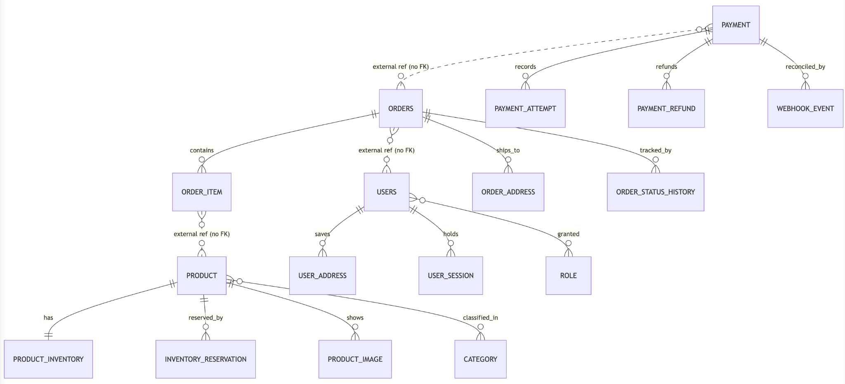Figure 4.01: Entity relationship diagram across the four stateful service schemas.
Diagrammatically, the cross-service picture looks like the above figure. Solid lines are real foreign keys inside one schema; dashed lines are logical references across services that are not enforced by the database.

4.2.1 Complete Implemented Schema Summary

The active service-local Flyway migrations are the executable source of truth. Product Catalog, User Management and Order Processor each own seven tables, while Payment Processor owns three. Notification Service and Service Discovery are stateless in the current code. This distinction avoids presenting the future-looking reference SQL as if every table were already used by the application.

Table 4.03: Implemented schema ownership summary
Owner | Active tables | Logical cross-service references
Product Catalog | product, category, product_category, product_inventory, inventory_reservation, product_image, outbox_event | inventory_reservation.order_id → Order
User Management | users, user_credential, user_session, user_address, role, user_role, outbox_event | No required physical reference outside the schema
Order Processor | orders, order_item, order_address, order_status_history, order_idempotency, inbox_event, outbox_event | orders.user_id → User; order_item.product_id → Product; latest_payment_id → Payment
Payment Processor | payment, webhook_event, outbox_event | payment.order_id → Order; payment.user_id → User
Notification / Discovery | No active Flyway tables | Consumes events or maintains live registration only

4.2.2 Entity Relationships and Enforcement
A physical foreign key is used only when the parent and child are owned by the same service. UUIDs that identify another service's aggregate are logical references and are validated at an API or event boundary. This rule protects independent schema evolution and prevents accidental cross-service joins.
Table 4.04: Important entity relationships.
Relationship | Cardinality | Enforcement and reason
category parent → category | many-to-one | Self-referencing Product Catalog foreign key supports hierarchy
product ↔ category | many-to-many | product_category composite primary key and two local foreign keys
product → inventory | one-to-one | product_inventory.product_id is both primary and foreign key
product → reservation / image | one-to-many | Local foreign keys; reservation also has unique order/product key
user → credential | one-to-one | user_credential.user_id is both primary and foreign key
user → session / address | one-to-many | Local foreign keys retain ownership in User Management
user ↔ role | many-to-many | user_role composite primary key prevents duplicate assignment
order → item / address / history | one-to-many | Local foreign keys preserve the complete order aggregate
order ↔ payment | logical one-to-one | Unique payment.order_id; ownership and amount checked through Order API

4.2.3 Indexing, Constraints and Migration Control
To maintain data integrity and prevent race conditions across distributed microservices, the system relies on a combination of relational constraints, optimistic versioning, and pessimistic locking. These built-in database mechanisms work together to ensure that business operations remain safe, retries are fully idempotent, and schema migrations are applied reliably.
Table 4.05: Database mechanisms and their purpose.
Mechanism | Examples | Purpose
Primary and foreign keys | UUID aggregate keys; local child-table foreign keys | Prevent duplicate identity and orphaned rows within a service
Unique business keys | product.sku, users.email, order_number, idempotency key pairs, provider_event_id | Make business retries and external callbacks safe
Check constraints | quantity > 0; reserved_quantity between zero and on-hand | Reject invalid inventory and order data at the database boundary
Worker indexes | outbox status/created time; reservation status/expiry; inbox status/received time | Support bounded polling without scanning entire tables
Optimistic version | product, inventory, user, order and payment aggregates | Detect conflicting concurrent updates
Pessimistic lock | Product inventory SELECT FOR UPDATE | Serialise reservations for the same item and prevent overselling
Flyway versions | V1 baselines plus V2 customer_email additions | Apply schema changes in repeatable order without rewriting shared history

4.3 Order State and Transitions
The order lifecycle is driven by a pure state machine so that every transition is validated by domain code rather than scattered through controllers.
Table 4.02: Order state machine transitions.
From state | Allowed next states
PENDING_PAYMENT | CONFIRMED, PAYMENT_FAILED, CANCELLED
CONFIRMED | PROCESSING, CANCELLATION_PENDING
PROCESSING | SHIPPED, CANCELLATION_PENDING
SHIPPED | DELIVERED
DELIVERED | (terminal)
PAYMENT_FAILED | PENDING_PAYMENT, CANCELLED
CANCELLATION_PENDING | CANCELLED (refund failure keeps it pending for retry)
CANCELLED | (terminal)

Feature Development Process

The inventory reservation module was selected for detailed examination as it addresses a critical vulnerability in e-commerce architectures: preventing stock overselling under high concurrency.
Furthermore, this component represents a fully realized implementation validated through rigorous testing, permitting an empirical description rather than a theoretical exposition.

5.1 The problem
When two customers try to buy the last unit of a product at nearly the same moment, both requests read "1 available", both decide there is enough stock, and both proceed — and now the system has sold two of something it has one of. The classic "read then write" pattern has a race condition. On top of that, network retries mean the same customer's reservation request might arrive twice, and the system must not treat that as two separate holds.

5.2 The request flow
The Order Processor calls the internal reservation endpoint on Product Catalog:
POST /internal/v1/inventory/reservations
{
"orderId": "<order-uuid>",
"lines": [ { "productId": "<uuid>", "quantity": 2 } ]
}

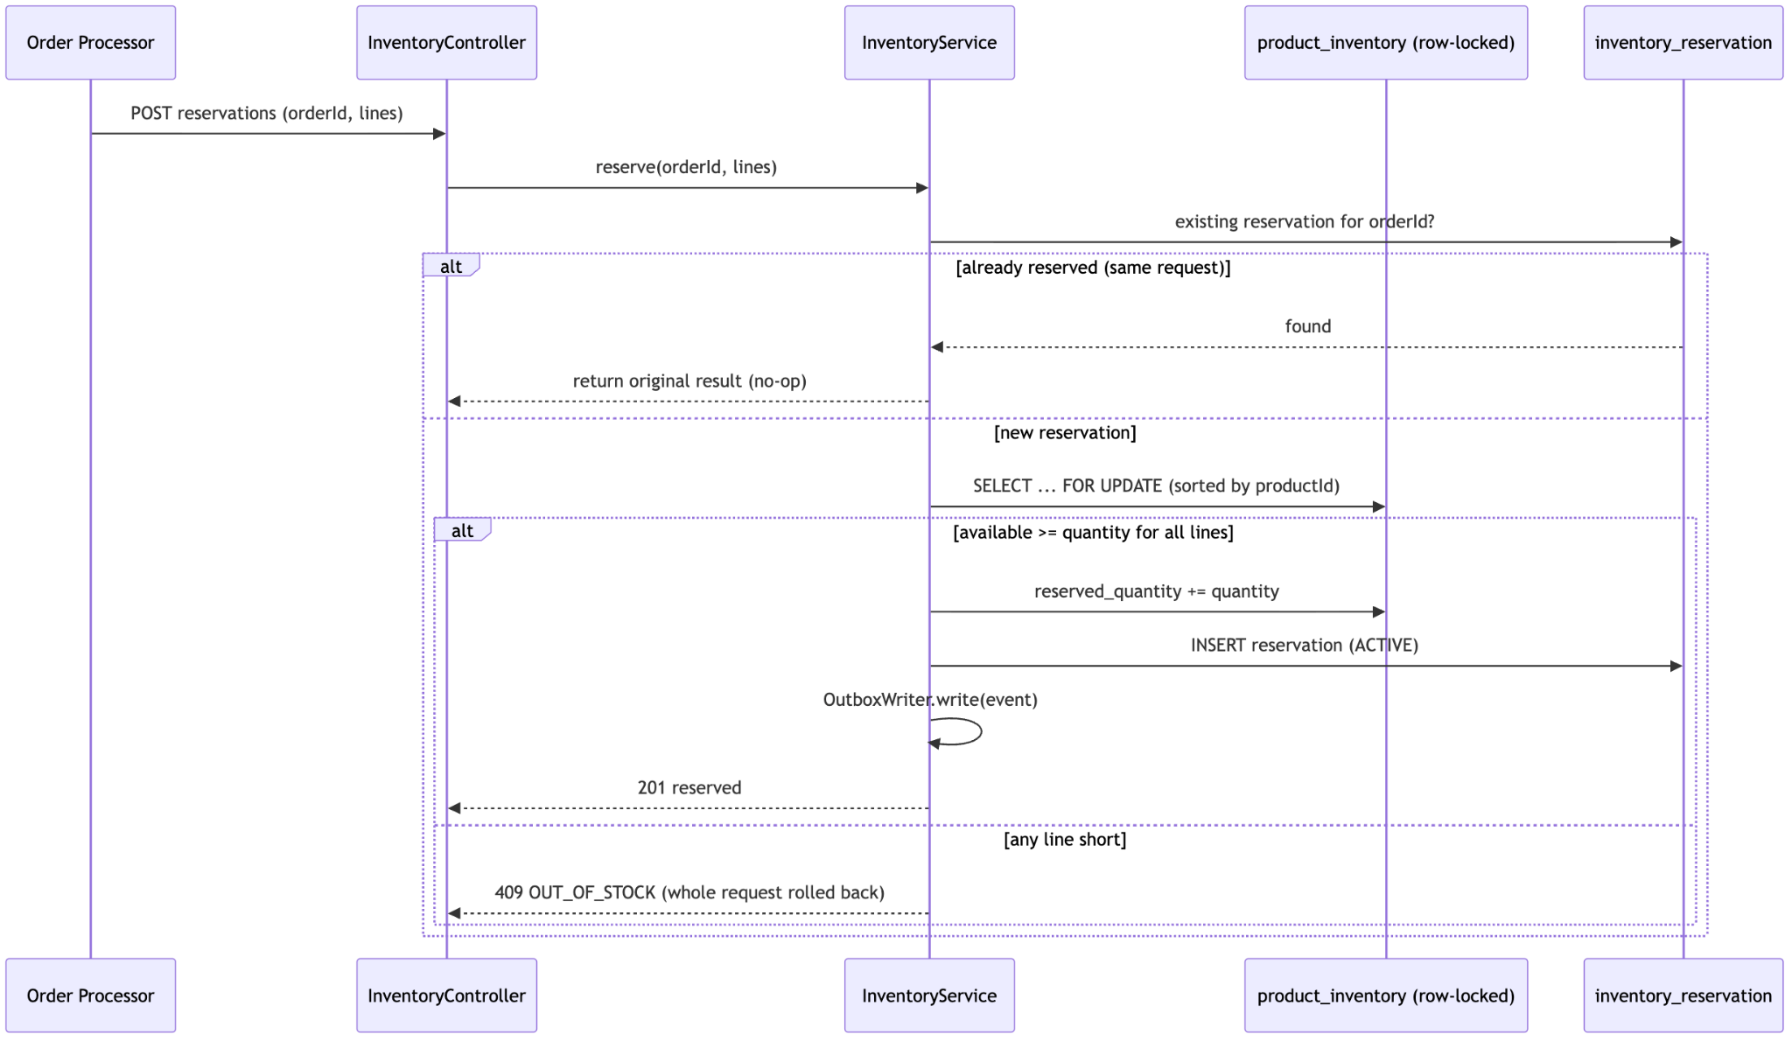
Figure 5.01: Inventory reservation request flow.

5.3 How the flow maps to MVC
- API request payload — the JSON above, validated by bean validation (non-null order ID, positive quantities).
- Controller — InventoryController.reserve() does only HTTP mapping and hands off to the service.
- Service — InventoryService.reserve() holds the whole business decision inside one @Transactional method.

5.4 The correctness mechanisms
This project uses three mechanisms together, because no single one is sufficient:
- Pessimistic row lock: the service loads each inventory row with SELECT ... FOR UPDATE (findByProductIdForUpdate). A concurrent reservation for the same product blocks until the first transaction commits, so the second one reads the already decremented quantity.
- Optimistic @Version: a backstop on the aggregate that catches any lost-update that slips past the lock.
- Idempotency on (order_id, product_id): before doing anything, the service checks for an existing reservation for that order. A replayed request returns the original result. A replay with a different quantity for the same order returns 409 DUPLICATE_REQUEST, because that is a genuine conflict rather than a retry.
Multi-line reservations are all-or-nothing: the lines are sorted by product ID (to avoid deadlocks between two orders locking the same products in opposite order) and the entire transaction rolls back if any single line is short, so a customer never ends up with a partial hold.

5.5 Verification
The behaviour is proven by tests :
- InventoryConcurrencyTest.concurrentReservations_cannotOversell fires two reservations at the last unit of stock and asserts exactly one succeeds and the other gets OUT_OF_STOCK.
- InventoryReservationTest covers idempotent replay (one business effect), release replay (no double increment), expiry running exactly once, and the different-quantity replay returning 409.
- reserve_multiLine_isAllOrNothing confirms partial reservations roll back.
The self-contained suite runs on in-memory H2 with no external dependency (.\mvnw.cmd test → 30 passed at the Week 2 gate), and a Testcontainers test applies the real Flyway migrations against a genuine MySQL 8.4 container during mvn verify when Docker is available. The same testing discipline extends across the monorepo: User Management, Order Processor, and Payment Processor each ship their own unit, slice, and Testcontainers migration tests (including WireMock tests for the cross-service HTTP clients and dedup tests for the inbox), so every service is proven the same way this one is.

5.6 Performance Note
The performance goal here is not raw throughput but correctness under contention. The pessimistic lock is scoped as tightly as possible — only the specific inventory rows are locked, only for the duration of the reservation transaction — so unrelated products are never blocked. Because reservation is idempotent, the Order service can safely retry on a timeout without inflating held stock, which removes an entire class of "phantom reserved quantity" bugs that would otherwise need a manual clean-up job. In other words, the optimisation scope here is the elimination of a correctness failure, measured by the concurrency test passing 100% of the time rather than by a millisecond figure.

5.7 Cross-Service API Contract Summary
The inventory feature sits inside a wider purchase contract. Public routes authenticate customers or administrators, while internal routes expose only the minimum information needed by another service. The client never supplies the final payment amount; Payment Processor reads it from Order Processor.
Table 5.01: Main implemented API groups.
Service | Endpoint group | Purpose
Product Catalog | GET/POST/PATCH/DELETE /api/v1/products and /categories | Search and administer catalogue data
Product Catalog | PUT /internal/v1/inventory/{productId}; POST/DELETE reservations | Adjust, reserve and release stock
User Management | POST /api/v1/auth/signup|login|refresh|logout | Credential and token lifecycle
User Management | GET/PATCH /api/v1/users/me and address routes | Owner-scoped profile and addresses
Order Processor | POST/GET /api/v1/orders and status route | Idempotent creation and owned order retrieval
Order Processor | GET /internal/v1/orders/{id}/payment-details | Authoritative payment owner, amount, currency and state
Payment Processor | POST/GET /api/v1/payments | Create one payment and return owned payment state
Payment Processor | POST /webhooks/stripe | Receive and verify Stripe events
Order / Payment | POST /internal/v1/outbox/{id}/requeue | Recover a failed outbox record

5.8 End-to-End Purchase and Event Flow

Table 5.02: Purchase flow and safety mechanism at each step.
Step | Interaction | Safety mechanism
1 | Customer → Order Processor | JWT identifies the owner; Idempotency-Key identifies a retry
2 | Order → Product Catalog | Live product snapshot plus row-locked, all-or-nothing reservation
3 | Order database transaction | Order aggregate, request hash and outbox event commit together
4 | Order outbox → Kafka | Relay retries publication without rolling back the accepted order
5 | Customer → Payment Processor | Payment reads authoritative order details and creates one provider intent
6 | Stripe → webhook endpoint | Signature verification and unique provider event ID prevent invalid or duplicate effects
7 | Payment outbox → Kafka | Payment result is published after local payment state commits
8 | Order Kafka consumer | Inbox event ID and state machine protect against replay and illegal transitions
9 | Notification consumer | Email/log delivery is outside the business transaction

The system implements an at-least-once processing architecture. While a request or event may be received multiple times, idempotency is enforced through database unique constraints, request hashes, inbox records, and webhook identifiers to ensure that each business operation is executed exactly once. Global exactly-once delivery guarantees are not claimed due to the independent failure domains of MySQL, Kafka, and Stripe.

5.9 Test Strategy and Requirement Traceability

This project uses a small test pyramid: pure unit tests for state and calculations, MVC tests for validation and authorization, WireMock for service clients, H2 integration tests for fast repository/use-case coverage, and separate MySQL/Kafka integration classes for behaviour that an in-memory database cannot prove.

Table 5.03: Requirement-to-test traceability.
Requirement | Tests | Verified behaviour
Stock is not oversold | InventoryConcurrencyTest | Two requests racing for the last unit cannot both succeed
Reservation replay is safe | InventoryReservationTest | Reserve/release/expiry have one business effect
Authentication lifecycle | AuthControllerTest; AuthFlowIntegrationTest | Signup, login, refresh, logout and invalid-token paths
Order creation is idempotent | OrderCreationIntegrationTest | Same key/body returns original; conflicting reuse is rejected
Order money is exact | OrderServiceMoneyTest | Decimal line totals and order totals
Order transitions are valid | OrderStateMachineTest | Only declared lifecycle changes are accepted
Payment uses Order authority | OrderPaymentDetailsClientWireMockTest | Remote contract and dependency failure mapping
Payment/webhook replay is safe | PaymentServiceTest; PaymentWebhookServiceTest | Idempotency key and provider event deduplication
Outbox failure is recoverable | OutboxRelayRecoveryIT; OutboxRelayPublisherTest | Failed publication remains visible and can be retried
Notification mapping is deterministic | NotificationMessageFactoryTest | Supported event payload becomes the expected message

Deployment Flow
The deployment target: the same stack is intended to run on a laptop and on a single AWS EC2 instance.
At the time of writing, the dependency stack — MySQL 8.4 and a single-node Kafka broker (KRaft, no ZooKeeper) — is containerised and brought up with one command (docker compose -f compose.deps.yaml up -d), while the five Spring services and the Eureka registry currently run as executable JARs built by Maven against that dependency stack. Packaging each service into its own image behind a single full-stack Compose file is the planned next step; the figure below shows that intended end state.
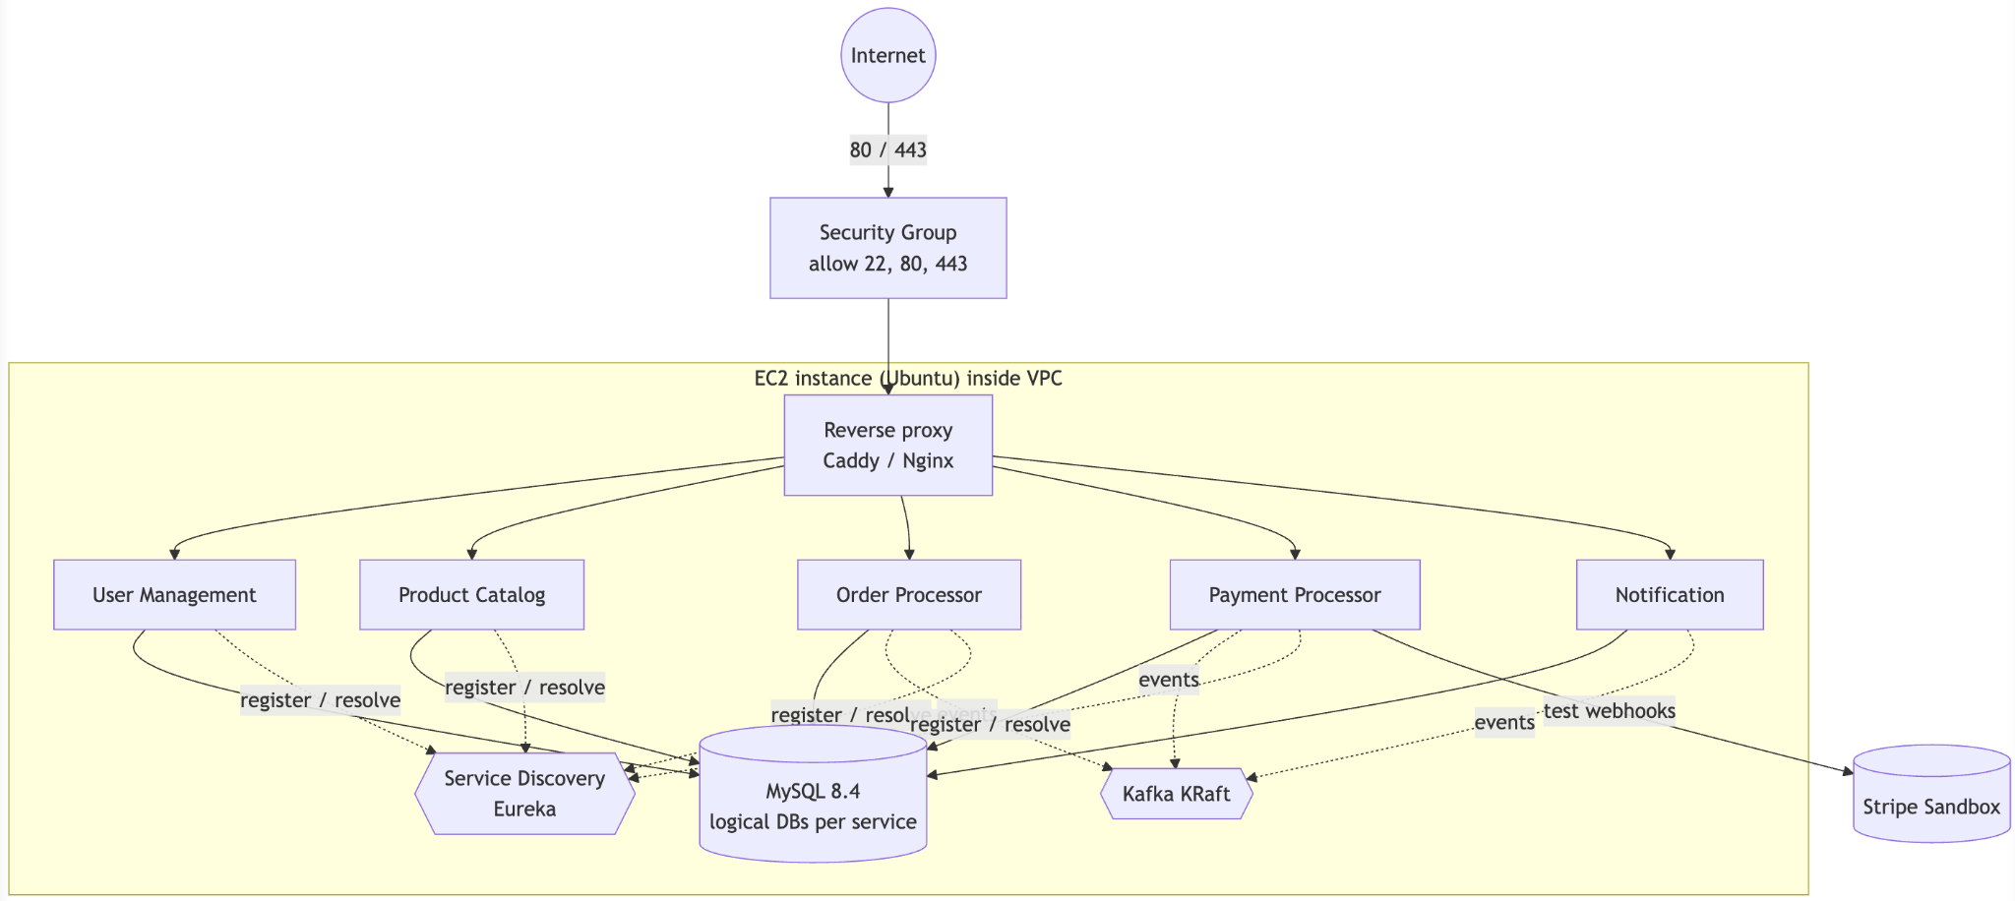
Figure 6.01: AWS single-host deployment topology.
EC2 (Elastic Compute Cloud). A single Ubuntu instance runs Docker Engine for the dependency stack and hosts the Spring services. In the intended end state all five services listen on container port 8080 and are reachable only through the private Compose network; only the reverse proxy publishes ports to the host. Service discovery is provided by the Netflix Eureka registry, so each service registers itself on startup and resolves its peers by logical name rather than by a hard-coded host and port.
VPC (Virtual Private Cloud). The instance sits inside a VPC that gives it network isolation. The application services, MySQL, and Kafka never have their ports exposed to the internet — port 3306 and port 9092 stay on the private Compose network and are deliberately not published on the EC2 host.
Security Groups. The instance's security group is the firewall. It allows inbound 22 (SSH, ideally restricted to my own IP), 80, and 443 only. Everything else is denied, so the database and broker cannot be reached from outside.
RDS (Relational Database Service). For this learning stage MySQL runs as a pinned container with a named volume, which keeps the whole thing to one host and one docker compose up. In a production-shaped evolution this container would be replaced by a managed RDS MySQL instance, moving backups, patching, and failover to AWS while the application configuration changes only its DB_HOST.
Cache. The current design does not yet add a cache, but the natural place for one is the Product Catalog read path (product detail and search), where a managed ElastiCache (Redis) layer would cut database load for hot products. It is deliberately deferred until the purchase flow works, to avoid optimising something that is not yet a bottleneck.
Managed infrastructure. Beyond a single instance, the same containers could run on Elastic Beanstalk or a container service, which would add rolling deploys and health-based restarts. That is out of scope for this project, and building the per-service container images is the immediate next step — planned as multi-stage Dockerfiles with a non-root runtime user and explicit JVM memory bounds (-XX:MaxRAMPercentage=70).
Secrets (database passwords, the JWT signing key, and the Stripe test keys) are supplied through a .env file that is never committed. The demo profile refuses to start if it is given a live Stripe key, which is a small guard that makes it impossible to accidentally point the learning deployment at real money.

6.1 Deployment Security and Operational Boundaries

This section outlines the key security and operational controls implemented across the deployment architecture. It details the specific protective measures established for public ingress, administrative access, database isolation, and application security. These boundaries ensure that sensitive infrastructure, credentials, and business data remain protected while maintaining system traceability and health monitoring.
Table 6.01: Deployment security boundary.
Area | Intended control | Justification
Public ingress | Expose only HTTP/HTTPS through a reverse proxy in the hosted design | Keeps service ports out of the public attack surface
Administrative access | Restrict SSH to the developer IP | Avoids global port 22 exposure
Database and Kafka | Private container/network access; never publish ports on a public EC2 interface | Business data and event traffic are internal dependencies
Credentials | Environment variables and an ignored .env file; no committed secrets | Separates configuration from source control
Payment | Reject live Stripe keys in the learning profile and verify webhook signatures | Prevents accidental real-money use and forged callbacks
Application identity | JWT owner/role checks on customer APIs | Prevents one customer reading another customer's order or payment
Health | Actuator liveness/readiness endpoints | Supports startup checks and future container restart decisions
Traceability | Correlation ID filters across REST services | Links a request to logs and downstream work

6.2 Current, Demonstration and Production-Shaped Deployment
AWS security groups should permit only required inbound traffic, and an eventual RDS instance should be reachable only from the application security group. The database, broker and registry should not be exposed directly to the internet.

Table 6.02: Deployment stages
Stage | Components | Status / interpretation
Current local development | Six Spring modules, MySQL 8.4 and single-node Kafka dependency Compose, Eureka registry | Implemented for development and automated testing; services start through Maven/IDE profiles
Planned academic demonstration | One EC2 host, Docker Engine/Compose, private service/dependency network, reverse proxy, Stripe test webhook | Appropriate low-cost target
Production-shaped evolution | Managed RDS, replicated Kafka, multiple service instances, managed secrets, central metrics/traces | Future improvement requiring cost, operations and availability work beyond project scope

Technologies Used
Table 7.01: Technology baseline summary.
Area | Technology | Why it was chosen
Language / runtime | Java 21 (LTS) | Long-term support, records, and modern language features.
Framework | Spring Boot 3.5.x | Web, Validation, Security, Data JPA, and Actuator in one consistent stack.
Service discovery | Spring Cloud Netflix Eureka | Lets services register and resolve each other by logical name instead of hard-coded hosts.
Build | Maven multi-module monorepo | One parent POM pins versions; each service builds its own executable JAR.
Database | MySQL 8.4 (LTS) + Flyway | Reliable relational store; Flyway makes schema changes reproducible per service.
Messaging | Apache Kafka (KRaft, single node) | Durable, replayable event log for asynchronous decoupling.
Payments | Stripe (test mode) | Real API/webhook behaviour without moving real money or storing card data.
Testing | JUnit 5, Mockito, Testcontainers, WireMock | Fast unit tests plus real-container integration tests.
Packaging / deploy | Docker + Docker Compose on AWS EC2 | One command brings up the whole stack locally and on the host.

Spring Boot. Spring Boot is the backbone of every service. It gives me dependency injection (which is what makes the ports-and-adapters design practical), declarative transactions with @Transactional, request validation, and production endpoints through Actuator. In real life the same framework runs a huge share of enterprise Java backends — banks, retailers, and streaming services — precisely because it standardises the boring parts and lets you focus on domain logic.
MySQL. MySQL is the system of record. Each service owns its own logical database, uses HikariCP for connection pooling, and manages its own schema through Flyway migrations. I rely on real relational features — unique constraints, check constraints, and row-level locking (SELECT ... FOR UPDATE) — to enforce correctness that would be fragile if left to application code alone. MySQL powers a large part of the web, from content platforms to e-commerce catalogues.
Apache Kafka. Kafka is the asynchronous spine. Services publish domain events (OrderCreated, PaymentSucceeded, InventoryReservationExpired) to topics keyed by order ID, and other services consume them at their own pace. Because Kafka is a durable, replayable log, a consumer that was down simply catches up when it returns. This is exactly how large systems — ride-hailing, logistics tracking, fraud detection — move events between teams without coupling their databases together. In this project Kafka is what lets the Notification service exist without any business transaction ever waiting on it.
Spring Cloud Netflix Eureka. Eureka is the service registry. On startup each service registers itself with the registry, and the Order and Payment services resolve their peers (for example Product Catalog and Order) by logical service name rather than by a hard-coded address. This keeps inter-service HTTP calls from breaking every time a host or port changes, and it is the same discovery mechanism that underpins many Spring-based microservice estates in industry. It runs here as a single node, which is sufficient for this project scope.
Stripe (test mode). Stripe handles the actual payment mechanics. The backend only ever creates a PaymentIntent and reacts to a signed webhook; the card number is entered directly into Stripe's UI elements in the browser and never touches my server or database. Using test keys and test cards (4242 4242 4242 4242) means the full flow — intent, confirmation, webhook, refund — behaves like production without any real charge. This is the standard way modern startups add payments without taking on the full weight of PCI compliance themselves.
Docker and Docker Compose. Docker packages each service into an image built with a multi-stage Dockerfile, and Compose wires the services, MySQL, Kafka, and a reverse proxy into one network. The practical payoff is that "works on my machine" becomes "works anywhere Docker runs" — the identical Compose file starts the stack on my laptop and on EC2. Container orchestration in this style underpins a large fraction of cloud deployments today.
Testcontainers and WireMock. These make the tests trustworthy. Testcontainers spins up a real MySQL 8.4 (and later Kafka) container during mvn verify, so migrations and JPA mappings are validated against the real database rather than an approximation. WireMock stands in for outbound HTTP dependencies so I can assert things like outbound idempotency headers without calling the real provider on every build.

Conclusion

- Key takeaways: A primary insight gained through this project is that correctness in a distributed architecture requires intentional engineering rather than reliance on the database alone. Idempotency keys, the transactional outbox pattern, and saga-style compensation are not academic curiosities; they are the difference between a system that double-charges customers under retries and one that does not. Building the inventory reservation feature end to end, and then writing the concurrency test that actually tried to break it, taught me more about locking and transaction boundaries than any amount of reading had.

- Practical applications: Every technology used here maps directly to how real backends are built. Spring Boot and MySQL run a large share of enterprise systems; Kafka is the standard way large organisations move events between independent teams; Stripe is how a great many businesses accept payments without owning the risk of raw card data; and Docker is how nearly all of it gets shipped. The patterns — service ownership, event-driven decoupling, and idempotent processing — are exactly what keep e-commerce, ticketing, and banking platforms correct while remaining available.

- Limitations and future improvements: The deployment runs on a single host, so it is not highly available - if the EC2 instance dies, everything is down. The MySQL and Kafka nodes are single instances with no replication, and the Eureka registry is a single node. There is no cache layer, no distributed tracing backend, and no automated CI pipeline yet. On the cost side, a single small EC2 instance is cheap, but a production-shaped version — managed RDS with multi-AZ failover, ElastiCache, a multi-broker Kafka cluster, and an orchestrator — would cost meaningfully more and is deferred as this is sufficient for academic project scope. The clearest next steps are to move the database to managed RDS and add a Redis cache on the catalogue read path. Adding an interactive UI for actors to use the system.

References

- Spring Boot Reference Documentation, Pivotal/VMware, https://docs.spring.io/spring-boot/
- MySQL 8.4 Reference Manual, Oracle Corporation,
https://dev.mysql.com/doc/
- Testcontainers for Java Documentation, https://java.testcontainers.org/
- Docker and Docker Compose Documentation, Docker Inc.,
https://docs.docker.com/
- Flyway Documentation, Redgate, https://documentation.red-gate.com/flyway
- JDK 21 Documentation, Oracle, https://docs.oracle.com/en/java/javase/21/
- Spring Cloud Netflix Reference — Eureka Service Discovery, Broadcom, https://docs.spring.io/spring-cloud-netflix/reference/
- Apache Kafka Design — Message Delivery Semantics, Apache Software Foundation, https://kafka.apache.org/40/design/design/
- Stripe PaymentIntents API Reference, Stripe Inc., https://docs.stripe.com/api/payment_intents
- Stripe Webhook Documentation, Stripe Inc.,
https://docs.stripe.com/webhooks
- WireMock Stubbing and Request Matching Documentation, https://wiremock.org/docs/stubbing/
- Amazon EC2 Security Groups, Amazon Web Services, https://docs.aws.amazon.com/AWSEC2/latest/UserGuide/ec2-security-groups.html
- Amazon RDS for MySQL, Amazon Web Services, https://docs.aws.amazon.com/AmazonRDS/latest/UserGuide/CHAP_MySQL.html
Books and Architecture References

- Sam Newman, Building Microservices: Designing Fine-Grained Systems, 2nd ed., O’Reilly Media, 2021.
- Martin Kleppmann, Designing Data-Intensive Applications, O’Reilly Media, 2017.
- Chris Richardson, Microservices Patterns, Manning Publications, 2018 (transactional outbox, saga, and idempotent consumer patterns).

Supplementary Design and Implementation Appendices
Appendix | Coverage
A | Package-level production source-class inventory
B | Column-level data dictionary from active Flyway migrations
C | Implemented public and internal REST endpoint catalogue
D | Additional verification cases not available in the core chapters

Appendix A — Source Class Inventory
Chapter 3 presents the core class relationships. This appendix lists the remaining production classes by package so configuration, DTO, exception and support types can be located without making the main class diagrams unreadable.
A.1 Product Catalog Source Inventory
Package | Classes | Responsibility
application root | ProductCatalogApplication | Spring Boot entry point
config | SchedulingConfig | Security, HTTP client, Kafka and application configuration
controller | CategoryController, InventoryController, ProductController | REST adapters and endpoint mapping
dto | ApiErrorDTO, CategoryCreateRequestDTO, CategoryResponseDTO, CategoryUpdateRequestDTO, InventoryAdjustRequestDTO, InventoryResponseDTO, ReservationRequestDTO, ReservationResponseDTO, ImageCreateRequestDTO, ImageResponseDTO, ImageUpdateRequestDTO, ProductCreateRequestDTO, ProductResponseDTO, ProductUpdateRequestDTO | Validated request and response contracts
enums | CategoryStatus, OutboxStatus, ProductStatus, ReservationStatus | Supporting production classes
exception | ApiException, BadRequestException, ConflictException, GlobalExceptionHandler, NotFoundException | Domain/API errors and common response handling
mapper | CategoryMapper, InventoryMapper, ProductMapper | Entity-to-DTO conversion
model | Category, InventoryReservation, OutboxEvent, Product, ProductCategory, ProductCategoryId, ProductImage, ProductInventory | JPA entities and persisted state
observability | CorrelationId, CorrelationIdFilter | Correlation ID support
repository | CategoryRepository, InventoryReservationRepository, OutboxEventRepository, ProductCategoryRepository, ProductImageRepository, ProductInventoryRepository, ProductRepository | Spring Data persistence interfaces
service | CategoryService, CategoryServiceImpl, InventoryService, InventoryServiceImpl, OutboxWriter, ProductService, ProductServiceImpl, ReservationExpiryWorker | Use cases, transactions and domain coordination
specification | ProductSpecifications | Dynamic Product Catalog query predicates
web | PageableUtils | Web-layer validation helpers

A.2 User Management Source Inventory
Package | Classes | Responsibility
application root | UserManagementApplication | Spring Boot entry point
config | AdminBootstrapRunner, JwtProperties, PasswordEncoderConfig, SecurityConfig, SecuritySettingsProperties | Security, HTTP client, Kafka and application configuration
controller | AuthController, InternalUserController, UserController | REST adapters and endpoint mapping
dto | AddressRequestDTO, AddressResponseDTO, AddressUpdateRequestDTO, ApiErrorDTO, AuthTokensDTO, LoginRequestDTO, LogoutRequestDTO, RefreshRequestDTO, SignupRequestDTO, UserResponseDTO, InternalUserDTO, UpdateProfileRequestDTO | Validated request and response contracts
enums | AddressType, RoleName, UserStatus | Supporting production classes
exception | ApiException, BadRequestException, ConflictException, GlobalExceptionHandler, NotFoundException, UnauthorizedException | Domain/API errors and common response handling
model | Role, User, UserAddress, UserCredential, UserSession | JPA entities and persisted state
observability | CorrelationId, CorrelationIdFilter | Correlation ID support
repository | RoleRepository, UserAddressRepository, UserCredentialRepository, UserRepository, UserSessionRepository | Spring Data persistence interfaces
security | AuthenticatedUser, JwtAuthenticationFilter, JwtTokenService, RefreshTokenSupport, TokenService | JWT validation and authenticated-user representation
service | AddressService, AuthenticationService, UserProfileService | Use cases, transactions and domain coordination

A.3 Order Processor Source Inventory
Package | Classes | Responsibility
application root | OrderProcessorApplication | Spring Boot entry point
client | ProductClient, ProductSnapshotDTO, ReserveRequest | Synchronous clients for another service
config | JwtProperties, KafkaTopicsConfig, OrderPricingProperties, ProductCatalogProperties, RestClientConfig, SecurityConfig | Security, HTTP client, Kafka and application configuration
controller | InternalOrderController, InternalOutboxController, OrderController | REST adapters and endpoint mapping
dto | ApiErrorDTO, AddressDTO, OrderCreateRequestDTO, OrderItemResponseDTO, OrderResponseDTO, OrderStatusResponseDTO, PaymentDetailsResponseDTO | Validated request and response contracts
enums | AddressType, ChangedByType, InboxStatus, OrderStatus, OutboxStatus | Supporting production classes
exception | ApiException, BadRequestException, ConflictException, DependencyUnavailableException, GlobalExceptionHandler, NotFoundException, UnauthorizedException | Domain/API errors and common response handling
mapper | OrderMapper | Entity-to-DTO conversion
messaging | EventEnvelope, EventEnvelopeSerializer | Event envelope and serialization types
model | InboxEvent, Order, OrderAddress, OrderIdempotency, OrderItem, OrderStatusHistory, OutboxEvent | JPA entities and persisted state
observability | CorrelationId, CorrelationIdFilter | Correlation ID support
repository | InboxEventRepository, OrderAddressRepository, OrderIdempotencyRepository, OrderItemRepository, OrderRepository, OrderStatusHistoryRepository, OutboxEventRepository | Spring Data persistence interfaces
security | AuthenticatedUser, JwtAuthenticationFilter, JwtTokenService, TokenService | JWT validation and authenticated-user representation
service | OrderPersistenceService, OrderService, OrderStateMachine, OutboxRelayPublisher, OutboxWriter, PaymentEventConsumer, PaymentEventHandler, RequestHasher, ResolvedLine | Use cases, transactions and domain coordination

A.4 Payment Processor Source Inventory
Package | Classes | Responsibility
application root | PaymentProcessorApplication | Spring Boot entry point
client | OrderPaymentDetailsClient, OrderPaymentDetailsDTO | Synchronous clients for another service
config | JwtProperties, KafkaTopicsConfig, OrderClientProperties, RestClientConfig, SecurityConfig, StripeConfig, StripeProperties | Security, HTTP client, Kafka and application configuration
controller | InternalOutboxController, PaymentController, StripeWebhookController | REST adapters and endpoint mapping
dto | ApiErrorDTO, CreatePaymentRequestDTO, PaymentResponseDTO | Validated request and response contracts
enums | OutboxStatus, PaymentStatus | Supporting production classes
exception | ApiException, BadRequestException, ConflictException, DependencyUnavailableException, GlobalExceptionHandler, NotFoundException, UnauthorizedException | Domain/API errors and common response handling
gateway | CreatePaymentCommand, CreatePaymentResult, PaymentGateway, StripePaymentGateway | External payment-provider port and Stripe adapter
messaging | EventEnvelope, EventEnvelopeSerializer | Event envelope and serialization types
model | OutboxEvent, Payment, WebhookEvent | JPA entities and persisted state
observability | CorrelationId, CorrelationIdFilter | Correlation ID support
repository | OutboxEventRepository, PaymentRepository, WebhookEventRepository | Spring Data persistence interfaces
security | AuthenticatedUser, JwtAuthenticationFilter, JwtTokenService, TokenService | JWT validation and authenticated-user representation
service | OutboxRelayPublisher, OutboxWriter, PaymentService, PaymentStateMachine, PaymentWebhookService | Use cases, transactions and domain coordination

A.5 Notification Service Source Inventory
Package | Classes | Responsibility
application root | NotificationServiceApplication | Spring Boot entry point
consumer | NotificationEventConsumer | Kafka input adapter
messaging | EventEnvelope, NotificationMessage | Event envelope and serialization types
service | EmailNotificationSender, LogNotificationSender, NotificationMessageFactory, NotificationSender | Use cases, transactions and domain coordination
A.6 Service Discovery Source Inventory

Package | Classes | Responsibility
application root | ServiceDiscoveryApplication | Spring Boot entry point

Appendix B — Column-Level Data Dictionary
Chapter 4 explains schema ownership, relationships, constraints and migration control. The following data dictionary records individual columns from the active service-local Flyway migrations and is retained as reference material rather than repeated in the main discussion.
B.1 Product Catalog Schema — Core Catalogue
Product is the catalogue aggregate root. Category has an optional self-reference for hierarchy, while product_category resolves the many-to-many relationship. Product rows are soft deleted so an old order snapshot remains understandable even after a product is no longer sold.

product
Column | Type | Key / constraint | Purpose
id | CHAR(36) | PK, not null | Application-generated product UUID
sku | VARCHAR(64) | Unique, not null | Business-facing stock keeping unit
name | VARCHAR(255) | Not null, indexed | Product display name
description | TEXT | Nullable | Long description
brand | VARCHAR(128) | Nullable | Manufacturer or brand
status | VARCHAR(32) | Default ACTIVE | Lifecycle state
base_price | DECIMAL(19,4) | Not null | Authoritative selling price
currency | CHAR(3) | Not null | ISO-4217 currency
created_at / updated_at | DATETIME(6) | Not null | UTC audit timestamps
deleted_at | DATETIME(6) | Nullable | Soft-delete marker
version | BIGINT | Default 0 | Optimistic locking version

category
Column | Type | Key / constraint | Purpose
id | CHAR(36) | PK | Category UUID
parent_category_id | CHAR(36) | FK → category.id | Optional parent in category tree
name | VARCHAR(128) | Not null | Category name
slug | VARCHAR(160) | Unique | URL-safe category identifier
status | VARCHAR(32) | Default ACTIVE | Lifecycle state
created_at / updated_at | DATETIME(6) | Not null | UTC audit timestamps

product_category
Column | Type | Key / constraint | Purpose
product_id | CHAR(36) | PK, FK → product.id | Joined product
category_id | CHAR(36) | PK, FK → category.id | Joined category
is_primary | BOOLEAN | Default false | Marks the main category
created_at | DATETIME(6) | Not null | Assignment time

B.2 Product Catalog Schema — Inventory and Events
Inventory is separated from product description because stock changes more frequently than catalogue text. A one-to-one product_inventory row holds counters. inventory_reservation records each order hold, and the unique order/product pair makes a repeated reservation idempotent.

product_inventory
Column | Type | Key / constraint | Purpose
product_id | CHAR(36) | PK, FK → product.id | One inventory row per product
on_hand_quantity | INT | Check ≥ 0 | Physical stock recorded
reserved_quantity | INT | 0 ≤ reserved ≤ on hand | Stock held for active orders
reorder_level | INT | Default 0 | Low-stock threshold
updated_at | DATETIME(6) | Not null | Last stock change
version | BIGINT | Default 0 | Optimistic locking version

inventory_reservation
Column | Type | Key / constraint | Purpose
id | CHAR(36) | PK | Reservation UUID
order_id | CHAR(36) | External reference | Order owner; deliberately no cross-schema FK
product_id | CHAR(36) | FK → product.id | Reserved product
quantity | INT | Not null | Held quantity
status | VARCHAR(32) | Default ACTIVE | ACTIVE, RELEASED, CONSUMED or EXPIRED
expires_at | DATETIME(6) | Indexed with status | Automatic release deadline
created_at / updated_at | DATETIME(6) | Not null | UTC audit timestamps
order_id + product_id | Composite | Unique | Database-level reservation idempotency

product_image
Column | Type | Key / constraint | Purpose
id | CHAR(36) | PK | Image metadata UUID
product_id | CHAR(36) | FK → product.id | Owning product
url | VARCHAR(1024) | Not null | External object URL
alt_text | VARCHAR(255) | Nullable | Accessible alternative text
display_order | INT | Default 0 | Stable image ordering
is_primary | BOOLEAN | Default false | Primary image marker
created_at | DATETIME(6) | Not null | Creation time

outbox_event
Column | Type | Key / constraint | Purpose
id | CHAR(36) | PK | Event UUID
aggregate_type / aggregate_id | VARCHAR(64) / CHAR(36) | Indexed | Source aggregate identity
event_type | VARCHAR(128) | Indexed | Domain event name
payload_json | JSON | Not null | Serializable event body
status | VARCHAR(24) | Default NEW | Relay state
created_at / published_at | DATETIME(6) | Published nullable | Creation and delivery time
retry_count / last_error | INT / VARCHAR(1000) | Default 0 / nullable | Relay recovery details

B.3 User Management Schema — Identity and Sessions
Profile, credential and session data are separate because they have different access and lifecycle rules. The users row can be read for a profile without loading a password hash. A refresh token is stored only as a hash, which supports revocation without retaining the usable token value.

users
Column | Type | Key / constraint | Purpose
id | CHAR(36) | PK | User UUID
email | VARCHAR(320) | Unique | Normalized login identity
first_name / last_name | VARCHAR(100) | Not null | Profile name
phone | VARCHAR(32) | Nullable | Contact number
status | VARCHAR(32) | Default ACTIVE | Account state
email_verified_at / last_login_at | DATETIME(6) | Nullable | Account activity dates
created_at / updated_at | DATETIME(6) | Not null | UTC audit timestamps
version | BIGINT | Default 0 | Optimistic locking version

user_credential
Column | Type | Key / constraint | Purpose
user_id | CHAR(36) | PK, FK → users.id | One credential row per user
password_hash | VARCHAR(255) | Not null | BCrypt output; never stores plain text
password_algorithm | VARCHAR(32) | Default BCRYPT | Hashing algorithm identifier
password_changed_at / updated_at | DATETIME(6) | Not null | Credential audit times

user_session
Column | Type | Key / constraint | Purpose
id | CHAR(36) | PK | Session UUID
user_id | CHAR(36) | FK → users.id | Session owner
refresh_token_hash | CHAR(64) | Unique | SHA-256 representation of refresh token
issued_at / expires_at | DATETIME(6) | Not null | Refresh token lifetime
revoked_at | DATETIME(6) | Nullable | Logout or rotation marker
client_fingerprint | VARCHAR(255) | Nullable | Optional client context

B.4 User Management Schema — Addresses, Roles and Events
A user may own several addresses and several roles. The user_role join table gives a conventional many-to-many mapping. CUSTOMER and ADMIN are inserted by the baseline migration so authorization has stable role identities in every environment.

user_address
Column | Type | Key / constraint | Purpose
id | CHAR(36) | PK | Address UUID
user_id | CHAR(36) | FK → users.id | Address owner
address_type | VARCHAR(24) | Default SHIPPING | Shipping or billing classification
recipient_name | VARCHAR(200) | Not null | Delivery recipient
line1 / line2 | VARCHAR(255) | Line1 not null | Street address
city / state_region | VARCHAR(128) | City not null | Locality and region
postal_code / country_code | VARCHAR(32) / CHAR(2) | Not null | Postal and ISO country data
phone | VARCHAR(32) | Nullable | Delivery contact
is_default | TINYINT(1) | Default 0 | Default-address marker
created_at / updated_at | DATETIME(6) | Not null | UTC audit timestamps

role
Column | Type | Key / constraint | Purpose
id | CHAR(36) | PK | Role UUID
name | VARCHAR(64) | Unique | CUSTOMER or ADMIN
description | VARCHAR(255) | Nullable | Human-readable purpose

user_role
Column | Type | Key / constraint | Purpose
user_id | CHAR(36) | PK, FK → users.id | Assigned user
role_id | CHAR(36) | PK, FK → role.id | Assigned role
assigned_at | DATETIME(6) | Not null | Assignment audit time

outbox_event
Column | Type | Key / constraint | Purpose
id | CHAR(36) | PK | Event UUID
aggregate_type / aggregate_id | VARCHAR(64) / CHAR(36) | Not null | Source user aggregate
event_type | VARCHAR(128) | Not null | Domain event name
payload_json | JSON | Not null | Event body
status | VARCHAR(24) | Default NEW | Relay state
created_at / published_at | DATETIME(6) | Published nullable | Creation and delivery time
retry_count / last_error | INT / VARCHAR(1000) | Recovery columns | Relay diagnostics

B.5 Order Processor Schema — Order Aggregate
The order database keeps snapshots instead of joining to Product Catalog or User Management. This is necessary because product names, prices and delivery addresses can change after purchase. Historical order presentation therefore remains stable and does not require another service to be online.

orders
Column | Type | Key / constraint | Purpose
id | CHAR(36) | PK | Order UUID
order_number | VARCHAR(32) | Unique | Customer-facing order number
user_id | CHAR(36) | External reference | Ordering user; no cross-schema FK
customer_email | VARCHAR(320) | Nullable, added by V2 | Email snapshot for downstream events
status | VARCHAR(40) | Default PENDING_PAYMENT | Order state machine value
currency | CHAR(3) | Not null | Order currency
subtotal / discount / tax / shipping | DECIMAL(19,4) | Not null | Price components
total_amount | DECIMAL(19,4) | Not null | Final amount due
latest_payment_id | CHAR(36) | External reference | Latest Payment service identifier
created_at / updated_at / cancelled_at | DATETIME(6) | Cancelled nullable | Lifecycle timestamps
version | BIGINT | Default 0 | Optimistic locking version

order_item
Column | Type | Key / constraint | Purpose
id | CHAR(36) | PK | Line UUID
order_id | CHAR(36) | FK → orders.id | Owning order
product_id | CHAR(36) | External reference | Original Product Catalog UUID
sku_snapshot / name_snapshot | VARCHAR(64) / VARCHAR(255) | Not null | Immutable product description at purchase
unit_price / line_total | DECIMAL(19,4) | Not null | Snapshot price and calculated line value
quantity | INT | Check > 0 | Purchased quantity
currency | CHAR(3) | Not null | Line currency

order_address
Column | Type | Key / constraint | Purpose
id | CHAR(36) | PK | Address snapshot UUID
order_id | CHAR(36) | FK → orders.id | Owning order
address_type | VARCHAR(24) | Unique with order_id | One address per type per order
recipient_name | VARCHAR(200) | Not null | Recipient snapshot
line1 / line2 | VARCHAR(255) | Line1 not null | Street snapshot
city / state_region | VARCHAR(128) | City not null | Locality snapshot
postal_code / country_code | VARCHAR(32) / CHAR(2) | Not null | Postal snapshot
phone | VARCHAR(32) | Nullable | Delivery contact snapshot

B.6 Order Processor Schema — History and Reliability
The remaining tables support traceability and safe retries. order_status_history is append-only audit data, order_idempotency gives a repeated create request the same result, inbox_event deduplicates payment events, and outbox_event publishes order changes after the database transaction commits.

order_status_history
Column | Type | Key / constraint | Purpose
id | BIGINT UNSIGNED | PK, auto increment | Ordered audit row
order_id | CHAR(36) | FK → orders.id | Tracked order
from_status / to_status | VARCHAR(40) | To status not null | State transition
reason_code / reason_text | VARCHAR(64) / VARCHAR(500) | Nullable | Explanation for transition
changed_by_type / changed_by_id | VARCHAR(24) / VARCHAR(128) | Type default SYSTEM | Actor information
created_at | DATETIME(6) | Indexed with order_id | Transition time

order_idempotency
Column | Type | Key / constraint | Purpose
id | CHAR(36) | PK | Idempotency record UUID
user_id | CHAR(36) | External reference | Requesting user
idempotency_key | VARCHAR(128) | Unique with user_id | Client retry identity
request_hash | CHAR(64) | Not null | Detects key reuse with a different payload
order_id | CHAR(36) | Nullable FK → orders.id | Resulting order
created_at / expires_at | DATETIME(6) | Not null | Retention window

inbox_event
Column | Type | Key / constraint | Purpose
event_id | CHAR(36) | PK | Deduplication identity
source_service / event_type | VARCHAR(64) / VARCHAR(128) | Not null | Event classification
payload_json | JSON | Not null | Incoming event body
status | VARCHAR(24) | Default RECEIVED | Consumer state
received_at / processed_at | DATETIME(6) | Processed nullable | Consumer timestamps
last_error | VARCHAR(1000) | Nullable | Failure details

outbox_event
Column | Type | Key / constraint | Purpose
id | CHAR(36) | PK | Event UUID
aggregate_type / aggregate_id | VARCHAR(64) / CHAR(36) | Not null | Source order aggregate
event_type | VARCHAR(128) | Not null | Domain event name
payload_json | JSON | Not null | Outgoing event body
status | VARCHAR(24) | Default NEW | Relay state
created_at / published_at | DATETIME(6) | Published nullable | Relay timestamps
retry_count / last_error | INT / VARCHAR(1000) | Recovery columns | Relay diagnostics

B.7 Payment Processor Schema
The active payment schema is intentionally smaller than the broader reference design. It contains the current Payment entity, Stripe webhook deduplication and the transactional outbox.

payment
Column | Type | Key / constraint | Purpose
id | CHAR(36) | PK | Payment UUID
order_id | CHAR(36) | Unique, external reference | One active payment row per order
user_id | CHAR(36) | External reference | Payment owner
customer_email | VARCHAR(320) | Nullable, added by V2 | Email snapshot for events
status | VARCHAR(40) | Not null | Payment state machine value
currency / amount | CHAR(3) / DECIMAL(19,4) | Not null | Authoritative order amount copied from Order
idempotency_key | VARCHAR(80) | Unique with user_id | Client retry identity
provider_payment_intent_id | VARCHAR(120) | Indexed, nullable | Stripe PaymentIntent ID
provider_status / failure_reason | VARCHAR(60) / VARCHAR(255) | Nullable | Provider outcome
version | BIGINT | Default 0 | Optimistic locking version
created_at / updated_at | DATETIME(6) | Not null | UTC audit timestamps

webhook_event
Column | Type | Key / constraint | Purpose
id | CHAR(36) | PK | Local webhook UUID
provider_event_id | VARCHAR(120) | Unique | Stripe event deduplication key
event_type | VARCHAR(80) | Not null | Stripe event name
status | VARCHAR(40) | Indexed | Webhook processing state
payment_id | CHAR(36) | Nullable logical reference | Matched payment; no FK in active migration
received_at / processed_at | DATETIME(6) | Processed nullable | Processing timestamps

outbox_event
Column | Type | Key / constraint | Purpose
id | CHAR(36) | PK | Event UUID
aggregate_id / aggregate_type | CHAR(36) / VARCHAR(40) | Indexed aggregate_id | Source payment aggregate
event_type | VARCHAR(80) | Not null | Payment event name
payload | JSON | Not null | Outgoing event body
status | VARCHAR(20) | Indexed with created_at | Relay state
retry_count / last_error | INT / VARCHAR(500) | Recovery columns | Relay diagnostics
created_at / published_at | DATETIME(6) | Published nullable | Relay timestamps

Appendix C — Implemented Endpoint Catalogue
Chapter 5 explains cross-service contracts and the purchase flow. This appendix lists implemented REST endpoints so routes and access expectations can be checked quickly without repeating the interaction narrative.

C.1 Product Catalog and User Management Endpoints
Method | Path | Purpose / access
GET | /api/v1/products | Search active products with bounded pagination and allowed sorting
GET | /api/v1/products/{productId} | Read product details
POST / PATCH / DELETE | /api/v1/products[/ {productId}] | Create, update or soft-delete a product; administrative use
POST / PATCH / DELETE | /api/v1/products/{productId}/images[/ {imageId}] | Maintain image metadata
GET / POST / PATCH / DELETE | /api/v1/categories[/ {categoryId}] | List and maintain categories
PUT | /internal/v1/inventory/{productId} | Adjust on-hand stock
POST | /internal/v1/inventory/reservations | Reserve all requested lines atomically
DELETE | /internal/v1/inventory/reservations/{orderId} | Idempotently release active reservations
POST | /api/v1/auth/signup | Register a customer
POST | /api/v1/auth/login | Return access and refresh tokens
POST | /api/v1/auth/refresh | Rotate a valid refresh session
POST | /api/v1/auth/logout | Revoke the refresh session
GET / PATCH | /api/v1/users/me | Read or update the authenticated profile
GET / POST / PATCH / DELETE | /api/v1/users/me/addresses[/ {addressId}] | Maintain the current user's addresses
GET | /internal/v1/users/{userId} | Small internal user projection

C.2 Order and Payment Endpoints
Method | Path | Purpose / access
POST | /api/v1/orders | Create an order using Idempotency-Key and authenticated user
GET | /api/v1/orders | List orders visible to the current user
GET | /api/v1/orders/{orderId} | Return an owned order with item and address snapshots
GET | /api/v1/orders/{orderId}/status | Return the current lifecycle state
GET | /internal/v1/orders/{orderId}/payment-details | Return authoritative owner, amount, currency and payable state
POST | /internal/v1/outbox/{id}/requeue | Administrative recovery of a failed outbox record
POST | /api/v1/payments | Create an idempotent Stripe test-mode PaymentIntent
GET | /api/v1/payments/{paymentId} | Read a payment owned by the caller or by an administrator
POST | /webhooks/stripe | Accept a signature-verified Stripe event

Validation errors, missing resources, state conflicts and dependency failures use a common ApiErrorDTO shape inside each REST service. CorrelationIdFilter accepts or creates a request correlation ID and places it on responses and logs, which makes a call traceable across service boundaries.

Appendix D — Additional Verification Cases
Chapter 5 contains the principal requirement-to-test traceability matrix. The short table below records only additional cases that are not listed in that core matrix.

D.1 Additional Test Evidence
Requirement | Representative test evidence | What the test checks
Multi-line reservation is atomic | InventoryReservationTest | One unavailable line rolls back the entire reservation.
Product API behaves consistently | ProductControllerTest; ProductCatalogIntegrationTest | Validation, mapping, persistence and response behaviour.
Active migrations match MySQL | *MysqlMigrationIT tests | Flyway scripts apply against the intended database engine.

