Ecommerce Application - Low-Level Design
Java / Spring Boot microservices using Maven, MySQL, Kafka, and SOLID principles

Architecture | Microservices; Java; Spring Boot; Maven; MySQL
Deployable services | 5
Repository model | Single GitHub monorepo
Design status | Proposed LLD / implementation baseline
Date | 18 August 2026

Primary design goals: strong service ownership, resilient asynchronous processing, idempotency, clear transaction boundaries, and SOLID-aligned code structure.

1. Scope
This LLD describes the implementation baseline for five independently deployable Spring Boot microservices maintained in one GitHub repository. It covers module structure, component responsibilities, interfaces, APIs, state transitions, communication patterns, transaction boundaries, reliability, security, and test strategy.
Service count: Only the five requested business services are deployable application services. Kafka, MySQL, ingress/API gateway, observability tooling, and CI/CD are infrastructure dependencies, not additional domain microservices.

2. Proposed Technology Baseline
Item | Decision / Detail
Language / runtime | Java 21 LTS.
Framework | Spring Boot 3.x; Spring Web, Validation, Security, Data JPA, Actuator.
Build | Maven multi-module monorepo with one parent pom.xml.
Database | MySQL 8.x, separate schema/database per service, HikariCP, Flyway.
Messaging | Apache Kafka for domain events; consumer groups per service. RabbitMQ can replace Kafka without changing application ports.
HTTP clients | Spring RestClient/WebClient or OpenFeign behind outbound ports; no controller calls repositories directly.
Resilience | Resilience4j for timeout/circuit breaker/retry where appropriate.
Mapping | MapStruct or explicit mappers between API DTOs, domain objects, and persistence entities.
Testing | JUnit 5, Mockito, Spring Boot Test, Testcontainers for MySQL/Kafka, WireMock for provider/client contracts.
Observability | Micrometer metrics, structured JSON logs, correlation/trace ids, OpenTelemetry-compatible tracing.

3. System Context and Communication
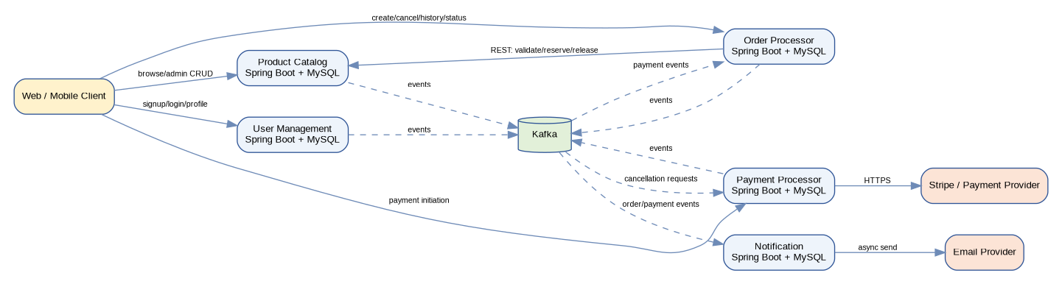
Synchronous business calls are kept narrow; lifecycle outcomes and notifications flow asynchronously through Kafka.
Notification decoupling: Order creation/payment/cancellation transactions never wait for Notification Service. Notification consumes committed events and retries delivery independently.

4. Monorepo and Maven Structure
ecommerce-platform/
pom.xml # parent / dependencyManagement / pluginManagement
services/
product-catalog-service/
pom.xml
user-management-service/
pom.xml
order-processor-service/
pom.xml
payment-processor-service/
pom.xml
notification-service/
pom.xml
libraries/
event-contracts/ # versioned event DTOs only; no domain logic
test-support/ # test fixtures/utilities only
infra/
docker-compose.yml # local MySQL instances/schemas + Kafka
observability/
docs/
architecture/
api/
- The root parent POM pins Java/Spring versions and build plugins; each service has its own dependency set and executable JAR.
- Do not create a shared "common-domain" module. Shared domain models cause lockstep coupling and undermine service ownership.
- The event-contracts module may contain only stable message envelopes/schema classes. A service can alternatively keep contracts independent and use schema registry/JSON Schema/Avro.
- Each service owns its own Flyway migration directory under src/main/resources/db/migration.

5. Standard Service Package Layout
com.acme.ecommerce.<service>/
api/
controller/ # REST transport only
dto/ # request/response contracts
mapper/
advice/ # error translation
application/
usecase/ # application orchestration
port/in/ # use-case interfaces
port/out/ # repository, provider, messaging, HTTP client interfaces
domain/
model/ # aggregates/value objects/enums
service/ # domain policies with no Spring dependency where practical
exception/
infrastructure/
persistence/entity/
persistence/repository/
persistence/adapter/
messaging/
client/
provider/
config/

6. SOLID Application
Principle | Concrete implementation rule | Example
Single Responsibility | Controller handles HTTP mapping; use case coordinates one business action; repository adapter persists; provider adapter calls external systems. | PaymentController never contains Stripe SDK logic; StripePaymentGateway implements PaymentGateway.
Open/Closed | Behavioral variation is behind interfaces/strategies so new providers/channels do not require editing core orchestration. | Add AdyenPaymentGateway or SmsNotificationSender without changing PaymentUseCase/NotificationUseCase.
Liskov Substitution | Implementations honor the same semantic contract, including error categories and idempotency expectations. | StripePaymentGateway and FakePaymentGateway return equivalent PaymentGatewayResult states.
Interface Segregation | Expose small purpose-specific ports rather than a god client/repository. | ProductQueryPort, InventoryReservationPort, PaymentGateway, NotificationSender are separate interfaces.
Dependency Inversion | Application/domain code depends on ports; Spring infrastructure implements them. | CreateOrderService depends on ProductSnapshotPort and InventoryReservationPort, not WebClient or JpaRepository.

7. Common Cross-Cutting Contracts
public record ApiError(
String code,
String message,
String correlationId,
Instant timestamp,
Map<String, String> fieldErrors) {}
public record EventEnvelope<T>(
UUID eventId,
String eventType,
int eventVersion,
String sourceService,
UUID aggregateId,
Instant occurredAt,
String correlationId,
T payload) {}
- Every mutation endpoint accepts/propagates X-Correlation-Id; create-order and create-payment also accept Idempotency-Key.
- Events are immutable and versioned. Consumers ignore unknown additive fields and reject incompatible major versions to a dead-letter workflow.
- Use application error codes such as PRODUCT_NOT_FOUND, OUT_OF_STOCK, INVALID_ORDER_STATE, PAYMENT_DECLINED, DUPLICATE_REQUEST, and UNAUTHORIZED.

8. Product Catalog Service
Item | Decision / Detail
Responsibilities | Product/category CRUD, product read/search, image metadata, inventory quantity, stock reservation/release for Order Processor.
Owns | Product Catalog MySQL schema and Product/Inventory events.
Must not own | Orders, users, payments, notification delivery.
Primary aggregate roots | Product, InventoryReservation.

8.1 Key Application Ports and Classes
Type | Class / Interface | Responsibility
Inbound port | CreateProductUseCase / UpdateProductUseCase / DeleteProductUseCase | Admin product lifecycle operations.
Inbound port | GetProductUseCase / SearchProductUseCase | Read model/search operations.
Inbound port | ReserveInventoryUseCase / ReleaseInventoryUseCase | Atomic stock reservation and compensation.
Application service | ProductApplicationService | Validates business rules and persists product changes.
Application service | InventoryReservationService | Locks/updates inventory, creates reservation, writes outbox event in one transaction.
Outbound port | ProductRepositoryPort | Product aggregate persistence.
Outbound port | InventoryRepositoryPort | Inventory/reservation persistence.
Outbound port | EventPublisherPort | Abstract event publication; infrastructure uses outbox relay.
Adapter | JpaProductRepositoryAdapter | Maps domain to JPA entities/repositories.
Adapter | KafkaOutboxPublisher | Publishes pending outbox rows and marks results.

8.2 REST API
Method | Endpoint | Auth | Purpose / important behavior
POST | /api/v1/products | ADMIN | Create product; SKU unique.
PATCH | /api/v1/products/{productId} | ADMIN | Partial update; optimistic locking.
DELETE | /api/v1/products/{productId} | ADMIN | Soft delete/discontinue.
GET | /api/v1/products/{productId} | Public | Get active product detail.
GET | /api/v1/products | Public | Paginated filter/search by query/category/status/price range.
PUT | /internal/v1/inventory/{productId} | ADMIN/Service | Adjust on-hand quantity with version check.
POST | /internal/v1/inventory/reservations | ORDER_SERVICE | Reserve quantities idempotently for orderId.
DELETE | /internal/v1/inventory/reservations/{orderId} | ORDER_SERVICE | Release active reservations idempotently.

Inventory consistency: Reserve inventory in a single local transaction using optimistic locking or SELECT ... FOR UPDATE. The reservation endpoint is idempotent on (order_id, product_id).

9. User Management Service
Item | Decision / Detail
Responsibilities | Signup, login, refresh, logout, profile retrieval/update, addresses, roles/authorization claims.
Owns | User profiles, credentials, sessions, addresses, role assignments.
Security boundary | Only this service verifies password hashes and issues first-party access/refresh tokens.

9.1 Key Application Ports and Classes
Type | Class / Interface | Responsibility
Inbound port | SignUpUseCase | Create user and credential; emit UserRegistered.
Inbound port | LoginUseCase / LogoutUseCase / RefreshSessionUseCase | Authentication/session lifecycle.
Inbound port | GetUserProfileUseCase / UpdateUserProfileUseCase | User profile operations.
Application service | AuthenticationService | Password verification, lockout policy, token/session issuance.
Domain service | PasswordPolicy | Password complexity/hash upgrade decision.
Outbound port | UserRepositoryPort | User aggregate persistence.
Outbound port | CredentialRepositoryPort / SessionRepositoryPort | Credential/session storage.
Outbound port | TokenService | JWT access-token creation/validation abstraction.

9.2 REST API
Method | Endpoint | Auth | Purpose
POST | /api/v1/auth/signup | Public | Create customer account.
POST | /api/v1/auth/login | Public | Authenticate; return short-lived access token + refresh token.
POST | /api/v1/auth/refresh | Refresh token | Rotate refresh token and issue access token.
POST | /api/v1/auth/logout | Authenticated | Revoke current session/refresh token.
GET | /api/v1/users/me | Authenticated | Current user detail.
PATCH | /api/v1/users/me | Authenticated | Update allowed profile fields.
GET/POST/PATCH/DELETE | /api/v1/users/me/addresses | Authenticated | Manage saved addresses.
GET | /internal/v1/users/{userId} | Trusted service | Minimal service-to-service user lookup when event data is insufficient.

Token model: Use short-lived JWT access tokens and opaque rotating refresh tokens. Persist only refresh-token hashes. Logout revokes the session; access tokens expire naturally.

10. Order Processor Service
Item | Decision / Detail
Responsibilities | Create/cancel orders, order history, state-only tracking, item/address snapshots, saga orchestration for inventory/payment outcomes.
Owns | Order state machine and order history.
Depends synchronously | Product Catalog for product snapshot and inventory reservation/release. User identity primarily comes from access-token claims.
Consumes | PaymentSucceeded, PaymentFailed, RefundSucceeded, RefundFailed.
Publishes | OrderCreated, OrderStatusChanged, OrderCancellationRequested, OrderCancelled.

10.1 Order State Machine
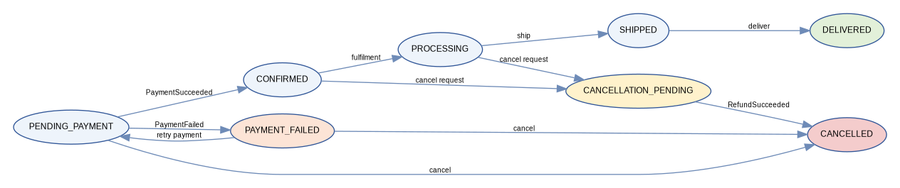

10.2 Key Application Ports and Classes
Type | Class / Interface | Responsibility
Inbound port | CreateOrderUseCase | Validate request, create snapshots, reserve stock, persist order/outbox.
Inbound port | CancelOrderUseCase | Enforce transition policy and initiate compensation/refund when required.
Inbound port | GetOrderUseCase / GetOrderHistoryUseCase | Read details/history for owning user/admin.
Application service | OrderApplicationService | Orchestrates create/cancel use cases.
Domain service | OrderStateMachine / CancellationPolicy | Pure transition and cancellation rules.
Outbound port | ProductSnapshotPort | Fetch current SKU/name/price/status.
Outbound port | InventoryReservationPort | Reserve/release inventory.
Outbound port | OrderRepositoryPort | Persist aggregate and history.
Event consumer | PaymentEventHandler | Deduplicate inbox event and apply payment/refund transition transactionally.

10.3 REST API
Method | Endpoint | Auth | Purpose
POST | /api/v1/orders | CUSTOMER | Create order; requires Idempotency-Key.
POST | /api/v1/orders/{orderId}/cancel | Owner/Admin | Request cancellation if state permits.
GET | /api/v1/orders/{orderId} | Owner/Admin | Full order detail.
GET | /api/v1/orders | CUSTOMER | Paginated order history for current user.
GET | /api/v1/orders/{orderId}/status | Owner/Admin | Current state and ordered state-history entries only.
PATCH | /internal/v1/orders/{orderId}/state | Trusted fulfilment/admin | Transition PROCESSING/SHIPPED/DELIVERED with policy checks.

11. Payment Processor Service
Item | Decision / Detail
Responsibilities | Create/confirm provider payment objects, ingest provider webhooks, record attempts, refund paid orders after cancellation requests.
Owns | Payment/provider/refund state and webhook deduplication.
Does not own | Order lifecycle; it publishes payment facts and lets Order Processor decide order state.
External dependency | Stripe behind PaymentGateway port.
Consumes | OrderCancellationRequested.
Publishes | PaymentSucceeded, PaymentFailed, RefundSucceeded, RefundFailed.

11.1 Key Application Ports and Classes
Type | Class / Interface | Responsibility
Inbound port | CreatePaymentUseCase | Create idempotent payment for order/amount.
Inbound port | HandlePaymentWebhookUseCase | Verify/deduplicate provider webhook and apply payment result.
Inbound port | RefundPaymentUseCase | Issue refund idempotently.
Application service | PaymentApplicationService | Coordinates local state, gateway calls, outbox.
Outbound port | PaymentGateway | Provider-neutral payment/refund operations.
Adapter | StripePaymentGateway | Stripe SDK/HTTP mapping and error normalization.
Domain service | PaymentStateMachine | Valid payment state transitions.
Event consumer | OrderCancellationHandler | Deduplicate cancellation request and trigger eligible refund.

11.2 PaymentGateway Interface
public interface PaymentGateway {
CreatePaymentResult createPayment(CreatePaymentCommand command);
RefundResult refund(RefundCommand command);
}
public record CreatePaymentCommand(
UUID paymentId, UUID orderId, BigDecimal amount,
Currency currency, String providerIdempotencyKey) {}

11.3 REST API
Method | Endpoint | Auth | Purpose
POST | /api/v1/payments | CUSTOMER | Create payment for an owned order; requires Idempotency-Key.
GET | /api/v1/payments/{paymentId} | Owner/Admin | Read sanitized payment state.
POST | /internal/v1/payments/{paymentId}/refunds | ORDER_SERVICE | Optional synchronous administrative refund endpoint; normal cancellation path is event-driven.
POST | /webhooks/stripe | Stripe signature | Receive provider events; verify signature before persistence/processing.

PCI boundary: Never accept or store raw card numbers/CVC in this service. Prefer Stripe-hosted/client-side tokenization; backend handles only provider payment method/payment intent identifiers and webhook outcomes.

12. Notification Service
Item | Decision / Detail
Responsibilities | Consume order/payment events, create durable notification jobs, render templates, call email provider, retry failures.
Dependency rule | No synchronous business service waits for Notification Service.
Consumes | OrderCreated/OrderStatusChanged/OrderCancelled and optionally PaymentFailed/RefundFailed for customer-facing alerts.
Public APIs | None required for business flow; Actuator health/metrics only. Optional admin template endpoints can be added later.
Scaling | Kafka consumers and delivery workers can scale horizontally; job/event uniqueness prevents duplicate sends.

12.1 Key Application Ports and Classes
Type | Class / Interface | Responsibility
Event consumer | OrderEventConsumer | Validate envelope, deduplicate event, map to notification job.
Application service | NotificationJobService | Choose template/channel, persist job, schedule retries.
Domain service | RetryPolicy | Exponential backoff/max attempts/dead-letter decision.
Outbound port | NotificationSender | Channel-neutral send contract.
Adapter | EmailNotificationSender | Email provider adapter.
Outbound port | TemplateRepositoryPort | Load active template/version.
Worker | NotificationDeliveryWorker | Claims due jobs, renders, sends, records attempt and status.

12.2 NotificationSender Interface
public interface NotificationSender {
DeliveryResult send(NotificationMessage message);
}
public record NotificationMessage(
UUID notificationId,
String recipient,
String subject,
String body,
Map<String, String> metadata) {}

13. End-to-End Workflows

13.1 Create Order and Payment Success
- Client calls Order Processor with authenticated user, cart lines, shipping/billing selection/snapshot, and Idempotency-Key.
- Order Processor obtains product snapshots and requests inventory reservation from Product Catalog. Product Catalog commits inventory/reservation and its outbox event atomically.
- Order Processor persists order/items/addresses/history with status PENDING_PAYMENT and writes OrderCreated/OrderStatusChanged to its outbox in the same transaction.
- Client initiates payment in Payment Processor for the order. Payment Processor creates a local payment and provider PaymentIntent using provider idempotency.
- Stripe webhook arrives. Payment Processor verifies signature, deduplicates provider_event_id, updates payment to SUCCEEDED, and writes PaymentSucceeded to outbox atomically.
- Order Processor consumes PaymentSucceeded, inserts inbox_event, transitions order to CONFIRMED, appends status history, and writes OrderStatusChanged in one local transaction.
- Notification Service consumes OrderStatusChanged/OrderCreated, deduplicates event_id, creates a notification job, and delivers asynchronously. Notification failures do not roll back the order.
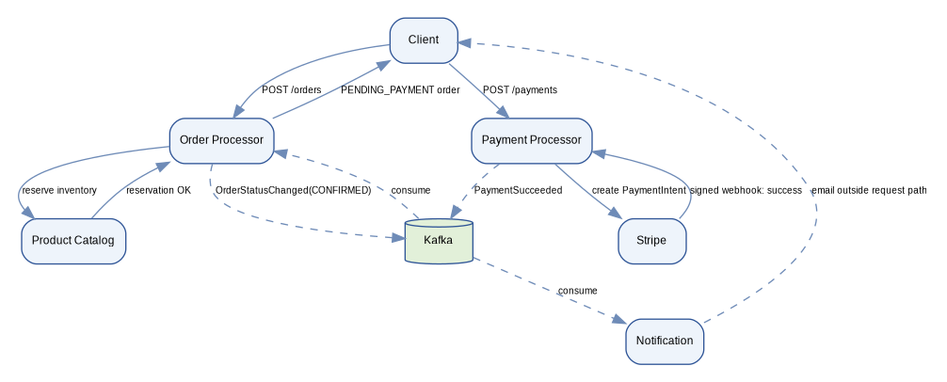

13.2 Cancellation / Refund Saga
- Order Processor validates ownership and CancellationPolicy.
- For PENDING_PAYMENT/PAYMENT_FAILED, it cancels locally and releases Product inventory reservation.
- For CONFIRMED or PROCESSING, it transitions to CANCELLATION_PENDING and publishes OrderCancellationRequested.
- Payment Processor consumes the request idempotently and submits the provider refund. A webhook or provider response completes refund state.
- Payment Processor publishes RefundSucceeded or RefundFailed.
- Order Processor consumes RefundSucceeded, transitions to CANCELLED, releases inventory when appropriate, and publishes OrderStatusChanged/OrderCancelled.
- Notification Service independently notifies the user of cancellation/refund outcome.

14. Transaction and Consistency Model
Concern | Design
Local transaction | @Transactional is scoped to one service database only.
Distributed transaction | Do not use XA/2PC. Use saga-style orchestration/compensation.
Publish-after-commit | Business state and outbox_event are written in the same transaction; a relay publishes later.
Consumer idempotency | Consumer inserts event id into inbox/consumed_event with unique PK before applying state. Duplicate event => safe no-op.
HTTP idempotency | Create order/payment require Idempotency-Key persisted with request hash and result.
Retries | Retry only transient failures. Use bounded exponential backoff + jitter. Do not blindly retry non-idempotent provider calls without provider idempotency keys.
Ordering | Partition order-related Kafka events by orderId; payment-related by orderId/paymentId to preserve per-aggregate order.
Dead letter | After bounded retries, record FAILED/DEAD state and route to operational DLQ/manual recovery path.

15. Security Design
- Spring Security validates JWT access tokens at Product admin, Order, Payment, and User protected endpoints. Authorization uses roles plus resource ownership checks.
- User Management hashes passwords with Argon2id or bcrypt using a modern work factor; never logs passwords or tokens.
- Service-to-service internal endpoints use mTLS or workload/service credentials in addition to network policy; do not trust network location alone.
- Stripe webhook endpoint verifies the provider signature and timestamp tolerance before accepting payloads.
- Secrets are injected from a secret manager/environment at runtime; never committed to the GitHub repository or application.yml.
- Apply request validation, body-size limits, rate limiting at ingress, and login-specific throttling/account lockout.
- Sanitize provider errors before persisting/returning them; logs must not include card data, credentials, refresh tokens, or sensitive address fields unnecessarily.

16. Resilience and Failure Handling
Dependency/failure | Behavior
Product Catalog unavailable during create order | Fail order creation before final acceptance; return 503/DEPENDENCY_UNAVAILABLE. Idempotency key allows safe retry.
Inventory race | Reservation transaction fails with OUT_OF_STOCK or retries on optimistic lock conflict; never oversell based only on prior GET availability.
Stripe timeout | Use provider idempotency key; status remains INITIATED/PENDING until reconciliation/webhook. Do not create a second logical payment blindly.
Kafka unavailable | Local business transaction can still commit with outbox NEW. Relay retries when Kafka returns.
Notification provider unavailable | Mark notification RETRY with next scheduled_at; order/payment remain complete.
Duplicate webhook/event | Unique provider_event_id/event_id converts duplicates into idempotent no-op.
Consumer crash after DB commit before Kafka offset commit | Message is redelivered; inbox uniqueness prevents duplicate business effect.

17. HTTP and Error Conventions
Scenario | HTTP | Code / Notes
Successful create | 201 | Location header to new resource.
Successful read/update/cancel | 200/204 | Return latest resource when useful.
Validation error | 400 | VALIDATION_ERROR with fieldErrors.
Unauthenticated / unauthorized | 401 / 403 | Do not expose existence of another user's resource.
Not found | 404 | RESOURCE_NOT_FOUND.
Conflict / invalid transition | 409 | DUPLICATE_REQUEST, INVALID_ORDER_STATE, SKU_EXISTS, OUT_OF_STOCK.
Provider declined payment | 402 or 409 | Prefer a stable application code PAYMENT_DECLINED; document chosen convention consistently.
Dependency unavailable | 503 | DEPENDENCY_UNAVAILABLE; include correlation id.

18. Observability
- Structured logs include timestamp, service, environment, correlationId, traceId, userId when safe, orderId/paymentId, eventId, and outcome code.
- Metrics: request rate/error/latency; DB pool usage; Kafka lag; outbox backlog age; failed inbox records; payment success/failure; webhook age; notification retry/dead counts; inventory reservation failures.
- Distributed tracing propagates traceparent/correlation headers over HTTP and correlationId/eventId in Kafka headers/envelopes.
- Actuator exposes liveness and readiness separately. Readiness should fail when a mandatory local dependency such as MySQL is unavailable; notification/email provider should not necessarily make the service unready if queued retry is possible.

19. Testing Strategy
Layer | Tests
Domain unit | State machines, cancellation policy, money calculations, inventory reservation rules, retry policy. No Spring context.
Application unit | Use-case orchestration with mocked ports; verify transactions/events conceptually.
Repository integration | Testcontainers MySQL; Flyway migrations; unique/check constraints; optimistic locking.
Messaging integration | Embedded/Testcontainers Kafka; duplicate delivery; outbox relay; consumer restart and inbox behavior.
HTTP contract | MockMvc/WebTestClient validation/security/error model; consumer/provider contract tests for internal APIs.
Stripe adapter | WireMock/provider sandbox; idempotency, timeout, decline mapping, webhook signature verification.
End-to-end | Create order -> payment success -> order confirmed -> notification job; cancellation -> refund -> cancelled; dependency outage recovery.

20. Configuration and Deployment
- Build each service as an independent Docker image from its Maven module. A change in one module should not require deploying all services.
- Each service receives its own DB credentials with permissions only to its schema.
- Use environment-specific Spring profiles only for wiring/configuration; business behavior should not fork by profile.
- Use separate Kafka consumer-group names per service and explicit topic configuration.
- Run Flyway before accepting traffic. For zero-downtime releases use expand/migrate/contract schema changes rather than destructive one-step migrations.
- Autoscale stateless HTTP pods on CPU/request metrics; Notification consumers may also scale on Kafka lag. Preserve idempotency so parallel consumers remain safe.

21. Suggested Implementation Plan
Phase | Deliverables | Exit criteria
1. Repository foundation | Parent POM, five service modules, coding standards, CI, Docker Compose, per-service MySQL/Flyway, Kafka, shared event envelope. | All services build/test independently; health endpoints green.
2. User + Product | Signup/login/logout/profile; roles; product/category CRUD; inventory; admin auth; migrations. | Authenticated customer/admin flows and product browsing work end-to-end.
3. Order core | Create order, product snapshots, inventory reservation, idempotency, order history/status, state history. | Order creation cannot oversell in concurrency test; retries are idempotent.
4. Payment | PaymentGateway port, Stripe adapter, payment records/attempts, webhook dedupe, PaymentSucceeded/Failed events. | Provider sandbox success/failure updates Order through Kafka.
5. Cancellation saga | OrderCancellationRequested, refunds, RefundSucceeded/Failed, inventory release, compensation paths. | Cancellation is correct under duplicate/reordered delivery and provider timeout.
6. Notification | Event consumer, templates, jobs, delivery attempts, retry/dead policy. | Order/payment never wait for notification; failed email retries independently.
7. Hardening | Security review, load tests, chaos/dependency outage tests, metrics/alerts, retention jobs, backup/restore runbook. | Operational SLOs and recovery procedures validated.

22. Key Architecture Decisions / Non-Goals
Decision | Rationale
Database per service | Prevents shared-schema coupling and allows independent migration/deployment.
Order owns commercial snapshots | Product names/prices/addresses can change after purchase; history must remain immutable.
Kafka + outbox/inbox | Provides durable async integration without distributed transactions.
Notification is event-only | Meets requirement that no other service depends on notification completion.
Stripe behind PaymentGateway | Keeps provider SDK from contaminating domain/application layers and makes provider replacement/test doubles straightforward.
No shared domain library | Avoids accidental lockstep deployment and preserves bounded contexts.
No full shipment/carrier model | Order tracking requirement is state-only; SHIPPED/DELIVERED are states, not a logistics subsystem.
No cart/promotion/review service | Outside the requested five-service scope; schema leaves room to add them later without reassigning current ownership.

