**INTRUDER DETECTION USING PIR MOTION SENSOR & ARDUINO**

**Description:**

PIR sensors allow you to sense motion, almost always used to detect whether a human has moved in or out of the sensors range. They are small, inexpensive, low-power, easy to use and don't wear out. For that reason they are commonly found in appliances and gadgets used in homes or businesses. They are often referred to as PIR, "Passive Infrared", "Pyroelectric", or "IR motion" sensors.

**Circuit Diagram:**

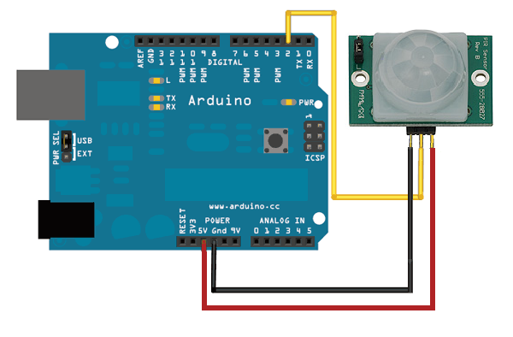

**Components Required:**

* Arduino Uno
* PIR Motion Sensor
* Connecting Wires

**Specifications:**

* Power Supply :+5V DC
* Quiescent Current : <50uA
* Ranging Distance: <120 ° within 7meters
* Measuring Angle: 110 ° cone angle
* Board Dimension: 32mm x 24mm

**Code:**

/* INTRUDER DETECTION USING PIR SENSOR */

//the time we give the sensor to calibrate (10-60 secs according to the datasheet)

int calibrationTime = 15;

int pirPin = 2; //the digital pin connected to the PIR sensor's output

int ledPin = 13;

void setup(){

Serial.begin(9600);

pinMode(pirPin, INPUT);

pinMode(ledPin, OUTPUT);

digitalWrite(pirPin, LOW);

//give the sensor some time to calibrate

Serial.print("calibrating sensor ");

for(int i = 0; i < calibrationTime; i++){

Serial.print(".");

delay(1000);

}

Serial.println(" done");

Serial.println("SENSOR ACTIVE");

delay(2000);

}

void loop(){

if(digitalRead(pirPin) == HIGH){

digitalWrite(ledPin, HIGH); //the led visualizes the sensors output pin state

Serial.println("motion detected! ");

delay(2000);

}

else if(digitalRead(pirPin) == LOW){

digitalWrite(ledPin, LOW); //the led visualizes the sensors output pin state

Serial.println("motion ended!"); //output

delay(2000);

}

else {

Serial.println("Sensor Fault");

}

}

**Output:**

Motion detected!

Motion ended!

Motion detected!

Motion ended!

Motion detected!

Motion ended!

Motion detected!

Motion ended!

Motion detected!