# REPLICA SETS CONCEPTS

RESHMA BANU A

23BDS1170

CHENNAI CAMPUS

**Create Directories**

mkdir C:\data\cfg1, C:\data\cfg2, C:\data\cfg3

mkdir C:\data\shard1_1, C:\data\shard1_2, C:\data\shard1_3

mkdir C:\data\shard2_1, C:\data\shard2_2, C:\data\shard2_3

mkdir C:\data\mongos

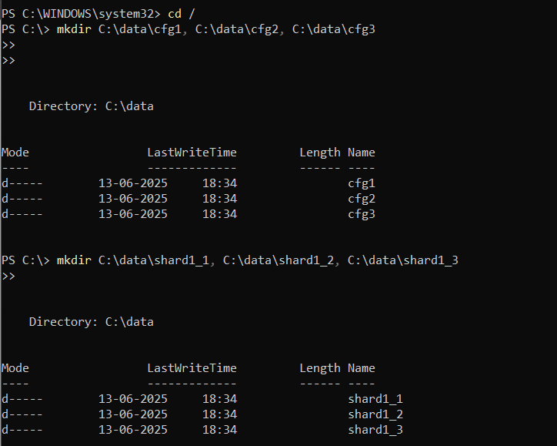

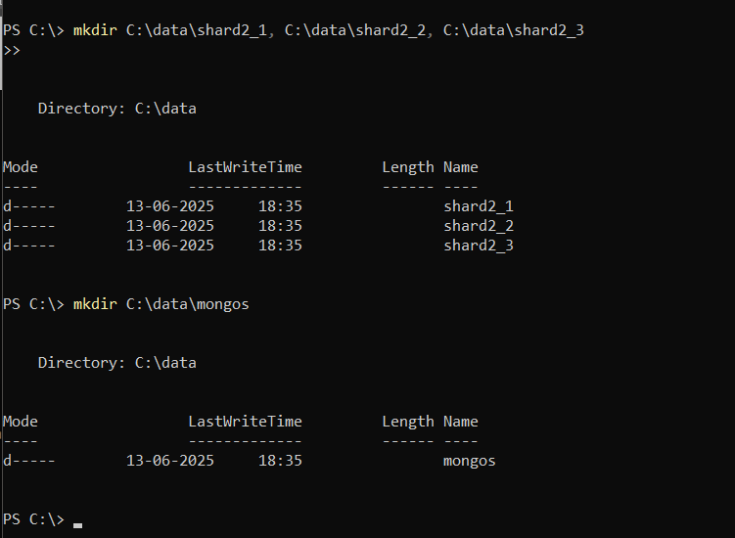



**Connect to MongoDB Compass:**

mongod --configsvr --replSet configReplSet --port 27019 --dbpath C:\data\cfg1 --bind_ip localhost

mongod --configsvr --replSet configReplSet --port 27020 --dbpath C:\data\cfg2 --bind_ip localhost

mongod --configsvr --replSet configReplSet --port 27021 --dbpath C:\data\cfg3 --bind_ip localhost

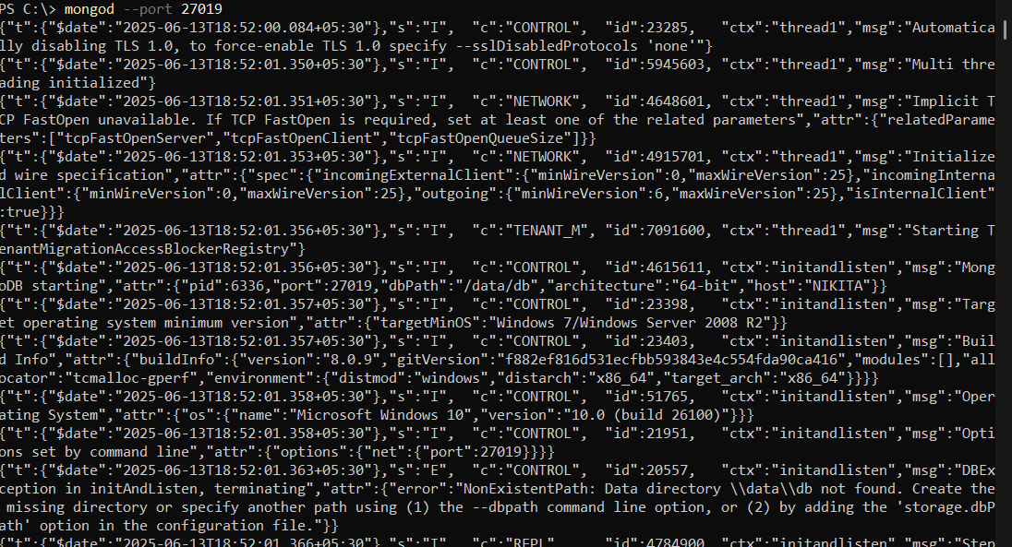

**Start Shard Replica Sets**

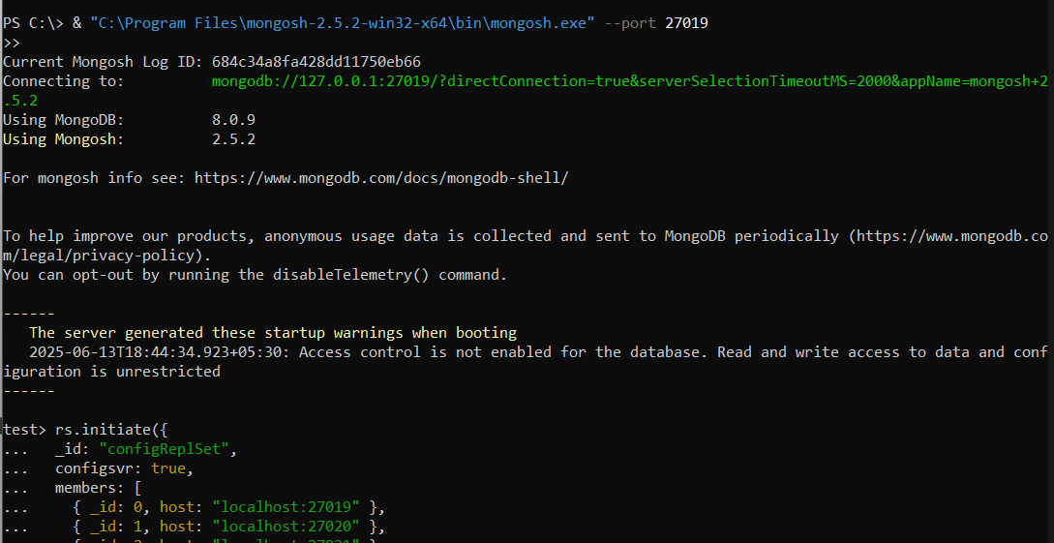

**Shard 1**

mongo --port 27019

rs.initiate({

_id: "configReplSet",

configsvr: true,

members: [

{ _id: 0, host: "localhost:27019" },

{ _id: 1, host: "localhost:27020" },

{ _id: 2, host: "localhost:27021" }

]

})

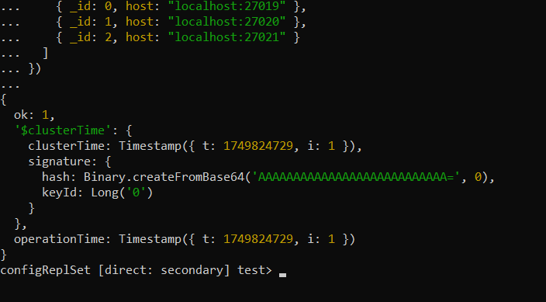

**Shard 2**

mongo --port 27022

rs.initiate({

_id: "configReplSet",

configsvr: true,

members: [

{ _id: 0, host: "localhost:27022" },

{ _id: 1, host: "localhost:27023" },

{ _id: 2, host: "localhost:27024" }

]

})

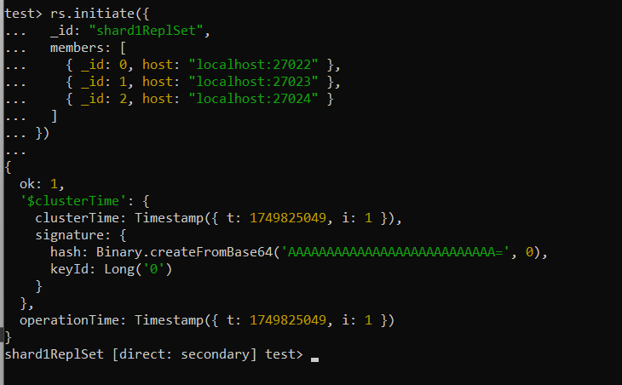

**Shard 3**

mongo --port 27025

rs.initiate({

_id: "configReplSet",

configsvr: true,

members: [

{ _id: 0, host: "localhost:27025" },

{ _id: 1, host: "localhost:27026" },

{ _id: 2, host: "localhost:27027" }

]

})

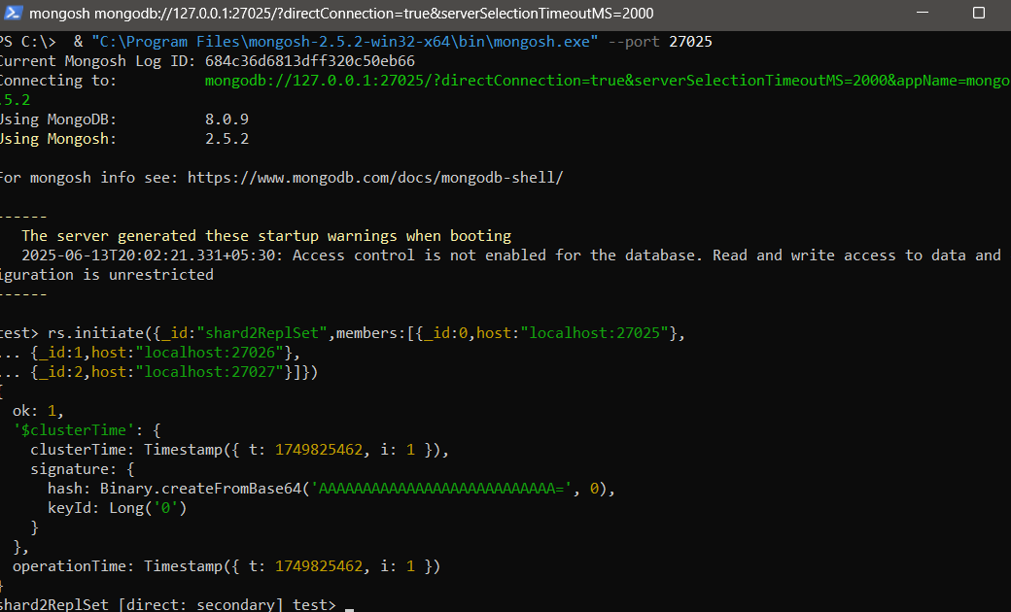

**Step 5: Configure Sharding:**

mongo --port 27018

sh.addShard("shard1ReplSet/localhost:27022,localhost:27023,localhost:27024")

sh.addShard("shard2ReplSet/localhost:27025,localhost:27026,localhost:27027")

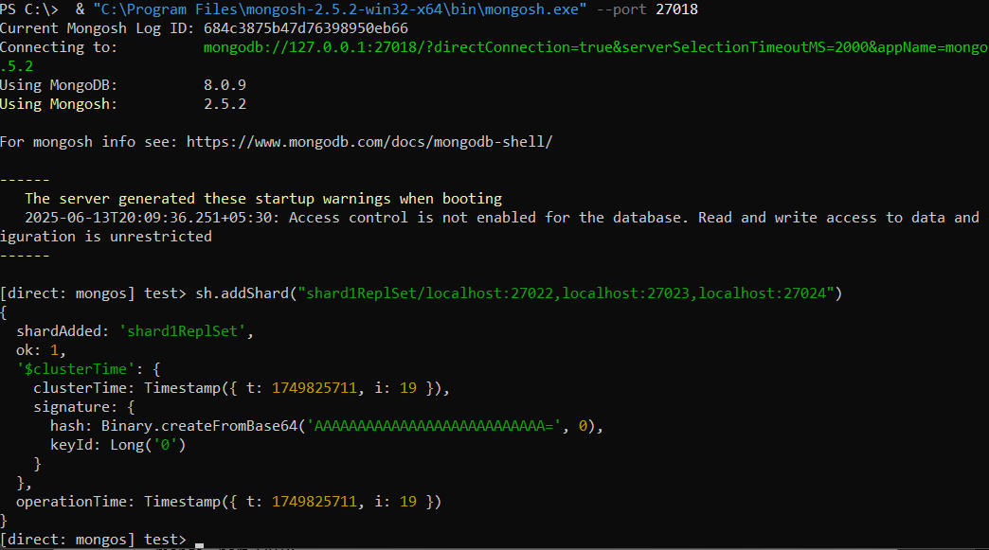

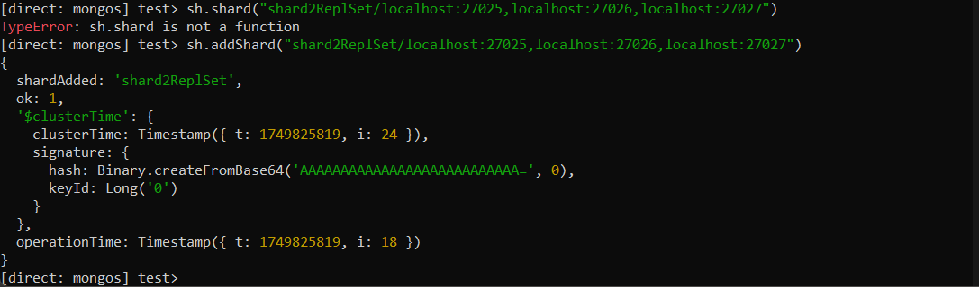

**Enable Sharding for Database and Collection**

sh.enableSharding("testDB")

sh.shardCollection("testDB.testCollection", { "_id": "hashed" })

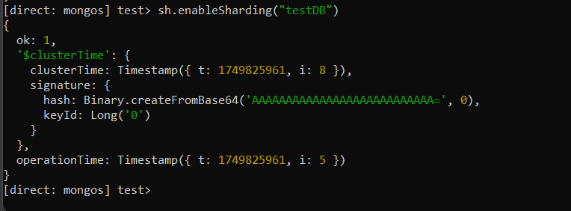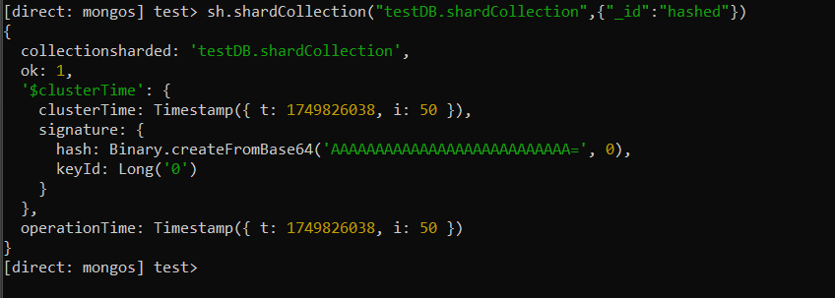

**Verify Sharding Status**

**sh.status()**

