Reshma Shaik

reshmashaik0910@gmail.com | +353 896074382 | Dublin www.linkedin.com/in/reshmask

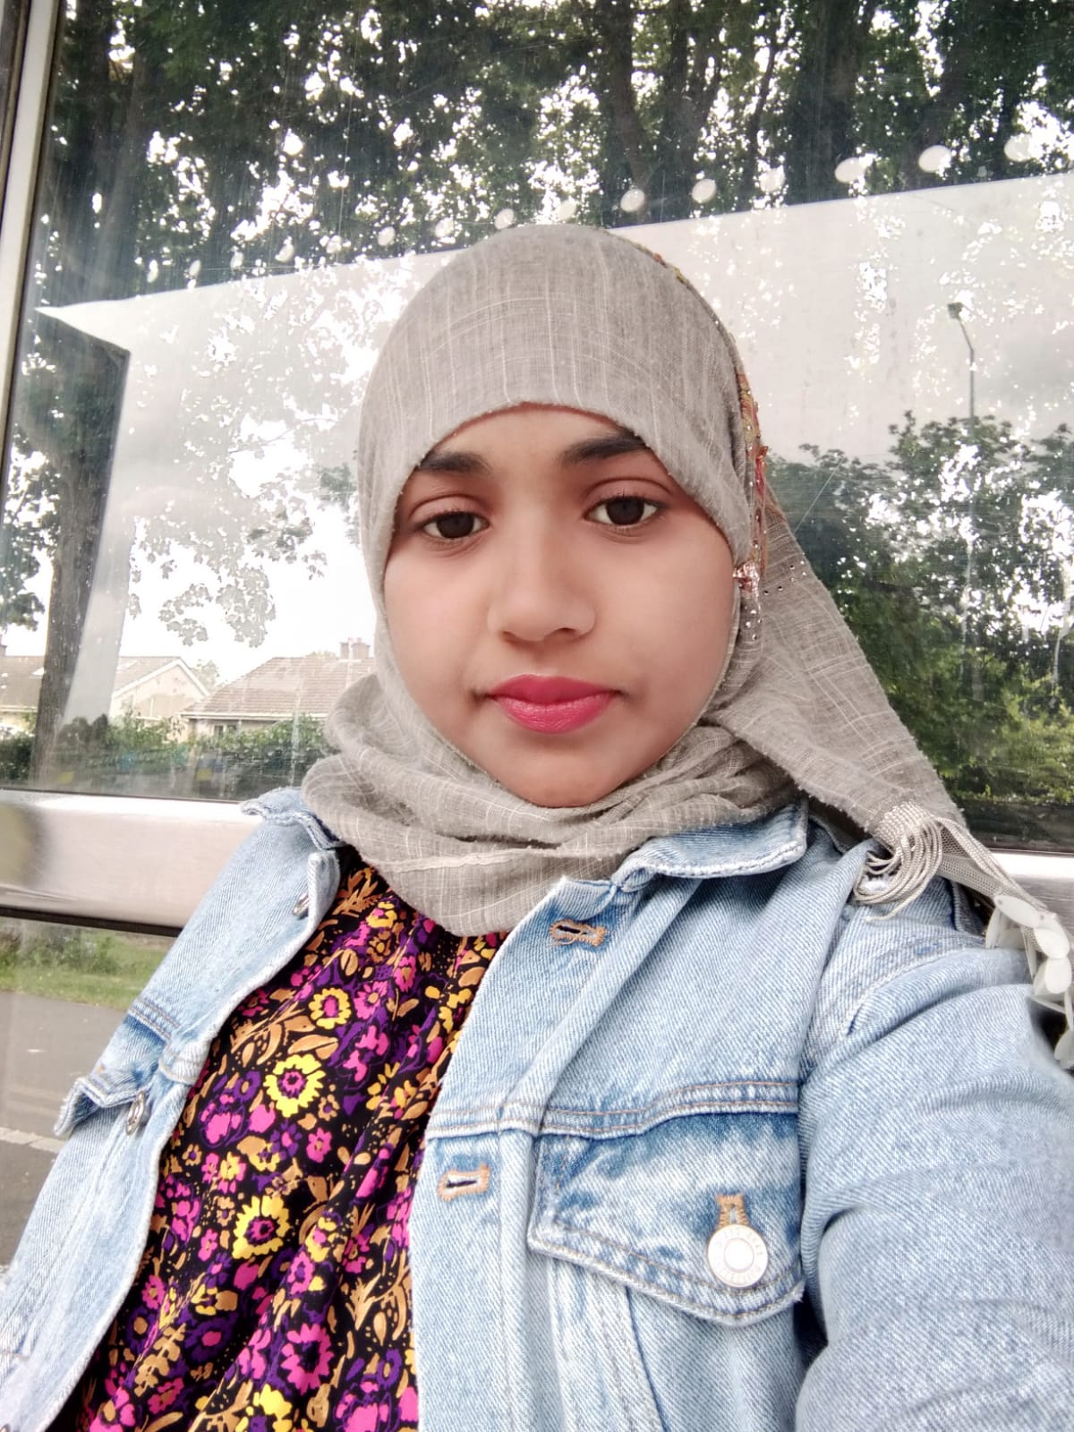

**Summary**

* Passionate Front End developer looking for starting my career in IT industry and add value to any organization
* Strong ability in creating responsive user interface using **HTML 5**, **CSS 3** and **JavaScript**
* Comprehensive knowledge of UX and responsive UI design with an emphasis on intuitive design
* Ability to write cross-browser and standards compliant code that meets flexibility, scalability, and performance requirements
* Expertise in developing applications using JavaScript
* Drive End 2 End delivery from gathering user requirements to delivering high quality programs and services to meet business needs.
* Authorized to work in Ireland as having valid Stamp 1G visa

**Soft Skills**

* Communication
* Teamwork
* Problem-solving
* Time management
* Organizational
* Adaptability

**Experience**

**Software Engineer(Intern),**

**Clawins Exims Private Limited** Mar/2012- Oct/2012

Designed user interface as per business requirements. Implemented enhancements on the existing website using HTML, CSS & JavaScript

**Education**

**Master of Computer Applications**, Computer Science

*Swarna Bharati Institute of Science & Technology, Khammam*  2007 – 2010

**Bachelor of Science**, Computers 2003 – 2006 *Priyadarshini Degree & PG College, Khammam*

**Languages**

English

Urdu

Telugu

**Certifications**

Code Institute 5 Day Coding Challenge - HTML & CSS