1. **REACTJS_HOL**

## **Objectives**

* Define SPA and its benefits
* Define React and identify its working
* Identify the differences between SPA and MPA
* Explain Pros & Cons of Single-Page Application
* Explain about React
* Define virtual DOM
* Explain Features of React

In this hands-on lab, you will learn how to:

* Set up a react environment
* Use create-react-app

**App.js:**

import React from 'react';

function App() {

  return (

    <div>

      <h1>Welcome to the first session of React</h1>

    </div>

  );

}

export default App;

**RESULT:**

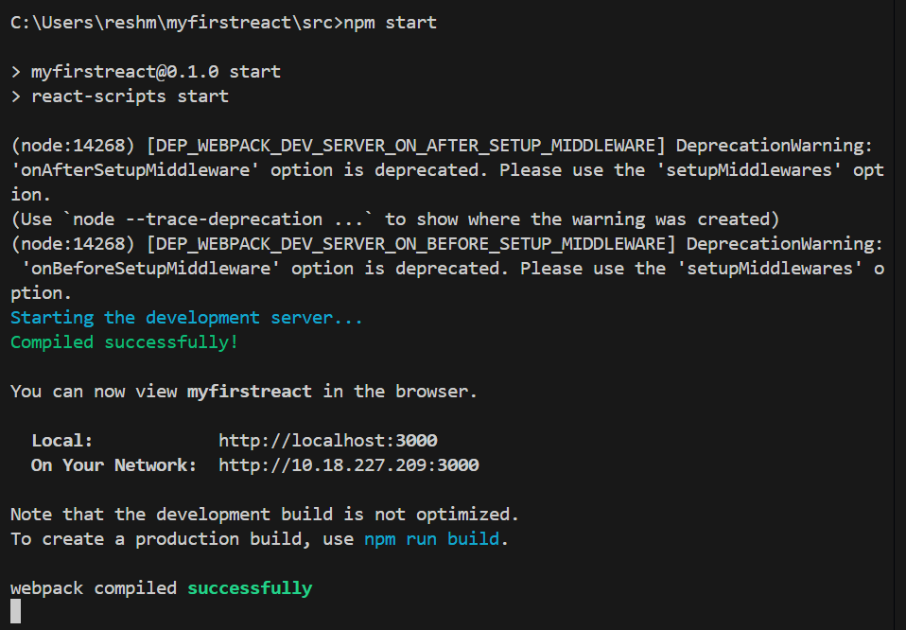

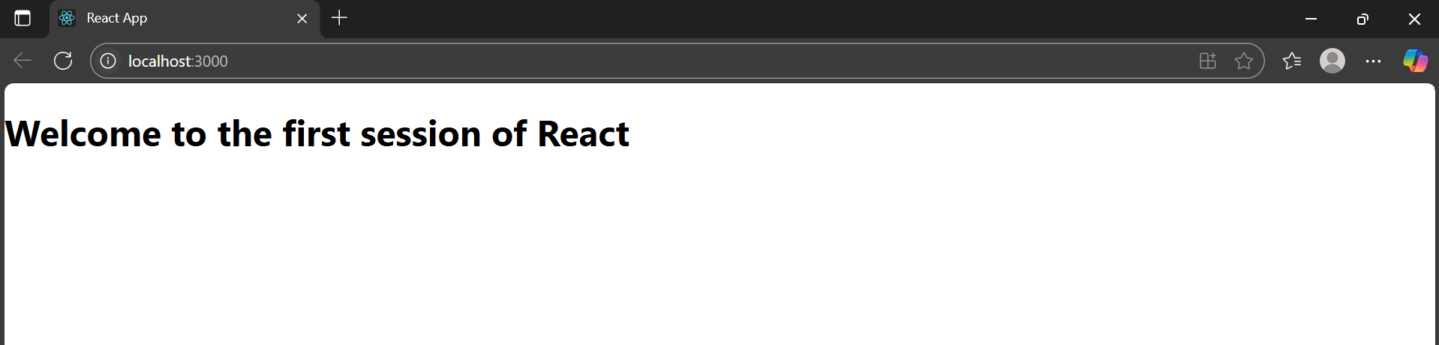

1. **REACTJS-HOL**

## **Objectives**

* Explain React components
* Identify the differences between components and JavaScript functions
* Identify the types of components
* Explain class component
* Explain function component
* Define component constructor
* Define render() function

In this hands-on lab, you will learn how to:

* Create a class component
* Create multiple components
* Render a component

**App.js:**

import React from 'react';

import './App.css';

import Home from './Components/Home';

import About from './Components/About';

import Contact from './Components/Contact';

function App() {

  return (

    <div className="App">

      <h1 className="main-heading">Student Management Portal</h1>

      <div className="component-section">

        <Home />

        <About />

        <Contact />

      </div>

    </div>

  );

}

export default App;

**Home.js:**

import React, { Component } from 'react';

class Home extends Component {

  render() {

    return (

      <div>

        <h2>Welcome to the Home page of Student Management Portal</h2>

      </div>

    );

  }

}

export default Home;

**About.js:**

import React, { Component } from 'react';

class About extends Component {

  render() {

    return (

      <div>

        <h2>Welcome to the About page of Student Management Portal</h2>

      </div>

    );

  }

}

export default About;

**Contact.js:**

import React, { Component } from 'react';

class Contact extends Component {

  render() {

    return (

      <div>

        <h2>Welcome to the Contact page of Student Management Portal</h2>

      </div>

    );

  }

}

export default Contact;

**RESULT:**

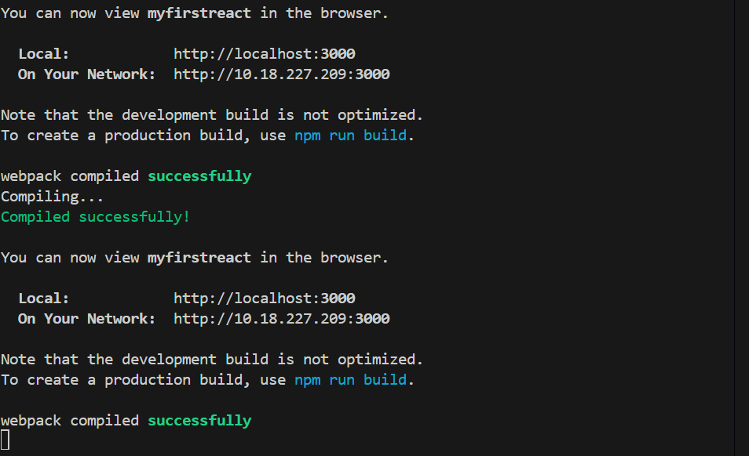

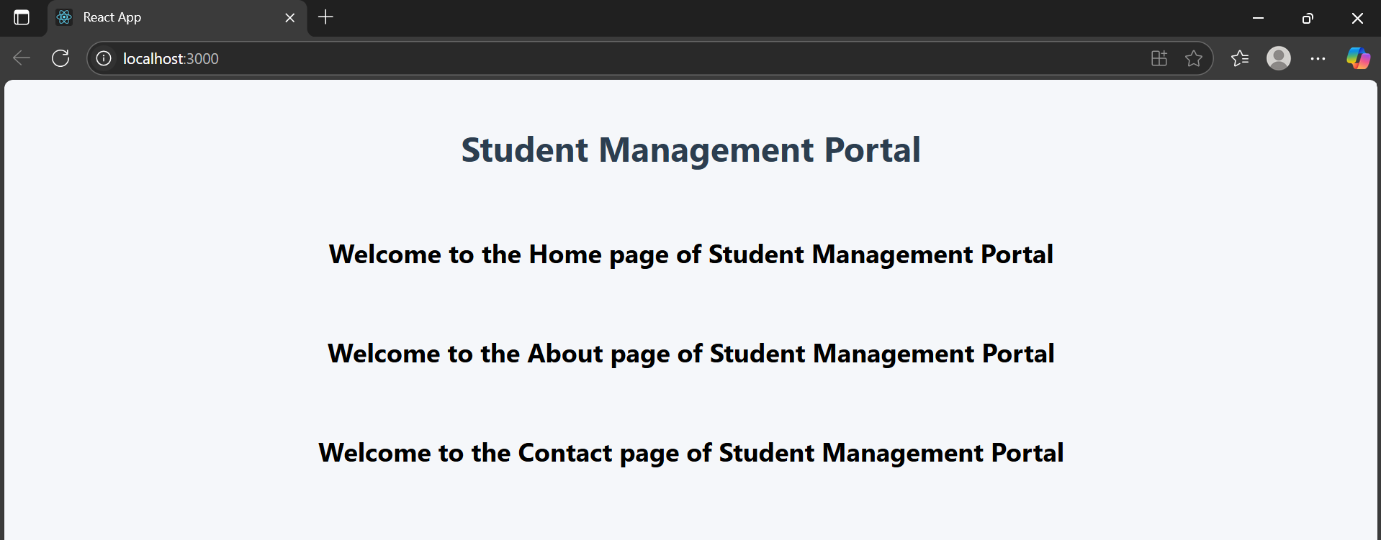

## **REACTJS-HOL**

## **Objectives**

* Explain React components
* Identify the differences between components and JavaScript functions
* Identify the types of components
* Explain class component
* Explain function component
* Define component constructor
* Define render() function

In this hands-on lab, you will learn how to:

* Create a function component
* Apply style to components
* Render a component

**App.js:**

import React from 'react';

import CalculateScore from './Components/CalculateScore';

function App() {

  return (

    <div>

      <h1>Score Calculator App</h1>

      <CalculateScore

        name="Reshma Geesala"

        school="SMVEC"

        total={470}

        goal={5}

      />

    </div>

  );

}

export default App;

**mystyle.css:**

.score-card {

  background-color: #f0f8ff;

  border: 1px solid #ccc;

  padding: 20px;

  margin: 40px auto;

  width: 400px;

  border-radius: 8px;

  font-family: Arial, sans-serif;

  box-shadow: 0 4px 8px rgba(0, 0, 0, 0.1);

}

.score-card h2 {

  color: #2c3e50;

}

.score-card p {

  margin: 10px 0;

  font-size: 16px;

}

**CalculateScore.js:**

import React from 'react';

import '../Stylesheets/mystyle.css';

function CalculateScore(props) {

  const average = props.total / props.goal;

  return (

    <div className="score-card">

      <h2>Student Score Details</h2>

      <p><strong>Name:</strong> {props.name}</p>

      <p><strong>School:</strong> {props.school}</p>

      <p><strong>Total Marks:</strong> {props.total}</p>

      <p><strong>Goal:</strong> {props.goal}</p>

      <p><strong>Average Score:</strong> {average.toFixed(2)}</p>

    </div>

  );

}

export default CalculateScore;

**RESULT:**

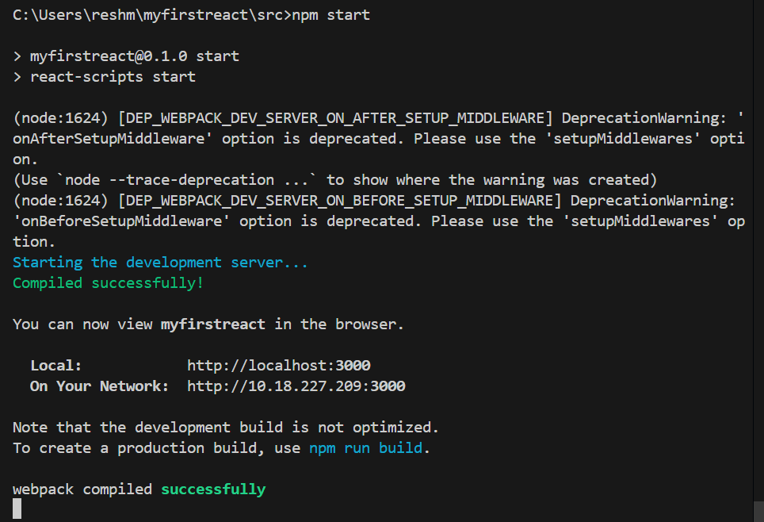

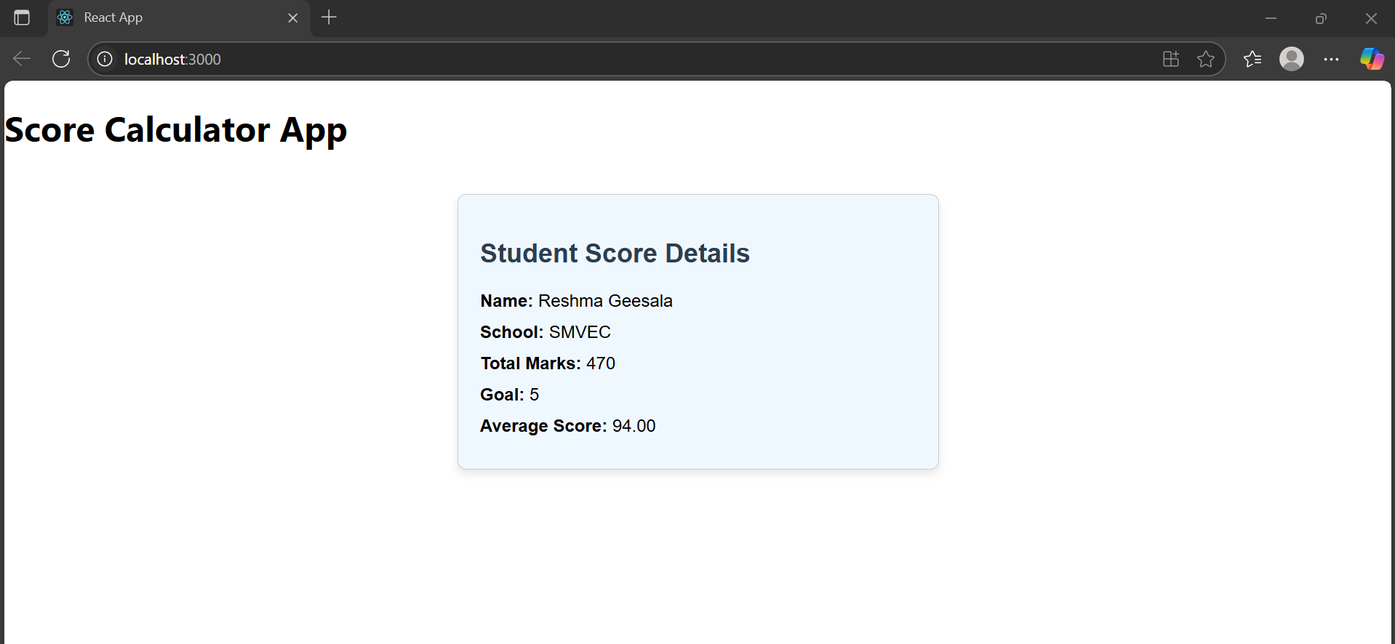

1. **REACTJS-HOL**

**Objectives**

* Explain the need and Benefits of component life cycle
* Identify various life cycle hook methods
* List the sequence of steps in rendering a component

In this hands-on lab, you will learn how to:

* Implement componentDidMount() hook
* Implementing componentDidCatch() life cycle hook.

**Posts.js:**

import React, { Component } from 'react';

import Post from './Post';

class Posts extends Component {

  constructor(props) {

    super(props);

    this.state = {

      posts: [],

      hasError: false

    };

  }

  componentDidMount() {

    this.loadPosts();

  }

  loadPosts() {

    fetch('https://jsonplaceholder.typicode.com/posts')

      .then(response => response.json())

      .then(data => this.setState({ posts: data }))

      .catch(error => {

        console.error('Error fetching posts:', error);

        this.setState({ hasError: true });

      });

  }

  componentDidCatch(error, info) {

    alert('Something went wrong while displaying posts.');

    console.error('Error caught in componentDidCatch:', error, info);

  }

  render() {

    if (this.state.hasError) {

      return <h2>Error loading posts.</h2>;

    }

    return (

      <div>

        <h1>Blog Posts</h1>

        {this.state.posts.map(post => (

          <Post key={post.id} title={post.title} body={post.body} />

        ))}

      </div>

    );

  }

}

export default Posts;

**App.js:**

import React from 'react';

import Posts from './Posts';

function App() {

  return (

    <div className="App">

      <Posts />

    </div>

  );

}

export default App;

**Post.js:**

import React from 'react';

function Post(props) {

  return (

    <div>

      <h3>{props.title}</h3>

      <p>{props.body}</p>

      <hr />

    </div>

  );

}

export default Post;

**RESULT:**

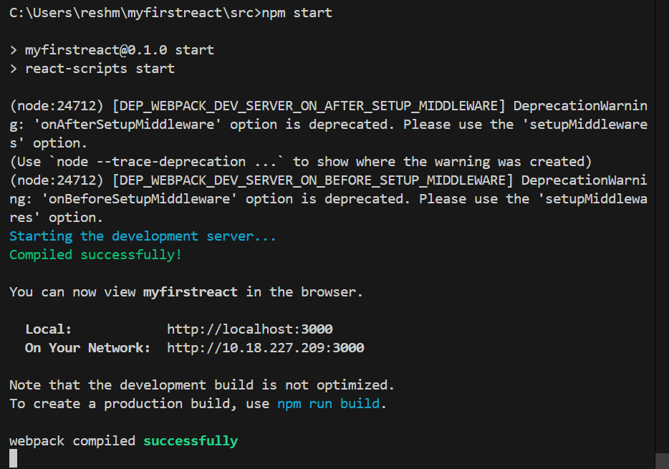

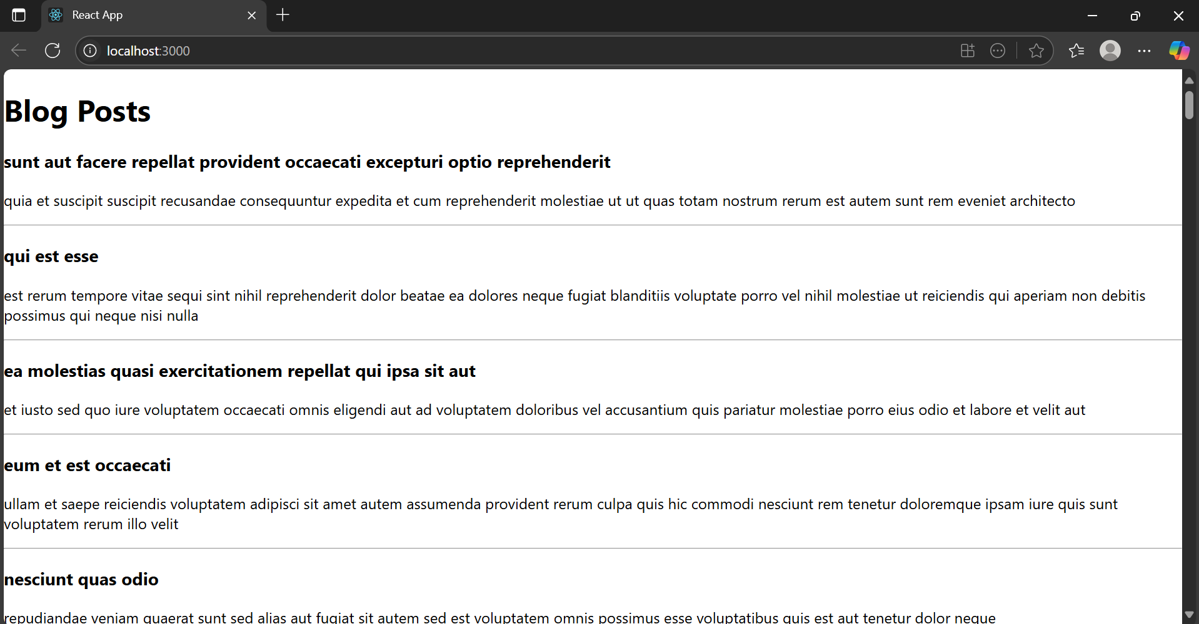

1. **REACTJS-HOL**

**Objectives**

* Understanding the need for styling react component
* Working with CSS Module and inline styles

In this hands-on lab, you will learn how to:

* Style a react component
* Define styles using the CSS Module
* Apply styles to components using className and style properties

**CohortDetails.module.css:**

.box {

  width: 300px;

  display: inline-block;

  margin: 10px;

  padding: 10px 20px;

  border: 1px solid black;

  border-radius: 10px;

}

dt {

  font-weight: 500;

}

**CohortDetails.js:**

import React from 'react';

import styles from './CohortDetails.module.css';

function CohortDetails(props) {

  const { name, status, description } = props;

  const headingStyle = {

    color: status.toLowerCase() === 'ongoing' ? 'green' : 'blue',

  };

  return (

    <div className={styles.box}>

      <h3 style={headingStyle}>{name}</h3>

      <dl>

        <dt>Status:</dt>

        <dd>{status}</dd>

        <dt>Description:</dt>

        <dd>{description}</dd>

      </dl>

    </div>

  );

}

export default CohortDetails;

**App.js:**

import React from 'react';

import CohortDetails from './CohortDetails';

function App() {

  return (

    <div>

      <h1>My Academy Cohorts</h1>

      <CohortDetails

        name="React Bootcamp"

        status="Ongoing"

        description="Intensive training on React fundamentals"

      />

      <CohortDetails

        name="Node.js Backend"

        status="Completed"

        description="Learn backend development using Node.js"

      />

    </div>

  );

}

export default App;

**RESULT:**

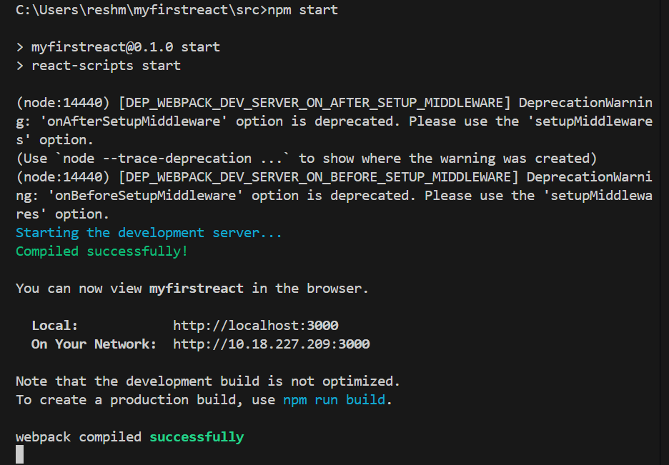

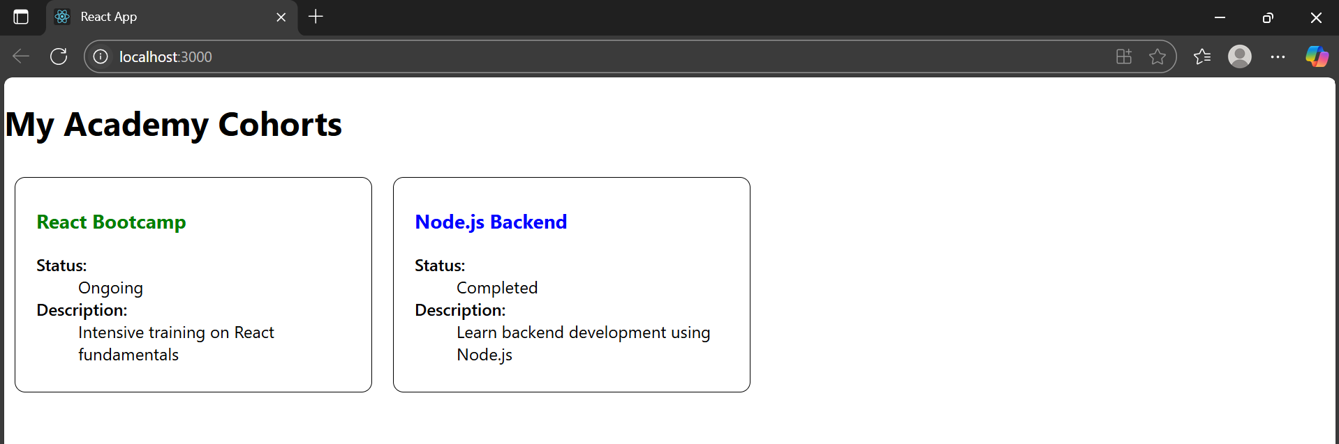

1. **REACTJS-HOL**

**Objectives**

* Explain the need and benefits of React Router
* Identify the Components in React Router
* List the types of Router Components
* Parameter passing via url

In this hands-on lab, you will learn how to:

* Implement a Simple Navigation Menu
* Add Basic Routes (install, configure)
* Use Routes in React Applications

**TrainerDetails.js:**

import React from 'react';

import { useParams } from 'react-router-dom';

import trainers from './TrainersMock';

function TrainerDetails() {

  const { id } = useParams();

  const trainer = trainers.find(t => t.trainerId === parseInt(id));

  if (!trainer) return <p>Trainer not found</p>;

  return (

    <div>

      <h2>Trainer Details</h2>

      <p><strong>Name:</strong> {trainer.name}</p>

      <p><strong>Email:</strong> {trainer.email}</p>

      <p><strong>Phone:</strong> {trainer.phone}</p>

      <p><strong>Technology:</strong> {trainer.technology}</p>

      <p><strong>Skills:</strong> {trainer.skills}</p>

    </div>

  );

}

export default TrainerDetails;

**App.js:**

import React from 'react';

import { BrowserRouter, Routes, Route, Link } from 'react-router-dom';

import Home from './Home';

import TrainersList from './TrainersList';

import TrainerDetails from './TrainerDetails';

import trainers from './TrainersMock';

function App() {

  return (

    <BrowserRouter>

      <div>

        <h1>Trainers App</h1>

        <nav>

          <Link to="/">Home</Link> | <Link to="/trainers">Trainers</Link>

        </nav>

        <hr />

        <Routes>

          <Route path="/" element={<Home />} />

          <Route path="/trainers" element={<TrainersList trainers={trainers} />} />

          <Route path="/trainer/:id" element={<TrainerDetails />} />

        </Routes>

      </div>

    </BrowserRouter>

  );

}

export default App;

**TrainersList.js:**

import React from 'react';

import { Link } from 'react-router-dom';

function TrainersList({ trainers }) {

  return (

    <div>

      <h2>Trainer List</h2>

      <ul>

        {trainers.map(trainer => (

          <li key={trainer.trainerId}>

            <Link to={`/trainer/${trainer.trainerId}`}>{trainer.name}</Link>

          </li>

        ))}

      </ul>

    </div>

  );

}

export default TrainersList;

**Home.js:**

import React from 'react';

function Home() {

  return (

    <div>

      <h2>Welcome to Trainers App</h2>

      <p>This app shows trainers and their technical skills.</p>

    </div>

  );

}

export default Home;

**TrainersMock.js:**

import Trainer from './Trainer';

const trainers = [

  new Trainer(1, "Reshma", "reshma@mail.com", "9876543210", "React", "Hooks, Router"),

  new Trainer(2, "Bhanu", "bhanu@mail.com", "9999999999", "Angular", "Directives, Services"),

  new Trainer(3, "DEEPU", "deepu@mail.com", "9123456780", "Vue", "Vuex, Composition API")

];

export default trainers;

**Trainer.js:**

export default class Trainer {

  constructor(trainerId, name, email, phone, technology, skills) {

    this.trainerId = trainerId;

    this.name = name;

    this.email = email;

    this.phone = phone;

    this.technology = technology;

    this.skills = skills;

  }

}

**RESULT:**

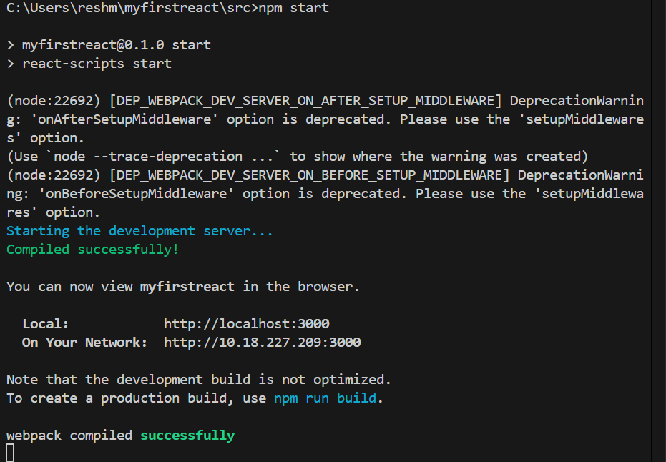

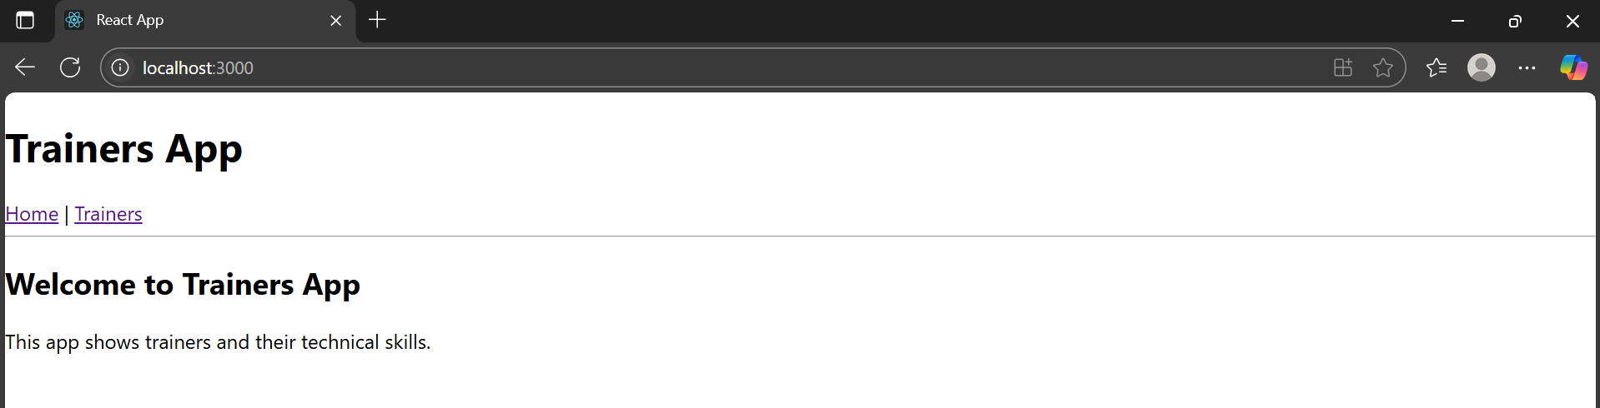

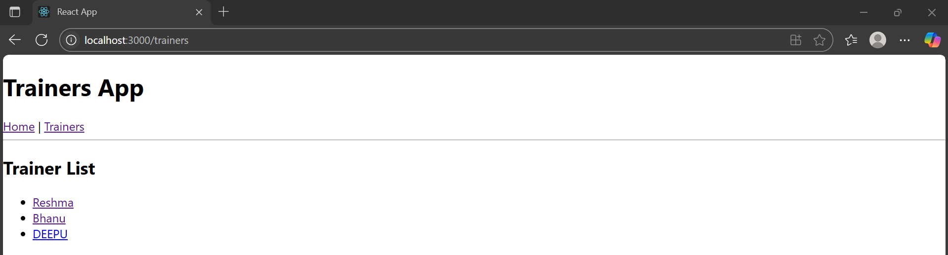

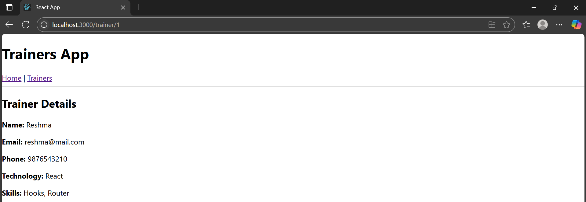

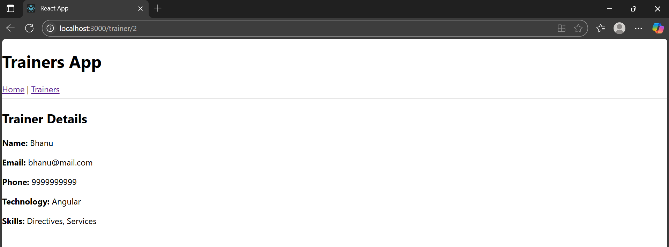

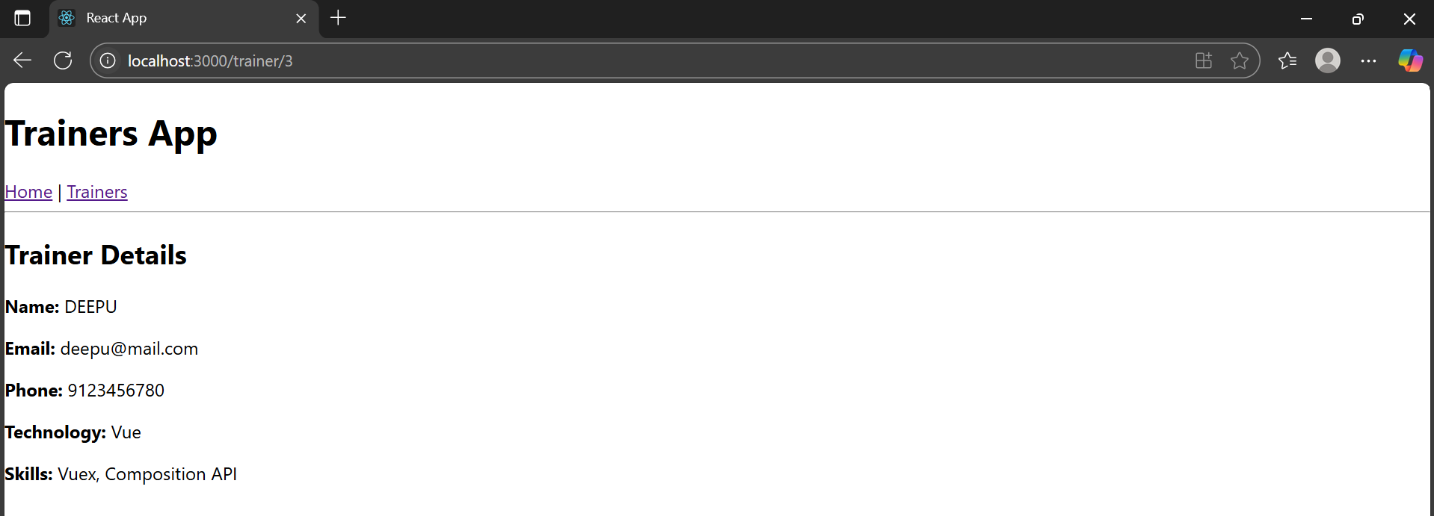

1. **REACTJS-HOL**

## **Objectives**

* Define Props
* Explain Default Props
* Identify the differences between State and Props
* Explain reactDOM.render()

In this hands-on lab, you will learn how to:

* Use Props
* Apply reactDOM.render()

**Cart.js:**

import React, { Component } from 'react';

class Cart extends Component {

  render() {

    return (

      <div>

        <p><strong>Item Name:</strong> {this.props.itemname}</p>

        <p><strong>Price:</strong> ₹{this.props.price}</p>

        <hr />

      </div>

    );

  }

}

Cart.defaultProps = {

  itemname: 'Unknown Item',

  price: 0

};

export default Cart;

**OnlineShopping.js:**

import React, { Component } from 'react';

class OnlineShopping extends Component {

  constructor(props) {

    super(props);

    this.items = [

      { name: 'Laptop', price: 80000 },

      { name: 'TV', price: 120000 },

      { name: 'Washing Machine', price: 50000 },

      { name: 'Mobile', price: 30000 },

      { name: 'Fridge', price: 70000 }

    ];

  }

  render() {

    return (

      <div>

        <h2 className="heading">Items Ordered :</h2>

        <table className="centered-table">

          <thead>

            <tr>

              <th>Name</th>

              <th>Price</th>

            </tr>

          </thead>

          <tbody>

            {this.items.map((item, index) => (

              <tr key={index}>

                <td>{item.name}</td>

                <td>{item.price}</td>

              </tr>

            ))}

          </tbody>

        </table>

      </div>

    );

  }

}

export default OnlineShopping;

**App.css:**

.heading {

  color: green;

  text-align: center;

  font-size: 30px;

  font-weight: bold;

  margin-top: 30px;

}

.centered-table {

  margin: auto;

  border-collapse: collapse;

  width: 300px;

  text-align: center;

  color: green;

  font-weight: bold;

  border: 1px solid gray;

}

.centered-table th,

.centered-table td {

  border: 1px solid gray;

  padding: 10px;

}

**App.js:**

import React from 'react';

import './App.css';

import OnlineShopping from './OnlineShopping';

function App() {

  return (

    <div className="App">

      <OnlineShopping />

    </div>

  );

}

export default App;

**index.js:**

import React from 'react';

import ReactDOM from 'react-dom/client';

import App from './App';

const root = ReactDOM.createRoot(document.getElementById('root'));

root.render(<App />);

**RESULT:**

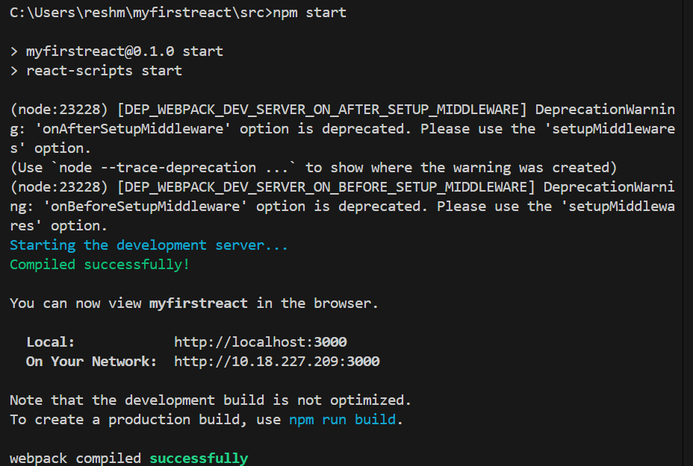

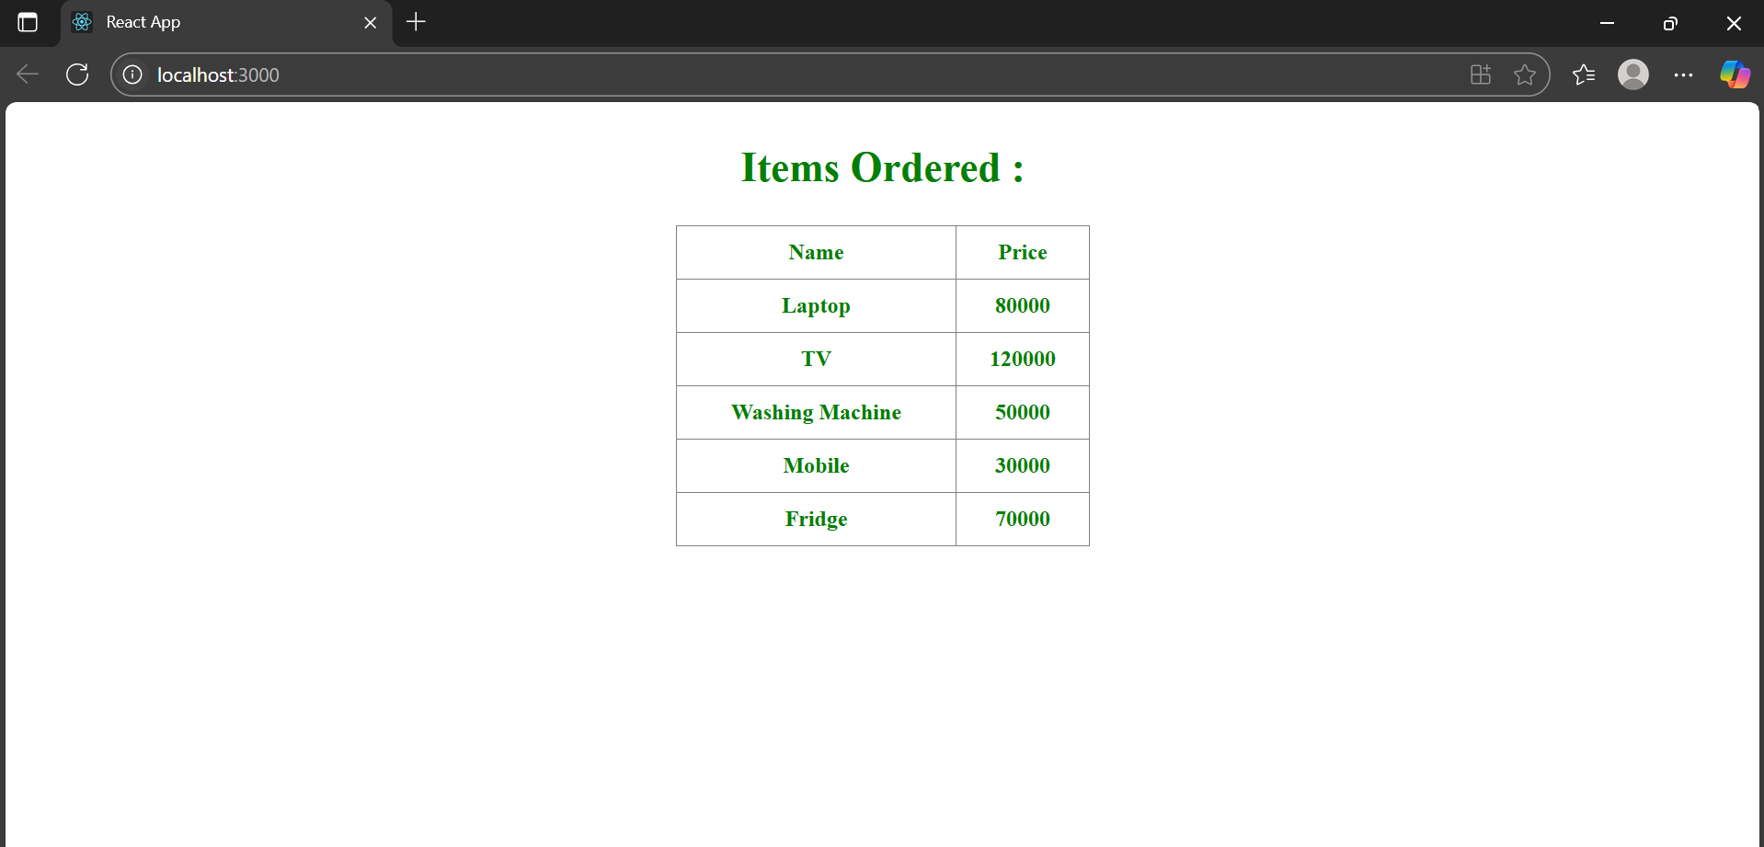

1. **REACTJS-HOL**

## **Objectives**

* Explain React State

In this hands-on lab, you will learn how to:

* Use React State object

## **Prerequisites**

The following is required to complete this hands-on lab:

* Node.js
* NPM
* Visual Studio Code

**CountPeople.js:**

import React, { Component } from 'react';

class CountPeople extends Component {

  constructor(props) {

    super(props);

    this.state = {

      entryCount: 0,

      exitCount: 0

    };

  }

  updateEntry = () => {

    this.setState(prevState => ({

      entryCount: prevState.entryCount + 1

    }));

  };

  updateExit = () => {

    this.setState(prevState => ({

      exitCount: prevState.exitCount + 1

    }));

  };

  render() {

    const buttonStyle = {

      backgroundColor: 'green',

      color: 'white',

      padding: '10px 20px',

      margin: '10px',

      border: 'none',

      borderRadius: '5px',

      cursor: 'pointer'

    };

    return (

      <div style={{ textAlign: 'center', marginTop: '50px' }}>

        <h2>Mall Entry Tracker</h2>

        <p>People Entered: {this.state.entryCount}</p>

        <p>People Exited: {this.state.exitCount}</p>

        <button onClick={this.updateEntry} style={buttonStyle}>Login</button>

        <button onClick={this.updateExit} style={buttonStyle}>Exit</button>

      </div>

    );

  }

}

export default CountPeople;

**App.js:**

import React from 'react';

import CountPeople from './CountPeople';

function App() {

  return (

    <div>

      <CountPeople />

    </div>

  );

}

export default App;

**RESULT:**

