PROJECT DOCUMENTATION
AI STUDY BUDDY
1. INTRODUCTION
Project Title: AI Study Buddy
Team ID: SWTID-2026-1610
Team Size: 4
Team Leader:
Name: Akshaya P
Email: akshayaachu065@gmail.com
Team Members:
- Name: Reshma D
Email: reshmamalathi144@gmail.com
- Name: Kiruthiga S
Email: kiruthigakeerthi02@gmail.com
- Name: Sivaranjani M
Email: ranjaniranjani1808@gmail.com

Introduction
AI Study Buddy is an AI-powered educational application designed to help students study and revise their learning materials effectively.
The system allows students to upload study materials in PDF format. The uploaded content is processed and analyzed using Google Gemini AI.
Based on the uploaded material, the system can generate:
- AI-based summaries
- Flashcards
- Multiple-choice quizzes
- Personalized study plans
The main purpose of this project is to provide students with a simple and intelligent study assistant that can reduce manual preparation time and make learning more organized.

2. PROJECT OVERVIEW
AI Study Buddy is developed to provide students with an intelligent and personalized learning experience.
Students normally spend considerable time preparing notes, revision questions, and study schedules manually. This system uses Artificial Intelligence to automate these activities.

Purpose
The main purpose of the project is to:
- Simplify the learning process.
- Reduce manual preparation of study materials.
- Generate quick summaries.
- Create revision flashcards.
- Generate practice quizzes.
- Prepare personalized study schedules.

Key Features
- Student authentication
- PDF study material upload
- PDF text extraction
- AI-generated summary
- AI-generated flashcards
- AI-generated quizzes
- Personalized study plan
- MongoDB data storage
- JWT-based authentication
- REST API-based backend

Target Users
- College students
- School students
- Learners preparing for examinations
- Students who need quick revision materials
3. PROBLEM STATEMENT AND OBJECTIVES

Problem Statement
Students often have to study from lengthy notes, PDFs, textbooks, and other learning materials.
Preparing summaries, revision questions, flashcards, and study schedules manually can take considerable time.

Problems Identified
- Lengthy study materials are difficult to revise quickly.
- Manual summary preparation takes time.
- Students may find it difficult to identify important topics.
- Creating practice questions manually requires additional effort.
- Students may not have a proper study schedule.
- Different study materials are often stored separately.

Proposed Solution
AI Study Buddy provides an AI-based solution for these problems.
The student uploads the study material and the system processes it using Google Gemini AI.
The system then generates useful learning resources automatically.

Objectives
- To provide an easy-to-use AI study assistant.
- To process uploaded study materials.
- To generate meaningful summaries.
- To create flashcards for revision.
- To generate practice quizzes.
- To create personalized study plans.
- To save time during exam preparation.

4. SYSTEM ARCHITECTURE
AI Study Buddy follows a backend-based architecture where the student request passes through the backend and the required information is processed using different technologies.

Architecture Components
1. Student
The student provides login details, uploads study materials, and requests AI-generated learning resources.
2. Node.js
Node.js provides the runtime environment for executing the backend application.
3. Express.js
Express.js is used to develop REST APIs and handle client requests.
4. MongoDB
MongoDB stores application data and study material information.
5. Google Gemini API
Gemini AI analyzes study material and generates learning content.
6. JWT
JWT is used for authentication and protected API access.

System Architecture
STUDENT
|
↓
Authentication
|
↓
Upload Study Material
|
↓
Node.js + Express
|
↓
PDF Text Extraction
|
↓
MongoDB
|
↓
Google Gemini API
|
┌────────┼────────┐
↓ ↓ ↓
Summary Flashcards Quiz
|
↓
Study Plan

5. TECHNOLOGY STACK

5.1 Node.js
Node.js is used as the runtime environment for the backend.
It allows JavaScript code to run on the server side.

5.2 Express.js
Express.js is a Node.js framework used to develop APIs and handle HTTP requests.

5.3 MongoDB
MongoDB is a NoSQL database used to store application and study material data.

5.4 Mongoose
Mongoose provides a structured way to work with MongoDB from the Node.js application.

5.5 Google Gemini API
Google Gemini API provides Artificial Intelligence capabilities to the project.
It is used to generate:
- Summaries
- Flashcards
- Quizzes
- Study plans

5.6 JWT
JSON Web Token is used to authenticate users and protect APIs.

5.7 Postman
Postman is used to test the APIs and verify their responses.

5.8 Visual Studio Code
Visual Studio Code is used as the development environment for writing and managing the project.
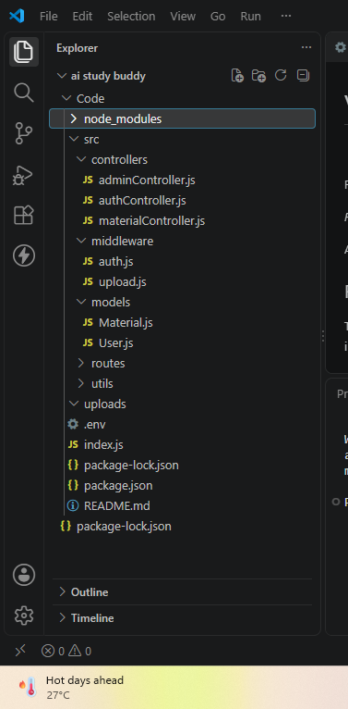

6. SYSTEM WORKFLOW
The complete working process of AI Study Buddy is given below.
Step 1 – Student Login
The student enters valid login credentials.
Step 2 – Authentication
The system verifies the credentials and generates a JWT token.
Step 3 – Upload Material
The student uploads a PDF study material.
Step 4 – Text Extraction
The backend extracts text from the uploaded PDF.
Step 5 – Store Material
The material information is stored in the database.
Step 6 – AI Processing
The extracted content is sent to Google Gemini API.
Step 7 – Generate Learning Resources
Gemini generates the required learning content.
Step 8 – Display Result
The generated result is returned through the API.

Workflow Diagram
Login
↓
JWT Authentication
↓
Upload PDF
↓
Extract Text
↓
Store Material
↓
Send Content to Gemini
↓
AI Processing
↓
Summary / Flashcards / Quiz / Study Plan
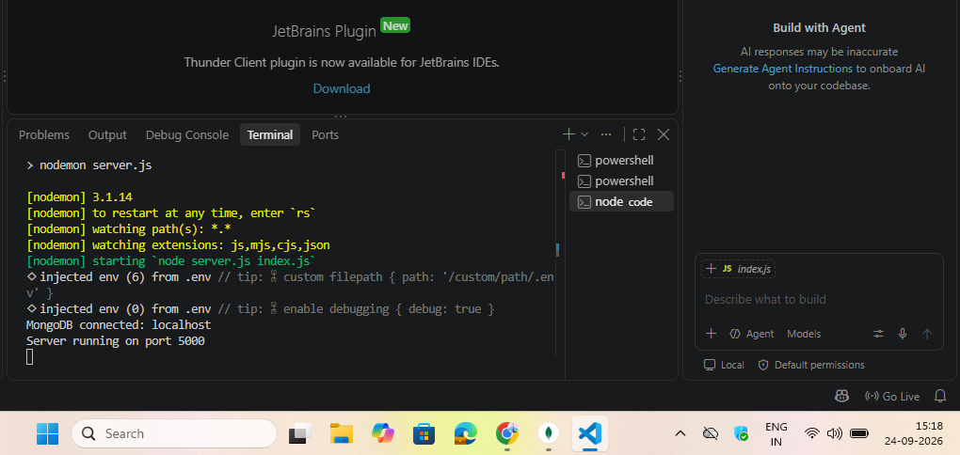
7. PROJECT MODULES
The project is divided into several modules.

7.1 Authentication Module
Handles:
- User login
- Credential verification
- JWT token generation
- Protected API access

7.2 Material Upload Module
Handles:
- PDF upload
- File processing
- Text extraction
- Material storage

7.3 Summary Module
Generates a simplified summary from the uploaded study material.

7.4 Flashcard Module
Generates question-and-answer flashcards for revision.

7.5 Quiz Module
Generates multiple-choice questions based on the uploaded material.

7.6 Study Plan Module
Generates a personalized study schedule based on:
- Goal
- Hours per day
- Number of days

Module Flow
Authentication
↓
Material Upload
↓
Text Extraction
↓
AI Processing
↓
┌────┼─────┬──────────┐
↓ ↓ ↓ ↓
Summary Flashcards Quiz Study Plan

8. AUTHENTICATION AND MATERIAL UPLOAD

8. Authentication Module
Authentication ensures that only authorized users can access protected resources.

Login Process
User
↓
Enter Login Details
↓
Credential Verification
↓
JWT Token Generated
↓
Authorized API Access

JWT Authentication
The JWT token is sent with protected requests using the Authorization header.
Authorization: Bearer <JWT_TOKEN>

Material Upload Module
The student can upload study material in PDF format.

Upload Process
Select PDF
↓
Upload File
↓
Backend Receives File
↓
Extract Text
↓
Store Material
The uploaded material receives a material ID that is used for further AI operations.
[SCREENSHOT 4 – Postman PDF Upload successful response]
👉 உன்னிடம் upload API successful response screenshot இருந்தா இங்கே போடு.
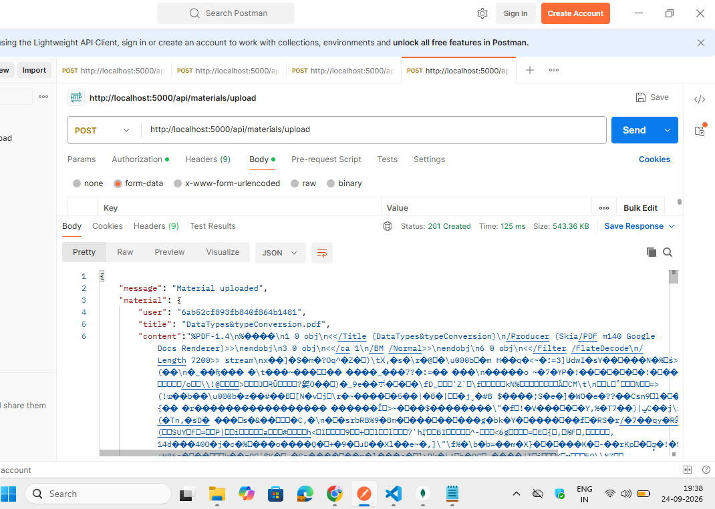

9. AI SUMMARY MODULE

9. AI Summary Generation
The Summary module generates a concise summary from the uploaded study material.

API Endpoint
POST /api/materials/:id/summarize

Process
Study Material
↓
Extracted Text
↓
Gemini AI
↓
Important Information
↓
Generated Summary

Example
The uploaded study material contained information about Data Types in Java.
The AI generated a summary covering:
- Purpose of data types
- Primitive data types
- Non-primitive data types
- Eight primitive data types
- Important characteristics

Result
The generated summary helps students understand the important concepts without reading the complete material repeatedly.
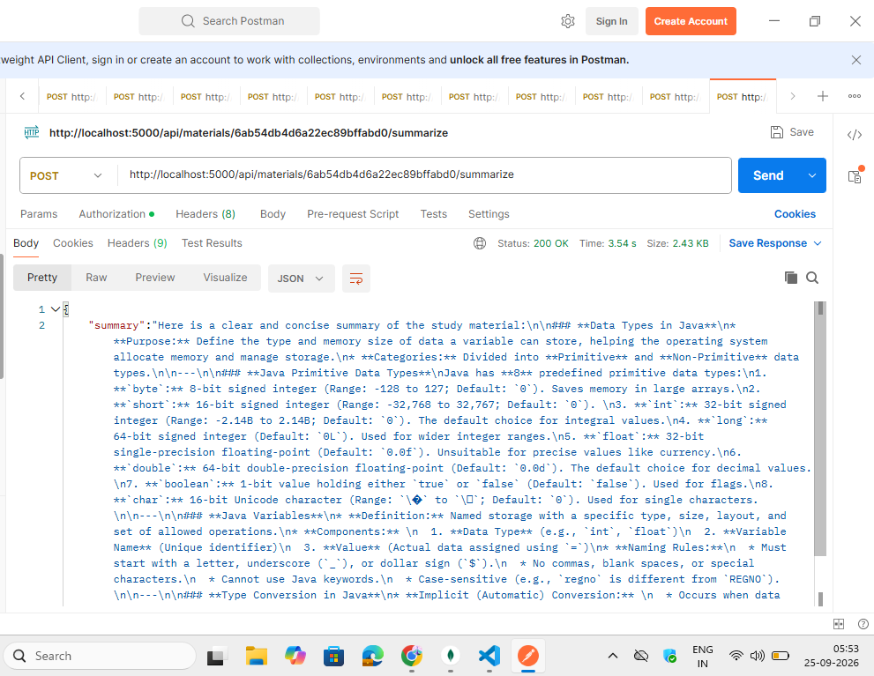

10. AI FLASHCARDS MODULE

10. AI Flashcards Generation
The Flashcards module creates question-and-answer cards from the uploaded study material.

API Endpoint
POST /api/materials/:id/flashcards

Flashcard Structure
Each flashcard contains:
- Question
- Answer

Sample Questions
The system generated questions related to:
- Java data type categories
- Boolean default value
- Floating-point values
- Java variable naming rules
- Implicit type conversion

Benefits
Flashcards help students:
- Revise quickly.
- Remember important concepts.
- Practice questions repeatedly.
- Prepare for examinations.
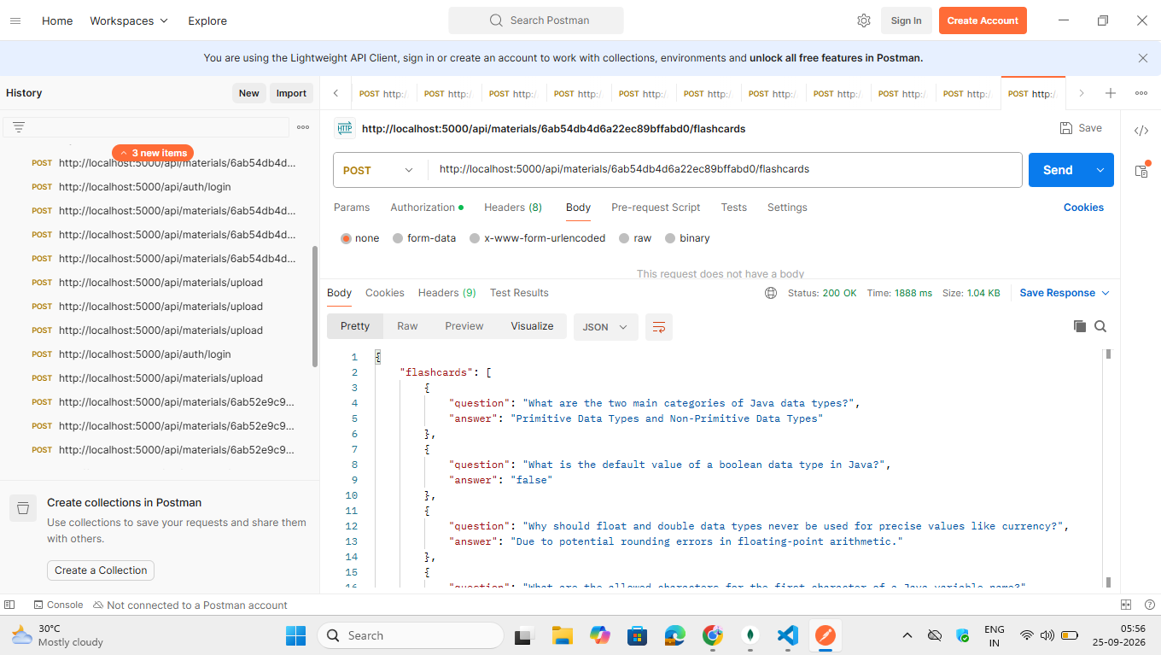
11. AI QUIZ MODULE

11. AI Quiz Generation
The Quiz module automatically generates multiple-choice questions from the uploaded study material.

API Endpoint
POST /api/materials/:id/quiz

Request Example
{
"count": 5
}

Quiz Structure
Each question contains:
- Question
- Four options
- Correct answer

Example Topics
The generated quiz included questions about:
- Java primitive data types
- Boolean default value
- Floating-point data types
- Java variable naming rules
- Implicit type conversion

Benefits
The quiz helps students:
- Test their understanding.
- Identify weak areas.
- Practice before examinations.
- Improve revision.
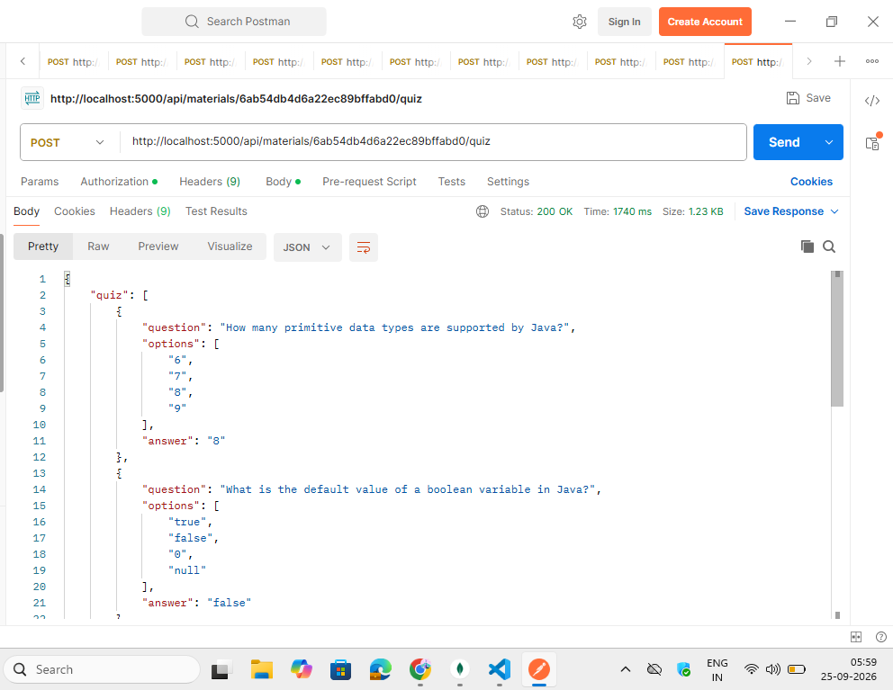
12. AI STUDY PLAN MODULE

12. AI Personalized Study Plan
The Study Plan module creates a personalized schedule according to the student's learning goal and available time.

API Endpoint
POST /api/materials/:id/study-plan

Input Example
{
"goal": "Understand Java data types",
"hoursPerDay": 2,
"days": 7
}

Process
Study Goal
+
Hours Per Day
+
Number of Days
↓
Gemini AI
↓
Personalized Study Plan

Generated Plan
For the given Java Data Types goal, the system generated a 7-day learning plan.
The plan included topics such as:
- Introduction to Java data types
- Integer data types
- Floating-point data types
- Boolean and character data types
- Type conversion
- Revision
- Practice

Benefits
- Provides organized learning.
- Helps manage study time.
- Divides topics into daily tasks.
- Supports examination preparation.
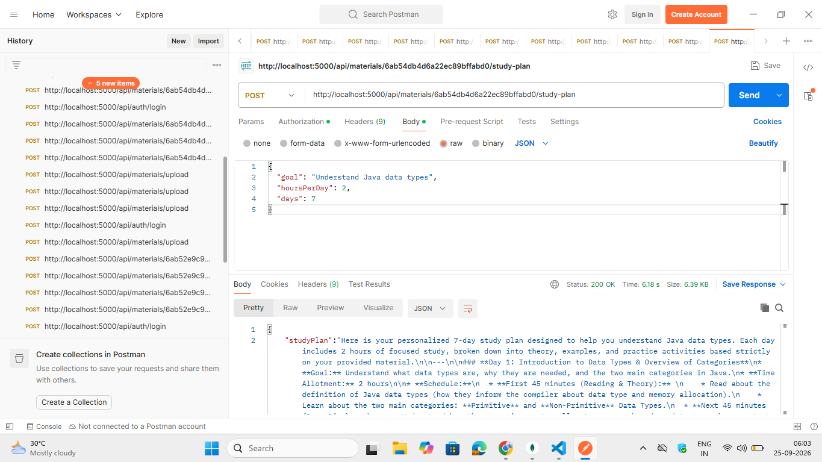

13. API DOCUMENTATION
The backend provides REST APIs for different operations.
Module | Method | Endpoint | Purpose
Authentication | POST | /api/auth/login | User login
Material Upload | POST | /api/materials/upload | Upload PDF
Summary | POST | /api/materials/:id/summarize | Generate summary
Flashcards | POST | /api/materials/:id/flashcards | Generate flashcards
Quiz | POST | /api/materials/:id/quiz | Generate quiz
Study Plan | POST | /api/materials/:id/study-plan | Generate study plan

API Authentication
Protected APIs require the JWT token.
Authorization: Bearer <JWT_TOKEN>

API Testing
Postman was used to test the APIs.
The API responses were checked for successful execution and generated AI content.
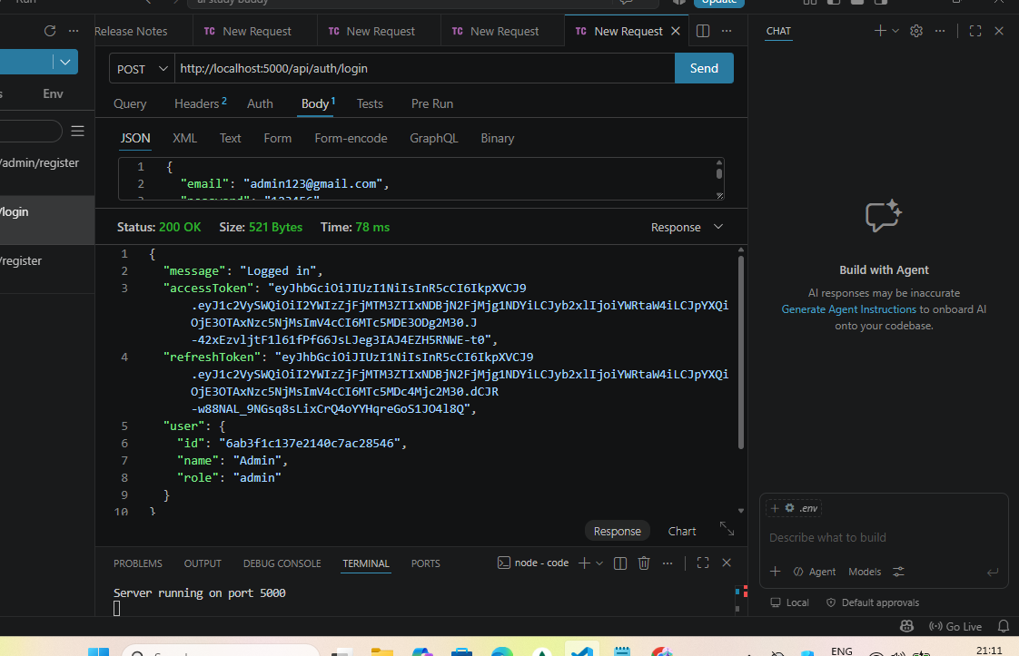
14. TESTING AND RESULTS
The system was tested using Postman.

Test Case 1 – Login
Expected Result: User should be authenticated and receive a token.
Result: Successful.

Test Case 2 – PDF Upload
Expected Result: PDF should be uploaded and processed.
Result: Successful.

Test Case 3 – Summary
Expected Result: AI should generate a summary from the study material.
Result: Successful.

Test Case 4 – Flashcards
Expected Result: AI should generate question-and-answer flashcards.
Result: Successful.

Test Case 5 – Quiz
Expected Result: AI should generate multiple-choice questions.
Result: Successful.

Test Case 6 – Study Plan
Expected Result: AI should generate a day-wise study plan based on the given requirements.
Result: Successful.

Output Screenshots

Server connected successfully

Mongo DB connected

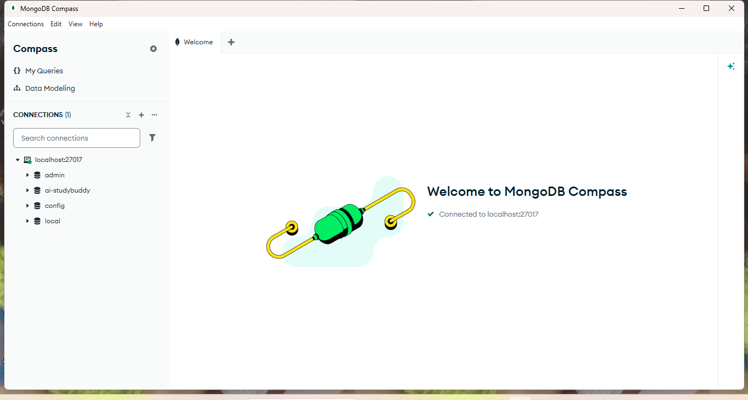

Student Registered successfully

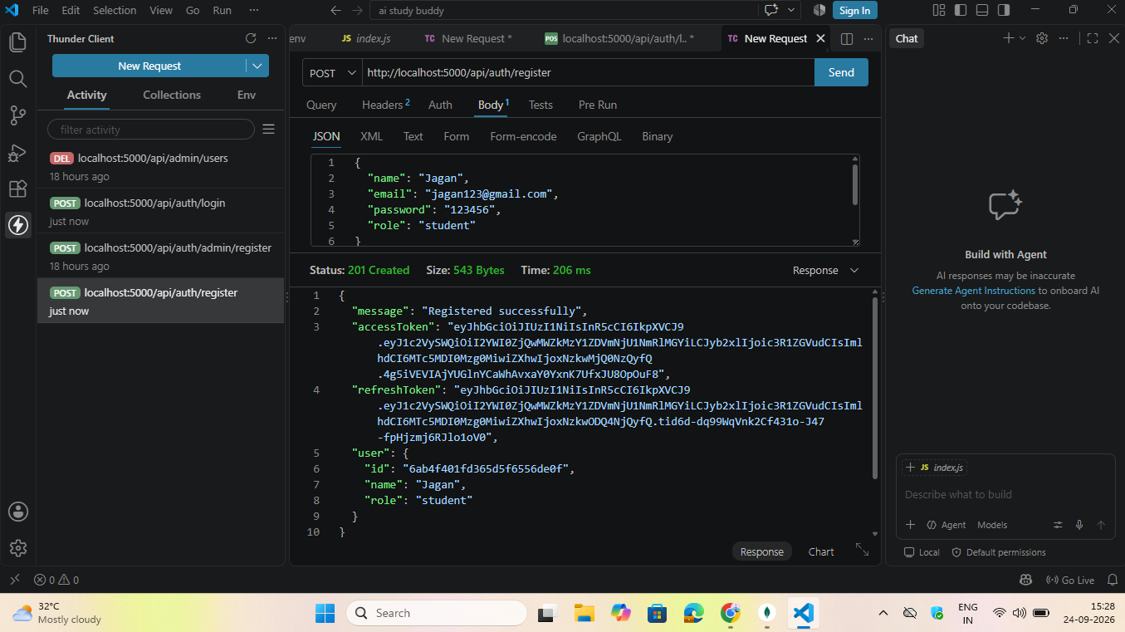
Admin Login successfully

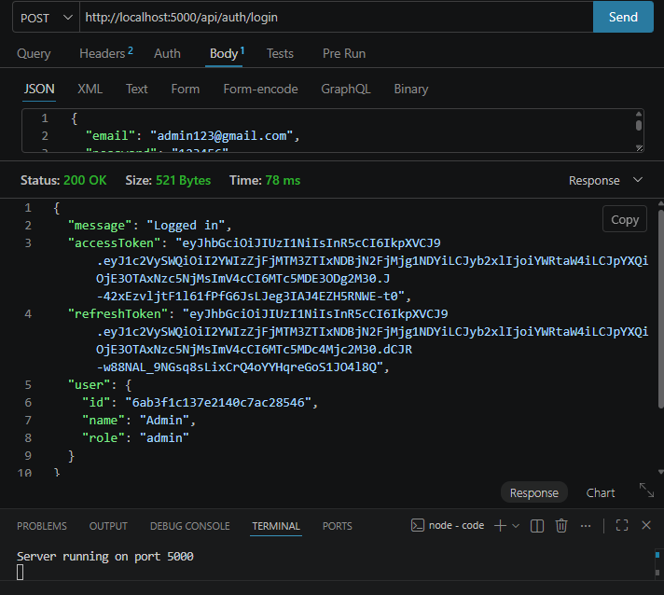

Upload the materials:
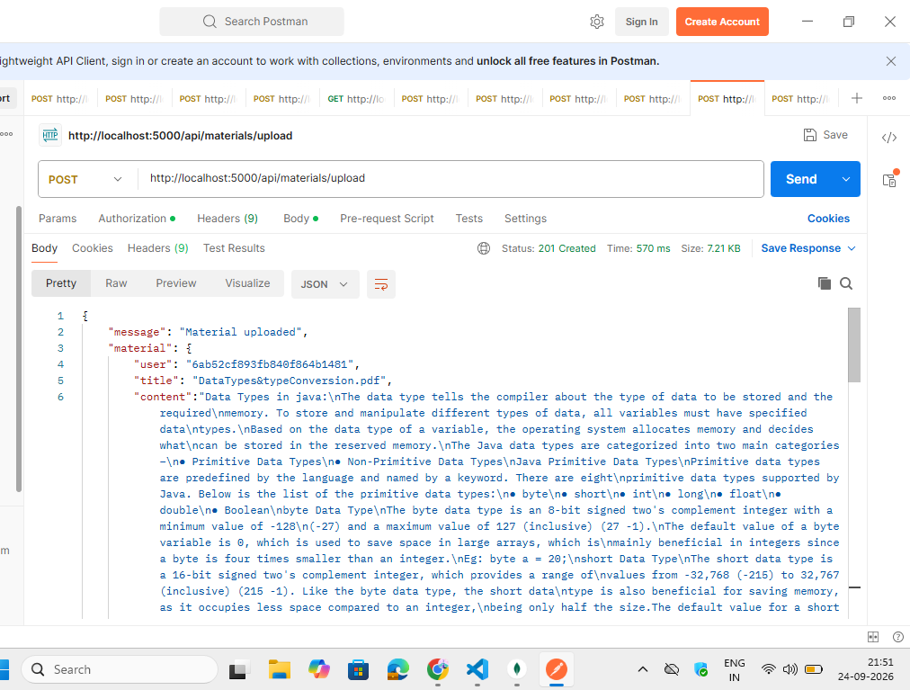

Summary:

Flash cards:

Generate the quiz

Study plan

15. SETUP, ADVANTAGES, FUTURE ENHANCEMENT & CONCLUSION

15. Setup Instructions

Prerequisites
- Node.js
- npm
- MongoDB
- Visual Studio Code
- Postman
- Git

Installation
Open the project folder in Visual Studio Code.
Install dependencies:
npm install
Configure the required environment variables in the .env file.
Start the server:
npm start
The backend application runs on:
http://localhost:5000

Advantages
- Easy to use.
- Saves study preparation time.
- Generates summaries automatically.
- Provides flashcards for quick revision.
- Generates practice quizzes.
- Creates personalized study plans.
- Uses Artificial Intelligence for learning assistance.
- Multiple learning resources can be generated from one study material.

Future Enhancements
- Student dashboard.
- Quiz score tracking.
- Learning progress tracking.
- Voice-based learning.
- Additional document formats.
- Study reminders.
- Mobile application.
- Personalized recommendations.
- Performance analytics.

Conclusion
AI Study Buddy is an AI-powered educational application developed to assist students in their learning and examination preparation.
The system allows students to upload study materials and uses Google Gemini AI to generate summaries, flashcards, quizzes, and personalized study plans.
The backend is developed using Node.js and Express.js, while MongoDB is used for data storage and JWT is used for authentication. The APIs were tested using Postman, and the major AI features were successfully tested.
The project demonstrates how Artificial Intelligence can be integrated into an educational application to provide students with automated and personalized learning support.

