**DATA ANALYTICS ASSIGNMENT 2**

Sk.Reshma

4thB.Tech(CSE)

VNITSW

21NN5A0507

**DONUT CHART**

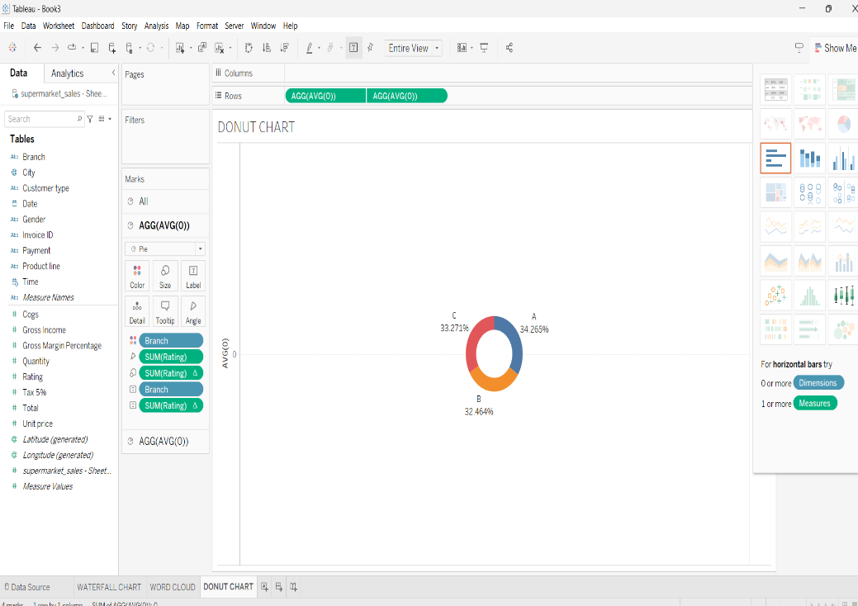

**AREA CHART**

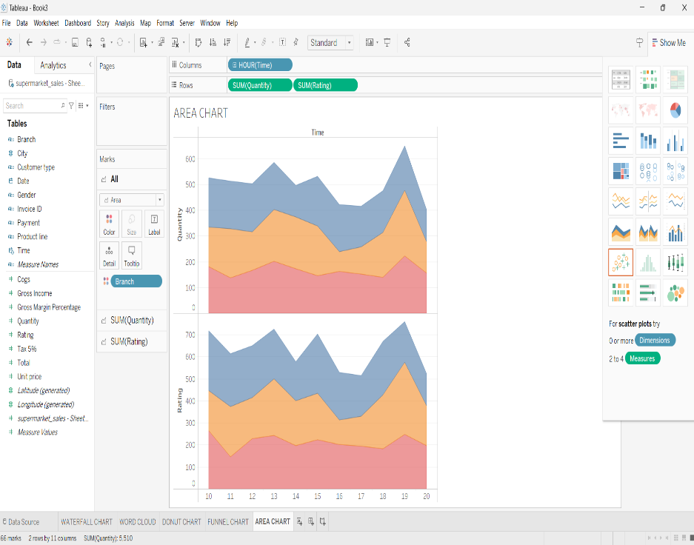

**TEXT TABLE  
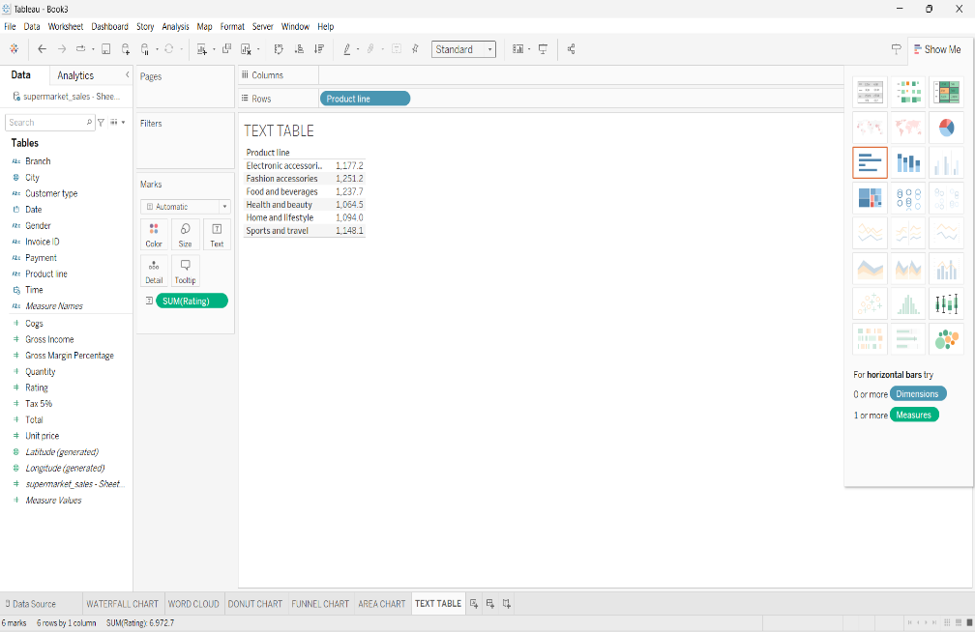**

**HIGHLIGHTED TABLE**

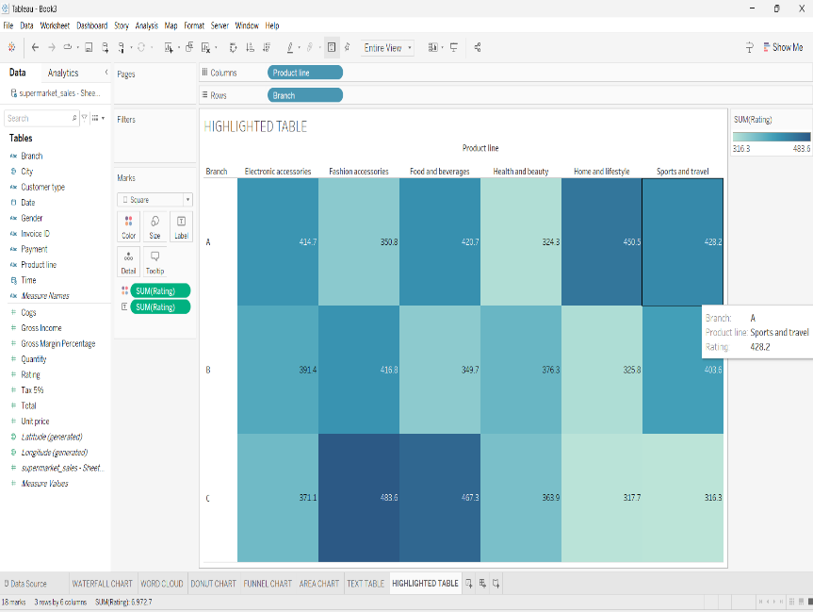

**WORD CLOUD**

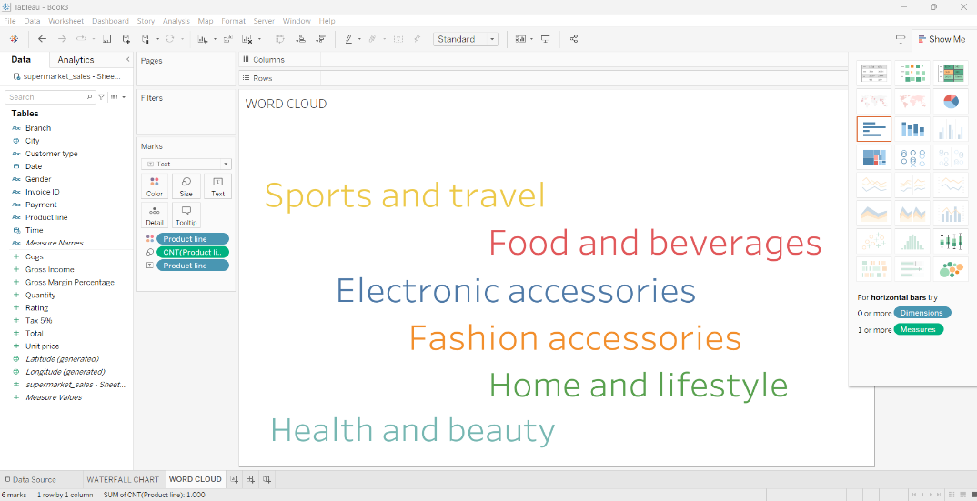

**FUNNEL CHART**

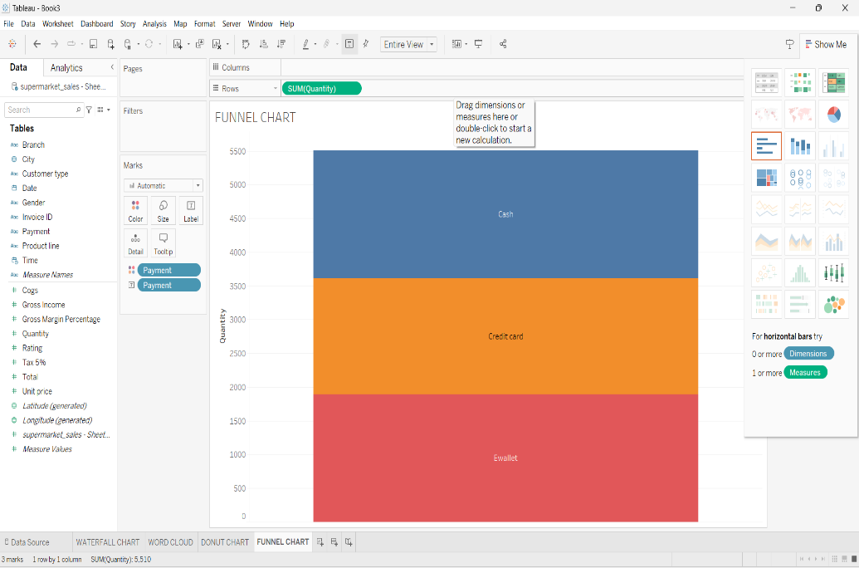

**WATERFALL CHART**

