HOSTEL ROOM ALLOCATION SYSTEM

A Mini Project-1 Report submitted
in partial fulfillment of the requirements
for the award of the degree of

BACHELOR OF TECHNOLOGY

In

COMPUTER SCIENCE & ENGINEERING

By

1 .N.SATYA.SARANYA 2.P.RESHMA

3. M.AMULYA 4.K.JYOTHIKA

Under the esteemed guidance of
Ms. R.V.SWATHI _{MTech}
Asst. Prof.



DEPARTMENT OF COMPUTER SCIENCE & ENGINEERING
SHRI VISHNU ENGINEERING COLLEGE FOR WOMEN(A)
(Approved by AICTE, Accredited by NBA & NAAC, Affiliated to JNTU Kakinada)
BHIMAVARAM – 534 202
2019 – 2020

SHRI VISHNU ENGINEERING COLLEGE FOR WOMEN(A)
(Approved by AICTE, Accredited by NBA & NAAC, Affiliated to JNTU Kakinada)
BHIMAVARAM – 534 202

DEPARTMENT OF COMPUTER SCIENCE & ENGINEERING

CERTIFICATE

This is to certify that the Mini Project-1 entitled “HOSTEL ROOM ALLOCATION SYSTEM”, is being submitted by NANDYALA SATYA SARANYA bearing the Regd. No. 18B01A0554 in partial fulfillment of the requirements for the award of the degree of “Bachelor of Technology in Computer Science & Engineering” is a record of bonafide work carried out by her under my guidance and supervision during the academic year 2019–2020 and it has been found worthy of acceptance according to the requirements of the university.

Internal Guide Head of the Department

ABSTRACT:

Abstract of the Project
Our project main idea is to book hostel room in the campus through our website .In our website, the
Warden can add hostels, update room status, retrieve the student information from database. The student can login into the website using temporary registration number and based on the status of the room, the user and book the room. In our system we are going to mention how many beds can be suited in a particular room, dimensions of the room as well as category of the room, whether it may be Ac or Non-Ac or attached or common or Ac-attached or Ac- common or Non-Ac attached or Non-Ac common. So that it will be easy to the student to choose his/her room. The temporary registration number will be given to the students ,when the submitted allotment order to the college and confirm their seat in the college. When a room is selected for a student ,for another student it will not be accessible(i.e., number of vacant beds will be reduced).
Existing System
In the existing system, the students used to check all the rooms manually and they need to go to warden office and register themselves by writing their name in the record which will be maintained in the warden office. In between the time taken to go to warden office any can book the room which was choosen by others . So, again they need to choose another room. In the existing system, it will be very difficult to retrieve the student details and update the student details from the file records. In this system, if students
Did not check all the rooms then, there is a chance of choosing a small room as there is no mention that all rooms are of same dimensions. These are some drawbacks in the Existing System.

Proposed System – Features
In our System, students can book their room in the place where they are. It will be easy to warden to retrieve the student details .Students can also know how many racks and beds are there in a particular room and also the dimensions of the room.
Software & Hardware Requirements
Functional Requirements:
The Functional Requirements define the functionality or the system services of the developed software or its components. For implementing our system, we required softwares like eclipse , mysql . We generally run the java programs in eclipse and all the web pages are connected to database through JDBC.
Non-Functional Requirements:
Nonfunctional requirements describe user-visible aspects of the system that are not directly related to the functional behavior of the system.
Hardware Considerations:
RAM : 4GB
Processor : Intel core i3 and above
Hard disk space : 258 GB
Operating System : windows 10 and above.

Contents

S.No. Topic Page No.
- Introduction 5
- System Analysis 5 - 6
  - Existing System
  - Proposed System
  - Feasibility Study
- System Requirements Specification 6 - 7
  - Software Requirements
  - Hardware Requirements
  - Functional Requirements
- System Design 7 - 16
  - Introduction
  - UML Diagrams
  - Database Design
    - ER Diagrams
    - Table Structures
- System Implementation 16 - 24
  - Introduction
  - Project Modules
  - Screens
- System Testing 24 - 26
  - Introduction
  - Testing Methods
  - Test Cases
- Conclusion 26
- Bibliography 26
- Appendix 26 - 27
  - Introduction to Java

1.INTRODUCTION:

Through our system the student can able to book the room. Firstly the user will register and login into the system using login Id and password. There are two users student and admin. The admin can able to add the hostels and view student details. In adding hostel , admin will enter the values – hostel name, room number , category(Ac-attached, Ac-common, Non-ac attached, Non Ac-common), dimensions of the room, number of rooms in that room , number of vacant rooms in that room. In view students – the admin can view the which students had selected which room. Admin can view student login Id , hostel name and room number which was selected by the student. Student can able to view the hostel details which are added by the admin and able to select room based on the availability. By giving the hostel name, room number, student login id student can able to book the room. The front end is written in html. All the backend pages are connected to mysql database using jdbc.

Technologies used in the Hostel Room Allocation system are:
Front-End: JSP, Html
Server-side: Servlets
Back-end: MYSQL (Database).
Server: Tomcat 8.5.

2 system analysis:

2.1 EXISTING SYSTEM:
In the existing system, manually the students have to check all the rooms. If the student likes any room then they has to register their details in the log book which will be present in the warden office . In between the time taken to go to warden office any can book the room which was choosen by others . So, again they need to choose another room. In the existing system, it will be very difficult to retrieve the student details and update the student details from the file records. In this system, if students did not check all the rooms then, there is a chance of choosing a small room as there is no mention, that all rooms are of same dimensions. These are some drawbacks in the Existing System.

2.2 PROPOSED SYSTEM:
In our System, students can book their room in the place where they are. It will be easy to warden to retrieve the student details .Students can also know how many beds are there in a particular room and also the dimensions of the room. It also helps to know the category of the room.

2.3 FEASIBILITY STUDY
Generally the feasibility study is used for determining the resource cost, benefits and whether the proposed system is feasible with respect to the organization. The proposed system feasibility could be as follows. There are six types of feasibility which are equally important are:

- Technical feasibility
- Economic feasibility
- Behavioural feasibility
Technical Feasibility
Technical feasibility deals with the existing technology, software and hardware requirements for the proposed system. The proposed system “Hostel Room Allocation System” is planned to run on Java. Thus, the project is considered technically feasible for the development. The work for the project can be done with current equipment, existing software technology .Hence the proposed system is technically feasible.
Economic Feasibility
This method is most frequently used for evaluating the effectiveness of a Java. It is also called as benefit analysis. This project “Hostel Room Allocation System” is developed on current equipment, existing software technology. Since the required hardware and software for developing the system is already available in the organization, it does not cost much for developing the proposed system.
Behavioural Feasibility
This project has been implemented by Java and it satisfies all conditions of the organization and the users. This proposed system “Hostel Room Allocation System” has much behavioural feasibility because users are provided with a better facility.
3.System Requirements Specification
3.1Software Requirements
The softwares used for this proposed system are :
- Database : mysql
- Tools : eclipse
- Server :Tomcat
- Languages :Java ,html,jsp.
3.2 HARDWARE REQUIREMENTS
The hardware requirements needed for this proposed system are:
- RAM : 4GB and above
- Processor : Intel core i3 and above
- Hard disk space : 258 GB and above
- Operating System : windows 10 and above.

3.3 FUNCTIONAL REQUIREMENTS
Functional requirements are the requirements which deals with the operational
requirements of the system and the requirements that are requested by the user .
They are:
- Student can able to book the room.
- Student can able to view the hostel details
- Admin can able to add the hostels
- Admin can able to retrieve the student details and their respective room
NON-FUNCTIONAL REQUIREMENTS
A non-functional requirement specifies the process that can be used to check the
Operations of a system. They are contrasted with the functional requirements that define
specific functions. The plan for implementing non-functional requirements is
detailed in the system architecture, because they are usually architecturally significant
requirements. Some of them are ,
- Robustness to cope with errors during execution and cope with erroneous input.
- Performance which tells us whether the input is valid or not and obtained output.
- The cost should be less when compared to the existing system.
- The system acts as platform independent.
- The system is secured.
4.SYSTEM DESIGN

4.1 INTRODUCTION
System design is the process of designing the elements of a system such as the architecture, modules and components, the different interfaces of those components and the data that goes through that system.
System Analysis is the process that decomposes a system into its component pieces for the purpose of defining how well those components interact to accomplish the set requirements. The purpose of the System Design process is to provide sufficient detailed data and information about the system and its system elements to enable the implementation consistent with architectural entities as defined in models and views of the system architecture.
The purpose of the design phase is to plan a solution of the problem specified by the requirement document. This phase is the first step in moving from problem domain to the solution domain. The design of a system is perhaps the most critical factor affecting the quality of the software, and has a major impact on the later phases, particularly testing and maintenance. The output of this phase is the design document. This document is similar to a blue print or plan for the solution, and is used later during implementation, testing and maintenance.
The design activity is often divided into two separate phase-system design and detailed design. System design, which is sometimes also called top-level design, aims to identify the modules that should be in the system, the specifications of these modules, and how they interact with each other to produce the desired results. At the end of system design all the major data structures, file formats, output formats, as well as the major modules in the system and their specifications are decided.
A design methodology is a systematic approach to creating a design by application of set of techniques and guidelines. Most methodologies focus on system design. The two basic principles used in any design methodology are problem partitioning and abstraction. A large system cannot be handled as a whole, and so for design it’s partitioned into smaller systems. Abstraction is a concept related to problem partitioning. When partitioning is used during design, the design activity focuses on one part of the system at a time. Since the part being designed interacts with other parts of the system, a clear understanding of the interaction is essential for property designing the part.
4.2.UML DIAGRAMS:

The diagrams are the graphical implementation of the models that incorporate symbols and text . Each symbol has a different meaning in the context of UML diagram. UML diagrams are classified into three categories. They are
- Structural diagrams
- Behavioural diagrams
- Interaction diagrams

STRUCTURAL DIAGRAMS:
It represents the static view of a system by portraying the structure of a system .It shows several objects residing in the system. Following are the structural diagrams given below:
- Class diagram
- Object diagram
- Package diagram
- Component diagram
- Deployment diagram

BEHAVIOURAL DIAGRAMS:

Behavioural diagrams depicts the behavioural features of a system. It deals with dynamic parts of the system. It encompasses the following diagrams:
- Activity diagram
- State machine or State chart diagram
- Use case diagram.
INTERACTION DIAGRAM:
Interaction diagrams are the subset of behavioral diagrams.It depicts the interaction between two objects and the data flow between them. Following are several interaction diagrams:
- Timing Diagram
- Sequence diagram
- Collaboration Diagram
UML DIGRAMS FOR HOSTEL ROOM ALLOCATION SYSTEM:

USE CASE DIAGRAM

A use case diagram is used to represent the dynamic behavior of a system. It encapsulates the system's functionality by incorporating use cases, actors, and their relationships. It models the tasks, services, and functions required by a system/subsystem of an application. It depicts the high-level functionality of a system and also tells how the user handles a system.
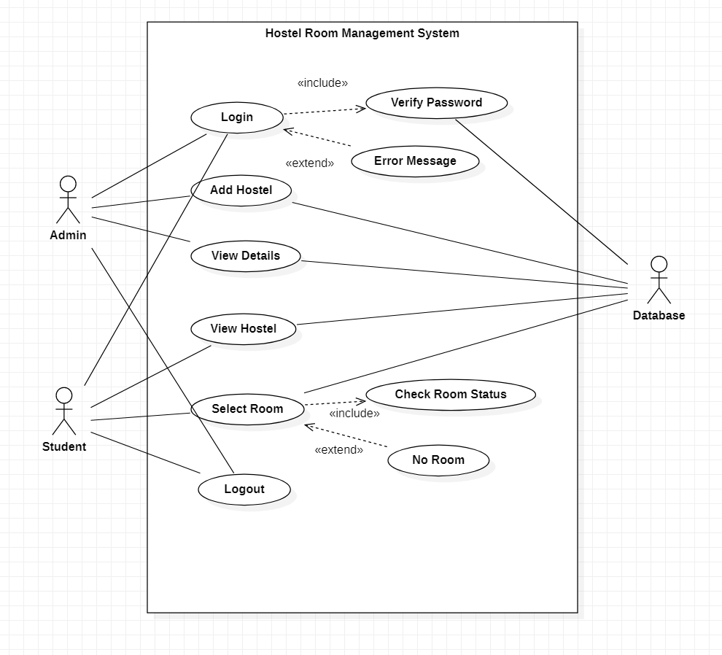

Actors:
- Admin: person who login, add hostel and get information about student who selected the room.
- Student: student will login, view the hostels and select the room.
- Database: It stores all the information which will be given by the student as well as student.

Activity diagram:
In UML, the activity diagram is used to demonstrate the flow of control within the system rather than the implementation. It models the concurrent and sequential activities. The activity diagram helps in envisioning the workflow from one activity to another. It put emphasis on the condition of flow and the order in which it occurs. The flow can be sequential, branched, or concurrent, and to deal with such kinds of flows, the activity diagram has come up with a fork, join, etc. It is also termed as an object-oriented flowchart. It encompasses activities composed of a set of actions or operations that are applied to model the behavioral diagram.
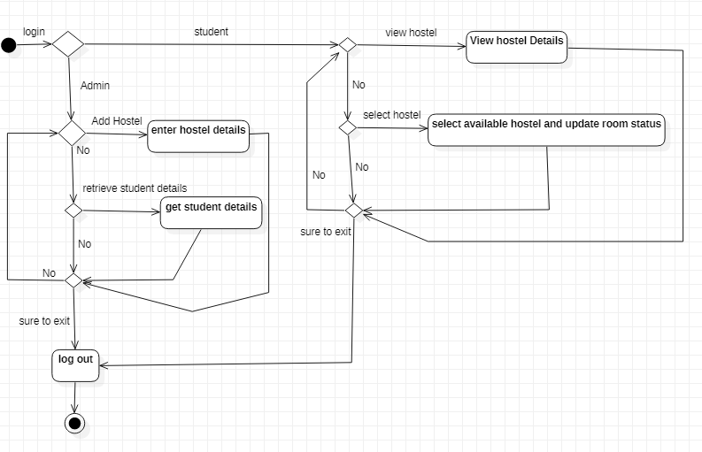
Activities:
1.enter hostel details: all details of hostel will be entered by admin 2.get student details: students who had selected the room will be retrieved 3.view hostel details: details of hostel will be viewed by the student. 4. select available hostel and update room status: selected room will be allocated to the student if it is available
Decisions:
1. add hostel 2.retrieve student details 3. view hostel 4. select hostel 5.sure to exit

SEQUENCE DIAGRAM:
The sequence diagram represents the flow of messages in the system and is also termed as an event diagram. It helps in envisioning several dynamic scenarios. It portrays the communication between any two lifelines as a time-ordered sequence of events, such that these lifelines took part at the run time. In UML, the lifeline is represented by a vertical bar, whereas the message flow is represented by a vertical dotted line that extends across the bottom of the page. It incorporates the iterations as well as branching.

Purpose of sequence diagram:
- To model high-level interaction among active objects within a system.
- To model interaction among objects inside a collaboration realizing a use case.
- It either models generic interactions or some certain instances of interaction.
SEQUENCE DIAGRAM FOR STUDENT:
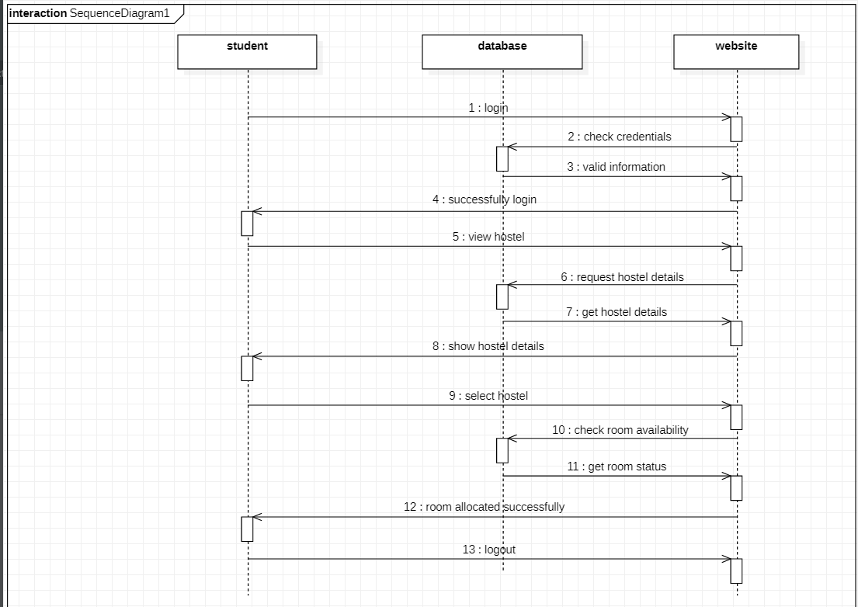
Objects:
- Student: student login to the system and performs operations like select hostel,view hostel
- Database: It contains all the information required for the system.
- Website: It accepts the request from the user and shows the response to them.

SEQUENCE DIAGRAM FOR ADMIN:

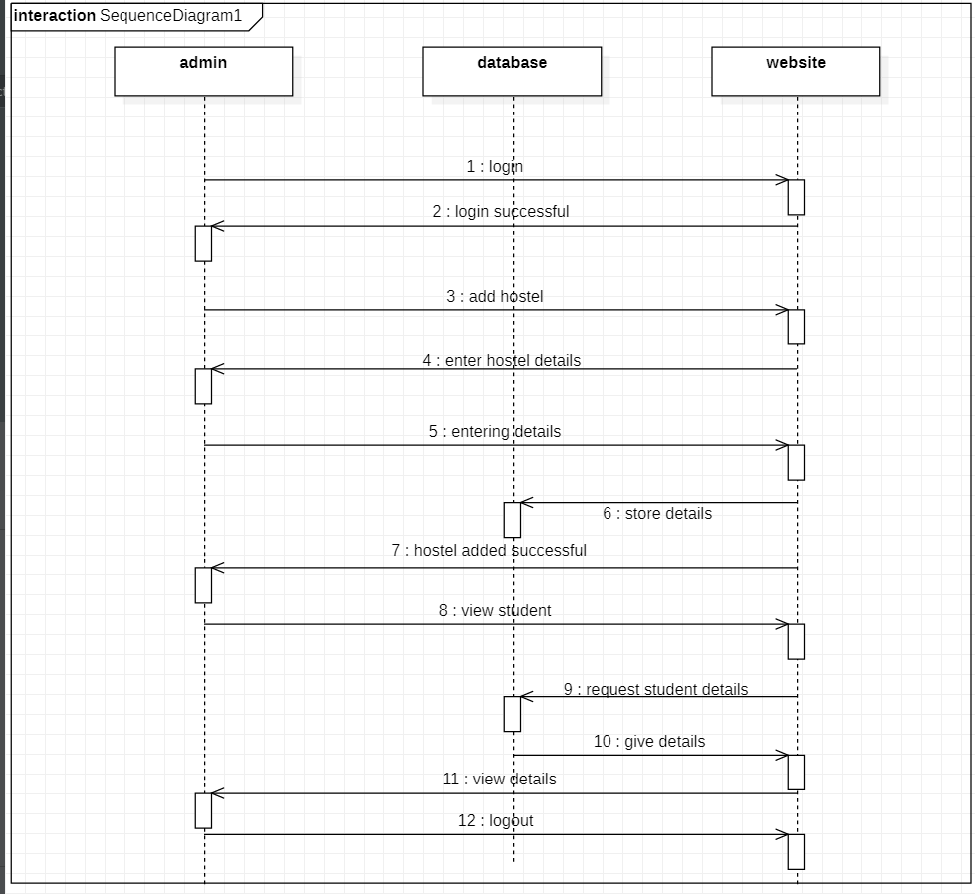
Objects:
- Admin: Admin will login to the system and performs operations like add hostel,view student details
- Database: It contains all the information required for the system.
- Website: It accepts the request from the user and shows the response to them.

CLASS DIAGRAM:
The class diagram depicts a static view of an application. It represents the types of objects residing in the system and the relationships between them. A class consists of its objects, and also it may inherit from other classes. A class diagram is used to visualize, describe, document various different aspects of the system, and also construct executable software code.
It shows the attributes, classes, functions, and relationships to give an overview of the software system. It constitutes class names, attributes, and functions in a separate compartment that helps in software development. Since it is a collection of classes, interfaces, associations, collaborations, and constraints, it is termed as a structural diagram.

Purpose of class diagram:
The main purpose of class diagrams is to build a static view of an application. It is the only diagram that is widely used for construction, and it can be mapped with object-oriented languages. It is one of the most popular UML diagrams. Following are the purpose of class diagrams given below:
- It analyses and designs a static view of an application.
- It describes the major responsibilities of a system.
- It is a base for component and deployment diagrams.
- It incorporates forward and reverse engineering.
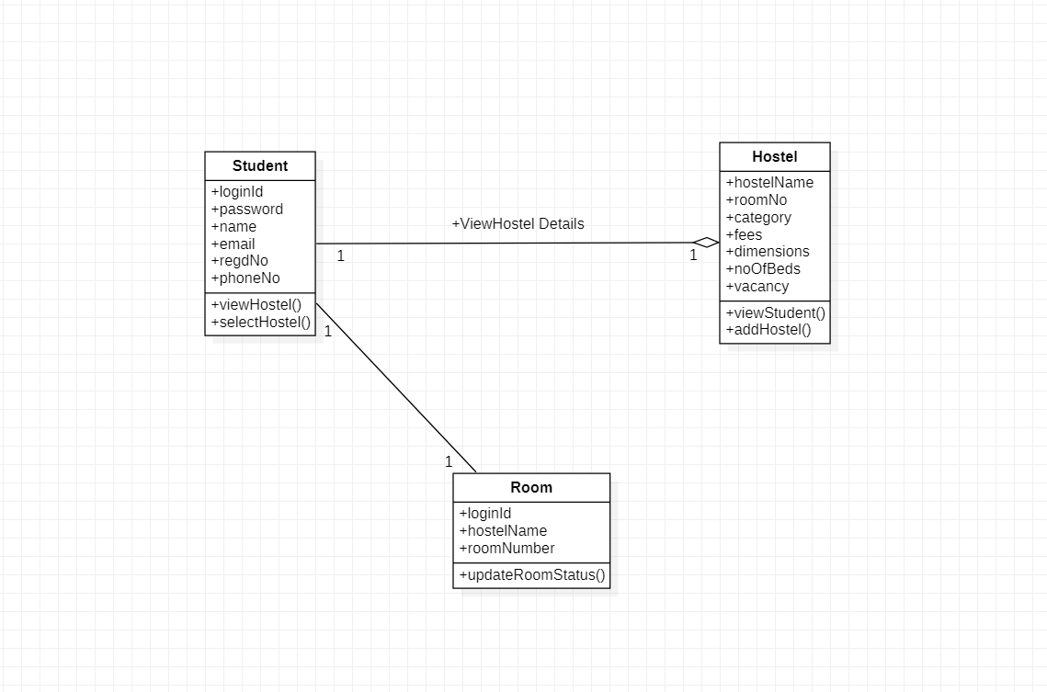

STATE CHART DIAGRAM:
The state machine diagram is also called the State chart or State Transition diagram, which shows the order of states underwent by an object within the system. It captures the software system's behavior. It models the behavior of a class, a subsystem, a package, and a complete system. It tends out to be an efficient way of modeling the interactions and collaborations in the external entities and the system. It models event-based systems to handle the state of an object. It also defines several distinct states of a component within the system. Each object/component has a specific state.
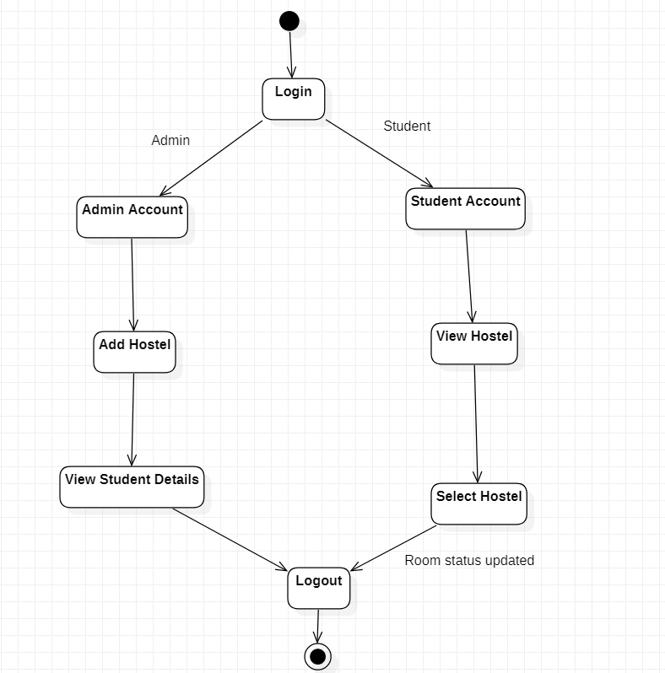States: 1.Admin Account 2.Student Account 3.Add Hostel 4.View Hostel 5.view student details 6.select Hostel
4.3 DATABASE DESIGN

4.3.1 E-R DIAGRAMS

An ER diagram shows the relationship among entity sets. An entity set is a group of similar entities and these entities can have attributes. In terms of DBMS, an entity is a table or attribute of a table in database, so by showing relationship among tables and their attributes, ER diagram shows the complete logical structure of a database. An ER diagram shows the relationship among entity sets. An entity set is a group of similar entities and these entities can have attributes. In terms of DBMS, an entity is a table or attribute of a table in database, so by showing relationship among tables and their attributes, ER diagram shows the complete logical structure of a database.

ER DIAGRAM FOR HOSTEL ROOM ALLOCATION SYSTEM:
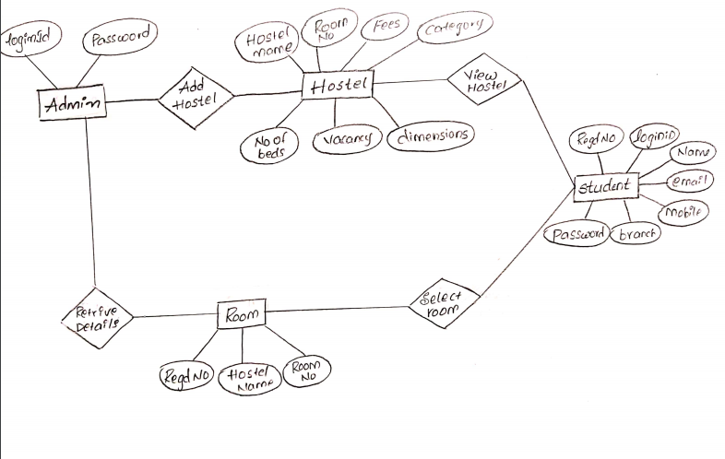

In the above ER diagram:
Entities: Admin, Hostel, Student, Room
Relationship: Add Hostel, View Hostel , Select Room , Retrieve Student Details
Attributes: 1.For Admin the attributes are loginId , password.
2. For Hostel the attributes are Hostel name , Room number,fees, category,
number of beds, vacancy, dimensions.
3.For Student the attributes are RegdNo, loginId, Name, email, mobile , branch
and password.
4.For Room the attributes are loginId, HostelName , Room number.

4.3.2 TABLE STRUCTURES

In our system we had used three tables .they are student table, hostel table, room table. when the student want to register they have to enter their details .Those details are stored in “student” table which consists columns name, registration number, email, branch, login Id, password ,phone number. When the admin wants to add hostels, then admin has to give the hostel details and those details are stored in the “hostel” table. Hostel table consists of columns hostel name, room number, fees, category, dimensions, number of beds ,vacancy. When the student selected the room, student login Id and the room details which was selected by the student should be stored in the “room” table. Room table consists of columns login Id ( of the student) , hostel name, room. These are the three tabes which are used in our system.

ROOM Table STRUCTURE:

LoginId – char(20) | Hostel – char(20) | Room Number –char(20)

STUDENT TABLE STRUCTURE:

Student name -char(10) | Regd no. char(10) | Loginid - char(10) | Branch -char(10) | Email id -char(20) | Phone number -char(10) | Password - char(10)

HOSTEL TABLE STRUCTURE:

Hostel name -char(10) | RoomNo- char(10) | fees- char(10) | dimensions-char(10) | category -char(20) | NoOfBeds - int(10) | vacancy-int(10)

- SYSTEM IMPLEMENTATION

5.1 INTRODUCTION:

Through the proposed system the student can able to book the room online. Firstly the user will register and login into the system using login Id and password. There are two users student and admin. The admin can able to add the hostels and view student details. In adding hostel , admin will enter the values – hostel name, room number , category(Ac-attached, Ac-common, Non-ac attached, Non Ac-common), dimensions of the room, number of rooms in that room , number of vacant rooms in that room. In view students – the admin can view the which students had selected which room. Admin can view student login Id , hostel name and room number which was selected by the student. Student can able to view the hostel details which are added by the admin and able to select room based on the availability. By giving the hostel name, room number, student loginid student can able to book the room. A web application is an application accessible from the web.
A web application is composed of web components like Servlet, JSP, Filter, etc. and other elements such as HTML, CSS, and JavaScript. The web components typically execute in Web Server and respond to the HTTP request. A servlet is a Java programming language class that is used to extend the capabilities of servers that host applications accessed by means of a request-response programming model. Although servlets can respond to any type of request, they are commonly used to extend the applications hosted by web servers. For such applications, Java Servlet technology defines HTTP-specific servlet classes. But to store the details we need database. So we use JDBC .MySQL is the most popular Open Source Relational SQL Database Management System.
MySQL is one of the best RDBMS being used for developing various web-based software applications. For the front end we use html, CSS, JSP.HTML(Hyper Text Markup Language) is the most basic building block of the Web. It defines the meaning and structure of web content. Other technologies besides HTML are generally used to describe a web page’s presentation(CSS) or functionality or behavior (JavaScript)."Hypertext" refers to links that connect web pages to one another, either within a single website or between websites. Links are a fundamental aspect of the Web. By uploading content to the Internet and linking it to pages created by other people, you become an active participant in the World Wide Web.HTML uses "markup" to annotate text, images, and other content for display in a Web browser.JSP Standard Tag Library (JSTL) represents a set of tags to simplify the JSP development. JSTL provides many tags that simplify the JSP.We can use the JSTL tags on various page. It avoids the use of script let tag. We use Eclipse for IDE. Eclipse is an integrated development environment used in computer programming. For the implementation of Servlets we use Apache Tomcat Server. Apache Tomcat (sometimes simply "Tomcat") is an open-source implementation of the Java Servlet, Java Server pages, Java expression language and WebSocket technologies. Tomcat provides a “pure Java” HTTP webserver environment in which Java code can run.

5.2 SYSTEM MODULES:

In our system there are two modules : 1.Student module 2. Admin module. In student module there are two functionalities – view hostel and select hostel. Based on the vacancy of the room the student can book the room online. In Admin module there are two functionalities – add hostel and retrieve student details . In adding hostel, admin will enter the hostel details. In retrieve student details the admin can able to get student loginId and hostel name and room number which is selected by them.

5.3 screens:

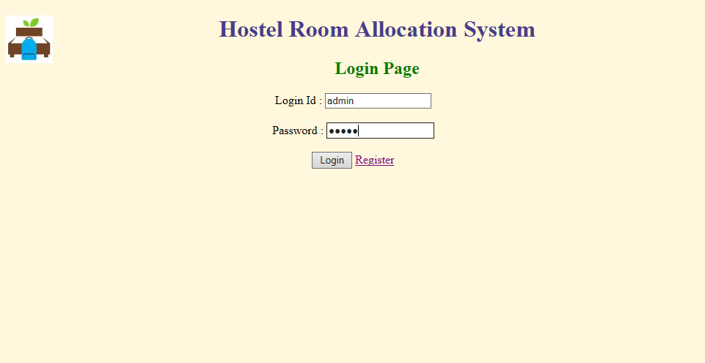

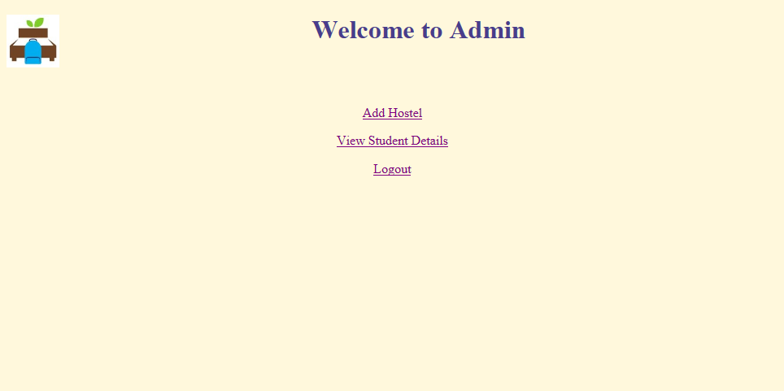

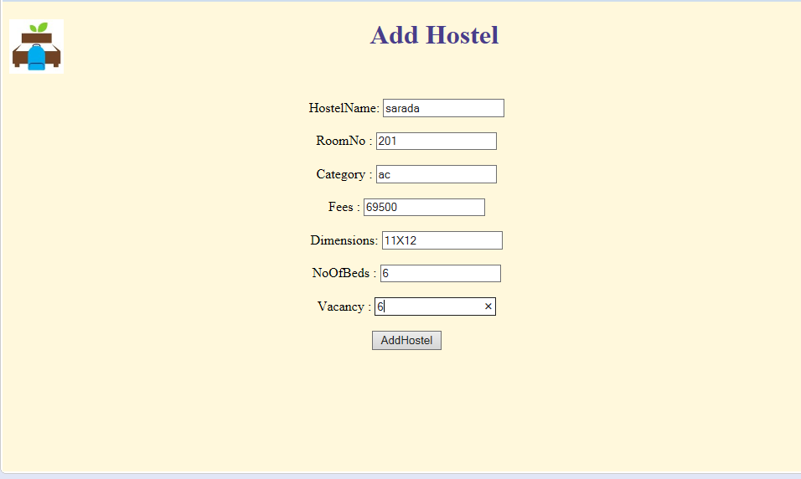

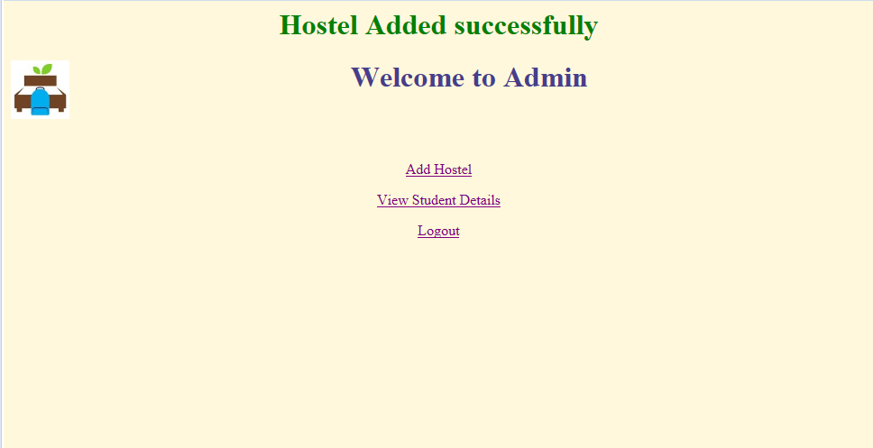

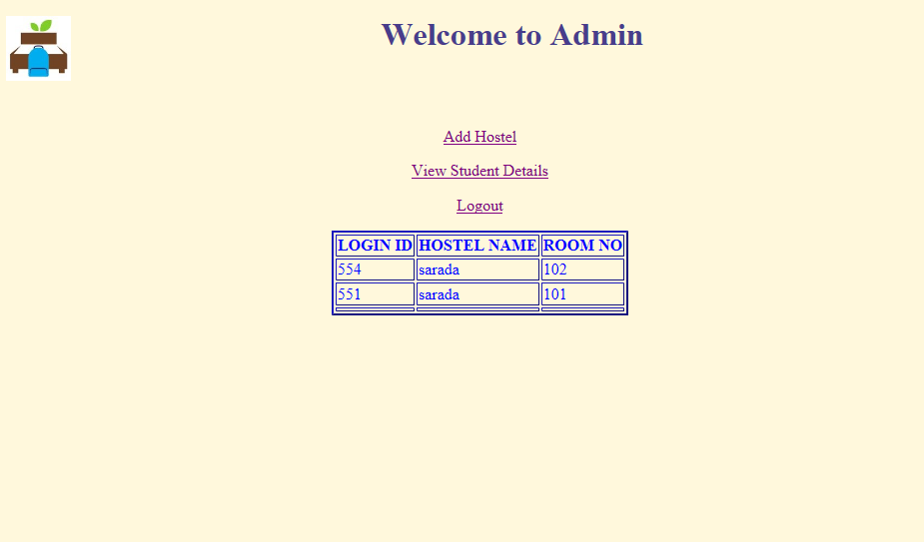

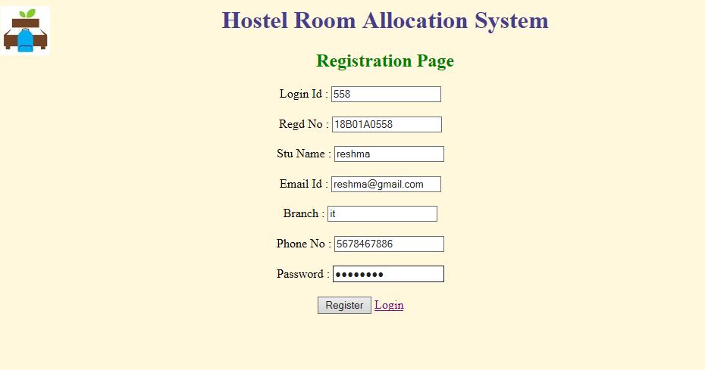

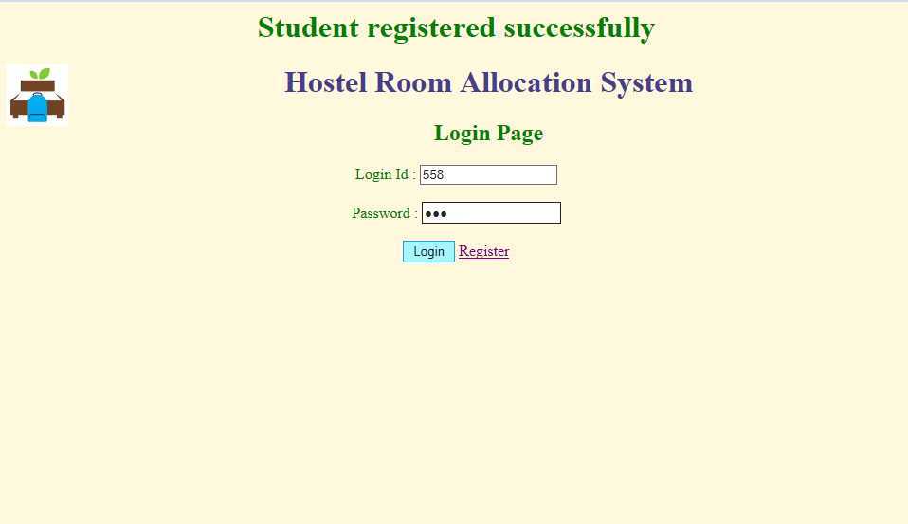

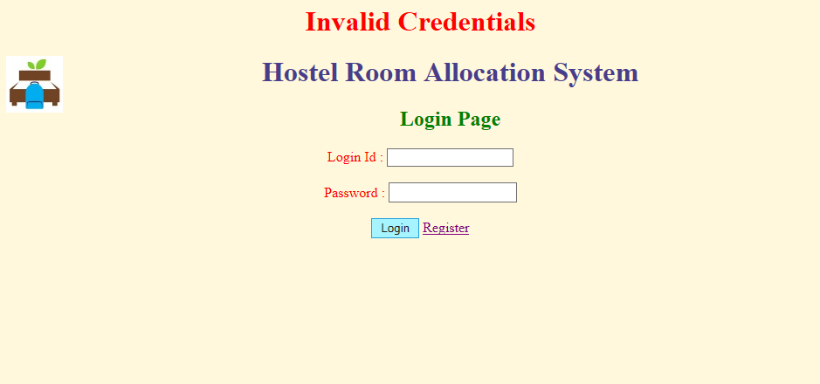

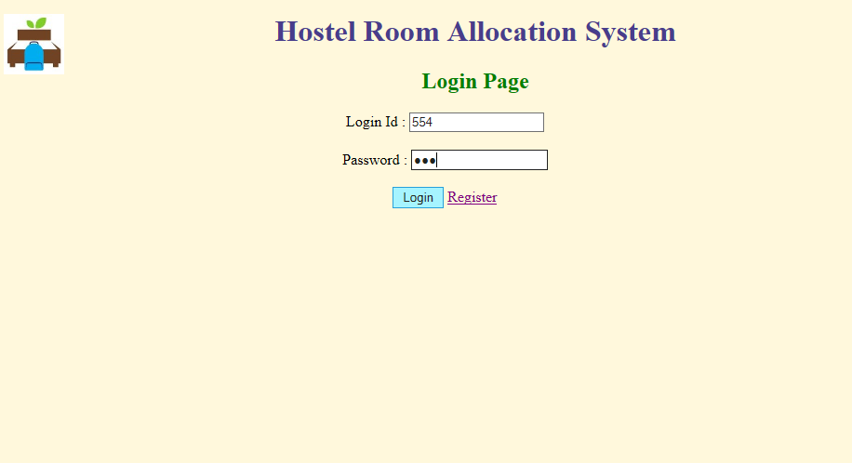

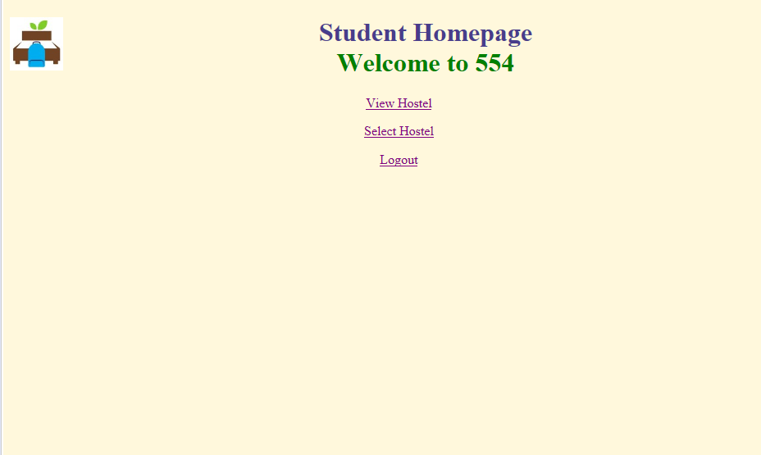

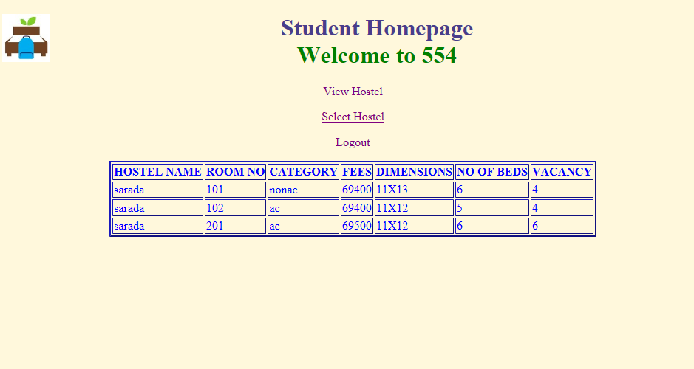

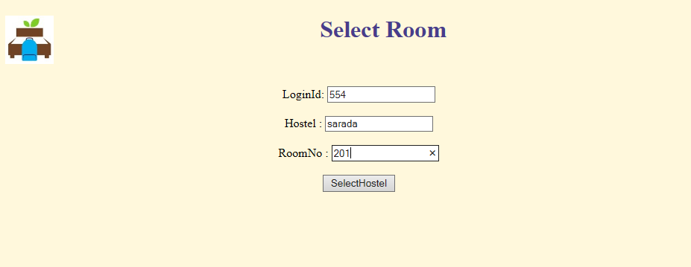

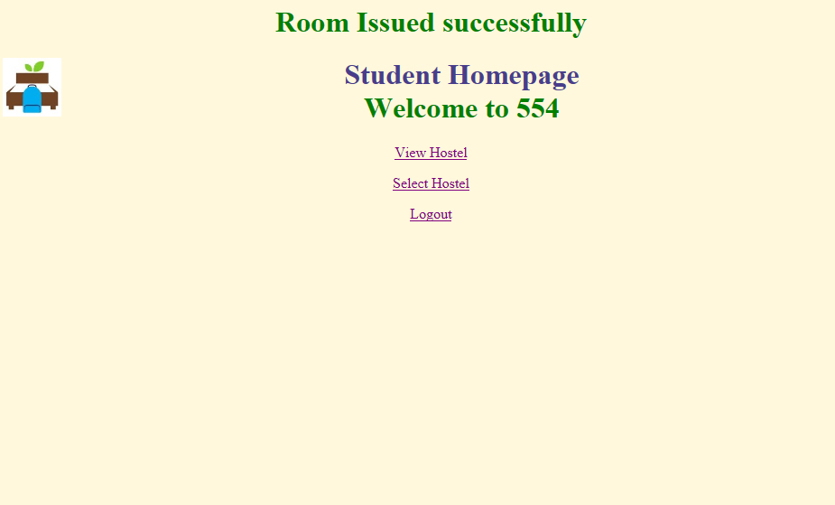

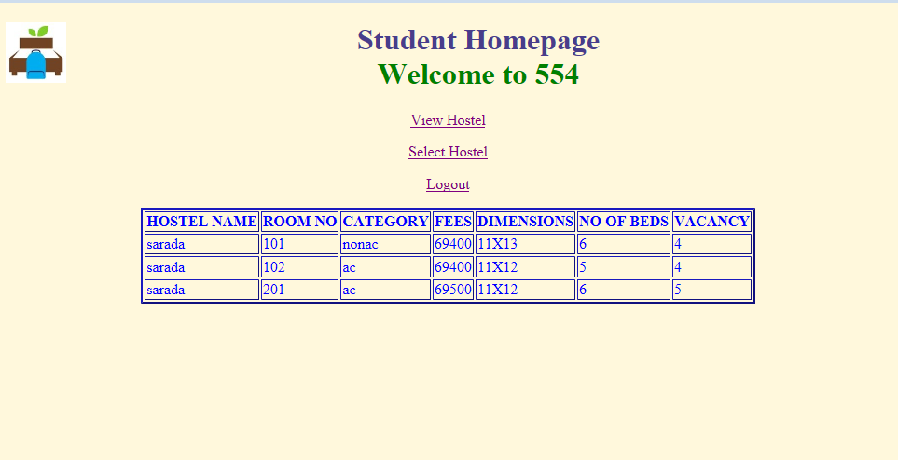

6. SYSTEM TESTING

6.1. INTRODUCTION:
Software Testing is an important element of the software quality assurance and represents the ultimate review of specification, design and coding. The increasing feasibility of software as a system and the cost associated with the software failures are motivated forces for III planned through testing.

TESTING OBJECTIVES
These are several rules that can save as testing objectives:
- Testing is a process of executing program with the intent of finding an error.
- A good testcase is one that has a high probability of finding an undiscovered error.
Test Levels
The purpose of testing is to discover errors. Testing is the process of trying to discover every conceivable fault or darkness in a work product. It provides a way to check the functionality of components, subassemblies, assemblies and/or a finished product. Software system meets its requirements and user expectations and does not fail in an unacceptable manner. There are various types of test. Each test type addresses a specific testing requirement.
6.2. TESTING METHODS
6.2.1 Unit Testing
Unit testing involves the design of test cases that validate that the internal program logic is functioning properly, and that program inputs produce valid outputs. All decision branches and internal code flow should be validated. It is the testing of individual software units of the application.
6.2.2 Integration Testing
Integration tests are designed to test integrated software components to determine if they run as one program. Testing is event driven and is more concerned with the basic outcome of screens or fields.
6.2.3 Functional Testing
Functional tests provide systematic demonstrations that functions tested are available as specified by the business and technical requirements, system documentation, and user manuals. Organization and preparation of functional tests is focused on requirements, key functions, or special test cases.
6.2.4 System Testing
System testing ensures that the entire integrated software system meets requirements. It tests a configuration to ensure known and predictable results. An example of system testing is the configuration oriented system integration test.

6.2.5 White Box Test
White Box Testing is a testing in which in which the software tester has knowledge of the inner workings, structure and language of the software, or at least its purpose. It is purpose. It is used to test areas that cannot be reached from a black box level.

6.2.6 Black Box Test
Black Box Testing is testing the software without any knowledge of the inner workings, structure or language of the module being tested. Black box tests, as most other kinds of tests, must be written from a definitive source document, such as specification or requirements document, such as specification or requirements document.
6.2.7 Unit Testing
Unit testing is usually conducted as part of a combined code and unit test phase of the software lifecycle, although it is not uncommon for coding and unit testing to be conducted as two distinct phases.
6.2.8 Integration Testing
Software integration testing is the incremental integration testing of two or more integrated software components on a single platform to produce failures caused by interface defects.
6.2.9 Acceptance Testing
User Acceptance Testing is a critical phase of any project and requires significant participation by the end user.
6.3 TEST CASES:
- The one who had registered earlier can only be able to login into the system otherwise it shows invalid credentials.
- Admin can view the students who had selected the successfully.
- When the admin can able to add the hostel successfully.
- Students can view the hostel which are added by the admin.
7. CONCLUSION

Finally through our system, the student can able to book their room online based on their wish that means whether the hostel may be of any category the student can select her room which saves a lot of time. By using this “Hostel room allocation system” a lot of time will be saved and also reduces the paper work. For warden it will be easy to retrieve the student details and their selected room.

8. BIBLIOGRAPHY

We had used the text book for reference :

1. Marty Hall and Larry Brown, “Core Servlets And Java server Pages”, 2 nd edition,
Prentice Hall, 2003 .

We had used the website for reference :

https://www.codejava.net/coding/how-to-code-login-and-logout-with-java-servlet-jsp-and- smysql

9.APPENDIX

INTRODUCTION TO JAVA
Java is a high-level programming language originally developed by Sun Microsystems and released in 1995. Java runs on a variety of platforms, such as Windows, Mac OS, and the various versions of UNIX. This tutorial gives a complete understanding of Java. This reference will take you through simple and practical approaches while learning Java Programming language.

Why to Learn java Programming?
Java is a MUST for students and working professionals to become a great Software Engineer specially when they are working in Software Development Domain. I will list down some of the key advantages of learning Java Programming:
- Object Oriented − In Java, everything is an Object. Java can be easily extended since it is based on the Object model.
- Platform Independent − Unlike many other programming languages including C and C++, when Java is compiled, it is not compiled into platform specific machine, rather into platform independent byte code. This byte code is distributed over the web and interpreted by the Virtual Machine (JVM) on whichever platform it is being run on.
- Simple − Java is designed to be easy to learn. If you understand the basic concept of OOP Java, it would be easy to master.
- Secure − With Java's secure feature it enables to develop virus-free, tamper-free systems. Authentication techniques are based on public-key encryption.
- Architecture-neutral − Java compiler generates an architecture-neutral object file format, which makes the compiled code executable on many processors, with the presence of Java runtime system.
- Portable − Being architecture-neutral and having no implementation dependent aspects of the specification makes Java portable. Compiler in Java is written in ANSI C with a clean portability boundary, which is a POSIX subset.
- Robust − Java makes an effort to eliminate error prone situations by emphasizing mainly on compile time error checking and runtime checking.

Applications of Java Programming
The latest release of the Java Standard Edition is Java SE 8. With the advancement of Java and its widespread popularity, multiple configurations were built to suit various types of platforms. For example: J2EE for Enterprise Applications, J2ME for Mobile Applications.
The new J2 versions were renamed as Java SE, Java EE, and Java ME respectively. Java is guaranteed to be Write Once, Run Anywhere.
- Multithreaded − With Java's multithreaded feature it is possible to write programs that can perform many tasks simultaneously. This design feature allows the developers to construct interactive applications that can run smoothly.
- Interpreted − Java byte code is translated on the fly to native machine instructions and is not stored anywhere. The development process is more rapid and analytical since the linking is an incremental and light-weight process.
- High Performance − With the use of Just-In-Time compilers, Java enables high performance.
- Distributed − Java is designed for the distributed environment of the internet.
- Dynamic − Java is considered to be more dynamic than C or C++ since it is designed to adapt to an evolving environment. Java programs can carry extensive amount of run-time information that can be used to verify and resolve accesses to objects on run-time.

