

A Project Report On

**ATM Interface**

**By**

**Batch:** 2022 – 7905

**Center: Trichy Thillai Nagar**

Under the Guidance of,

**Chittaranjan Ghosh.**

**Technical Trainer**

**EduBridge**

(ATM INTERFACE)

## Introduction:

This ATM Interface enables the clients of a bank to have access to their accounts without going to the bank. This is achieved only by developing the application using online concepts.

When the product is implemented, the user who uses this product will be able to see all the information and services provided by the ATM, when he enters the necessary option and arguments. The product also provides services like requests for cheques, deposit cash, and another advanced requirement of the user. The data is stored in the database and is retrieved whenever necessary. The implementation needs ATM machine hardware to operate, or similar simulated conditions can also be used to successfully use the developed product.

**Modules:**

* Login
* Check Balance
* Deposit
* Withdraw
* Change PIN
* Account Information
* Logout

I have developed this Application in **Java 8 and MySQL.**

* **Function(Login):** When user click the button “USERS” it will show the new GUI for entering their registered username and password. They need to enter the correct username and password.
* **Function(Withdraw)**: The **ATM Interface** is the project which is used to access their Username to make cash withdrawals. Whenever the user needs to make cash withdraws, they can enter their PIN number (personal identification number) and it will display the amount to be withdrawn. Once their withdrawal was successful, the amount will be debited from their account.
* **Function(Deposit):** To deposit into the account click on the button “DEPOSIT”. It will show a deposit GUI on the screen. They need to enter the amount to deposit into their account.
* **Function(Balance Check):** When a user executes this program it will show the details (username, password and current balance) from the text file in the console. They will also see the startup GUI (Graphical User Interface) of this program.
* **Function(Change PIN):** Users can also change their password (pin). For that they need to click the button “CHANGE PIN”. It will show the screen for changing the pin where users need to enter their current username and password for verification. Then click the button “CHANGE”.
* **Function(Account Information):** It means any information relating to the Account including without limitation the account number, account balance or value, gross receipts, withdrawals and payments from the account.

**Software Requirements:**

* **Back end:** JAVA 8, MySQL workbench.
* **IDE:** Eclipse – Workspace
* **Operating System:** Window

# Data Dictionary:

Create Database **atminterfaceDB**:

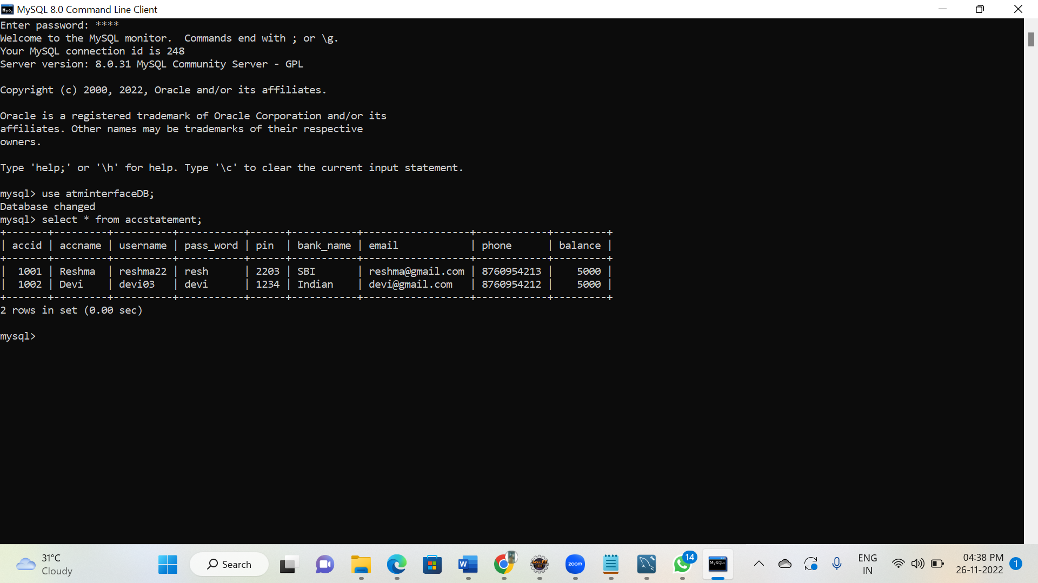

# Screenshots:

## Login:

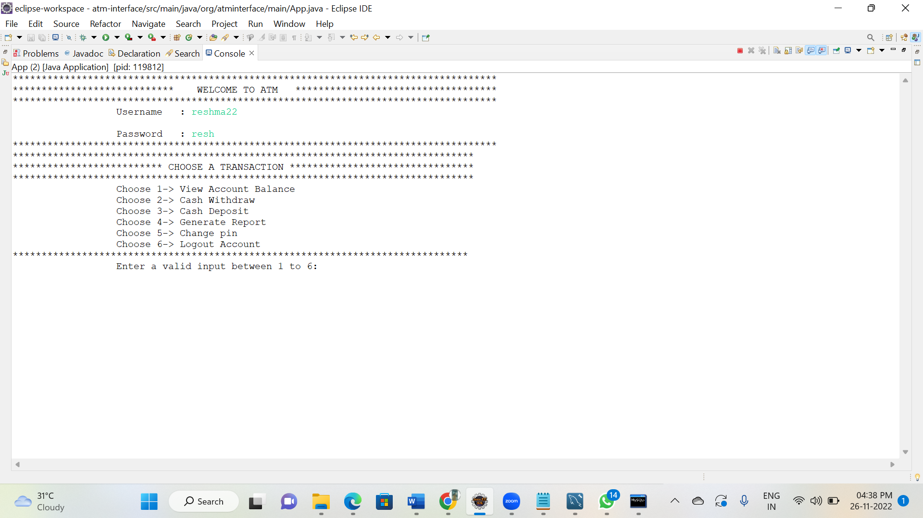

**Withdraw**:

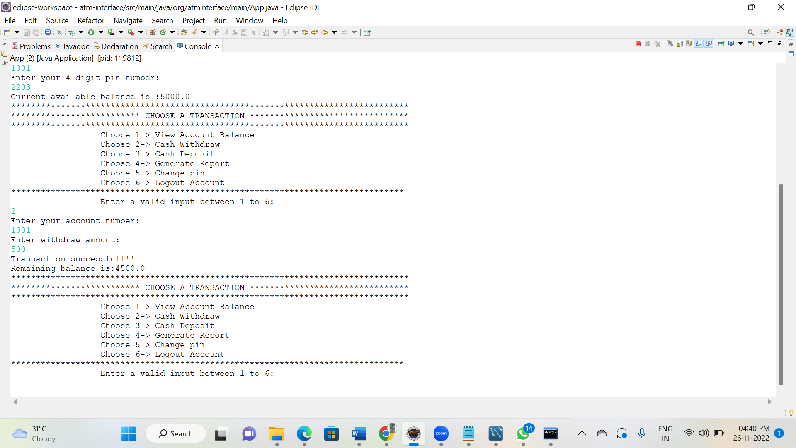

**Deposit:**

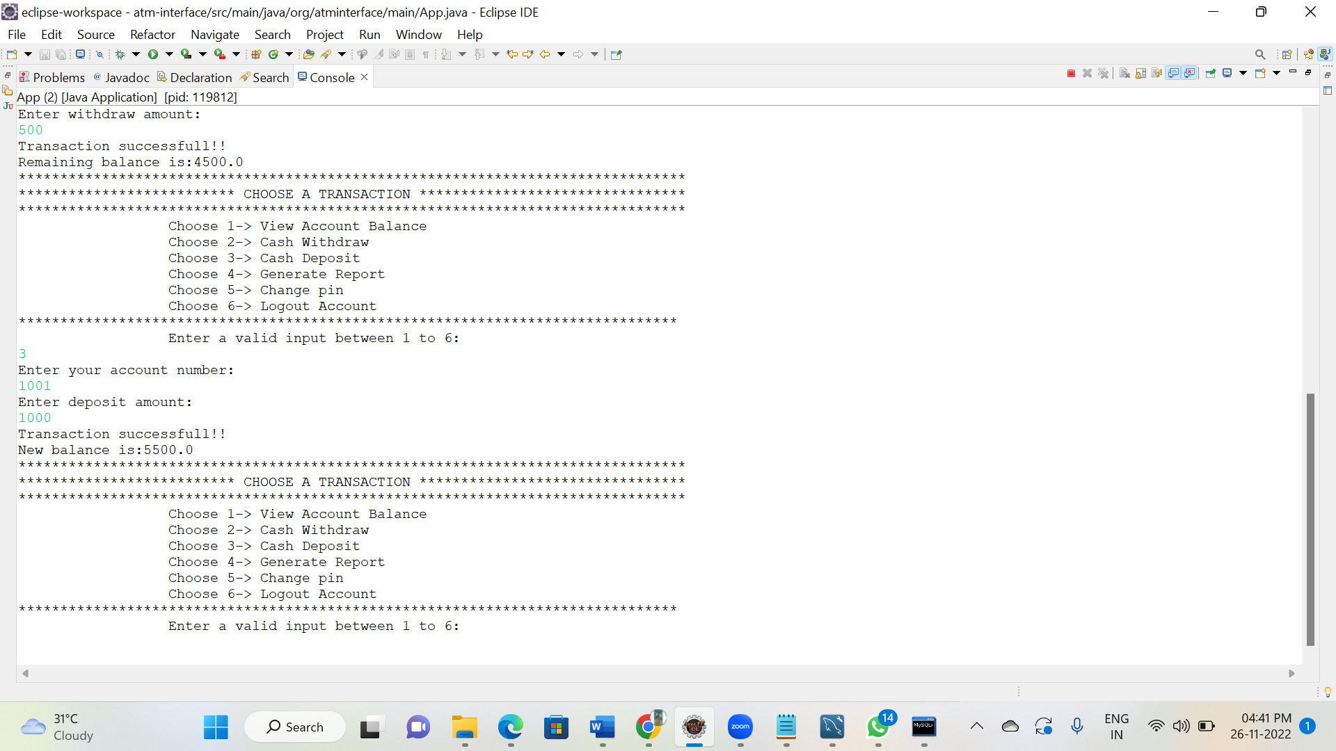

**Check Balance:**

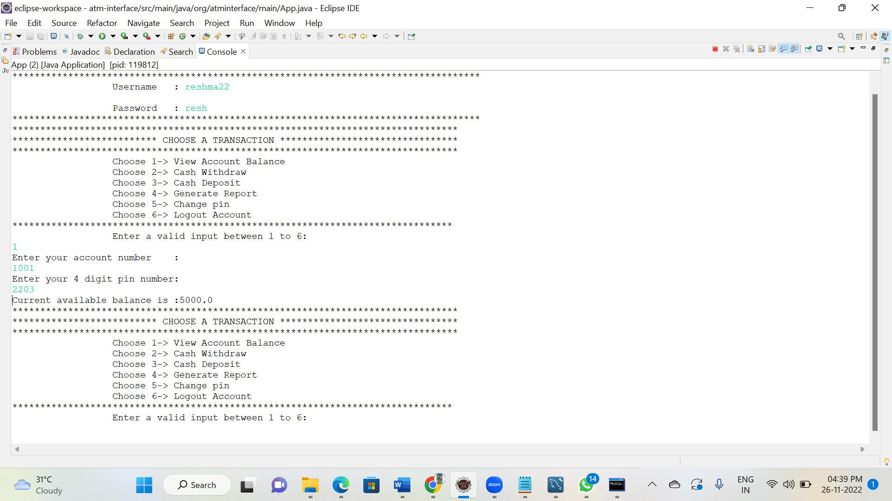

**Account Information:**

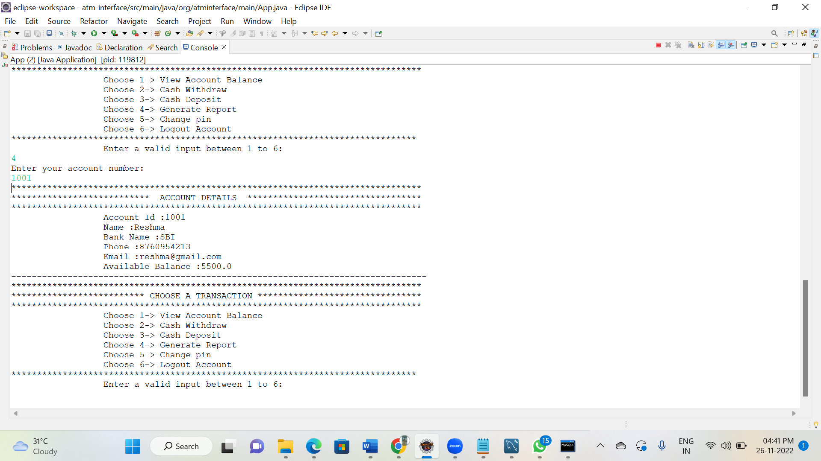

**Change PIN:**

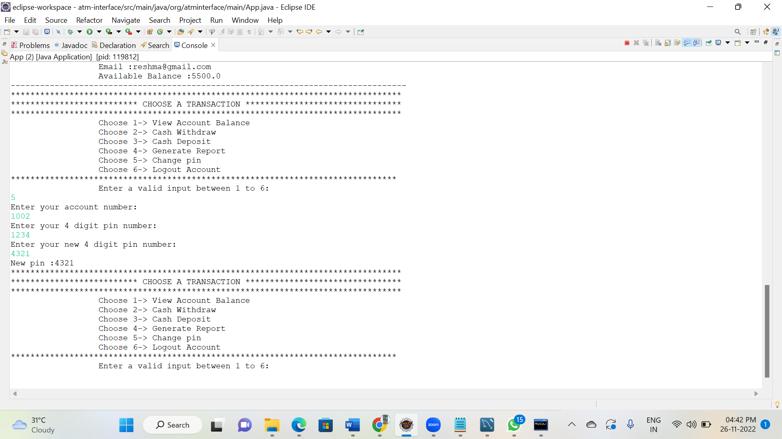

**Logout:**

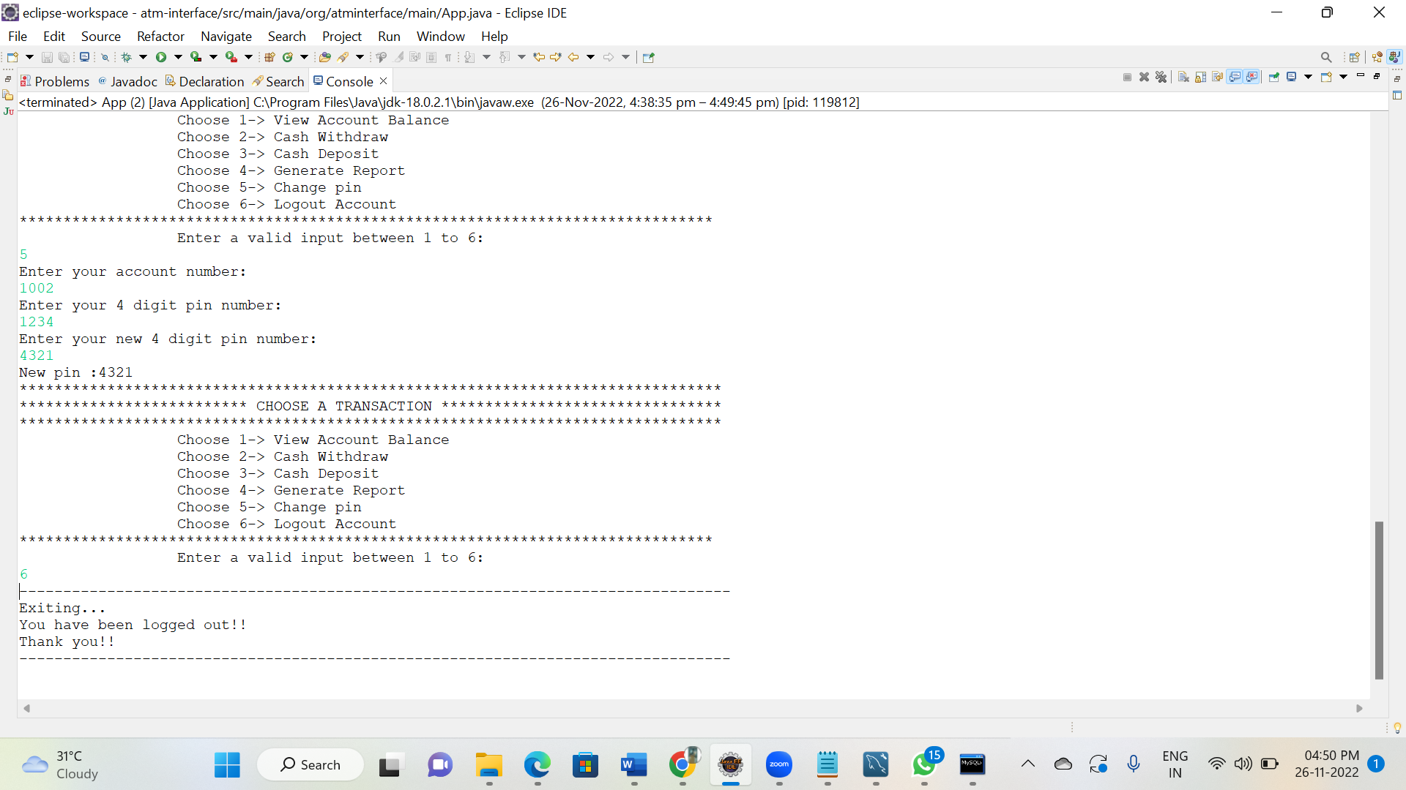

**Thank you…**