RECRUITING ASSISTANT FOR HR MANAGERS

**INTRODUCTION**

# Overview

In this project, we use custom objects, relationships, page layouts to give the HR team easy access to data they need on an existing recruitment app. To make the existing app more efficient for the HR team we create custom objects and relationships to store and access the data more efficiently. We install an unmanagedpackagein the org to get metadata that acts as existing datain the recruitment app

* 1. **Purpose**

The recruitment function of HR includes analyzing the requirements of an available job,attracting suitable candidates to the position ,carefully screening and slecting all applicants,hiring and seamlessly integrating new employees and roles into the organization

Problem Definition & Design Thinking

* 1. **Empathy Map**

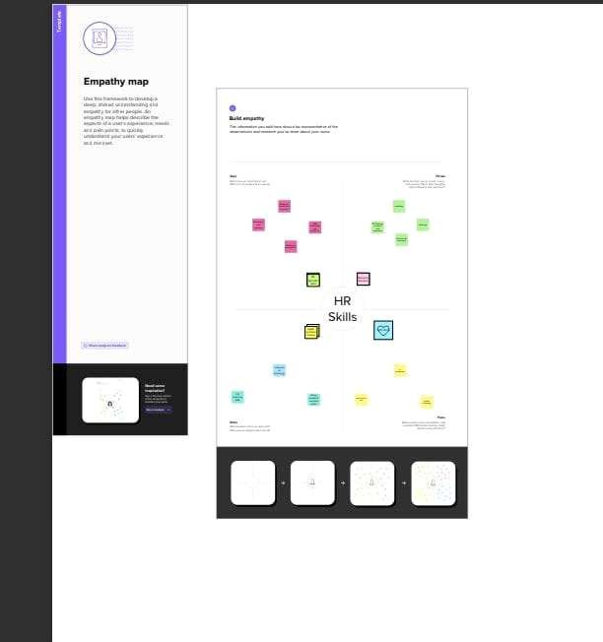

* 1. Ideation & Brainstorming Map

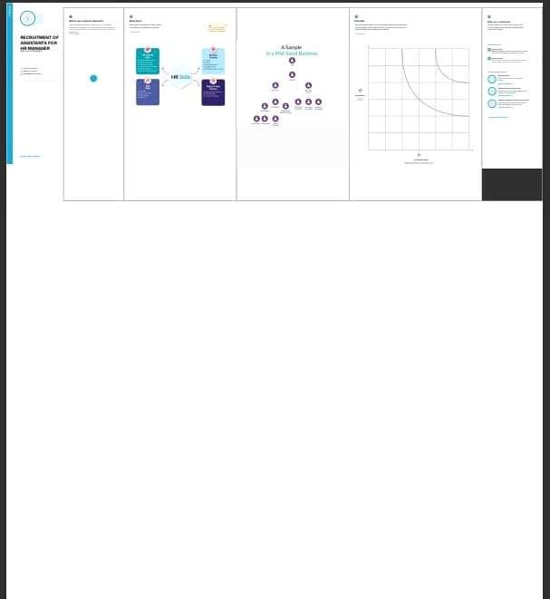

RESULT

# 3.1 Data Model:

Fields in the Object

Object Name

Data type: Master details relationship

Lable: Position

Data type: Master details relationship

lable:job posting site

**Job posting**

3.1 Activity & Screenshot

# Activity-1:

Creating Developer Account Creating a developer org in salesforce.

1. Go to developers.salesforce.com/
2. Click on sign up.
3. On the sign-up form, enter the following details: • First name & Last name • Email • Role: Developer • Company: College Name • County: India • Postal Code: pin code • Username: should be a combination of your name and company This need not be an actual email id, you can give anything in the format: [username@organization.com](mailto:username@organization.com)

Click on sign up after filling these.

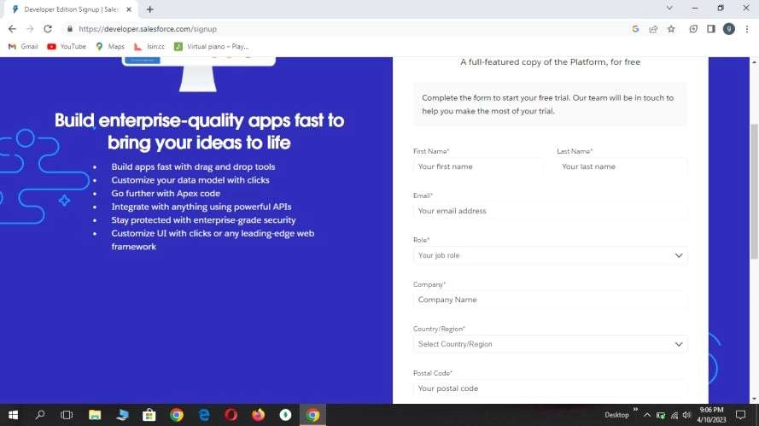

Activity-2:

## Package installation

click to launch the App Launcher, then click PlaygroundStarterand follow the steps

1. Click the install a package tab. 2. Paste 04t0P000000N9rs into the field. 3. Click install. 4. Select install for admins only,

Milestone 3: Object What is an object?

Salesforce objects are database tables that permit you to store data that is specific to an

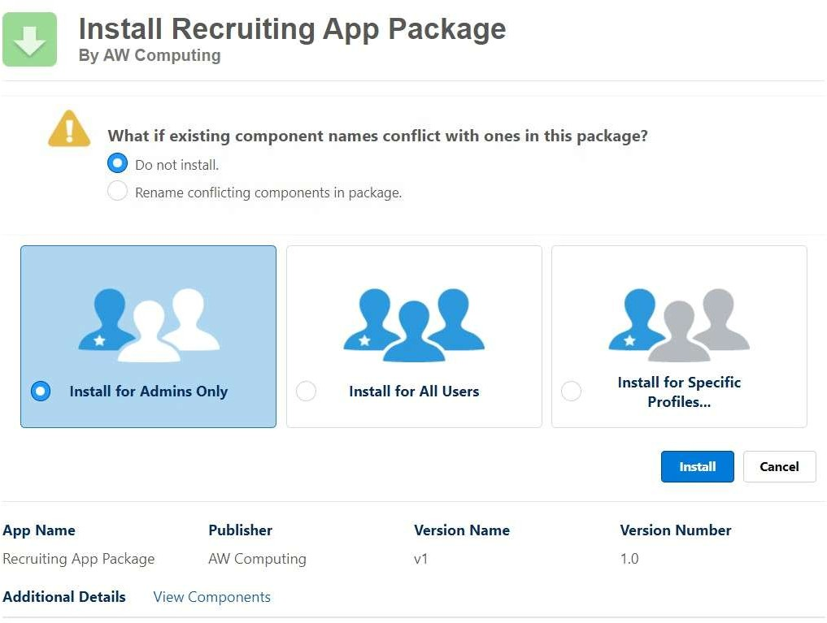

Activity-3:

# Object

Part-1

To create a custom object, follow these steps : 1. From setup click on object manager.

1. Click create, select custom object.
2. Fill in the label as "Job Posting Site".
3. Fill in the plural label as "Job Posting Sites".
4. Record name : "Site Name"

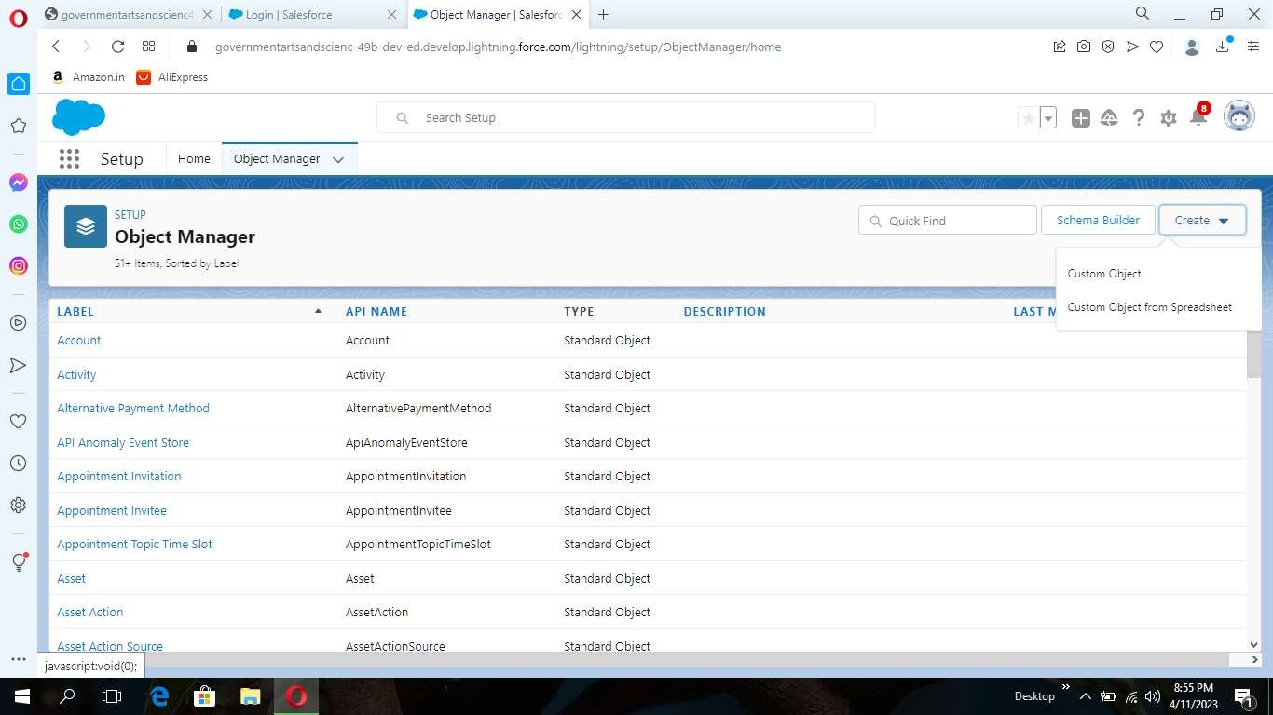

1. Select the data type as "Text".
2. In the Optional Features section, select Allow Reports and Track Field History.
3. In the Deployment Status section,ensure Deployed is selected.
4. In the Search Status section, select Allow Search.
5. In the Object Creation Options section, select select these options: Add Notes and Attachments related list to default page layout Launch New Custom Tab Wizard after saving this custom object
6. Leave everything else as is, and click Save.

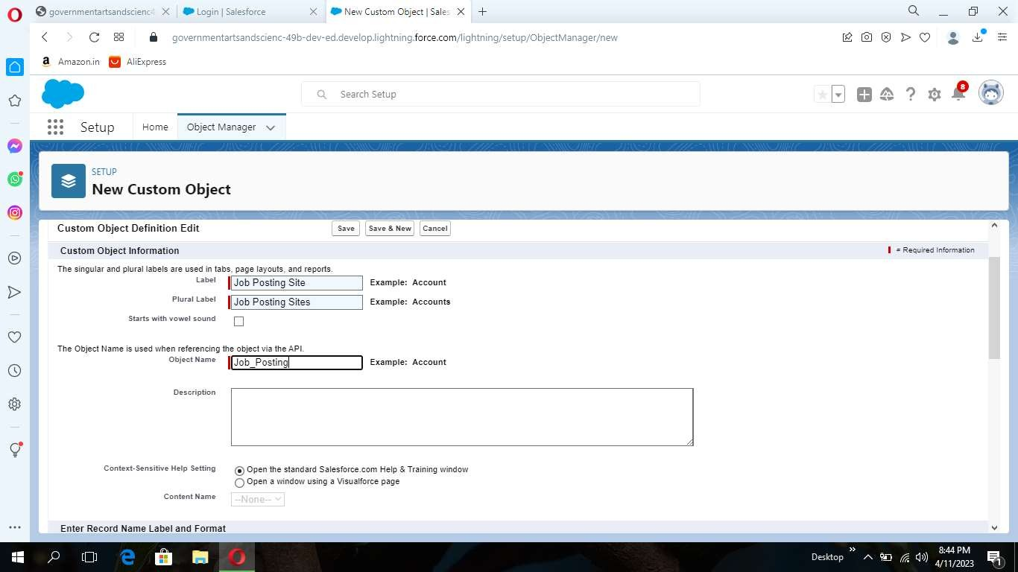

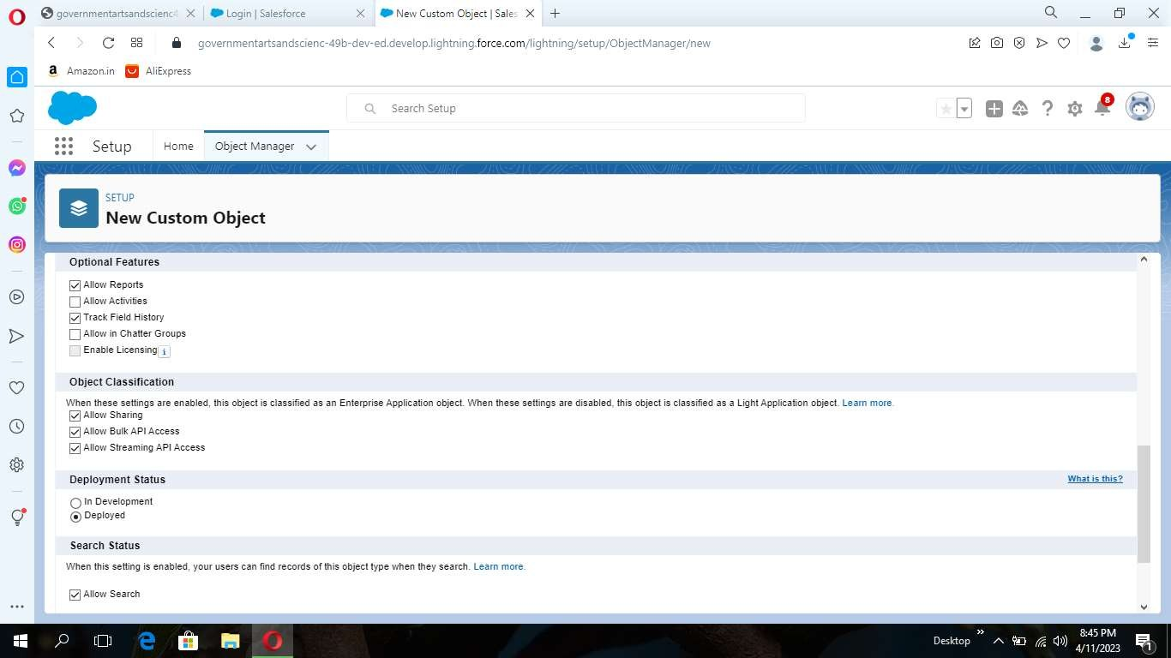

### Part-2

Create a custom object for reviews To create a custom object, follow these steps :

1. From setup click on object manager.
2. Click create, select custom object.
3. Fill in the label as "Review".
4. Fill in the plural label as "Reviews".
5. Record name : "Review Number"
6. Select the data type as "Auto Number".
7. Under display format enter "REV-{0000}".
8. Enter the starting number as 1.
9. In the Optional Features section, select Allow Reports and Track Field History.
10. In the Deployment Status section, ensure Deployed is selected.
11. In the Search Status section, select Allow Search.
12. In the Object Creation Optionssection,selectAddNotesandAttachmentsrelatedlistto default page layout.
13. Leave everything else as is, and click Save

Activity-4:

# Tab

1. To Select the Tab Style: Click the magnifying glass and select Real Estate
2. Click Next.
3. Leave the profile as is and click Next.
4. In the Add to Custom Apps section:
5. Deselect Include Tab.
6. Select Append tab to users’ existing personal customizations.
7. Click Save.

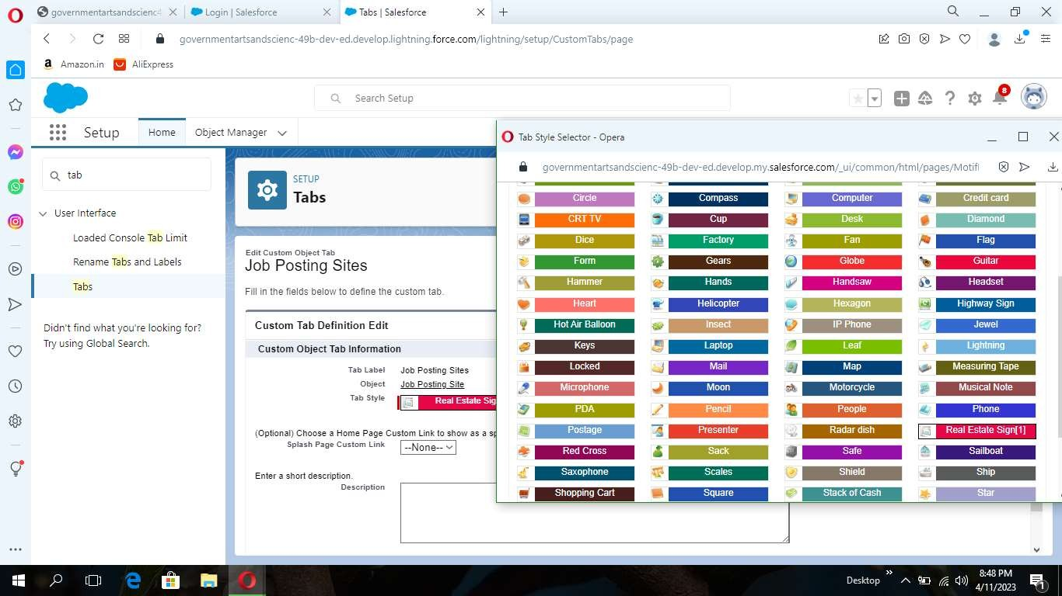

Activity-5:

### Fields

1. Click on new.
2. Select the data type as URL.
3. Click Next.
4. For Field Label, enter the Job Posting Site URL.
5. Click Next, Next, and click Save & New.

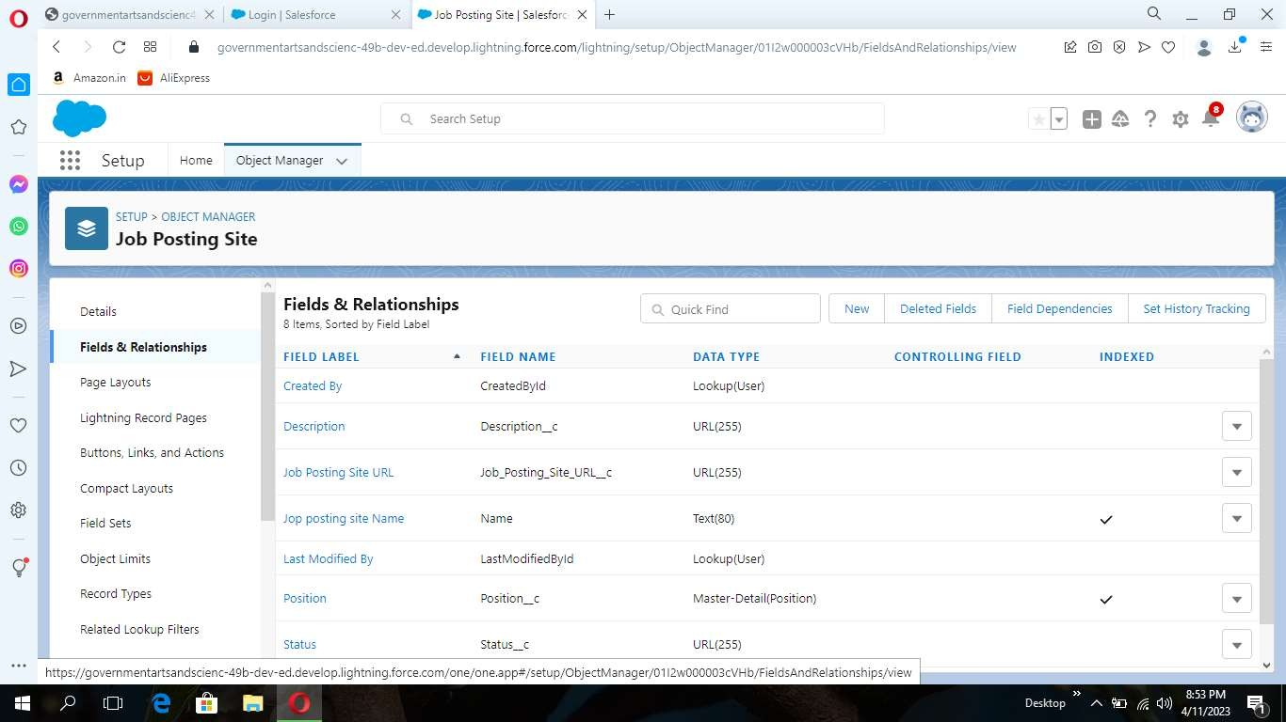

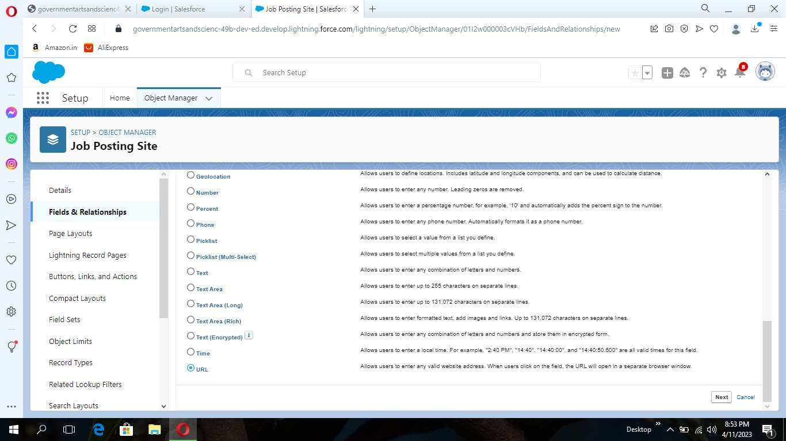

Create a Fields for Job Posting site

1. Status
2. Technical site
3. Description

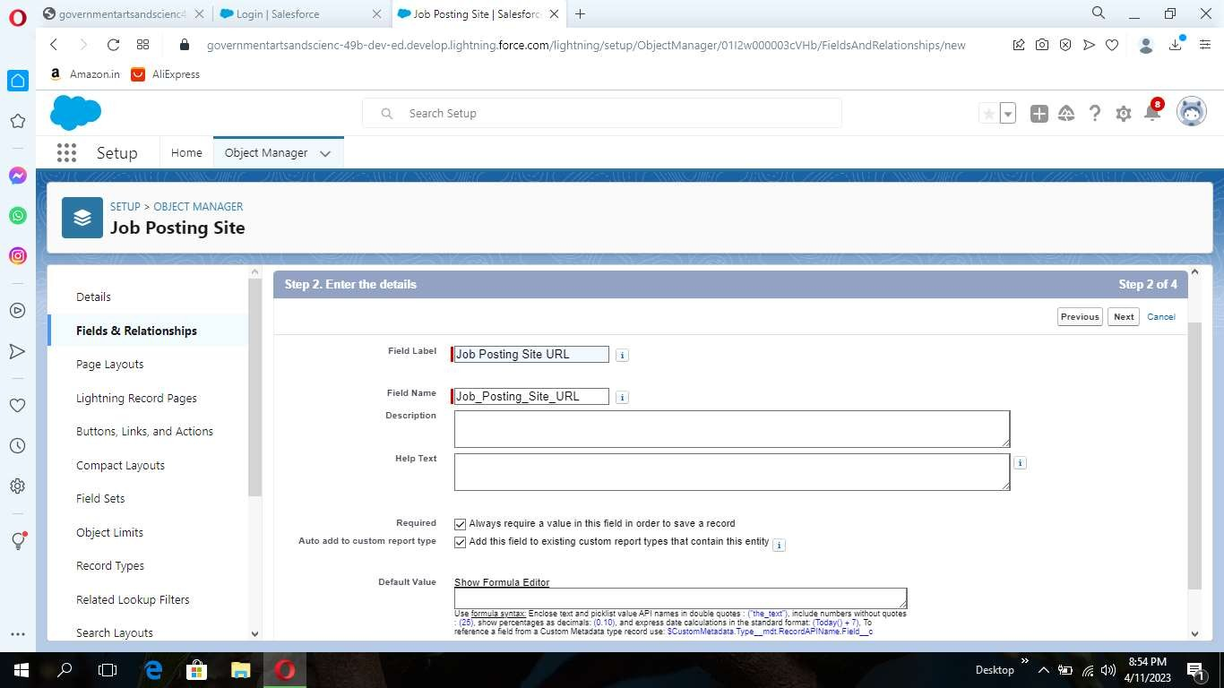

Activity-6:

### Junction Object

Part-1

1. From setup, click object Manager.
2. Click create, select custom object.
3. Enter the label as "Job posting".
4. Enter the plural label as "Job postings".
5. Enter the record name as "Job posting number".
6. select the data type as "Auto Number".
7. Enter the display format as "JOBPOST-{0000}"
8. Enter the Starting number as 1.



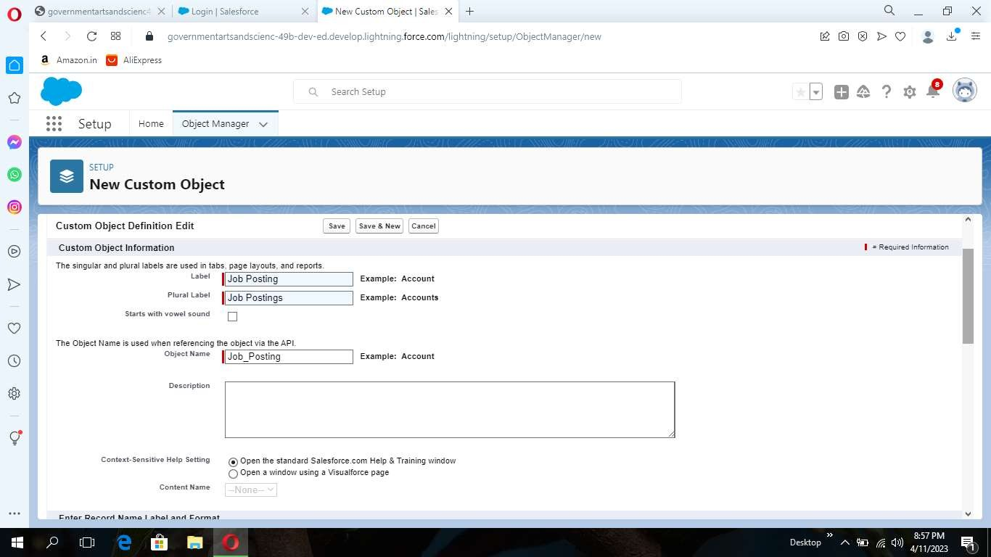

1. Leave everything else as is, and click save.

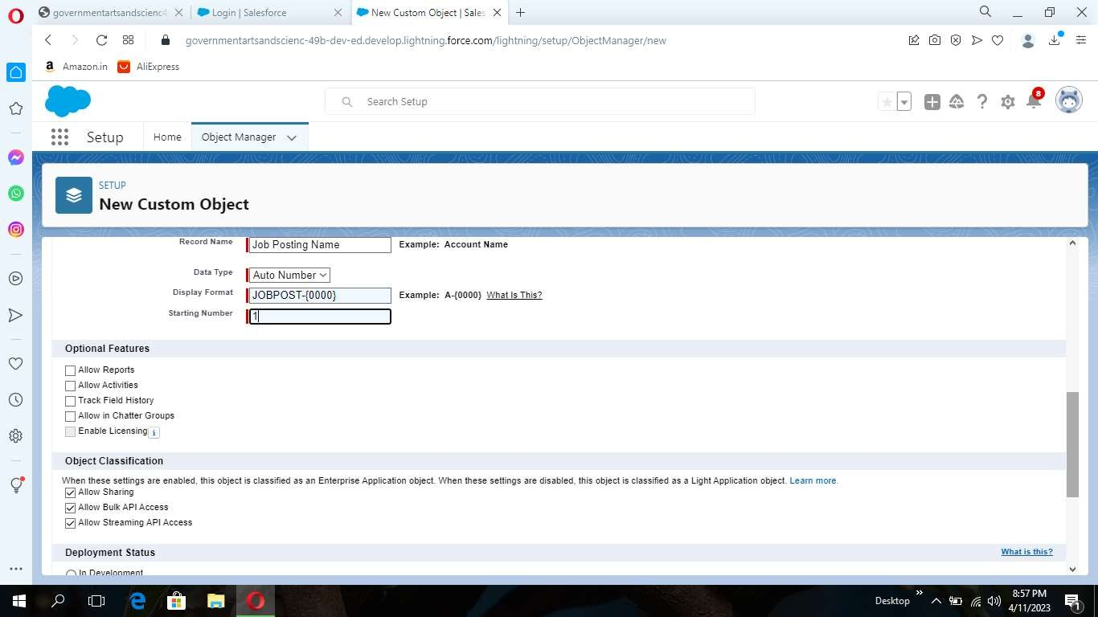

Part-2

Create a Relationships Object

Creating a master-detail relationship between Job posting and job posting site.

1. From setup, click object manager.
2. Select Job posting object, click on field and relationships, click new.
3. Select the data type as Master-detail relationship.
4. Click Next, relate to the Job posting site.
5. Enter the label Job Posting site.
6. Click next, next, next and save.

Creating a master-detail relationship between job posting and position.

1. From setup, click object manager.
2. Select Job posting object, click on field and relationships, click new.
3. Select the data type as Master-detail relationship.
4. Click Next, relate to position.
5. Enter the label Position.
6. Click next, next, next and save.

Activity-7:

### Page Layout

Part-1

Modifying the page layouts :

1. From setup, click on object manager.
2. Click position, then page layouts.

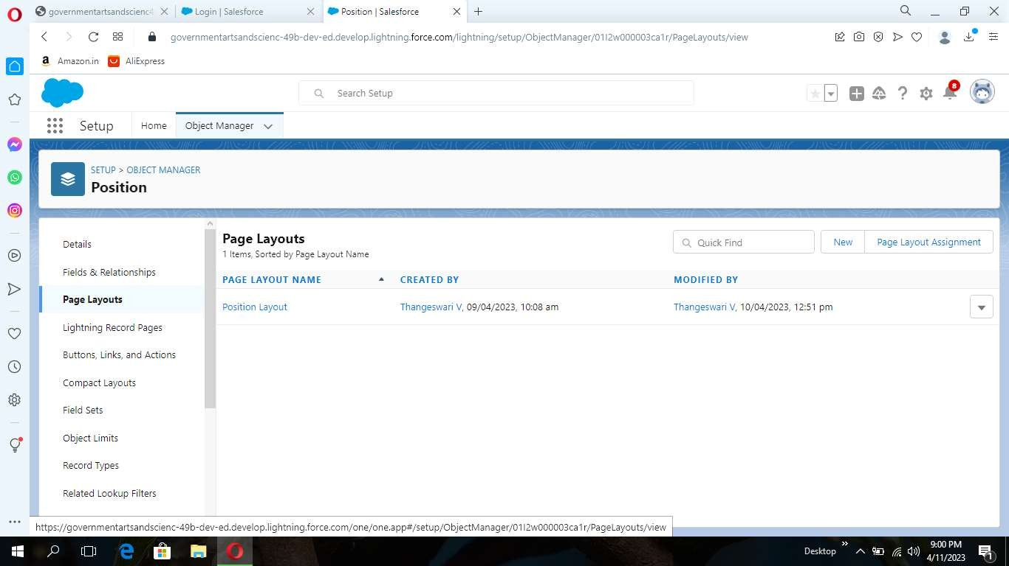

1. Click down array next to the position layout and select edit.
2. Scroll down to the job posting related list, and click the wrench icon in the header to edit it.
3. From the available fields section, select Job posting site : Status Job posting site : Technical Site
4. Click add.
5. From the selected fields section, select job posting : Job posting number and click remove.
6. Click ok, then save.

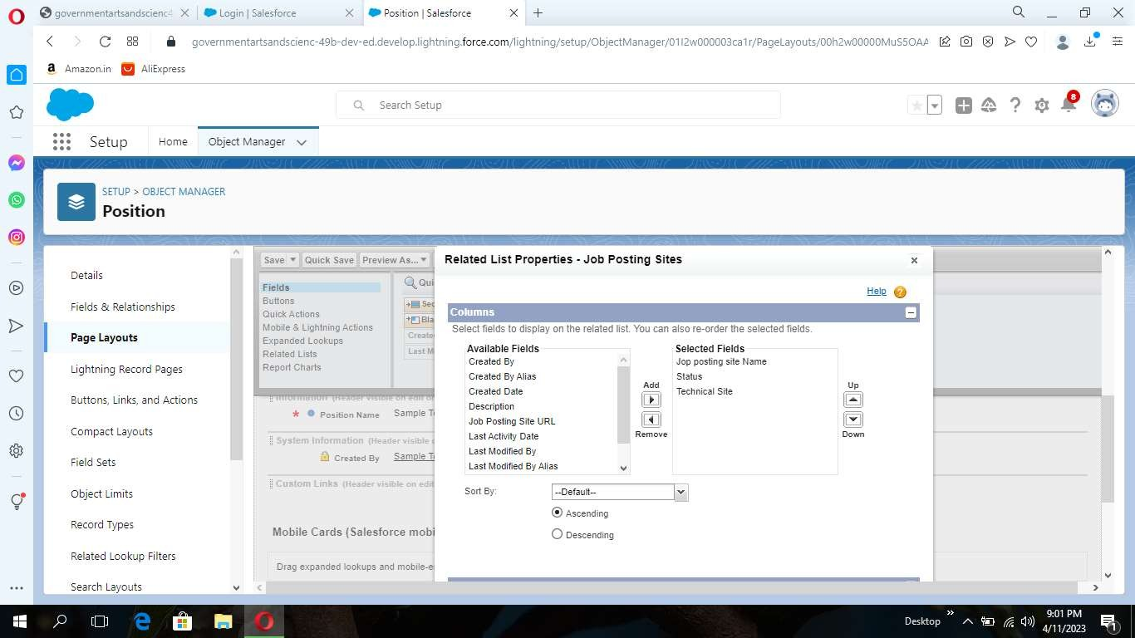

Part-2

Create a Page layout for Review Object

Activity-8:

### Validation Rules

Part-1

To create a validation rule:

Go to object manager, select the object on which validation rule has to beimplemented,scroll down and click validation rule, New.

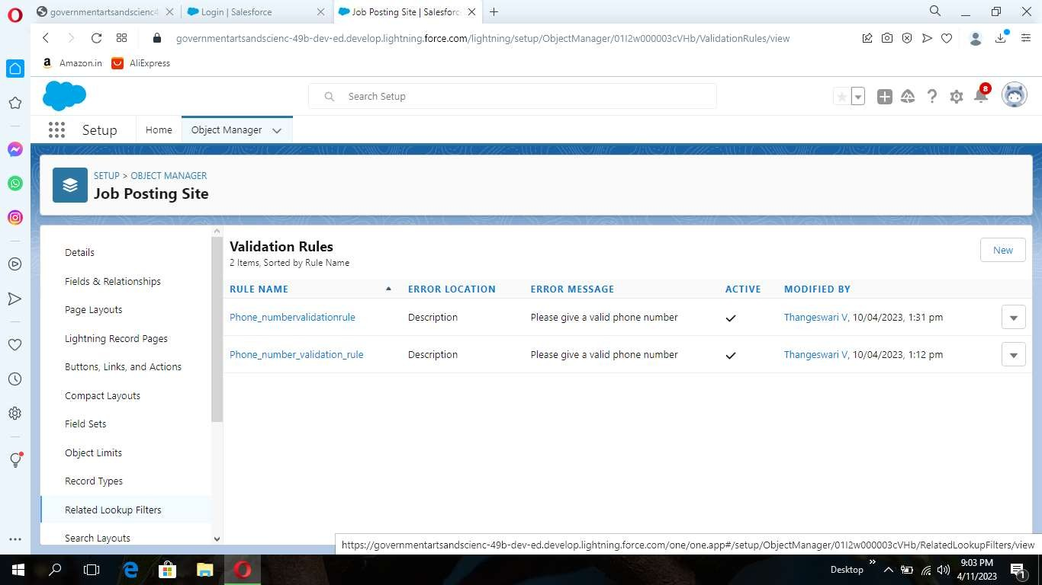

Give details as:

1. Rule name: Phone number validation rule.
2. Active: checked
3. Description: phone number should not be more than or less than 10 digits.
4. Under Error Condition Formula: write the condition using insert field, insert operator, insert function
5. Using check syntax: check if the formula you entered is valid or not.

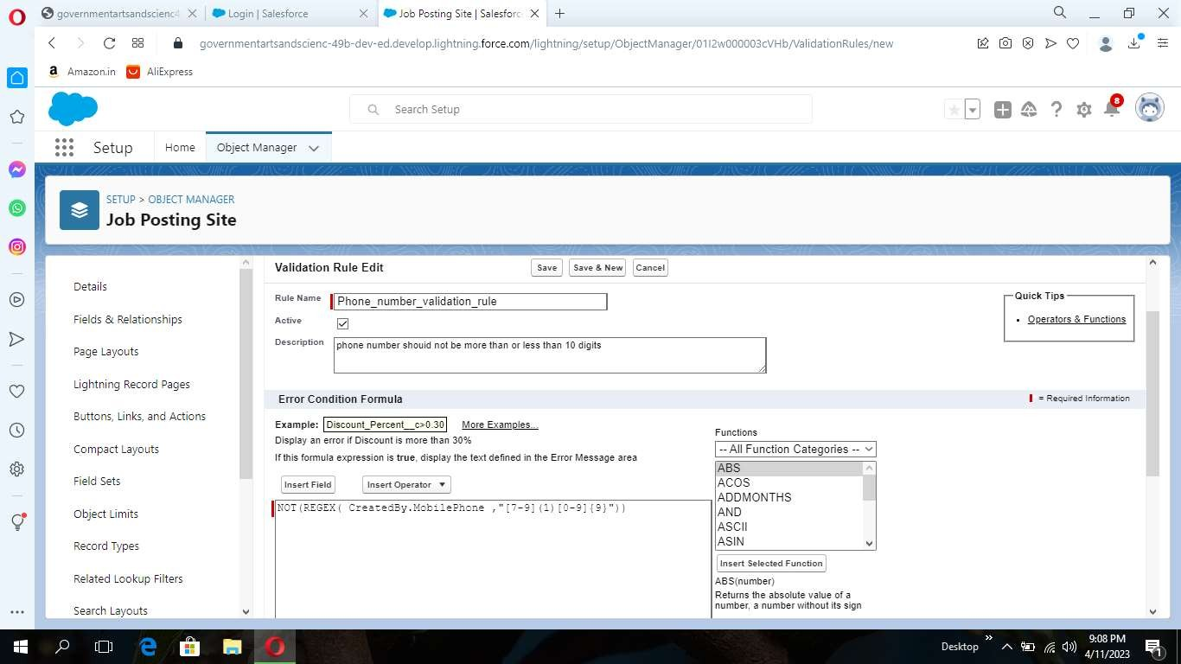

1. Error Message: Please give a valid phone number
2. Error location: select field
3. Save

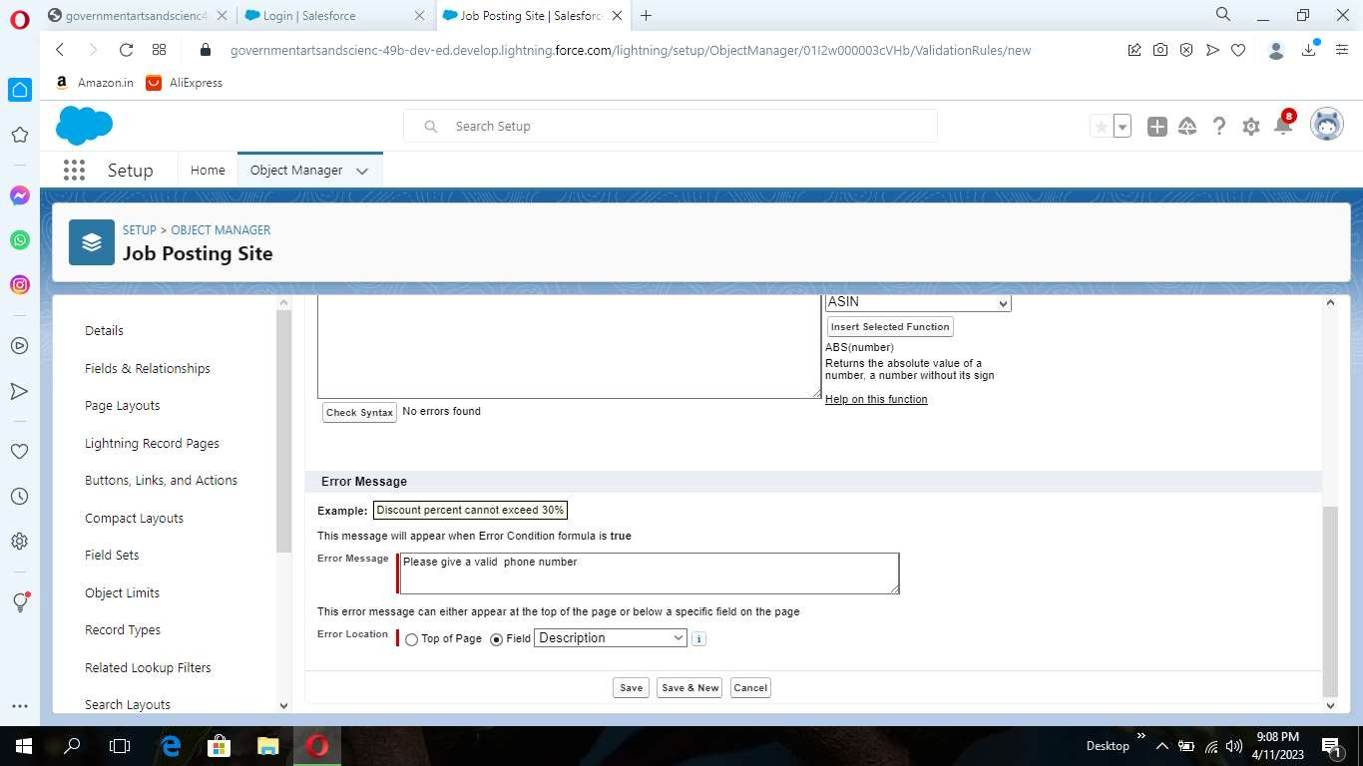

Part-2

Create a Validation rule For Technical Site Checkbox is equal to True

Activity-9:

### Profile

Part-1

From Setup enter Profiles in the Quick Find box, and select Profiles.

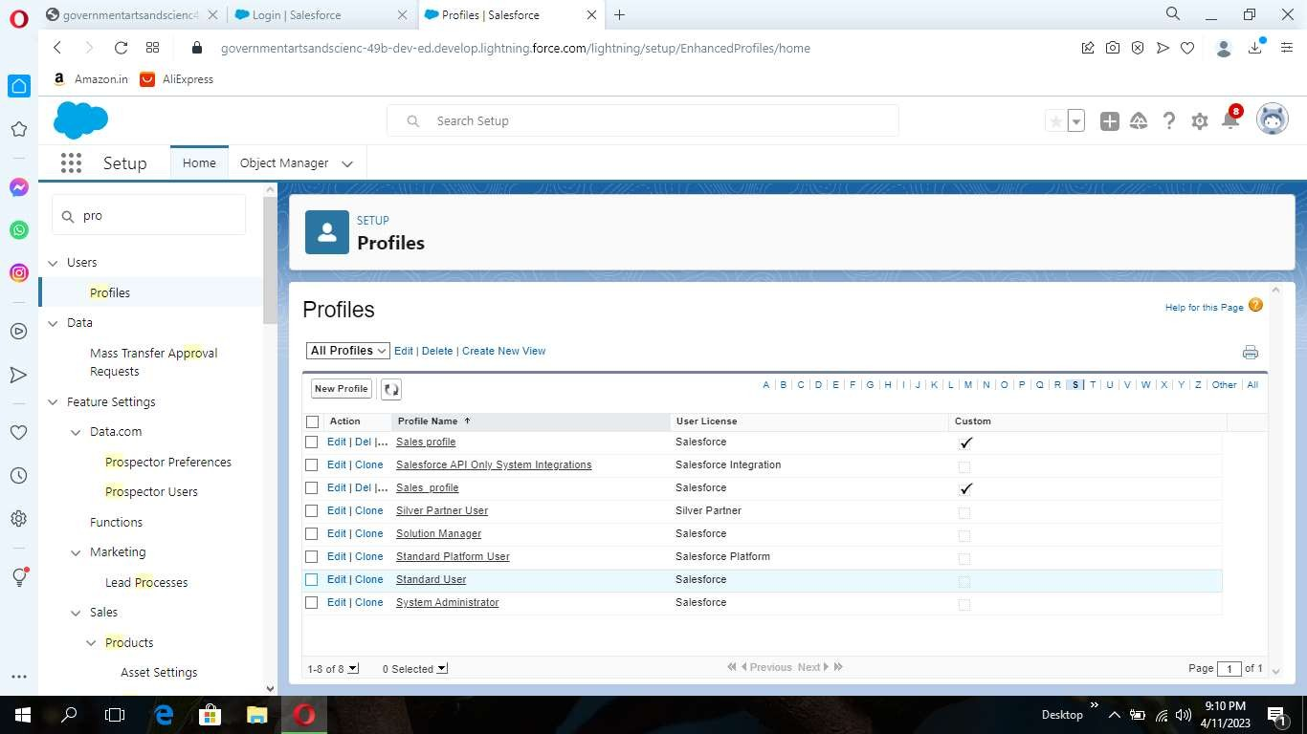

1. From the list of profiles, find Standard User.
2. Click Clone.
3. For Profile Name, enter Event user profile.
4. ClickSave

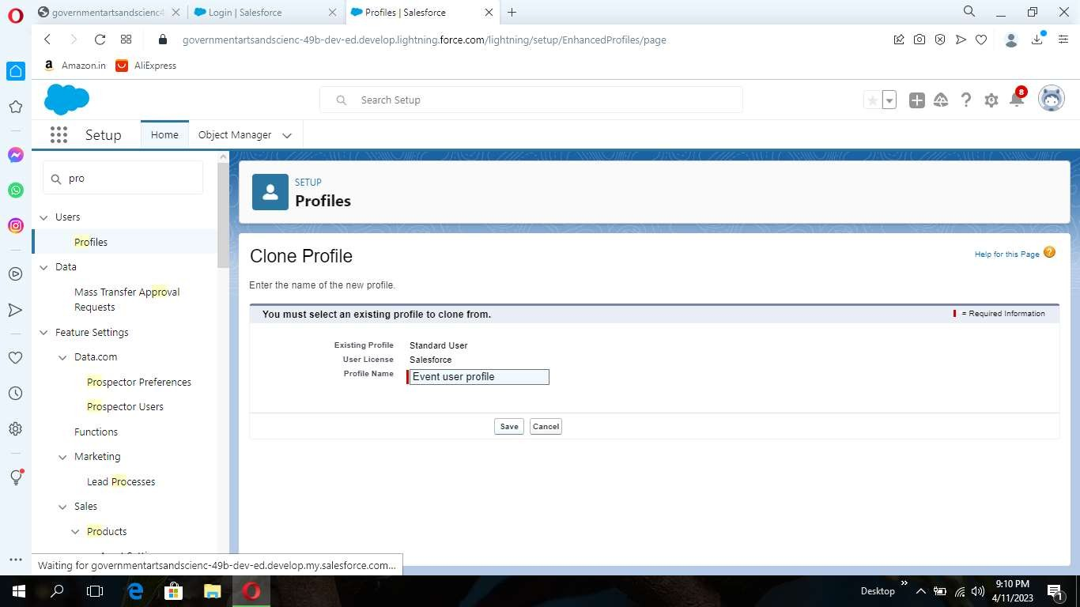

1. While still on the Event profile page, then click Edit.
2. Scroll down to Custom Object PermissionsandGiveviewallaccesspermissionstothe Order details, supplier, product, customer, category, payment.

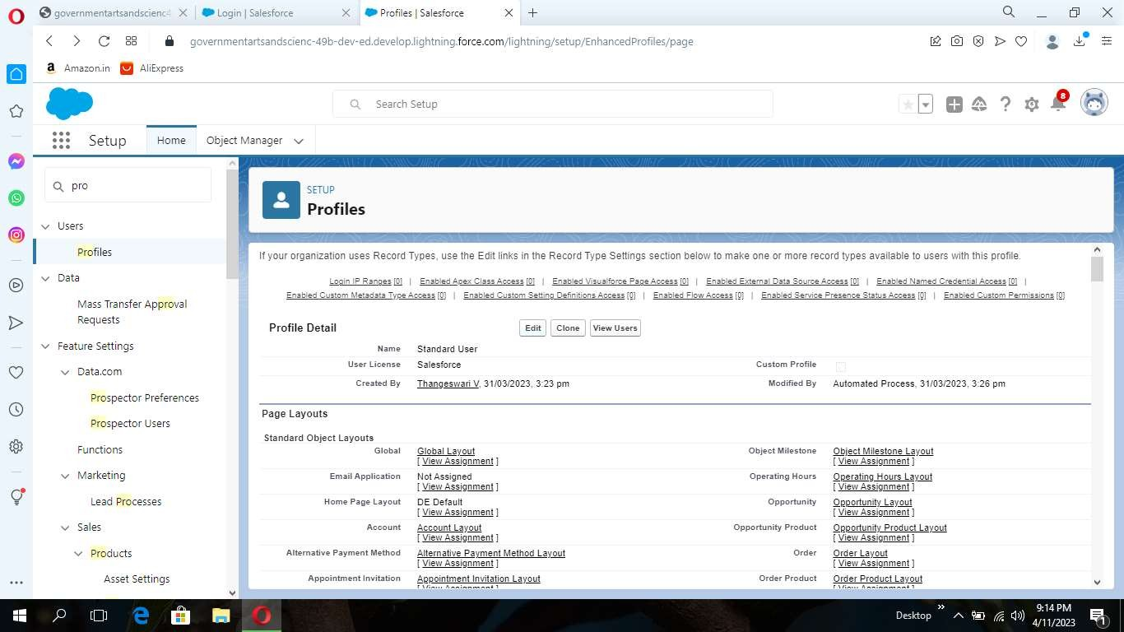

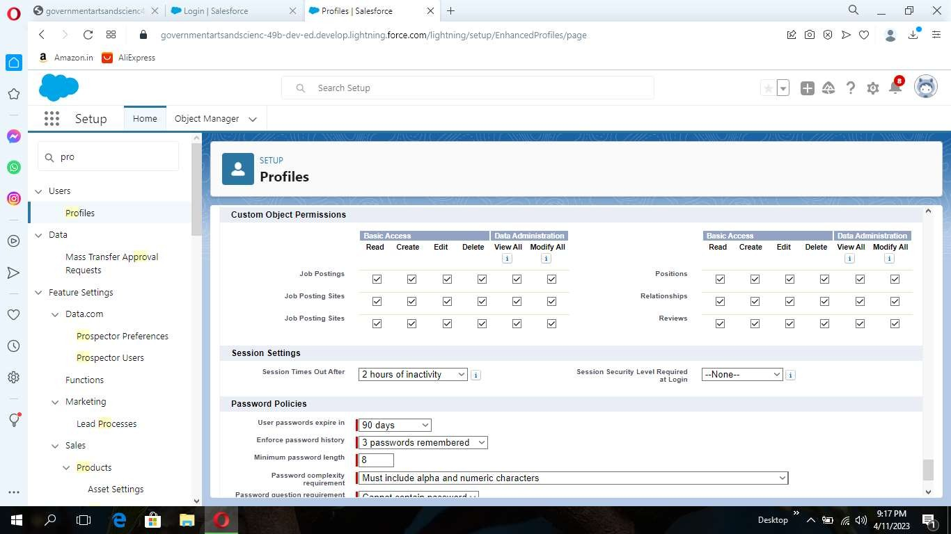

Part-2

Create a profile with the profile name as “Sales profile

Activity-10:

### User

Part-1

From setup type “users” in quick find and select users, then click New User

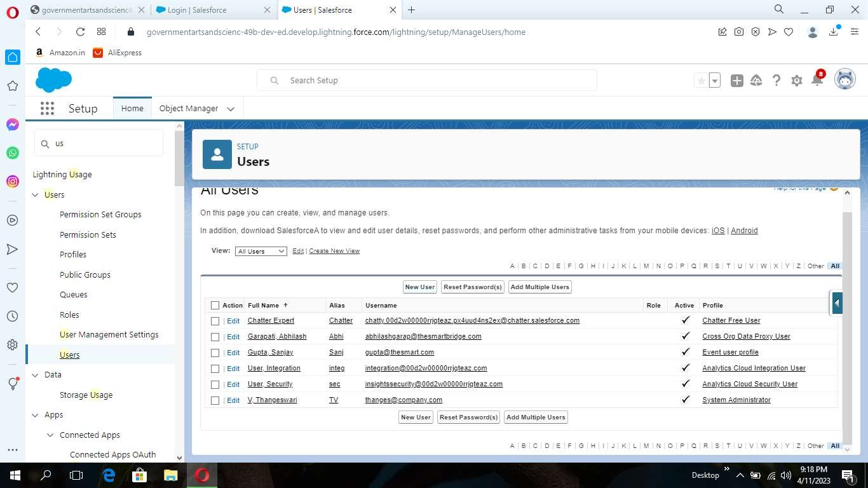

· First Name: Sanjay · Last Name: Gupta · Alias: Sanj ·

Email: provide your personal email id for future reference · Username: [sanjaygupta@thesmartbridge.com](mailto:sanjaygupta@thesmartbridge.com) ·

Nickname: Sanju ·

Role: leave it as default · User License: Salesforce · Profile: Event User Profile

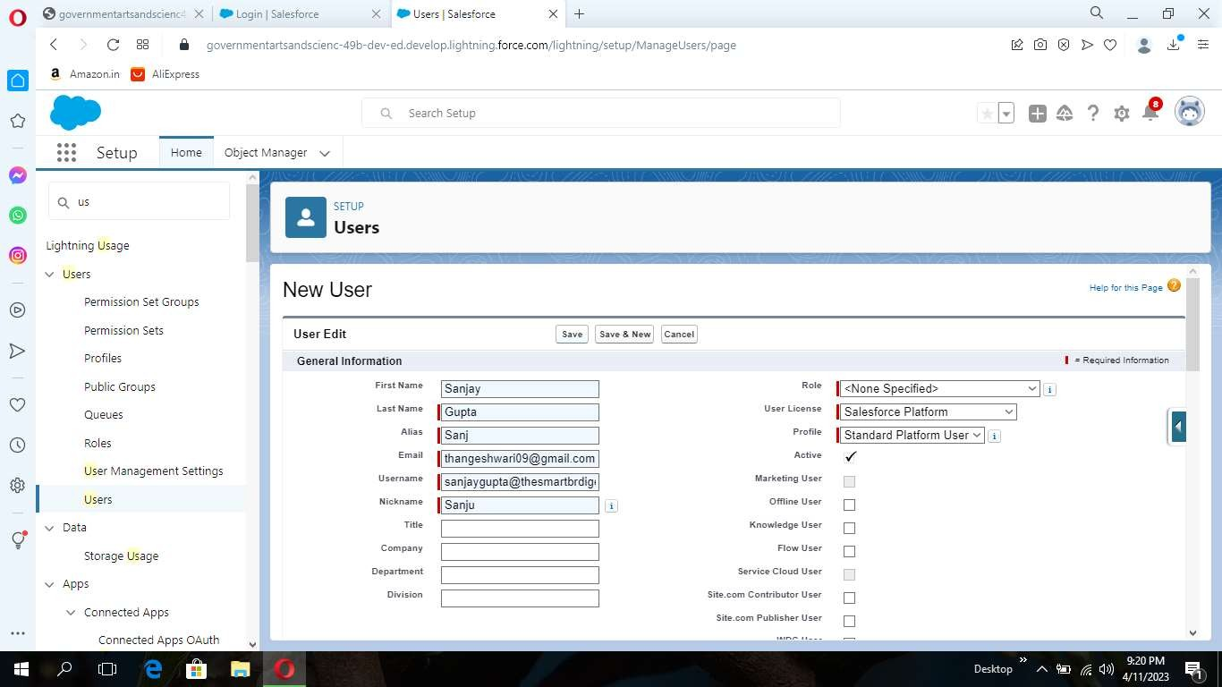

Part-2

Create a user with a username as “Abhilash Garapati”, and assign him the sales profile

Activity-11:

### Permission Set

Part-1

1. From setup search “permission sets” in quick find and select permission set then click on New.

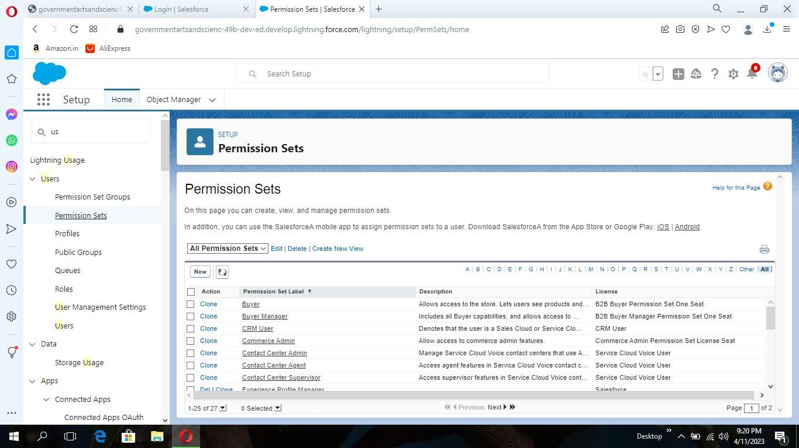

1. Enter label as: Supplier Permits and Save.
2. After saving the permission click on the Manage assignment

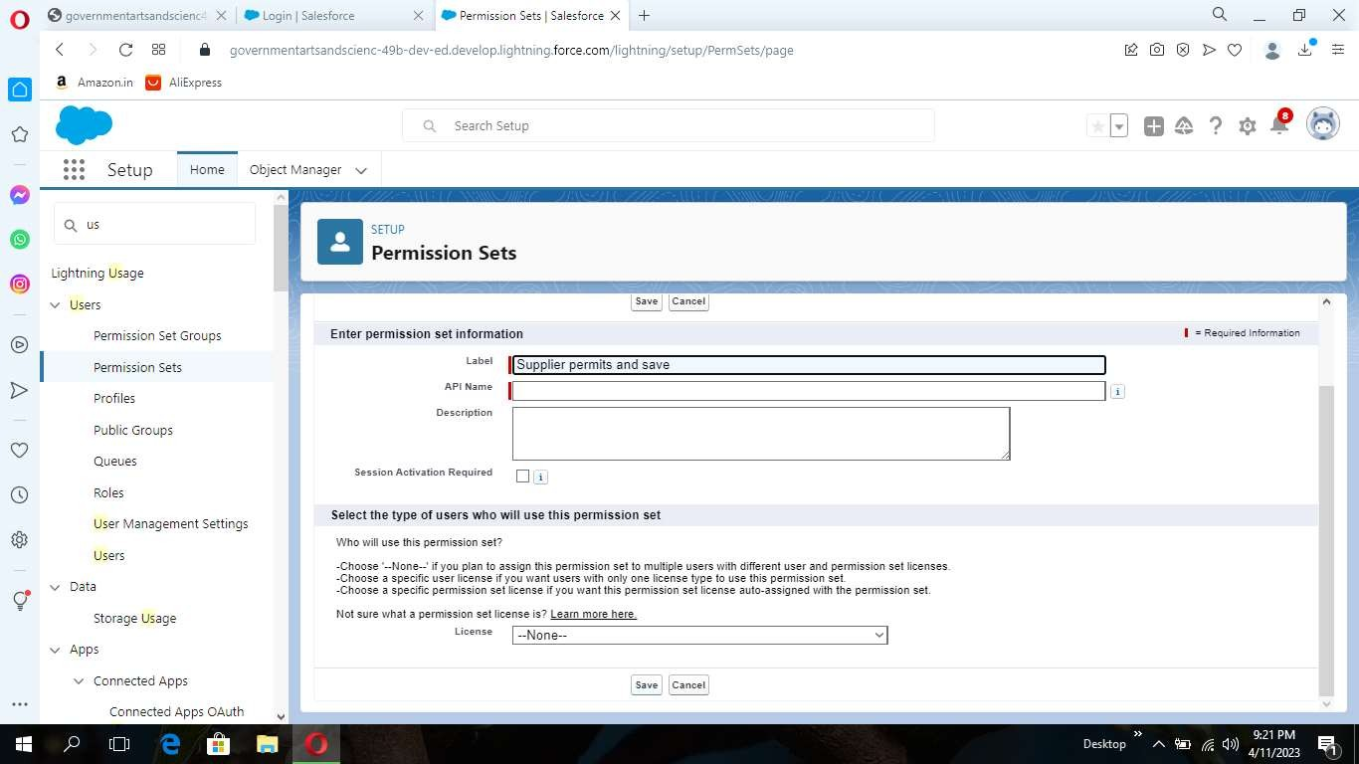

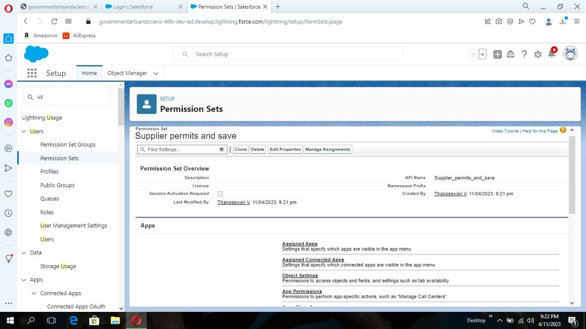

1. Now click on the Add Assignment

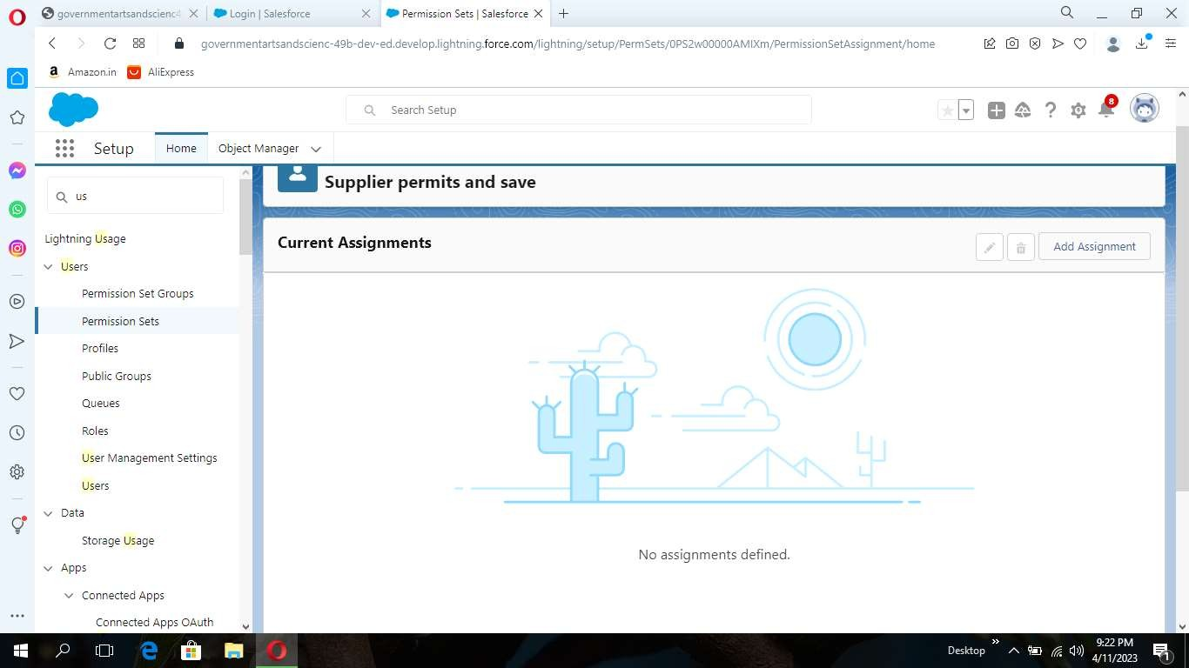

1. Now select the users and click on save

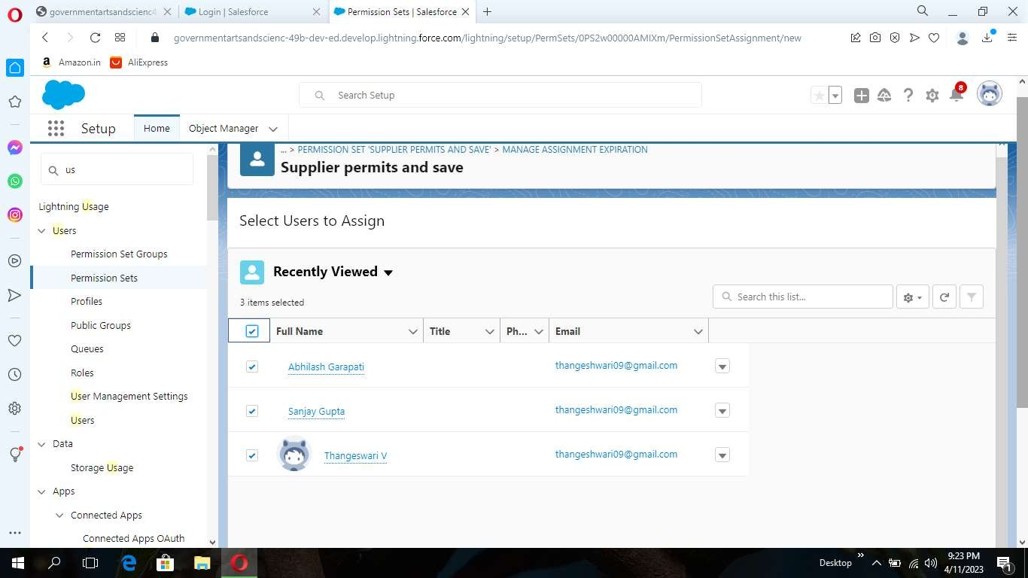

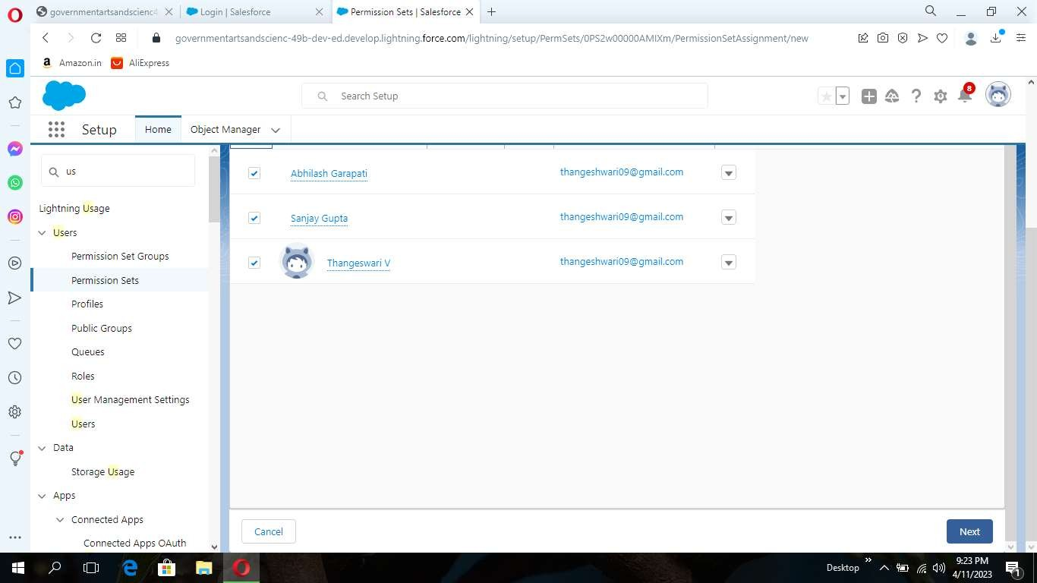

Part-2

Create a Permission set for Review object

Activity-12:

Reports:

Part-1

1. From the Reports tab, click New Report.

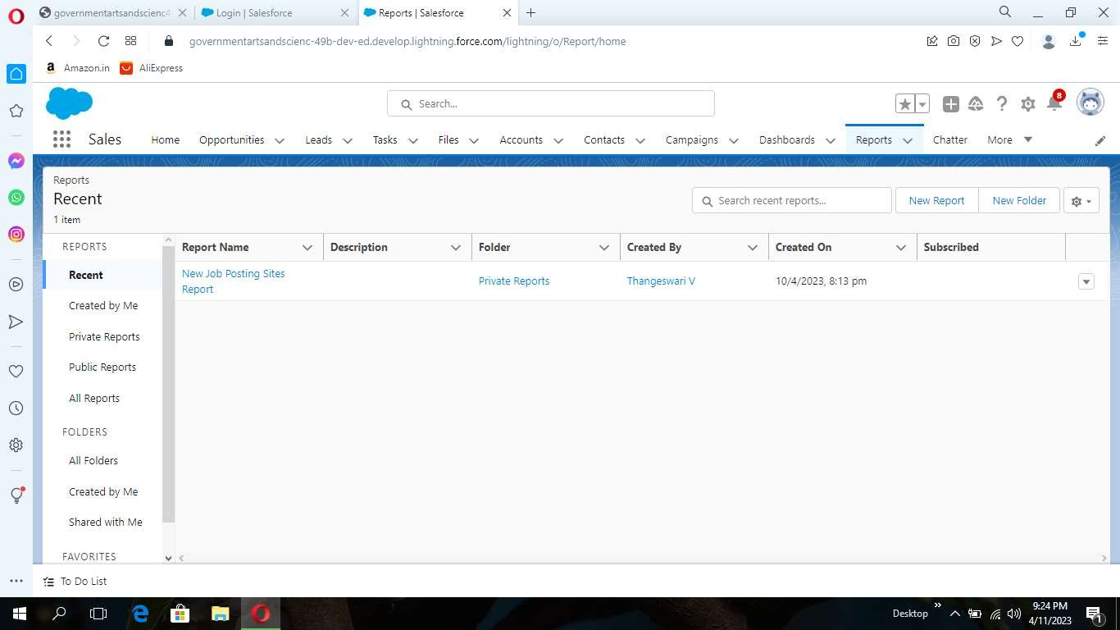

1. Select the report type Attendees with events for the report, and click Create

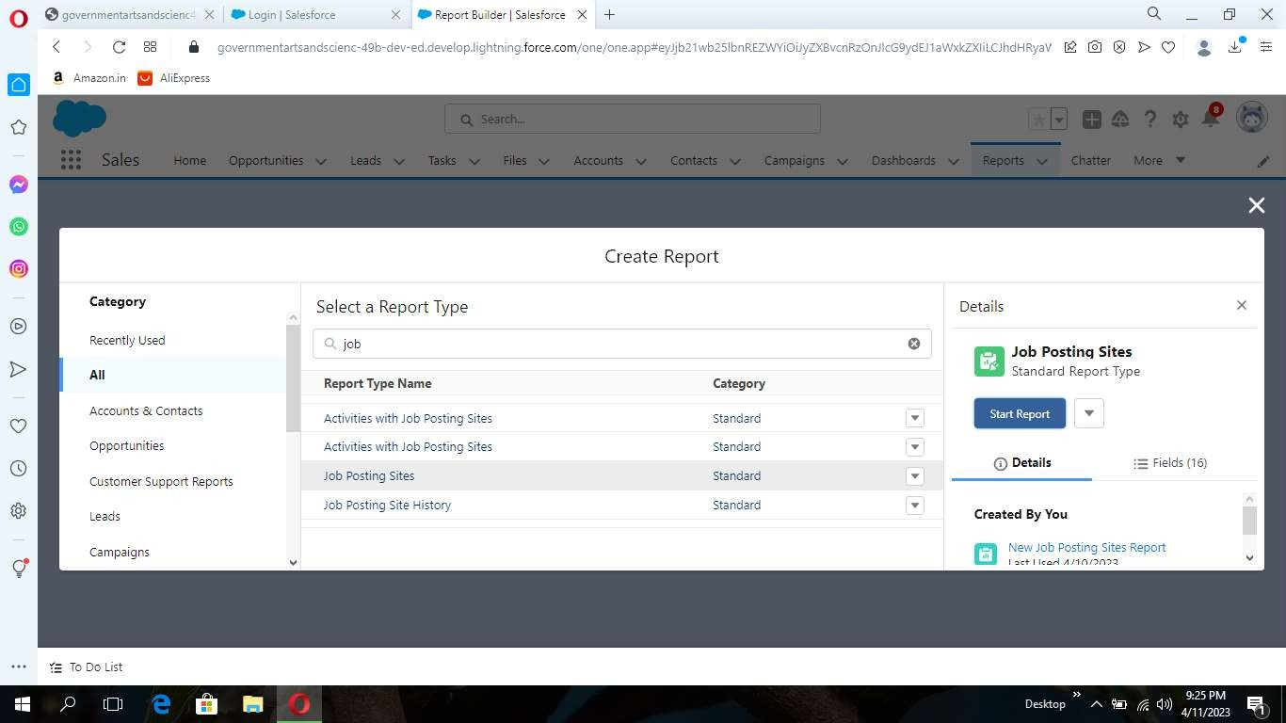

1. Customize your report accordingly and include all fields, then save or run it.

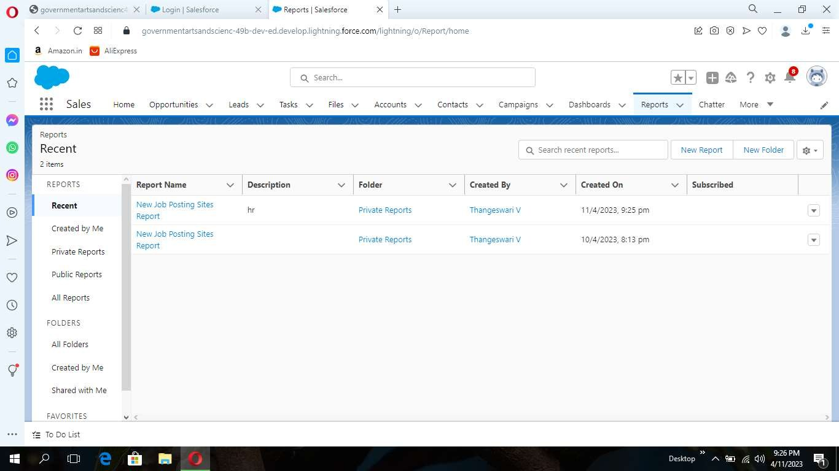

Part-2

Create a report for review and Job Posting Objects.

Trailhead Profile public URL

Team Lead- <http://trailblazer.me/id/rey001> Team Member 1- <http://trailblazer.me/id/thala39>

Team Member 2- <http://trailblazer.me/id/thanv23> Team Member 3- <http://trailblazer.me/id/vaitm3> Team Member 4- <http://trailblazer.me/id/vijas54>

ADVANTAGES & DISADVANDAGES

Advantages:

. Hiring internal candidates can be more efficient than recruiting externally,because it can:

. Know how your company operates and most of your policies and practices.

. May be familiar with people in their new team,especially in smaller businesses.

. May already know the content and context of their new roles if if they move.

### Disadvantages:

. Despite all the merits of internal recruitment, there are some things to keep in mind . Hiring from within can:

### Aplications:

.Travel approvel request app will help users quickly sent a travel request through mobile using power apps

. Keeping recruiting assistant for HR managers will not be difficult any more and essential task of aprovel will be unter senior managements monitering with such a multiherarchy automated approval process

## CONCLUSION:

These the way to create the page for recruiting assistant for HR mansgers

### FUTURE SCOPE:

Its actual proose ir to recruit them via online, there is no need to showup personally. it makes HR's to select the required assistant easily bt this page.