**Name: RESHMA KS**

**Roll No:27**

**Batch:MCA-B**

**Date:01-09-2022**

**DATA SCIENCE LAB**

**Experiment No.: 3**

**Aim**

 Programs to handle data using pandas.

**Question**

**Q1 - Pandas  Series**

1. How to create Series with nd array
2. How to create Series with Mutable index
3. Creating a series from a Dictionary
4. Print all the values of the Series by multiplying them by 2.
5. Print Square of all the values of the series.
6. Print all the values of the Series that are greater than2
7. Addition of two series
8. Print the first and last 5 elements of a series
9. Print the values from index 0 to 5
10. Selection Using loc, iloc index label
11. Retrieve subsets of data using slicing

**Q2 Dataframe**

1. create Dataframe From Series
2. DataFrame from List of Dictionaries
3. Display the first 5 rows of data frame
4. Select the last two columns of the data frame
5. Add two data frames
6. Demonstrate deletion, and renaming of columns
7. Demonstrate concat, Merge operations in data frame
8. Write a Pandas program to join the two given dataframes along rows and assign all data

**Test Data:**

student_data1:

  student_id              name  marks

0         S1  Danniella Fenton    200

1         S2      Ryder Storey    210

2         S3      Bryce Jensen    190

3         S4         Ed Bernal    222

4         S5       Kwame Morin    199

student_data2:

  student_id              name  marks

0         S4  Scarlette Fisher    201

1         S5  Carla Williamson    200

2         S6       Dante Morse    198

3         S7    Kaiser William    219

4         S8   Madeeha Preston    201

**Procedure**

#1.How to create Series with nd array

import pandas as pd

import numpy as np

arr=np.array([10,15,18,22])

s = pd.Series(arr)

print(s)

**Output**

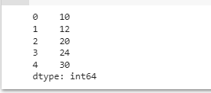

#2. How to create Series with Mutable index

import pandas as pd

import numpy as np

arr=np.array(['a','b','c','d'])

p=pd.Series(arr, index=['first','second','third','fourth'])

print(p)

import pandas as pd

x = pd.Series(50 , index=[20,30,40,50])

print(x)

**Output**

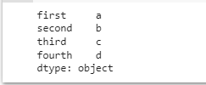

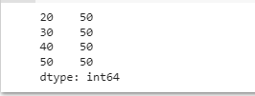

#3. Creating a series from a Dictionary

import pandas as ps

d = {'name' : 'kia', 'phone' : 98563953, 'runs' : 1500}

y = pd.Series(d)

print(y)

**Output**

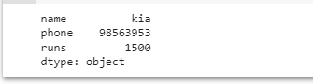

4. Print all the values of the Series by multiplying them by 2

import pandas as pd

p=pd.Series([1,2,3,4,5])

print(p)

print("multlipling all values in series by 2")

print(p*2)

**Output**

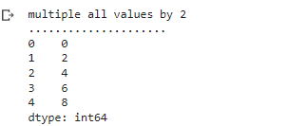

5.Print Square of all the values of the series

import pandas as pd

p=pd.Series([1,2,3,4,5])

print('..............................................')

print("square of all values")

print(p**2)

**Output**

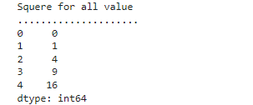

6 Print all the values of the Series that are greater than2

import pandas as pd

p=pd.Series([1,2,3,4,5])

print("when the value greater than 2")

print(p[p>2])

print('..............................................')

**Output**

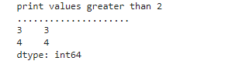

#7. Addition of two series

import pandas as pd

s1=pd.Series([1,2,3,4,5],index=['a','b','c','d','e'])

s2=pd.Series([10,20,30,40,50],index=['a','b','c','d','e'])

s3=pd.Series([5,14,23,32],index=['a','b','c','d'])

print("Add S1 and S2")

print('.....................')

print(s1+s2)

print("Add S2 and S3")

print('.....................')

print(s2+s3)

print("Add S2 and S3 and filled non matching index with 0")

print('.....................')

print(s2.add(s3,fill_value=0))

**Output**

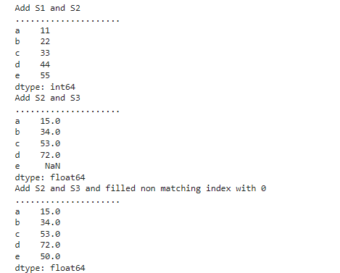

8. Print the first and last 5 elements of a series

import pandas as pd

import numpy as np

arr=np.array([10,12,23,3,4,56,57,6,7])

s=pd.Series(arr)

print(s.head(5))

**Output**

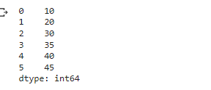

9. Print the values from index 0 to 5

import pandas as pd

import numpy as np

arr=np.array([10,12,23,3,4,56,57,6,7])

s=pd.Series(arr)

print(s.head(6))

**Output**

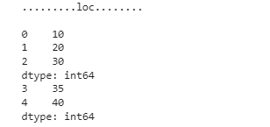

10.Selection Using loc, iloc index label

import pandas as pd

import numpy as np

arr=np.array([10,12,23,3,4,56,57,6,7])

s=pd.Series(arr)

print(s)

print(s.loc[:2])

print(s.iloc[3:4])

**Output**

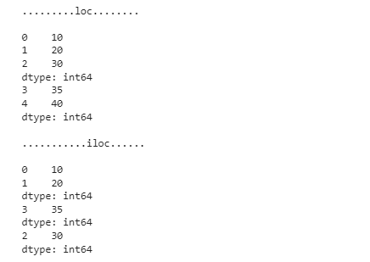

#11. Retrieve subsets of data using slicing

import pandas as pd

import numpy as np

arraa=np.array([10,15,20,25,30,40])

f=pd.Series(arraa,index=['A','B','C','D','E','F'])

print(f)

print(s[1:5:2])

print(s[0:6:2])

**Output**

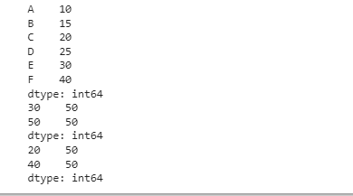

Dataframe:

1.create Dataframe From Series

import pandas as pd

s = pd.Series(['a','b','c','d'])

df=pd.DataFrame(s)

print(df)

**Output**

  0

0  a

1  b

2  c

3  d

#2. DataFrame from List of Dictionaries

import pandas as pd

l = [{'name':'sachin','sirname':'bhardwaj'},

   {'name':'vinod','sirname':'verma'},

   {'name':'rajesh','sirname':'mishra'}]

df1=pd.DataFrame(l)

print(df1)

**Output**

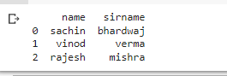

#3. Display the first 5 rows of data frame

import pandas as pd

m = [{'name':'sachin','sirname':'bhardwaj'},

   {'name':'vinod','sirname':'verma'},

   {'name':'rajesh','sirname':'mishra'},

   {'name':'ran','sirname':'mira'},

   {'name':'ram','sirname':'mia'},

   {'name':'mesh','sirname':'kashra'}]

df2=pd.DataFrame(m)

print(df1)

for(row_index,row_value) in df2.iterrows():

  print('\n Row index is ::',row_index)

  print('Row value is::')

  print(row_value)

**Output**

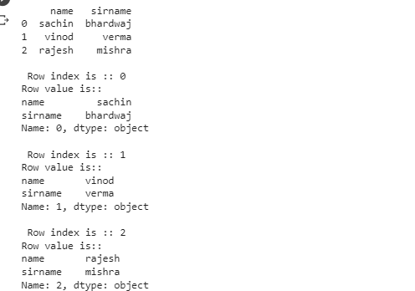

#4. Select the last two columns of the data frame

import pandas as pd

l = [{'name':'sachin','sirname':'bhardwaj'},

   {'name':'vinod','sirname':'verma'}]

df3=pd.DataFrame(l)

print(df3)

for(col_name,col_value) in df3.iteritems():

  print('\n')

  print('Column name is ::',col_name)

  print('column values are::')

  print(col_value)

out put

**Output**

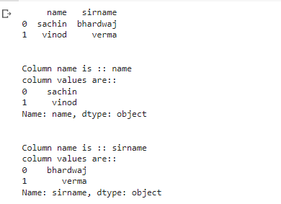

#5. Add two data frames

import pandas as pd

g = pd.Series([10,15,18,22])

df=pd.DataFrame(g)

df.columns=['List1']

df['List2']=20

df['List3']=df['List1']+df['List2']

print(df)

**Output**

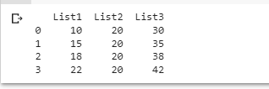

#6. Demonstrate deletion, and renaming of columns

import pandas as pd

g = pd.Series([10,15,18,22])

df=pd.DataFrame(g)

df.columns=['List1']

df['List2']=20

df['List3']=df['List1']+df['List2']

del df['List3']

print(df)

print('\npop\n')

df.pop('List2')

print(df)

**Output**

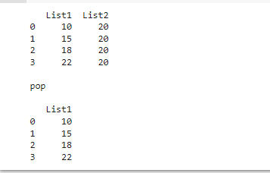

#7. Demonstrate concat, Merge operations in data frame

import pandas as pd

dict1={'id':['1','2','3','4','5'],'value1':['A','C','E','G','I'],

       'value2':['B','D','F','H','J']}

dict2={'id':['2','3','6','7','8'],'value1':['K','M','O','Q','S'],

       'value2':['L','N','P','R','T']}

dict3={'id':['2','3','1','7','8','9','1','4','5','0'],

       'value3':['cA','ra','Ka','Ma','Oa','Qa','ta','ja','ea','Sa']}

df1=pd.DataFrame(dict1)

df2=pd.DataFrame(dict2)

df3=pd.concat([df1,df2])

print("..........concat........\n", df3)

df4=pd.DataFrame(dict3)

print("\ndict4 = \n",df4)

df5=pd.merge(df1,df4,on='id')

print("\n\n====merge====\n",df5)

**Output**

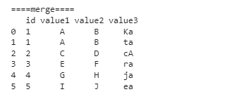

#8. Write a Pandas program to join the two given dataframes along rows and assign all data

import pandas as pd

df6.to_csv('output.csv')

data=pd.read_csv('output.csv')

data

**Output**

