**NETWORKING & SYSTEM ADMINISTRATION LAB**

**Name: Reshma k s**

**Roll No:27**

**Batch: MCA-R**

**Date:23-05-2022**

**Experiment No.: 24**

**Aim**

Docker Installation.

**Procedure**

**Step 1:** Open the terminal on Ubuntu.

**Step 2:** Remove any Docker file that are running in the system, using the following command:

|  |
| --- |
| **$ sudo apt-get remove docker docker-engine docker.io** |

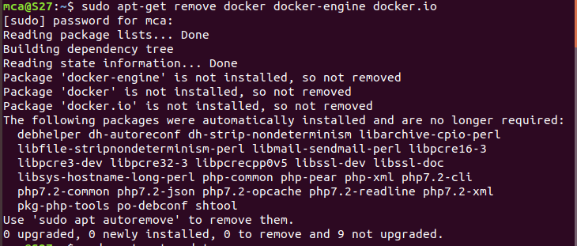

**Step 3:** Check if the system is up-to-date using the following command:

|  |
| --- |
| **$ sudo apt-get update** |

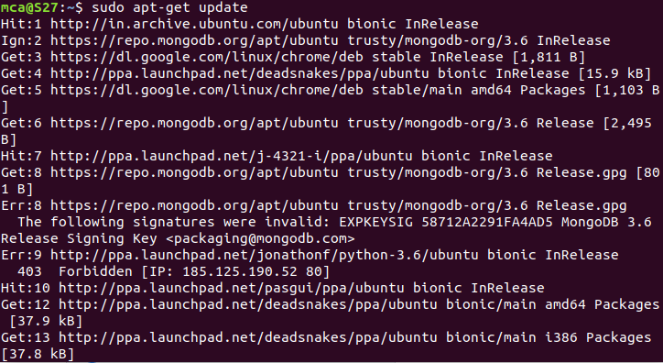

**Step 4:** Install Docker using the following command:

|  |
| --- |
| **$ sudo apt install docker.io** |

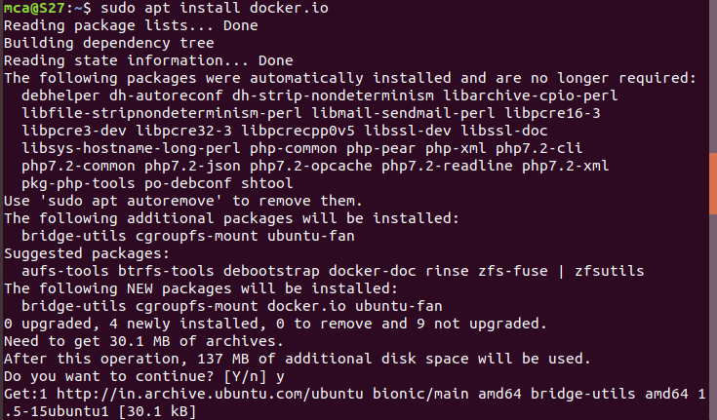

**Step 5:** Install all the dependency packages using the following command

|  |
| --- |
| **$ sudo snap install docker** |



**Step 6:** Before testing Docker, check the version installed using the following command

|  |
| --- |
| **$ docker --version** |



**Step 7:** Pull an image from the Docker hub using the following command:

|  |
| --- |
| **$ sudo docker run hello-world** |

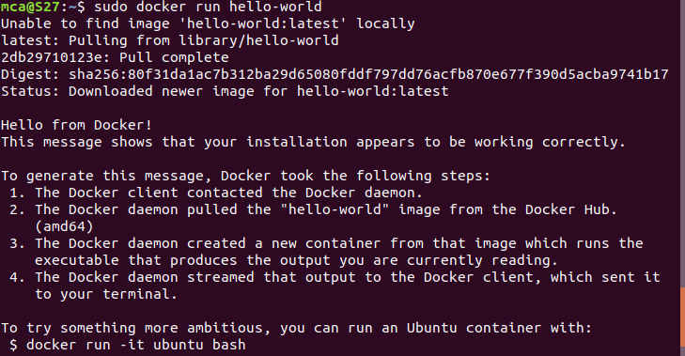

**Step 8:**Check if the docker image has been pulled and is present in your system using the following command:

|  |
| --- |
| **$ sudo docker images** |

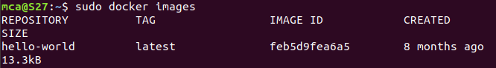

**Step 9:** To display all the containers pulled, use the following command

|  |
| --- |
| **$ sudo docker ps -a** |

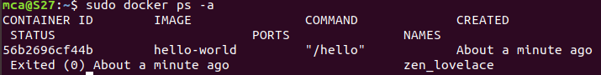

**Step 10:** To check for containers in a running state, use the following command:

|  |
| --- |
| **$ sudo docker ps** |

