**NETWORKING&SYSTEM ADMINISTRATION LAB**

**Experiment No.: 3**

**Aim**

Familiarization of Linux Commands

**Procedure**

**1. pwd**

The pwd command is used to display the location of the current working directory.

**Syntax :**



**2. mkdir**

The **mkdir command is used to create a new directory under any directory**

**Syntax :**



**3. ls**

The ls command is used to display a list of content of a directory

**Syntax :**

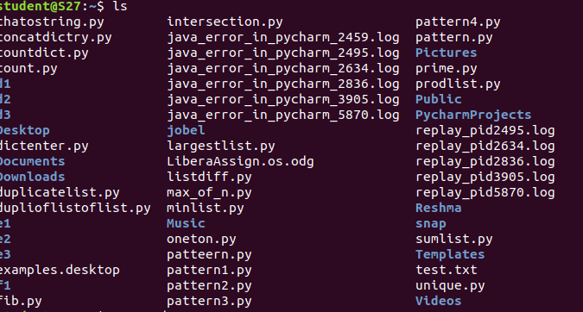

**4. ls -l**

**Syntax :**

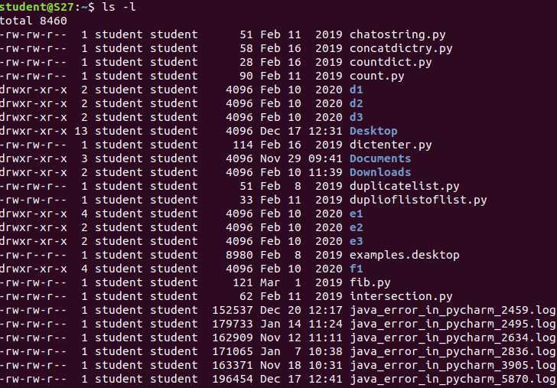

**5. ls -R**

**Syntax :**

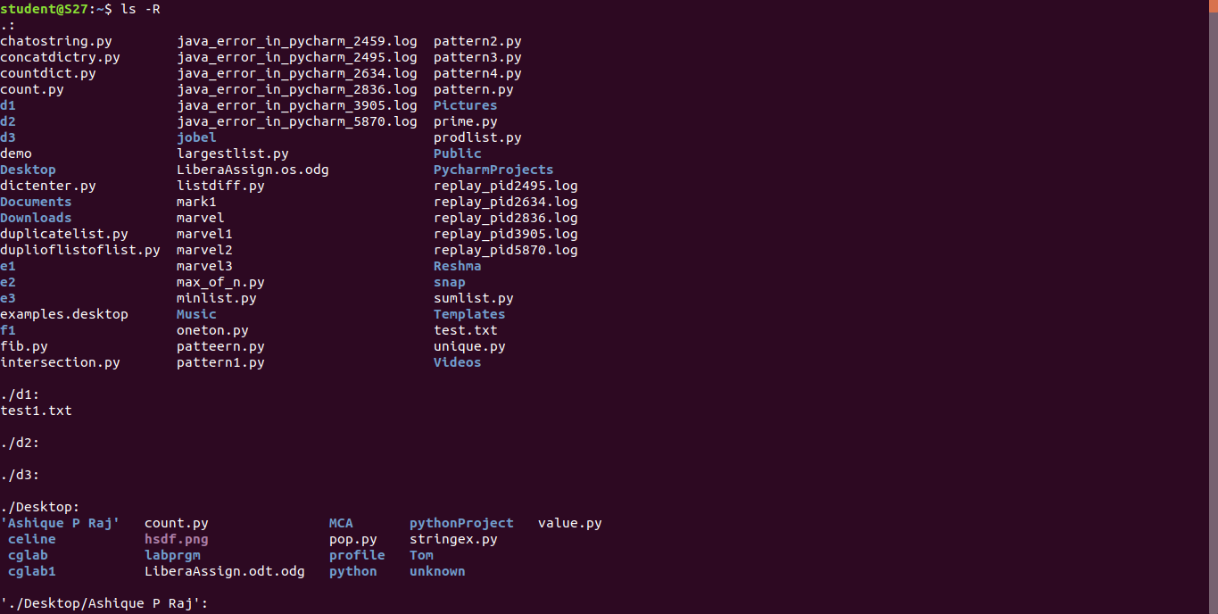

6. ls -a

**Syntax :**

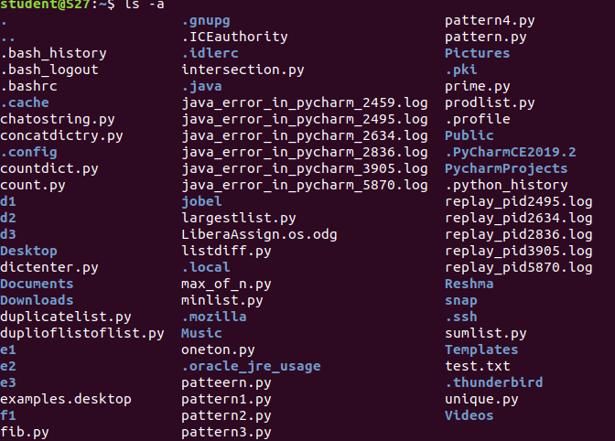

7. ls -al

**Syntax :**

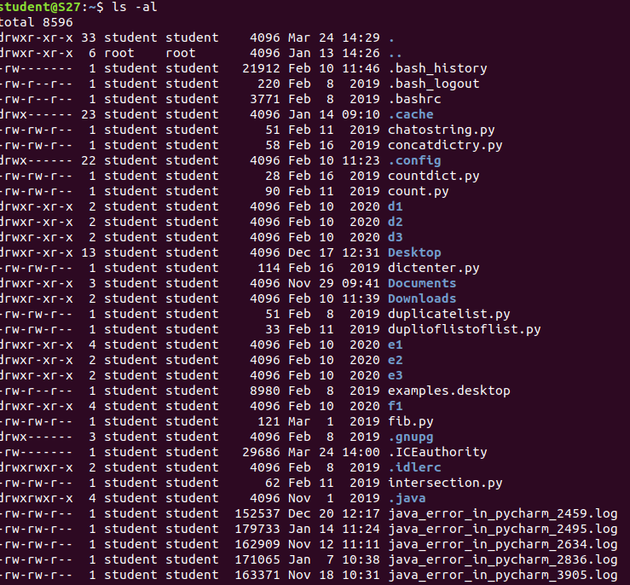

8. ls -t

**Syntax :**

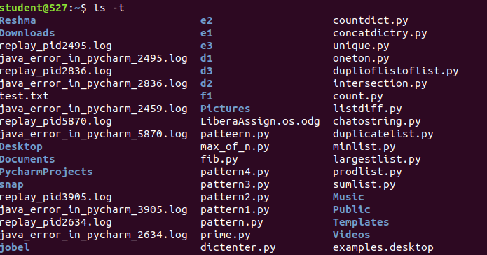

9. cd

The cd command is used to change the current directory

**Syntax :**



10. cd -

**Syntax :**



11. cat > a.txt

The cat command is a multi-purpose utility in the Linux system. It can be used to create a file, display content of the file, copy the content of one file to another file, and more.

**Syntax :**

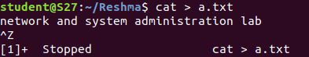

12. cat >> a.txt

**Syntax :**

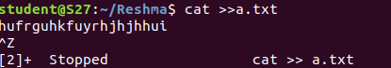

13. cat a.txt

**Syntax :**



14. cat a.txt > b.txt

**Syntax :**



15. cat b.txt

**Syntax :**



16. man

**Syntax :**



