**NETWORKING&SYSTEM ADMINISTRATION LAB**

**Name: Reshma ks**

**Roll No:27**

**Batch:B**

**Date:21-04-2022**

**Experiment No:7**

**Aim**

Familiarization of Linux Commands

**Procedure**

**1. read**

The read command is used to read the content of a line to a variable.

**Syntax :**

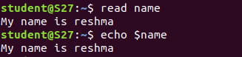

**2. locate**

Thelocate command is used to locate a particular file in directory.

**Syntax :**

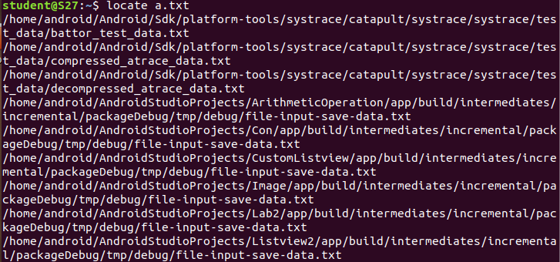

**3. locate -i**

The locate -i command is used to locate a file which is in upper case or lower case characters.

**Syntax :**



**4. find**

The find command is used to find a particular file from a particular directory.

**Syntax :**



**5. grep**

The grep command will let you search through all the text in a given file.

**Syntax :**



**6. grep -A1**

The grep -A1 command is used to display a line after the result.

**Syntax :**



**7. grep -B1**

The grep -B1 command is used to display a line before the result.

**Syntax :**



**8.grep C1**

The grep -C1 command is used to display aline before and after the result.

**Syntax :**

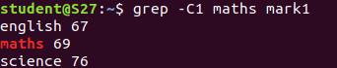

**9.grep -v**

The grep -v command is used for an inverted search.

**Syntax :**



**10.grep -i**

The grep -i command is used for case insensitive search.

**Syntax :**



**11.df**

The df command is used to get a report on system disk space usage.

**Syntax :**

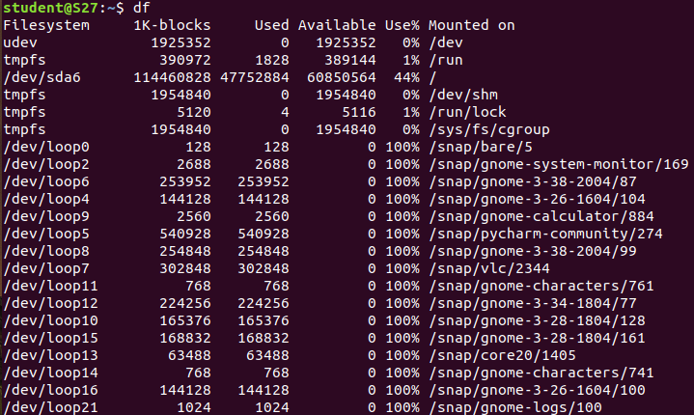

**12. df -m**

The df -m command is used to see the report in megabytes.

**Syntax :**

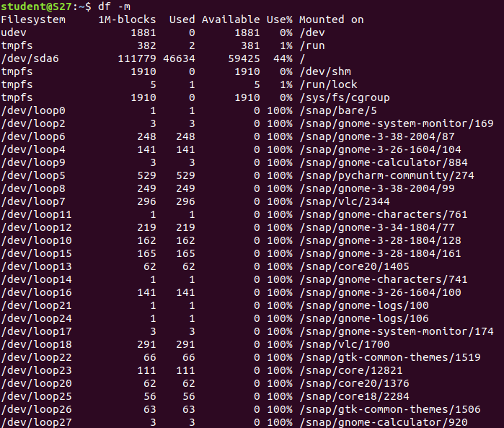

**13. du**

The du command is used to check how much space a file on directory takes.

**Syntax :**

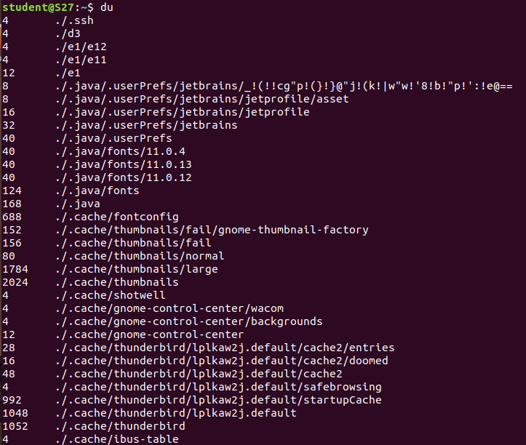

**14.wc**

The wc command is used for counting purpose.

**Syntax :**



**15. wc -l**

The wc -l command is used for counting lines.

**Syntax :**



**16. wc -w**

The wc -w command is used for counting words.

**Syntax :**



**17. wc -c**

The wc -c command is used for counting character.

**Syntax :**



**18. wc -m**

The wc -m command is used for counting byte.

**Syntax :**

