**NETWORKING & SYSTEM ADMINISTRATION LAB**

**Name: Reshma ks**

**Roll No: 27**

**Batch: B**

**Date: 04-04-2022**

**Experiment No.: 6**

**Aim**

Familiarization of the linux commands.

**Procedure**

**1. cp**

cp means copy. 'cp' command is used to copy a file or a directory.

Syntax :- $ cp filename1 filenme2

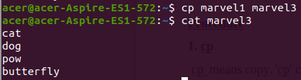

**2. cp -r**

This command is used to copy a directory along with its sub dirctories..

Syntax :- $ cp -r directory1 directory2



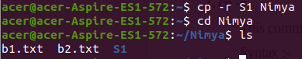

**3. cp -i**

This command asks for confirmtion.

Syntax :-$ cp -i filename1 directory1

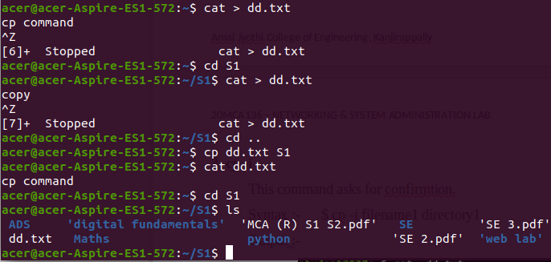

**4. mv**

This command is used to move existing file or directory from one location to another. It is also used to rename a file or directory.

Syntax :-$ mv file1 directory1

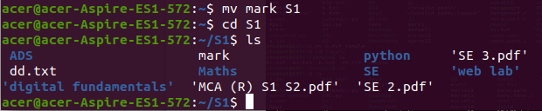

->This command is used to move existing file or directory from one location to another.

Syntax :-$ mv directory1 directory2

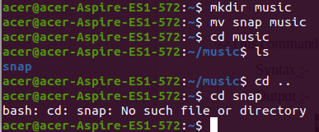

**5. mv -i**

This command is asks for permission to over write

Syntax :-$ mv -i file1 directory1

