**Name:**

**Roll No:**

**Batch:**

**Date:**

**NETWORKING & SYSTEM ADMINISTRATION LAB**

**Experiment No.: 4**

**Aim**

Familiarization of Linux Commands

**Procedure**

**Procedure**

**1. -n**

This command is used to displays line numbers incontents.Syntax:- $ cat -nfilename

**Output :-**

**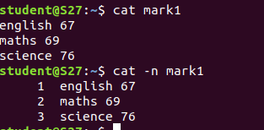**

**2. -b**

This command is used to removes the empty lines.

Syntax :- $ cat -b filename

Output:

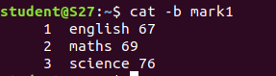

**3. Touch**

This command is used to create an empty file.

Syntax :-$ touch filename

Output:

exp4_3

4. $echo //contents// >>text.txt: it is used to add contents to an empty file.

Output:-

exp4_4

5. head

This head command is used to display the first ten line of contents and head -4 which displays the first four lines of contents.

Syntax :-

$ head filename

$ head -4 filename

Output:

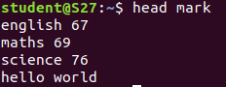

6. Tail

This tail command is used to displays the last ten lines of contents and tail -4 which displays the last 4

lines of contents.

Syntax :-

$ tail filename.txt

$ tail -4 filename.txt

Output:-



7. Cut f2,Cut f1

This cut f2 command is used to display the second column contents and f1 which displays the first

column contents.

Syntax :-

$cut –d- -f2 filename.txt

$cut –d- -f1 filename.txt

Output:

