|  |  |  |  |  |  |
| --- | --- | --- | --- | --- | --- |
| Sr No. | Supply Address | Previous Usage | New Supply Details Chosen | Stage Reached | Last URL Reached |
|  |  |  |  |  |  |

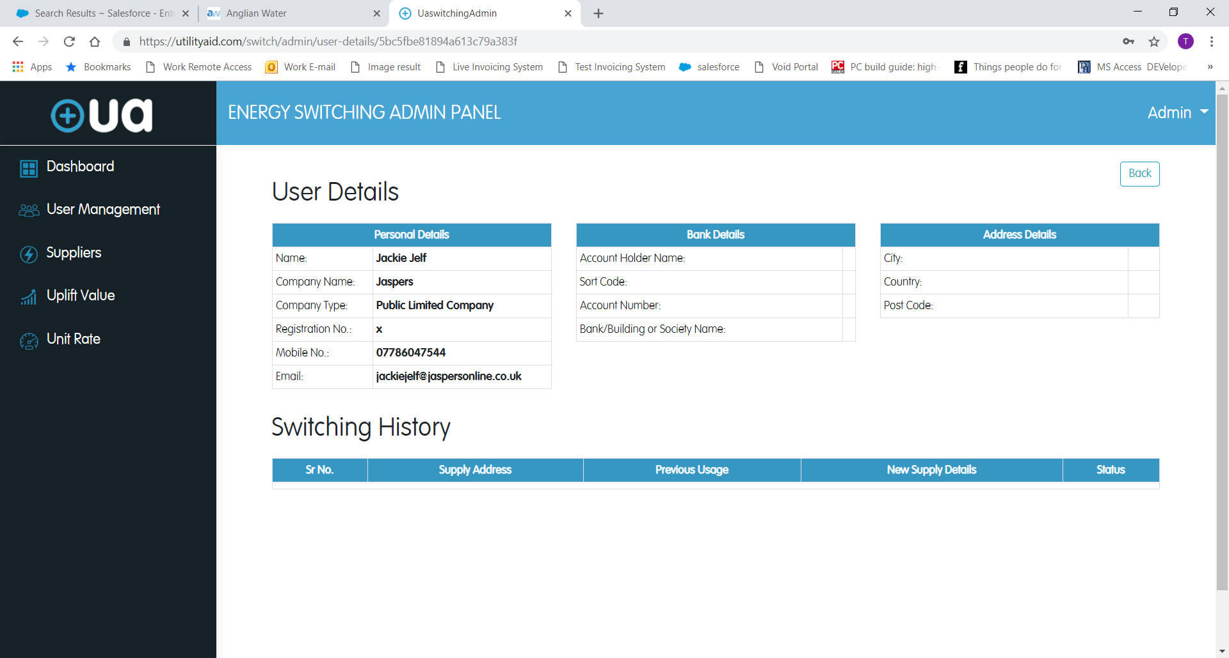

To Go Here

**Activity History**