 

**INSTITUTE FOR ADVANCED COMPUTING**

**AND SOFTWARE DEVELOPMENT AKURDI,**

**PUNE**

# Documentation On

# “AI Tutor : Generating Answers and Solutions

# Using LLM and RAG”

**PG-DBDA SEPT-2023**

**Submitted By:**

# Group No: 8

**Roll No.** **Name:**

248537 Reshma Nitin Jamdade

248522 Kimaya Kishor Patil

**Dr. Shantanu Pathak** **Mr. Rohit Puranik**

**Project Guide Centre Coordinator**

# DECLARATION

I, the undersigned, hereby declare that the project report titled **"AI Tutor: Generating Solutions Using LLM and RAG"** written and submitted by me to **Institute for Advanced Computing and Software Development, Akurdi, Pune**, in fulfillment of the requirement for the award of the **Post Graduate Diploma in Big Data Analytics (PG DBDA)** under the guidance of **Dr. Shantanu S. Pathak**, is my original work.

I have not copied any code or content from any source without proper attribution, and I have not allowed anyone else to copy my work. The project was completed using **Python, NLP models (BART/Sentence Transformer), Retrieval-Augmented Generation (RAG), LangChain, and vector DB**. This project was developed as part of my academic coursework.

I also confirm that this project is **original** and has **not been submitted previously** for any other academic or professional purpose.

**Place: Signature:**

**Date: Name: 1. Kimaya Patil**

**2. Reshma Jamdade**

**ACKNOWLEDGEMENT**

I would like to express my sincere gratitude to **Dr Shantanu S Pathak**, Project Guide, for providing me with the guidance and support to complete this academic project. Their valuable insights, expertise, and encouragement have been instrumental in the success of this project.

I would also like to thank my fellow classmates for their support and cooperation during the project. Their feedback and suggestions were helpful in improving the quality of the project.

I would like to extend my gratitude to **Mr. Rohit Puranik**, Centre Coordinator, for providing me with the necessary resources and facilities to complete this project. Their support has been crucial in the timely completion of this project.

Finally, I would like to thank my family and friends for their constant encouragement and support throughout the project. Their belief in me has been a constant source of motivation and inspiration.

Thank you all for your support and guidance in completing this academic project.

# ABSTRACT

The **AI Tutor** project aims to build an intelligent tutoring system that leverages **Large Language Models (LLMs) and Retrieval-Augmented Generation (RAG)** to enhance learning experiences. By integrating **machine learning** and **natural language processing (NLP)** techniques, the system provides high-quality responses to educational queries, retrieves relevant information from knowledge bases, and generates accurate, context-aware answers.

The project utilizes **LangChain** to structure the interaction between **LLMs and vector databases**, enabling efficient document retrieval and response generation. It employs **Hugging Face Transformers** and **Sentence-Transformers (all-MiniLM-L6-v2)** to generate embeddings for text similarity search. The **PyMuPDF (fitz)** library is used for extracting content from educational PDFs, while **Scikit-learn and NumPy** facilitate **cosine similarity calculations** for document ranking.

By combining **retrieval-based search with generative AI**, AI Tutor ensures that answers are both **accurate and informative**. The project demonstrates a **scalable and adaptable** tutoring solution, offering automated assistance across various academic subjects.

This system is valuable for **students, educators, and researchers**, providing **real-time, reliable** learning support. The integration of **cutting-edge AI and retrieval mechanisms** ensures that users receive **contextually relevant** answers, reducing reliance on purely generative models while improving factual accuracy.

We would also like to express our appreciation to the faculty members of our department for their constructive feedback and encouragement. Their insights and suggestions have helped us to refine our ideas and enhance the quality of our work.

Furthermore, we would like to thank our families and friends for their unwavering support and encouragement throughout our academic journey. Their love and support have been a constant source of motivation and inspiration for us.

Thank you all for your valuable contributions to our project.

**INDEX**

**1 Introduction ……………………………………………………... 6**

1.1 Description……………………………………………………. 6

1.2 Scope of the project ………………………………………….. 6

1.3 Objective of the project……………………………………….. 7

1.4 Limitation of the project………………………………………. 7

**2 Project Description………………………………………………. 8**

2.1 Project work flow diagram …………………………………… 8

2.2 Data collection ………………………………………………... 8

2.3 Studying the model …………………………………………… 9

2.4 Implementing the model ……………………………………… 9

2.5 Validating the model ………………………………………….. 11

**3 Model Description ……………………………………………….. 12**

3.1 Sentence Transformer Model …………………………………. 12

3.2 Key Features of all-MiniLM-L6-v2 ………………………….. 12

3.3 BART Transformer Model ……………………………………. 13

3.4 Key Features of facebook/bart-large-cnn …………………….. 13

**4 Data Flow ………………………………………………………… 14**

4.1 Data flow of project

**5 Tools used in project …………………………………………….. 16**

5.1 Langchain ……………………………………………………. 16

5.2 Langchain-community ………………………………………. 17

5.3 PyMuPDF ……………………………………………………. 18

5.4 Sklearn ……………………………………………………….. 18

5.5 Numpy ……………………………………………………….. 20

5.6 Transformers …………………………………………………. 22

**6 Project Requirements ……………………………………………… 24**

6.1 Hardware Requirements ………………………………………. 24

6.2 Software Requirements ……………………………………….. 24

**7 Future Scope ………………………………………………………. 25**

**8 Conclusion ………………………………………………………… 28**

**9 References …………………………………………………………. 29**

## 1. Introduction

**1.1 Description**

The **AI Tutor** project is an advanced educational tool designed to generate exercises and solutions using **Large Language Models (LLM)** and **Retrieval-Augmented Generation (RAG)**. The system leverages Natural Language Processing (NLP) techniques to process educational materials, extract relevant content, and intelligently generate customized exercises and answers.

Traditional learning methods often require manual effort to create exercises, assess comprehension, and provide solutions. AI Tutor automates these processes by retrieving relevant information from provided documents (PDFs) and generating structured questions and answers. This enhances learning efficiency, making education more interactive, personalized, and scalable.

By utilizing **document processing, embedding-based retrieval, and generative AI models**, the AI Tutor ensures high-quality and context-aware learning materials. The system is beneficial for students, educators, and institutions looking for an AI-powered solution to streamline knowledge acquisition and assessment.

### 1.2 Objective of the Project

**1) Automated Exercise Generation**: Develop an AI-powered tutor capable of generating structured exercises (MCQs, fill-in-the-blanks, descriptive questions, etc.) based on educational materials.

**2)** **Accurate Solution Generation**: Provide contextually relevant and accurate answers to the generated exercises using advanced NLP techniques.

**3)** **Efficient Content Retrieval**: Implement an embedding-based search mechanism to retrieve relevant information from educational documents.

**4) Summarization for Better Understanding**: Use transformer-based models to generate concise summaries, helping learners grasp complex topics quickly.

### 1.3 Scope of the Project

The AI Tutor project is designed to automate and enhance the learning experience by generating exercises and solutions using LLM (Large Language Models) and RAG (Retrieval-Augmented Generation). The scope of this project covers multiple aspects of education, technology, and automation, making it a valuable tool for students, teachers, and institutions.

1. Supports various subjects, including **science, mathematics, language learning, and humanities**.
2. Utilizes **NLP and deep learning models** to extract and process text from **PDFs, textbooks, and digital documents**.
3. Provides **context-aware** question and solution generation.
4. Integration with **AI chatbots** for **interactive tutoring**.

### 1.4 Limitations of the Project

**1) Accuracy Issues** – The AI may generate **incorrect or irrelevant** questions and solutions, requiring manual validation.

**2) Data Dependency** – Poorly formatted or scanned PDFs can lead to **errors in text extraction** and question generation.

**3) Computational Requirements** – The system requires **high processing power**, which may cause delays in real-time responses.

**4) Limited Customization** – The AI may not fully **adapt to different curriculums** or provide **personalized learning experiences**.

## 5) Ethical & Security Concerns – Risks include plagiarism, misleading answers, and data privacy issues in educational platforms.

**2.PROJECT DESCRIPTION**

**2.1 Project Workflow Diagram:**

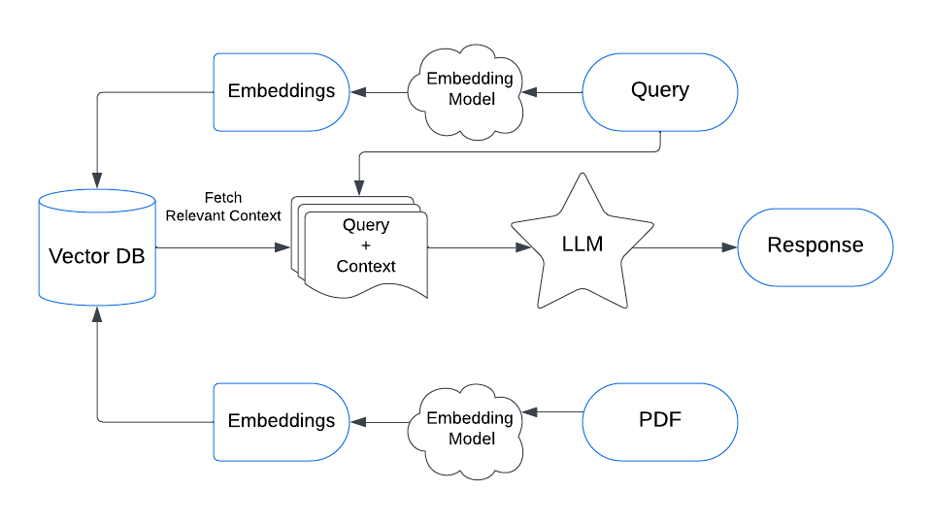

**2.2 Data collection:**

The AI Tutor system collects and processes educational data from various sources, including:

* Publicly available educational PDFs (textbooks, research papers).
* Pretrained language models (Hugging Face Transformer models).
* User queries submitted to the system for dynamic learning.
* Online knowledge bases for real-time fact retrieval.

For document-based responses, PyMuPDF (fitz) is used for text extraction from PDFs, ensuring that the system has access to structured learning material.

**2.3 Studying the Model:**

The AI Tutor system integrates state-of-the-art NLP models for text understanding and response generation. Key models include:

* Sentence-Transformers (***all-MiniLM-L6-v2***) – Generates vector embeddings for document retrieval.
* Pretrained LLMs (***BART***-based models) – Enhances response accuracy.
* Scikit-learn Cosine Similarity – Measures the relevance of retrieved documents.

The system leverages RAG (Retrieval-Augmented Generation), ensuring that AI-generated responses are grounded in factual, retrieved content rather than purely generative AI outputs.

**2.4 Implementing the model:**

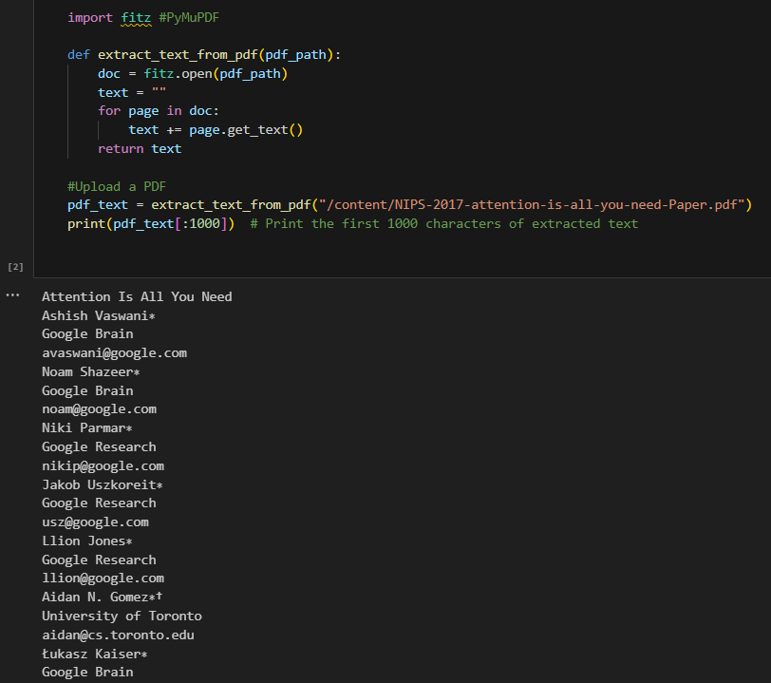

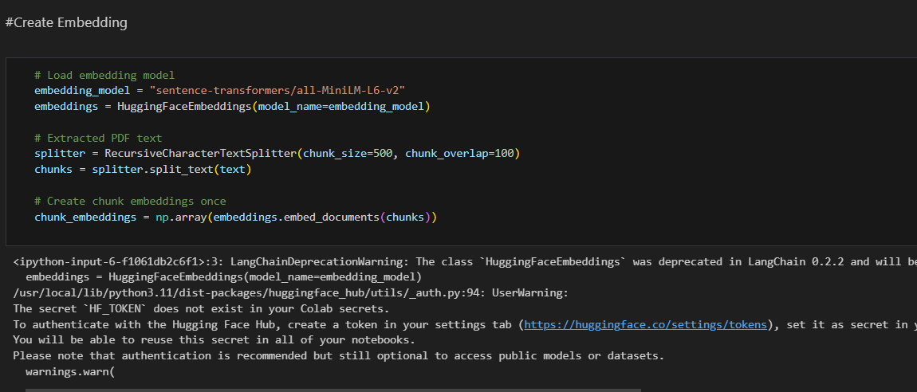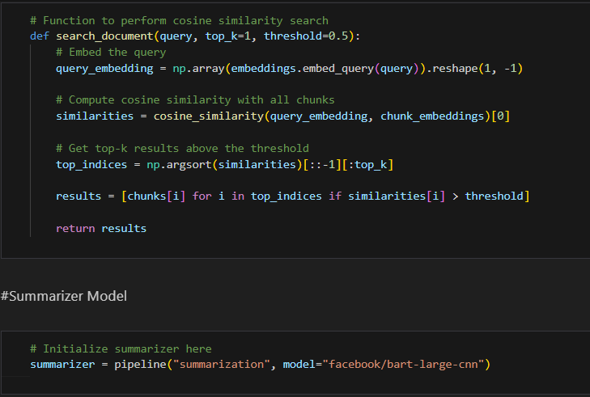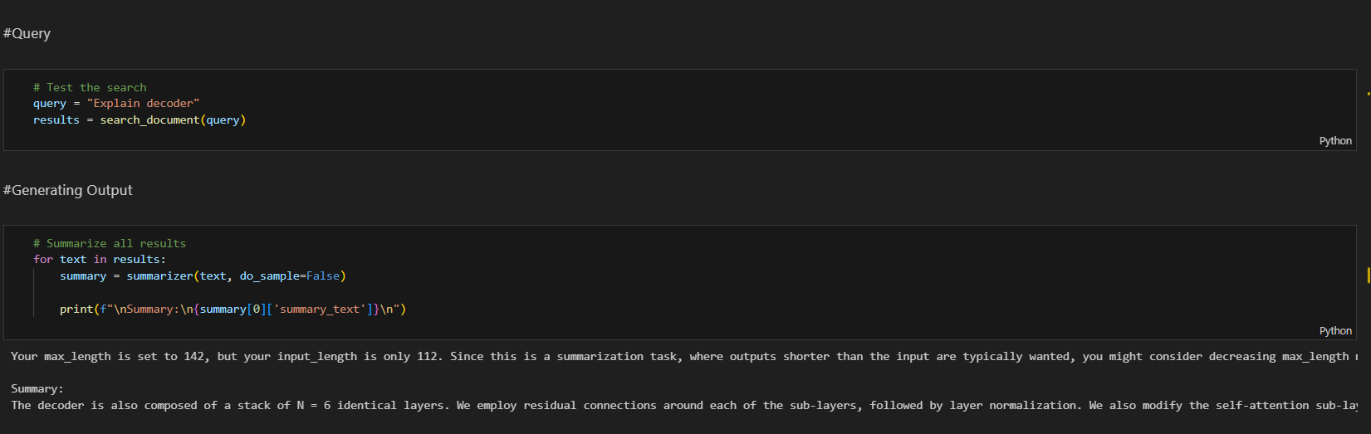

**2.5** **Validating the Model:**

The AI Tutor system undergoes rigorous testing to ensure response accuracy and retrieval efficiency. Manual evaluation is conducted by experts to assess AI-generated responses for correctness. Automated testing is performed using benchmark queries to measure accuracy scores. User feedback is integrated into the system to continuously refine responses based on real-world interactions. Additionally, robust error handling and debugging processes are implemented to identify failure cases and enhance overall system performance. These validation steps ensure that the AI Tutor provides reliable, high-quality educational assistance.

## 3.Model Description

### 3.1 Sentence Transformer model

### The Sentence Transformer model, specifically all-MiniLM-L6-v2, is a lightweight, pre-trained model designed for generating dense vector representations (embeddings) of sentences. It is based on the MiniLM architecture, which is a smaller, more efficient version of transformer models like BERT. The all-MiniLM-L6-v2 model is optimized to create embeddings that are suitable for a variety of tasks, including semantic textual similarity, information retrieval, and clustering.

### 3.2 Key features of all-MiniLM-L6-v2:

### Lightweight: It is designed to be fast and memory-efficient, making it suitable for real-time applications.

### High-quality embeddings: Despite being smaller, it provides high-quality sentence embeddings that are effective for tasks like semantic search, sentence classification, and similarity comparison.

### 6-layer architecture: The model consists of 6 transformer layers, which strikes a good balance between performance and efficiency.

### It is particularly useful for tasks where you need to embed sentences or documents into fixed-size vectors for tasks like cosine similarity search, semantic search, or clustering.

### Seamless: PySpark seamlessly integrates with Python libraries and tools such as NumPy, pandas, scikit-learn, TensorFlow, and more, allowing data scientists to leverage their existing Python skills and ecosystem.

Scalable: PySpark scales from a single machine to thousands of nodes, making it suitable for processing petabytes of data across large clusters.

Fault Toleance: Spark's built-in fault-tolerance mechanisms ensure reliable processing of data even in the presence of failures.

### 3.3 BART Transformer Model

The **BART (Bidirectional and Auto-Regressive Transformers)** model, specifically **facebook/bart-large-cnn**, is a transformer-based model developed by Facebook AI, primarily designed for **text generation** and **text understanding** tasks. It combines the benefits of **BERT** (bidirectional attention) and **GPT** (autoregressive generation) models. BART is especially effective for **sequence-to-sequence tasks** like **summarization**, **translation**, and **question answering**.

**3.4 Key Features of facebook/bart-large-cnn:**

* **Encoder-Decoder Architecture**: BART uses a typical encoder-decoder structure where the encoder reads the input (context) and the decoder generates output based on that.
* **Pre-training**: It is pre-trained using a denoising autoencoder approach, where random noise is added to the input text, and the model learns to reconstruct the original sentence. This helps it better handle corrupted or incomplete input text.
* **CNN-based for Summarization**: The **facebook/bart-large-cnn** variant is specifically fine-tuned for **text summarization** tasks, leveraging a large CNN (Convolutional Neural Network)-style attention mechanism, which helps it excel at generating coherent summaries of long documents.

deferred until an action is triggered, ensuring efficient execution. After completing your data processing tasks, it's important to stop the SparkSession to release resources using the spark.stop**()** method. Overall, the SparkSession in PySpark provides a powerful and flexible interface for distributed data processing, enabling developers to efficiently work with large-scale datasets.

**4.DATA FLOW**

**4.1 Data flow of project :**

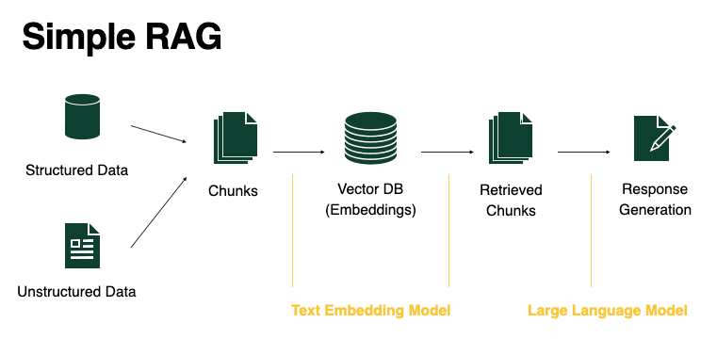



**1. Data Ingestion (Input Processing)**

* **User Query/Input:** The system receives a user query (e.g., "Explain multi-head attention" or "Generate exercises on linear algebra").
* **PDF/Text Source Processing:** If the system retrieves content from a document (such as textbooks or research papers), the PDF is loaded, and **PyMuPDF** extracts raw text.
* **Preprocessing:** The extracted text undergoes **cleaning**, **tokenization**, and **formatting** to ensure it is structured for further processing.

**2. Text Chunking and Embedding Generation**

* **Text Splitting:** Since large documents cannot be processed at once, **Langchain’s RecursiveCharacterTextSplitter** divides the text into smaller chunks.
* **Embedding Generation:** The **Sentence Transformer (all-MiniLM-L6-v2)** generates vector embeddings for each chunk.
* **Storage:** The embeddings are stored in a vector database or in-memory for similarity searches.

**3. Retrieval-Augmented Generation (RAG) Process**

* **Query Embedding:** When a user asks a question, it is also converted into an embedding using **sentence-transformers**.
* **Similarity Search:** The system performs a **cosine similarity search** between the query embedding and stored document embeddings to retrieve the most relevant text chunks.
* **Contextual Retrieval:** The top-matching chunks (above a similarity threshold) are selected to provide context for generating a response.

**4. Content Generation**

* **Summarization :** If the retrieved chunks are too long, **BART (facebook/bart-large-cnn)** is used to summarize the content.
* **Exercise and Solution Generation:** The refined information is sent to an **LLM**  which generates:
  + **Conceptual Explanations**
  + **Multiple-choice questions**
  + **Fill-in-the-blanks**
  + **Short answer questions**
  + **Detailed solutions with explanations**

**5. Output Delivery (Response Generation)**

* **Formatting:** The AI-generated responses are structured in a user-friendly format.
* **Displaying Results:** The final exercises and solutions are displayed on the UI or returned via API.
* **Iterative Feedback:** Users can refine their queries, request modifications, or ask follow-up questions.

**5.Tools Used in Project**

Following libraries are used in project:

**5.1 langchain**:

A framework that helps with building applications using large language models (LLMs) and retrieval-augmented generation (RAG). It is used here for text embeddings and document processing.

* from langchain.embeddings import HuggingFaceEmbeddings
* from langchain.text_splitter import RecursiveCharacterTextSplitter

**Document Processing**:

* Langchain provides tools for splitting, chunking, and embedding documents, making it easy to work with large volumes of text.
* It supports a variety of text splitters, such as **RecursiveCharacterTextSplitter**, to break text into smaller chunks suitable for embedding.

**Embeddings**:

* Langchain integrates with different embedding models, such as **Hugging Face embeddings** and **OpenAI embeddings**, to convert text into dense vector representations.
* These embeddings are then used for tasks like **semantic search**, **clustering**, and **similarity comparison**.

**Retrieval-Augmented Generation (RAG)**:

* Langchain enables RAG-based applications by allowing you to use LLMs along with external knowledge sources (such as embeddings and document databases).
* It provides easy ways to combine retrieved information with the model's generative capabilities, which is especially useful for question answering and summarization tasks.

**Chains and Agents**:

* Langchain allows you to create **chains** of operations, where multiple LLM calls or data transformations are linked together in a sequential workflow.
* **Agents** in Langchain are able to make decisions about which tools or models to use based on the context, enabling more dynamic and intelligent systems.

**Support for Multiple LLM Providers**:

* Langchain works with a variety of popular LLMs, such as **OpenAI GPT**, **Hugging Face models**, and others.
* This provides flexibility to developers to choose the best-suited model for their application.

**Integration with External Tools**:

* Langchain integrates with external databases, APIs, and storage solutions, allowing for knowledge retrieval from external sources like PDFs, websites, and structured data (e.g., databases, spreadsheets).

**Easy Deployment**:

* Langchain is designed to scale well in production environments, making it easier to deploy LLM-based solutions.

**5.2 langchain-community**:

**Langchain Community** is an open-source, community-driven extension of the Langchain framework. It includes additional features, integrations, and tools contributed by developers worldwide. The community enhances Langchain with custom modules, new embedding models, document processors, and integrations with various platforms. It's a space for collaboration, where developers share solutions, tutorials, and contribute to the development of the framework. Through this community, Langchain users can access more functionalities, such as advanced search mechanisms, new APIs, and specialized tools for different domains.

**5.3 pymupdf (fitz):**

**PyMuPDF** (also known as **fitz**) is a Python library for working with PDF, XPS, and other document formats. It allows you to extract text, images, and metadata from documents, as well as manipulate the content, such as merging, splitting, or rotating pages. It is fast, lightweight, and provides a simple API for handling PDF files. Some features are,

* **Text Extraction**: Extracts text from PDF documents, including handling different fonts, layouts, and structures.
* **Image Extraction**: Extracts images embedded within PDFs.
* **Document Manipulation**: Allows operations like merging PDFs, rotating pages, and modifying content.
* **Support for Multiple Formats**: In addition to PDFs, PyMuPDF supports XPS, EPUB, and other document types.

It is commonly used for tasks like PDF text extraction and manipulation, making it a useful tool in projects involving document processing.

**5.4 sklearn (scikit-learn):**

A machine learning library used here for computing **cosine similarity** between query embeddings and document chunk embeddings.

* from sklearn.metrics.pairwise import cosine_similarity

Scikit-learn is a popular Python library used for machine learning and data mining tasks. It's built on top of other scientific libraries like NumPy, SciPy, and matplotlib, and provides easy-to-use tools for data analysis, modeling, and evaluation. Here's an overview of its main features:

1. Supervised Learning:

* Scikit-learn includes a wide range of algorithms for supervised learning, where the goal is to predict an output variable (label) based on input data (features).
* Examples of supervised learning algorithms include:
  + **Classification**: Used to predict categorical outcomes. Examples: Decision Trees, Support Vector Machines (SVM), k-Nearest Neighbors (k-NN), Random Forest.
  + **Regression**: Used to predict continuous outcomes. Examples: Linear Regression, Ridge Regression, Lasso.

2. Unsupervised Learning:

* Unsupervised learning is used for tasks where there is no label and the goal is to find patterns in the data.
* Examples of unsupervised learning algorithms include:
  + **Clustering**: Grouping data points into clusters based on similarity. Examples: k-Means, DBSCAN.
  + **Dimensionality Reduction**: Reducing the number of features while retaining essential information. Examples: PCA (Principal Component Analysis), t-SNE.

3. Model Selection and Evaluation:

* Scikit-learn provides tools for evaluating the performance of models through techniques like cross-validation and metrics like accuracy, precision, recall, F1 score, and more.
* It also supports hyperparameter tuning (e.g., grid search and random search) to optimize model performance.

4. Preprocessing:

* Before applying machine learning algorithms, the data often needs to be cleaned, normalized, and transformed. Scikit-learn includes many preprocessing tools such as:
  + **Standardization**: Scaling features to have mean 0 and variance 1 (e.g., StandardScaler).
  + **Normalization**: Scaling data into a fixed range, often [0,1] (e.g., MinMaxScaler).
  + **Handling Missing Data**: Imputing missing values (e.g., SimpleImputer).

5. Pipeline:

* A pipeline in Scikit-learn allows you to chain multiple steps together, such as preprocessing, model fitting, and prediction, into one cohesive process. This helps in making the code more organized and avoids data leakage during cross-validation or model testing.

6. Model Persistence:

* Scikit-learn supports saving and loading trained models using joblib or pickle. This allows models to be reused without needing to retrain them every time.

7. Feature Engineering**:**

* It also provides tools for extracting useful features from raw data, such as CountVectorizer or TfidfVectorizer for text data, and tools for encoding categorical variables like OneHotEncoder.

8. Other Utilities:

* Scikit-learn also has utilities for generating synthetic datasets, working with sparse matrices, and feature selection.

Overall, Scikit-learn is known for its user-friendly interface and its ability to quickly build and evaluate machine learning models, making it one of the most commonly used libraries in the field.

**5.5 numpy:**

A library for numerical computations, used for handling and manipulating embeddings as arrays.

* import numpy as np

**NumPy** (Numerical Python) is an open-source Python library that provides support for working with **large, multi-dimensional arrays and matrices**, along with a collection of **mathematical functions** to operate on these arrays. It is the foundational package for numerical computing in Python and is widely used in fields like data analysis, machine learning, scientific computing, and engineering. Feature of numpy are

1. N-dimensional Arrays:
   * NumPy introduces the ndarray object, which is a powerful N-dimensional array. This allows you to store and manipulate large datasets efficiently.
   * Unlike Python's built-in lists, NumPy arrays are **homogeneous** (all elements are of the same data type) and support **vectorized operations** for fast computation.
2. Efficient Array Operations:
   * NumPy allows you to perform element-wise operations on arrays (such as addition, subtraction, multiplication, and division) efficiently. These operations are typically faster than looping through lists manually.
   * Supports **broadcasting**, which enables arithmetic operations between arrays of different shapes in a way that avoids the need for explicit looping.
3. Mathematical Functions:
   * NumPy provides a wide range of mathematical functions for operations like linear algebra, statistical analysis, Fourier transforms, and random number generation.
   * Some common functions include:
     + **Linear Algebra**: dot(), inv(), eig(), linalg.solve()
     + **Statistical Functions**: mean(), std(), sum(), var(), median()
     + **Random Number Generation**: random.rand(), random.randint(), random.normal()
4. Shape Manipulation:
   * NumPy allows you to reshape arrays, add or remove dimensions, and perform other operations such as transposition, stacking, and splitting using functions like reshape(), concatenate(), transpose(), etc.
   * This makes it highly flexible for manipulating data for machine learning, image processing, etc.
5. Integration with Other Libraries:
   * NumPy arrays serve as the foundation for other popular libraries, such as **pandas** (for data manipulation), **scikit-learn** (for machine learning), and **matplotlib** (for plotting).
   * Many scientific libraries and frameworks are built around NumPy's data structures, which is why it's considered the backbone of numerical computing in Python.
6. Memory Efficiency:
   * NumPy arrays are more memory efficient than Python lists because they use contiguous blocks of memory and are of a fixed size.
   * The library also provides tools for handling large datasets by using techniques like memory mapping with np.memmap for reading large files without loading them entirely into memory.
7. Vectorization:
   * NumPy supports **vectorized operations**, meaning you can apply operations on entire arrays without the need for explicit loops. This leads to more concise and faster code.

**5.6 transformers**:

A library by Hugging Face used for natural language processing tasks like text summarization. The BART model is used here for summarization.

* from transformers import pipeline

Common Use Cases of Transformers:

1. Text Classification:
   * **Sentiment Analysis**: Classifying text as positive, negative, or neutral.
   * **Spam Detection**: Identifying whether a message is spam or not.
   * **Topic Classification**: Classifying text based on its topic or subject.
2. Text Generation:
   * **Chatbots and Conversational AI**: Generating responses in a dialogue system using models like GPT-3.
   * **Story Generation**: Creating text based on a prompt or theme.
3. Question Answering:
   * Using a context and a question, transformer models can extract or generate the correct answer. For example, **SQuAD** (Stanford Question Answering Dataset) models.
4. Translation:
   * Machine translation between different languages using models like **T5** and **MarianMT**.
5. Text Summarization:
   * **Abstractive Summarization**: Generating a summary that may include rephrased sentences (e.g., using **BART**).
   * **Extractive Summarization**: Selecting the most important sentences from a document.
6. Named Entity Recognition (NER):
   * Extracting entities such as names, dates, and locations from text.
7. Speech and Audio Processing:
   * Some transformer models are also applied to speech-to-text and other audio-based tasks.

**6.Project Requirements**

**6.1 Hardware Requirement:**

1. 500 GB hard drive (Minimum requirement)

2. 8 GB RAM (Minimum requirement)

3. PC x64-bit CPU

4. Internet with minimum speed 5 Mbps

**6.2 Software Requirement:**

1. Operating System (Windows/Mac/Linux)

2. Python with version 3.9 or above

3. Python Libraries

* langchain-community
* PyMuPDF
* Scikit-learn
* Numpy
* Transformers

4. For coding VS code/Anaconda/spider

5. Web browser like Google Crome / Mozilla Firefox

6. Google Colab or Jupyter Notebook

**7.Future Scope**

The AI Tutor project that generates exercises and solutions using Large Language Models (LLM) and Retrieval-Augmented Generation (RAG) has a lot of exciting potential for the future. Here are some possible future directions and scope for this project:

**1. Personalized Learning:**

* Adaptive Content Generation: AI tutors can adapt to the learning pace and style of individual students. For example, the AI could generate exercises and solutions based on the student's previous answers, providing targeted content to address their weaknesses.
* Dynamic Difficulty Adjustment: The AI could assess a learner's progress and adjust the difficulty level of exercises accordingly, ensuring a continuous learning curve.
* Customizable Learning Paths: Students could specify their learning goals, and the AI tutor could generate a custom curriculum with exercises, assessments, and solutions tailored to those goals.

**2. Cross-Subject and Multi-Disciplinary Learning:**

* The AI Tutor could support a wide range of subjects (e.g., math, science, literature, history, language learning) by generating domain-specific exercises.
* Cross-disciplinary exercises could be generated, combining knowledge from different subjects to offer holistic learning experiences (e.g., integrating physics with coding or math with language).

**3. Multilingual and Multicultural Education:**

* The AI could generate exercises in multiple languages, making education accessible to learners from various linguistic backgrounds. This would allow students to study in their native language or learn new languages through targeted exercises.
* It could be customized to cater to various cultural contexts by adjusting content, examples, and solutions to be region-specific or culturally sensitive.

**4. Real-Time Feedback and Assessments:**

* The AI tutor could offer real-time feedback on exercises and solutions, helping students understand their mistakes and guiding them toward the correct answers.
* It could analyze student responses and provide instant hints, explanations, or even step-by-step solutions, fostering active learning and problem-solving skills.

**5. AI-Assisted Teacher and Educator Support:**

* AI tutors could be used to assist teachers in creating lesson plans, quizzes, and homework assignments by automatically generating a wide variety of exercises and solutions.
* For teachers, AI can help in grading assignments, analyzing student performance, and providing additional learning materials to students who need extra help.

**6. Ethics, Bias Mitigation, and Inclusivity:**

* Future work could focus on ensuring that the AI tutor is ethically sound and free from bias, providing fair opportunities for all learners.
* Efforts can be made to ensure inclusivity by designing the AI to be sensitive to issues like gender, race, and socioeconomic background, providing an equal learning environment for all students.
* Peer-to-peer learning could be encouraged, where students can share their solutions and discuss concepts with each other, with the AI providing guidance and feedback on group discussions.

**7. AI-Tutor for Professional Development:**

* In addition to K-12 or university students, the AI tutor could also be adapted for professional development, helping adults and employees learn new skills, such as programming, data science, project management, etc.
* It could also provide certification exams and coursework for various industries (e.g., healthcare, finance, technology), allowing learners to gain recognized credentials.

**8. Global Scaling and Educational Access:**

* AI tutors can help bridge the gap in regions with limited access to qualified teachers, offering quality education to underserved populations.
* The tutor could be scaled globally, providing affordable and accessible education to anyone with an internet connection.

**8.Conclusion**

The **AI Tutor** project leverages **Large Language Models (LLM)** and **Retrieval-Augmented Generation (RAG)** to create personalized, scalable educational tools that generate custom exercises and solutions. By providing real-time feedback, the AI Tutor adapts to each learner's pace, improving engagement and efficiency.

It enhances accessibility, particularly for underserved regions, and supports teachers by automating tasks like quiz generation and grading. With future possibilities like **gamification**, **VR**, and **adaptive learning**, the AI Tutor has the potential to revolutionize education, making learning more personalized, interactive, and widely accessible.

**9.References**

* 1. Vaswani et al., "Attention Is All You Need" (2017), which introduces the Transformer architecture.
  2. Lewis et al., "Retrieval-Augmented Generation for Knowledge-Intensive NLP Tasks" (2020).
  3. *"MiniLM: Deep Self-Attention Distillation for Speech Recognition"* by W. Wang et al.
  4. Hugging Face Transformers Documentation:

<https://huggingface.co/docs/transformers>

* 1. <https://scikit-learn.org/0.21/tutorial/index.html>