SPORTS CLUB MANAGEMENT SYSTEM

DATA FLOW DIAGRAM

ZERO LEVEL DFD FOR SPORTS CLUB MANAGEMENT SYSTEM

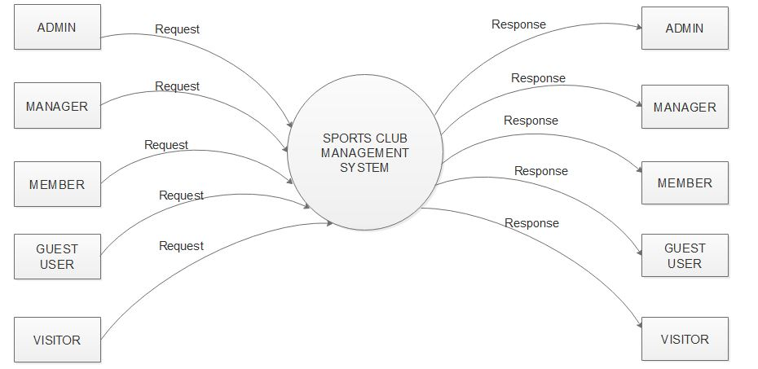

LEVEL1 DFD FOR ADMIN

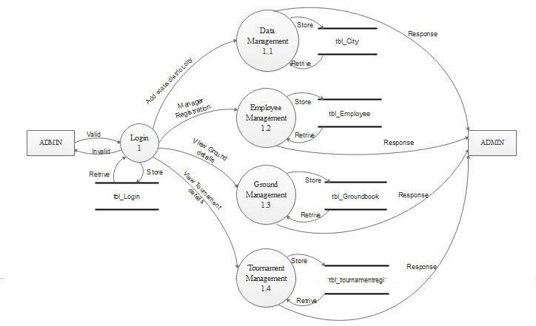

LEVEL1 DFD FOR MANAGER

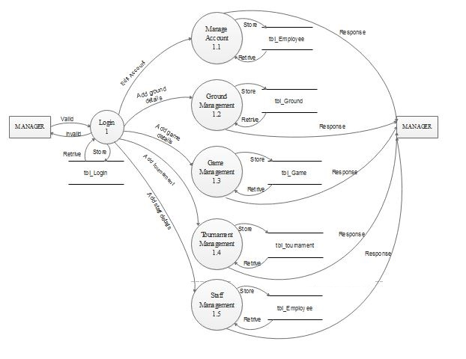

LEVEL1 DFD FOR MEMBER

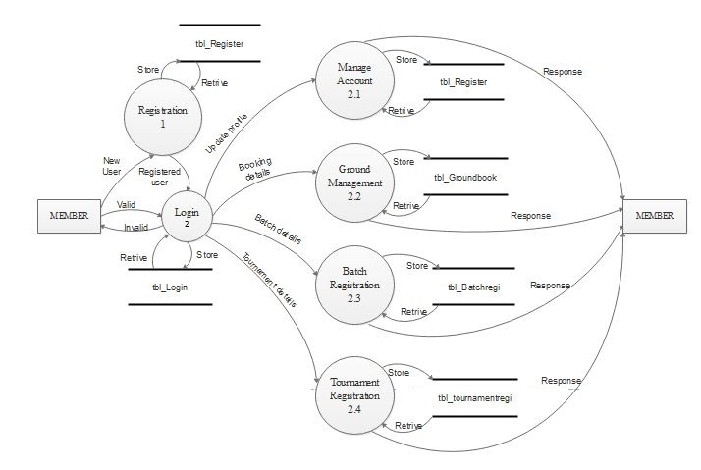

LEVEL1 DFD FOR GUEST USER

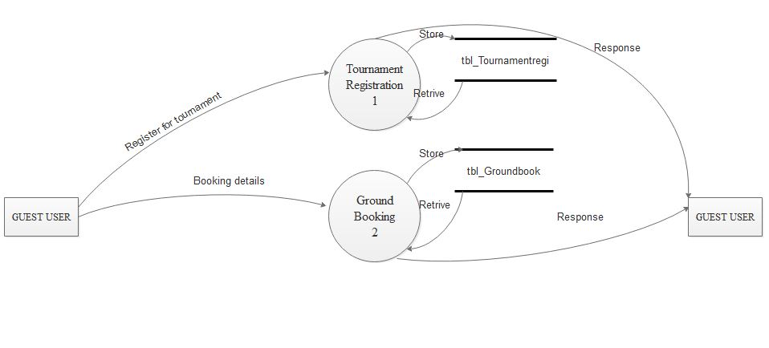

LEVEL2 DFD FOR PROCESS NUMBER 1.1 OF ADMIN

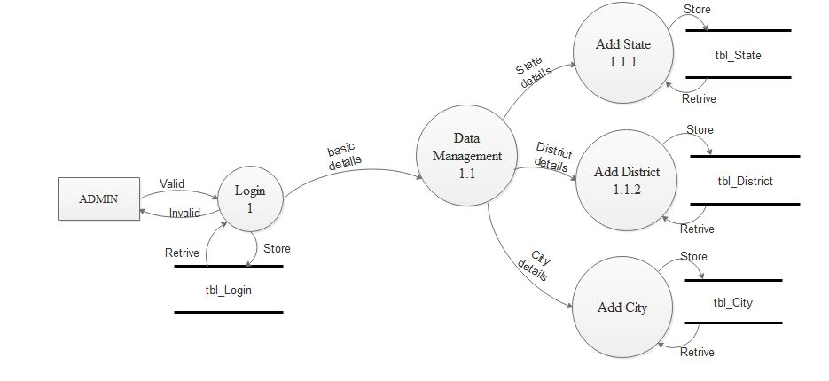

LEVEL2 DFD FOR PROCESS NUMBER 1.2 OF ADMIN

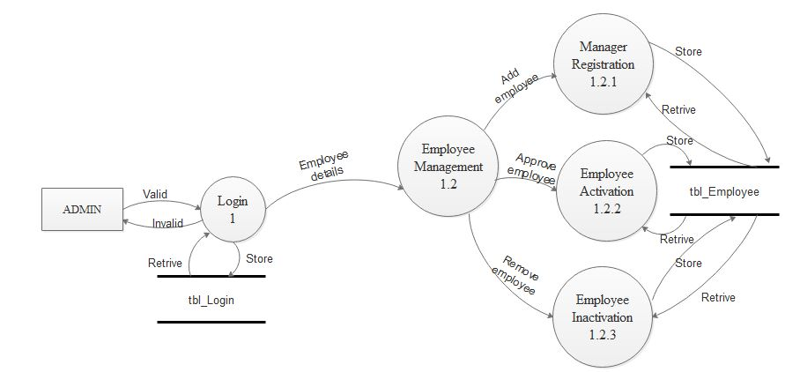

LEVEL2 DFD FOR PROCESS NUMBER 1.2 OF MANAGER

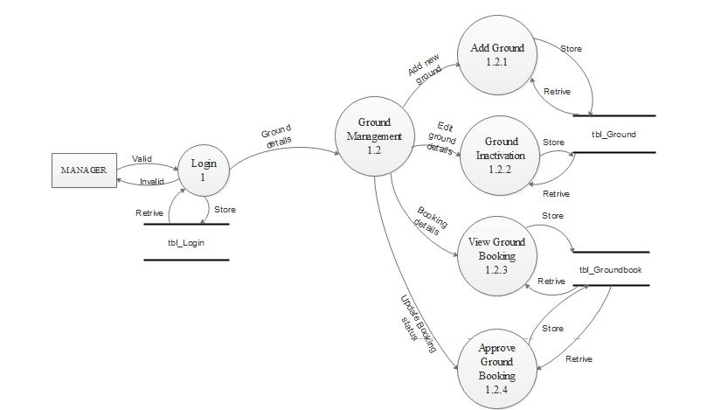

LEVEL2 DFD FOR PROCESS NUMBER 1.3 OF MANAGER

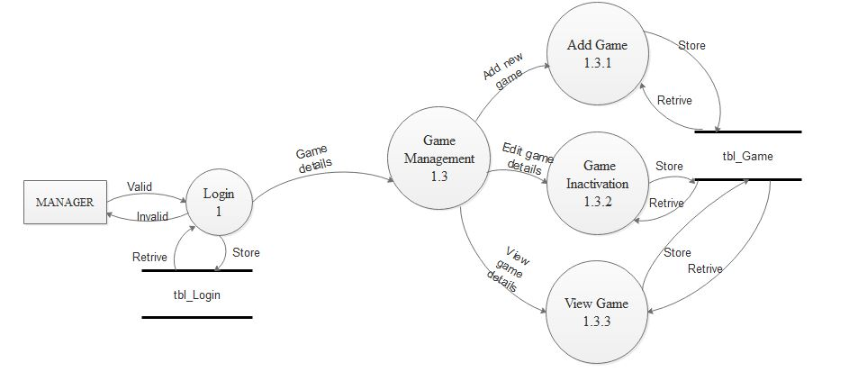

LEVEL2 DFD FOR PROCESS NUMBER 1.4 OF MANAGER

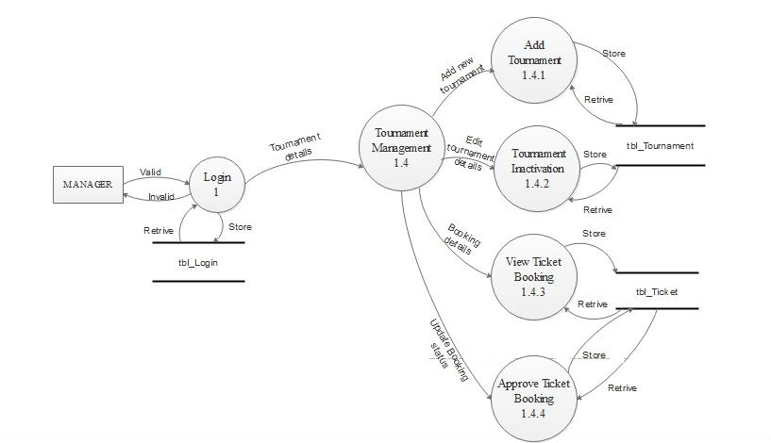

LEVEL2 DFD FOR PROCESS NUMBER 2.1 OF MEMBER

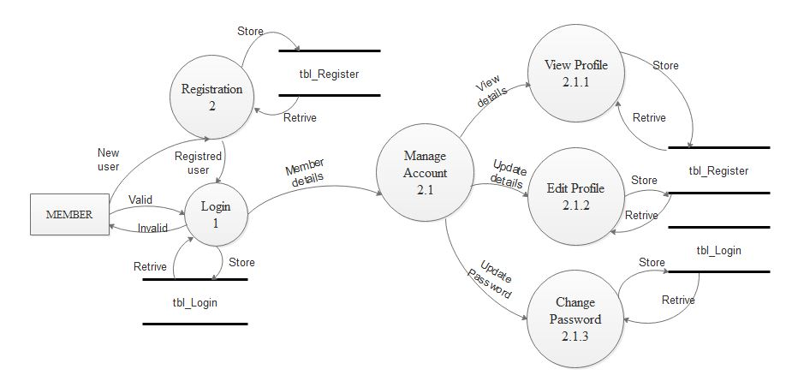

LEVEL2 DFD FOR PROCESS NUMBER 2.2 OF MEMBER

