
Rizvi Education Society’s
Rizvi College of Engineering
Department of Artificial Intelligence and Data Science Engineering
Project Synopsis Report
on
Campus Complaint Router: NLP-Based Department Routing and Urgency Detection of Student Complaints

Submitted in partial fulfilment of the requirements
of the degree of
Bachelors of Engineering
by
Reshma Malik (231A031)

Guide:
Prof. Vijay Shanker

University of Mumbai
2026 - 2027

Abstract

Educational institutions receive a steady stream of student complaints about hostels, libraries, canteens, examinations, transport and IT services. In most colleges these complaints arrive through email, forms and messaging apps and are read and forwarded to the responsible department by hand. This is slow, prone to mis-routing, and lets urgent problems such as contaminated food or water leakage wait in the same queue as minor issues. With growing student numbers and digital communication, automating this first step of grievance handling is a need of the hour. This project, Campus Complaint Router, applies Natural Language Processing and machine learning to read a complaint written in plain English, predict the department that should handle it, report a confidence score, and flag its urgency as HIGH or NORMAL. The text is cleaned and converted into TF-IDF features, and a Logistic Regression classifier is compared with a Multinomial Naive Bayes baseline on a dataset of 96 complaints spread equally over six departments. On a held-out test set of 24 complaints the two models reached 88% and 92% accuracy respectively, above the 85% target. The system is delivered as a Flask web application that also shows the words behind each decision, so that staff can verify every routing.

Keywords: Natural Language Processing, Text Classification, TF-IDF, Logistic Regression, Naive Bayes, Complaint Routing, Urgency Detection, Flask


Rizvi Education Society’s
Rizvi College of Engineering

Off Carter Road, Bandra(W), Mumbai-400050

Department of Artificial Intelligence and Data Science Engineering
Certificate
This is to certify that the Mini-Project Synopsis Report entitled ‘Campus Complaint Router: NLP-Based Department Routing and Urgency Detection of Student Complaints’ is a bonafide work of Reshma Malik Shafaat (231A031) submitted to the University of Mumbai in partial fulfillment of the requirement for the Mini-Project of Natural Langauge Processing Lab for Fourth Year of the Bachelor of Engineering in “Artificial Intelligence & Data Science” which has been submitted by

Reshma Malik (231A031)

under the guidance of Prof. Vijay Shanker

in partial fulfillment of the requirement for the award of the Degree of Bachelor of Engineering in Artificial Intelligence and Data Science Engineering – Year 2026-27 Semester VII from University of Mumbai under the syllabus scheme R2019C.

Certified By
Prof. Vijay Shanker
Project Guide
Prof. Junaid Mandviwala  Head of Department |  | Dr. Varsha Shah  Principal

Index
Sr. No | Title | Page No
1. | Introduction | 1
2. | Literature Survey | 2
2.1 | Survey of Existing Systems | 2
2.2 | Limitations of Existing Systems / Research Gap | 3
2.3 | Problem Statement and Objectives | 4
2.4 | Scope | 4
3. | Proposed System | 6
3.1 | Analysis / Framework / Algorithm | 6
3.2 | Details of Hardware and Software | 8
3.3 | Design Details | 8
3.4 | Methodology | 11
3.5 | Relevance to PO and PSO of the Department | 11
4. | Implementation Plan, Status and Proposed Cost | 13
4.1 | Implementation Plan | 13
4.2 | Present Status | 13
4.3 | Proposed Cost of the Project | 13
4.4 | Gantt Chart | 14
5. | Results | 15
5.1 | Model Performance | 15
5.2 | Sample Predictions | 16
5.3 | Web Application Screenshots | 16
5.4 | Observations | 18
6. | Conclusion | 19
7. | References | 20
 | Appendix-I | 21
 | Acknowledgement | 23

Chapter 1: Introduction

Campus Complaint Router is a Natural Language Processing project that reads a student’s complaint written in plain English and automatically routes it to the correct college department: Hostel, Library, Canteen, Exam, Transport or IT. It also flags the complaint as HIGH or NORMAL urgency and highlights the words behind the decision. The system uses TF-IDF features with Logistic Regression and is delivered through a simple Flask web application for easy use by staff.
Chapter 2: Literature Survey

2.1 Survey of Existing Systems
Existing practice in colleges. In most colleges a complaint is submitted by email, on a paper or online form, or through a messaging group. A staff member reads it and forwards it to the department concerned. Some online grievance forms ask the student to choose a category from a drop-down list, which moves the sorting work to the student, who may not know which department is responsible. Helpdesk and ticketing tools commonly offer routing rules based on fixed keywords, and these rules must be written and maintained by hand.
Research on automatic text classification. Automatically assigning a piece of text to one of several predefined categories is a well-studied problem. Table 2.1 summarises the work that the present project builds on.
Table 2.1: Survey of existing work on text classification
Ref. | Technique / contribution | Relevance and limitation for this project
[1] Salton and Buckley, 1988 | Term-weighting for text retrieval: a word is weighted by how often it occurs in a document and how rare it is across the collection (the basis of TF-IDF). | Used for feature extraction. Gives numbers to words but ignores word order and meaning.
[2] Sebastiani, 2002 | Survey of machine-learning methods for automatic text ategorization, showing the shift from hand-written rules to classifiers learned from labelled examples. | Justifies the supervised approach. It is a general survey and does not address short campus complaints.
[3] McCallum and Nigam, 1998 | Compares event models of Naïve Bayes for text; the multinomial model performs well on larger vocabularies. | Used as the baseline model. Assumes that words are independent of each other given the class.
[4] Joachims, 1998 | Applies Support Vector Machines to text ategorization and explains why linear models suit high-dimensional, sparse text features. | Supports the choice of a linear model. SVMs do not give class probabilities directly.
[5] Devlin et al., 2019 | BERT: deep bidirectional transformer pre-trained on large text and fine-tuned for many language tasks with state-of-the-art results. | Understands context better, but needs more data and computing power and is harder to explain. Kept as future work.
[6] Ribeiro et al., 2016 | LIME: explains individual predictions of any classifier so that users can decide whether to trust them. | Motivates explainability. This project uses the built-in word weights of a linear model instead of a separate explainer.

2.2 Limitations of Existing Systems / Research Gap
• Manual reading and forwarding is slow and can send a complaint to the wrong department.
• Urgent complaints, for example food poisoning or water leakage, are not separated from minor ones and may wait in the same queue.
• Drop-down categories depend on the student knowing the correct department, and fixed keyword rules are brittle and give no confidence value.
• General text-classification studies do not target short, informal campus complaints, and they do not combine department routing with urgency flagging.
• Deep learning models need large labelled datasets and computing power, and they give little insight into why a decision was made.
• Many simple classifier demonstrations return only a label, without a confidence score, the influencing words or a warning when the model is unsure.
Research gap: there is a need for a lightweight system that can be trained on a small dataset, routes a complaint to a department, flags its urgency, and explains its decision, all through an easy-to-use web interface.
2.3 Problem Statement and Objectives
Problem statement: Given a short complaint written by a student in free English text, automatically (a) identify which of six college departments should handle it and (b) decide whether it needs urgent attention, in a way that staff can understand and verify.
Objectives:
1. To identify the correct department (Hostel, Library, Canteen, Exam, Transport or IT) for a complaint.
2. To mark each complaint as HIGH or NORMAL urgency so that urgent problems are seen first.
3. To achieve at least 85% accuracy on complaints that the model has never seen during training.
4. To compare two learning methods, Multinomial Naïve Bayes and Logistic Regression, on the same test data.
5. To make every decision explainable by showing the confidence, the words that influenced the prediction and a low-confidence warning.
6. To provide a simple web interface through which a complaint can be entered and the result viewed.
2.4 Scope
In scope:
• English complaints of one or two sentences (up to 500 characters).
• Six departments: Hostel, Library, Canteen, Exam, Transport and IT, with one department predicted per complaint.
• A small dataset of 96 complaints, with the model trained on a personal computer.
• Two urgency levels, HIGH and NORMAL, decided by a rule-based keyword list.
• A local web application with confidence score, department score chart, keyword explanation, session history and CSV download.
Out of scope (future work): Hindi and Marathi complaints, voice input, complaints that belong to more than one department, learned (non-rule-based) urgency detection, and online deployment for real use.
Chapter 3: Proposed System

3.1 Analysis / Framework / Algorithm
Requirement analysis. The system must accept a complaint of up to 500 characters and return the predicted department, a confidence percentage, the urgency level, the urgent words found, the top influencing words and the score of every department. It must reject empty or over-long input without crashing, keep a session history that can be downloaded as a CSV file, and use no personal data. It should be easy to install and run on an ordinary laptop.
Framework. The project follows the classical supervised text-classification pipeline: (1) text pre-processing, (2) feature extraction with TF-IDF, (3) classification with a learned model and (4) a separate rule-based urgency check. The model is evaluated on unseen data and then served through a web application.
Algorithms used.
(a) Text cleaning. The complaint is converted to lower case, everything except letters is replaced by a space (regular expression [^a-z\s]), the text is split into words (tokenisation), and English stop-words such as “the”, “is” and “in” are removed using the scikit-learn stop-word list.
(b) TF-IDF features. Each cleaned complaint becomes a vector of unigram and bigram scores (for example “hot”, “water” and “hot water”). The score of a term t in a complaint d is:
tf-idf(t, d) = tf(t, d) × idf(t), idf(t) = ln[(1 + n) / (1 + df(t))] + 1
where tf(t, d) is the number of times t occurs in d, n is the number of complaints, and df(t) is the number of complaints that contain t. Each vector is then normalised to unit length. The vocabulary is learned from the training data only, to avoid data leakage.
(c) Logistic Regression (final model). For each department c the model learns a weight vector w_c and bias b_c, and gives the probability of the department using the softmax function:
P(c | x) = exp(w_c · x + b_c) / Σ_k exp(w_k · x + b_k)
The department with the highest probability is the prediction, and this probability is shown as the confidence. Logistic Regression was chosen as the final model because it gives probabilities and learned word weights, which make the decision explainable.
(d) Multinomial Naive Bayes (baseline). This model counts how often words occur in each department and applies Bayes’ rule with the assumption that words are independent given the department:
P(c | d) ∝ P(c) × Π_t P(t | c)^{n(t, d)}
(e) Urgency detection (rule based). After cleaning, the complaint is marked HIGH if it contains at least one word from the urgent-word list, otherwise NORMAL. The list used by the web application is: urgent, urgently, asap, emergency, immediately, sick, fire, unsafe, danger, accident, tomorrow, today, leakage, broke, blocked, insect and rash. This part uses no machine learning.
(f) Explanation and low-confidence warning. For the predicted department, the contribution of each word is its TF-IDF value multiplied by the learned weight for that department; the three largest positive contributions are shown to the user. If the highest probability is below 30%, the page warns that the routing should be checked manually.
Algorithm summary.
Training:
1. Load complaints.csv (columns: text, department) and clean every complaint.
2. Split into 75% training and 25% testing data, stratified by department (random_state = 42).
3. Fit the TF-IDF vectoriser on the training data and transform both parts.
4. Train Naive Bayes and Logistic Regression; measure accuracy, precision, recall, F1 and the confusion matrix on the test data.
Prediction:
1. Clean the incoming complaint in the same way as the training data and convert it with the fitted vectoriser.
2. Obtain the probability of every department, select the highest one and compute the top keywords.
3. Run the urgent-word check and return department, confidence, urgency, keywords and all scores to the web page.
3.2 Details of Hardware and Software
Table 3.1: Hardware requirements
Component | Requirement
Computer | Personal computer or laptop; no GPU is needed
Processor | Dual-core processor or better
Memory | 4 GB RAM or more
Storage | About 1 GB of free disk space for Python and libraries
Network | Internet is needed only to install packages and to load Chart.js for the bar chart

Table 3.2: Software and tools
Software / tool | Purpose
Python 3 | Programming language for the whole project; the re module is used for text cleaning
Pandas | Loads complaints.csv and handles the data table
scikit-learn | TF-IDF vectoriser, stop-word list, train/test split, Naive Bayes, Logistic Regression and evaluation metrics
Matplotlib | Draws and saves the confusion matrix
Flask | Lightweight web server that connects the web page to the model
HTML, CSS, JavaScript | Builds the web page and sends requests to the server
Chart.js | Draws the bar chart of department scores in the browser
Web browser | Used to open the application at http://127.0.0.1:5000
GitHub | Source-code hosting and version control

3.3 Design Details
System architecture. Figure 3.1 shows the overall flow. The student types a complaint on the web page; the Flask server (app.py) validates it and passes it to the NLP model (model.py), which returns the department and urgency; the result is displayed on the page. Inside the model, the cleaned text follows two parallel branches: a machine-learning branch for the department and a rule-based branch for the urgency.
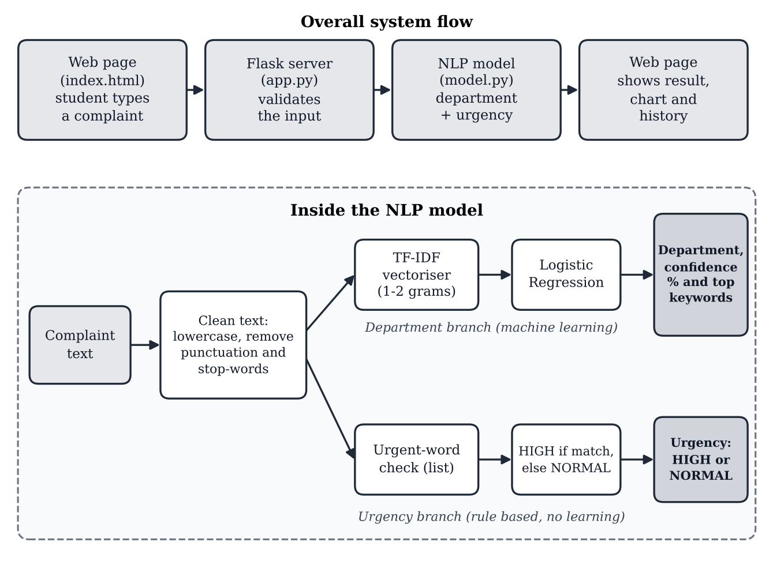
Fig. 3.1: System architecture and flow of the Campus Complaint Router
Module design.
Table 3.3: Project modules
File | Role
app.py | Flask server with three routes; validates the input and returns JSON
model.py | Cleaning, TF-IDF, Logistic Regression, urgency rule, keyword explanation; trains once when the server starts
complaint_router.py | Stand-alone script that trains and compares both models and prints the accuracy report and confusion matrix
complaints.csv | Dataset of 96 labelled complaints (columns: text, department)
templates/index.html | Web page layout
static/style.css, static/script.js | Styling, and browser logic: sends the complaint, shows the result, bar chart, history and CSV download

Data design. The dataset is a CSV file with two columns, text and department. It holds 96 short complaints, 16 for each of the six departments, so the classes are balanced. The data is synthetic: it was written for this project with AI assistance and contains no real student data or personal information.
Interface and server design. The server exposes three routes (Table 3.4). Empty input and input longer than 500 characters return an error message, and any unexpected failure is caught and returned as a server error instead of crashing the application. The page (Figure 3.2) provides sample complaints, the predicted department with a coloured urgency badge, the confidence, the complaint with urgent words highlighted, the influencing keywords, a bar chart of all department scores and a session history table.
Table 3.4: Server routes
Route | Method | Purpose
/ | GET | Serves the web page
/api/samples | GET | Returns six sample complaints for the quick-try buttons
/predict | POST | Accepts the complaint text and returns department, confidence, low-confidence flag, urgency, urgent words, keywords and all department scores

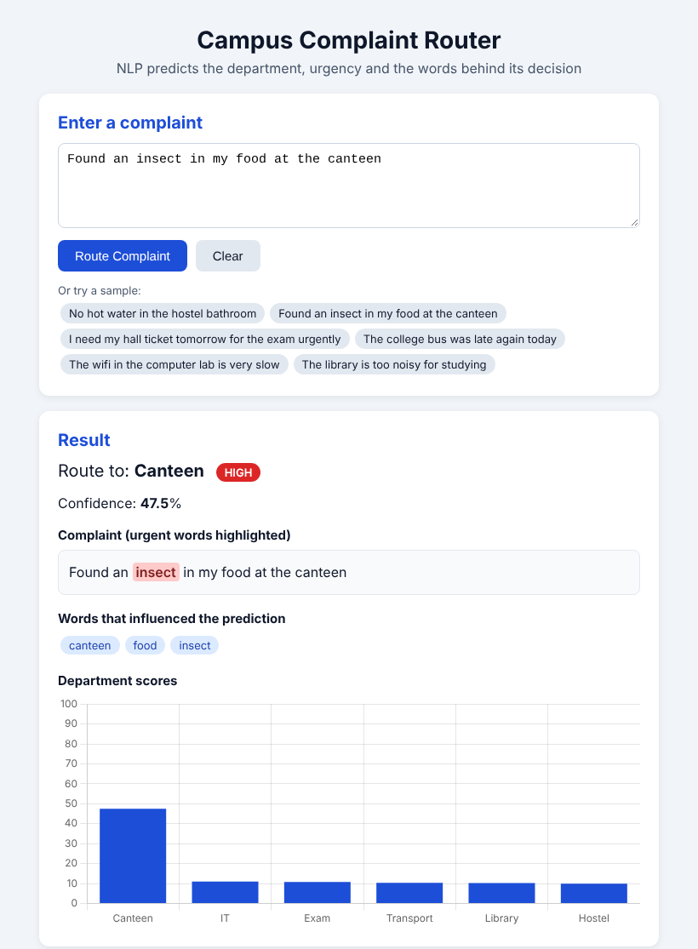
Fig. 3.2: Web interface routing a sample complaint (Canteen, HIGH urgency)
3.4 Methodology
The problem is solved with the following approach.
1. Collect data. A dataset of 96 short complaints, 16 for each of the six departments, was prepared and saved as complaints.csv.
2. Clean the text. Complaints are lower-cased, punctuation and digits are removed, the text is tokenised and stop-words are removed.
3. Split the data. 75% (72 complaints) is used for training and 25% (24 complaints) is kept for testing, stratified by department with a fixed random seed of 42, so every run gives the same split.
4. Convert words to numbers. TF-IDF with unigrams and bigrams is fitted on the training data only and applied to the test data.
5. Train two models. Multinomial Naive Bayes (baseline) and Logistic Regression are trained on the same features.
6. Evaluate. Both models are tested on the 24 unseen complaints using accuracy; the final model is also evaluated with precision, recall, F1-score and a confusion matrix.
7. Add urgency and explanation. The rule-based urgent-word check, the keyword explanation and the low-confidence warning are added to the prediction function.
8. Deploy locally. The web application trains the final Logistic Regression model on all 96 complaints when the server starts, and serves predictions through the browser. The held-out evaluation is reported by complaint_router.py.
3.5 Relevance to PO and PSO of the Department
The project is mapped to the Programme Outcomes (POs) for engineering graduates and to the Programme Specific Outcomes (PSOs) of the Artificial Intelligence and Data Science programme in Table 3.5.
Table 3.5: Mapping of the project to POs and PSOs
Outcome | How the project addresses it
PO1 Engineering knowledge | Applies mathematics, probability and computing knowledge (TF-IDF, softmax, Bayes’ rule) to a real problem.
PO2 Problem analysis | Analyses how complaints are handled manually and identifies delay, mis-routing and missed urgency as the problems.
PO3 Design and development of solutions | Designs and builds a complete NLP pipeline and web application with explainable output.
PO4 Investigation of complex problems | Compares two models on unseen data and studies the errors using a confusion matrix.
PO5 Modern tool usage | Uses Python, scikit-learn, Pandas, Flask and Chart.js.
PO6 The engineer and society | Helps students get faster replies and helps staff see urgent problems first.
PO8 Ethics | Uses synthetic data with no personal information, and states that predictions need human review before real decisions.
PO10 Communication | Documents the work in this report and presents it with slides and a live demonstration.
PO11 Project management | Follows a phased plan with a Gantt chart (Chapter 4).
PO12 Life-long learning | Learning NLP techniques and planning extensions such as transformer models and multilingual support.
PSO1 | Applies data science and machine learning techniques to analyse data and build predictive models.
PSO2 | Designs, develops and deploys an AI-based application using modern tools to solve a real-world problem.

Chapter 4: Implementation Plan, Status and Proposed Cost
4.1 Implementation Plan
The work is divided into ten phases over the academic year 2026-27 (August to April). Phases 1 to 5 are complete, and phases 6 to 10 are planned extensions. The schedule is shown as a Gantt chart in Section 4.4.
Table 4.1: Implementation phases
Phase | Activity | Period | Status
P1 | Problem study and literature survey | Aug – Sep | Completed
P2 | Dataset creation (96 complaints) and text pre-processing | Sep | Completed
P3 | TF-IDF, Naive Bayes and Logistic Regression; evaluation | Sep – Oct | Completed
P4 | Flask web application with explanation features | Oct | Completed
P5 | Synopsis report | Oct | Completed
P6 | Dataset expansion and cross-validation | Nov – Dec | Planned
P7 | Hindi/Marathi support and comparison with a transformer model | Dec – Feb | Planned
P8 | Learned urgency classifier | Jan – Feb | Planned
P9 | Deployment and user testing | Mar | Planned
P10 | Final report and paper | Mar – Apr | Planned

4.2 Present Status
The following work has been completed: the dataset, the cleaning and TF-IDF pipeline, both classifiers, the evaluation script, the rule-based urgency detector and the complete Flask web application with its keyword explanation, score chart, history table, CSV download and input validation. The results of the completed work are given in Chapter 5.
Remaining work: enlarge the dataset with real, anonymised complaints and use cross-validation, add Hindi and Marathi, try a transformer model such as BERT, learn the urgency from data, and deploy the application for user testing.
4.3 Proposed Cost of the Project
The project uses open-source software and a computer that is already available, so the additional cost is very small (Table 4.2). The amounts are estimates.
Table 4.2: Estimated cost
Item | Details | Cost (INR)
Computer / laptop | Already owned, no new purchase | 0
Software and libraries | Python, scikit-learn, Pandas, Flask, Matplotlib and Chart.js are free and open source | 0
Dataset | Created by the student, no purchase | 0
Hosting for demonstration | Runs locally; a free tier is enough if deployed later | 0
Printing and binding | Synopsis and final report copies (estimate) | 500
Total |  | 500

4.4 Gantt Chart
Figure 4.1 shows the schedule of the phases in Table 4.1. Dark cells are completed work and light cells are planned work.
Activity | Aug | Sep | Oct | Nov | Dec | Jan | Feb | Mar | Apr
P1 Study and literature survey
P2 Dataset and pre-processing
P3 Model building and evaluation
P4 Flask web application
P5 Synopsis report
P6 Dataset expansion
P7 Hindi/Marathi and BERT
P8 Learned urgency classifier
P9 Deployment and testing
P10 Final report and paper

Fig. 4.1: Gantt chart (Aug 2026 – Apr 2027; dark = completed, light = planned)
Chapter 5: Results
5.1 Model Performance
Accuracy. Both models were tested on the same 24 unseen complaints (Table 5.1). Both exceed the 85% target.
Table 5.1: Test accuracy of the two models
Model | Correct / total | Test accuracy
Multinomial Naive Bayes (baseline) | 22 / 24 | 92%
Logistic Regression (final model) | 21 / 24 | 88%

Logistic Regression was kept as the final model because it provides probabilities and word weights for explanation. With only 24 test complaints, one complaint changes the accuracy by about 4 percentage points, so the gap between the two models is not conclusive.
Confusion matrix and per-class results. Figure 5.1 shows the confusion matrix of Logistic Regression and Table 5.2 gives the classification report. Canteen, Hostel and Library were classified perfectly. The three errors are one Exam complaint predicted as IT, one IT complaint predicted as Exam, and one Transport complaint predicted as IT.
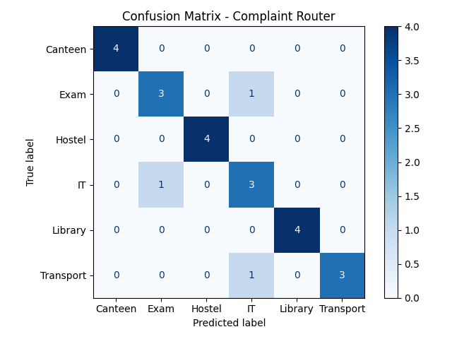
Fig. 5.1: Confusion matrix of the Logistic Regression model on the test set
Table 5.2: Classification report of Logistic Regression (24 test complaints)
Department | Precision | Recall | F1-score | Support
Canteen | 1.00 | 1.00 | 1.00 | 4
Exam | 0.75 | 0.75 | 0.75 | 4
Hostel | 1.00 | 1.00 | 1.00 | 4
IT | 0.60 | 0.75 | 0.67 | 4
Library | 1.00 | 1.00 | 1.00 | 4
Transport | 1.00 | 0.75 | 0.86 | 4
Macro average | 0.89 | 0.88 | 0.88 | 24

5.2 Sample Predictions
Sample outputs. Table 5.3 shows predictions of the evaluated model. Confidence values are modest because there are six classes and only 96 complaints. The last row shows a known weakness: the word “today” in the urgent-word list makes an ordinary late-bus complaint HIGH.
Table 5.3: Sample predictions
Complaint | Department | Confidence | Urgency
The wifi in my hostel is not working | IT | 28% | NORMAL
I need the hall ticket tomorrow for my exam urgently | Exam | 39% | HIGH
Found an insect in my food | Canteen | 30% | HIGH
The bus was late again today | Transport | 36% | HIGH

5.3 Web Application Screenshots
This section shows the working web application. The model behind the pages is the Logistic Regression model trained on all 96 complaints, so its confidence values can differ from the held-out evaluation in Section 5.2.
Home page. Figure 5.2 shows the input page with the complaint box, the Route Complaint and Clear buttons and six sample complaints that can be clicked to try the system.
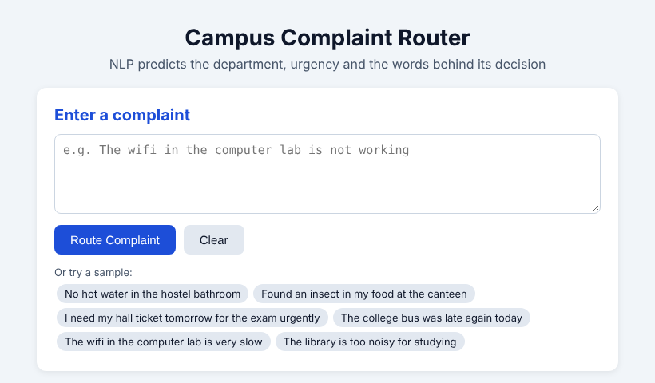
Fig. 5.2: Home page with sample complaints
Routing results. Figures 5.3 and 5.4 show a complaint with urgent words and a complaint without them. The page shows the department, the urgency badge (red for HIGH, green for NORMAL), the confidence, the complaint with urgent words highlighted, the keywords that influenced the prediction, and a bar chart of the scores of all six departments.
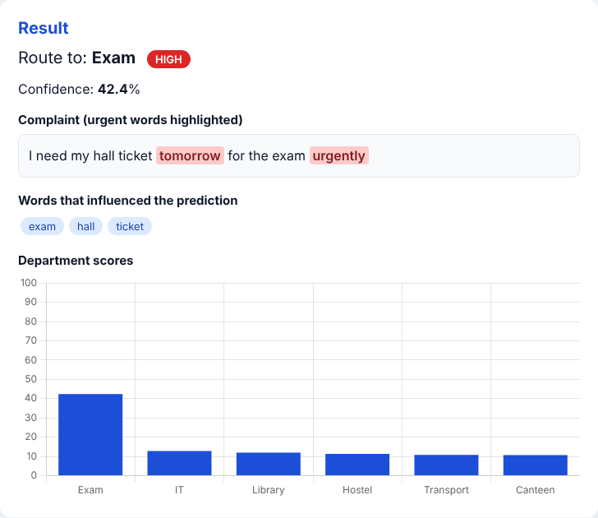 | 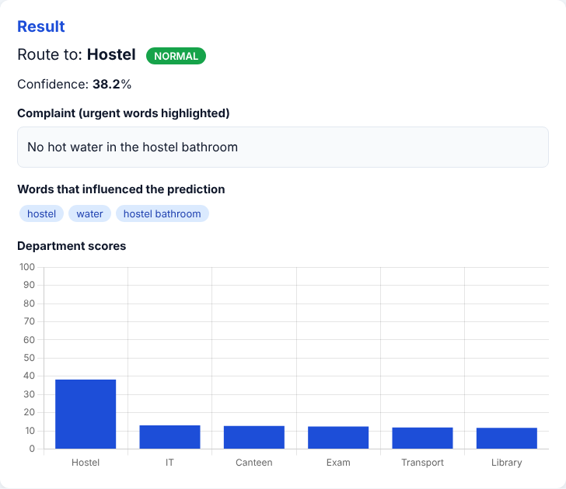
Fig. 5.3: Exam complaint, HIGH urgency (“tomorrow” and “urgently” highlighted) | Fig. 5.4: Hostel complaint, NORMAL urgency

Weak points shown by the interface. Figure 5.5 shows the late-bus complaint, which is routed correctly to Transport but marked HIGH only because of the word “today”. Figure 5.6 shows a complaint that mixes two topics (wifi in the hostel): the confidence falls below 30%, so the page displays a low-confidence warning asking the staff to check the routing manually.
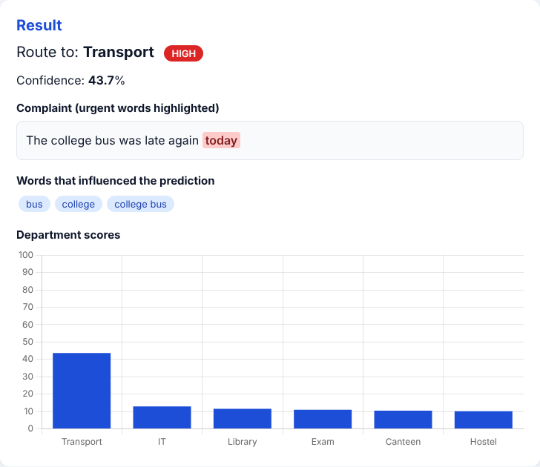 | 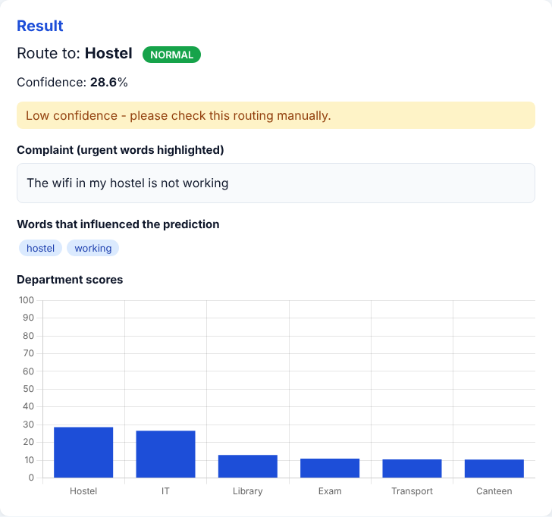
Fig. 5.5: Transport complaint flagged HIGH because of the word “today” | Fig. 5.6: Low-confidence warning for an overlapping topic

Input validation and session history. Figure 5.7 shows the error message displayed when the complaint box is empty, so the server is never given invalid input. Figure 5.8 shows the session history table, which lists every complaint routed in the current session and can be downloaded as a CSV file.
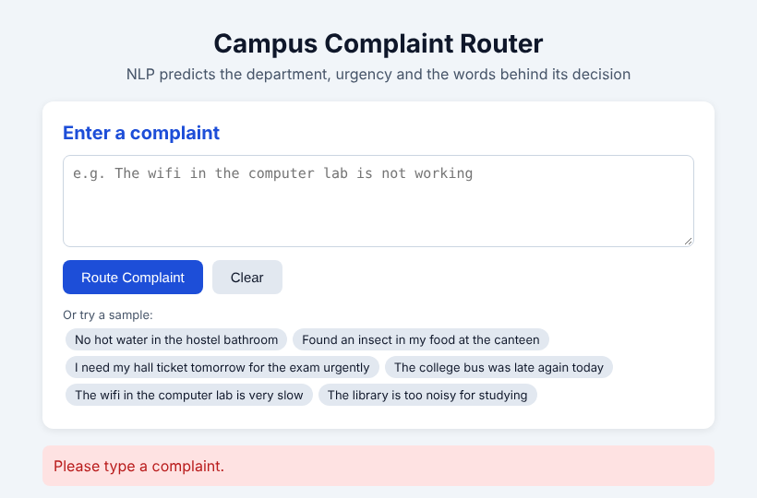 | 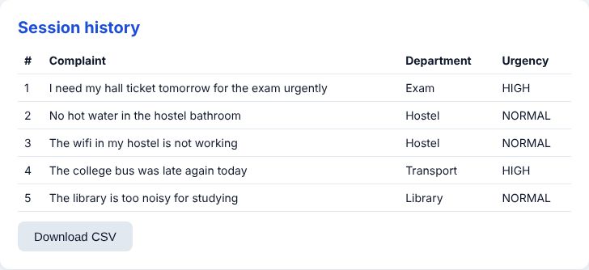
Fig. 5.7: Error message for empty input | Fig. 5.8: Session history with CSV download

5.4 Observations
(i) Topic words such as “wifi”, “bus” and “hall ticket” are strong indicators of their departments. (ii) Overlapping topics, such as wifi in the hostel, lower the confidence. (iii) Bag-of-words ignores word order, and “not” is even removed as a stop-word. (iv) The urgent-word list is simple and can raise false HIGH flags. (v) The dataset is small and synthetic, so performance on real complaints may be lower. (vi) Both models exceed the 85% objective, which meets the target set in Section 2.3.
Conclusion

This project showed that classical NLP techniques can route student complaints to the correct college department and flag the urgent ones. Text cleaning, TF-IDF features and Logistic Regression reached 88% accuracy on 24 unseen complaints, and Naive Bayes reached 92%; both are above the 85% objective. Logistic Regression was chosen for the final system because it provides confidence scores and word weights, which let the web application explain each decision and warn when it is unsure.
The results must be read with care. The dataset has only 96 synthetic complaints, the test set has only 24, urgency is a simple word list, and the model counts words without understanding their meaning. The system is therefore a decision aid for staff and not a replacement for human review. With more real data, cross-validation, Hindi and Marathi support, a learned urgency classifier and transformer models, the system can be developed into a practical complaint-handling tool for the college.
References

[1] G. Salton and C. Buckley, “Term-weighting approaches in automatic text retrieval,” Information Processing & Management, vol. 24, no. 5, pp. 513–523, 1988.
[2] F. Sebastiani, “Machine learning in automated text categorization,” ACM Computing Surveys, vol. 34, no. 1, pp. 1–47, 2002.
[3] A. McCallum and K. Nigam, “A comparison of event models for Naïve Bayes text classification,” in AAAI-98 Workshop on Learning for Text Categorization, 1998, pp. 41–48.
[4] T. Joachims, “Text categorization with support vector machines: Learning with many relevant features,” in Proc. European Conference on Machine Learning (ECML), 1998, pp. 137–142.
[5] F. Pedregosa et al., “Scikit-learn: Machine learning in Python,” Journal of Machine Learning Research, vol. 12, pp. 2825–2830, 2011.
[6] J. Devlin, M.-W. Chang, K. Lee and K. Toutanova, “BERT: Pre-training of deep bidirectional transformers for language understanding,” in Proc. NAACL-HLT, 2019, pp. 4171–4186.
[7] M. T. Ribeiro, S. Singh and C. Guestrin, “‘Why should I trust you?’: Explaining the predictions of any classifier,” in Proc. ACM SIGKDD Conference on Knowledge Discovery and Data Mining, 2016, pp. 1135–1144.
[8] C. D. Manning, P. Raghavan and H. Schütze, Introduction to Information Retrieval. Cambridge, U.K.: Cambridge University Press, 2008.
[9] M. Grinberg, Flask Web Development, 2nd ed. Sebastopol, CA, USA: O’Reilly Media, 2018.
Appendix-I
A. Project Folder Structure
Campus-Complaint-Router-NLP/
|-- Dataset/
| `-- complaints.csv (96 complaints)
|-- Results/
| |-- confusion_matrix.png
| `-- app_screenshot.png
|-- Source Code/
| |-- app.py (Flask server)
| |-- model.py (NLP model)
| |-- complaint_router.py (evaluation)
| |-- complaints.csv
| |-- requirements.txt
| |-- templates/
| | `-- index.html
| `-- static/
| |-- style.css
| `-- script.js
|-- AI_Ethics_Declaration_Page.pdf
`-- README.md

B. Running the Project
cd “Source Code”
pip install -r requirements.txt
python app.py # web app at http://127.0.0.1:5000
python complaint_router.py # accuracy report + confusion matrix

C. Why Each Tool Was Used
Tool / Choice | Why
Pandas | Reading the complaints dataset from the CSV file and handling it as a table.
Regular expressions (re) | Removing punctuation and digits while cleaning the complaint text.
Stop-word list (scikit-learn) | Removing common words such as “the” and “is” that do not help to find the department.
TF-IDF, ngram_range=(1, 2) | Converts text into numeric features; bigrams capture phrases such as “hot water” and “hall ticket”.
Logistic Regression | Final model; gives a probability for every department (predict_proba) and learned word weights for explanation.
Multinomial Naïve Bayes | Fast and classic baseline for text, used to compare against Logistic Regression.
Stratified split, random_state = 42 | Keeps the same class balance in training and test sets and gives the same split in every run.
Confusion matrix (Matplotlib) | Shows which departments are confused with each other.
Rule-based urgent-word list | Simple, transparent urgency flag that needs no training data.
Flask | Web server that connects the browser page to the model using only Python.
Chart.js | Draws the bar chart of department scores in the browser.

D. Known Limitations
• The dataset has only 96 synthetic complaints and the test set only 24, so the accuracy figures are not conclusive.
• TF-IDF with a linear model counts words and ignores word order; for example “not” is removed as a stop-word.
• Urgency is a fixed word list, so a word such as “today” can raise a false HIGH flag, and urgent complaints without these words are missed.
• Complaints that mix two topics, such as wifi in the hostel, get low confidence and may be routed to the wrong department.
• Spelling mistakes and words not seen in training are ignored by the model.
• Only English is supported, and one department is predicted per complaint.
• The application runs locally and has not been deployed or tested with real users.
Acknowledgement

I would like to express my sincere gratitude to my project guide, Prof. Vijay Shanker, for his guidance and support throughout this work. I am also grateful to Prof. Junaid Mandviwala, Head of the Department of Artificial Intelligence and Data Science Engineering, and to Dr. Varsha Shah, Principal, Rizvi College of Engineering, for providing the facilities and encouragement needed to complete this project.
Reshma Malik
(231A031)

