ASE- Lab report

UML Class Diagram:

The class diagram consists of System,Controller class with all the basic functionality to control the security system such as setAlarm(), TurnLightsOn(), TurnLightsOff() etc. System class is used to configure the security code and contact phone number which is utilized by Controller. Sensor class is the base class for SmokeSensor, TemperatureSensor, EntrySensor and FloodSenser. All the different sensors are inhereted from the class sensor. Controller and system have a strong relationship so is system and controller.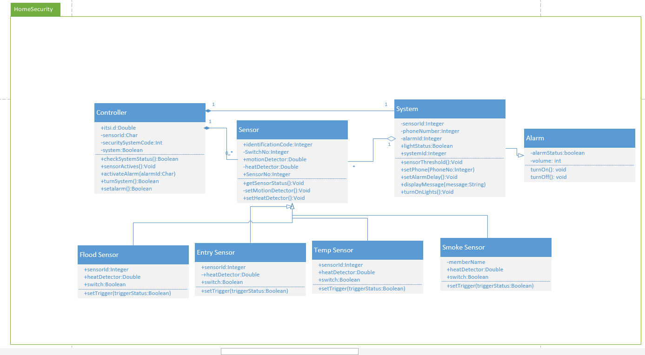

UML Sequence diagram:

Operator switches the system on by entering the security code. After activation of all the sensors, operator would then enter the security code to switch off the system.The system sends the sctivatedAlarm() and displays a message on the screen.After operator putsin the security code alarm will go off and the system is swited off. Owner has the right to set threshold limit, delays for alarms and also can program phone numbers in order to receive phone calls.

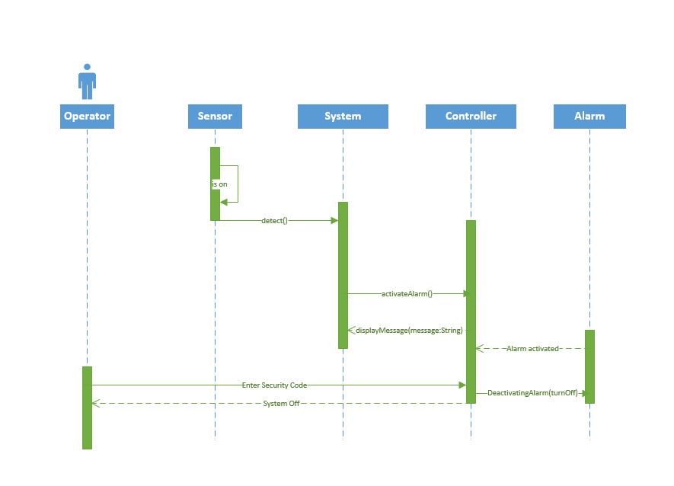

Git Hub repository creation:

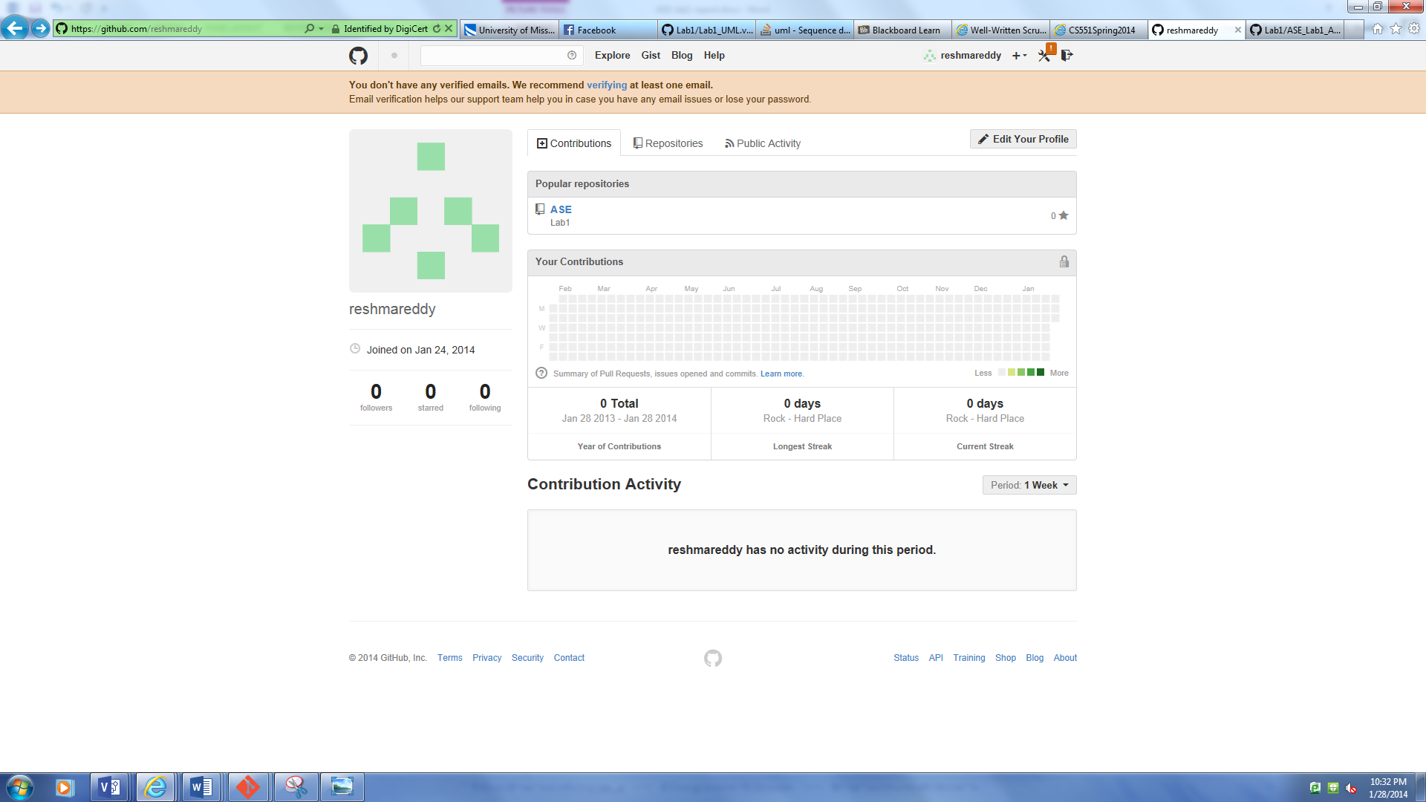

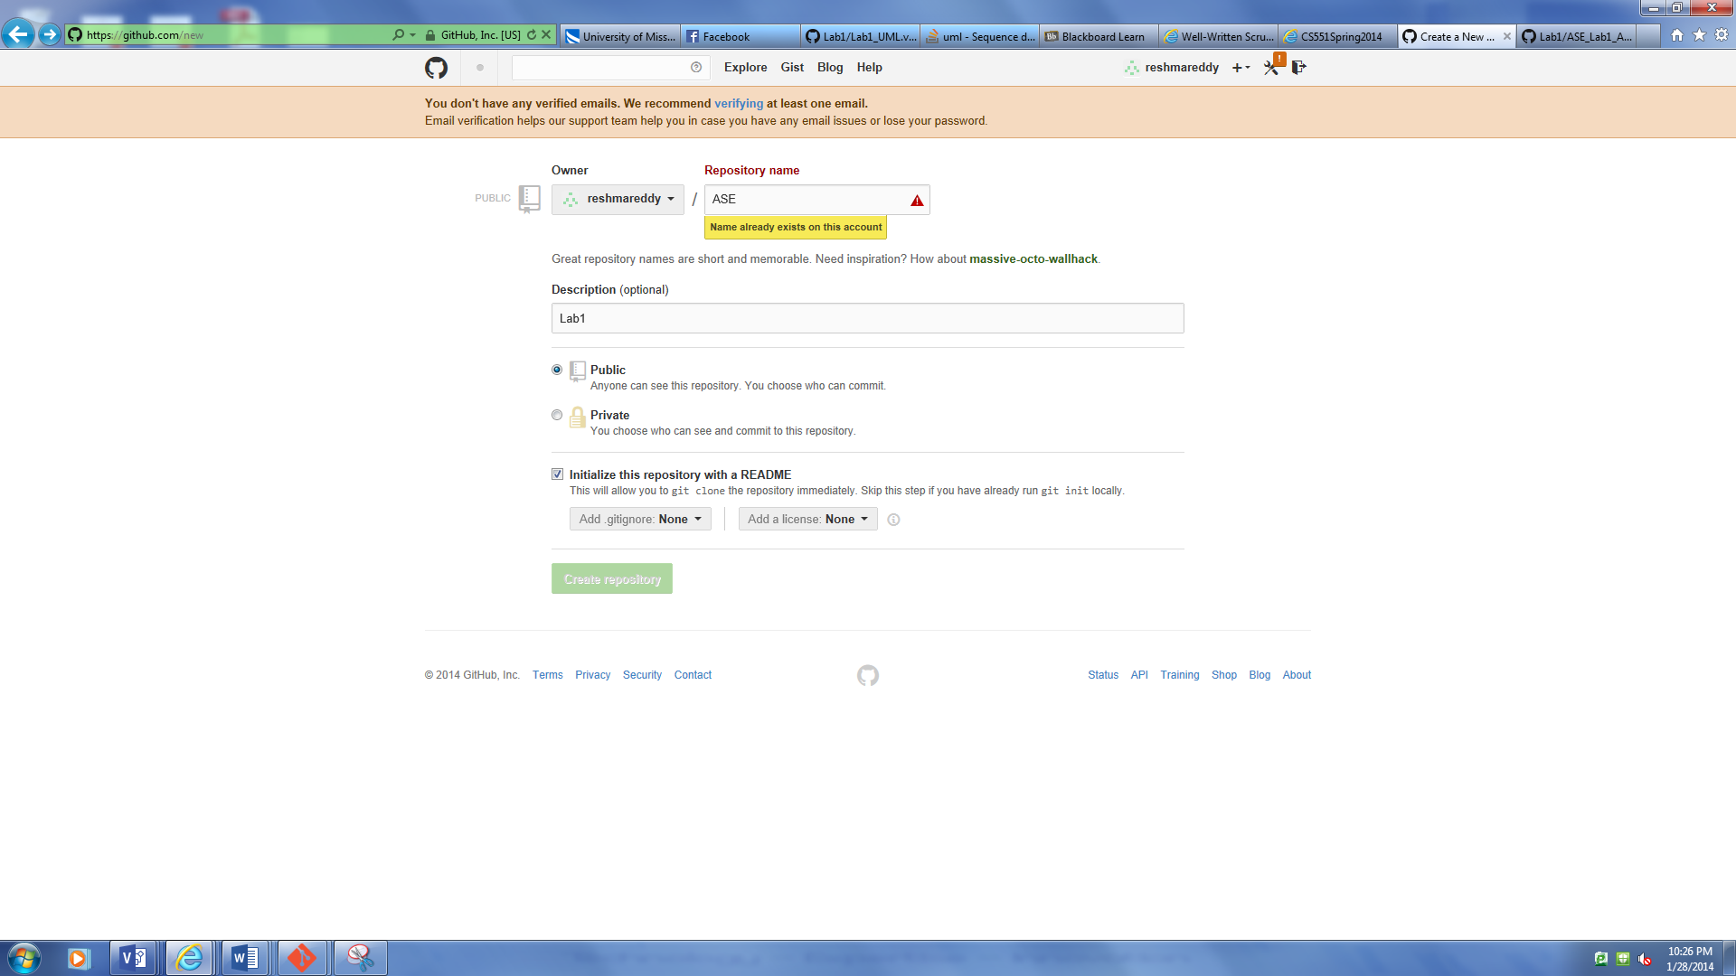

While pushing content in the git hub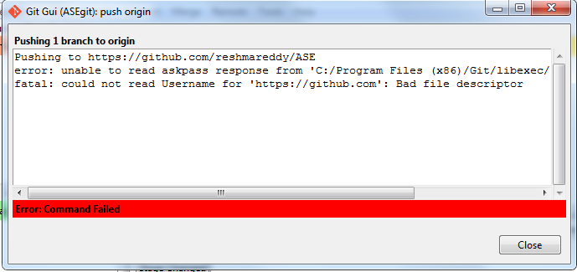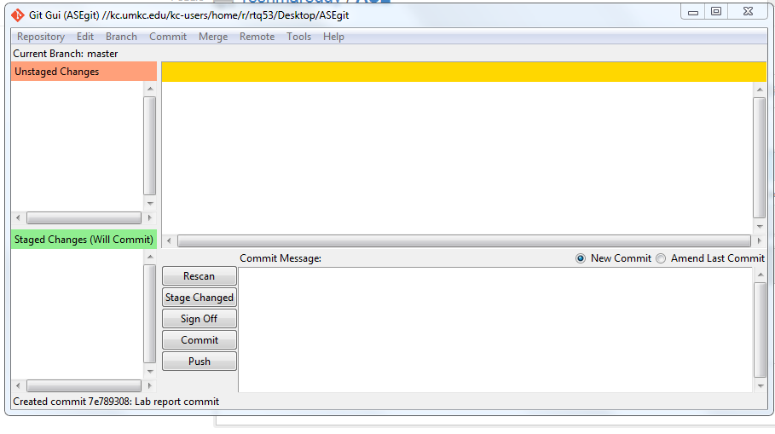

Scrum- do:

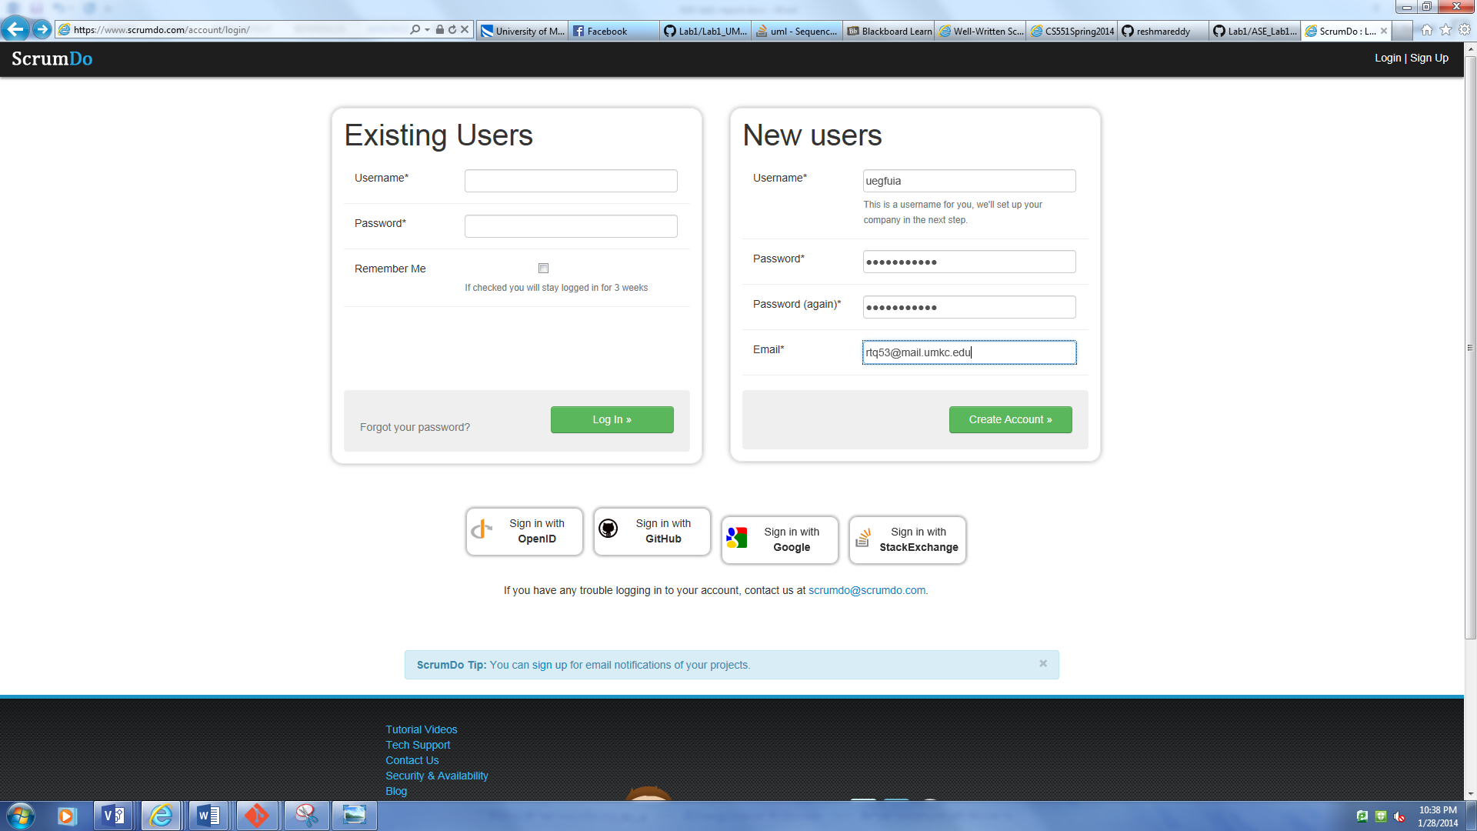

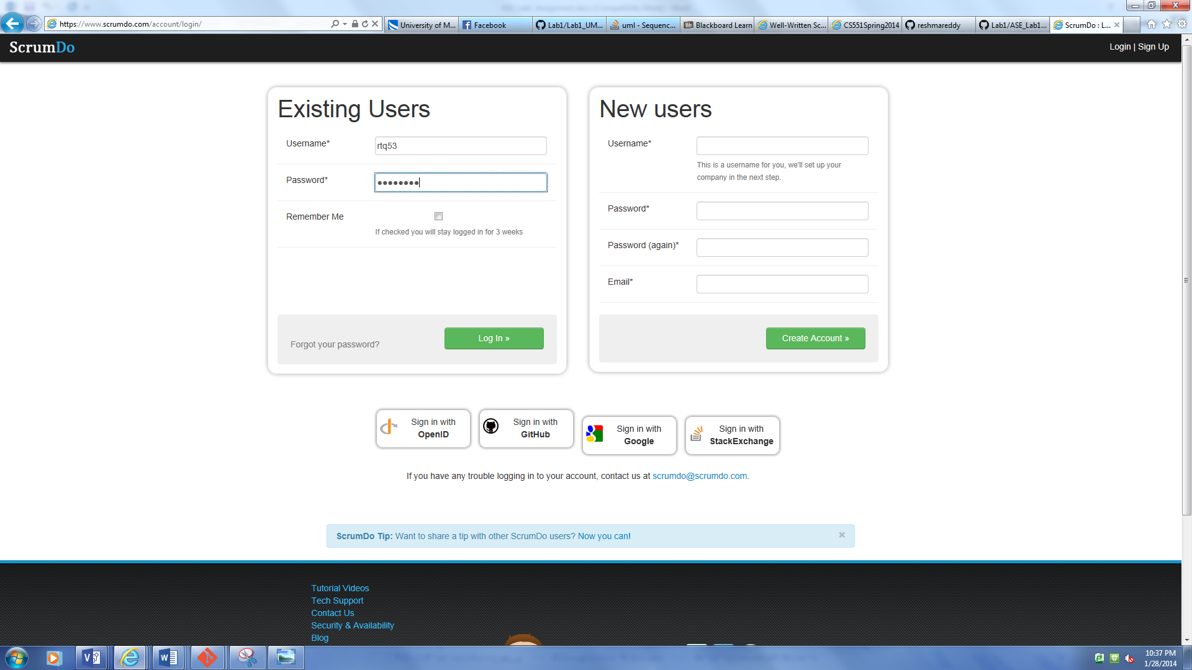

Project creation: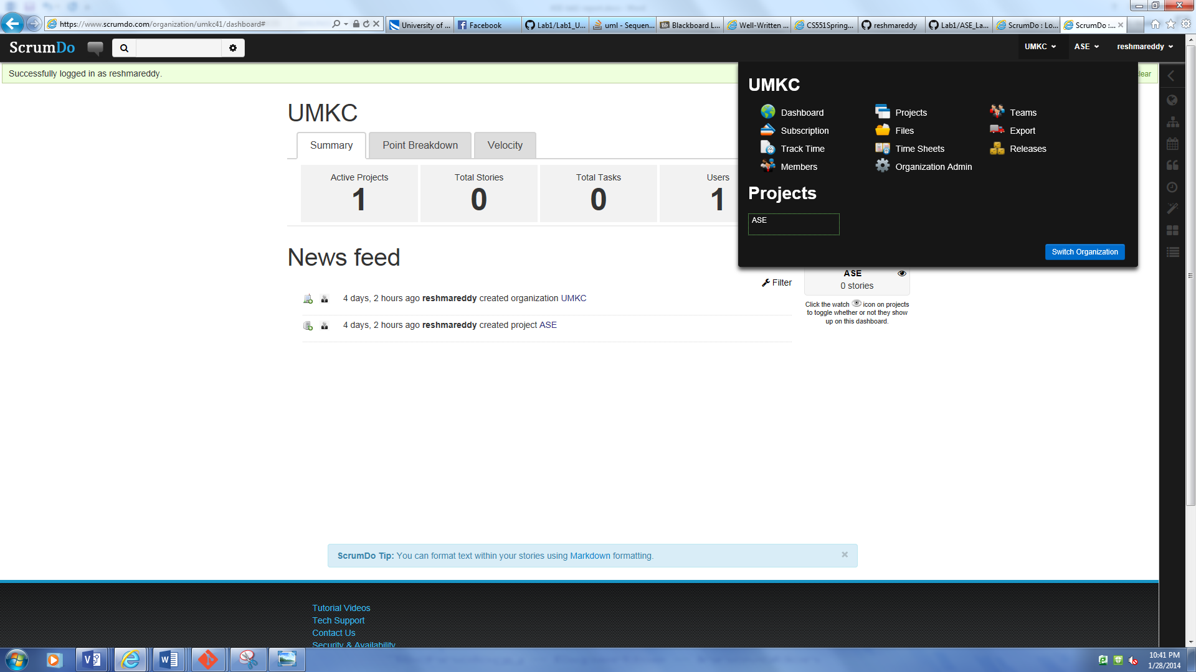

Story creation:

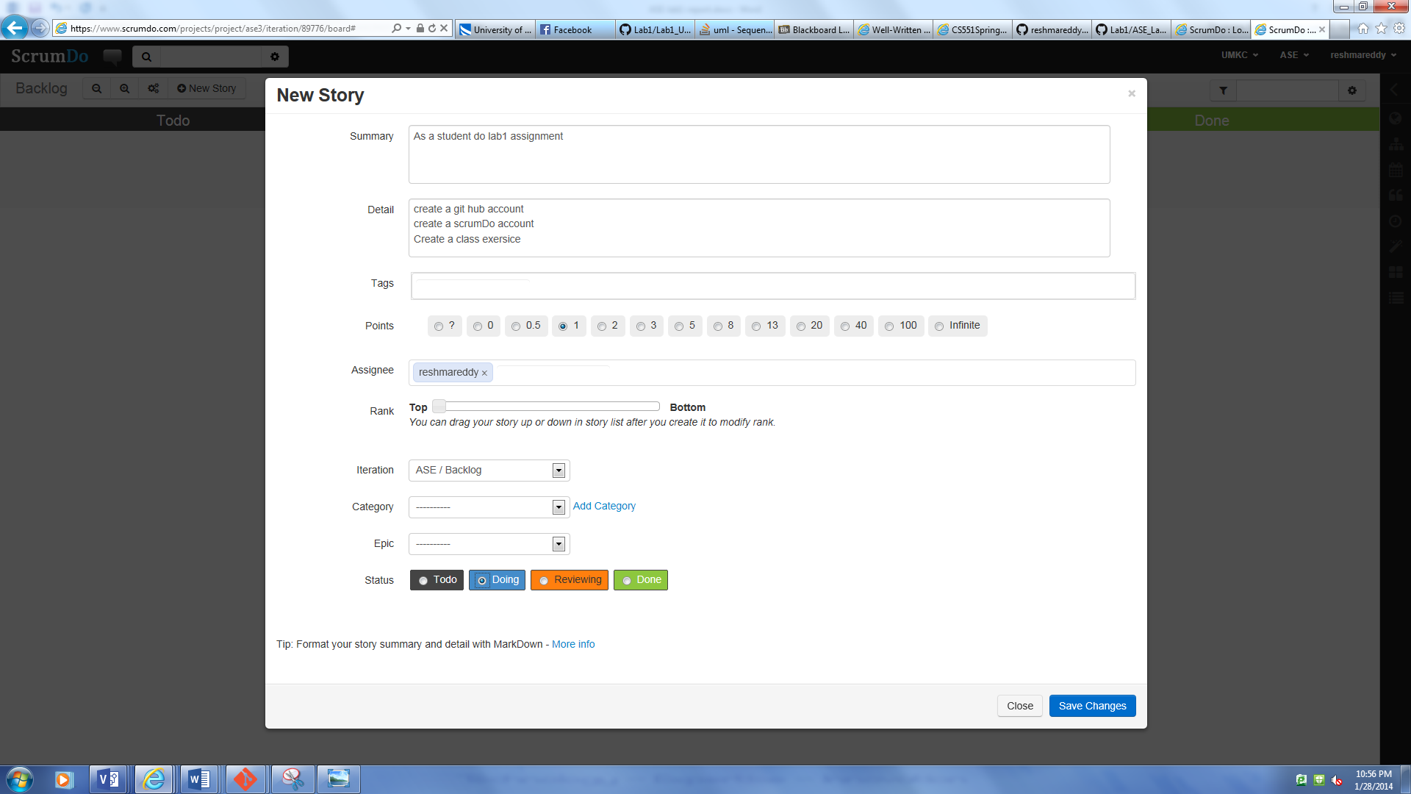

Scrum do story board:

