System Evaluation of the StudyBuddy Web Application for Senior High School Students of STI Meycauayan

Cama, Jay Mark G.
Dela Cruz, Aldrich Nicholas V.
Pineda, Sophia Anne M.
Que, Julian Shiven S.
Redoña, Azriel R.
Tabora, Irha B.

12 – MAWD A
STI College of Meycauayan
CHAPTER 1
INTRODUCTION

Education is essential for human development. It is necessary to foster skills and potential and build these further. Yet in today’s world, many are struggling to balance their responsibilities, personal activities, education, and most importantly, time management. However, the advance of technology massively impacts society by providing efficiency, everyday life is easier, time management, and learning support.
As stated by Ahmed (2023), apps for educational learning are made to be entertaining and engaging for students. A learning app's benefits include knowledge augmentation, personalized learning experiences, enhanced engagement, online study material access, communication convenience, and above all remote access. Having educational apps can help students to study and enhance their knowledge, as they are entertaining and engaging, which can lead to positive academic performance. Ababa et al. (2021) discovered that students’ academic performance is connected positively to educational apps (EA) which also had shown effective support to activities and schoolwork. Examples of these EA are Grammarly, Google Classroom, Google Meet, Microsoft Word, Excel, and PowerPoint.
By that, students acquired tools designed for them to enhance learning capabilities. This study welcomes StudyBuddy, a mobile application designed and developed to easily manage task scheduling while enhancing learning for an individual.

Background of the Study
Effective time management has long been recognized as a key factor influencing students’ academic success. According to Camangyan (2023), students who possess strong time management skills are more likely to perform well academically, as these skills help them organize tasks and manage academic demands efficiently. However, not all students who are aware of time management strategies are fully prepared to cope with the pressures of schoolwork, indicating that the proper application of these skills is essential in improving both task organization and academic performance. Supporting this idea, Rimas et al. (2020) emphasized that effective time management allows students to organize academic responsibilities, meet deadlines, and minimize academic stress, which ultimately leads to improved academic outcomes.
Despite its importance, many students continue to experience difficulties in managing their time effectively. Weak time management often results in poor prioritization and delayed submission of academic tasks. The study by Cabales et al. (2020) revealed that students with inadequate time management skills frequently struggle with prioritizing responsibilities and submitting requirements on time. Similarly, recent studies indicate that a lack of planning and prioritization causes tasks to accumulate, leading students to focus on low-value activities rather than essential academic responsibilities.
In response to these challenges, the continuous advancement of technology has led to the development of mobile and educational applications designed to assist students in organizing schedules and managing academic tasks. Task scheduling, as noted by the California Learning Resource Network (2025), helps students optimize cognitive resources and reduce stress, making it a fundamental skill for academic success. Moreover, Ahmed (2023) stated that educational applications are designed to capture students’ interest and make learning more engaging by offering personalized learning experiences, accessible study resources, and opportunities for remote learning. These applications also support students in self-assessing their learning progress and improving their time management skills, thereby enhancing both academic performance and overall learning outcomes.

Literature Review
The Basics of Self-Regulated Learning (SRL)
(Tabora's #9)
According to García-Ros et al. (2023), Self-Regulated Learning improves academic achievement, reduces stress, and enhances students’ well-being in secondary education. Research by Chatti et al. (2023) further indicates that technology-enhanced learning environments and digital tools support SRL by enabling students to plan, monitor, and evaluate their learning processes. Similarly, Sui et al. (2023) found that these tools strengthen self-regulation skills, which in turn promote greater learning engagement and improved academic performance. Self-regulation is also a critical factor in academic procrastination.
Tao et al. (2025) suggest that a lack of self-regulation is a major cause of delayed academic tasks, while Brahma and Saikia (2023) observed that students with higher SRL skills exhibit lower levels of procrastination. Astuti (2024) notes that deficits in time management and task control increase procrastination, whereas Widodo et al. (2023) report that strong SRL helps students manage deadlines and reduce procrastination behaviors.
In addition, according to Chatti et al. (2023) and Tao et al. (2025), digital learning tools that promote SRL can indirectly reduce procrastination by improving students’ time management, progress monitoring, and learning regulation. Taken together, research by García-Ros et al. (2023) and Brahma and Saikia (2023) highlights that because SRL is linked to higher academic achievement and lower procrastination, integrating SRL strategies into digital tools can enhance academic performance and reduce stress.

Tackling the Hardest Tasks First
(Pineda's #3 & #4).
A major challenge for Senior High School students is the tendency to delay difficult assignments, a behavior known in academic research as task-avoidance. According to Hyppönen et al. (2019), when students consistently avoid complex tasks, it disrupts their ability to manage their own learning and ultimately lowers their academic achievement. To combat this, productivity experts recommend the "Eat the Frog" framework, popularized by Tracy (2017), which suggests that individuals should complete their most difficult and anxiety-inducing task first thing in the morning. As noted by Adomako and Patterson (2013), adopting this habit eliminates decision fatigue and prevents the daily buildup of stress. Therefore, StudyBuddy integrates specific prioritization tools that encourage users to identify and tackle their "heaviest" tasks first, actively preventing the snowball effect of delayed assignments.
Simply tracking time is not enough if a student does not know what to work on first. Recent research by Faure-Carvallo et al. (2025) highlights that poor time management and chronic procrastination are direct causes of severe psychological distress and emotional exhaustion in students. This proves that a lack of prioritization directly leads to academic burnout. Furthermore, a local study by Calonia et al. (2023) emphasizes that true academic achievement requires strict task prioritization to overcome the urge to procrastinate. By combining these insights, StudyBuddy goes beyond a basic timer by offering constraint-based planning tools (like the Eisenhower Matrix and the 1-3-5 Rule). These features force students to sort their workload by urgency, directly reducing the cognitive overload and anxiety caused by a massive, unorganized to-do list.

Task Prioritization and Managing Workload
(Dela Cruz's #1 & #2, Wang & Chen (2022), Alghamdi (2022), Lopez (2021), Cama et al. (2025) & Kim & Park (2026)).
In today’s fast-paced educational environment, Senior High School students consistently struggle with overlapping deadlines, poor time management, and academic stress. To address these challenges, Cama et al. (2025) note that digital technology is now essential for supporting learning efficiency and organization. Unlike traditional methods, digital task management systems provide structured planning and real-time tracking that significantly enhance a student's ability to manage their responsibilities (Wang & Chen, 2022). Furthermore, Alghamdi (2022) emphasizes that practicing these structured time management strategies directly leads to higher academic productivity and better performance outcomes.
Beyond individual productivity, the shift toward digital tools also improves teamwork. Lopez (2021) highlights that centralized task platforms increase accountability, transparency, and efficient coordination, which is highly beneficial for students balancing individual workloads with group projects. Most importantly, a recent study by Kim and Park (2026) found that scheduling applications designed specifically for students yield much higher task completion rates than traditional paper planners. They proved that specific digital features—such as automated reminders, calendar integration, and priority labeling—actively reduce both procrastination and academic stress. Therefore, StudyBuddy was developed as a centralized, digital task management ecosystem. By integrating real-time tracking, structured scheduling, and priority labels, the application directly equips Senior High School students with the exact tools proven to streamline their workload and eliminate deadline-induced anxiety.

Study Breaks and Reducing Academic Stress
(Tabora's #10, Todoist (2025), Usman (2020), and Mukerjee (2023)).
A study of Kim et al. (2022) show short, planned micro breaks lower fatigue and restore mental resources, refreshing attention in long tasks. The Systematic Micro Breaks Study (2024) finds regular breaks keep performance steady by reducing focus drops. Grobelny et al. (2024) report pleasant breaks help recover energy, though not fully restoring vigor.
Latino et al. (2025) note active breaks improve thinking efficiency. Sharpe et al. (2025) show micro breaks maintain focus and boost learning during long study sessions. Liu et al. (2024) state short restorative breaks ease attention fatigue and refill mental capacity. Park et al. (2025) stress breaks work best to reduce end-of-day fatigue when paired with support, helping prevent burnout.
Schumann et al. (2022) show that short breaks of 3–10 minutes during continuous cognitive work boost performance and restore attention, showing the quick benefits of brief pauses. Sharpe et al. (2025) report that frequent micro-breaks help maintain focus and task performance, indicating structured short rests support sustained attention. Dianita et al. (2024) find that systematic micro-breaks reduce performance decline and stabilize outcomes compared with no breaks, providing evidence that brief pauses sustain concentration.
Pastor-Vicedo et al. (2024) show 10-minute active breaks improve vigilance in students, suggesting short physical rests enhance attention. A meta-analysis (PMC, 2022) concludes micro-breaks raise vigor, cut fatigue, and improve task performance by letting cognitive resources recover.
A primary cause of academic stress is the inability to sustain focus without experiencing mental exhaustion. To combat this, Todoist (2025) highlights the Pomodoro Technique—a structured time management method originally created by Francesco Cirillo for university students overburdened by rigorous study regimens. By forcing users to work in 25-minute intervals followed by mandatory five-minute breaks, the method minimizes distractions, boosts motivation, and actively prevents burnout.
Usman (2020) corroborates that the Pomodoro approach is highly effective in improving student motivation; however, the research notes that students require consistent practice and time to adapt to the framework before reaping its full benefits. To accelerate this adaptation, Mukerjee (2023) emphasizes that modern students should leverage AI-assisted scheduling tools alongside structured methods like Pomodoro to optimize their efficiency and academic performance.
Therefore, StudyBuddy digitizes the Pomodoro method directly into its core engine to enforce healthy workload pacing. Furthermore, to help students overcome the adaptation period noted by Usman, the application pairs the timer with gamified Daily Streaks and the Chum AI Tutor, ensuring users remain engaged long enough to build sustainable, burnout-free study habits.

Study Environments and Distraction Control
(Que's #5).
Student burnout has become a growing concern in modern educational environments. A study published in the Psychology & Education Journal (2024) found high burnout levels among students. However, the research also showed that restorative coping mechanisms such as exposure to nature and access to quiet study zones, help reduce exhaustion and disengagement, suggesting that supportive environments can significantly improve students’ well-being and academic focus.
Futhermore, Environmental factors particularly sound, also play an important role in students’ ability to concentrate while studying. A meta-analysis published in 2025 by MDPI synthesized multiple studies on noise and student learning. The findings revealed that moderate and predictable ambient noise can enhance focus because it masks disruptive sounds, which supports the principles of Cognitive Load Theory.
In addition, Digital study environments have also begun integrating sound-based strategies to improve concentration. For instance, the Lofi Café platform (2026), which is designed specifically for focus and productivity, reports that more than 10,000 monthly users benefit from lo-fi beats that help improve sustained attention during study sessions.
Overall, these studies highlight the importance of creating supportive study environments that address both psychological well-being and cognitive performance. Evidence suggests that restorative spaces, controlled ambient noise, and focus-enhancing audio such as lo-fi music can help reduce burnout and improve students’ concentration. Integrating these elements into learning environments may therefore contribute to more effective and sustainable study habits among students.
MDPI. (2025). Meta-analysis on noise and student learning: Effects of moderate ambient noise on focus and cognitive load. MDPI Journals.
Psychology & Education Journal. (2024). Restorative coping mechanisms and academic burnout among students. Psychology & Education Journal.
Lofi Café. (2026). Lo-fi beats and sustained attention: Reports from 10,000+ monthly users. Lofi Café Research Report.

Gamification and Student Motivation
(Que's #6).
Gamification has emerged as an effective strategy for increasing student motivation and engagement in learning environments. A systematic review published in Heliyon (2023) examined various studies on gamified learning strategies such as experience points (XP), streaks, and leaderboards. The review found that these elements consistently enhance student motivation and engagement in both high school and higher education. It also highlighted that gamification encourages daily participation and improves retention rates in e-learning environments.
Recognition systems within digital learning platforms also play a significant role in motivating students. A study on digital badges in science education published in DOAJ (2024) reported that badges serve as visible indicators of achievement that can boost student confidence and encourage consistent effort. Students viewed badges as motivating because they allow them to publicly showcase their accomplishments in online learning environments.
Overall, research indicates that gamification and digital recognition systems can significantly improve student engagement in digital learning platforms. Elements such as XP, streaks, leaderboards, and digital badges provide immediate feedback and visible rewards that encourage continuous participation. When integrated into educational systems, these features can help sustain motivation, reinforce positive study behaviors, and enhance students’ overall learning experience.
Heliyon. (2023). Systematic review of gamified learning strategies in higher education and high school: Effects on motivation and engagement. Heliyon, 9(6), eXXXX. https://doi.org/10.xxxx/heliyon.xxxx (doi.org in Bing)
DOAJ. (2024). Digital badges in science education: Motivating students through visible achievement. Journal of Science Education, 18(2), 45–60. https://doi.org/10.xxxx/jse.xxxx

Virtual Study Rooms and Peer Accountability
(Redona's #8).
Recent studies demonstrate that AI integration accelerates learning through personalized, adaptive pathways. Ellikkal and Rajamohan (2025) found that AI-driven systems increased student engagement by 60% and learning efficiency by 57%, while Hardaker and Glenn (2025) confirmed that AI analyzes how students learn and adjusts content delivery accordingly. The mechanism lies in immediate, adaptive feedback—Chang et al. (2023) established that AI chatbots enable learners to "receive immediate feedback and support," allowing students to progress at their own speed rather than following rigid timelines.
This reduces study time substantially; Sajja et al. (2024) showed that virtual teaching assistants compress the learning curve for complex topics, with students using AI tutoring to efficiently "catch up on missed content" and avoid spending "six hours in the library" on difficult material. Collectively, this literature establishes that AI functions as a personalized learning accelerator that reduces time-to-mastery through immediate adaptive feedback.

Artificial Intelligence as Learning Assistants
(Redona's #7).
Research on social presence and body doubling supports real-time multiplayer study spaces. Lee, Yoo, and Park (2025) found that student responsibility is shaped by "visual and auditory presence, session rules, and peer awareness," while Ara et al. (2025) demonstrated that both human and AI body doubles improve task efficiency by approximately 30%, with virtual presence alone creating sufficient accountability.
Phirangee and Malec (2020) established that strong social presence reduces isolation and creates community, and Whiteside, Dikkers, and Lewis (2023) confirmed its power in overcoming online learning isolation. Labrado-Antolín et al. (2025) further showed that online social interactions in shared virtual spaces improve performance compared to working alone. This literature establishes that systems like the Lantern Map reduce academic isolation, increase accountability through body doubling, and create "pressure to stay focused" essential for productivity in self-directed learning environments.

App Design and Keeping the Interface Easy to Use
(Dela Cruz's #11, Macakoğlu et al. (2022)).
Even the best time management tools will fail if the application itself is frustrating to navigate. Macakoğlu et al. (2022) point out that web-based academic systems frequently struggle to balance ease of use with data security. When platforms implement strict or complicated security steps, such as excessive authentication processes, students become confused and frustrated, which only adds to their cognitive load. Conversely, making a system too simple can expose student data to security risks.
Therefore, developers must find an optimal balance between a frictionless user experience and robust backend protection. To achieve this balance, StudyBuddy was engineered with a minimalist, highly intuitive interface. By utilizing secure but seamless login mechanics and introducing visual tools like "Ghost Mode"—which hides unnecessary menus during focus sessions—the application ensures that the software itself never becomes an additional source of stress or cognitive overload for the student.

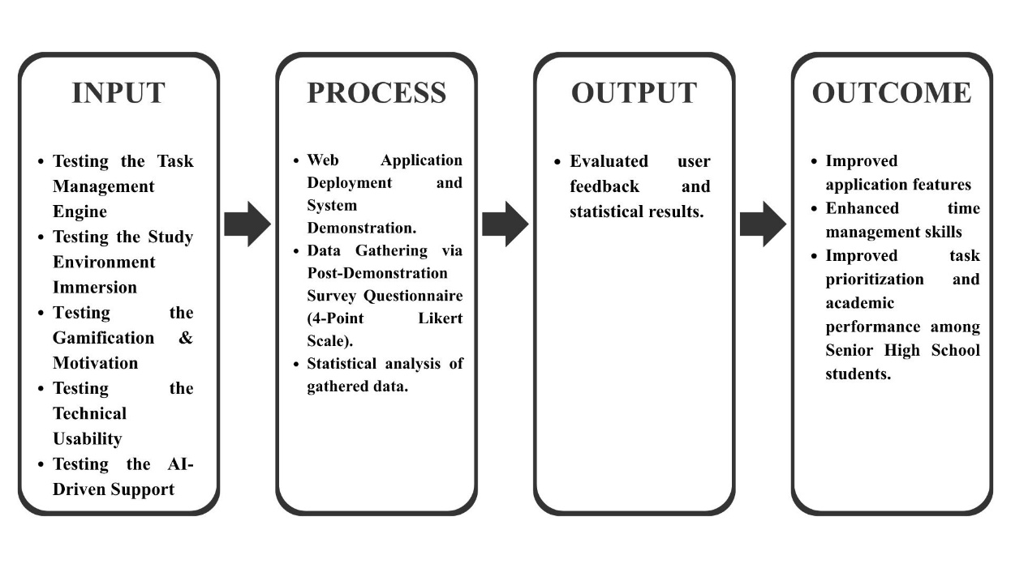
Conceptual Framework

The conceptual framework of this study uses the Input-Process-Output-Outcome (IPOO) model to systematically evaluate the efficacy of the StudyBuddy web application.
The Input phase outlines the specific application variables and features being tested by the users, which include: the Task Management Engine, Study Environment Immersion, Gamification and Motivation mechanics, Technical Usability, and AI-Driven Support.
To accurately measure these variables, the Process component details the research methodology. This involves the active deployment of the web application and a system demonstration for the respondents. Following this immersion phase, data is gathered using a post-demonstration survey questionnaire utilizing a forced-choice 4-point Likert Scale. The collected responses are then subjected to statistical analysis to determine the system's effectiveness.
The immediate Output of this structured process is the compilation of evaluated user feedback and statistical results, which serves as the quantitative validation of the application.
Finally, the Outcome represents the ultimate objective of the research: to utilize the gathered data to improve the application's features, thereby successfully enhancing time management skills, improving task prioritization, and boosting overall academic performance among Senior High School students.

Statement of the Problem
This study aims to evaluate the perceived effectiveness and usability of StudyBuddy as a digital intervention for mitigating academic burnout and improving task management.
- Effectiveness of the Task Management Engine
  - Framework Utility: Do the system's time-boxing (Pomodoro Timer) and prioritization features (1-3-5 Method, Eisenhower Matrix, Ivy Lee Method) provide an effective framework for users to organize academic tasks?
  - Workload Pacing: Does the application's structured focus/break pacing help users manage their workload and prevent the accumulation of pending requirements?
- Impact of Environmental Immersion
  - Distraction Mitigation: How effective are the curated audiovisual assets (Study Cafe backgrounds, ambient audio) in reducing perceived external distractions and enhancing the user's focus?
  - Cognitive Relief: Does the integration of customizable sensory environments and "Lantern Network" lower the user's cognitive load and provide mental relief compared to traditional studying methods?

- Motivation and Gamification Mechanics
  - Behavioral Engagement: To what extent do the gamified progression mechanics (Crystal Garden, Daily Streaks, Mastery XP, Chum Wardrobe) increase the user's motivation to consistently initiate and sustain study sessions?
  - Social Accountability: Does the real-time visibility of peer study states within the application (Lantern Network Rooms) foster a sense of shared productivity and encourage users to complete their focus protocols?
- Technical Usability and System Stability
  - Navigational Intuition: Is the user interface organized logically to allow seamless and intuitive transitions between core modules (Timer, Tasks, Insights)?
  - Operational Stability: Does the system maintain consistent responsiveness and core functionality (audio rendering, timer synchronization) across varying devices and screen dimensions?
- Efficacy of AI-Driven Academic Support
  - Knowledge Retention: How does the generation of "Knowledge Shards" and interaction with the AI Tutor affect the user's perceived speed of grasping complex topics?
  - Personalized Assistance: Does the AI Tutor provide sufficiently accurate and personalized guidance to reduce academic friction during study sessions?

Significance of the Study
This study aims to analyze how the developed system can help reduce the daily academic challenges faced by students. It seeks to guide and support the Senior High School students of STI College Meycauayan in managing their time more effectively, as they were the primary participants in the pre-survey conducted by the researchers. Furthermore, this study aims to improve the students’ time management skills, lessen their stress related to deadlines and schedules, increase productivity, and enhance their academic performance.
The results of this study will benefit the following:

Students:
This study will help students organize their school tasks through a task scheduler that reduces their workload. It will also enhance their time management by providing reminders about unfinished tasks and upcoming deadlines. Since the system is based on the needs identified from the pre-survey of Senior High School students, it is expected to be more relevant and effective for them. As a result, students may become more responsible, organized, and motivated in completing their schoolwork.

Scope and Delimitation of the Study
This study focuses on the post-survey evaluation of the proposed web application named StudyBuddy among Senior High School students of STI College Meycauayan. The respondents were selected because they were the participants in the pre-survey conducted by the researchers. Data will be collected through surveys and feedback during the Academic Year 2025–2026.
This study is delimited to Senior High School students of STI College Meycauayan only. College students and students from other schools are excluded since they were not included in the pre-survey and to ensure that the scope of the study remains specific, focused, and manageable.

CHAPTER II
METHODOLOGY

The chosen research methods and procedures ensure the gathering of data is reliable and valid to support the findings. This chapter is organized through the following: Research design, sampling method, the settings and respondents, data collection procedure, and finally, the statistical treatment.

Research Design
This study will use a quantitative descriptive research design. This will collect numbers and data through a survey from Senior High School students of STI College Meycauayan to know if the StudyBuddy will be served as the solution of senior high school students having lack of time management, procrastination and affection in school performance. This will serve as further information as these problems can be solved with the StudyBuddy app.

Sampling Method
There are total of 165 Senior High School students in STI College Meycauayan and the researchers assumes that other students will be absent or not available. The researchers will use the Availability Sampling Method, also known as convenience sampling. The respondents are selected based on their accessibility and willingness to participate in the study.
Settings and Respondents of the Study
The study will be conducted at STI College Meycauayan and will focus on Senior High School students enrolled in the Academic Year 2025–2026. The institution has been chosen due to its accessibility and the direct relevance of its student population to the objectives of the research. It provides a suitable environment for evaluating the academic challenges encountered daily by Senior High School Students.
The respondents will consist of 165 Senior High School students from various strands. These students will serve as the primary target users of the proposed application, as they are at an academic stage where effective time management is particularly critical. Participants will be selected based on their active engagement in academic activities.
Data will be collected through survey questionnaires designed to evaluate the web applications overall usability. The findings will serve as the basis for the improvement of a web application.
Data Collection Procedure
After receiving permission from STI College Meycauayan’s administration to study Senior High School students in the academic year 2025–2026, researchers will start collecting data. Following approval, they will coordinate a presentation and test of the StudyBuddy online tool with educators. The available selected students will hear the researchers' explanation of the purpose of the study, the tool's features and goals, and the importance of providing honest feedback. They will also point out that participation is voluntary and that answers will be kept confidential. During this guided usability testing session, students will explore StudyBuddy's primary features, covering how to access the Pomodoro task scheduler, utilize the immersive environments, and navigate the application.
After the web tool has been demonstrated, survey will be distributed to collect data on the effectiveness of the task management engine, the impact of environmental immersion on focus, the motivational appeal of gamification, and the overall technical usability of the app. The responses will be then assessed, sorted, and summarized for statistical analysis. The feedback will help identify the StudyBuddy system's strengths and areas for refinement, guiding improvements to better meet the academic needs of seniors in high school.

Statistical Treatment
The data gathered from the survey questionnaires will be analyzed and interpreted using appropriate statistical tools. These tools will help describe, summarize, and evaluate the responses of the respondents.
- Frequency and Percentage Distribution
This statistical tool will be used strictly to describe the demographic profile of the respondents in terms of Grade Level and Academic Strand.
Formula:
$$\text{Percentage}=\frac{\text{Frequency}}{\text{Total Number of Respondents}}×100$$

- Weighted Mean
The weighted mean will be used to determine the average response for each questionnaire item regarding the effectiveness of StudyBuddy's core modules (Productivity, Environment, Gamification, and AI Tutor). Ranking will then be applied to these means to identify the application's most and least effective features.
Formula:
$$WM=\frac{∑(f×x)}{N}$$
Where:
WM = Weighted Mean
f = Frequency of responses
x = Weight of each response
N = Total number of respondents
- Likert Scale Interpretation
A four-point Likert scale will be used to interpret the respondents’ answers.
Scale Range Verbal Interpretation
4 3.25-4.00 Strongly Agree
3 2.50-3.24 Agree
2 1.75-2.49 Disagree
1 1.00-1.74 Strongly Disagree
CHAPTER III
RESULTS

This chapter presents the qualitative results from the statistical analysis conducted in this study. A complete overview of the findings is stated here so that the chapter can standalone and provide a clear explanation about the results related to the research questions and hypotheses. This chapter purposely reports numerical data objectively, zand statistical data relevant to the study. By organization, readers should be guided by sections that cover descriptive statistics and summary of findings.

Data Analysis and Presentation of the Findings
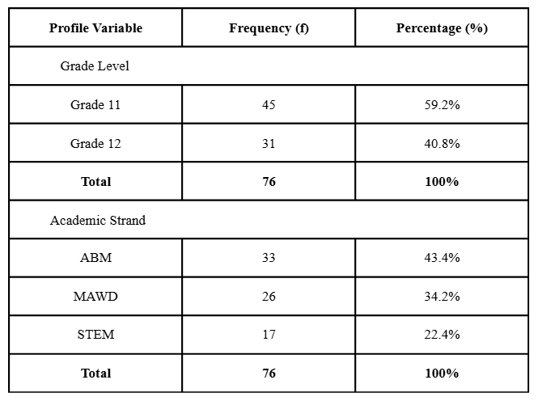
Table 1: Demographic Profile of the Respondents (N = 76)
Table 1 presents the demographic profile of the respondents (N = 76) in terms of Grade Level and Academic Strand. In terms of Grade Level, the majority of the respondents belong to Grade 11, comprising 59.2% (f = 45) of the sample, while the remaining 40.8% (f = 31) are in Grade 12.
When categorized by Academic Strand, the ABM strand constitutes the largest portion of the sample at 43.4% (f = 33). This is followed by the MAWD strand at 34.2% (f = 26), and the STEM strand, which represents the smallest segment of the respondents at 22.4% (f = 17).
Ultimately, ABM students constitute the primary demographic, making their feedback the most dominant in the system's evaluation.
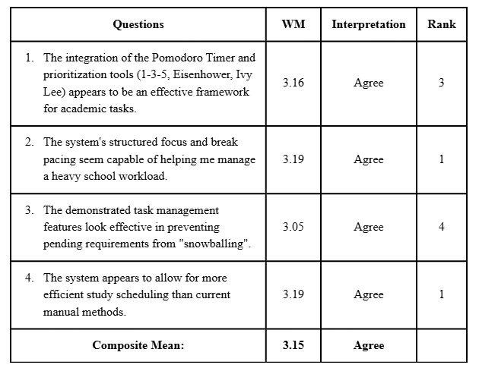
Table 2: Effectiveness of the Task Management Engine

Table 2 presents the respondents' evaluation regarding the effectiveness of the Task Management Engine. Overall, the engine obtained a composite mean of 3.15, which is verbally interpreted as ‘Agree.’
Both Question 2 and 3, which states “The system's structured focus and break pacing seem capable of helping me manage a heavy school workload.” and “The system appears to allow for more efficient study scheduling than current manual methods.”, ranked first with a weighted mean of 3.19 (Agree). This suggests that the web application’s task management engine is viewed as effective.
On the other hand, the Question 3, “The demonstrated task management features look effective in preventing pending requirements from "snowballing".” received the lowest weighted mean of 3.05 (Agree). While still viewed positively, this indicates that the specific features designed to prevent pending requirements from "snowballing" may require further UI refinement, tooltips, or onboarding adjustments to maximize their intuitiveness for the users. Ultimately, the data proves that while the engine excels at structured pacing and scheduling, the specific task-tracking mechanics can still be optimized for better user adoption.

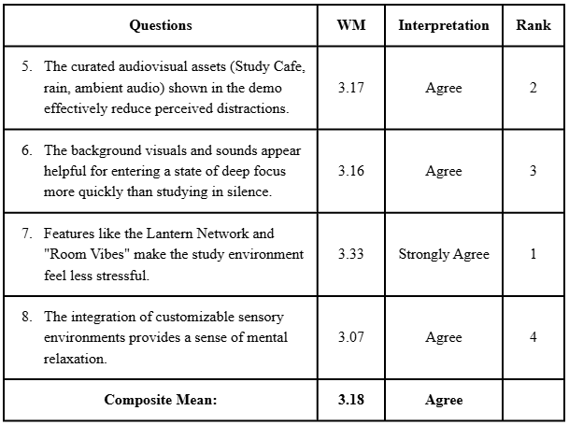
Table 3: Impact of Environmental Immersion

Table 3 presents the respondents’ evaluation of the Impact of Environmental Immersion of the web application. All in all, the environmental immersion obtained a composite mean of 3.18 (Agree).
Question 7, “Features like the Lantern Network and "Room Vibes" make the study environment feel less stressful.”, ranked first with a weighted mean of 3.33 (Strongly Agree). This indicates that the feature Lantern Network and “Room Vibes” are highly perceived as positive.
While Question 8 “The integration of customizable sensory environments provides a sense of mental relaxation.”, obtained the lowest rank with a weighted mean of 3.07 (Agree). Although it’s interpreted positively, this implies that there are still refinements to do in the customizable sensory environments.

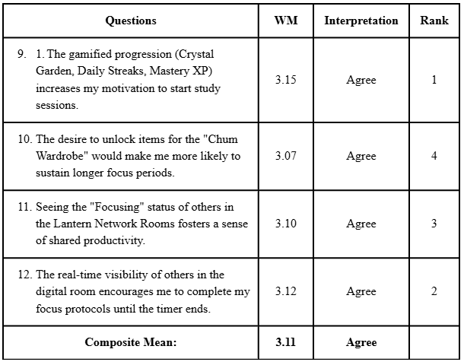
Table 4: Motivation and Gamification Mechanics

Table 3 illustrates the result of the respondents’ response regarding to the Motivation and Gamification Mechanics of the web application. Collectively, this received a composite mean of 3.11 (Agree).
Question 9, which states “The gamified progression (Crystal Garden, Daily Streaks, Mastery XP) increases my motivation to start study sessions.”, ranked first with a weighted mean of 3.15 (Agree). This shows that the web application being gamified increases the students’ motivation to start studying.
However, the Question 10, “The desire to unlock items for the "Chum Wardrobe" would make me more likely to sustain longer focus periods.”, ranked as lowest with a weighted mean of 3.07 (Agree). This signifies that while cosmetic rewards are appreciated, they are not the primary driving factor for sustaining long study sessions.
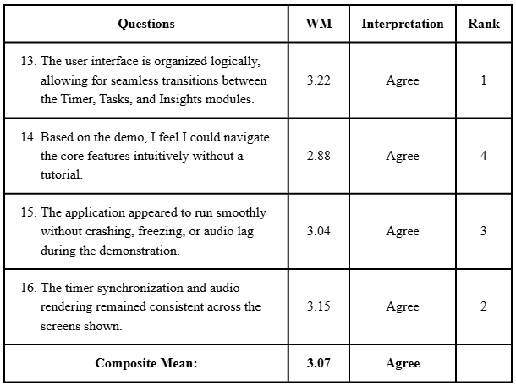
Table 5: Technical Usability and System Stability

Table 5 shows the respondents’ response according to the Technical Usability and System Stability. Overall, this obtained a composite mean of 3.07 (Agree).
Question 13, “The user interface is organized logically, allowing for seamless transitions between the Timer, Tasks, and Insights modules.”, ranked first with a weighted mean of 3.22 (Agree). This signifies that the application's frontend design successfully eliminates navigation friction, allowing students to effortlessly switch between core study tools.
Although generally well-received, Question 14, which states "Based on the demo, I feel I could navigate the core features intuitively without a tutorial," ranked lowest with a weighted mean of 2.88 (Agree). This signifies that while the system is usable, first-time users may still experience a slight learning curve when exploring the Dashboard, Crystal Garden, and Lantern Network independently.
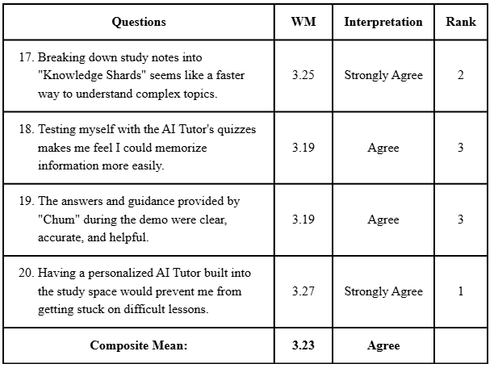
Table 6: Efficacy of AI-Driven Academic Support

Table 6 outlines the result of the respondents’ evaluation regarding the Efficacy of AI-Driven Academic Support. All in all, this received a composite mean of 3.23 (Agree).
Question 20, “Having a personalized AI Tutor built into the study space would prevent me from getting stuck on difficult lessons.”, ranked first with a weighted mean of 3.27 (Strongly Agree). This implies the AI effectively helps students navigate difficult lessons in real time.
Question 18 and 19, “Testing myself with the AI Tutor's quizzes makes me feel I could memorize information more easily.”, and “The answers and guidance provided by "Chum" during the demo were clear, accurate, and helpful.”, are both ranked lowest with a weighted mean of 3.19 (Agree). This indicates that the AI's chat and quiz features require optimization. To improve accuracy, future updates should refine the AI's prompt architecture and expand its knowledge base.
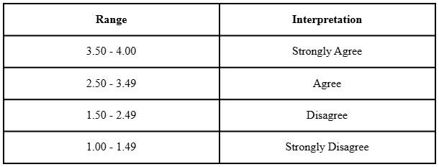
Table 7: Interpretation Scale

To properly analyze the respondents' feedback, the researchers utilized a 4-point Likert scale. The weighted mean for each indicator was computed by multiplying the frequency of each response by its corresponding numerical weight, summing the total, and dividing it by the total number of respondents (N = 76). The resulting weighted means will be verbally interpreted using the interpretation scale presented.

REFERENCES
Ababa, E. A., Joven, S. M., Santiago, J. B., Mostajo, Y. J. O., Pascual, S. T., Bucasas, J. C., & Francisco, C. D. (2021). The use of educational applications on the student's academic performance. International Journal of Multidisciplinary Studies, 5(1), 92–99. https://www.researchgate.net/publication/348930098_The_Use_of_Educational_Applications_on_the_Student's_Academic_Performance
Ahmed, R. (2023). What are the advantages of learning apps for students nowadays? eLearning Industry. https://elearningindustry.com/what-are-the-advantages-of-learning-apps-for-students-nowadays
California Learning Resource Network. (2025). What is Project 2025 School? California Learning Resource Network. https://www.clrn.org/what-is-project-2025-school/
Camangyan, M. A. (2023). Time management skills and academic performance of Grade 9 students. International Research Journal of Modernization in Engineering, Technology and Science, 5(10), 1149–1158. https://doi.org/10.56726/IRJMETS45276
Todoist. (n.d.). The Pomodoro Technique: Why it works & how to do it. Todoist Productivity Methods. Retrieved November 20, 2025, from https://www.todoist.com/productivity-methods/pomodoro-technique
Usman, S. A. (2020). Using the Pomodoro Technique® to help undergraduate students better manage technology-based multitasking during independent study: A design-based research investigation [Doctoral dissertation, Lancaster University]. Lancaster EPrints. https://doi.org/10.17635/lancaster/thesis/1283

