Home Assignment:

Integrate the Jira with this existing codebase

Activity: Integrate the AI Agent with Jira by adding a "Connect Jira" feature that allows users to establish a connection using their Jira Base URL, Email ID, and Jira API Token. Once the connection is successfully established, retrieve and populate the available Jira user stories within the application. Ensure the implementation follows the existing project architecture, UI design, and coding standards while maintaining compatibility with the current functionality.

1. Implement the UI Changes
2. Then Implement the Connectivity

Sample prompt for Jira integration:

Front end:

Need to add "Connect to Jira" button to establish the connection

Base url: https://reshmatesting321.atlassian.net
Email id: reshmatesting321@gmail.com
Jira API key: ATATT3xFfGF04OIq7cCs7wXYLniy_iYSBo4pDus0Bw4ZKXySLqvwza-RfNtDgG5ADd1wE9H1eY5vwzxVKxioYFvrVzghYOEklWHitmGMyVuI-WBxKGrGfC-wcTnGXGGQ-e5vLJQoPsnqNIsYGGkkjnBkP_GXA9hql87XpyKQeDEJnLDIA5EwzNA=EAD606FA

Sample prompt for UI:

Read my entire workspace and understand how UI implemented in the frontend folder

I want to add "Connect to Jira" button to establish the connection(Base url
Email id,Jira API key_)

once the jira is connected userstories should be populated in the UI screen.

[STRICTLY] DO THE IMPLEMENTATION ONLY ON UI

After Implementing the UI changes, ensure that the "Connect Jira" button is functional and triggers the connection process. Upon successful connection, fetch the user stories from Jira and display them in a structured format within the UI.
—-
1. Log in to Jira and click your Profile icon in the top-right corner.
2. Select Account Settings.
3. Open the Security tab from the top menu.
4. Scroll down to the API Tokens section.
5. Click Create and manage API tokens.
6. Jira may ask you to verify your identity. A verification code will be sent to your registered email address.
7. Enter the verification code and continue.
8. Click Create API Token.
9. Enter a suitable name for the token and click Create.
10. Copy and save the API token securely, as it may not be shown again.

⚠️ Important: Do not share the API token publicly or with unauthorized users.

PROMPT 1: Act as a senior full-stack developer. Inspect the existing codebase,
then implement the UI for a “Connect Jira” feature in this AI Agent
application.

Requirements:
1. Add a “Connect Jira” button in the application header.
2. On click, open a modal with these required fields:
- Jira Base URL
Placeholder: https://your-site.atlassian.net
- Email ID
- Jira API Token
3. Mask the API Token and provide a show/hide option.
4. Add Connect and Cancel buttons.
5. Validate required fields, HTTPS URL format, and email format.
6. Prepare UI states for connecting, connected, and connection failed.
7. Add a project dropdown and a user-story table with columns:
Story Key, Summary, Status, Assignee, and Select.
8. Include loading, empty, and error states for the story table.

Follow the existing architecture, reusable components, UI styling,
and coding standards. Preserve current functionality.

Implement only the UI in this phase. Do not show a successful connection
without backend verification. Do not store API tokens in browser storage
or logs.

Run the relevant build checks and summarize the files changed.

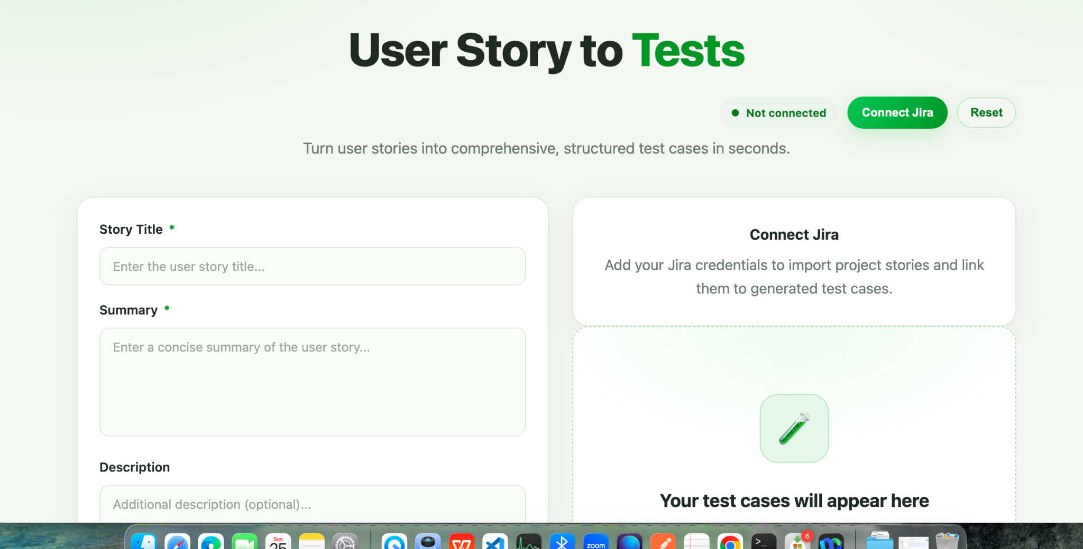

PROMPT2:
Act as a senior full-stack developer. Inspect the existing codebase,
then implement the UI for a “Connect Jira” feature in this AI Agent
application.

Requirements:
1. Add a “Connect Jira” button in the application header.
2. On click, open a modal with these required fields:
- Base url: https://reshmatesting321.atlassian.net
- Email id: reshmatesting321@gmail.com
- Jira API key: ATATT3xFfGF04OIq7cCs7wXYLniy_iYSBo4pDus0Bw4ZKXySLqvwza-RfNtDgG5ADd1wE9H1eY5vwzxVKxiokjnBkP_GXA9hql87XpyKQeDEJnLDIA5EwzNA=EAD606FA
3. Mask the API Token and provide a show/hide option.
4. Add Connect and Cancel buttons.
5. Validate required fields, HTTPS URL format, and email format.
6. Prepare UI states for connecting, connected, and connection failed.
7. Add a project dropdown and a user-story table with columns:
Story Key, Summary, Status, Assignee, and Select.
8. Include loading, empty, and error states for the story table.

Follow the existing architecture, reusable components, UI styling,
and coding standards. Preserve current functionality.

Implement only the UI in this phase. Do not show a successful connection
without backend verification. Do not store API tokens in browser storage
or logs.

Run the relevant build checks and summarize the files changed.

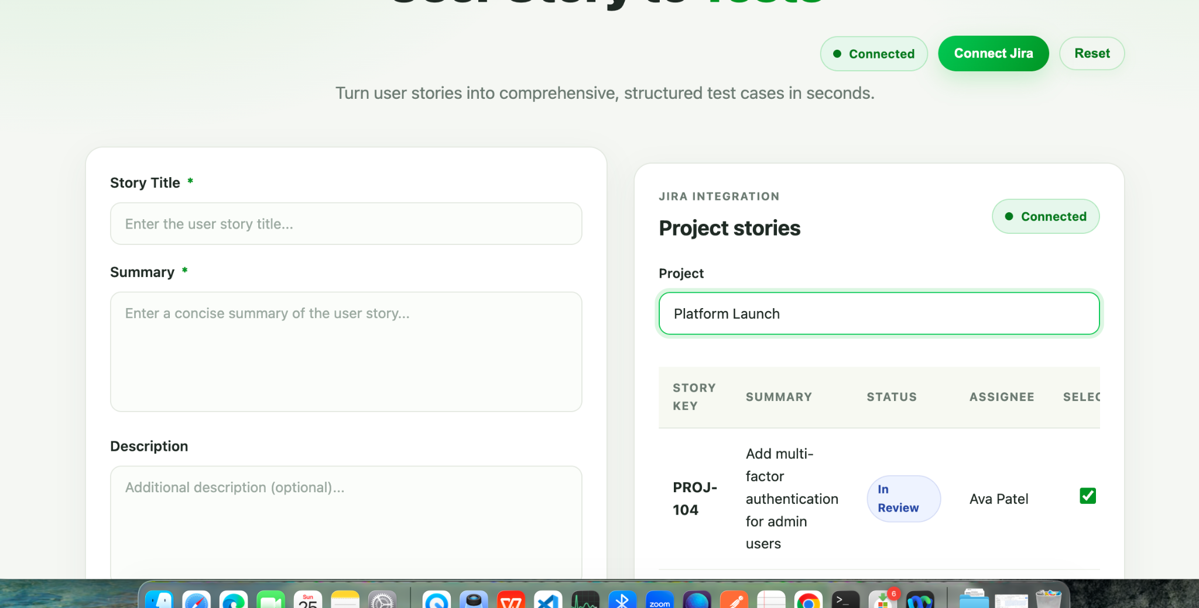

—------------------------------------------------------
Assignment1: Adding Extension and generating Playwright/Typescript script:

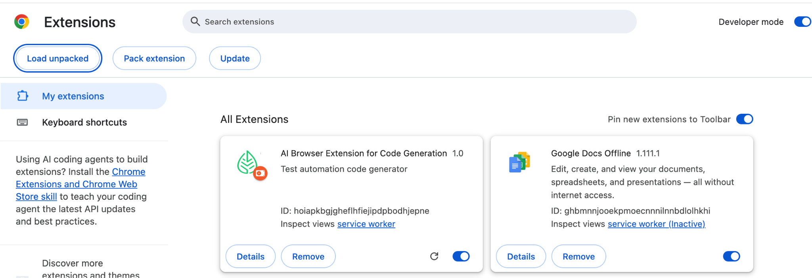

Model Addition, “oss-safegaurd”:
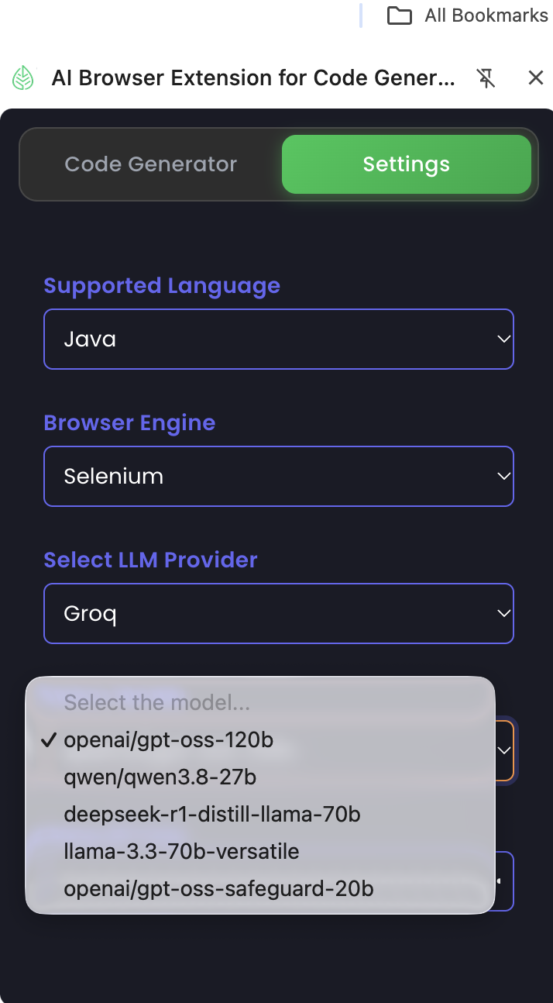Playwright/Typescript:

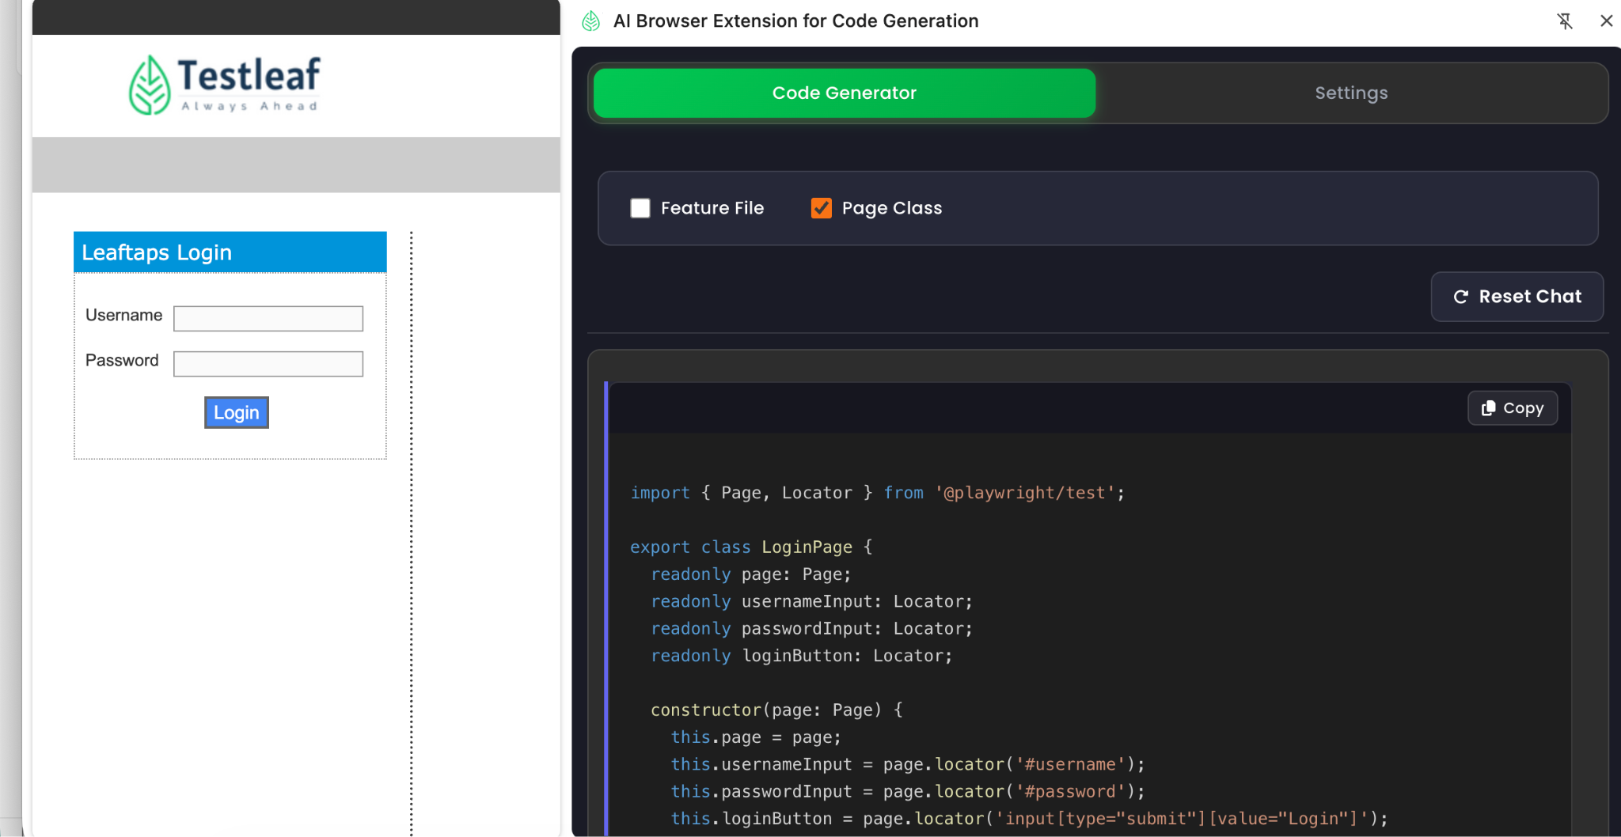

Class Assignment2:

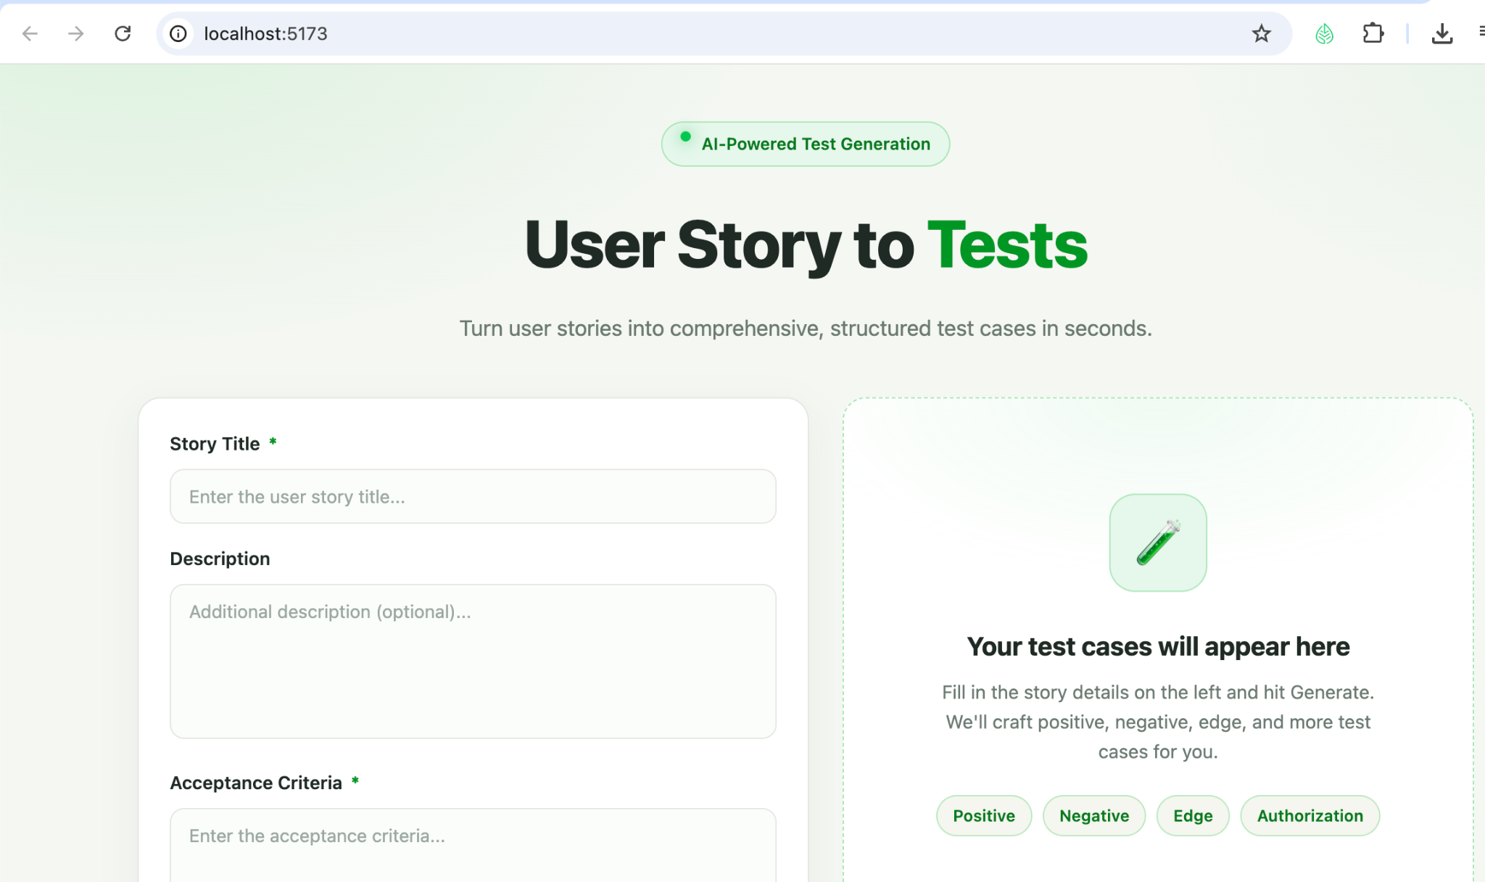

With Reset button and generated testscript: Before Reset button:
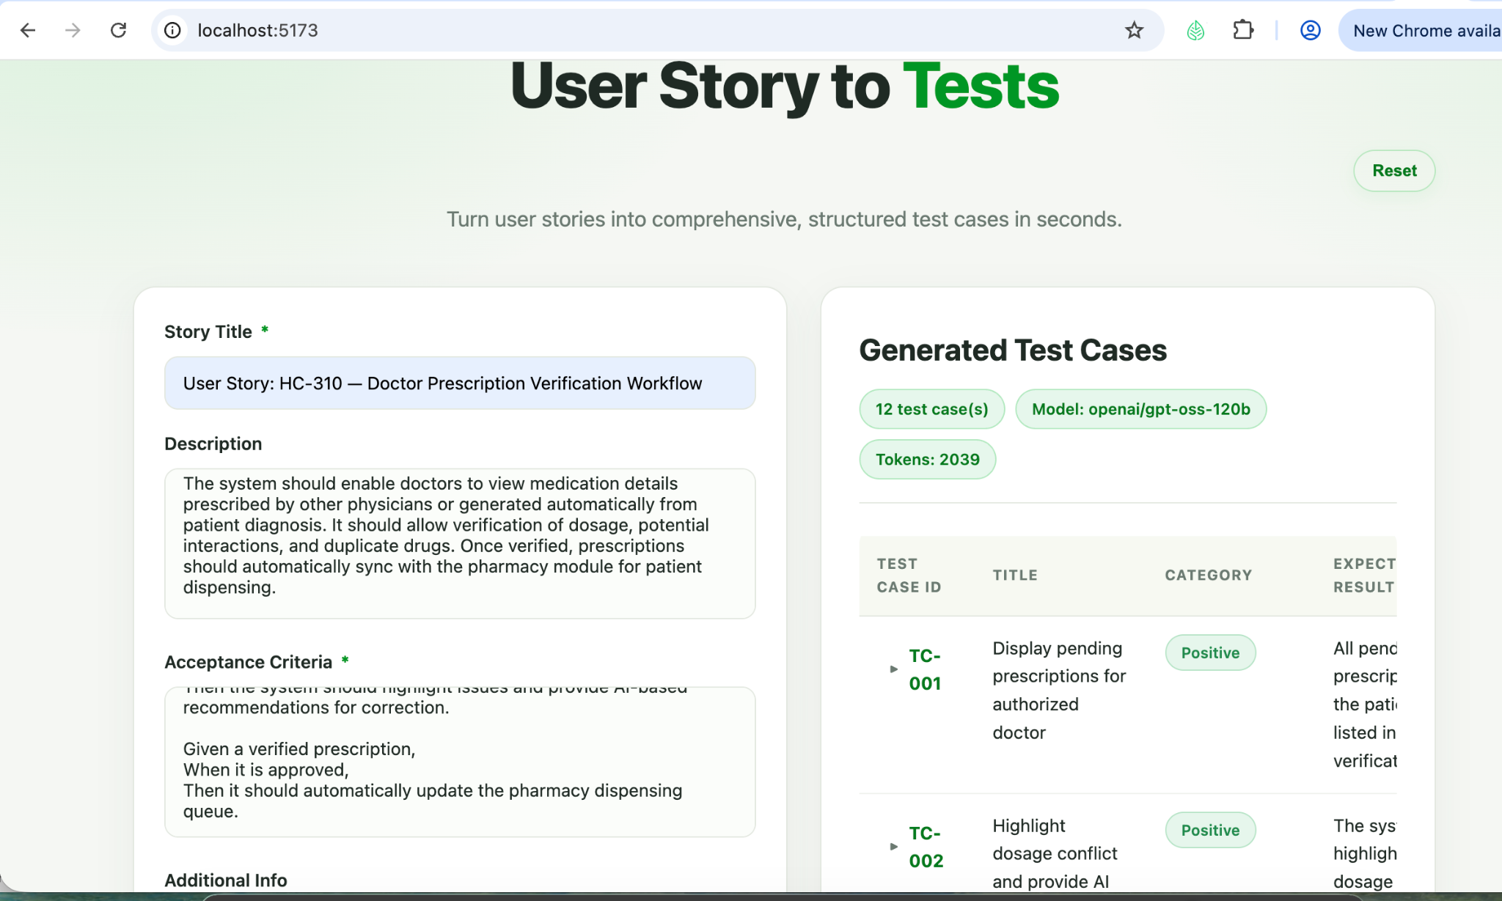

After clicking Reset button:
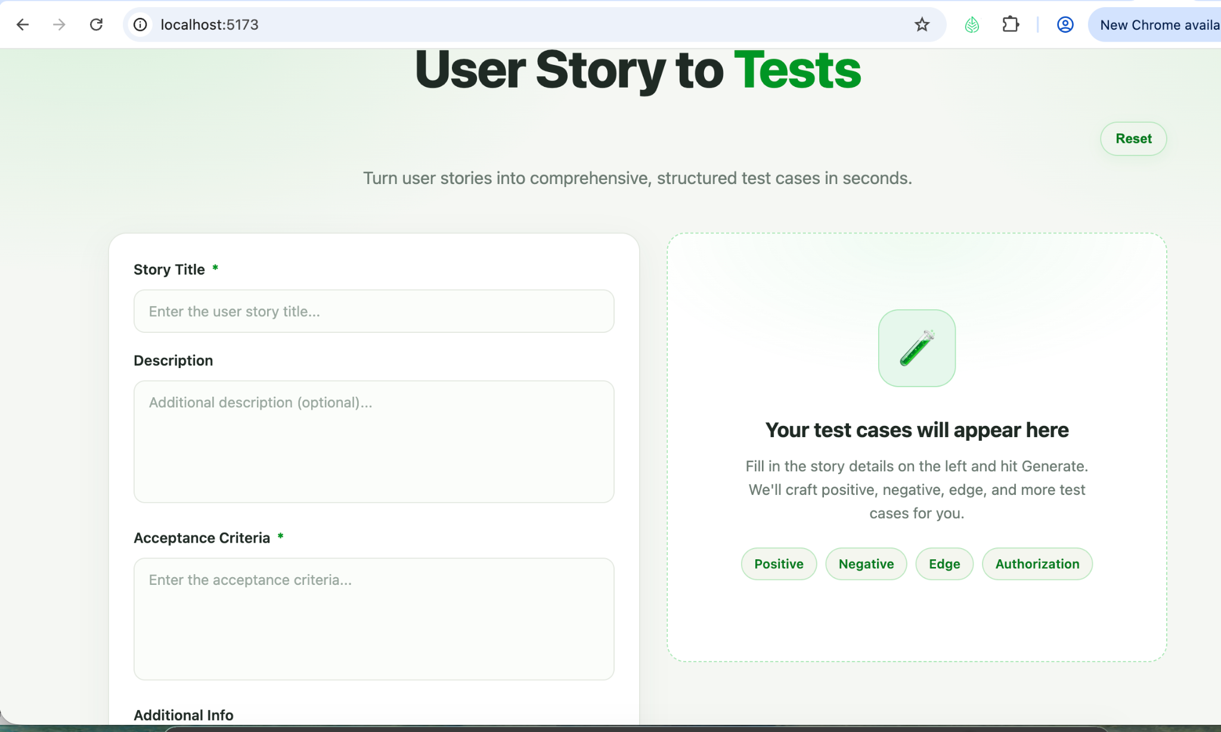

Question2: Add Summary field:
