1. Install the required packages. Open a terminal or command prompt and run the following command: pip install flask flask-restful flask-swagger-ui
2. Import the necessary modules in your Python code:

from flask import Flask from flask_restful import Api, Resource from flasgger import Swagger

1. Initialize your Flask application and create an instance of the Swagger object:

app = Flask(__name__) api = Api(app) swagger = Swagger(app)

1. Define your API endpoints as classes inheriting from **Resource**:

class EventResource(Resource): """ API endpoint for managing events. """ @swagger.doc({ 'tags': ['events'], 'description': 'Get an event by its unique ID', 'parameters': [ { 'name': 'event_id', 'description': 'The ID of the event', 'in': 'query', 'type': 'integer', 'required': True } ], 'responses': { '200': { 'description': 'Event details', 'schema': { 'type': 'object', 'properties': { 'id': {'type': 'integer'}, 'uid': {'type': 'integer'}, 'name': {'type': 'string'}, 'tagline': {'type': 'string'}, 'schedule': {'type': 'string'}, 'description': {'type': 'string'}, 'moderator': {'type': 'string'}, 'category': {'type': 'string'}, 'sub_category': {'type': 'string'}, 'rigor_rank': {'type': 'integer'}, 'attendees': {'type': 'array', 'items': {'type': 'integer'}} } } }, '404': {'description': 'Event not found'} } }) def get(self): # Implementation of the GET request to retrieve an event by ID pass # Define other methods for your API endpoints (POST, PUT, DELETE) in a similar manner

1. Add your API endpoints to the Flask application:

api.add_resource(EventResource, '/api/v3/app/events')

1. Run your Flask application:

if __name__ == '__main__': app.run()

1. Start your Flask server, and you can access the Swagger documentation by visiting **http://localhost:5000/apidocs/**. This will provide an interactive interface where you can view and test your API endpoints.

By following these steps, you can use Swagger to document your API endpoints and provide an interactive documentation interface. Remember to update the Swagger documentation comments for each API endpoint with the appropriate descriptions, parameters, and responses based on your specific requirements.

Method = GET

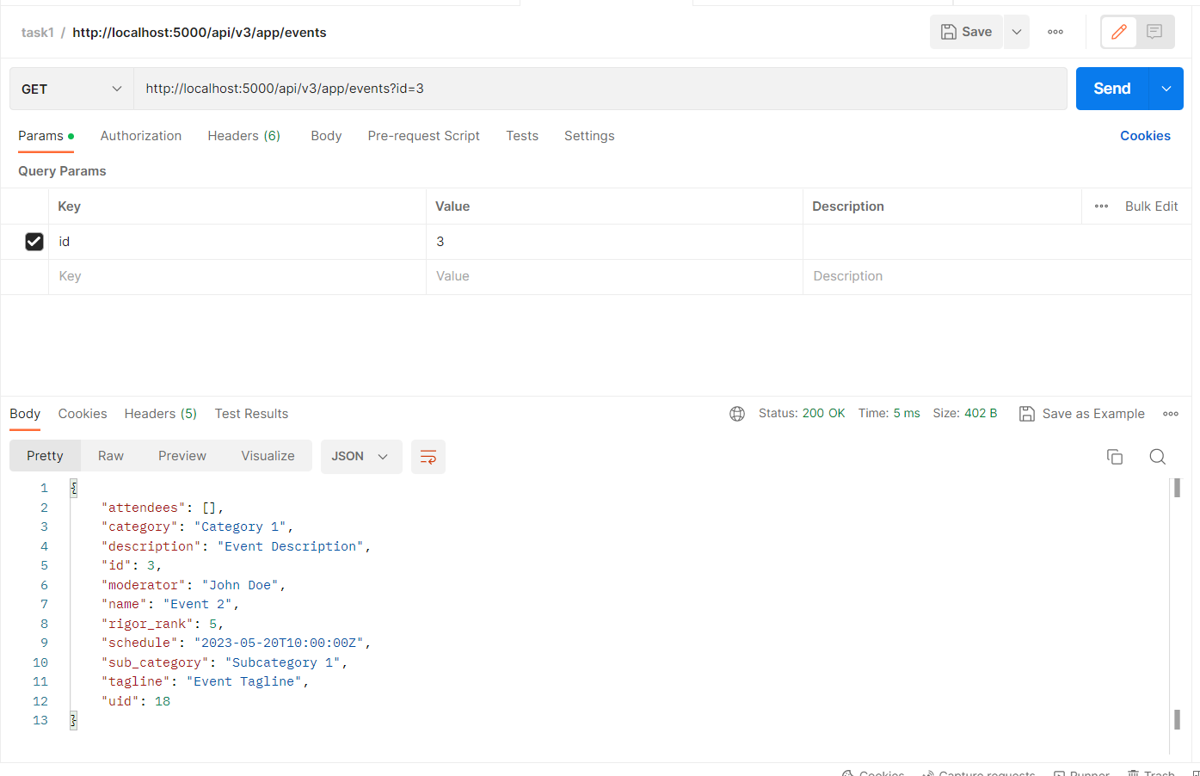

Method = POST

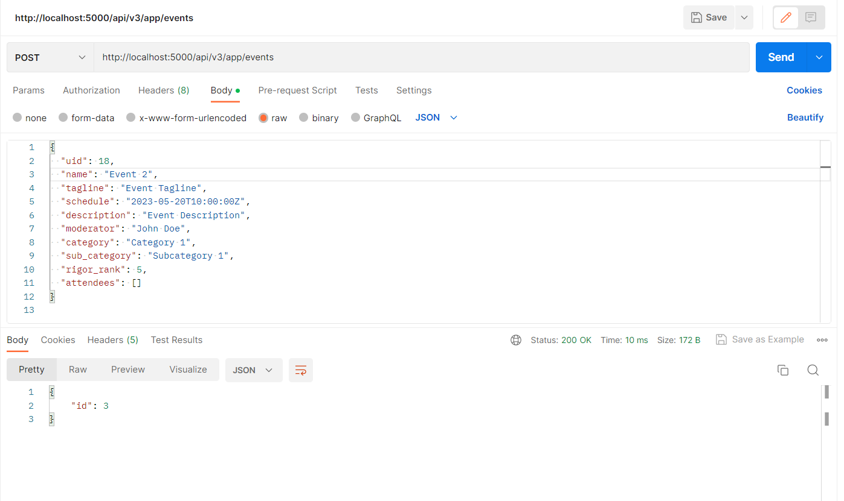

Method = DELETE

