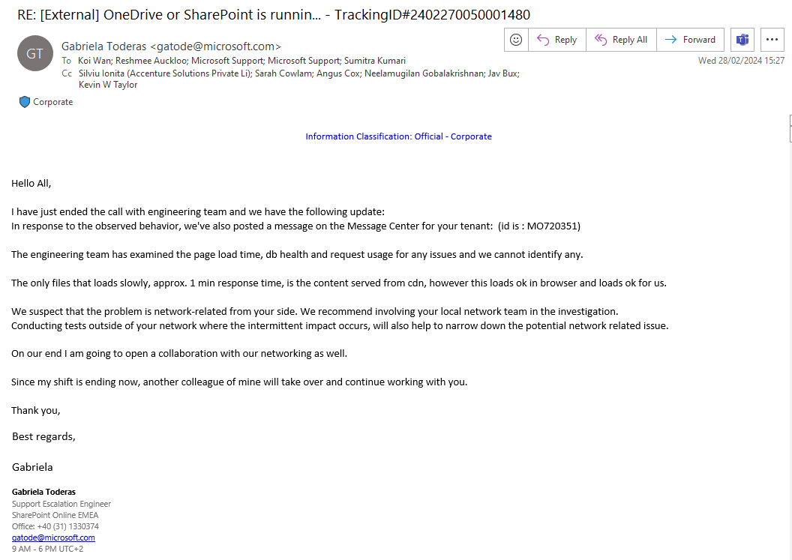

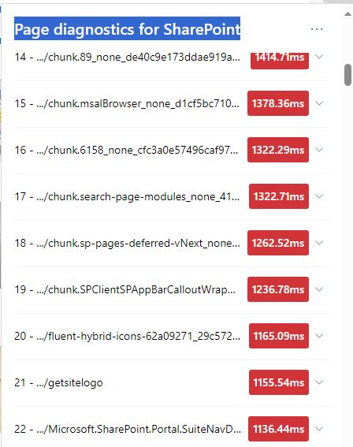

<https://res-1.cdn.office.net/files/odsp-web-prod_2024-02-09.011/splistwebpack/1302.js>

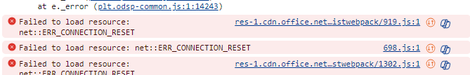

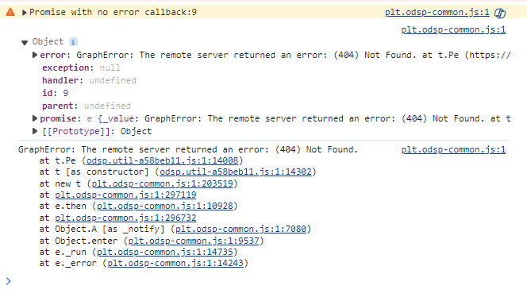

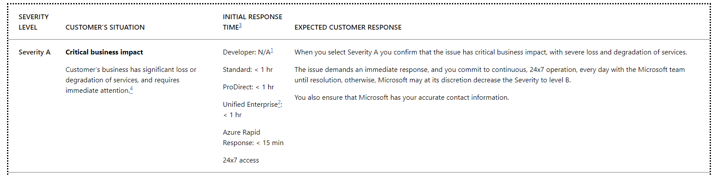

We don’t control the CDN profiles for res-1.cdn.office.net or res.cdn.office.net as they are the Microsoft ones, hence no changes from our end. Have there been any changes on the Microsoft end related to cdn?

The CDN we have set up are

*/USERPHOTO.ASPX  
*/SITEASSETS  
SITES/CONNECTDESIGNASSETS/SITETEMPLATES   
SITES/CONNECTDESIGNASSETS/APPROVEDPHOTOS  
*/MASTERPAGE  
*/STYLE LIBRARY         
*/CLIENTSIDEASSETS

Examples of complete URL

<https://ppfonline.sharepoint.com/SITES/CONNECTDESIGNASSETS/APPROVEDPHOTOS>

<https://ppfonline.sharepoint.com/SITES/CONNECTDESIGNASSETS/SITETEMPLATES>

GET <https://res-1.cdn.office.net/files/sp-client/sp-pages-assembly_en-us_dabadef8fce89e16a072e1ef7c166a4d.js?1709042329628> net::ERR_CONNECTION_RESET 200 (OK)

GET <https://shell.cdn.office.net/shellux/en/shellstrings.52af792134b43bb66ac6fb020ec0b324.json> net::ERR_HTTP2_PING_FAILED 200 (OK)

1. Page diagnostics tool
2. Network tool

<https://connectivity.office.com/report/e8f2281a-df8e-4f05-93b2-949ba9b5958d>

https://learn.microsoft.com/en-us/microsoft-365/enterprise/microsoft-365-ip-web-service?view=o365-worldwide