Use the

Master VM for Jenkins, Ansible, Puppet, GIT etc.

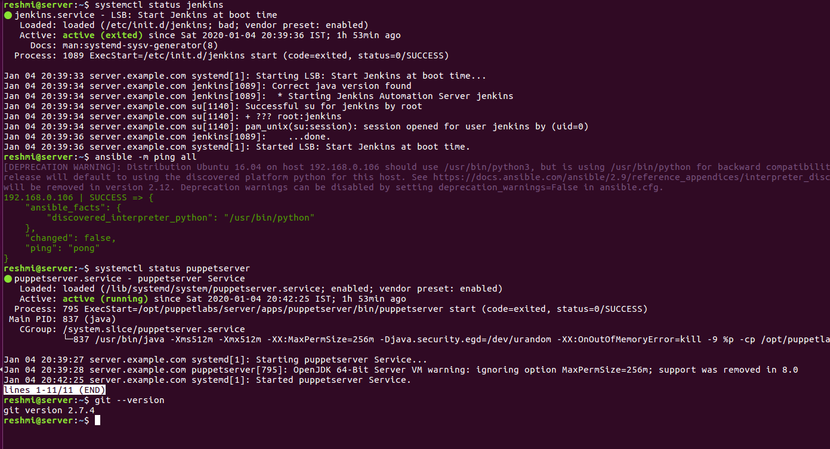

Use the Clean Ubuntu VM image provided in the “Edureka Setup Guide” for Jenkins Slave

Node (Test Server)

Jenkins slave connected.

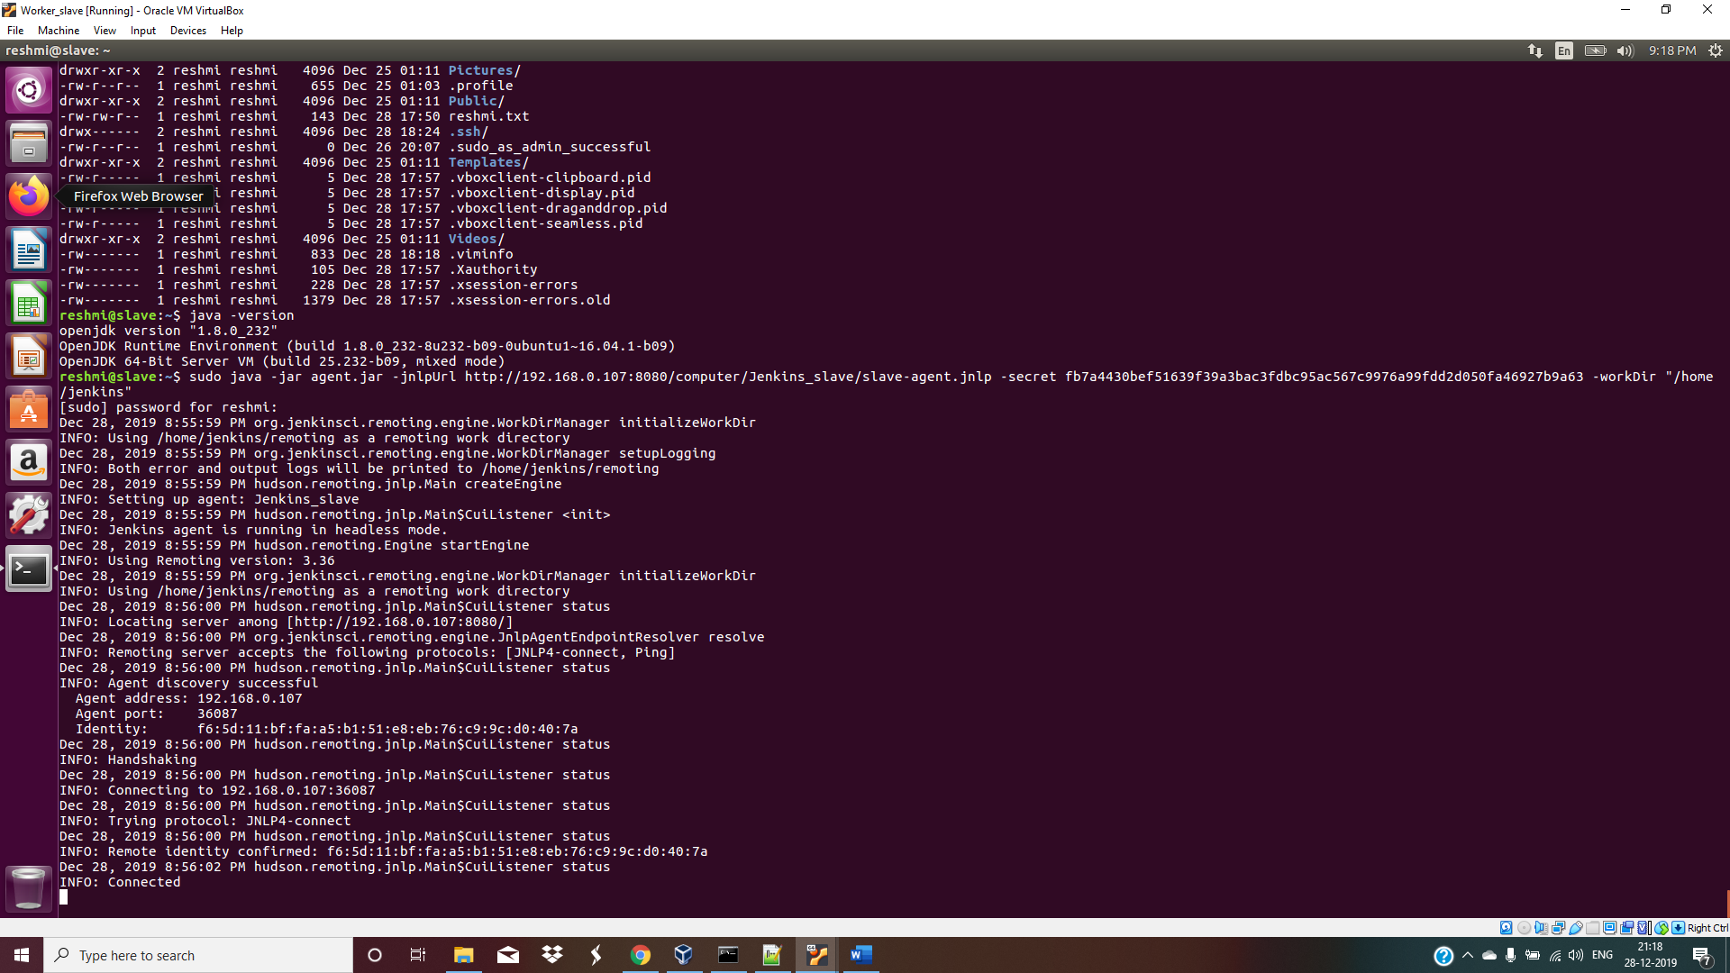

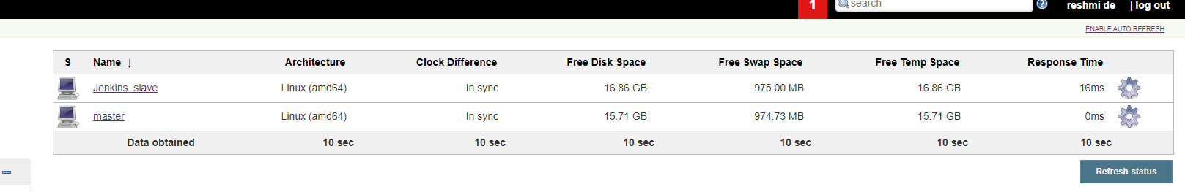

Change the IP address of the VMs accordingly

Add Build Pipeline Plugin and Post

build task plugin to Jenkins on the master VM

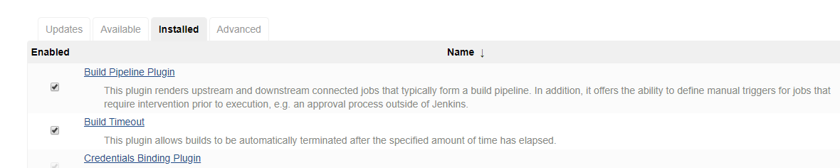

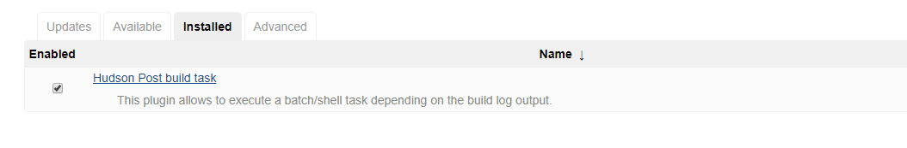

Set up the necessary tools such as git, chromedriver(selenium), chromium

browser(selenium) on the slave node through Ansible

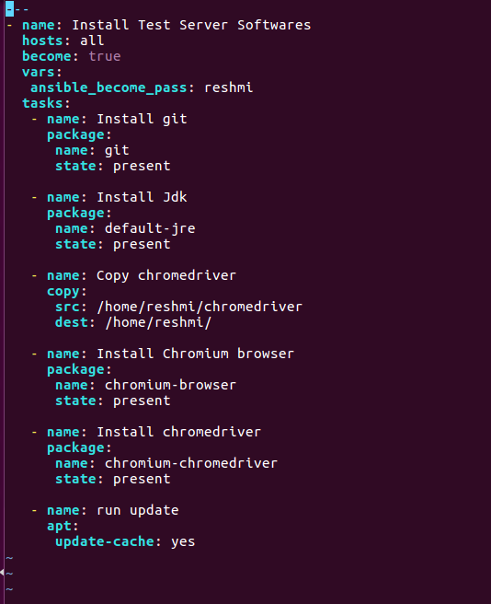

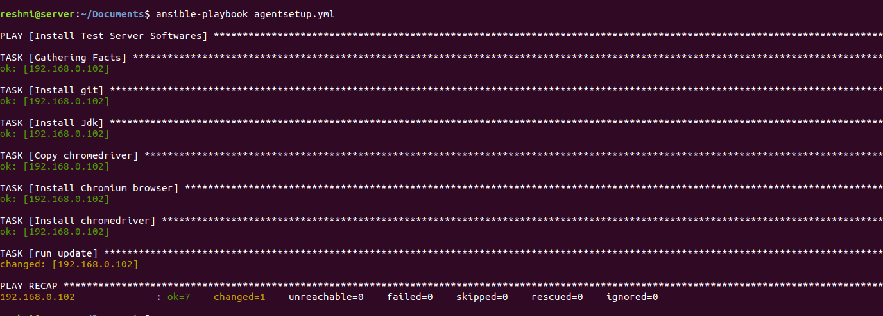

Use the image devopsedu/webapp and add y

our PHP website to it using a Dockerfile

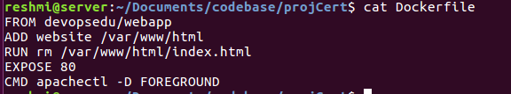

Create a Selenium Test for your PHP website. It should click on “About” and verify the

text written in it. This will conclude the website is deployed and is running fine.

Test result in eclipse:=

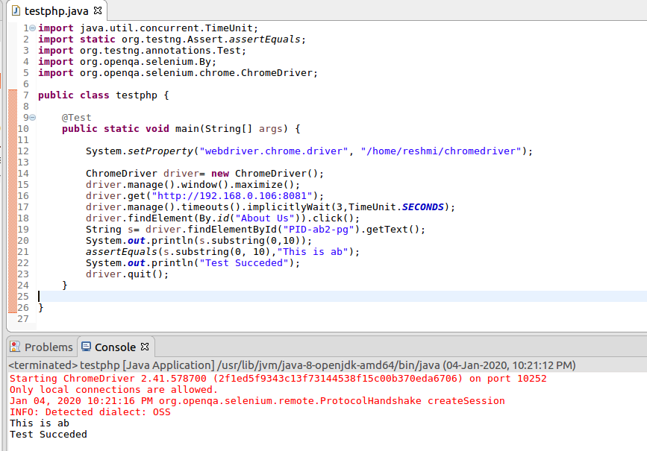

Push the PHP website, Dockerfile and Seleniu

m JAR to a git repository

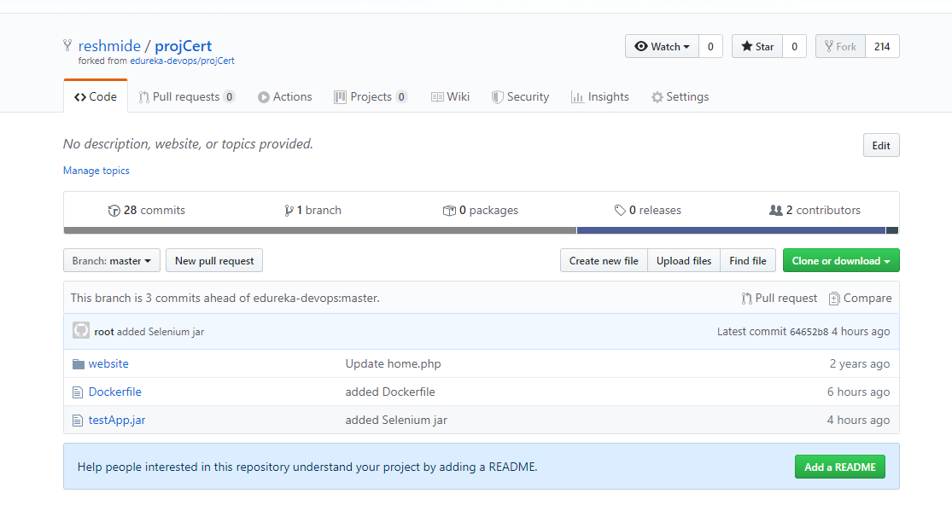

Below tasks should be automated through Jenkins by creating a pipeline:

1.

Install and configure puppet agent on the slave node (Job 1)

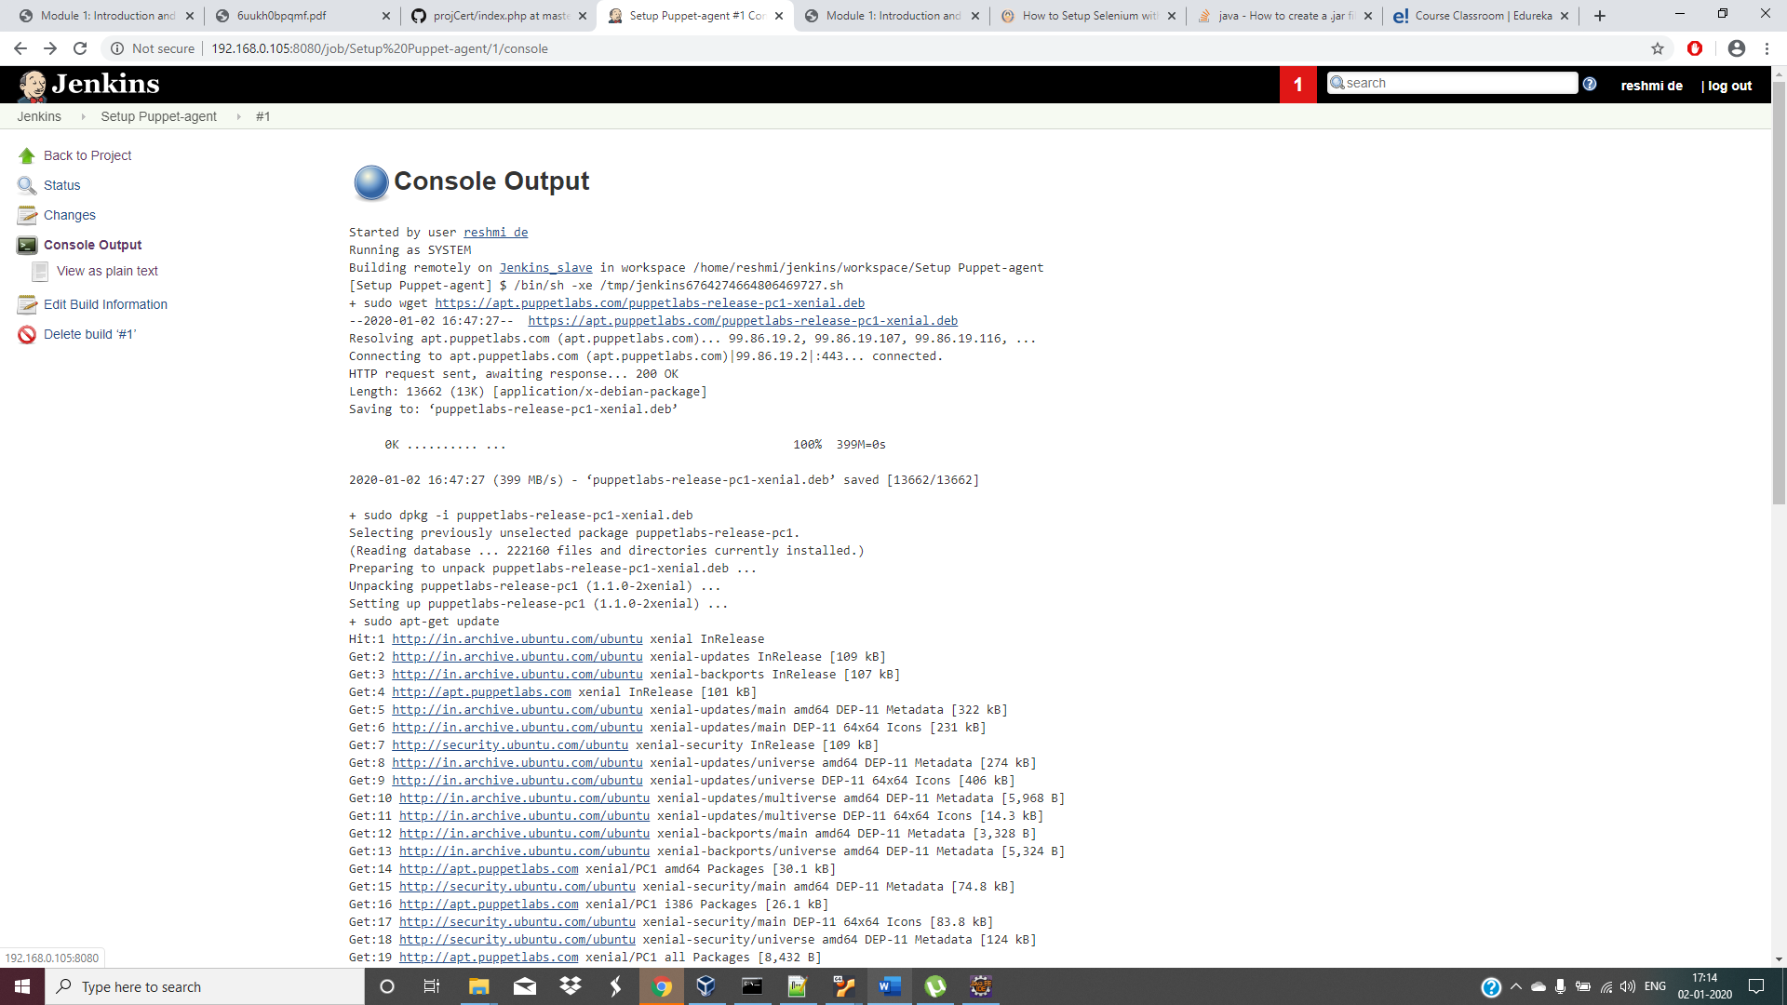

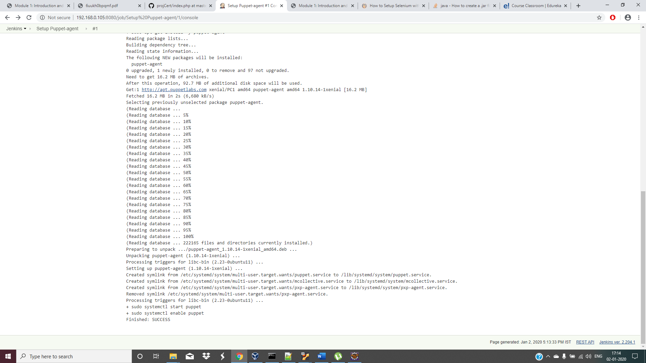

2.

Sign the puppet certificate on master using Jenkins (Job 2)

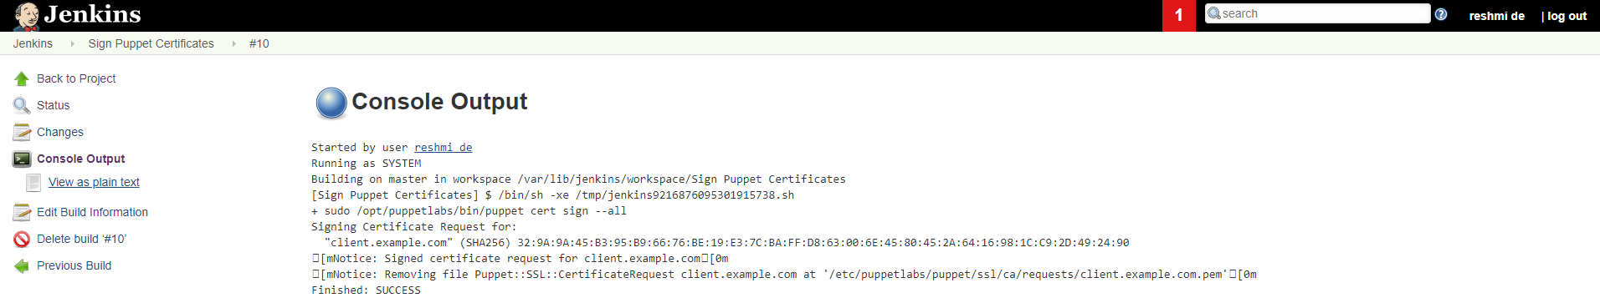

3.

Trigger the puppet agent on t

est server to install docker (Job 3)

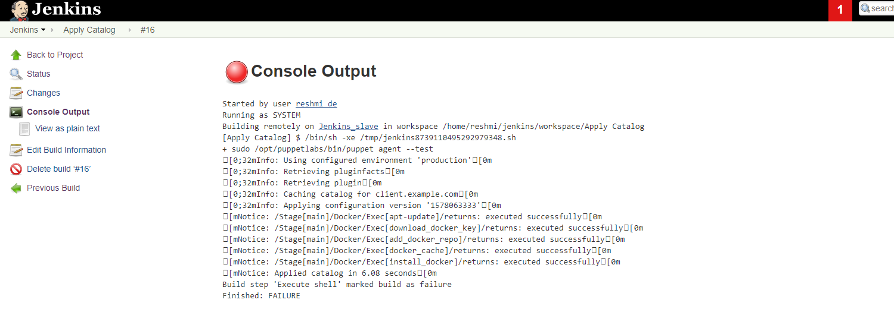

4.

Pull the PHP website, Dockerfile and Selenium JAR from your git repo and build and deploy

your PHP docker container. After this test the deployment using Selenium JAR file. (Job 4)

5.

If Job 4 fails, delete the running con

tainer on Test Serve

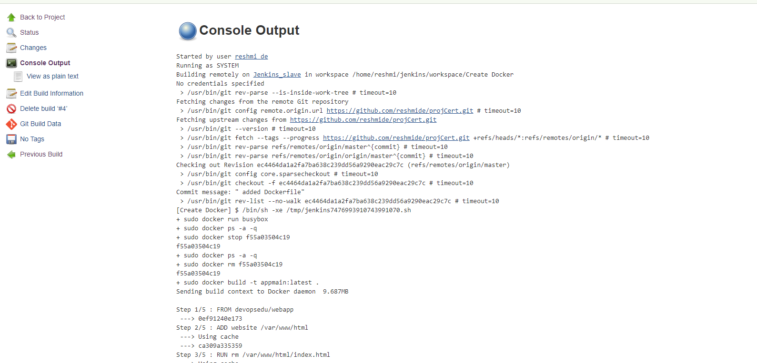

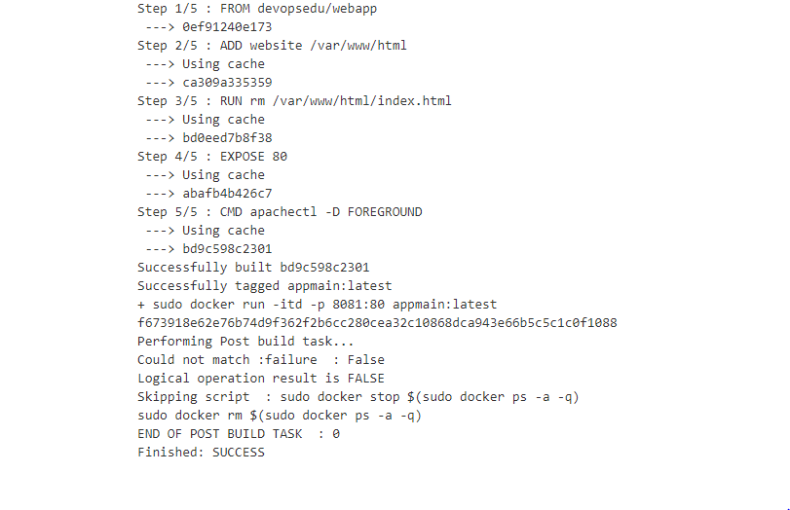

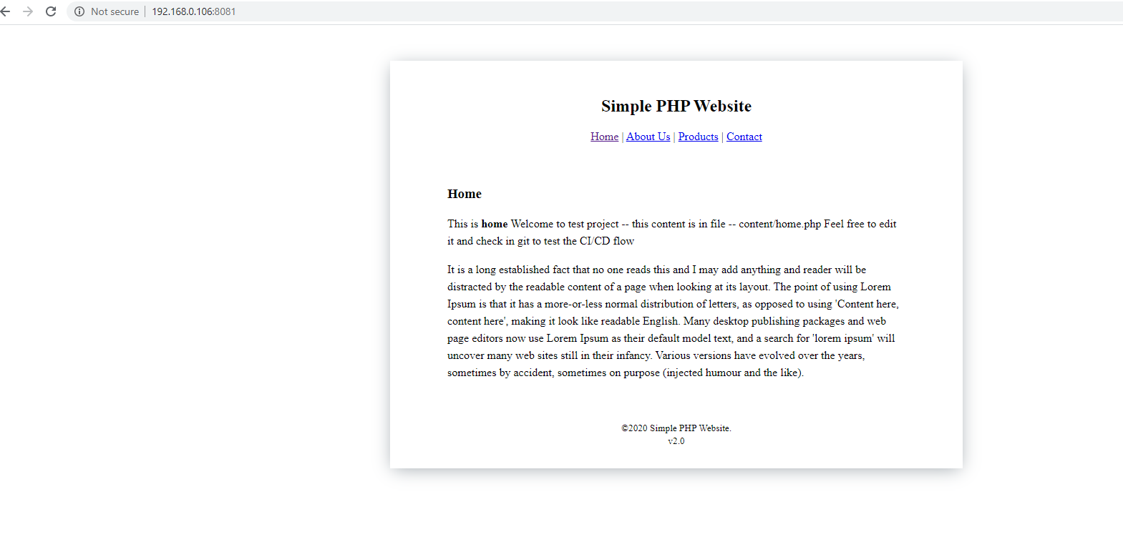

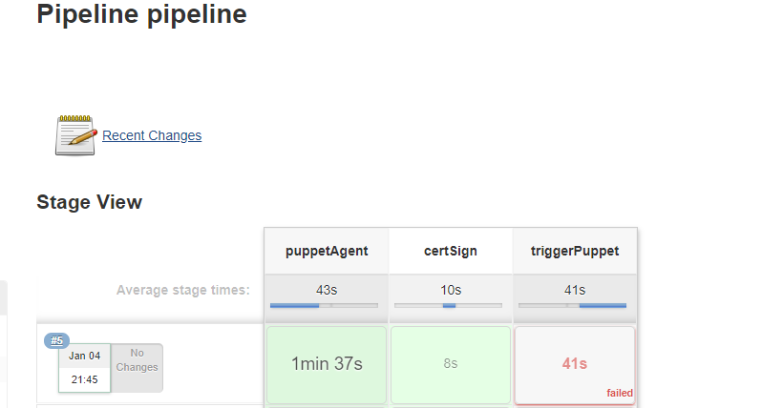

Downstream Job: Create Docker/ stage- deployApplication is not shown in stage view but can be seen from console that it got triggered and was successful.

