|  |
| --- |
|  |
| The Documentation |
| [Type the document subtitle] |
|  |
| **[Your Name]** |
| **[Pick the date]** |

[Type the abstract of the document here. The abstract is typically a short summary of the contents of the document. Type the abstract of the document here. The abstract is typically a short summary of the contents of the document.]

Table of Contents

[To update the table of contents, right click the message below and select Update Field (F9 on PC, ⌥⌘U on Mac).]

**No table of contents entries found.**

1. Pages
   1. Page Tree

Login  
 Dashboard  
 Add Beacon  
 Customers  
 Analytics  
 Orders  
 Help  
 Beacons List  
 Maps  
 Ads  
 Deals

* 1. Login
     1. User Interface

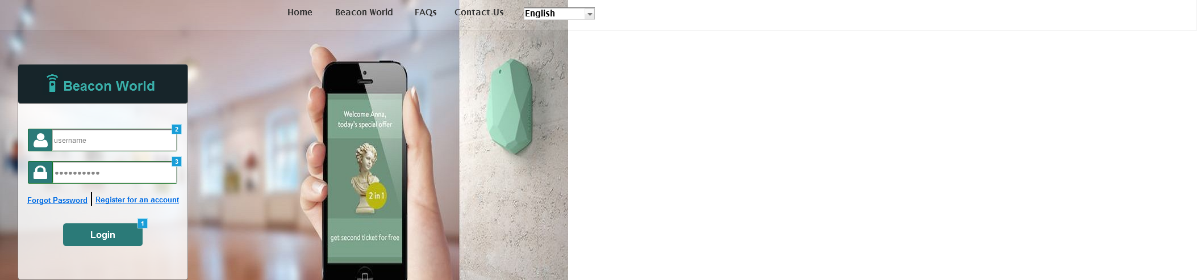

* + 1. Widget Table

| Footnote | Name | Interactions |
| --- | --- | --- |
| 1 |  | OnClick:  Case 1  (If text on UsernameTextField equals "" and text on PasswordTextField equals ""):  Show emptyFieldsAlert  Case 2  (Else If text on UsernameTextField equals "reshmi" and text on PasswordTextField equals "reshmi"):  Open Dashboard in Current Window  Case 3  (Else If text on UsernameTextField does not equal "reshmi" and text on UsernameTextField does not equal " " and text on PasswordTextField does not equal "reshmi" and text on PasswordTextField does not equal " "):  Show invalidFieldAlert |
| 2 | UsernameTextField | OnClick:  Case 1:  Set text on This equal to "" |
| 3 | PasswordTextField | OnClick:  Case 1:  Set text on This equal to "" |

* 1. Dashboard
     1. User Interface

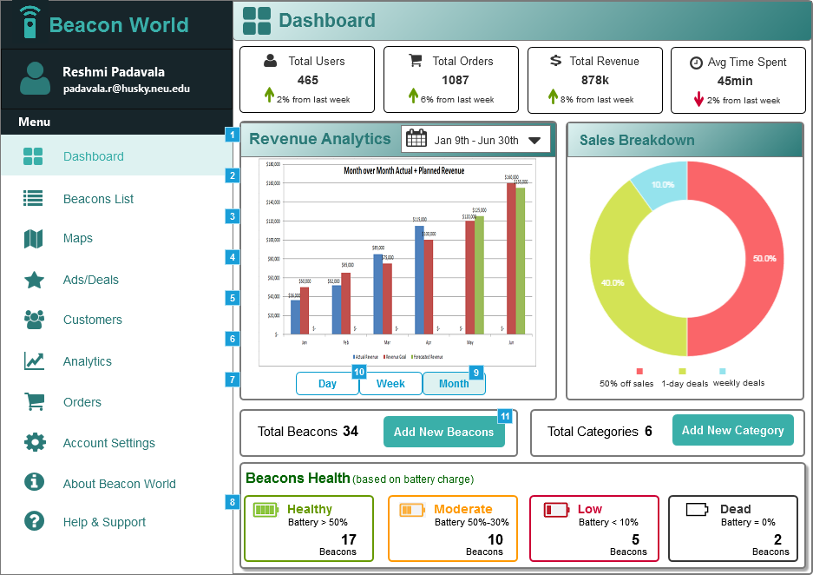

* + 1. Widget Table

| Footnote | Name | Interactions |
| --- | --- | --- |
| 1 | dashboard | OnClick:  Case 1:  Open Dashboard in Current Window |
| 2 | beaconlist | OnClick:  Case 1:  Open Beacons List in Current Window |
| 3 | maps | OnClick:  Case 1:  Open Maps in Current Window |
| 4 | ads | OnClick:  Case 1:  Open Deals in Current Window |
| 5 | customers | OnClick:  Case 1:  Open Customers in Current Window |
| 6 | analytics | OnClick:  Case 1:  Open Analytics in Current Window |
| 7 | orders | OnClick:  Case 1:  Open Orders in Current Window |
| 8 | help | OnClick:  Case 1:  Open Help in Current Window |
| 9 | MonthButton | OnClick:  Case 1:  Hide dailyreports |
| 10 | DayButton | OnClick:  Case 1:  Show dailyreports |
| 11 |  | OnClick:  Case 1:  Open Add Beacon in Current Window |

* 1. Add Beacon
     1. User Interface

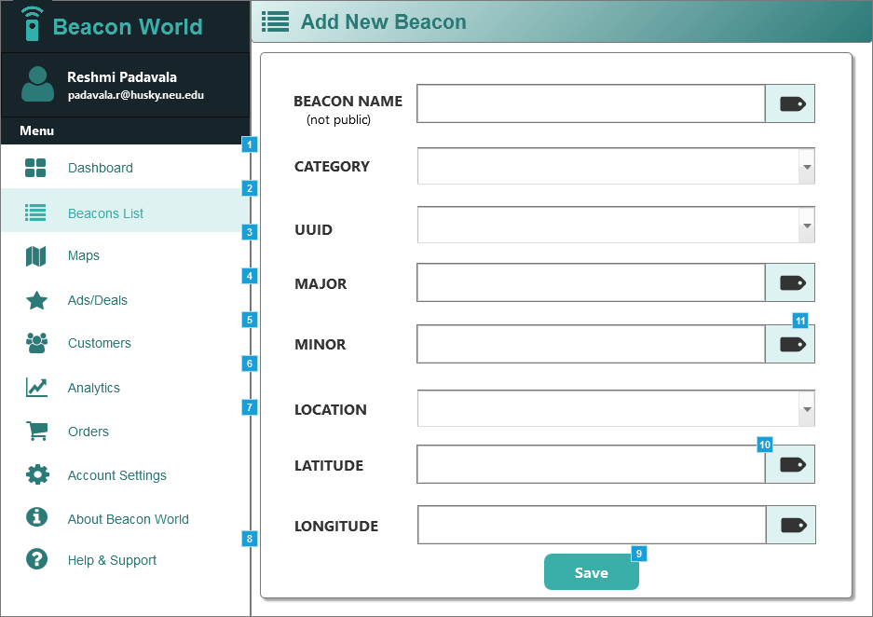

* + 1. Widget Table

| Footnote | Name | Interactions |
| --- | --- | --- |
| 1 | dashboard | OnClick:  Case 1:  Open Dashboard in Current Window |
| 2 | beaconlist | OnClick:  Case 1:  Open Beacons List in Current Window |
| 3 | maps | OnClick:  Case 1:  Open Maps in Current Window |
| 4 | ads | OnClick:  Case 1:  Open Deals in Current Window |
| 5 | customers | OnClick:  Case 1:  Open Customers in Current Window |
| 6 | analytics | OnClick:  Case 1:  Open Analytics in Current Window |
| 7 | orders | OnClick:  Case 1:  Open Orders in Current Window |
| 8 | help | OnClick:  Case 1:  Open Help in Current Window |
| 9 | saveButton | OnClick:  Case 1:  Open Beacons List in Current Window |
| 10 | adLatitudeTextField | OnClick:  Case 1:  Show latitudeMap |
| 11 |  | OnClick:  Case 1:  Set text on adLatitudeTextField equal to "N 42° 20.3501'" OnMouseEnter:  Case 1:  Show latitudeLabel OnMouseOut:  Case 1:  Hide latitudeMap OnMouseHover:  Case 1:  Show latitudeLabel |

* 1. Customers
     1. User Interface

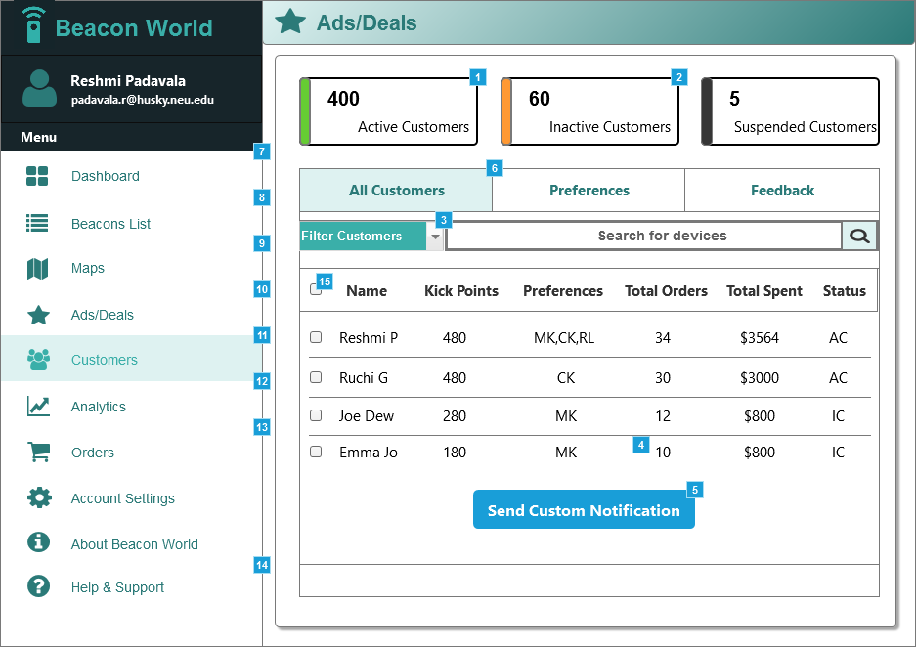

* + 1. Widget Table

| Footnote | Name | Interactions |
| --- | --- | --- |
| 1 | ACGroup | OnClick:  Case 1:  Hide ICRow1  Hide ICRow2  Show CustomerTableRow, CustomerTableRow |
| 2 | ICGroup | OnClick:  Case 1:  Show FilterICGroup |
| 3 |  | OnSelectionChange:  Case 1  (If selected option of This equals "Active"):  Hide FilterICGroup, ICGroup  Case 2  (Else If selected option of This equals "Inactive"):  Show FilterICGroup, Hide ICGroup, CustomerTableRow, CustomerTableRow |
| 4 |  | OnClick:  Case 1:  Hide existingAdsGroup |
| 5 | SendCustomNotifyButton | OnClick:  Case 1:  Show existingAdsGroup |
| 6 |  | OnClick:  Case 1:  Show CustomerTableRow, CustomerTableRow, ICRow2, ICRow1 |
| 7 | dashboard | OnClick:  Case 1:  Open Dashboard in Current Window |
| 8 | beaconlist | OnClick:  Case 1:  Open Beacons List in Current Window |
| 9 | maps | OnClick:  Case 1:  Open Maps in Current Window |
| 10 | ads | OnClick:  Case 1:  Open Deals in Current Window |
| 11 | customers | OnClick:  Case 1:  Open Customers in Current Window |
| 12 | analytics | OnClick:  Case 1:  Open Analytics in Current Window |
| 13 | orders | OnClick:  Case 1:  Open Orders in Current Window |
| 14 | help | OnClick:  Case 1:  Open Help in Current Window |
| 15 |  | OnSelected:  Case 1:  Set is selected of IC_Checkbox equal to "true", and  is selected of IC_Checkbox equal to "true" OnUnselected:  Case 1:  Set is selected of IC_Checkbox equal to "false", and  is selected of IC_Checkbox equal to "false" |

* 1. Analytics
     1. User Interface

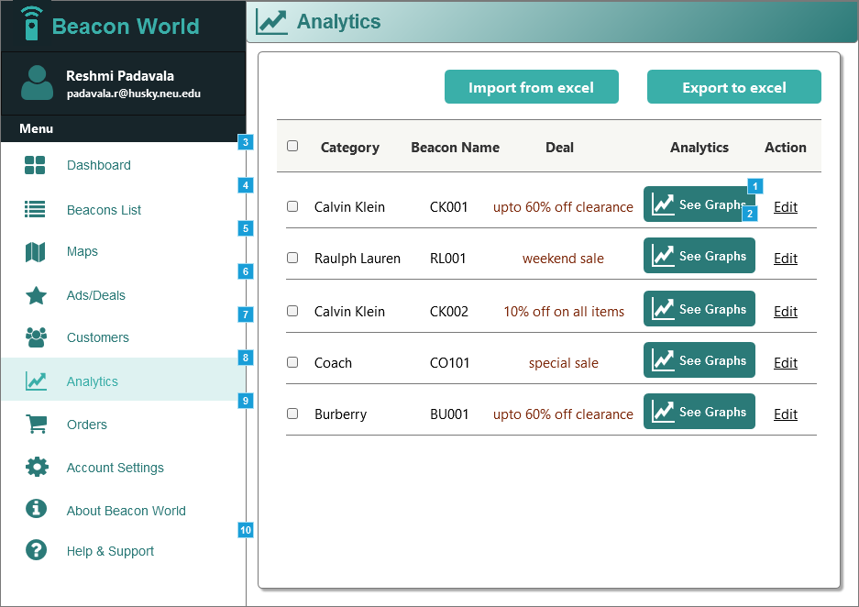

* + 1. Widget Table

| Footnote | Name | Interactions |
| --- | --- | --- |
| 1 |  | OnClick:  Case 1:  Show AnalyticsDialog |
| 2 |  | OnClick:  Case 1:  Hide AnalyticsDialog |
| 3 | dashboard | OnClick:  Case 1:  Open Dashboard in Current Window |
| 4 | beaconlist | OnClick:  Case 1:  Open Beacons List in Current Window |
| 5 | maps | OnClick:  Case 1:  Open Maps in Current Window |
| 6 | ads | OnClick:  Case 1:  Open Deals in Current Window |
| 7 | customers | OnClick:  Case 1:  Open Customers in Current Window |
| 8 | analytics | OnClick:  Case 1:  Open Analytics in Current Window |
| 9 | orders | OnClick:  Case 1:  Open Orders in Current Window |
| 10 | help | OnClick:  Case 1:  Open Help in Current Window |

* 1. Orders
     1. User Interface

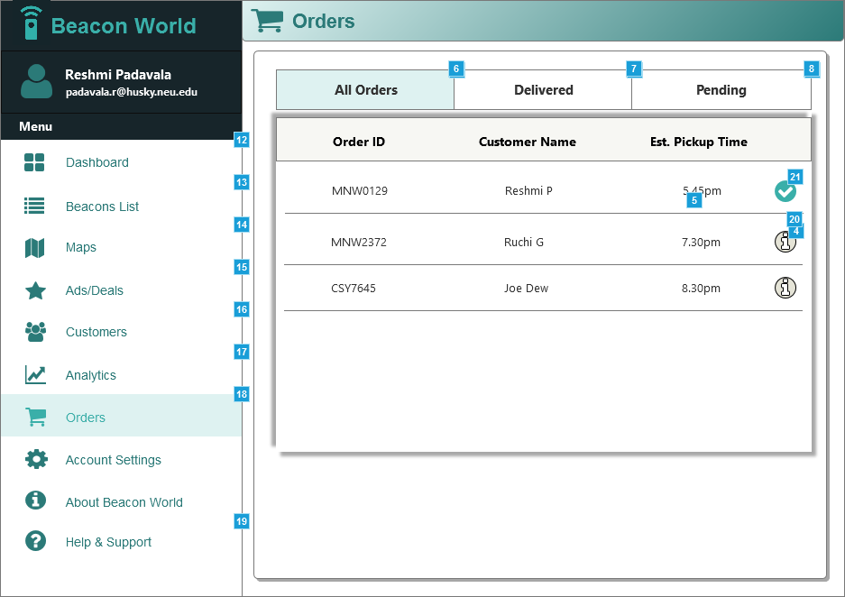

* + 1. Widget Table

| Footnote | Name | Interactions |
| --- | --- | --- |
| 1 |  | OnClick:  Case 1:  Hide deliveredOrderGroup, pendingOrdersGroup |
| 2 |  | OnClick:  Case 1:  Show deliveredOrderGroup, Hide pendingOrdersGroup |
| 3 |  | OnClick:  Case 1:  Show pendingOrdersGroup, Hide deliveredOrderGroup  Show/Hide Widget |
| 4 |  | OnClick:  Case 1:  Show orderAlertGroup |
| 5 |  | OnClick:  Case 1:  Hide orderAlertGroup |
| 6 |  | OnClick:  Case 1:  Hide deliveredOrderGroup, pendingOrdersGroup |
| 7 |  | OnClick:  Case 1:  Show deliveredOrderGroup, Hide pendingOrdersGroup  Show/Hide Widget |
| 8 |  | OnClick:  Case 1:  Show pendingOrdersGroup  Hide deliveredOrderGroup |
| 9 |  | OnClick:  Case 1:  Hide deliveredOrderGroup, pendingOrdersGroup |
| 10 |  | OnClick:  Case 1:  Show deliveredOrderGroup, Hide pendingOrdersGroup  Show/Hide Widget |
| 11 |  | OnClick:  Case 1:  Show pendingOrdersGroup, Hide deliveredOrderGroup |
| 12 | dashboard | OnClick:  Case 1:  Open Dashboard in Current Window |
| 13 | beaconlist | OnClick:  Case 1:  Open Beacons List in Current Window |
| 14 | maps | OnClick:  Case 1:  Open Maps in Current Window |
| 15 | ads | OnClick:  Case 1:  Open Deals in Current Window |
| 16 | customers | OnClick:  Case 1:  Open Customers in Current Window |
| 17 | analytics | OnClick:  Case 1:  Open Analytics in Current Window |
| 18 | orders | OnClick:  Case 1:  Open Orders in Current Window |
| 19 | help | OnClick:  Case 1:  Open Help in Current Window |
| 20 |  | OnClick:  Case 1:  Show orderAlertGroup |
| 21 | po1 | OnClick:  Case 1:  Show orderAlertGroup |

* 1. Help
     1. User Interface

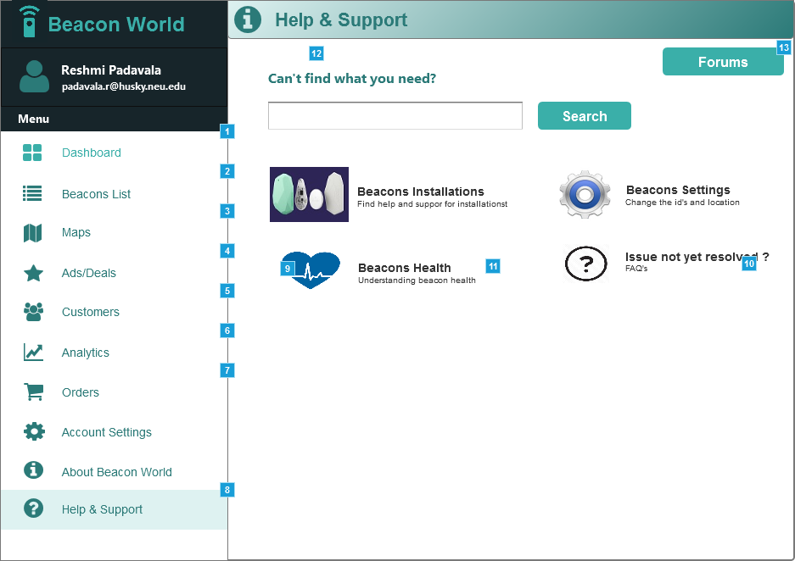

* + 1. Widget Table

| Footnote | Name | Interactions |
| --- | --- | --- |
| 1 | dashboard | OnClick:  Case 1:  Open Dashboard in Current Window |
| 2 | beaconlist | OnClick:  Case 1:  Open Beacons List in Current Window |
| 3 | maps | OnClick:  Case 1:  Open Maps in Current Window |
| 4 | ads | OnClick:  Case 1:  Open Deals in Current Window |
| 5 | customers | OnClick:  Case 1:  Open Customers in Current Window |
| 6 | analytics | OnClick:  Case 1:  Open Analytics in Current Window |
| 7 | orders | OnClick:  Case 1:  Open Orders in Current Window |
| 8 | help | OnClick:  Case 1:  Open Help in Current Window |
| 9 |  | OnClick:  Case 1:  Show forumAnswer |
| 10 |  | OnMouseEnter:  Case 1: |
| 11 |  | OnMouseEnter:  Case 1:  Toggle forumAnswer Show slide down 60 ms Hide slide up 60 ms |
| 12 | backButton | OnClick:  Case 1:  Hide ForumPage |
| 13 |  | OnClick:  Case 1:  Show ForumPage |

* 1. Beacons List
     1. User Interface

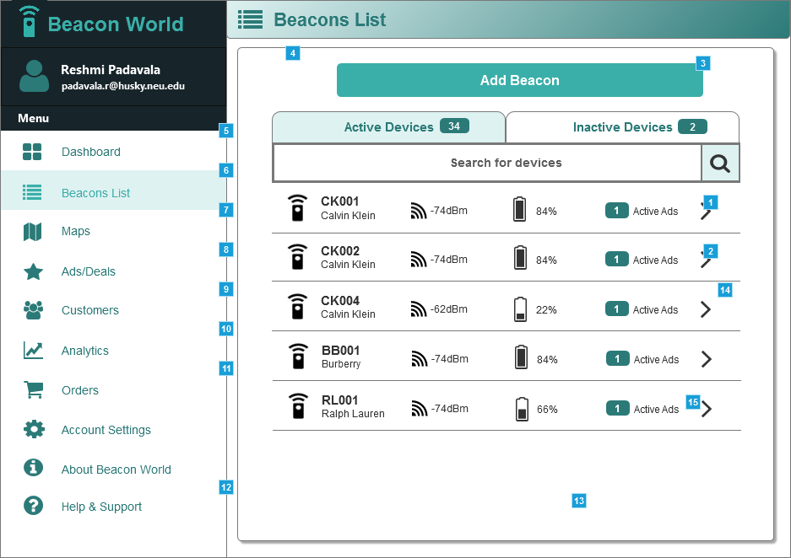

* + 1. Widget Table

| Footnote | Name | Interactions |
| --- | --- | --- |
| 1 |  | OnClick:  Case 1:  Show addBeaconGroup, saveButton, backButton, Hide addBeaconLabel, BeaconListPage |
| 2 |  | OnClick:  Case 1:  Show addBeaconGroup |
| 3 |  | OnClick:  Case 1:  Open Add Beacon in Current Window |
| 4 | backButton | OnClick:  Case 1:  Show BeaconListPage, Hide addBeaconGroup |
| 5 | dashboard | OnClick:  Case 1:  Open Dashboard in Current Window |
| 6 | beaconlist | OnClick:  Case 1:  Open Beacons List in Current Window |
| 7 | maps | OnClick:  Case 1:  Open Maps in Current Window |
| 8 | ads | OnClick:  Case 1:  Open Deals in Current Window |
| 9 | customers | OnClick:  Case 1:  Open Customers in Current Window |
| 10 | analytics | OnClick:  Case 1:  Open Analytics in Current Window |
| 11 | orders | OnClick:  Case 1:  Open Orders in Current Window |
| 12 | help | OnClick:  Case 1:  Open Help in Current Window |
| 13 | saveButton | OnClick:  Case 1:  Show BeaconListPage, Hide addBeaconGroup |
| 14 |  | OnClick:  Case 1:  Set text on adLatitudeTextField equal to "N 42° 20.3888' " OnMouseEnter:  Case 1:  Show latitudeLabel OnMouseOut:  Case 1:  Hide latitudeMap OnMouseHover:  Case 1:  Show latitudeLabel |
| 15 | adLatitudeTextField | OnClick:  Case 1:  Show latitudeMap |

* 1. Maps
     1. User Interface

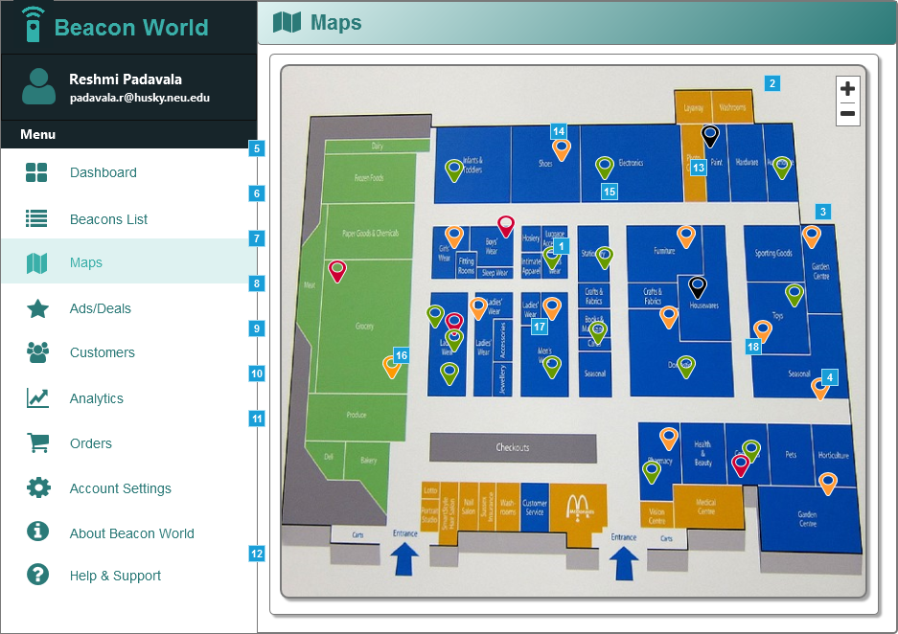

* + 1. Widget Table

| Footnote | Name | Interactions |
| --- | --- | --- |
| 1 |  | OnMouseEnter:  Case 1:  Show HoverDialog OnMouseOut:  Case 1:  Hide HoverDialog |
| 2 | HoverDialog | OnMouseEnter:  Case 1:  Show This OnMouseOut:  Case 1:  Hide This |
| 3 | HoverDialog | OnMouseEnter:  Case 1:  Show This OnMouseOut:  Case 1:  Hide This |
| 4 |  | OnMouseEnter:  Case 1:  Show HoverDialog OnMouseOut:  Case 1:  Hide HoverDialog |
| 5 | dashboard | OnClick:  Case 1:  Open Dashboard in Current Window |
| 6 | beaconlist | OnClick:  Case 1:  Open Beacons List in Current Window |
| 7 | maps | OnClick:  Case 1:  Open Maps in Current Window |
| 8 | ads | OnClick:  Case 1:  Open Deals in Current Window |
| 9 | customers | OnClick:  Case 1:  Open Customers in Current Window |
| 10 | analytics | OnClick:  Case 1:  Open Analytics in Current Window |
| 11 | orders | OnClick:  Case 1:  Open Orders in Current Window |
| 12 | help | OnClick:  Case 1:  Open Help in Current Window |
| 13 |  | OnClick:  Case 1:  Hide MapNavigator |
| 14 | HoverDialog | OnMouseEnter:  Case 1:  Show This OnMouseOut:  Case 1:  Hide This |
| 15 | HoverDialog3 | OnMouseEnter:  Case 1:  Show This OnMouseOut:  Case 1:  Hide This |
| 16 |  | OnMouseEnter:  Case 1:  Show HoverDialog3 OnMouseOut:  Case 1:  Hide HoverDialog3 |
| 17 |  | OnClick:  Case 1:  Show MapNavigator  Hide HoverDialog3 |
| 18 |  | OnClick:  Case 1:  Show MapNavigator  Hide HoverDialog3, HoverDialog, HoverDialog, HoverDialog |

* 1. Ads
     1. User Interface

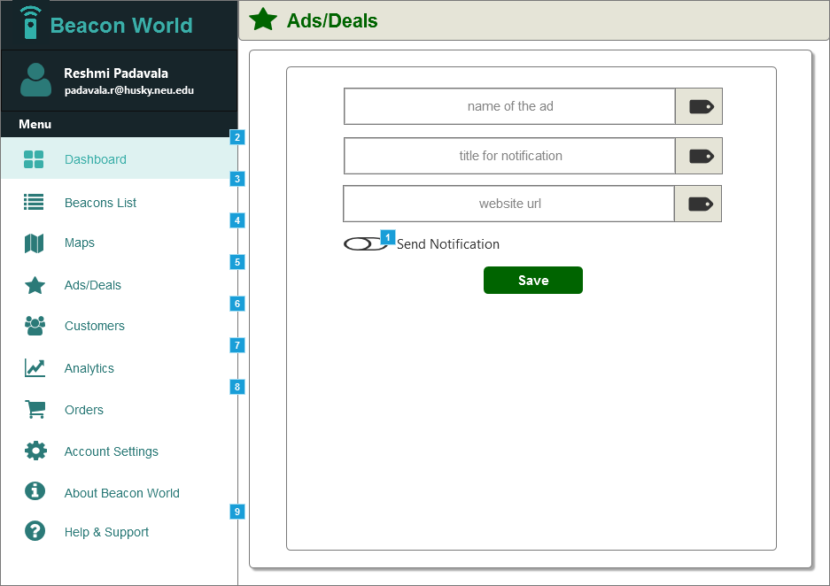

* + 1. Widget Table

| Footnote | Name | Interactions |
| --- | --- | --- |
| 1 | toggleOff | OnClick:  Case 1:  Show SendNotifyGroup |
| 2 | dashboard | OnClick:  Case 1:  Open Dashboard in Current Window |
| 3 | beaconlist | OnClick:  Case 1:  Open Beacons List in Current Window |
| 4 | maps | OnClick:  Case 1:  Open Maps in Current Window |
| 5 | ads | OnClick:  Case 1:  Open Deals in Current Window |
| 6 | customers | OnClick:  Case 1:  Open Customers in Current Window |
| 7 | analytics | OnClick:  Case 1:  Open Analytics in Current Window |
| 8 | orders | OnClick:  Case 1:  Open Orders in Current Window |
| 9 | help | OnClick:  Case 1:  Open Help in Current Window |

* 1. Deals
     1. User Interface

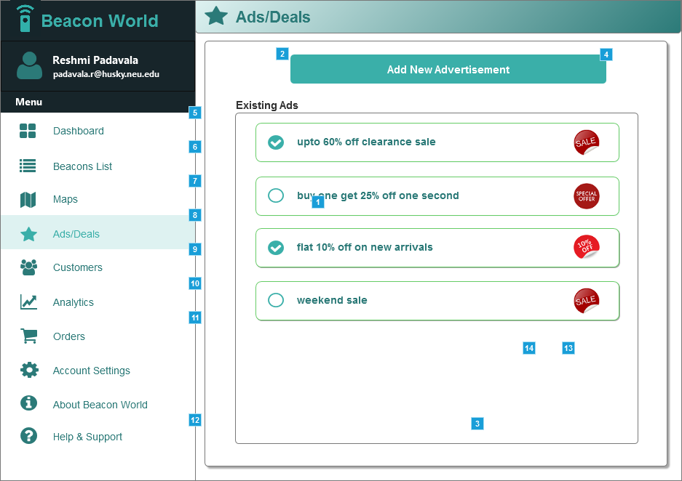

* + 1. Widget Table

| Footnote | Name | Interactions |
| --- | --- | --- |
| 1 | toggleOff | OnClick:  Case 1:  Show SendNotifyGroup |
| 2 |  | OnClick:  Case 1:  Hide SendNotifyGroup, adDetailsGroup |
| 3 |  | OnClick:  Case 1:  Hide SendNotifyGroup  Hide adDetailsGroup |
| 4 |  | OnClick:  Case 1:  Show adDetailsGroup |
| 5 | dashboard | OnClick:  Case 1:  Open Dashboard in Current Window |
| 6 | beaconlist | OnClick:  Case 1:  Open Beacons List in Current Window |
| 7 | maps | OnClick:  Case 1:  Open Maps in Current Window |
| 8 | ads | OnClick:  Case 1:  Open Deals in Current Window |
| 9 | customers | OnClick:  Case 1:  Open Customers in Current Window |
| 10 | analytics | OnClick:  Case 1:  Open Analytics in Current Window |
| 11 | orders | OnClick:  Case 1:  Open Orders in Current Window |
| 12 | help | OnClick:  Case 1:  Open Help in Current Window |
| 13 | defaultSunday | OnClick:  Case 1:  Hide defaultSunday |
| 14 | defaultSaturday | OnClick:  Case 1:  Hide defaultSaturday |