**UE20CS302**

**SOFTWARE ENGINEERING**

PROJECT PLANNING

**Simple Text Editor**

Name and SRN:

Rashmi KR PES2UG20CS266

Reshmi Pradeep PES2UG20CS270

Rimzim Sanghvi PES2UG20CS273

1. Identify the lifecycle to be followed for the execution of your project and justify why you have chosen the model.

Since the software being implemented is small and the there are no major changes in the requirements, we will be using the waterfall models. It accommodates small and less complex projects and has a testing phase at the very end. The tools and techniques used are also not subject to change.

1. Identify the tools which you want to use throughout the lifecycle like planning tool, design tool, version control, development tool, bug tracking and testing  
   tool.

Planning tool, Bug tracking tool: Jira software - this is a work management, planning, bug tracking tool for all kind of use cases.  
Design tool: Draw.io, Canva  
Version control: Github  
Development Tools: Python

1. Determine all the deliverables and categorise them as reuse/build components and justify the same.

File Handling Module: This is a build component as it consists of the functions that help user create a file, close and save a file.

Edit Module: This is a build component as it consists of the cut, copy and paste commands and functions to help ease of using the text editor.

Format Module: This is a re-use component it consists of functions that help a user to choose different themes and indenting and font types and size.

Program Module: This is a build component as it consists of commands that allow the user to run the text as a program and run it. It specifically consists of: Undo and redo commands, autocomplete brackets, run current file, find and replace functions.

1. Create a WBS for the functionalities in detail

A deliverable based WBS is shown below

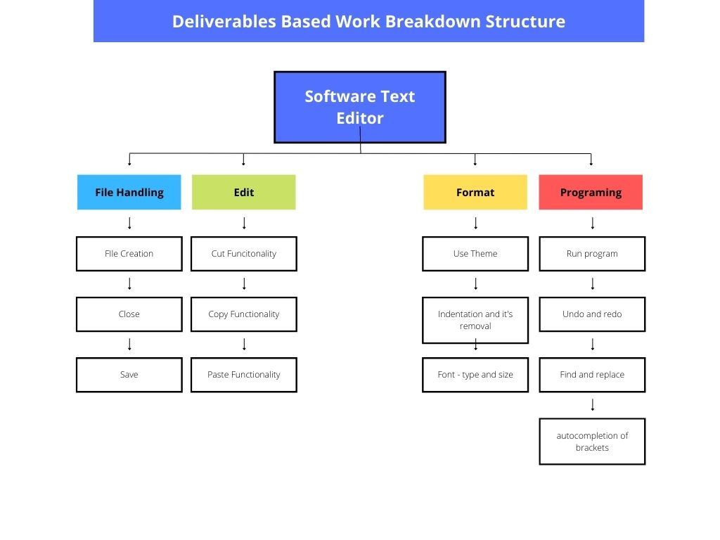

1. Do a rough estimate of effort required to accomplish each task in terms of person months.

With respect to the Constructive Cost Model (COCOMO), schedule and cost are related as

P= KLOC / E  
where, P=Productivity, KLOC = Kilo lines of code (the estimated size) and E= Effort (the total effort in person months)

Since this is a rough estimate, consider the value of KLOC to be 40.

Considering this to be organic,  
Effort = a1 * KLOC * a2 (PM)

Where, a1=2.4 and a2=1.05  
Therefore, Effort = (2.4)(40)(1.05)PM = 100.8 PM

Productivity, P = KLOC / Effort

Therefore, P = 40 / 100.8 = 396.8 LOC/PM

1. Create the Gantt Chart for scheduling using any tool.

