Software Requirements Specification

for

SIMPLE TEXT EDITOR

Version 1.0 approved

Prepared by:

Rashmi KR PES2UG20CS266

Reshmi Pradeep PES2UG20CS270

Rimzim Sanghvi PES2UG20CS273

PES UNIVERSITY, Bangalore

04/09/2022

Table of Contents

Table of Contents ii

Revision History ii

1. Introduction 1

1.1 Purpose 1

1.2 Intended Audience and Reading Suggestions 1

1.3 Product Scope 1

1.4 References 1

2. Overall Description 2

2.1 Product Perspective 2

2.2 Product Functions 2

2.3 User Classes and Characteristics 2

2.4 Operating Environment 2

2.5 Design and Implementation Constraints 2

2.6 Assumptions and Dependencies 3

3. External Interface Requirements 3

3.1 User Interfaces 3

3.2 Software Interfaces 3

3.3 Communications Interfaces 3

**4. Analysis Models**

5. System Features 4

5.1 System Feature 1 4

5.2 System Feature 2 (and so on) 4

6. Other Nonfunctional Requirements 4

6.1 Performance Requirements 4

6.2 Safety Requirements 5

6.3 Security Requirements 5

6.4 Software Quality Attributes 5

6.5 Business Rules 5

7. Other Requirements 5

Appendix A: Glossary 5

Appendix B: Field Layouts 5

Appendix C: Requirement Traceability matrix 6

Revision History

|  |  |  |  |
| --- | --- | --- | --- |
| **Name** | **Date** | **Reason For Changes** | **Version** |
|  |  |  |  |
|  |  |  |  |

# Introduction

## Purpose

The purpose of this document is to build a simple text editor. It helps users to open any text file, write, edit and format texts and save it in a file, which summarizes its basic scope.

## 

## Intended Audience

This project is a prototype for an editor and it is restricted within the college premises. This project is useful for the anyone who wishes to do any type of programming or coding for any

purpose with ease. Readers can include developers, users, and testers.

## Product Scope

Text editor is a simple application used to write, edit and format texts and save it in a file. This editor is to be implemented using python and it’s libraries like Tkinter.

A text editor makes it easier to type texts, especially ones in different program languages, so many special features and the ability to compile and run your code from the editor.

To make it attractive and easier to read, different themes and color schemes that can be customized are also included. Above all, we will try to provide the user with an easy, customizable and user-friendly editor to help code with ease

## 

## References

<https://www.mattduck.com/build-your-own-text-editor.html>

<https://www.geeksforgeeks.org/editors-types-system-programming/>

<http://www.tezu.ernet.in/~utpal/course_mat/ss_editor.html>

# Overall Description

## Product Perspective

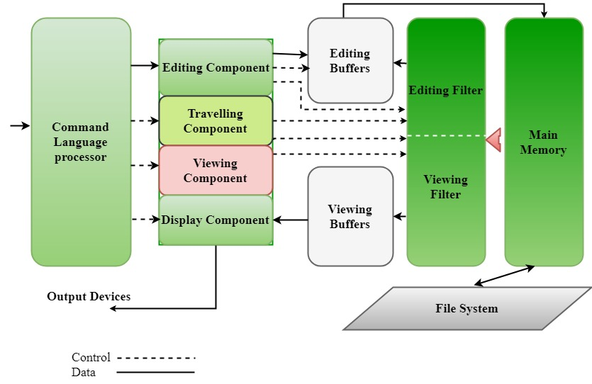

## 

## Product Functions

The major functions of text editor are:

* Creation of a file
* Open file and edit its contents
* Save file
* Close file
* Cut, copy and paste the text
* Choose custom themes

The functions coupled with a few more tentative functions make up the text editor as shown in the following entity-relationship diagram.

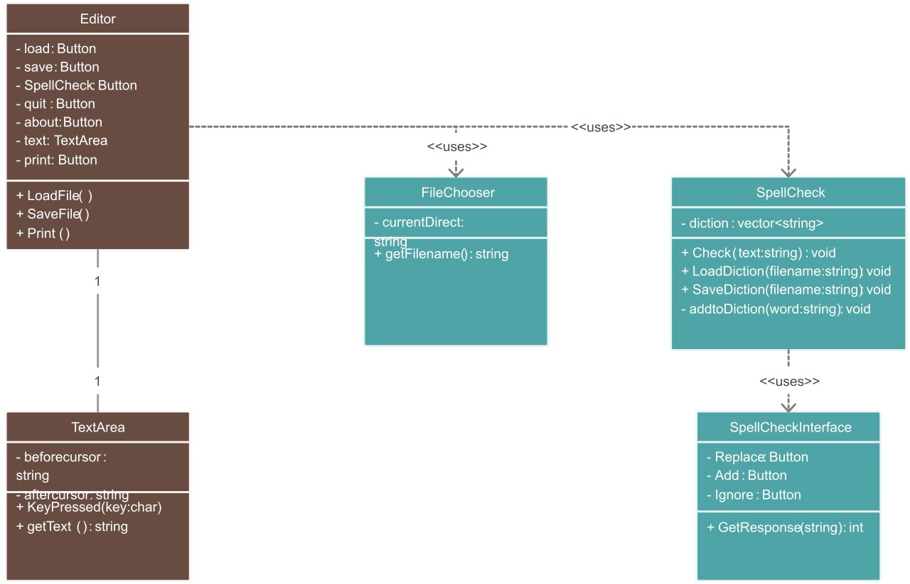

## 

## User Classes and Characteristics

The main user for this product will the any person acting as the user and using the editor to open, modify and save files with data, in an easier and organized method.

The system engineer will have access to installing and dealing with issues related to the editor.

## 

## Operating Environment

## Operating environment for simple text editor is as listed below.  distributed database

* Operating system: Windows.
* Platform: python

## Design and Implementation Constraints

## The file system cannot be largely kept track of as no DBMS is being used. The editor is not launchable from the terminal and free to run scripts from any platform due the differences in the syntax and less generalisation.

## Assumptions and Dependencies

## Since a lot of pre-defined libraries are to be used in this product, including Tkinter from Python for GUI, it could have certain unexpected changes during the process of making the editor.

# External Interface Requirements

## User Interfaces

## The screen layout would be similar to that of any editor, with text area in the middle and a small task bar and menu bar. It would have buttons for most functions like save, new file, quit, run, etc. All the typing is done in the text area. Tkinter is used for all the GUI which makes the entire text editor and it’s appearance on the screen.

## Software Interfaces

## Software interfaces used for the text editor:

* Front-end software: Python 3.10 (Tkinter library for GUI)
* Back-end software: Python 3.10
* Operating system: Windows operating system for its best support and user-friendliness.
* More libraries to be used (TBD)

## Communications Interfaces

No communication functions or interfaces used.

# Analysis Models

USE CASE

From the problem description, we can see that the system has 2 actors.

Regular user

System Manager

To define system’s functionalities, we can view the system as a collection of following cases:

* File handling
* Editing
* Formatting
* Programming

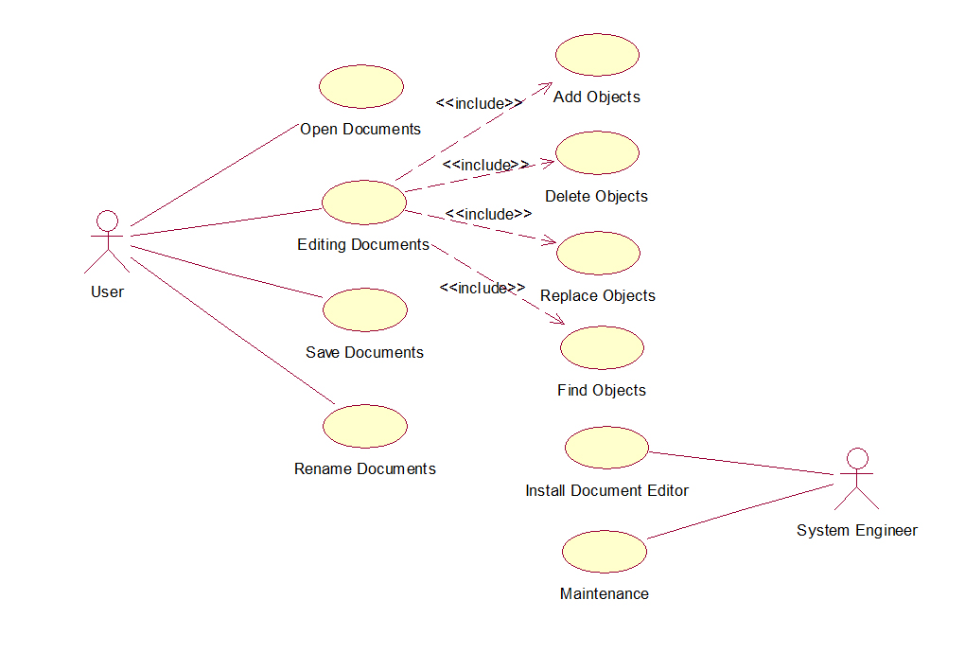

# System Features

## File Handling

Description and Priority

User can create and modify any file they can open in the text editor. The priority is high for this feature as it is required so that further features can be put into place.

Stimulus/Response Sequences

File handling is necessary to manage all the files. It comes into use when a user opens, edits or deletes a particular file through the text editor. This then accesses both the view and edit filters along with memory access.

Functional Requirements

All implemented using python.

REQ-1: Create file - gives error when user tries to name it the same as an existing file name and is handled by asking user to change file name or replace it.

REQ-2: Open file ­– error when the mentioned file name doesn’t exist

REQ-3: Save file

REQ-4: Close file – asks for saving changes made before closing

## Editing

Description and Priority

User can perform many editing operations like cut, copy, paste:

Cut - Select the portion or whole of the text you want to cut and then press cut.

Copy - Select the portion or whole of the text you want to copy and then press copy

Paste - Press the paste button at the place you want to paste the copied text.

Its priority is after the highest priorities as the text editor can still work without these features

Stimulus/Response Sequences

Editing comes into use when a user opens a file and selects some text to modify it. This again opens up the edit filter with access to the memory.

Functional Requirements

REQ-1: Cut text command

REQ-2: Copy text command

REQ-3: Paste text command

REQ-4: Find and Replace

Shortcut keys for the commands would also be greatly helpful and are implemented.

## Formatting

Description and Priority

User can use formatting to work with the text in the text editor. They can customize the font to their liking, as well as the syntax highlighting and the overall theme of the editor from some preloaded themes. This has the lowest priority as it’s just to make the editor look presentable and is related to the gui.

Stimulus/Response Sequences

Formatting is when the user edits the font features or picks a theme from the available themes.

Functional Requirements

REQ-1: Choose different themes

REQ-2: Indenting and unindenting

REQ-3: Font color and bold, italic, underline

## Programming help

Description and Priority

Since text editors are most commonly used for programming and coding, some helpful features for coding are included. This includes autocompleting brackets, syntax highlighting and some other functionalities. This has low priority as its just to make the editor easier to use.

Stimulus/Response Sequences

These come into use when a user is coding using text editor. They could also be useful for normal note-taking or texts as well. The user selects some text and then performs the functions on it. It calls the editing filter and memory access too.

Functional Requirements

REQ-1: Autocomplete brackets

REQ-2: Syntax Highlighting

REQ-3: Run current file

# Other Non-functional Requirements

## Performance Requirements

* Pleasing layout to look at
* Save files to desirable location
* Help/ guide to use the editor
* Should be fast and shouldn’t take up much space

Timing relationship for real time system (deadline of tasks)

* week 1: create, open and close files
* week 2: edit files including copy and paste
* week 3: formatting files
* week 4: compiling files

Performance requirements for each function:

(a)reliability of each function

-which includes availability of files

(b)maintainability of files

-scalability of text editor:

-overall easy access of files

Safety Requirements

- files could be lost: this could be prevented by saving the files

- files can be edited and other functions are done only by users

- files can be damaged while compiling

Safety certifications show their commitment to safety and risk management, skills for managing safety of yourself and others

ex: CSP (certified safety professional) certificate obtained after completing ASP certificate.

## Security Requirements

## Security systems need database storage just like many other applications. However, the special requirements of the security market mean that vendors must choose their database partner carefully.

## Software Quality Attributes

## Qualities important for both user and customers:

## - reusability: each file can be used any number of times for viewing or editing

## - flexibility: easy compilation of the files

## - robustness: all the functions should be done quick

## - adaptability

## - availability: space for saving files

## all these qualities help the user to easily use all the functions

## Business Rules

The user should be able to create as many new Untitled text files as they wish, the application should allow the user to open a file from any drive or network onto the desktop.

After editing a file either on the Source code desktop, the user should be able to save it.

Keeping in mind the same context, the user should have the option of saving a selected file as another new file.

In the event of editing text, the application should support cut, copy and paste operations

# Other Requirements

Other non-functionality requirements:

Good response time

Efficiency

Effectiveness

Interface is user friendly

Easy to use

No special downloads necessary

Simple to install

Appendix A: Glossary

* REQ – Requirement
* DBMS – Database Management System
* TBD – To Be Determined
* Appendix B: Field Layouts

**Information required to create or open a file**

|  |  |  |  |  |
| --- | --- | --- | --- | --- |
| **Field** | **Length** | **Data Type** | **Description** | **Is Mandatory** |
| File name | 256 | String | Name of the file | Y |
| File type | - | String | Type of the file | Y |

Appendix C: Requirement Traceability Matrix

|  |  |  |  |  |  |  |  |
| --- | --- | --- | --- | --- | --- | --- | --- |
| **Sl. No** | **Requirement ID** | **Brief Description of Requirement** | **Architecture Reference** | **Design Reference** | **Code File Reference** | **Test Case ID** | **System Test Case ID** |
| 1. | Req-01 | Creating a new file | Document Processing Architecture - IBM | Digitizer V5 | texteditor.py | UT-01 | UT-01 |
| 2. | Req-02 | Opening an existing file | Document Processing Architecture - IBM | Digitizer V5 | texteditor.py | UT-03 | UT-03 |
| 3. | Req-03 | Saving a file | Document Processing Architecture - IBM | Digitizer V5 | texteditor.py | UT-06 | UT-06 |
| 4. | Req-04 | Closing a file | Document Processing Architecture - IBM | Digitizer V5 | texteditor.py | UT-10 | UT-10 |
| 5. | Req-05 | Cut (Ctrl+X) text | None | None | Context.py | UT-11 | UT-11 |
| 6. | Req-06 | Paste (Ctrl+V) text | None | None | Context.py | UT-12 | UT-12 |
| 7. | Req-07 | Copy (Ctrl+C) text | None | None | Context.py | UT-14 | UT-14 |
| 8. | Req-08 | Find and Replace | None | None | Find.py | UT-16 | UT-16 |
| 9. | Req-09 | Themes for editor | None | None | Syntax_and_themes.py | UT-21 | UT-21 |
| 10. | Req-10 | Auto-indentation of text | None | None | Context.py | UT-23 | UT-23 |
| 11. | Req-11 | Font formatting | None | None | Context.py | UT-25 | Ut-25 |
| 12. | Req-12 | Auto-completion of brackets | None | None | Texteditor.py | UT-28 | UT-28 |
| 13. | Req-13 | Syntax highlighting for program files | None | None | Syntax_highlighting.py | UT-30 | UT-30 |
| 14. | Req-14 | Running a program file from editor | None | None | Loaders.py | UT-31 | UT-31 |